**INCIDENT REPORT FORM**

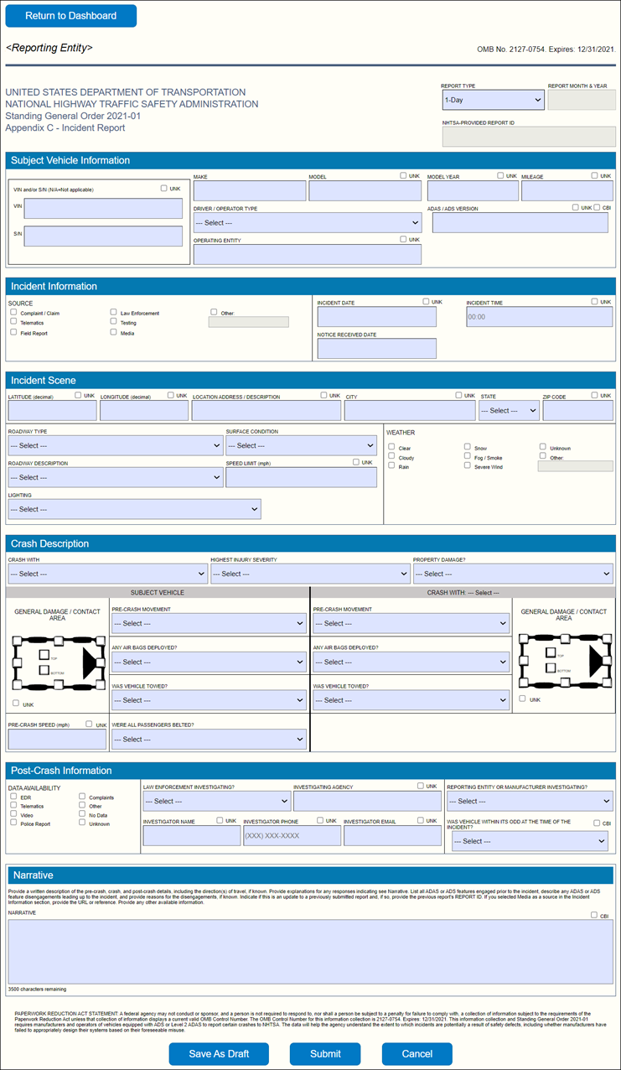

**DATA ELEMENTS: DESCRIPTION**

**General Guidance**

All fields are *mandatory*. In cases where a value is unknown select the corresponding drop-down menu option or the checkbox (□UNK) next to the field name.

Note: Non-bold, underlined items are drop-down selections.

**REPORT TYPE:** Select the appropriate report type. “Update” report types are only available when updating a previously submitted report.

* 1-Day: The initial report for an incident meeting the criteria in Request No. 1 of the SGO, which requires an initial report within one calendar day and a supplemental report within ten calendar days.
* 10-Day Update: This report type is used for any updated report required under Request No. 1 of the SGO.
* Monthly: Report for an incident meeting the criteria in Request No. 2 of the SGO, which requires a report on the fifteenth day of the following month. Use separate reports for multiple incidents in the same reporting month.
* Monthly Update: This report type is used for any updated report required under Request No. 3 of the SGO.
* Monthly – No Incidents: This monthly report is required under Request No. 4 in the absence of monthly incident reports under Request No. 2 or monthly updated reports under Request No. 3, to confirm the lack of any such monthly reportable information. In the absence of a monthly report under Request No. 2 or Request No. 3, a monthly report is required under Request No. 4 regardless of whether one or more reports was filed under Request No. 1.
* Other Update: This report type is used for any updated report that is not a 10-Day Update or a Monthly Update.

**REPORT MONTH & YEAR**: The reporting month and year. For a monthly report filed under Request Nos. 2, 3, or 4, this will be the calendar month prior to the calendar month in which the report is being filed – i.e., the period for which the report is being filed. Thus, a report filed under Request No. 4 in December reflects the lack of any information reportable under Request No. 2 or Request No. 3 during November. The report month and year for a monthly report should therefore designate the month and year for which the report is being filed.

**REPORT ID**: Unique incident number to track initial and updated reports for a given incident. The ID is generated when the report is first saved or submitted. (Read-only)

**Subject Vehicle Information**

Note that “subject vehicle” is defined in the SGO in the “Definitions” section.

**VIN or S/N**: Vehicle identification or serial number for the subject vehicle.

**MAKE**: Make of the subject vehicle as branded.

**MODEL**: Model of the subject vehicle as branded.

**MODEL YEAR**: Model year of the subject vehicle.

**MILEAGE**: The odometer reading of the subject vehicle in miles at the time of the incident. If the odometer reading is in kilometers or any other unit other than miles, report the reading in miles.

**DRIVER / OPERATOR TYPE**: An individual responsible for fallback operation or any part of the dynamic driving task (DDT) for the subject vehicle at the time of the incident.

* Consumer: Any individual who is operating a commercially available ADAS / ADS and is not engaged in any activity on behalf of a motor vehicle or motor vehicle equipment manufacturer at the time of the incident.
* In-Vehicle (Commercial / Test): An individual, other than a consumer, located within the subject vehicle.
* Remote (Commercial / Test): An individual, other than a consumer, not located within the subject vehicle who is capable of providing remote driving, fallback, and/or assistance.
* In-Vehicle and Remote (Commercial / Test): A combination of both In-Vehicle (Commercial / Test) and Remote (Commercial / Test) individuals.
* None: No individual is responsible for any part of the DDT at the time of the incident.
* Other, see Narrative
* Unknown

**ADS EQUIPPED?**: Is the subject vehicle equipped with an Automated Driving System?

* Yes
* No
* Unknown, see Narrative

**AUTOMATION SYSTEM ENGAGED AT THE TIME OF THE INCIDENT**: Select the highest-level driving automation system engaged at any time during the period 30 seconds immediately prior to the commencement of the crash through the conclusion of the crash.

* ADAS
* ADS
* Unknown, see Narrative

**ADAS / ADS VERSION**: Hardware and software version numbers of the ADAS or ADS in use at the time of the incident.

**OPERATING ENTITY**: The entity that meets the definition of “operator” in the “Definitions” section of the SGO. This can be different from the reporting entity.

**Incident Information**

**SOURCE**: The source from which the reporting entity first received notice of the incident. “Notice” is defined in the “Definitions” section of the SGO.

* Complaint / Claim: A communication of any kind addressed to the reporting entity and made by a consumer or other individual; also, a written request or written demand for relief.
* Telematics: A communication in the form of electronic data transmitted from the subject vehicle to the reporting entity providing notice of a reportable incident.
* Field Report: A communication in writing, including communications in electronic form, from an employee or representative of a reporting entity.
* Law Enforcement: A communication in writing, including communications in electronic form, from a law enforcement agency.
* Testing: A communication, including communications in electronic form, regarding a subject vehicle that is undergoing evaluation, development, or validation testing when the incident occurs.
* Media: Notice received from a media organization, either through specific inquiries to the reporting entity or through a reported account of an incident.
* Other: Please specify how the reporting entity learned of the incident involving the subject vehicle.

**INCIDENT DATE**: The date the incident occurred. [YYYY-MM-DD]

**INCIDENT TIME**: The local time the incident occurred. [24-hour format]

**NOTICE RECEIVED DATE**: The date the reporting entity received notice of the incident that met the reporting criteria. [YYYY-MM-DD]

**IDENTIFIER**: If multiple notices were received on the same date, enter a number to uniquely identify each notice.

**Incident Scene**

**LATITUDE (decimal)**: Latitude in decimal degrees (ex: 38.889747) where the incident occurred.

**LONGITUDE (decimal)**: Longitude in decimal degrees (ex: -77.009351) where the incident occurred.

**LOCATION ADDRESS / DESCRIPTION**: The street address or the roadway location where the incident occurred.

**CITY**: The city where the incident occurred.

**STATE**: The state or territory where the incident occurred.

**ZIP**: The 5-digit ZIP code where the incident occurred.

**ROADWAY TYPE**: Choose the option that best describes the type of road on which the subject vehicle was operating at the time of the incident.

* Highway / Freeway: A divided arterial highway with full control of access.
* Street: Local city or residential road not at an intersection; does not include unpaved or rural roads
* Intersection: An area where two or more roadways join or cross.
* Parking Lot: Dedicated area intended for parking vehicles, including a publicly-accessible road within a dedicated parking area and on-street parking.
* Traffic Circle: A circular intersection, rotary, roundabout, or similar junction in which road traffic is permitted to flow in one direction.
* Rural Road: Local road outside densely populated areas; does not include unpaved roads or a highway/freeway.
* Unpaved Road: A roadway where the surface is not concrete or asphalt.
* Unknown

**SURFACE CONDITION**: The roadway surface environmental state at the time of the incident.

* Dry: No adverse conditions.
* Snow / Slush / Ice: The roadway surface was, at a minimum, partially covered with snow, slush, and/or ice.
* Wet: The roadway surface was wet without any frozen water.
* Other, see Narrative
* Unknown

**ROADWAY DESCRIPTION**: The roadway description at the time of the incident. Excludes weather conditions.

* No Unusual Conditions: The roadway did not contain any unusual anomalies or imperfections.
* Traffic Incident: A prior traffic event that adversely affected normal traffic operations separate from the reported incident. Examples include, but are not limited to, traffic crashes, disabled vehicles, and spilled cargo.
* Work Zone: An area of a roadway where construction, maintenance, or utility work activities are identified by warning signs, signals, or other indicators.
* Missing / Degraded Markings: The roadway lane markings were missing, degraded, or otherwise altered, not in conjunction with a work zone.
* Other, see Narrative
* Unknown

**SPEED LIMIT (mph)**: The posted speed limit on the roadway where the incident occurred.

**LIGHTING**: The lighting conditions at the location of the incident.

* Daylight: The incident occurred when there was daylight.
* Dawn / Dusk: The incident occurred during dusk or dawn.
* Dark - Lighted: The incident occurred when it was dark, but street lights were on.
* Dark - Not Lighted: The incident occurred when it was dark, but there were no street lights.
* Dark - Unknown Lighting: The incident occurred when it was dark, but the presence of street lights is unknown.
* Other, see Narrative
* Unknown

**WEATHER**: The weather or environmental conditions at the time of the incident.

* Clear: No adverse weather conditions.
* Cloudy: The sun is obscured by clouds.
* Rain: Raining at the time of the incident.
* Snow: Snowing at the time of the incident.
* Fog / Smoke: Low visibility conditions including smog.
* Severe Wind: Atmospheric conditions producing strong winds.
* Unknown
* Other: Please specify in the provided field.

**Crash Description**

**CRASH WITH**: Identify the vehicle, non-motorist, animal, or object with which the subject vehicle came into contact.

* Passenger Car: Traditional passenger car.
* SUV: Crossover or sport utility vehicle.
* Van: Traditional large van or minivan.
* Pickup Truck: Traditional pickup truck.
* Motorcycle: Motorized two- or three-wheel vehicle.
* Bus: Traditional transit bus, school bus, or motorcoach.
* Heavy Truck: Truck with a GVWR greater than 10,000 pounds.
* First Responder Vehicle: An emergency response (ambulance, tow truck, etc.) or law enforcement vehicle.
* Non-Motorist: Pedestrian: Any human not on a motorized or non-motorized transport.
* Non-Motorist: Cyclist: Non-motorized two- or three-wheel vehicle.
* Non-Motorist: Other
* Pole / Tree: A tall narrow object.
* Other Fixed Object: A physical structure such as a building, bridge, guardrail, etc.
* Animal: A dog, cat, deer, or other animal.
* Other, see Narrative
* Unknown

**HIGHEST INJURY SEVERITY REPORTED**: Select the highest crash injury severity level reported.

* Fatality: Confirmed or alleged incident where an involved party was fatally injured.
* Serious: Confirmed or alleged incident where an involved party sustained serious injuries that required hospitalization or emergency treatment.
* Moderate: Confirmed or alleged incident where an involved party sustained injuries and sought medical treatment (excludes hospitalization and emergency treatment).
* Minor: Confirmed or alleged incident where an involved party sustained possible injuries that did not require medical treatment.
* No Injuries Reported: No injuries were reported or alleged from the incident.
* Unknown

**PROPERTY DAMAGE?**

* Yes
* No
* Unknown

**GENERAL DAMAGE / CONTACT AREA**: Identify location of damage or contact on the subject vehicle and the vehicle the subject vehicle contacted (as applicable) using the graphics. Mark all that apply. If the subject vehicle did not contact another vehicle, only fill out the graphic for the subject vehicle.

* Front
* Front right corner
* Front left corner
* Rear
* Rear right corner
* Rear left corner
* Right side
* Left side
* Top
* Bottom

**PRE-CRASH SPEED (mph)**: The speed of the subject vehicle at the time of the incident.

**PRE-CRASH MOVEMENT**: The movement of the subject vehicle, other vehicle, or non-motorist (NM) prior to the incident. Some options are not available for the subject vehicle.

* Stopped: Vehicle was stopped and not moving.
* Proceeding Straight: Vehicle was moving uniformly in one direction only.
* Lane / Road Departure: Vehicle left the original lane of travel.
* Making Right Turn: Vehicle was turning right.
* Making Left Turn: Vehicle was turning left.
* Making U-Turn: Vehicle was making a U-Turn.
* Backing: Vehicle was backing in reverse.
* Passing: Vehicle was passing another vehicle.
* Changing Lanes: Vehicle was in the process of changing lanes within the same direction of travel.
* Parking Maneuver: Vehicle was parking into a space including: forward, reverse, or parallel.
* Entering Traffic: Vehicle was entering onto a roadway from a non-roadway – e.g., parking lot, driveway.
* Crossing into Opposing Lane: Vehicle traveled into the opposing lane intentionally to maneuver around a vehicle, object, or other obstruction.
* Parked: Vehicle was parked at the time of the incident.
* Merging: Vehicle was merging onto a roadway from another roadway.
* Traveling Wrong Way: Vehicle was traveling on the roadway in the wrong direction of the intended traffic flow.
* NM Crossing Roadway: Non-motorist moving across the roadway.
* NM Waiting to Cross Roadway: Non-motorist waiting to attempt to cross the roadway.
* NM Moving Alongside Roadway: Non-motorist walking or cycling along the side of a roadway (not on a sidewalk) with or against the flow of traffic.
* NM Moving on Sidewalk: Non-motorist walking or cycling on a sidewalk alongside a roadway with or against the flow of traffic.
* NM in Roadway – Other: Non-motorist moving in the roadway with or against the flow of traffic.
* Other, see narrative: Please specify in the narrative if not listed above.
* Unknown

**ANY AIR BAGS DEPLOYED?:** Indicate if any air bag in any vehicle deployed. Some options are not available for the subject vehicle.

* Yes
* No
* Not Applicable: Not a vehicle equipped with an air bag.
* Unknown

**WAS VEHICLE TOWED?**: Indicate if any vehicle was towed from the scene. Some options are not available for the subject vehicle.

* Yes
* No
* Not Applicable
* Unknown

**WERE ALL PASSENGERS BELTED?**: Indicate if all passengers in the subject vehicle were wearing seat belts at the time of the incident.

* Yes
* No, see Narrative: Specify the number and position of unbelted passenger(s), if available.
* No Passengers in Vehicle: Vehicle was unoccupied at the time of the incident.
* Unknown

**Post-Crash Information**

**DATA AVAILABILITY**: Select all sources of available incident data.

* EDR: Subject vehicle Event Data Recorder available.
* Telematics: Electronic data transmitted from the subject vehicle to a reporting entity notifying or indicating a reportable incident.
* Video: Video from the subject vehicle or another source is available.
* Police Report: Police report or other official record or investigation of the incident is available.
* Complaints: Consumer complaint information is available.
* Other: Please specify in narrative.
* No Data: Additional data not available.
* Unknown

**LAW ENFORCEMENT INVESTIGATING?**: Indicate if a law enforcement agency is investigating the incident. If so, provide contact information.

* Yes
* No
* Unknown

**INVESTIGATING AGENCY**: Name of the law enforcement agency investigating the incident.

**INVESTIGATOR NAME:** Name of the primary point of contact for the investigation.

**INVESTIGATOR PHONE**: Phone number of the primary point of contact for the investigation.

**INVESTIGATOR EMAIL**: Email address of the primary point of contact for the investigation.

**REPORTING ENTITY OR MANUFACTURER INVESTIGATING?**: Indicate if the company filing this report or the manufacturer of the subject vehicle is conducting an investigation of the incident.

* Yes: An investigation has been or planned to be conducted.
* No: An investigation will not be conducted.
* Unknown: It is unknown if an investigation has been or will be conducted.

**WAS VEHICLE WITHIN ITS ODD AT THE TIME OF THE INCIDENT?:** Was the vehicle within its Operational Design Domain (ODD) in the moments leading up to the incident?

* Yes
* No, see Narrative
* Unknown, see Narrative

**Narrative**

Provide a written description of the pre-crash, crash, and post-crash details. Include explanations for any responses indicating “see Narrative”, list all ADAS or ADS features engaged prior to the incident, describe any ADAS or ADS feature disengagements leading up to the incident, and provide any other available information. Indicate if this is an update to a previously submitted report and provide the previous report's REPORT ID. If you selected Media as a source in the Incident Information section, provide the URL or reference for any reported account.

**Other Definitions**

Subject Vehicle: The vehicle that is being reported on and meets the definition in the “Definitions” section of the SGO.

Non-Motorist (NM): Non-motorist or NM are crash partners that are not occupants in a motor vehicle such as pedestrians or cyclists.