SUPPORTING STATEMENT FOR

GI Bill® School Feedback Tool
(OMB Control Number 2900–0797)

A. Justification.

1. Explain the circumstances that make the collection of information necessary. Identify legal or administrative requirements that necessitate the collection of information.

Executive Order 13607, Establishing Principles of Excellence, which is now identified as the GI Bill School Feedback Tool is used for Educational Institutions serving service members, Veterans, spouses, and other family members, requires the establishment of a centralized complaint system for students receiving federal military and Veteran educational benefits. The purpose of the complaint system is to provide a standardized method to submit a complaint against an educational institution alleging fraudulent and unduly aggressive recruiting techniques, misrepresentation, payment of incentive compensation, failure to meet state authorization requirements, or failure to adhere to the Principles of Excellence as outlined in the Executive Order.

The VA’s Principles of Excellence GI Bill® School Feedback Tool leverages the Salesforce platform to collect and manage complaints. The complainants access the complaint system through the GI Bill website and eBenefits portal. Veterans, family members, or other members of the public are able to open links at the VA website location and enter the requested information. Complainants are offered the opportunity to review the information in their complaint prior to clicking on the submit button. Once a complaint is submitted, the complainant receives an email verifying that the complaint was received.

At this point, the complaint is stored in the complaint system and is available to select VA employees for review. VA reviews the complaint, and on behalf of the complainant, shares the complaint with the institution which is subject of the complaint. VA requests the institution to formally respond to the complaint within 90 days. If an institution fails to respond within 90 days, VA will contact the institution and request a status update.

Once VA receives a response from the institution, VA will forward the response to the complainant. At this point, VA will close the case. Valid complaints received are transmitted to the central repository at FTC Consumer Sentinel. The information in the central repository is the same information provided by the complainant. Authorized law enforcement officials who have been granted access to the FTC Consumer Sentinel database have access to view all complaints.

2. Indicate how, by whom, and for what purposes the information is to be used; indicate actual use the agency has made of the information received from current collection.

The respondent submits a complaint about an educational institution online through either the GI Bill website or the eBenefit portal. The information gathered can only be obtained from the individual respondents. Valid complaints will be accepted from third parties.

The Feedback Tool process for VA’s complaint system data elements include:

  - Institution/Employer: There are over 36,000 educational institutions that are approved for VA education benefits
  - Anonymous Complaints: The Feedback Tool Complaint System allows for a user to file anonymous complaints. Based on working group discussions with CFPB and FTC, VA believes that allowing anonymous complaints will garner more ground truth on what is happening with Veterans using their education benefits at different schools.
  - Required fields: As a result of allowing anonymous complaints, many of the fields will not be required by VA.

3. Describe whether, and to what extent, the collection of information involves the use of automated, electronic, mechanical, or other technological collection techniques or other forms of information technology, e.g., permitting electronic submission of responses, and the basis for the decision for adopting this means of collection. Also describe any consideration of using information technology to reduce burden.

The GI Bill® School Feedback Tool system leverages information technology to receive the complaint, case management for processing, and referrals as necessary. VA Management Analysts/Complaint Case Managers coordinate with educational institutions to reach a resolution for the individual. The complaints are uploaded to a central repository, FTC’s Consumer Sentinel Network. All complaints will be accessible by state and federal agencies and law enforcement via the central repository. In addition, VA compiles a profile at the institutional level with the types of complaints received for other tools that provide streamlined comparisons of institutions. VA uses this profile information to conduct regular and risk-based compliance surveys for educational institutions.

4. Describe efforts to identify duplication. Show specifically why any similar information already available cannot be used or modified for use for the purposes described in Item 2 above.

Program reviews were conducted to identify potential areas of duplication; however, none were found to exist. There is no known Department or agency which maintains the necessary information, nor is it available from other sources within VA.

5. If the collection of information impacts small businesses or other small entities, describe any methods used to minimize burden.

The information collection involves individuals (Veterans, service members, and their family members). The information may be collected directly from individuals or submitted on behalf of someone else. The information may also be submitted anonymously. There is no impact on education institutions or small businesses for the information collection.

6. Describe the consequences to Federal program or policy activities if the collection is not conducted or is conducted less frequently as well as any technical or legal obstacles to reducing burden.

If this information is not collected, VA would not have a uniform manner for individuals to submit complaints for possible fraudulent, unduly aggressive recruiting, misrepresentation, or adherence with the Principles of Excellence GI Bill® School Feedback Tool against educational institutions. There are no technical or legal obstacles to reducing the burden of this information collection.

7. Explain any special circumstances that would cause an information collection to be conducted more often than quarterly or require respondents to prepare written responses to a collection of information in fewer than 30 days after receipt of it; submit more than an original and two copies of any document; retain records, other than health, medical, government contract, grant-in-aid, or tax records for more than three years; in connection with a statistical survey that is not designed to produce valid and reliable results that can be generalized to the universe of study and require the use of a statistical data classification that has not been reviewed and approved by OMB.

There are no special circumstances requiring collection in a manner inconsistent with 5 CFR 1320.6 guidelines.

8. If applicable, provide a copy and identify the date and page number of publications in the Federal Register of the sponsor’s notice, required by 5 CFR 1320.8(d), soliciting comments on the information collection prior to submission to OMB. Summarize public comments received in response to that notice and describe actions taken by the sponsor in responses to these comments. Specifically address comments received on cost and hour burden.

The Department notice was published in the Federal Register on December 20, 2021, Volume 86, Number 241, pages 72027-72028. Three comments were received.

Comment #1

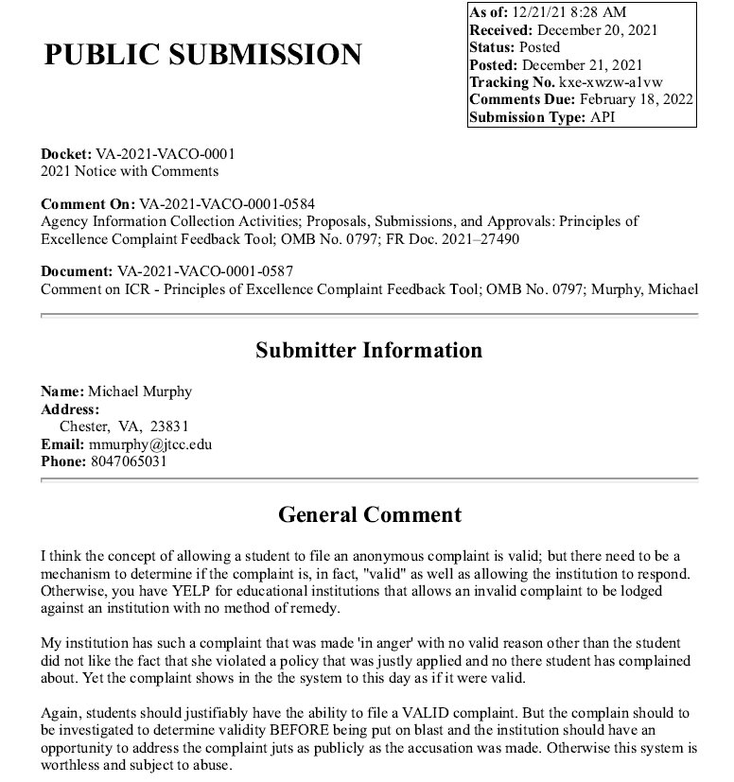

VA RESPONSE: Thank you for your comment. Executive Order (EO) 13607 gives the student the ability to file complaints and VA screens the complaints to determine the validity based on the EO. If the complaint doesn’t violate the EO, the complaint is not valid and not reported on the VA Comparison Tool. Only valid complaints are reported on the VA Comparison Tool.

Anonymous complaints are sent to the school for awareness and are not reflected in the number of complaints shown in the VA Comparison Tool, and they are not reported to the FTC.

Thanks, Education Service

Comment #2

(202) 922-2800 Feehan, LLC info@mattfeehan.com

The GI Bill® Feedback Tool, a Waste of U.S. Taxpayer Dollars
Matthew Feehan, Principal

Few colleges and universities in the United States conspicuously share the Department of Veterans Affairs GI Bill® Feedback Tool with their students. Some institutions, the State University of New York (SUNY), for example, train administrative staff to treat the Feedback Tool as a compliance risk—as opposed to a student resource.1 Understandably, this creates a chilling effect within the marketplace and incentivizes Institutes of Higher Education (IHE) to ignore the Feedback Tool because it poses a risk to student enrollment.

In defense of IHE purporting to be committed to the Principles of Excellence, Executive Order 13607 charged the “Secretaries of Defense and Veterans Affairs” to create a plan, not IHE.2 Thus, almost a decade later, servicemembers, veterans, spouses, and other family members have a better chance of being shown high definition, production quality images of a university’s veterans center than of the Feedback Tool, Postsecondary Education Complaint Intake (DoD), or their respective data.

This is a problem because a student veterans center – as well equipped as some are – does not provide information on Recruiting/Marketing Practices; Quality of Education; Accreditation; Grade Policy; Financial Issues (e.g., Tuition/Fee charges); Release of transcripts; Student Loans; Transfer of Credits; Post-Graduation Job Opportunities; Refund Issues; Change in Degree Plan/Requirement; or any other relevant information3 that servicemembers, veterans, spouses, and other family members should know when choosing between colleges and universities.

In response to Veterans Benefits Administration, Department of Veterans Affairs (VA)’s Notice, Federal Register Document 2021–27490, the proposed collection of information by the VA is not necessary for the proper performance of the Veterans Benefits Administration’s functions because the information is already being collected and compared through a multitude of different means offered by the private sector. Moreover, the Feedback Tool, which accepts third-party complaints, has had an identity crisis since its inception and cannot decide if it is meant to resolve complaints or receive feedback. Accordingly, the GI Bill Comparison Tool, which pulls its complaint data from the Feedback Tool, is inundated with an excessive number of expertly drafted complaints disproportionally brought by third parties targeting specific schools.

The quality, utility, and clarity of the information to be collected can be improved by engaging in strategic partnerships with organizations familiar with artificial intelligence. This will also minimize the burden of collecting information on respondents and best comply with the Principles of Excellence.

1 Gilliland, J. F., Administrator Bootcamp, The State University of New York. (last visited Feb. 15, 2022) https://www.newpaltz.edu/media/idmh/conference-materials/best-and-shared-practices-for-military-students/powerpoints/Administrator%20Bootcamp.pdf (training administrative staff risks of non-compliance).
2 Exec. Order No. 13607, 77 Fed. Reg. 26861 (Apr. 27, 2012) available at https://www.govinfo.gov/content/pkg/FR- 2012-05-02/pdf/2012-10715.pdf.
3 GI Bill Feedback Tool, U.S. Department of Veterans Affairs, https://www.benefits.va.gov/GIBILL/Feedback.asp (last visited Feb. 15, 2022)
VA RESPONSE: Thank you for your comment. Executive Order (EO) 13607 gives the student the ability to file complaints and VA screens the complaints to determine the validity based on the EO. If the complaint doesn’t violate the EO, the complaint is not valid and not reported on the VA Comparison Tool. Only valid complaints require a response and are reported on the VA Comparison Tool.
Anonymous complaints are sent to schools for their awareness. Anonymous complaints are not to be reflected in the number of complaints shown in the VA Comparison Tool, and they are not reported to the Federal Trade Commission (FTC).
Thanks,
Education Service

Comment #3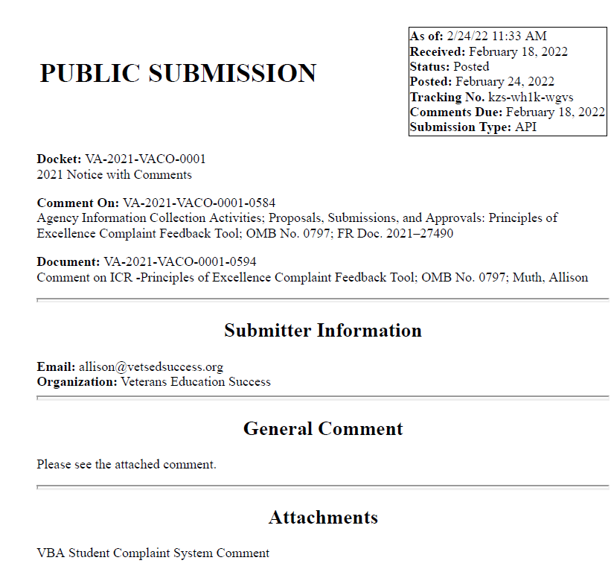

February 18, 2022

Department of Veterans Affairs Veterans Benefits Administration 810 Vermont Avenue NW Washington, DC 20420
Via electronic submission

Re: Principles of Excellence Complaint Feedback Tool, OMB Control No. 2900-0797
Dear Sir/Madam:
Thank you for the opportunity to comment on the collection of information by the Veterans Benefits Administration (VBA) regarding the GI Bill School Feedback Tool. This student complaint system was first authorized by Executive Order 13607,¹ Establishing Principles of Excellence for Educational Institutions Serving Service Members, Veterans, Spouses, and Other Family Members. The order directed the Departments of Defense and Veterans Affairs to create “streamlined tools to compare educational institutions using key measures of affordability and value” and “a strong enforcement system through which to file complaints when institutions fail to follow” the Principles of Excellence. The goals of Executive Order 13607 align with VA’s mission to serve and honor America’s veterans.

The student complaint system is also codified in 38 U.S.C. § 3698(b)(2), which requires the Secretary to provide “a centralized mechanism for tracking and publishing feedback from students and State approving agencies regarding the quality of instruction, recruiting practices, and post-graduation employment placement.”

We offer comments on the continuing need for this student complaint system and suggestions for its improvement below.

The proposed collection of information is necessary for the proper performance of VBA’s functions

We believe that the collection of this information is essential for the success of GI Bill students and the administration of educational benefits. The tracking and reporting of student feedback is essential because it:

¹ Exec. Order No. 13607, 77 FR 25861 (2012).

- Provides prospective students with key information to make informed college choices. Feedback from other veterans² helps prospective GI Bill students compare educational institutions and make careful college selections.

- Enables VBA to provide customer service to veterans – to inform, support, and protect them. The GI Bill School Feedback Tool system is the primary method for students to lodge complaints against their school, to be heard, and to know that VBA has their backs.

- Provides VBA with a critical early warning system to enable proper oversight and efficient administration of the GI Bill. Student feedback can alert VBA to systemic problems at schools – such as missing or mishandled GI Bill funds, changes to degree requirements, or loans taken out without the veteran’s permission.

- Protects taxpayer funds from waste, fraud, and abuse. Knowing about problems enables VBA to stop improper payments to ineligible colleges – as VA’s Inspector General pointed out.³

Ways to enhance the quality, utility, and clarity of the information to be collected

We offer recommendations to enhance the clarity of the GI Bill School Feedback Tool and to increase the accuracy and utility of the information collected and reported through the GI Bill Comparison Tool.

- Utilize complaints to trigger risk-based surveys. The Johnny Isakson and David P. Roe, M.D., Veterans Health Care and Benefits Improvement Act of 2020 requires state approving agencies (SAAs) to include student complaints submitted through the GI Bill School Feedback Tool in risk-based surveys.⁴ Although the statute does not require student complaints to trigger risk-based surveys, such complaints are an important early warning sign to VBA of fraud, and VBA should exercise its discretion to direct SAAs to conduct a risk-based survey of a school if complaints show a pattern of abuse or a serious violation of law or VA regulations.

- Do not deem complaints “invalid.” We understand from discussions with VBA that complaints are reviewed and deemed valid or invalid, and that only valid complaints are sent to the school. We have been told that a number of veterans’ complaints submitted to the GI Bill School Feedback Tool by our organization were determined to be invalid. This is concerning, because all of the student complaints we receive are serious and deserve consideration. Moreover, VBA has not published any process or criteria to deem a complaint “invalid.” We urge VBA to consider as “valid” all complaints that touch on a Principles of Excellence issue on the GI Bill Comparison Tool and to upload all

² Where the term “veteran” is used, we also refer to other GI Bill beneficiaries.
³ VA’s Oversight of State Approving Agency Program Monitoring for Post-9/11 GI Bill Students, Department of Veterans Affairs, Office of Inspector General (Dec. 3, 2018), https://www.va.gov/oig/pubs/VAOIG-16-00862- 179.pdf.
⁴ 38 U.S.C. § 3673A(b)(2)(C).

complaints to Consumer Sentinel. We urge VBA to recall that, at its August 2016 meeting discussing the Principles of Excellence with veterans and military organizations and representatives of the Departments of Defense and Education, the Consumer Financial Protection Bureau (CFPB), and the Federal Trade Commission (FTC), VBA’s federal agency partners specifically noted that VBA lacks sufficient experience in consumer protection law to deem complaints invalid, and VBA specifically pledged that it would deem “valid” (and upload into Consumer Sentinel) any complaint alleging a Principles of Excellence issue, so long as it was not about “hamburgers” or anything else far outside of the Principles of Excellence.

- Do not deem complaints “closed” until the student has an opportunity to react to the school’s response.⁵ Veterans tell us that VBA sends form letters saying that a student’s complaint is “closed” once the school has responded – regardless of the nature or content of the school’s response. Veterans report that this process leaves them feeling unsupported by VBA and as though VBA is taking the schools’ side. Although the letter invites veterans to share additional information, veterans say it would not be worthwhile because the complaint has already been “closed.” Instead of closing a complaint whenever a school has responded, we urge VBA to ask the veteran if the school’s response is satisfactory. If the answer is yes, then it makes sense to close the complaint. But if not, VBA should seek more information from the veteran to determine their desired outcome. In addition, all closed complaints should be listed on the GI Bill Comparison Tool as closed either “to the satisfaction” of the student or not – which is the practice and recommendation of the CFPB.

- Ensure all complaints are uploaded and publicly available. All complaints should be public and searchable on the GI Bill Comparison Tool in order to increase public confidence in VBA’s management of the GI Bill School Feedback Tool; to prompt schools, states, SAAs, and accreditors to address problems; and to ensure prospective students have an accurate picture of the concerns raised by other students.⁶
  - Do not time-restrict the complaints shown on the Comparison Tool. In 2019, VBA changed the Comparison Tool to show only those complaints filed in the last 24 months, reportedly at the request of schools. Please remember that veterans are VBA’s constituency, and policy decisions should prioritize veterans’ interests. Prospective students, SAAs, accreditors, other federal agencies, and academic researchers deserve to know if a school has a long history of student complaints, and there is no reason that a complaint submitted 25 months ago should be hidden from a veteran who is making a decision to attend.
  - List all complaints – open or closed, as well as anonymous complaints and complaints deemed “invalid.” The complaints could be categorized according to these classifications on the GI Bill Comparison Tool, but they should all be included in some capacity for the sake of transparency. Students should know if there is a large number of open complaints about a school they are considering

⁵ We have been concerned about this practice going back to 2013. Public Comment, OMB Control No. 2900-NEW (Principles of Excellence Complaint System Intake) (Oct. 15, 2013), https://vetsedsuccess.org/public-comment-by- veterans-military-organizations-providing-suggestions-for-vas-student-complaint-intake-system-2/.
⁶ Id.

attending. We urge you not to discount anonymous complaints because we agree with VA’s assessment, as stated in the Federal Register notice, that “allowing anonymous complaints will garner more ground truth on what is happening with Veterans using their education benefits at different schools.”⁷ Students may file anonymous complaints because they fear retaliation from the school or for a number of other valid reasons, and these complaints should be reported.
  - All complaints – whether open or closed – should be uploaded to Consumer Sentinel. It is our understanding that VBA is uploading complaints only after they are validated and closed. Law enforcement agencies must have access to all student complaints if they are to enforce the law – as they specifically requested of VBA, and as VBA specifically pledged to do, in August 2016. We urge VBA to upload all complaints to Consumer Sentinel in a timely manner after receiving the feedback.

- Give students the option to make the narrative portion of their complaint public. “Yelp-style” feedback, which VBA has contemplated since 2014, would give GI Bill students a real sense of the experiences of fellow students at a school. There is no reason not to include this information, which is shared in complaint databases utilized by both the government (CFPB) and non-government companies (Yelp, Angie’s List, and many others).

- Improve caution flags on the GI Bill Comparison Tool. Caution flags on the GI Bill Comparison Tool are crucial because veterans frequently report that they view a school’s GI Bill eligibility as amounting to a “VA stamp of approval.” As we have raised since 2016, caution flags are neither consistently nor uniformly posted.⁸ Veterans should always be warned if a school has experienced legal or regulatory problems. For example, as of February 18, 2022, neither American InterContinental University nor Colorado Technical University bears a caution flag on the GI Bill Comparison Tool, despite a settlement between their parent company and the FTC, a settlement of nearly $500 million with 49 states, and an additional action by the state of New York. VBA should also post a caution flag when a school has received a large number of student complaints.

- Tweak the new GI Bill Comparison Tool location search function to better serve students. We appreciate the new addition of a method for students to search for schools by location. We have several suggestions for improving the search functionality.
  - Provide an explanation of how the location search function works. This information could be included on the opening page of the GI Bill Comparison Tool, or a link could be provided to another page that contains the information. It would also be helpful if the opening page of the Comparison Tool linked students

⁷ Agency Information Collection Activity: Principles of Excellence Complaint Feedback Tool (Dec. 20, 2021), https://www.federalregister.gov/documents/2021/12/20/2021-27490/agency-information-collection-activity- principles-of-excellence-complaint-feedback- tool?utm_source=federalregister.gov&utm_medium=email&utm_campaign=subscription+mailing+list.
⁸ Letter to Robert Worley, Director of the Education Service, Department of Veterans Affairs, from Derek Fronabarger, Director of Policy, Student Veterans of America, and Walter Ochinko, Policy Director, Veterans Education Success (May 10, 2016), https://vetsedsuccess.org/wp-content/uploads/2019/01/gi-bill-comparison-tool- letter-worley.pdf.

to College Scorecard and College Navigator in order to alert GI Bill beneficiaries to the extensive information those resources provide on institutional outcomes.
  - Describe how to filter a location search upfront – before users initiate a location search, not after.
  - Identify the institutional sector of a school, even if students do not filter their search.
  - Add additional filtering options, including the ability to search for schools that are eligible for federal student aid, schools that offer specific types of credentials and degree programs (e.g., nursing, business, welding), and schools that offer exclusively online instruction. The search could also be enhanced by allowing students to sort the results by cost.
  - Do not include schools outside of the search radius in search results. Currently, location searches list other campuses for multi-campus schools that happen to have a single campus located within the search radius, even when the other campuses are situated all across the country. This obscures the true list of schools that are located nearby and ends up promoting low-quality chain schools with worse student outcomes.
  - Resolve inconsistencies in the number of schools identified in location search results. On several different days in January 2022, a Veterans Education Success employee performed the same location search, and the school results varied significantly each time. VBA should ensure that all location searches provide consistent results.

- Make the GI Bill School Feedback Tool form more “user-friendly.” Veterans and military service organizations have made this request since 2013.⁹ VBA should preface the form with encouragement to students to speak up and file their complaint. In addition, many of the terms and descriptions are not easy for students to understand and fail to help VBA (and law enforcement, including the Inspector General) learn about the true breadth and nature of fraud students face. Specifically:

  - Recruiting or marketing practices: Students would understand this category better if “recruiting” was replaced with “admissions” or “enrollment.” Likewise, “marketing” could be replaced with “advertising.”
  - Accreditation: The description currently says, “The school is unable to get or keep accreditation.” But Executive Order 13607 specifically explains that some bad actor schools lie to students about the accreditation they do have. A better description would include, “The school promised it had accreditation that was the same as other schools”; “the degree you earned does not qualify you for the job you want”; and “the school told you that you would be able to obtain a license and you cannot.”
  - Financial concern: The current description, “The school is charging you a higher tuition or extra fees,” could be clarified by adding the phrase “than you expected” or “than you were promised.” Please also add other examples that are important to protecting veterans and informing law enforcement, including, “The school

⁹ Supra note 5.
promised the GI Bill would cover everything, but it didn’t” and “the school promised a ‘veteran discount’ but never gave it to you.”
  - Student loan: The description is too narrow. Please add additional examples, including, “The school signed you up for loans without your permission”; “the school told you that you were signing up for grants, not loans”; and “the school told you that you needed to take out loans until your GI Bill payments came in.”
  - Post-graduation job opportunity: The description is too narrow. Please add additional examples, including, “You can’t find a job in your field”; “the school did not deliver the job placement help it promised”; and “the school promised that you would earn a specific amount of money after graduation.”
  - Change in degree plan or requirements: The description is too narrow. Please add additional examples, including, “The school discontinued a program that you were pursuing” and “the school signed you up for a program you did not want to study.”
  - Quality of education: The description is too narrow. Please add additional examples, including, “The school did not deliver the ‘hands-on’ education it promised”; “the school used outdated materials”; and “employers do not take your degree seriously.”
  - Transfer of credits: Students frequently share that their school told them their credits would transfer to other schools. The description could be improved by referencing this fact: “The school promised that your credits would transfer to other schools, but you have found out they won’t.” Another example would be, “The school promised it would accept credits you had previously earned, but it didn’t.”
  - Refund issues: The current description is not very clear, since students do not often receive refunds of the GI Bill. Please expand the description, such as, “The school has not returned your GI Bill funds to VA after you withdrew from a class.”
  - Other: Another issue that frequently arises is that a school does not accommodate a student’s military service, which Executive Order 13607 requires schools to do. This should be added to an existing category or shared as a new category of complaint.

- Adjust the ability to submit a complaint on behalf of someone else. Although a person can submit a complaint to the GI Bill School Feedback Tool on behalf of someone else, the tool states that the submitter’s name is sent to the school that is the subject of the complaint, rather than the name of the student. In many instances, the person submitting the complaint has no formal representative capacity for the veteran and should not be the one with which the school communicates to resolve the complaint. As one example, a student’s spouse or family member may submit the complaint for the student because he or she is deployed on active duty in the military and unable to access a computer. Also, a veterans service organization may submit complaints from veterans, with permission. The name of the third party can be collected by VA, but only the name of the student veteran that attended the institution should be shared with the school.

We appreciate your consideration of these perspectives and recommendations and stand ready to provide any support necessary should VBA choose to implement them.

Sincerely,

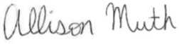

Allison Muth Christopher J. Madaio
Attorney Vice President for Legal Affairs
Veterans Education Success Veterans Education Success

VA RESPONSE: Thanks for your support for the VA Principles of Excellence Program and recommendations regarding improvements to the GI Bill Feedback Tool. Your proposed recommendations have been submitted to VA leadership for acknowledgement and consideration.
9. Explain any decision to provide any payment or gift to respondents, other than remuneration of contractors or grantees.

VA does not provide any payment or gifts to respondents.

10. Describe any assurance of privacy, to the extent permitted by law, provided to respondents and the basis for the assurance in statute, regulation, or agency policy.

This information will be destroyed three years after the date of final action on investigation or litigation. Our assurance of privacy is covered by 38 U.S.C. 5701 and our System of Records, Principles of Excellence Centralized Complaint System – VA (170VA22).

11. Provide additional justification for any questions of a sensitive nature (Information that, with a reasonable degree of medical certainty, is likely to have a serious adverse effect on an individual's mental or physical health if revealed to him or her), such as sexual behavior and attitudes, religious beliefs, and other matters that are commonly considered private; include specific uses to be made of the information, the explanation to be given to persons from whom the information is requested, and any steps to be taken to obtain their consent.

None of the information collected is of a sensitive nature.

12. Estimate of the hour burden of the collection of information. Please show mathematical calculations:

- Number of Responses: 1,202

- Frequency of Response: On occasion.

- Annual Burden Hours: 300 (1,202 X 15/60 = 300)

- Estimated Completion Time: 15 minutes

The respondent population consists of Veterans and their dependent students. VBA cannot make further assumptions about the population of respondents because of the variability of factors such as the educational background and wage potential of respondents. Therefore, VBA used general wage data to estimate the respondents’ costs associated with completing the information collection.

The Bureau of Labor Statistics (BLS) gathers information on full-time wage and salary workers. According to the latest available BLS data, the mean weekly earnings of full-time wage and salary workers are $1,082.80. Assuming a forty (40) hour work week, the mean hourly wage is $27.07 based on the BLS wage code – “00-0000 All Occupations.” ($27.07 X 40 hours). This information was taken from the following website: (https://vaww.infoshare.va.gov/sites/educationservice/pro/Lists/Procedures%20Task%20Creation/Attachments/43/May%202020%20National%20Occupational%20Employment%20and%20Wage%20Estimates%20BLS.html, May 2021).

Legally, respondents may not pay a person or business for assistance in completing the information collection. Therefore, there are no expected overhead costs for completing the information collection. VBA estimates the total cost to all respondents to be $8,121.00 (300 burden hours X $27.07 per hour).

13. Provide an estimate of the total annual cost burden to respondents or recordkeepers resulting from the collection of information. (Do not include the cost of any hour burden shown in items 12 and 14).

This submission does not involve any record keeping costs.

14. Provide estimates of annual cost to the Federal Government. Also, provide a description of the method used to estimate cost, which should include quantification of hours, operation expenses (such as equipment, overhead, printing, and support staff), and any other expense that would not have been incurred without this collection of information. Agencies also may aggregate cost estimates from Items 12, 13, and 14 in a single table.
Estimated Costs to the Federal Government:

- Based on the number of complaints received and completed (300), 80% of the less complex complaint cases takes VA Management Analysts/Complaint Case Managers 30 minutes to complete, and 60 minutes to complete the remaining 20% for the more complex and egregious complaint cases. See Below:

- In addition, the contract costs for complaint system currently remains at $145,000 for this reporting period.
See Below:

Grade-WDC | Step | Burden Time | Hourly Rate | Percentage Completed | Total Responses | Total
-- | -- | -- | -- | -- | 300 | --
13 | 05 | 30min | $56.31 | 80% | (240) | $6,756.00
13 | 05 | 60min | $56.31 | 20% | (60) | $3,378.60
-- | -- | -- | -- | -- | -- | $10,134.60
Overhead at 100% Salary |  |  |  |  |  | $10,134.60
Overhead costs are 100% of salary and are the same as the wage listed above; and the amount is included in the total.
Processing / Analyzing Costs |  |  |  |  |  | $10,134.60
Printing and Production Cost |  |  |  |  |  | $0
Contract Costs for complaint system |  |  |  |  |  | $145,000.00
Total Cost to Government |  |  |  |  |  | $155,134.60

Note: The hourly wage information above is based on the hourly 2021 General Schedule (Base) Pay for GS-Grade VA employees. https://www.opm.gov/policy-data-oversight/pay-leave/salaries-wages/salary-tables/pdf/2021/DCB_h.pdf.

The processing time estimates above are based on the actual amount of time employees of the grade level spend to process to completion a claim received on this information collection.

15. Explain the reason for any burden hour changes since the last submission.

There was an increase in burden hours due to an increase in the number of complaints received, from the previous 912 responses, to this current 1,202 responses received for periods 2020 through August, 2021.

16. For collections of information whose results will be published, outline plans for tabulation and publication. Address any complex analytical techniques that will be used. Provide the time schedule for the entire project, including beginning and ending dates of the collection of information, completion of report, publication dates, and other actions.

VA does not publish this information or make it available for publication.

17. If seeking approval to not display the expiration date for OMB approval of the information collection, explain the reasons that display would be inappropriate.

We are not seeking approval to omit the expiration date for OMB approval.

18. Explain each exception to the certification statement identified in Item 19, “Certification for Paperwork Reduction Act Submissions,” of OMB 83-I.

This information collection complies with all requirements under 5 CFR 1320.8(b)(3).

B. Collection of Information Employing Statistical Methods.

This collection of information gathered by the Veterans Benefits Administration will not employ statistical methods.

