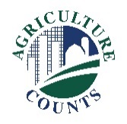
United States Department of Agriculture
National Agricultural Statistics Service

June XX, 20XX
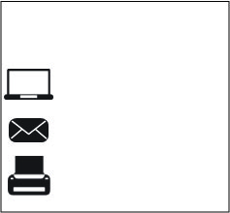
What should I do next?
Complete your survey in one of the following ways:
Online at www.agcounts.usda.gov beginning on Friday, July 27, 2018. Online reporting is fast, cost-effective, and secure. All you need is the 17-digit survey code on the enclosed form to begin.

By mail or fax. Complete the survey questionnaire and mail it back in the return envelope provided or fax it to (855) 415-3687.

Why am I getting this letter?
You have been selected to participate in the enclosed 20XX County Agricultural Production Survey (CAPS). The survey will collect information on total acres planted and harvested, and total yield and production of small grains crops down to the county level. Please complete the questionnaire at your earliest convenience. Your information is important.

How will the data be used?
CAPS will provide the data needed to estimate acreage and production of selected crops in the United States. County yields resulting from the survey will be used by the USDA’s Farm Service Agency (FSA) for Agricultural Risk Coverage (ARC), Price Loss Coverage (PLC) and other programs. In addition, the Risk Management Agency (RMA) uses the data for administering the Area Risk Protection Insurance Policies. When drought and flooding impact crop production, these data are crucial to the agriculture industry.

If we do not hear from you by Monday, August XX, 20XX, we may contact you to arrange a telephone or personal interview.

The results of this survey will be kept confidential and available in aggregate form only, ensuring that no individual operation or producer can be identified, as required by federal law. We will publish the county-level survey findings for barley, oats, and wheat in the NASS Quick Stats database (https://quickstats.nass.usda.gov/) at 3:00 pm ET on Thursday, December XX, 20XX.
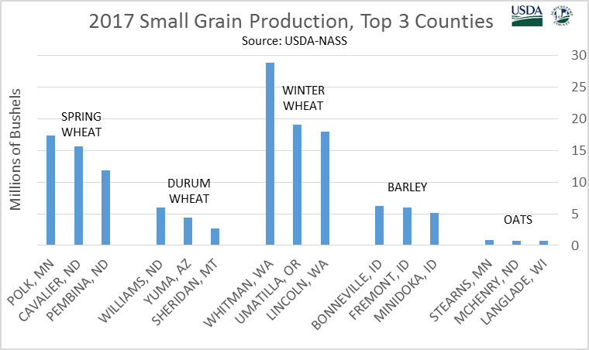
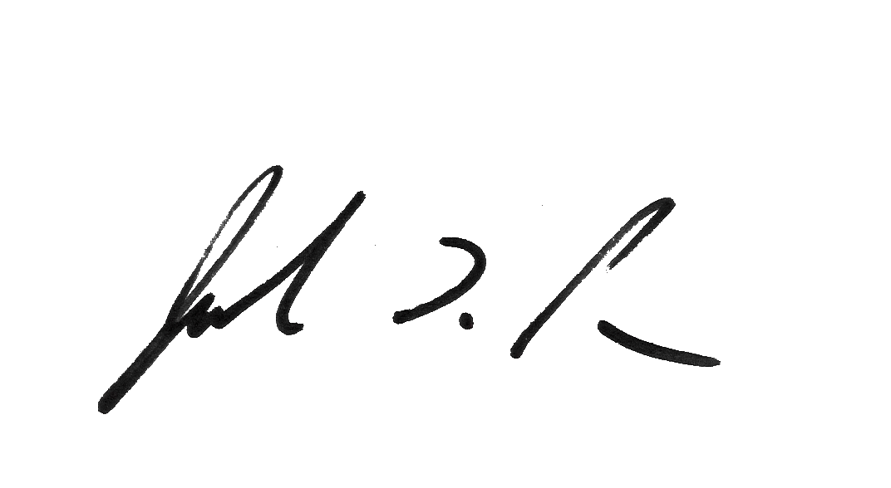
Thank you for participating and for your support of U.S. agriculture. If you have any questions, please feel free to contact us at (888) 424-7828.
Sincerely,

Joseph L. Parsons
Chair, Agricultural Statistics Board

Enclosure

