Richard L. Snyder

Emeritus Biometeorology Specialist

# California Irrigation Survey

Dear California Grower:

We recently sent you a questionnaire in mid-July pertaining to irrigation methods and water sources. Your participation in this survey will be anonymous. If you have already filled it out, THANK YOU. If not, please take a few minutes of your time to complete the questionnaire. You can complete the questionnaire online at agcounts.usda.gov using your unique survey code, XXXX. Or you may complete the questionnaire and mail it back in the prepaid return envelope provided, or fax it to 1-855-415-3687. If you have any questions or concerns, please contact Rosa Avilla at (916) 738-6615. Thank you for your help.

Respectfully Yours,

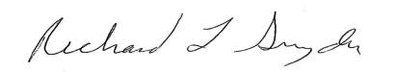

University of California, Davis

In cooperation with USDA NASS

Pacific Regional Office

P.O. Box 1258

Sacramento, CA 95812-1258