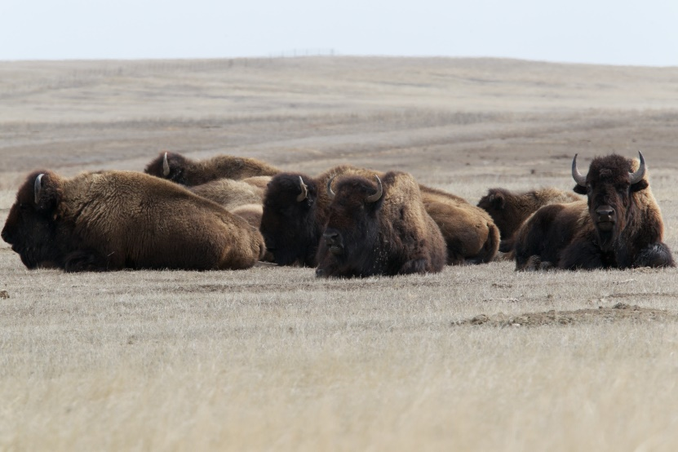

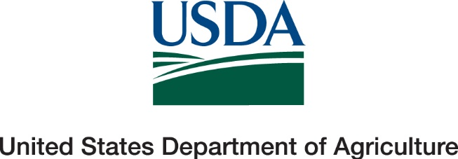

Thank you very much for participating in the NAHMS Bison 2022 study. We appreciate the time and effort you took to answer our questions. We know these studies can be time consuming; however, they provide valuable information to the U.S. bison industry. These studies could not be completed without you.
To view results from the Bison 2022 study, please visit our website at http://www.aphis.usda.gov/nahms.
Thanks again,
NAHMS Bison 2022 Team
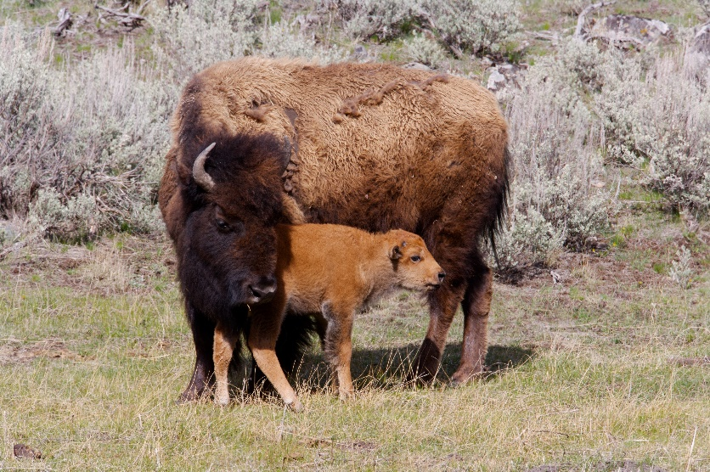

Thank you very much for participating in the NAHMS Bison 2022 study. We appreciate the time and effort you took to answer our questions. We know these studies can be time consuming; however, they provide valuable information to the U.S. bison industry. These studies could not be completed without you.
To view results from the Bison 2022 study, please visit our website at http://www.aphis.usda.gov/nahms.
Thanks again,
NAHMS Bison 2022 Team
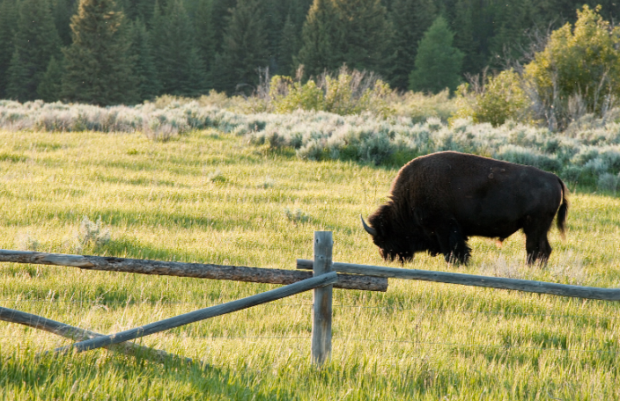

Thank you very much for participating in the NAHMS Bison 2022 study. We appreciate the time and effort you took to answer our questions. We know these studies can be time consuming; however, they provide valuable information to the U.S. bison industry. These studies could not be completed without you.
To view results from the Bison 2022 study, please visit our website at http://www.aphis.usda.gov/nahms.
Thanks again,
NAHMS Bison 2022 Team

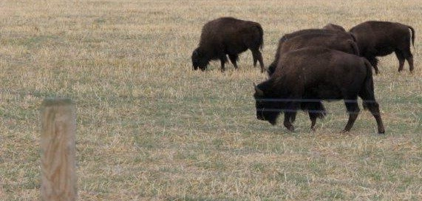

Thank you very much for participating in the NAHMS Bison 2022 study. We appreciate the time and effort you took to answer our questions. We know these studies can be time consuming; however, they provide valuable information to the U.S. bison industry. These studies could not be completed without you.
To view results from the Bison 2022 study, please visit our website at http://www.aphis.usda.gov/nahms.
Thanks again,
NAHMS Bison 2022 Team

