United States Department of Agriculture
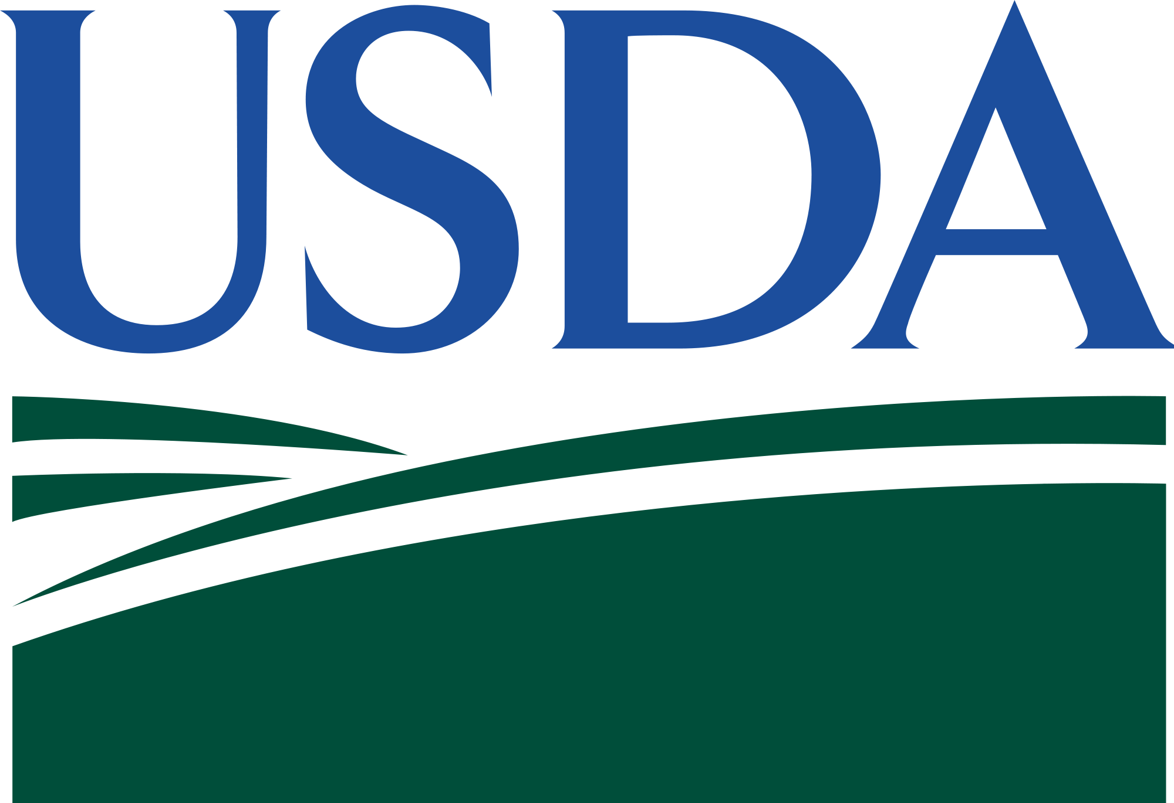

NAHMS Bison 2022 Study Timeline

The Bison 2022 study is designed to provide participants and industry stakeholders with benchmarking information on the U.S. bison industry. Information collected will contribute to critically important epidemiologic surveillance that will inform disease management and preparedness strategies to safeguard the bison industry.

NASS PHASE

NAHMS Bison 2022 Study Survey
JULY-AUGUST 2022
NATIONAL AGRICULTURAL STATISTICS SERVICE (NASS)

► Implemented by NASS via paper-assisted self-interview (PASI), computer-assisted self-interview (CASI), and computer-assisted telephone interview (CATI).

Informed Consent Form for Biological Testing
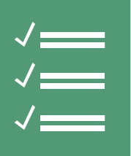
► Producer consent for Biologics Phase
July-November 2022

Biological Testing
► Enteric Microbe Test: Detection and antimicrobial susceptibility testing of Salmonella, E. coli, and Campylobacter in your bison.
► Fecal Parasite Test: Pre- and post-deworming fecal egg counts and egg count reduction tests will give you information about parasite levels and dewormer resistance on your operation.
Do not deworm 60 days prior to pre-deworming sampling.
► Forage Test: Forage quality test will provide you with information on the nutritional value of the sampled pasture forage from your operation.
November 2022-Onward

Producer Reports
►Operation- specific biologic test results mailed to producers in a sealed envelope

Descriptive Reports
►Reference guides for benchmarking and analyzing trends in the industry

Information Sheets
►Focused analyses on important issues to the industry
REPORTS
BIOLOGICS PHASE

United States Department of Agriculture

NAHMS Bison 2022 Study
Producer Benefits
July-November 2022

Safeguarding the U.S. Bison Industry

Collectively, bison producers like you will play an important role in safeguarding the
U.S. bison industry. Information provided in the Bison 2022 study will:

Provide transparent, credible information on U.S. bison industry practices.
- Assist policymakers and industry stakeholders in making more informed decisions affecting the bison industry.

Pre- and post-deworming fecal egg counts and egg count reduction tests will give you information about parasite levels and dewormer resistance on your operation.

Do not deworm 60 days prior to pre-deworming sample submission.

Detection of Salmonella

Detection of E. coli

Detection of Campylobacter

Antimicrobial susceptibility testing of detected microbes

Biological testing costs include
► Diagnostic testing
► Confidential, descriptive report of results
* Values based on estimated average cost at diagnostic laboratories for forage samples taken at 20 locations and 20 fecal samples per farm.
Fecal Microbe Test: $2000 Value*

Fecal Parasite Test: $700 Value*

Nutritional analysis on pasture forage will help you determine your forage quality and need for nutritional supplementation.
Forage Test: $300 Value*

