Appendix G.3. Invitation Letter With Mail Survey for NAP Participant List Sample in English (2 mailings)
<STUDY LETTERHEAD AND LOGO>
Dear current resident,
We recently invited you to take part in a survey about health and well-being. If you have already completed the survey—either online or on paper—thank you! If you have not completed the survey, please do so as soon as possible. Your answers will help us learn more about households in Puerto Rico, especially when it comes to food and nutrition needs. The results of this survey will also help the U.S. Department of Agriculture and the Administración para el Desarrollo Socieconómico de la Familia improve programs and services offered to Puerto Rican households.
Your voice matters.
Participating is easy. You can—
- Return the enclosed paper survey, using the postage-paid envelope, OR
- Go to www.surveyname.com or scan the QR code: 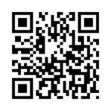
  - Enter your passcode [####].
You will receive a $40 gift card for completing the survey.
The survey will take about 40 minutes. The study report will not include names or other information that could be used to identify you or your household. Your participation is voluntary. If you or anyone in your household receives assistance from Administración de Desarollo Socioeconómico de la Familia, participating in the survey will not affect your benefits, the benefits anyone else in your household receives, or the benefits you may apply for in the future.
Endorsed by
- ADSEF
- Organization …
- Organization …
Sponsored by
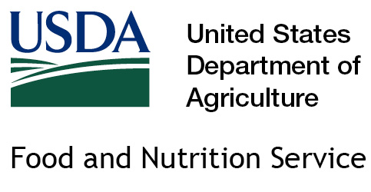
USDA Food and Nutrition Service | USDA-FNS
Need help?
- Send us an email at email@address.com
- Visit the study website at www.healthandwellbeingPR.com
- Call us at [1.800.XXX.XXXX]
Thank you for taking part in this important survey.
[Name]
[Title and Division]

Public Burden Statement
This information is being collected to assist the Food and Nutrition Service (FNS) in understanding food security status and economic well-being among Puerto Rico residents. This is a voluntary collection. FNS will use the information as a baseline for future assessments of food security and the Nutrition Assistance Program, particularly in the context of natural disasters. This collection does not request personally identifiable information under the Privacy Act of 1974. According to the Paperwork Reduction Act of 1995, an agency may not conduct or sponsor, and a person is not required to respond to, a collection of information unless it displays a valid OMB control number. The valid OMB control number for this information collection is 0584-XXXX. The time required to read this information is estimated to average 3 minutes. Send comments regarding this burden estimate or any other aspect of this collection of information, including suggestions for reducing this burden, to: U.S. Department of Agriculture, Food and Nutrition Service, Office of Policy Support, 1320 Braddock Place, Alexandria, VA 22314. ATTN: PRA (0584-XXXX). Do not return the completed form to this address.

