Appendix G.9. Text for Website (Home Page) in English
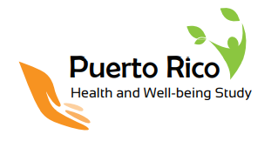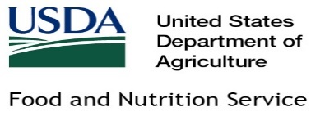
Puerto Rico Health and Well-Being Study [links to homepage]
Sponsored by the U.S. Department of Agriculture
Toggle: English / Español
Links/tabs:
FAQs  [links to FAQ document in next section] | Support for the Study | Contact Information | Survey  [links to the survey home page with PIN entry]
Study Overview
The purpose of this study is to learn about the health, well-being, and nutrition needs of households in Puerto Rico. The results of this study will help the U.S. Department of Agriculture (USDA) and the Administración de Desarrollo Socieconómico de la Familia (ADSEF) improve programs and services offered to Puerto Rican households, such as the Nutrition Assistance Program (NAP).
The study team will be in Puerto Rico to conduct the following activities:
- A household survey on the health and well-being of Puerto Rico residents
- In-person interviews to better understand how Puerto Rico residents cope with natural disasters such as hurricanes and earthquakes and how existing programs can help
Survey distribution and in-person interviews will be conducted in spring and summer 2023.
Support for the Puerto Rico Health and Well-Being Study
[ADSEF endorsement]
[logos for other community-based organizations that endorse the study]
Contact Information
For more information, contact the study team via email at name@insightpolicyresearch.com or by phone at XXX.XXX.XXXX.
Your participation is voluntary. If you or anyone in your household receives assistance from ADSEF, participating in the study will not affect your benefits, the benefits of anyone else in your household, or the benefits you may apply for in the future.
For additional privacy information, visit https://www.usda.gov/privacy-policy.
About Insight Policy Research
Insight Policy Research (Insight) is a certified woman-owned small business located in Arlington, Virginia. Insight’s core focus is on programs and issues that affect at-risk and vulnerable populations in the areas of family support, food and nutrition, education, health, workforce development, and military and veteran support. For more information about Insight, please visit https://www.insightpolicyresearch.com.
About Westat
Westat is a private employee-owned research company headquartered in Rockville, Maryland, with 14 locations nationwide. Dedicated to improving lives through research, Westat works in the fields of health, education, social policy, and transportation. For more information about Westat, please visit https://www.westat.com.
About Estudios Técnicos
Estudios Técnicos is the leading firm in planning, research, market strategies, social analysis, and economic advisory consulting in Puerto Rico. The mission of Estudios Técnicos is to contribute to the social and economic development of Puerto Rico through the delivery of research and advice to institutions in the public, entrepreneurial, and nonprofit sectors. For more information about Estudios Técnicos, please visit https://estudiostecnicos.com.

Public Burden Statement
This information is being collected to assist the Food and Nutrition Service (FNS) in understanding food security status and economic well-being among Puerto Rico residents. This is a voluntary collection. FNS will use the information as a baseline for future assessments of food security and the Nutrition Assistance Program, particularly in the context of natural disasters. This collection does not request personally identifiable information under the Privacy Act of 1974. According to the Paperwork Reduction Act of 1995, an agency may not conduct or sponsor, and a person is not required to respond to, a collection of information unless it displays a valid OMB control number. The valid OMB control number for this information collection is 0584-XXXX. The time required to read this information is estimated to average 5 minutes. Send comments regarding this burden estimate or any other aspect of this collection of information, including suggestions for reducing this burden, to: U.S. Department of Agriculture, Food and Nutrition Service, Office of Policy Support, 1320 Braddock Place, Alexandria, VA 22314. ATTN: PRA (0584-XXXX). Do not return the completed form to this address.

