**TRICARE SELECT SURVEYS-PROVIDERS (TSS-P)**

**FY2019 WEB SURVEY**

1. **MD SURVEY**

INTRO1:

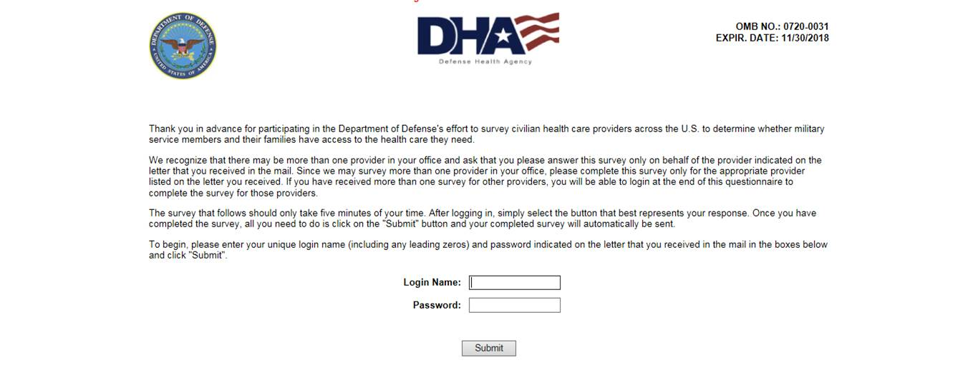

TRANSITION:

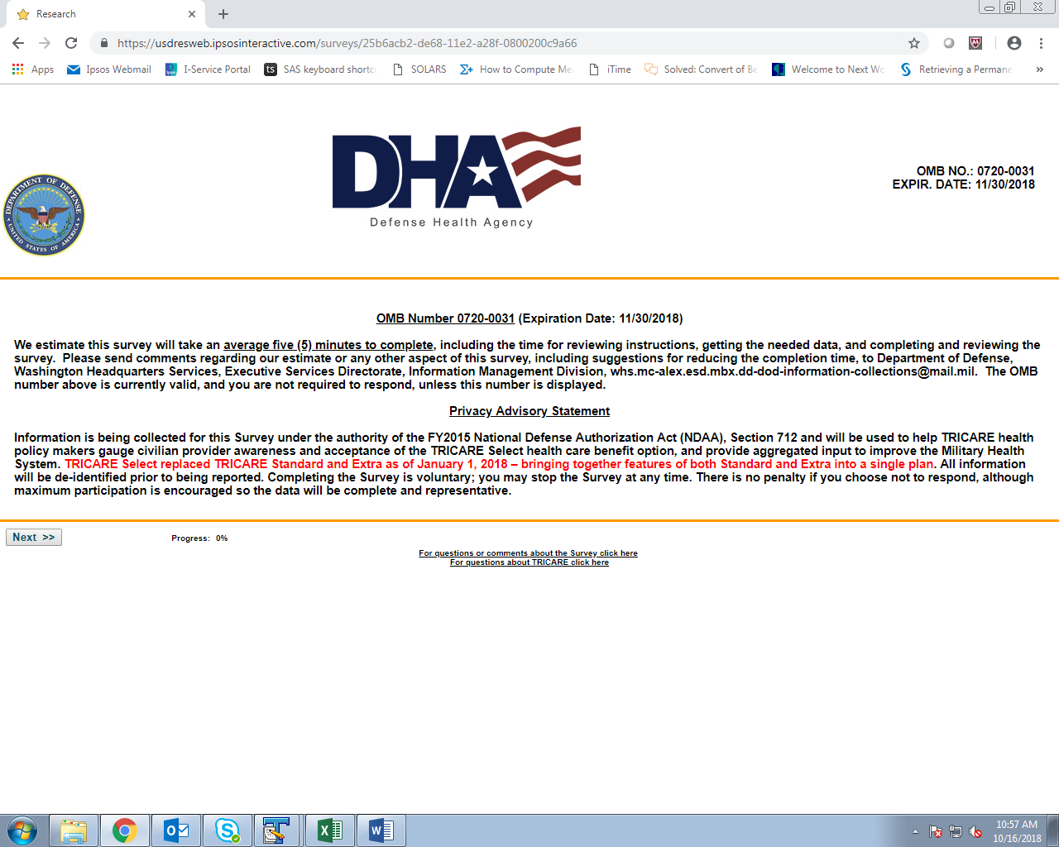

Q1:

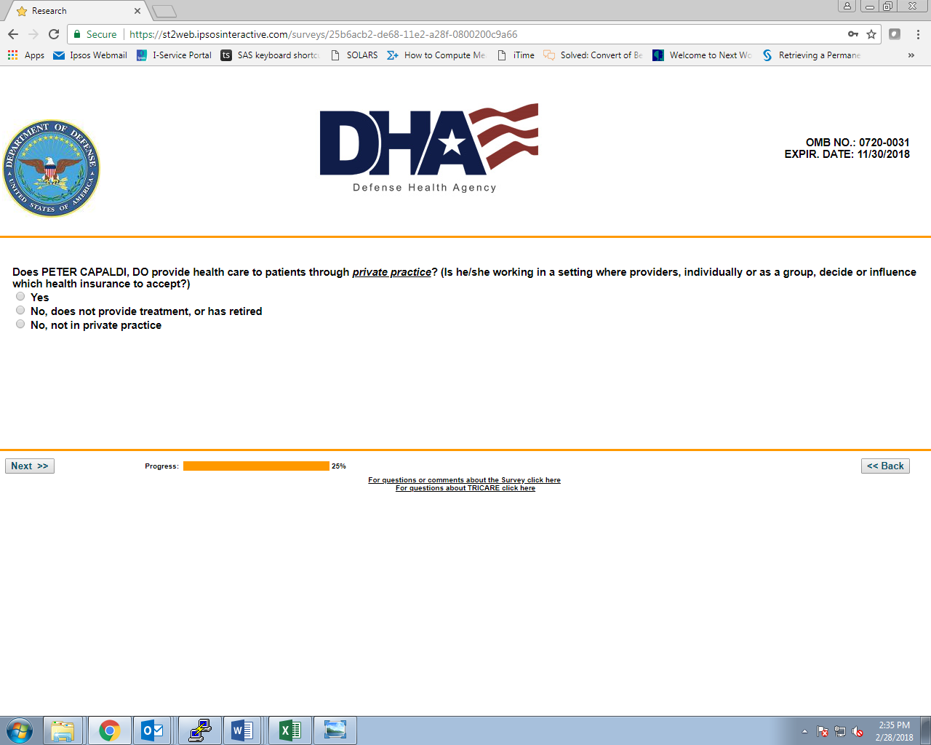

Q1A (IF ‘NO, NOT IN PRIVATE PRACTICE’ AT Q1):

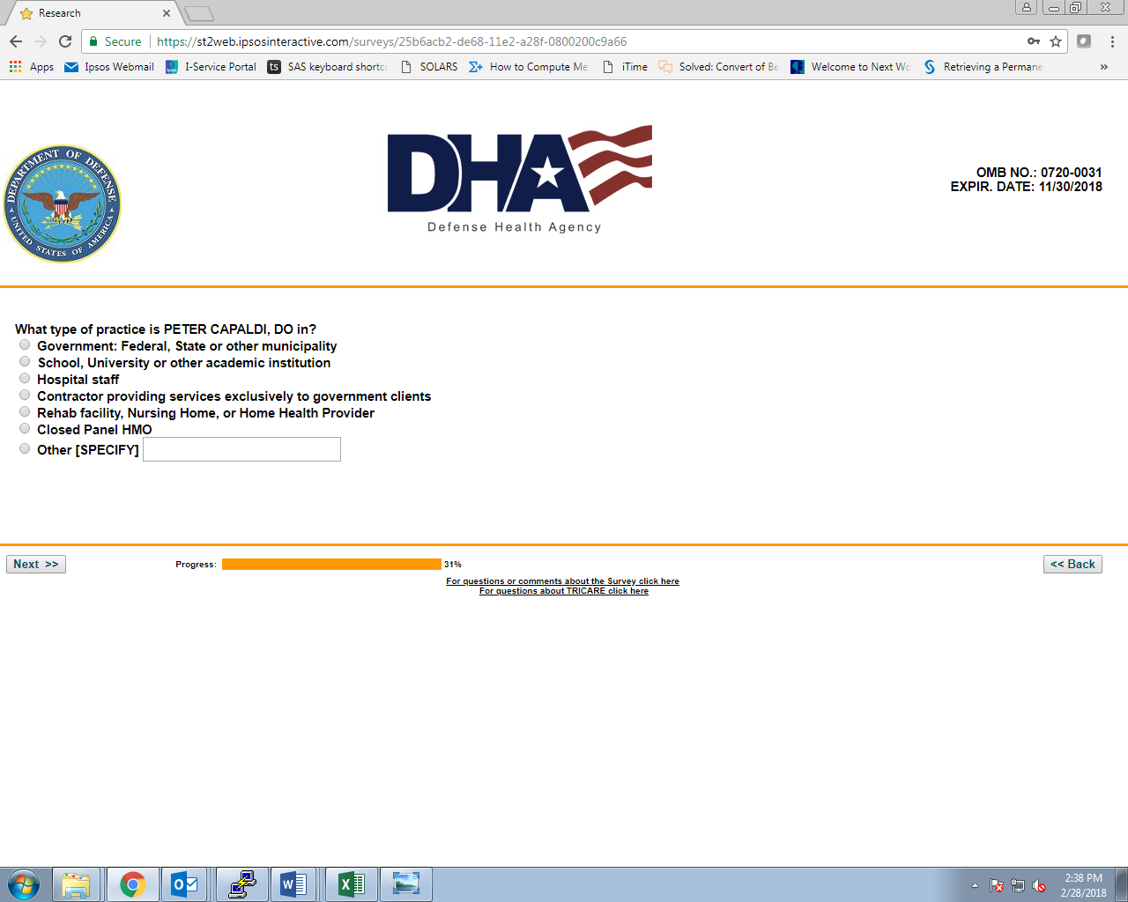

END (IF ‘NO, DOES NOT PROVIDE TREATMENT, OR HAS RETIRED’ AT Q1):

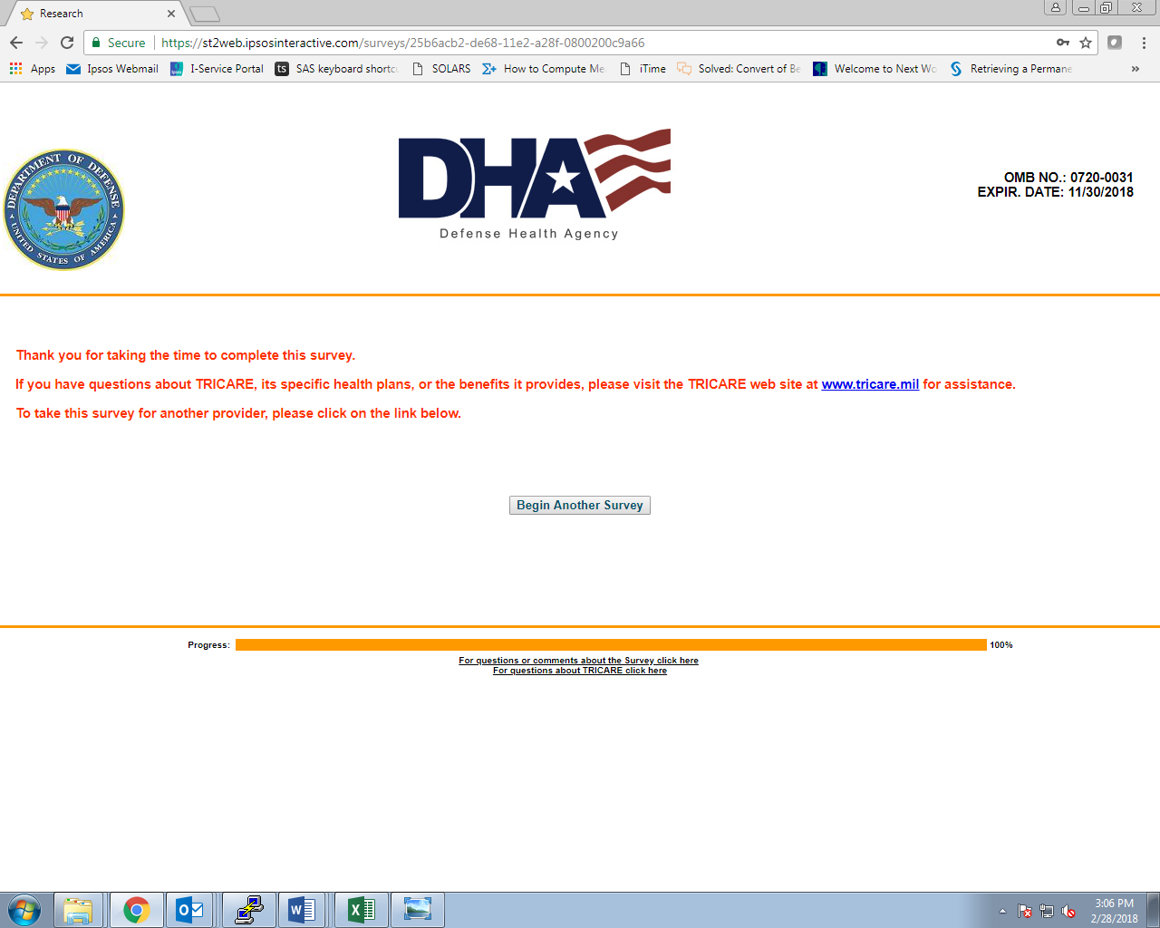

Q2:

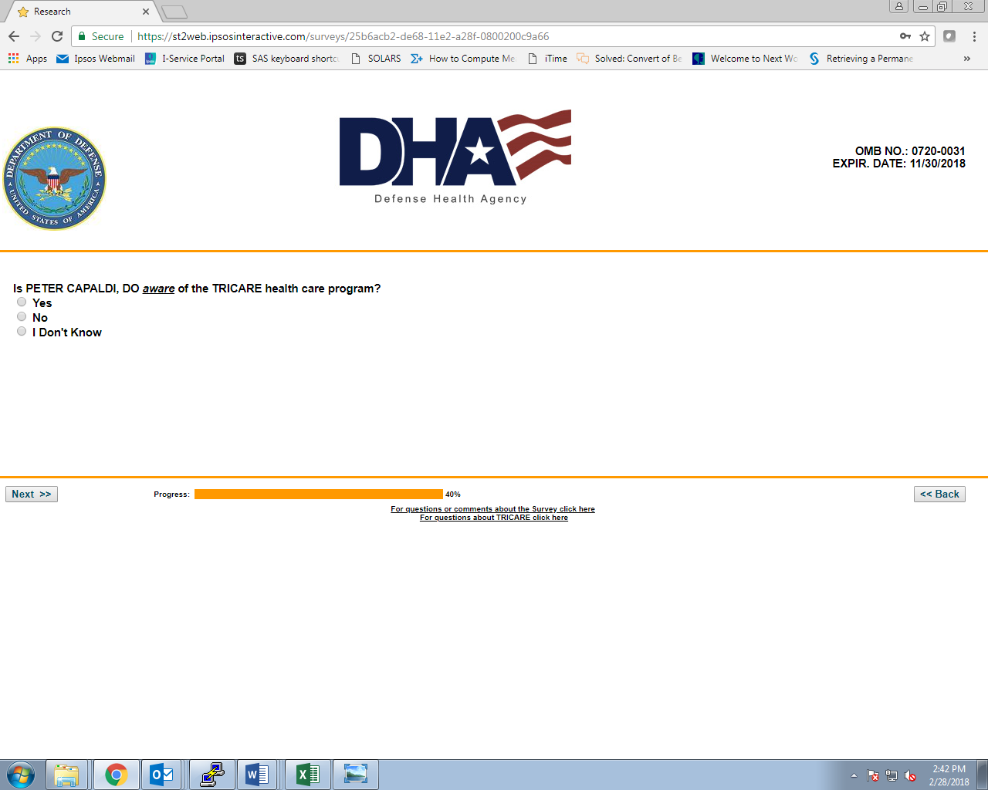

Q3:

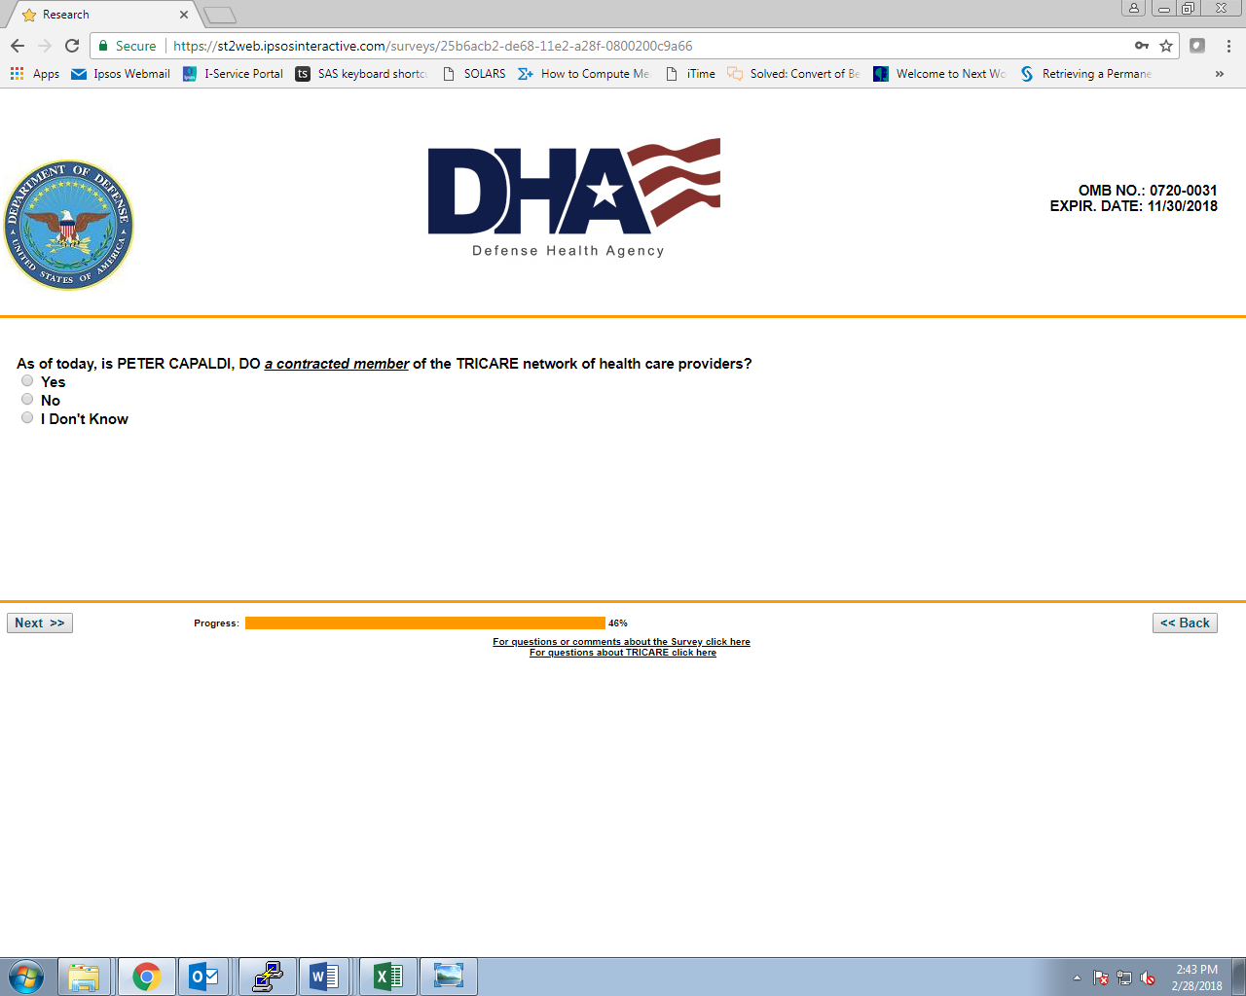

Q4:

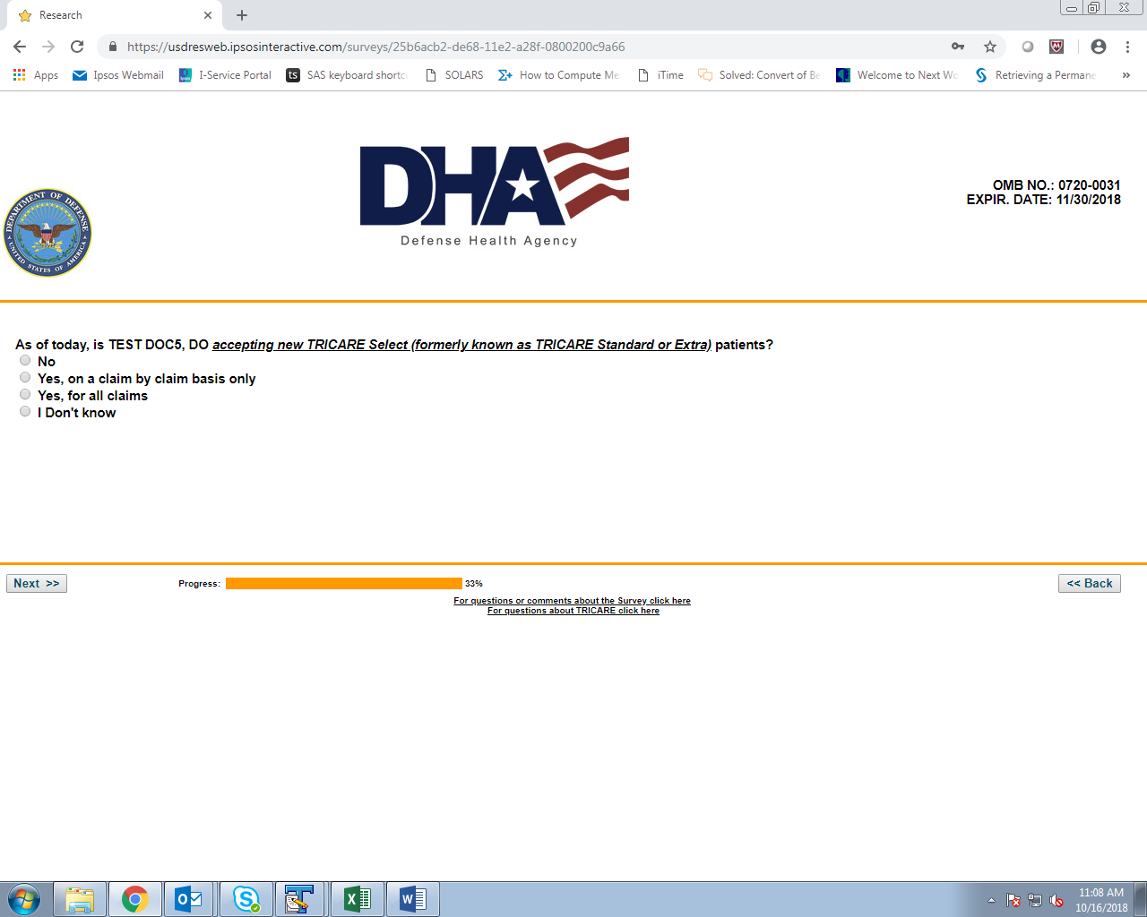

Q5 (IF ‘NO’ AT Q4):

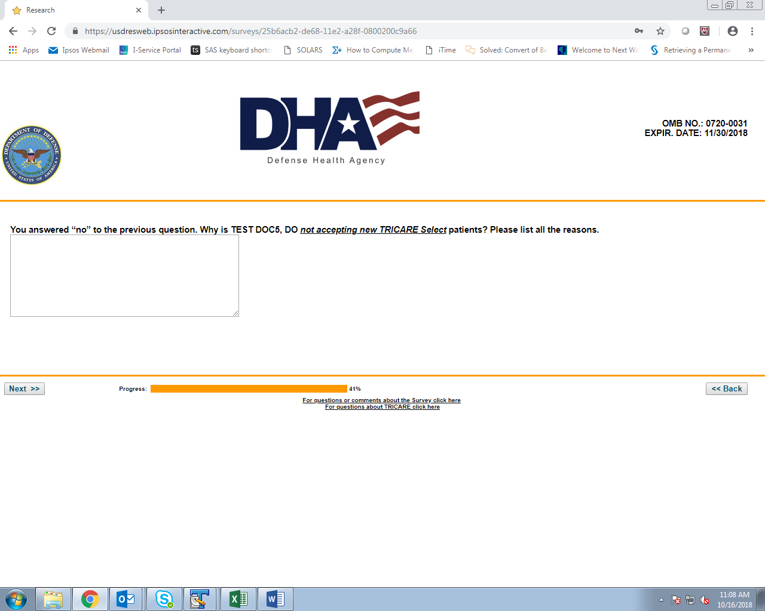

Q6:

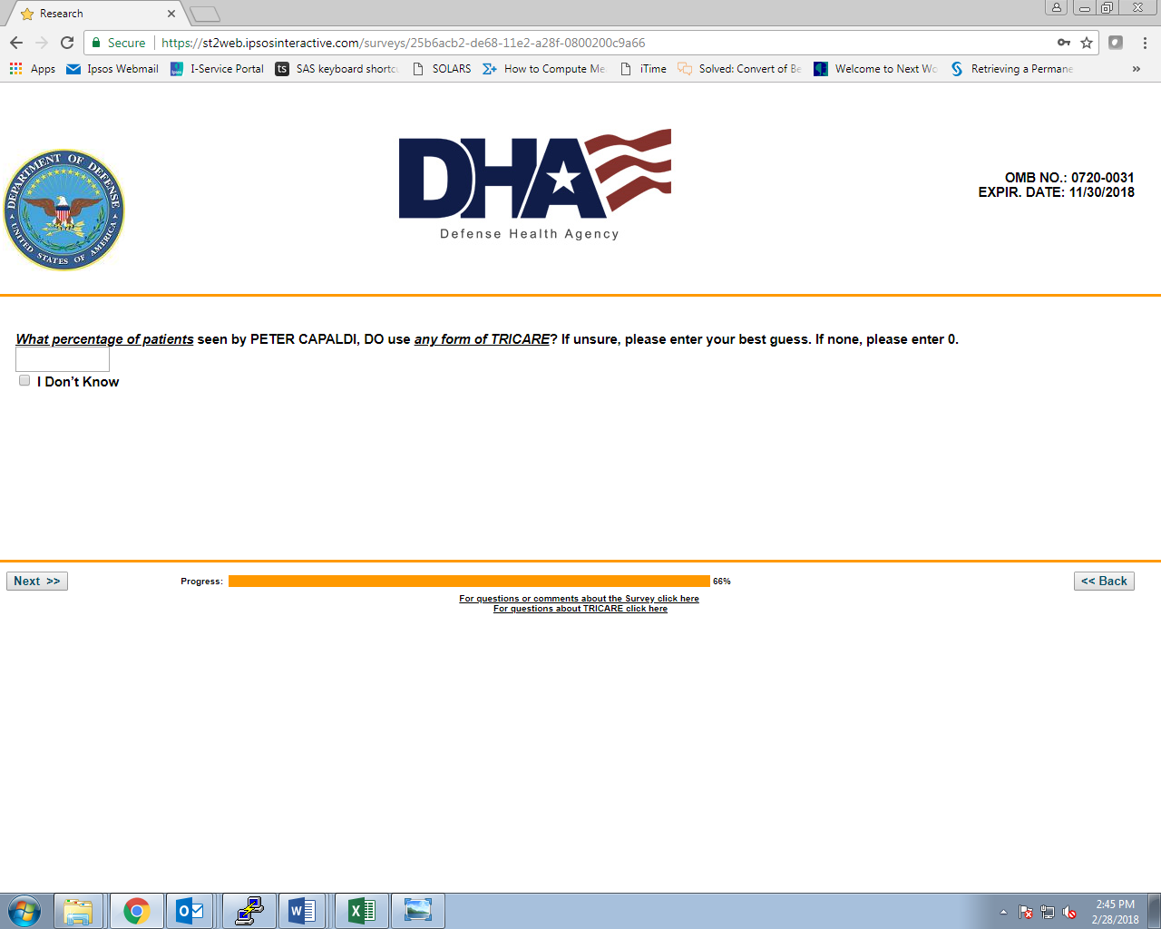

Q7:

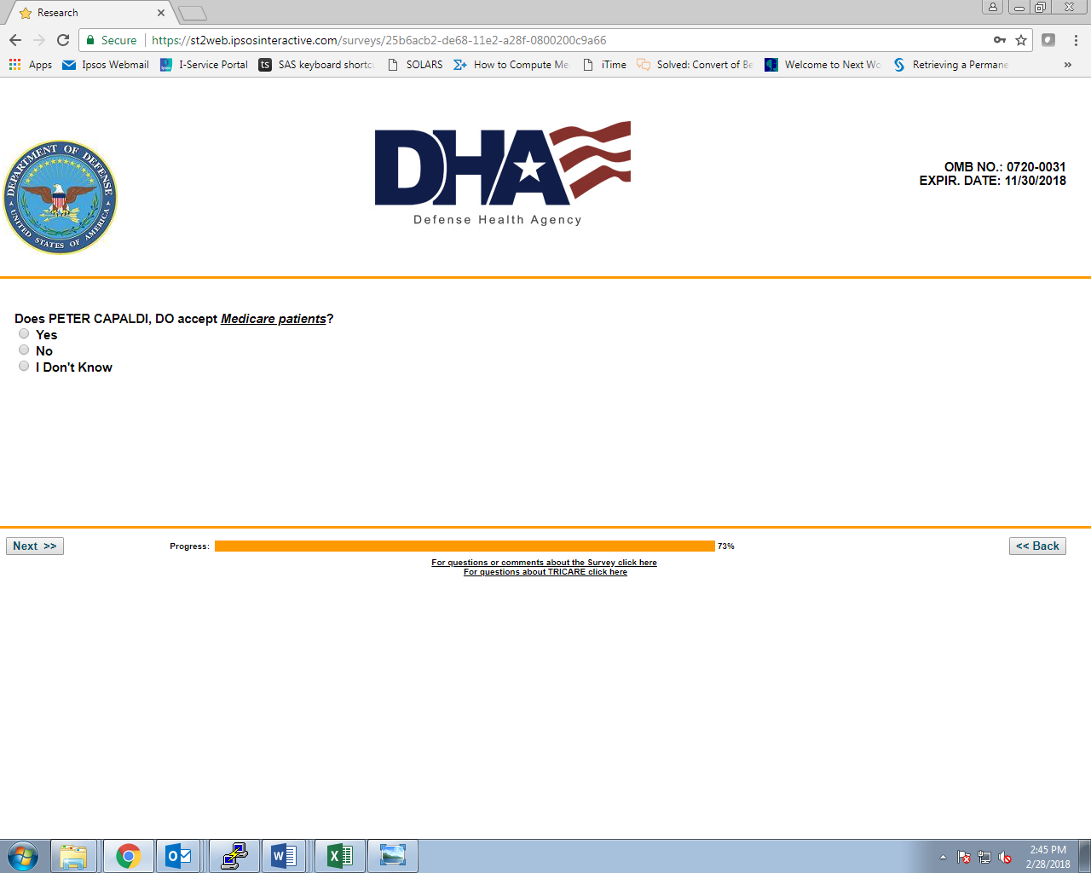

Q8:

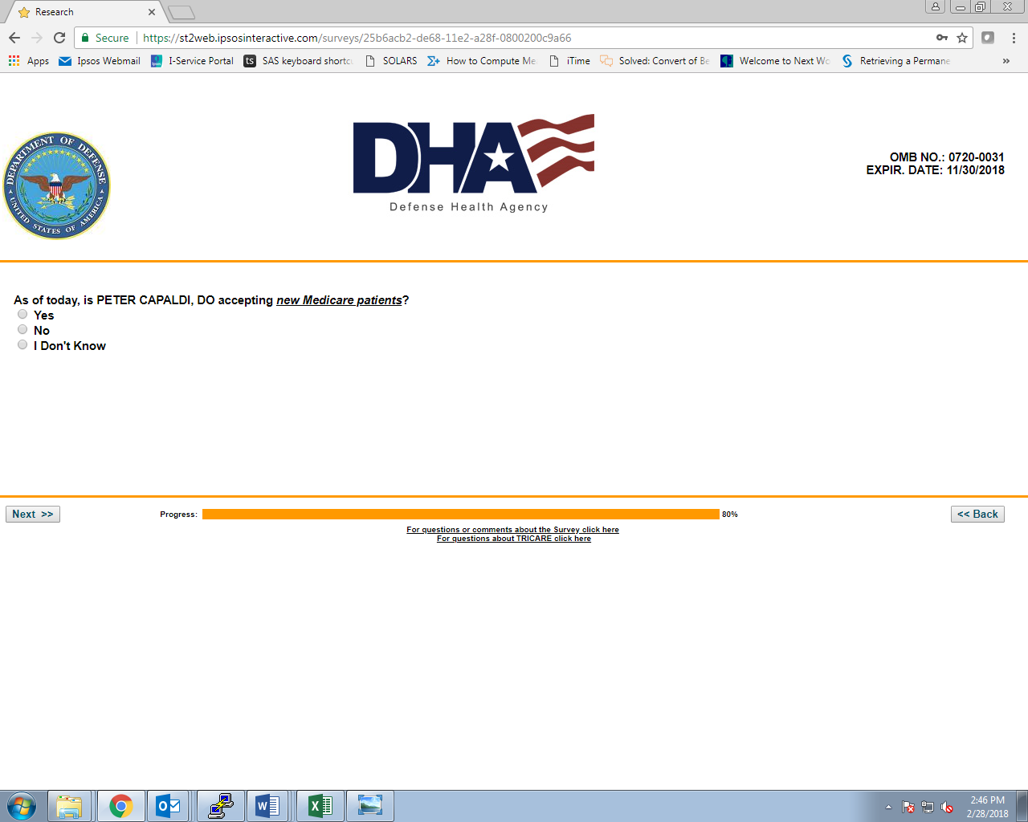

END (IF ‘YES’ TO Q8):



Q9 (IF ‘NO’ TO Q8):

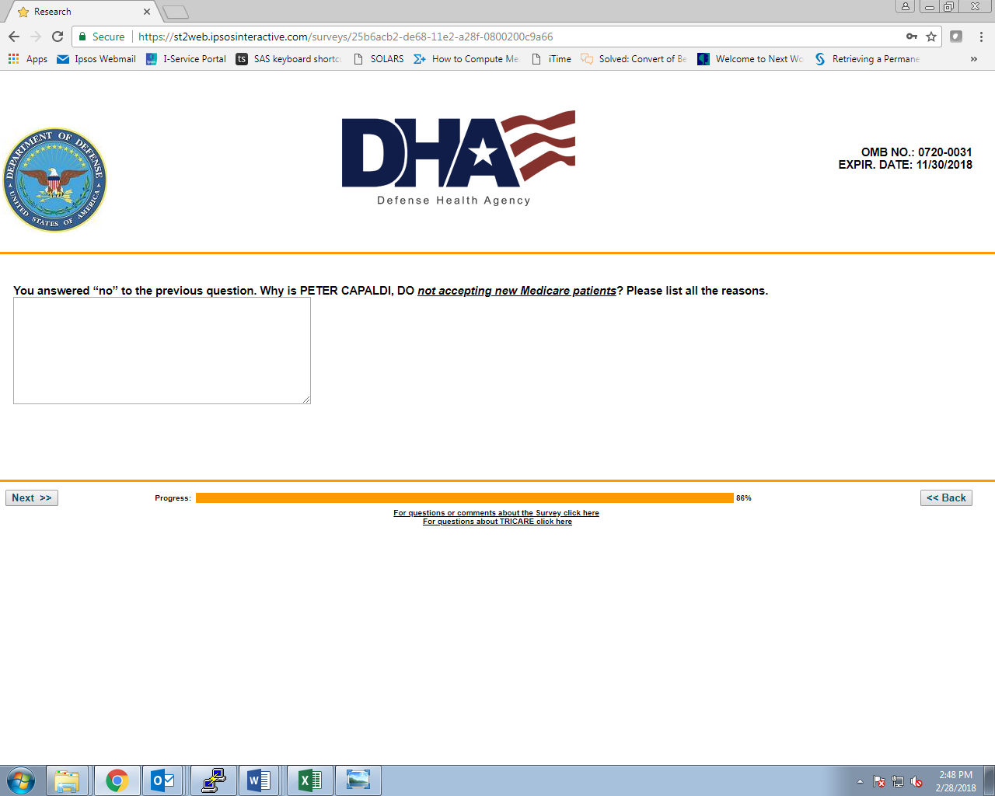

Q10 (IF ‘NO’ OR ‘DON’T KNOW’ AT Q8):

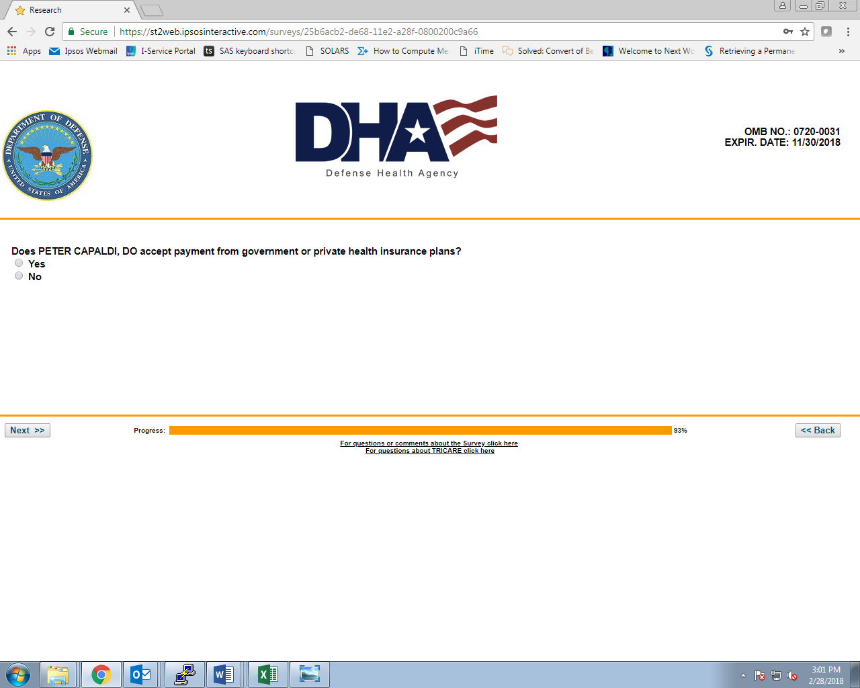

Q11 (IF ‘NO’ OR ‘DON’T KNOW’ AT Q8):

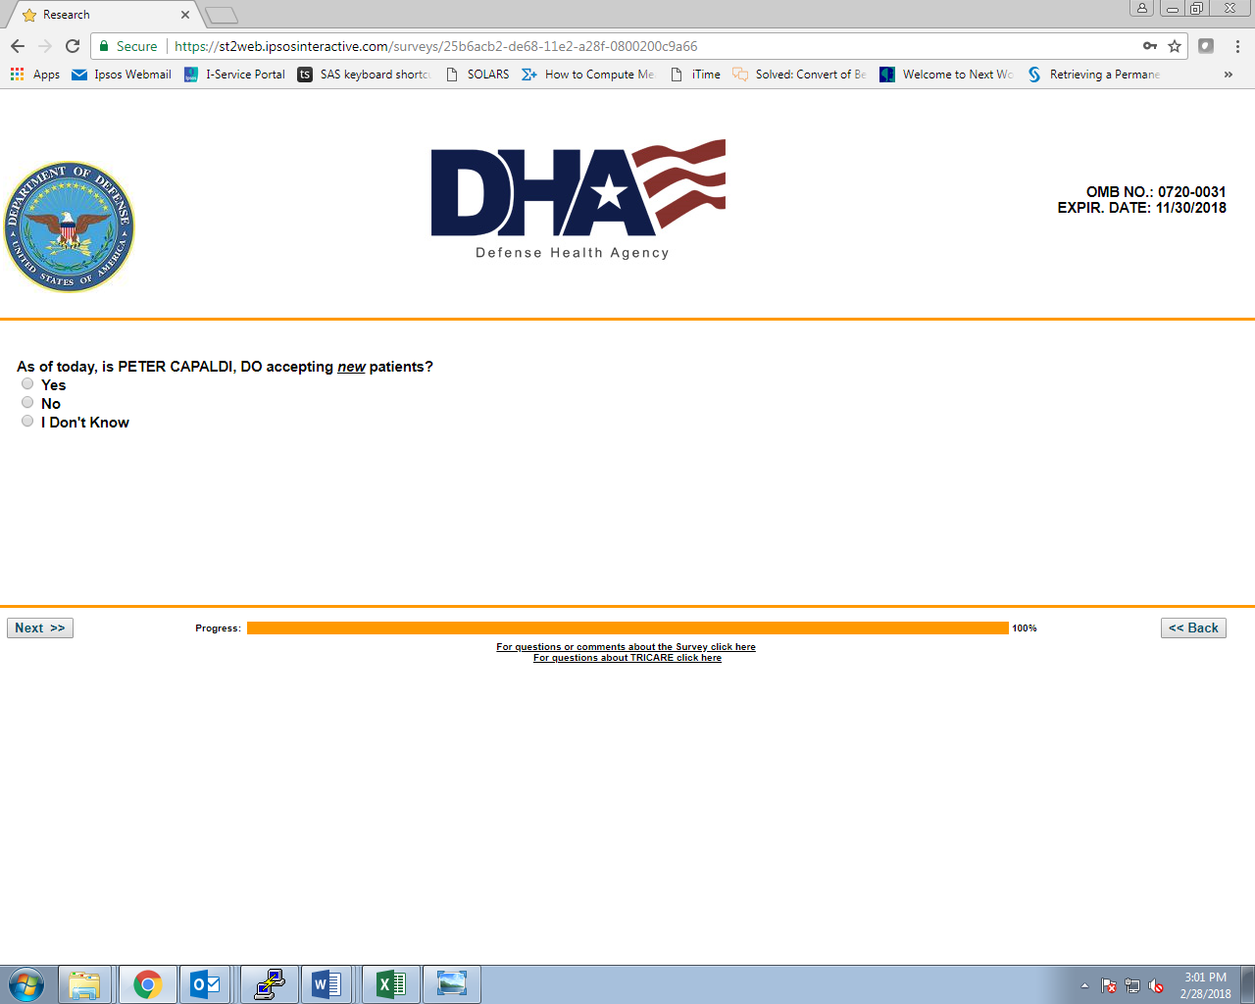

END:



**END OF MD SURVEY**

1. **BEHAVIORAL HEALTH PROVIDER SURVEY**

INTRO1:



TRANSITION:

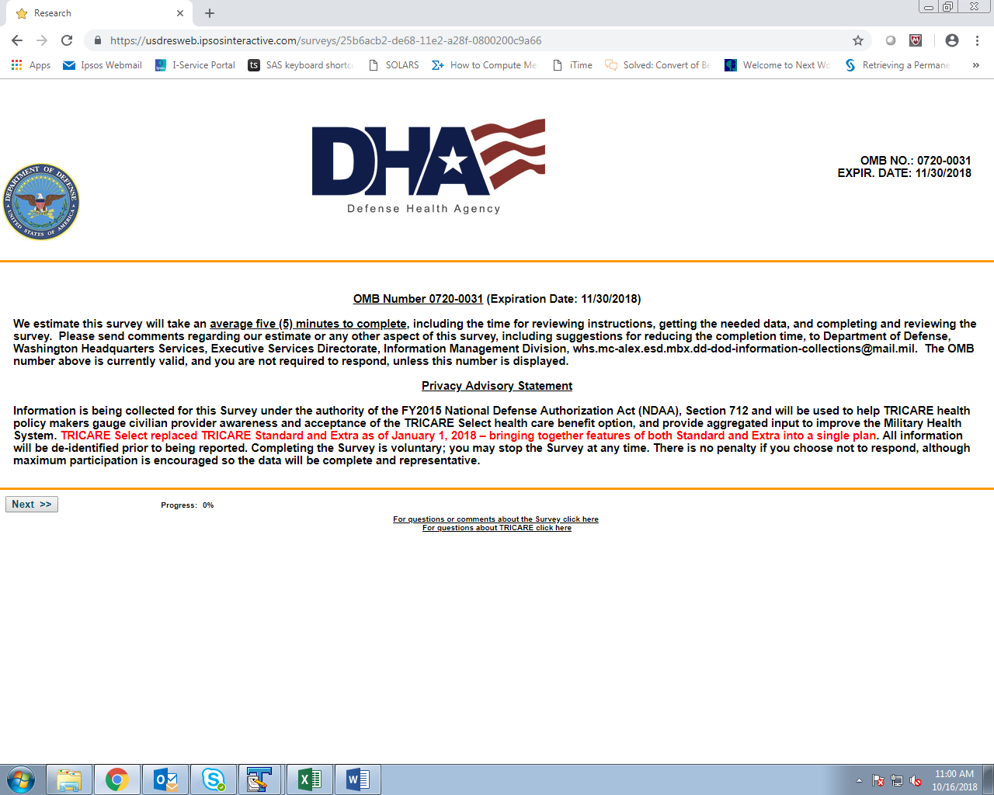

Q1:

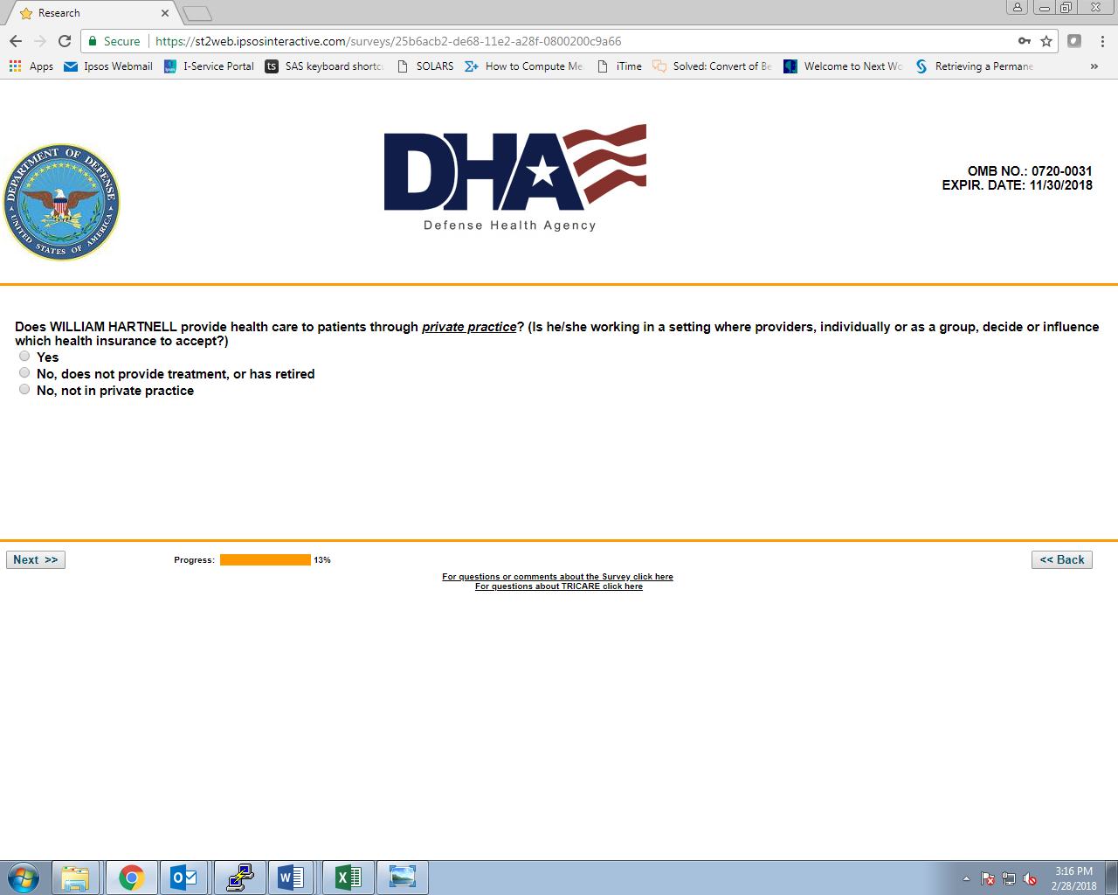

Q1A (IF ‘NO, NOT IN PRIVATE PRACTICE’ AT Q1):

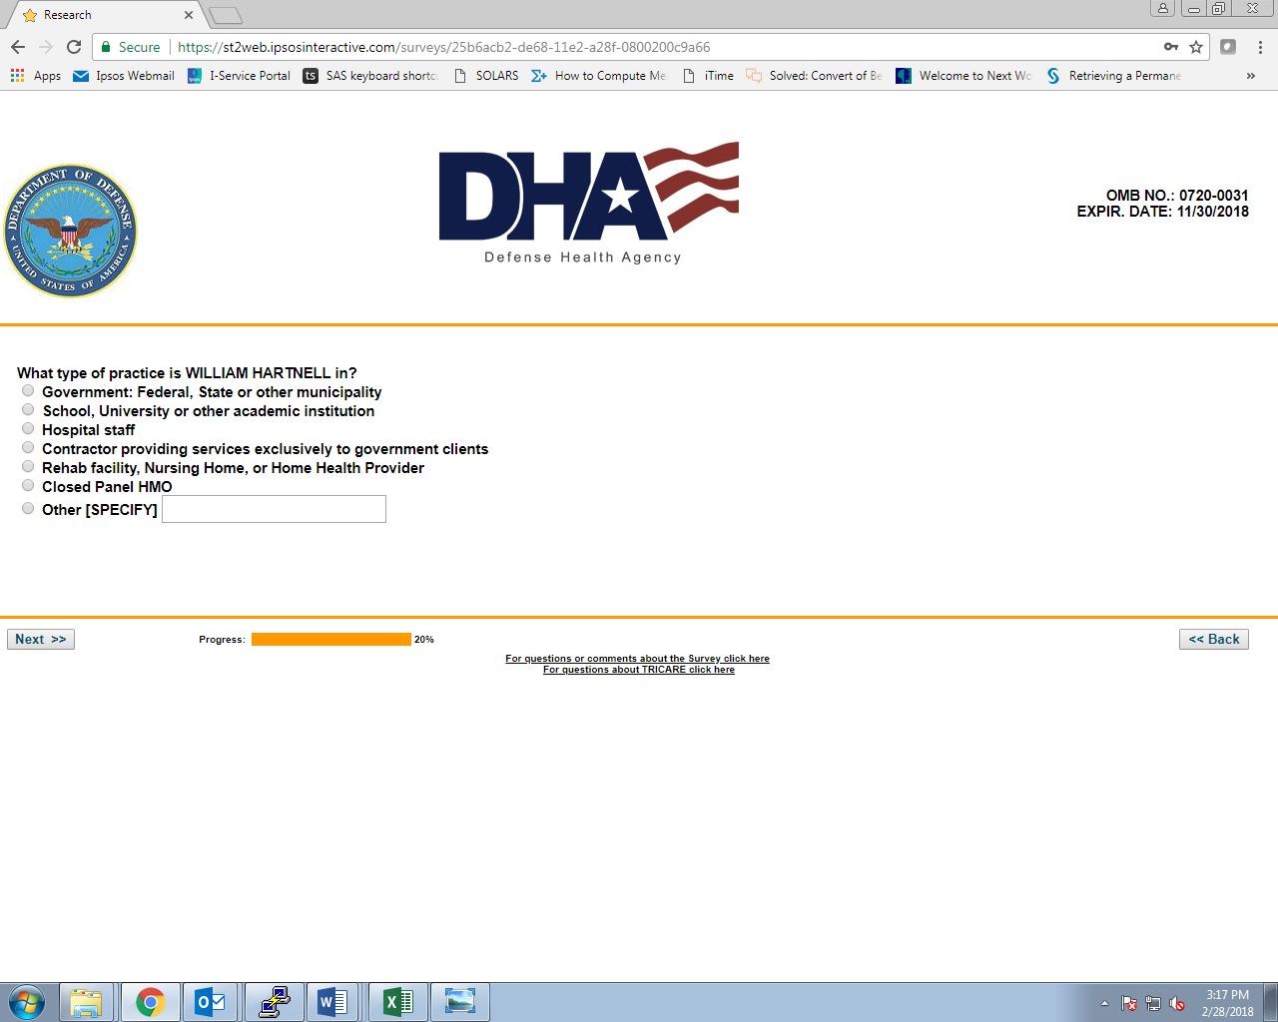

END (IF ‘NO, DOES NOT PROVIDE TREATMENT, OR HAS RETIRED’ AT Q1):



Q1B (IF SAMPLE TYPE = ‘BEHAVIORAL HEALTH PROVIDER’):

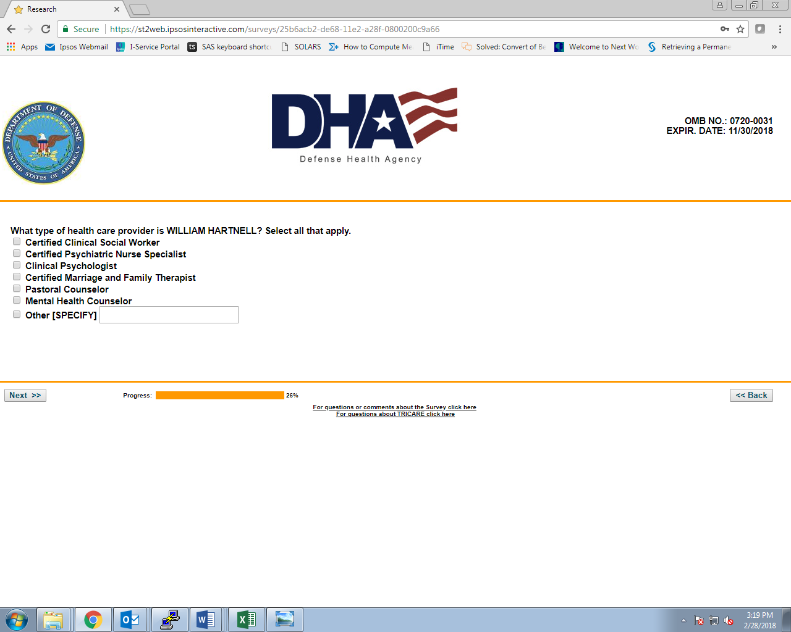

Q2:

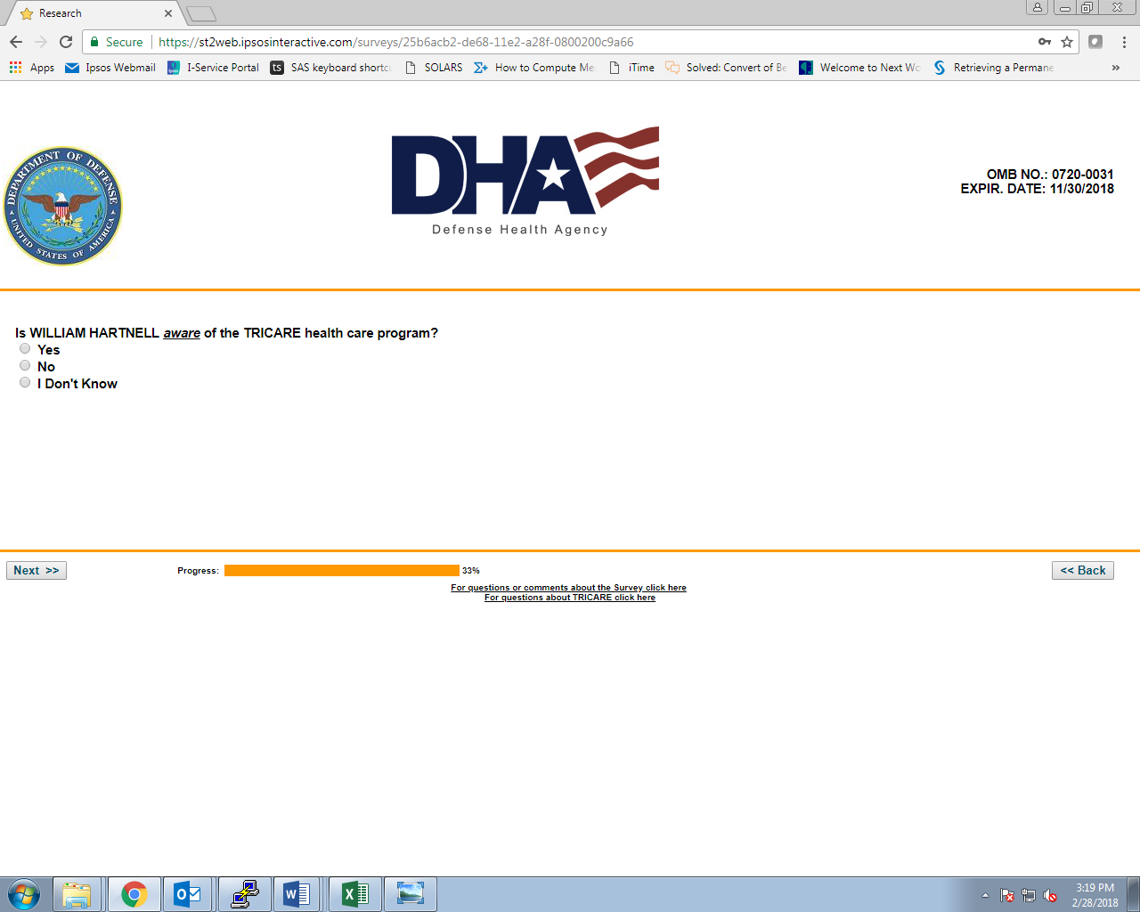

Q3:

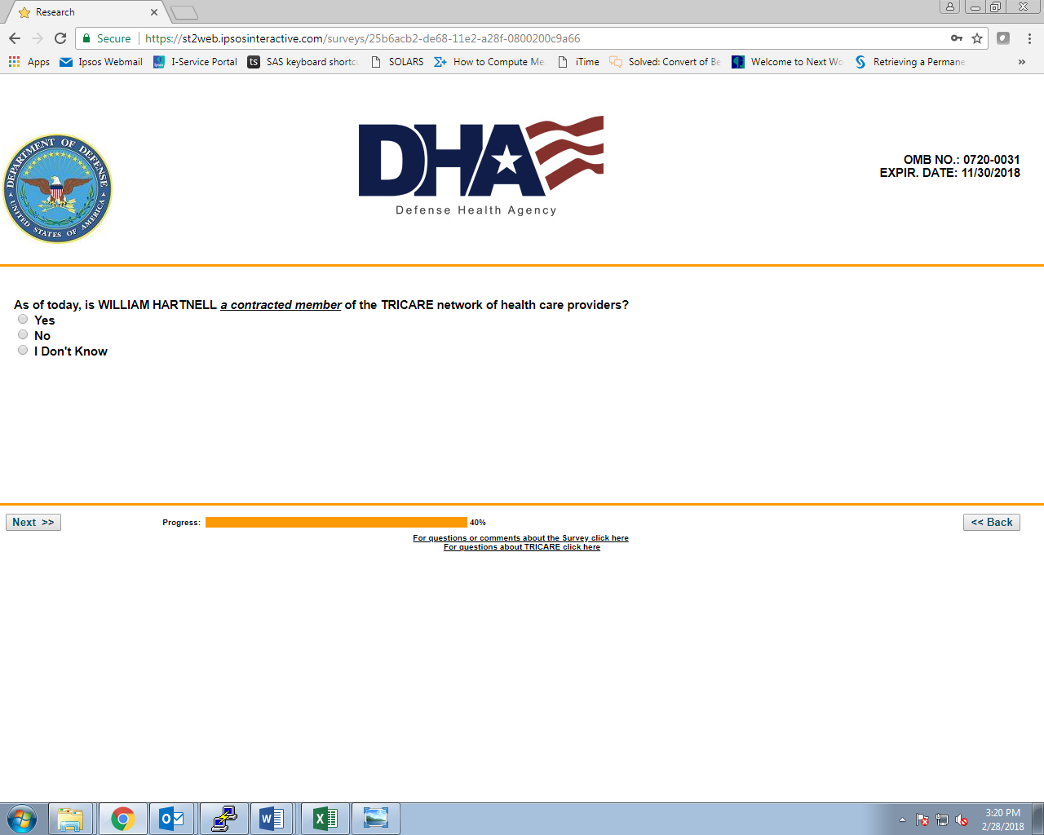

Q4:

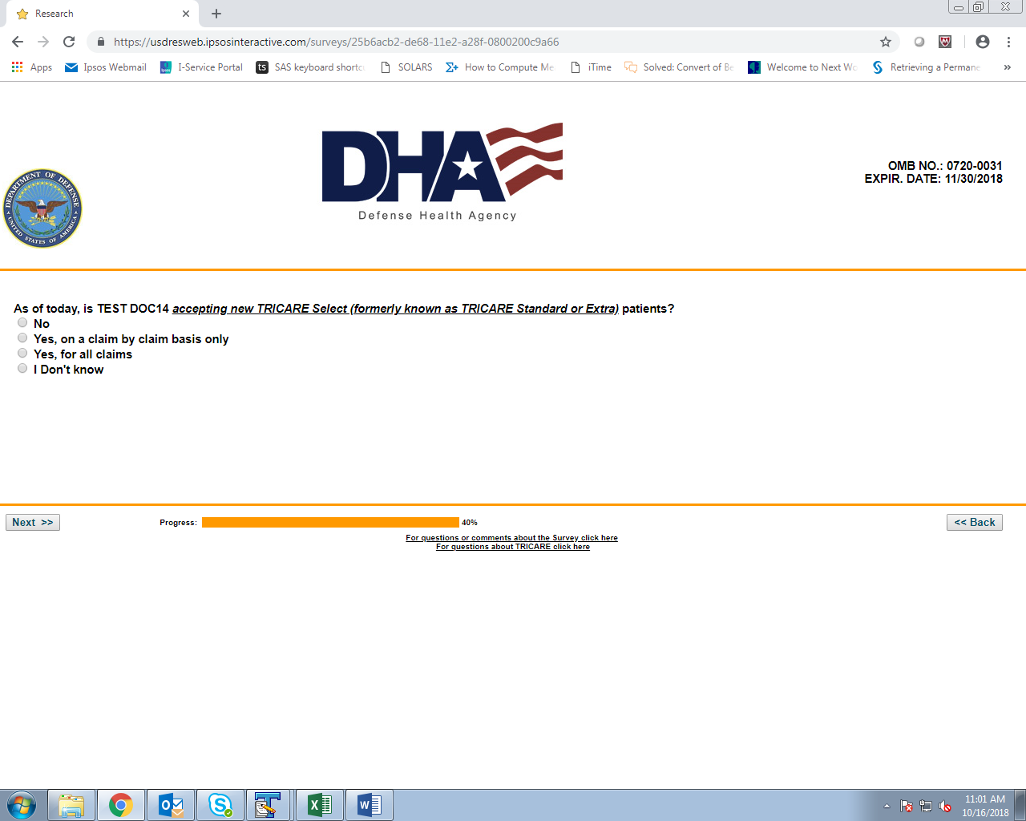

Q5 (IF ‘NO’ AT Q4):

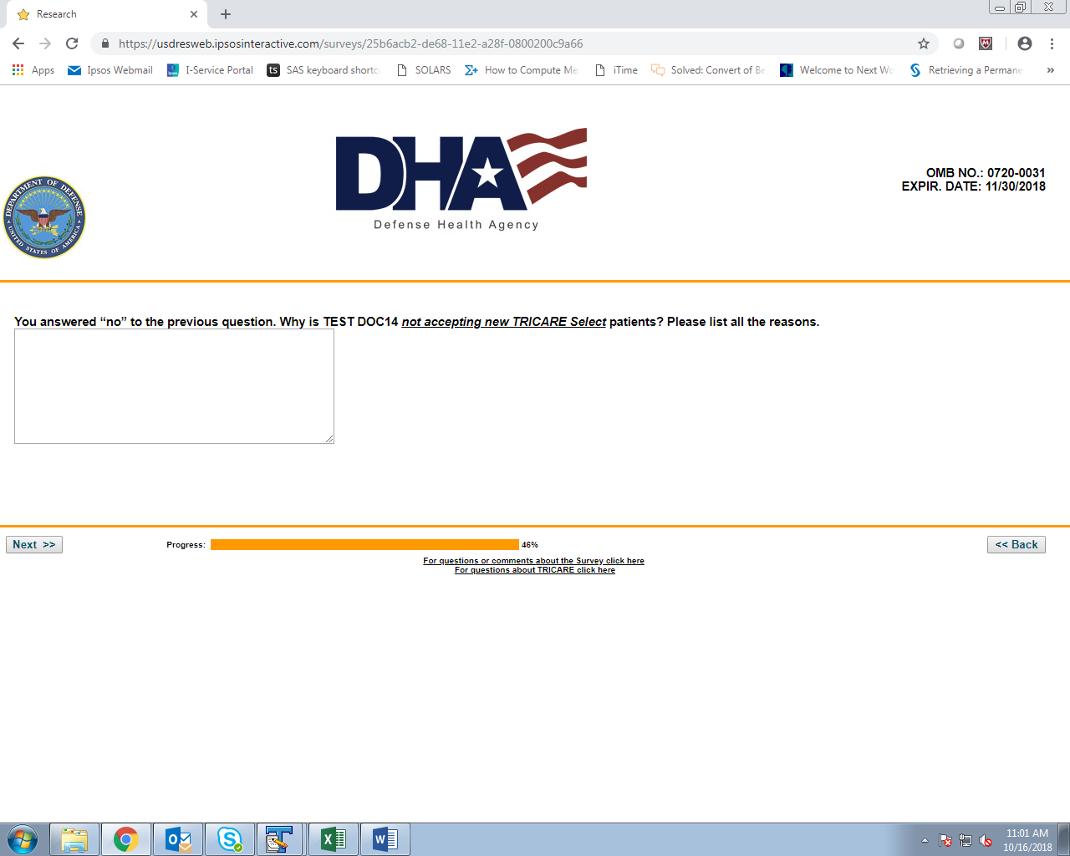

Q6:

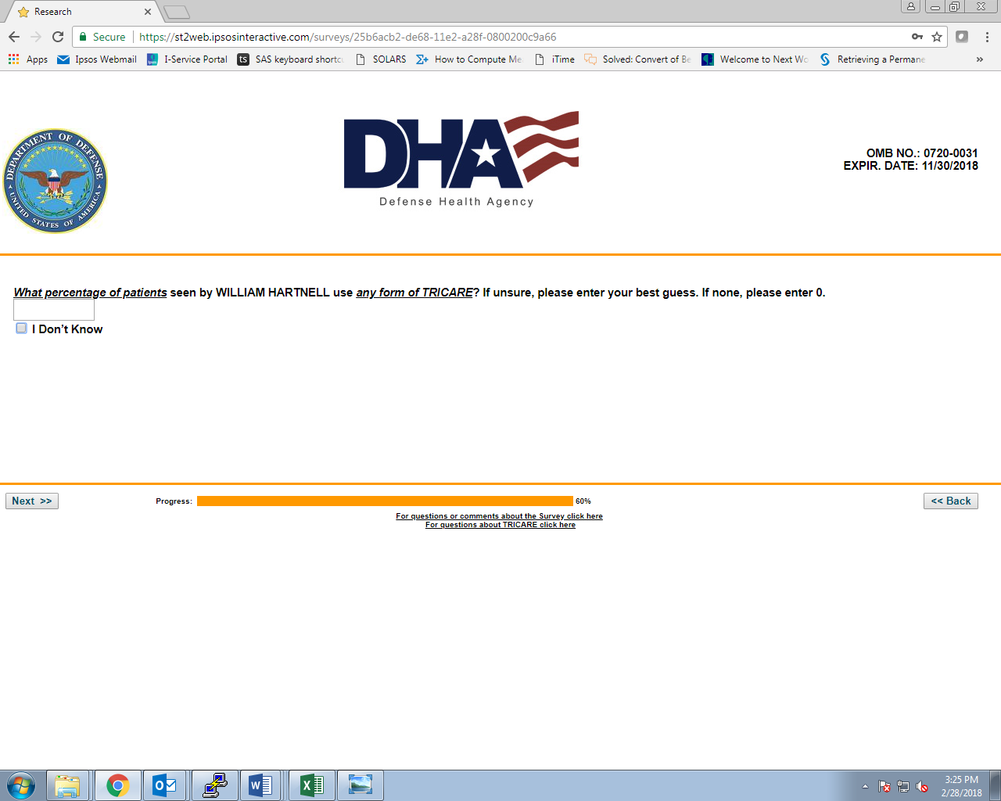

Q7:

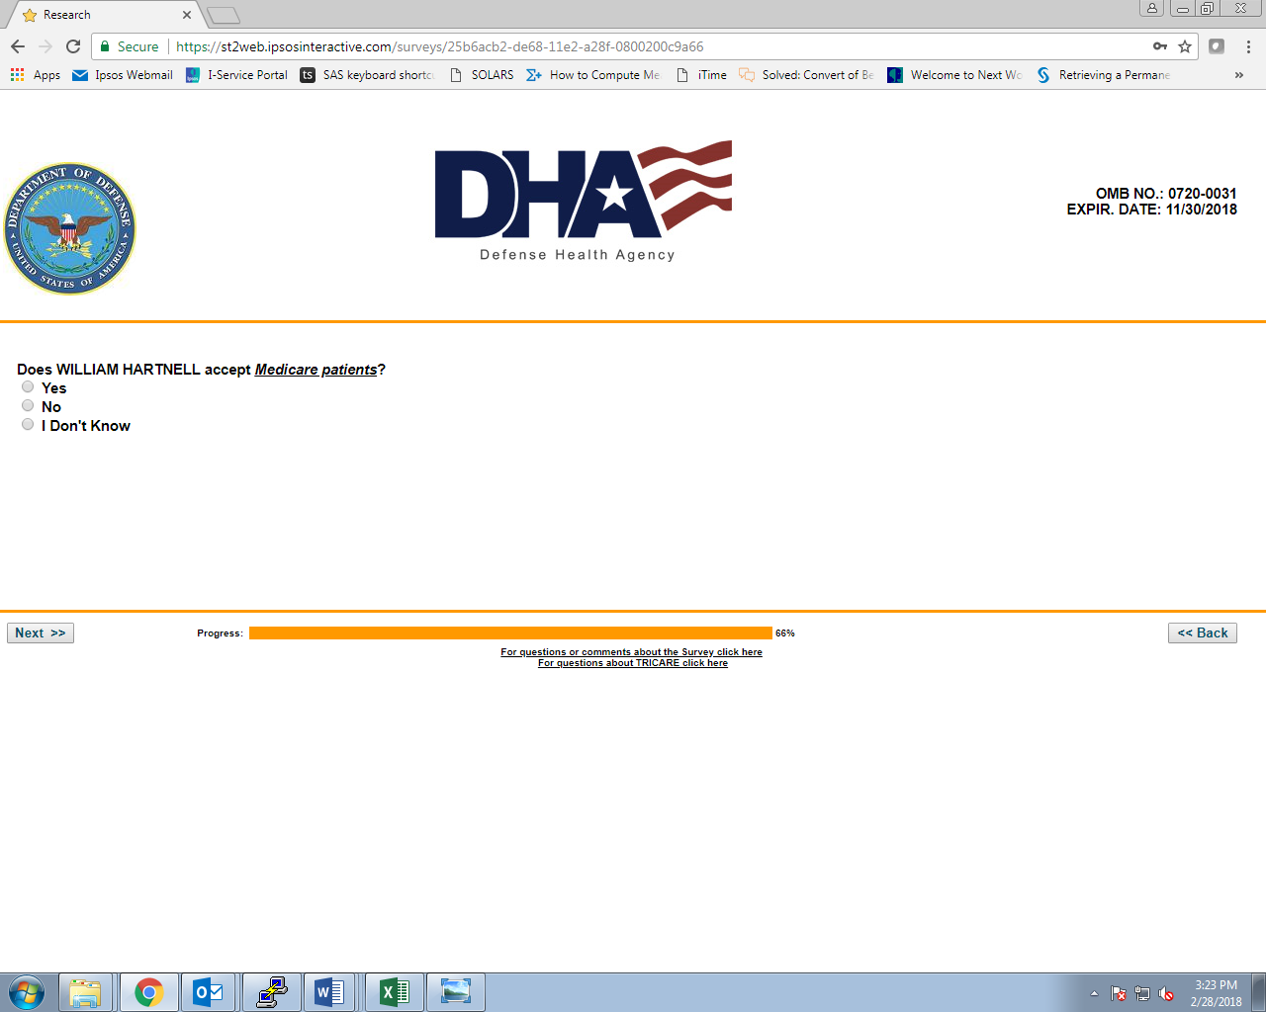

Q8:

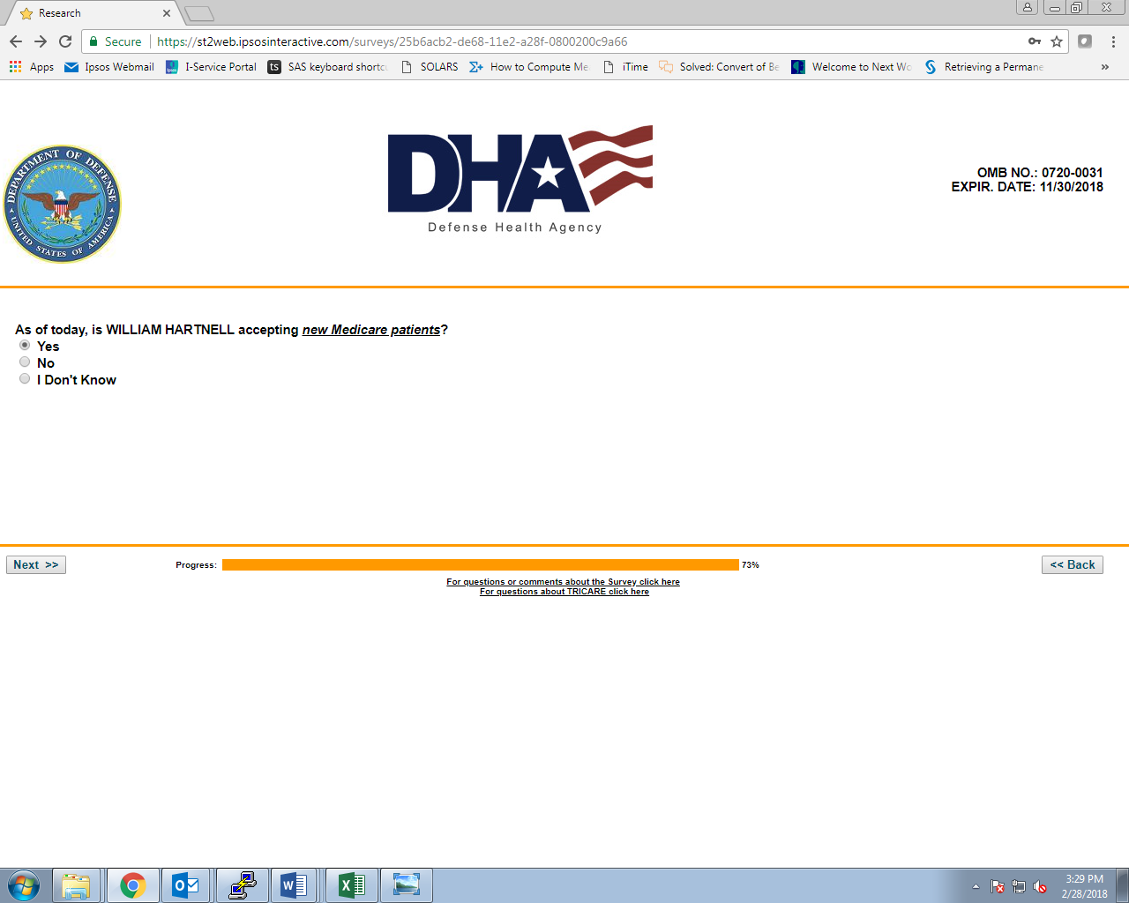

END (IF ‘YES’ TO Q8):



Q9 (IF ‘NO’ TO Q8):

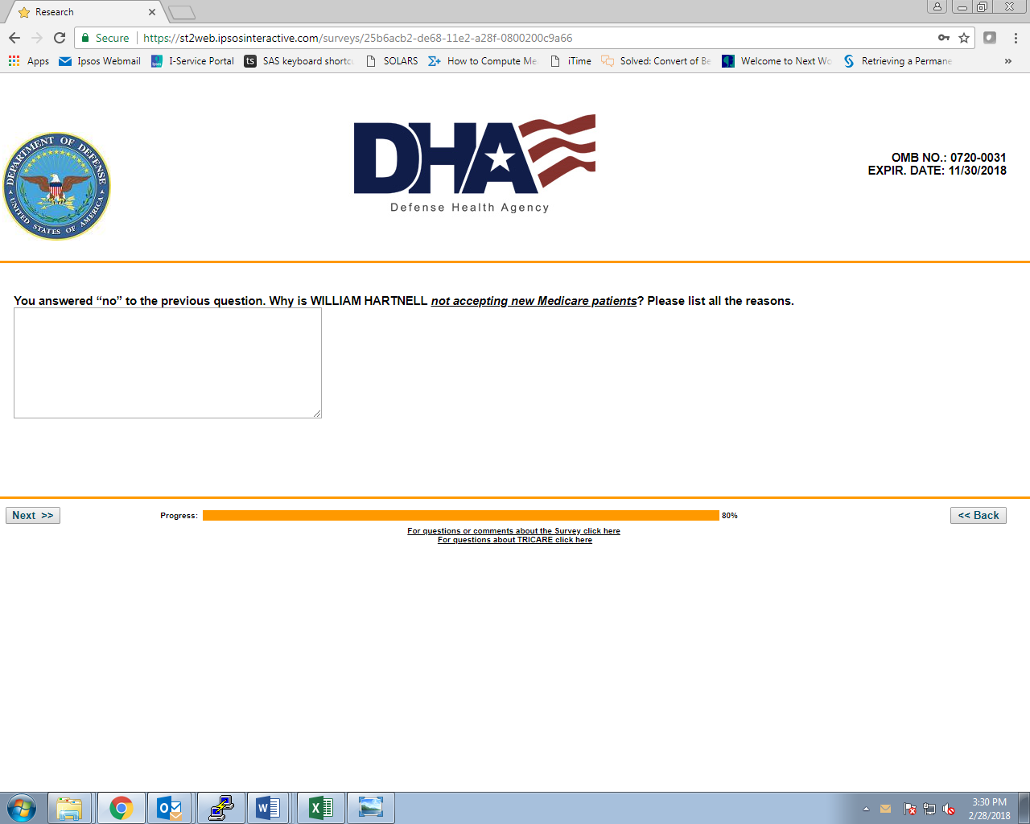

Q10 (IF ‘NO’ OR ‘DON’T KNOW’ AT Q8):

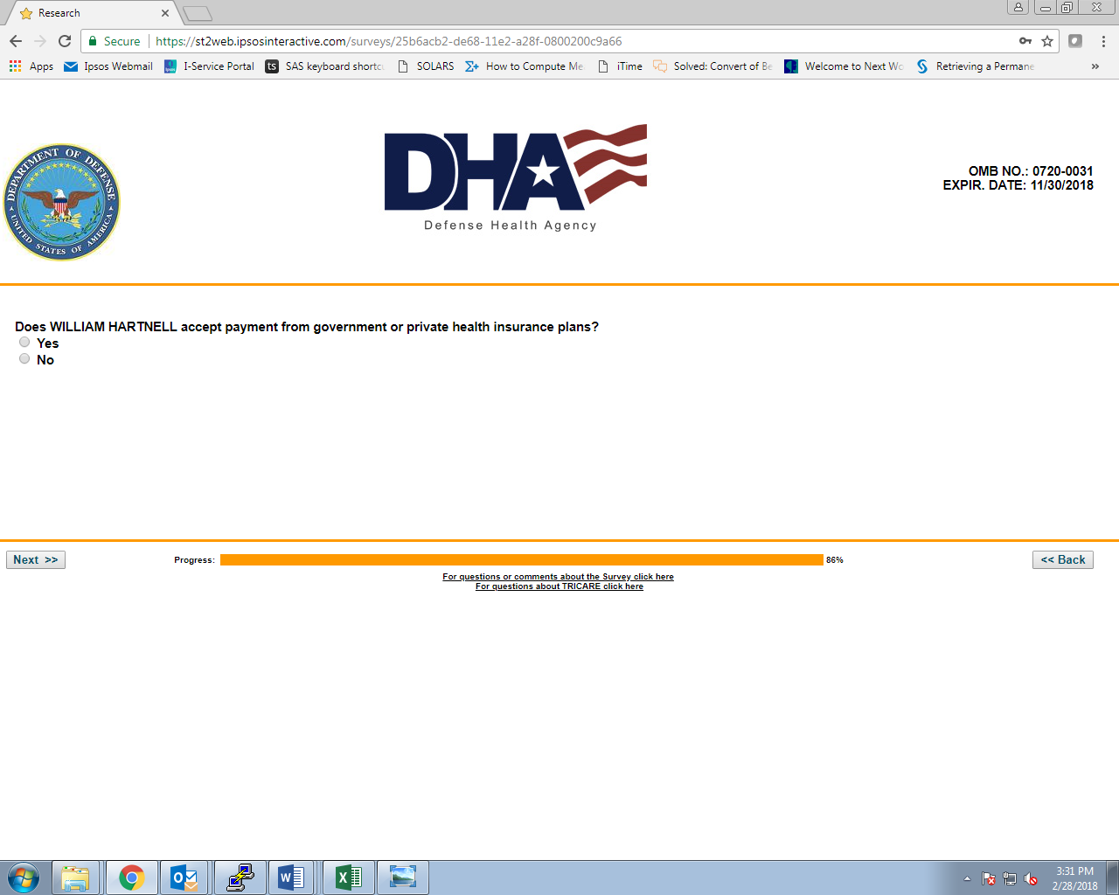

Q11 (IF ‘NO’ OR ‘DON’T KNOW’ AT Q8):

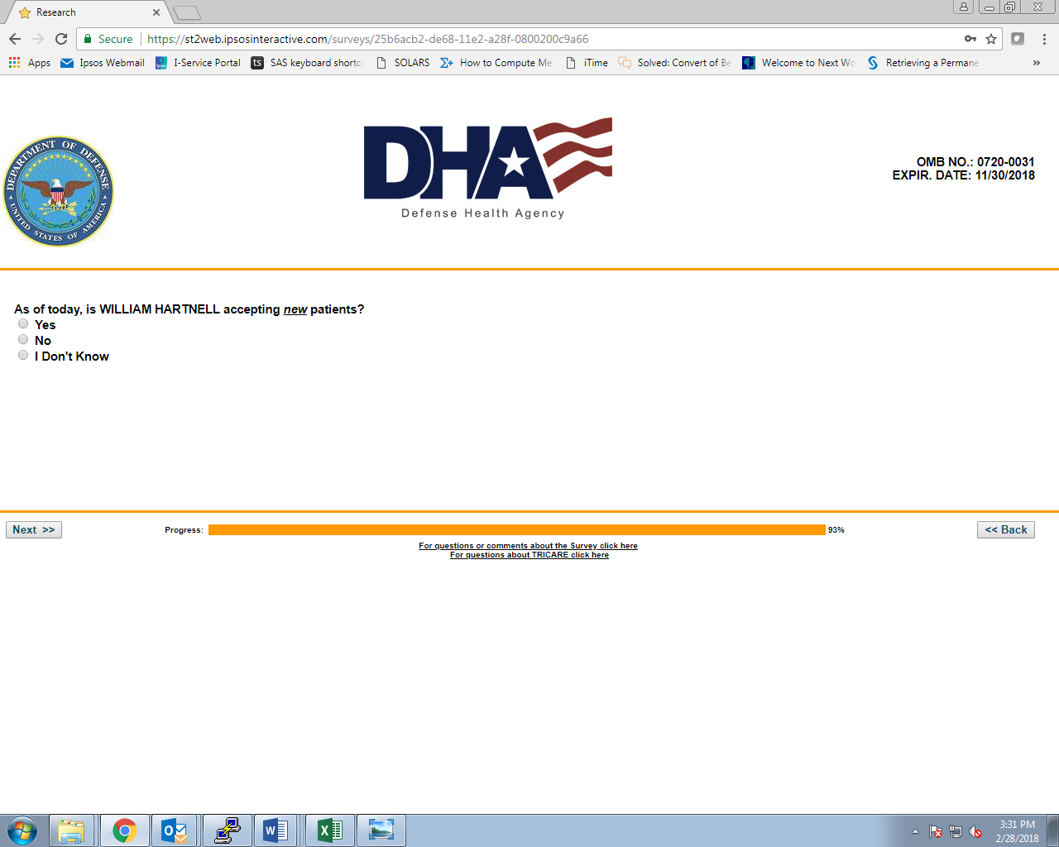

END:

