STEP 1: Login with valid Optum ID or One Healthcare ID:
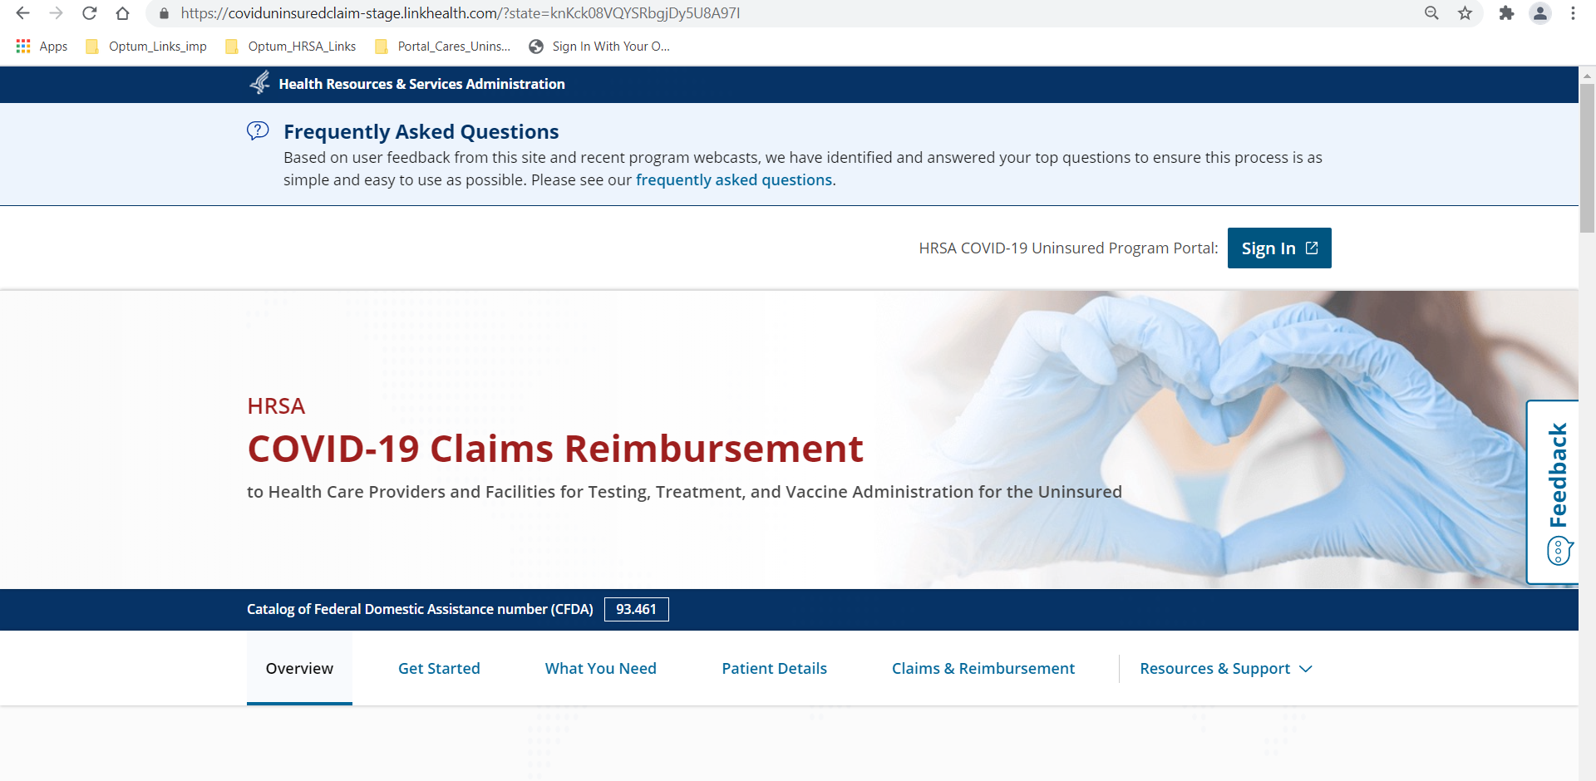
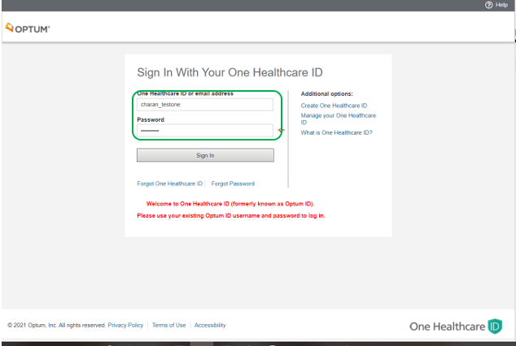
User Logins successfully and Billing TIN Dashboard is displayed for Uninsured Program:
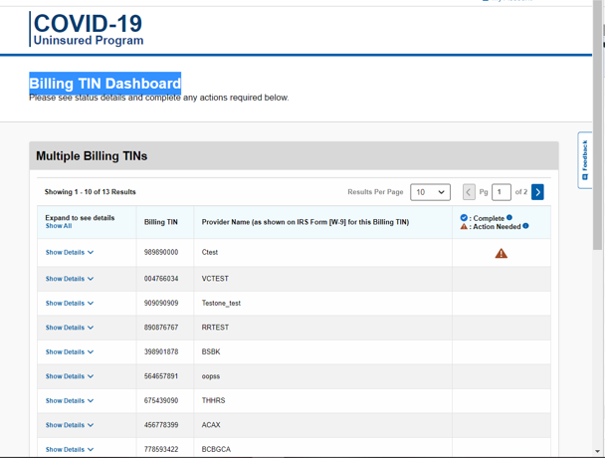

Add a new Billing TIN/ New Billing TIN with 9 digits unique one with Provide name.
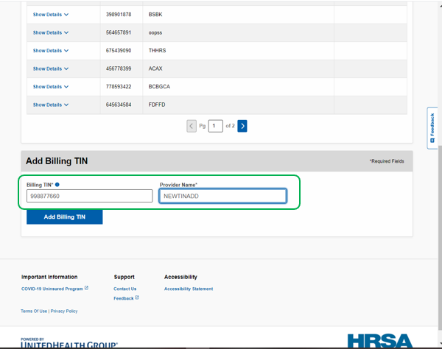

Attest the following: Program Administrator Attestation | TIN Validation | COVID-19 Uninsured Program
Program Administrator Attestation for Billing TIN XXXXXXXXX. Then Click on I Accept:
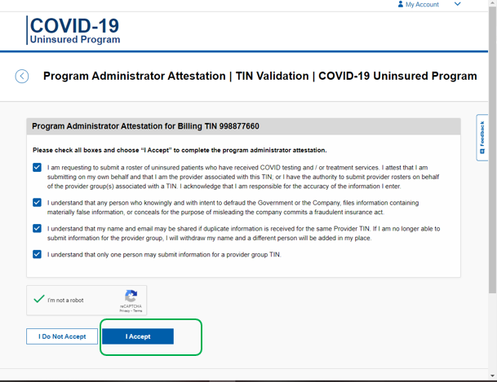

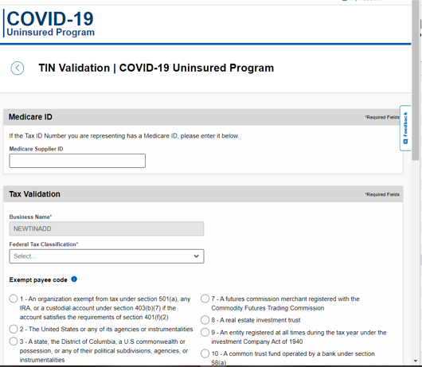

Provide the Required fields and click on ‘Continue’

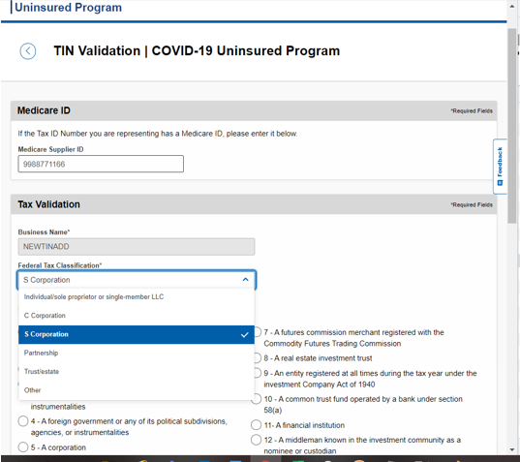
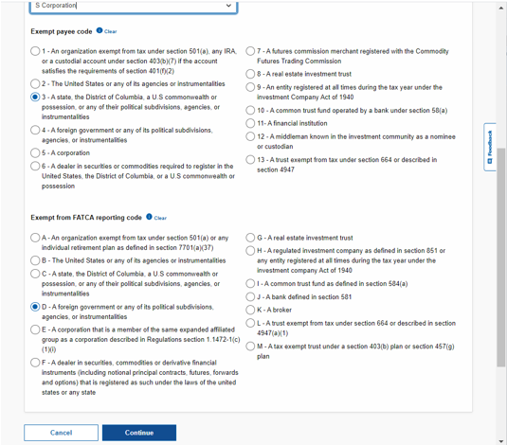

Provide the Billing TIN Address then click on ‘Continue’
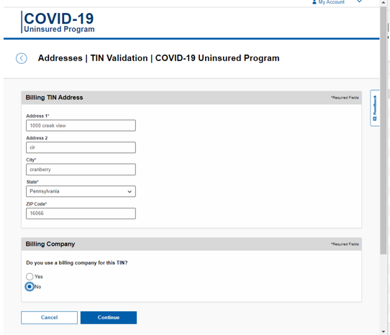

Submit the TIN
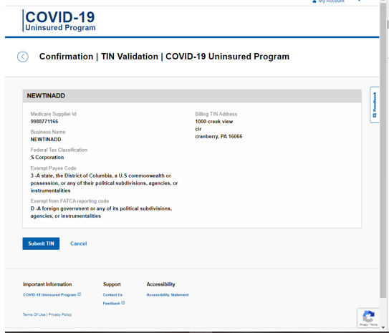

The TIN Validation will be in processing status.
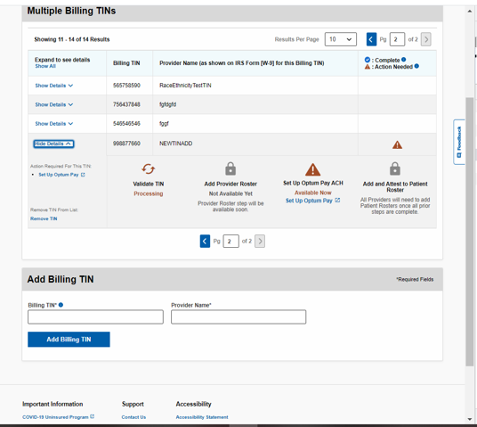

After all TIN validations it will be in complete state.
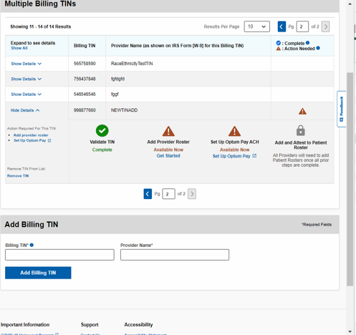

STEP 2: Adding the Provider Roster or Uploading Provider Roster:
Download the Template and enter the data for “Group/Individual/ Hospital_Ancillary_Clinic” follow the instructions provided in the Template.
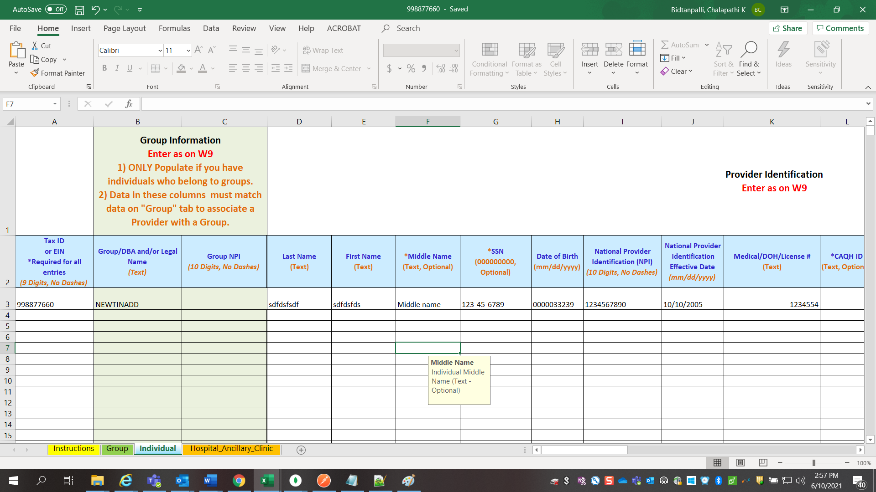

Fill the template and upload the file to submit the Roster:
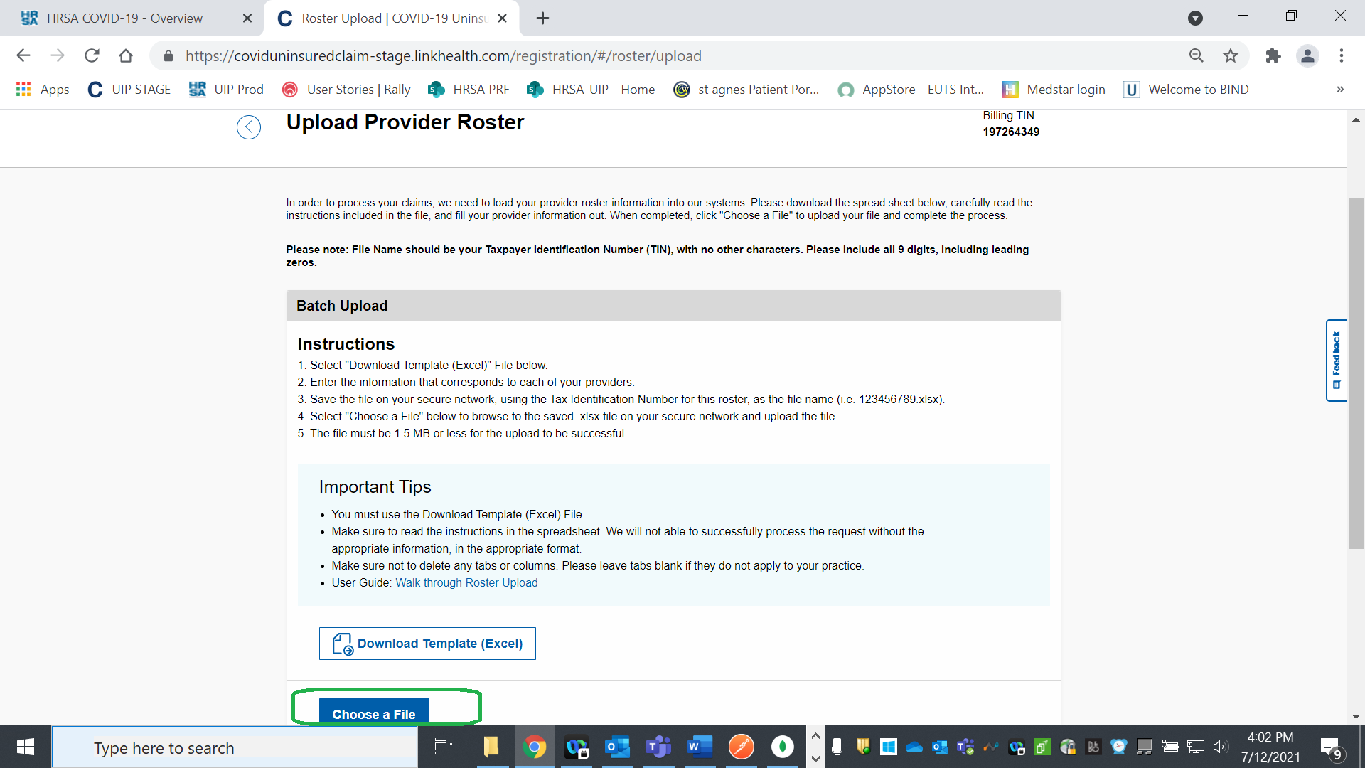

The Provider Roster is submitted successfully the reference number is generated with fsDocumentId
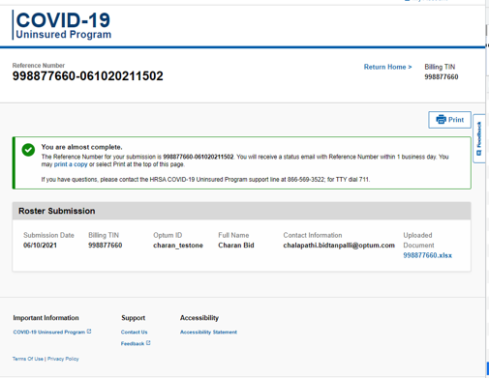

The provider roster will be in ‘Processing Upload’ status.
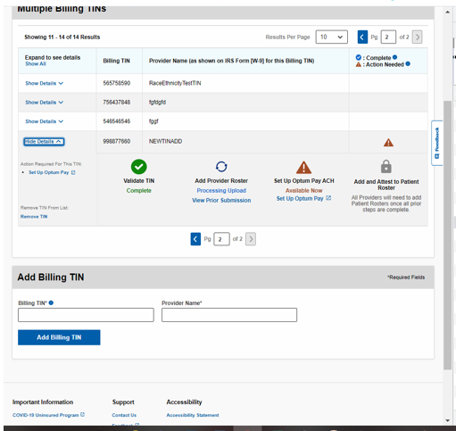

After uploading the correct Provider Roster, the status is changed to success
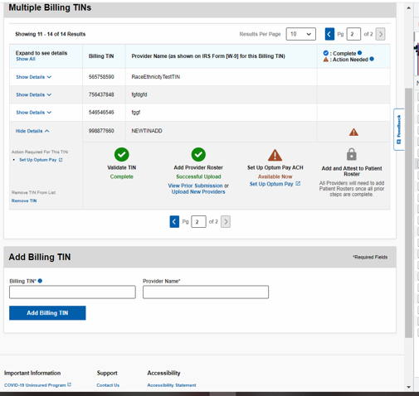

Step 3 Click on the ‘Set Up Optum Pay’ and follow instructions on the ‘Optum Pay’ website.
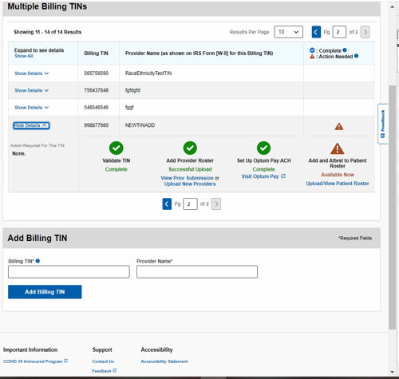

Step 4: Add and Attest to Patient Roster (Click on Upload/View Patient Roster)
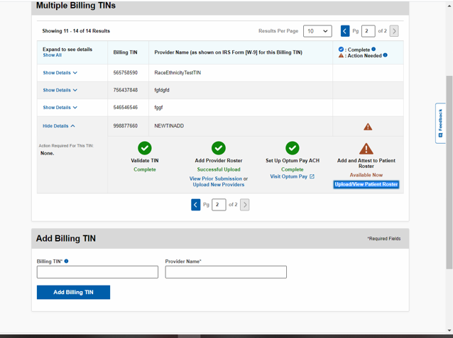

The screen will redirect to Patient Member Portal
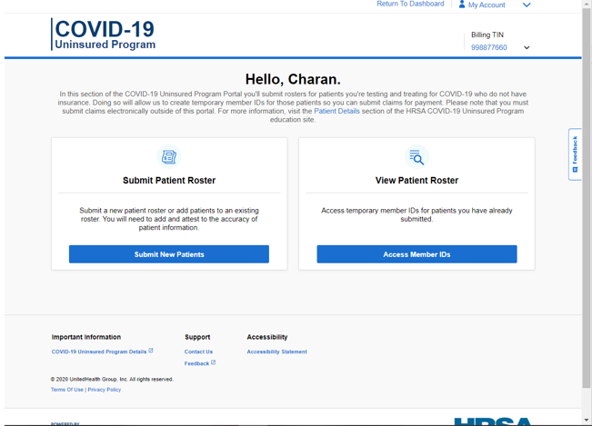

Click on Submit Patient Roster. The user can submit the Individual or Batch Upload
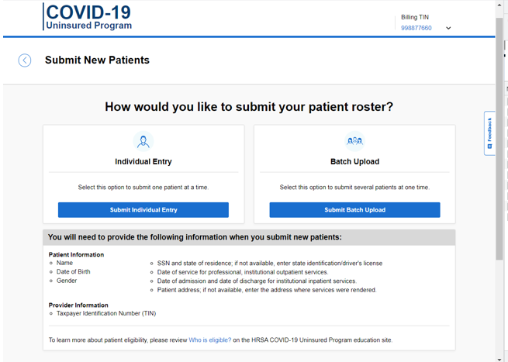

Enter all the required Fields
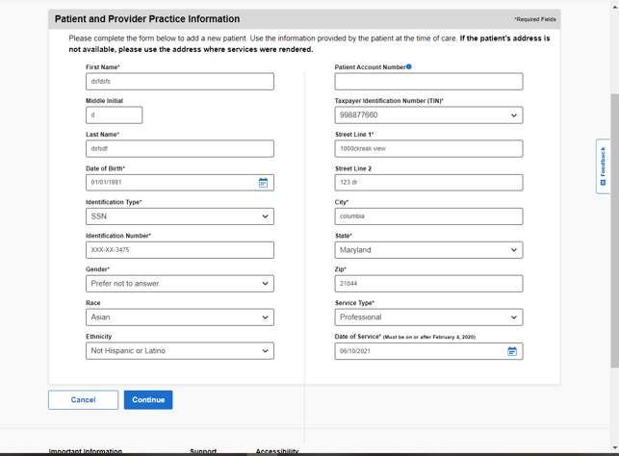

Then the Submit the Patient Roster Attestation
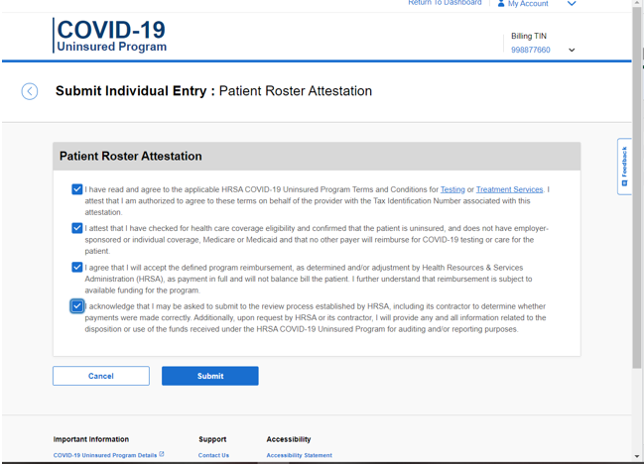

The Bundle Id will be created and the submitted patient data can be viewed from View Patient Roster
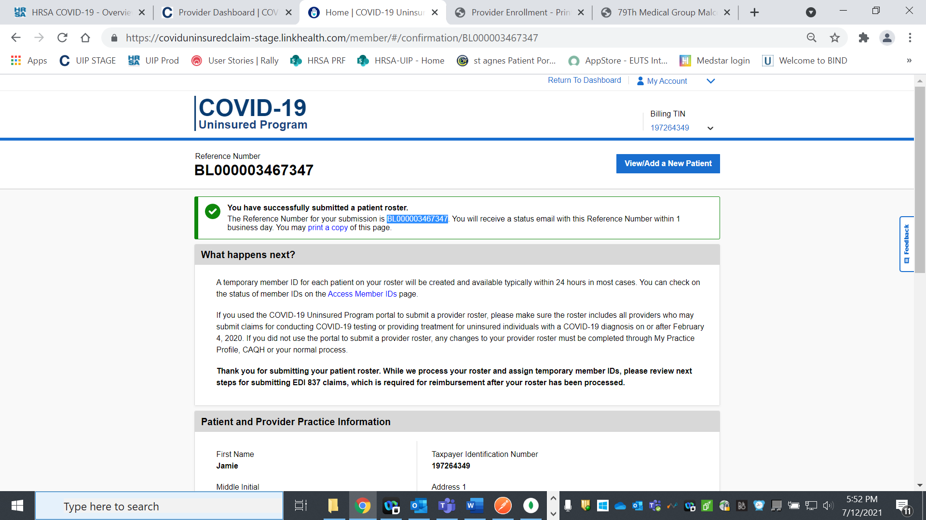
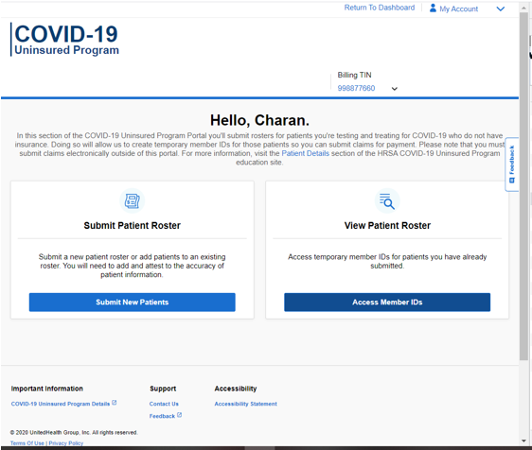
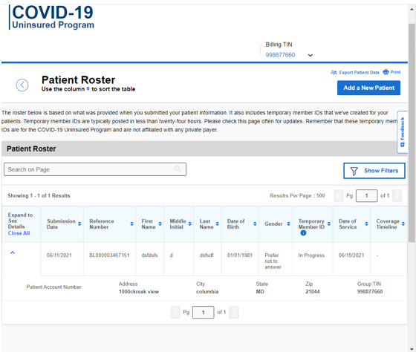

The User can submit the Batch upload by downloading the template and entering the details.
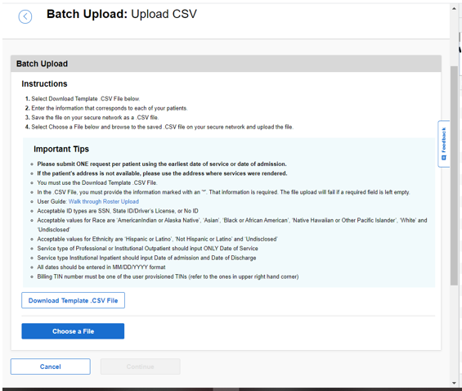
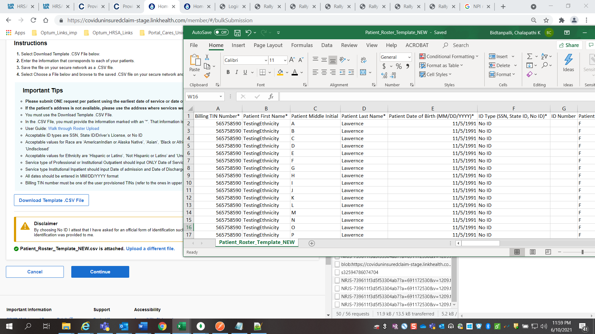
Click on Continue. The user can modify or delete the record before submitting the attestation.
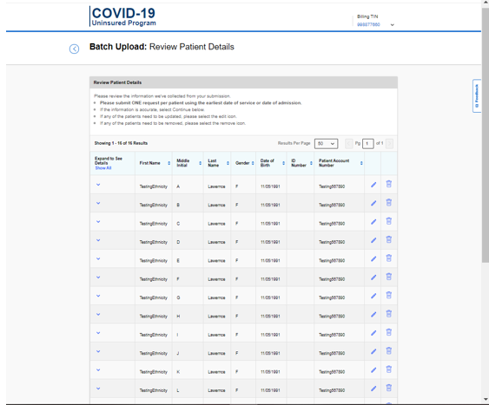
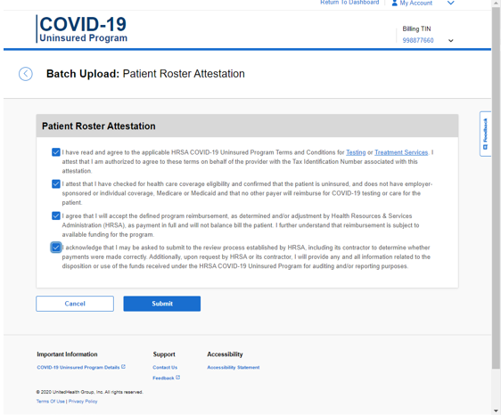

The Bundle Id is generated for Bulk upload
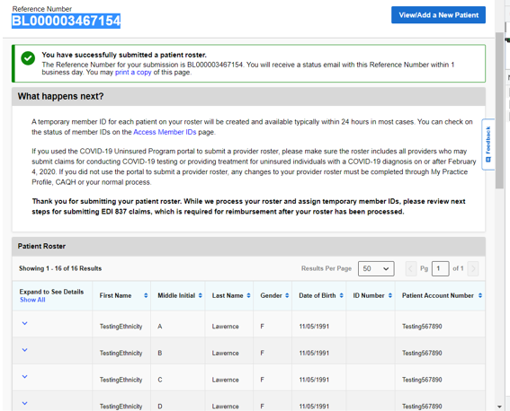

To View Patient Roster, Click on ‘Access Member IDs’
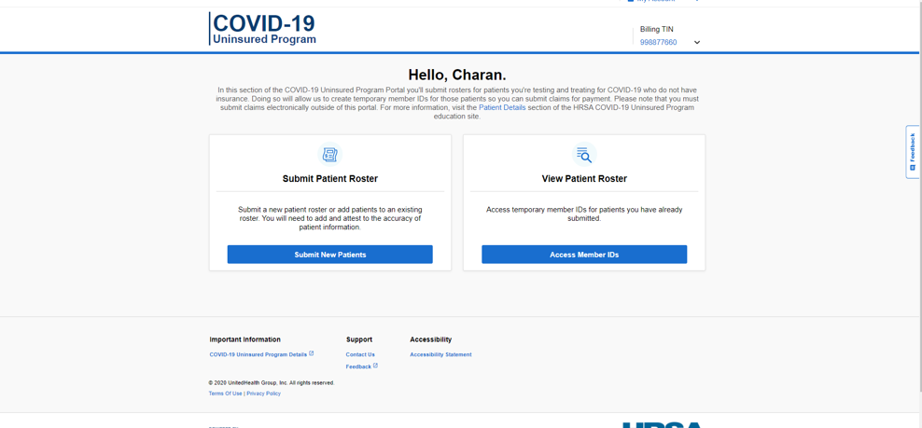

Records are displayed for the specific Billing TIN
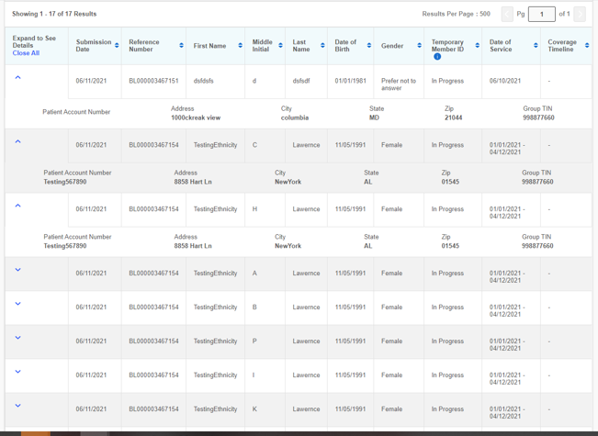

Patient Roster records can be Filtered based on the below options
