Paperwork Reduction Act Statement: According to the Paperwork Reduction Act of 1995, an agency may not conduct or sponsor, and a person is not required to respond to a collection of information unless it displays a valid OMB control number. The valid OMB control number for this information collection is 0910-0865. The burden time required to complete this portion of the information collection is estimated to average 10 minutes per response, including the time to review instructions, search existing data sources, gather and maintain the data needed, and complete and review the collection of information.

Send comments regarding this burden estimate or any other aspects of this collection of information, including suggestions for reducing burden to PRAStaff@fda.hhs.gov.
The survey is being conducted on behalf of the U.S. Food and Drug Administration.
Subject: Feedback Opportunity: FDA would like your opinion on the CORE Outbreak Investigation Table
Greetings,
FDA’s Coordinated Outbreak Response and Evaluation (CORE) would like your feedback on its newly released CORE Outbreak Investigation Table (CIT) currently available here on the FDA website. The CIT, located about halfway down the webpage, is a list of outbreak investigations being managed by FDA’s CORE Response Teams. The CIT was developed to publicly share current outbreaks earlier on in the investigation process, even if there isn’t actionable advice for the public yet.
Your feedback is completely voluntary and your responses will be kept secure to the extent allowed by law. You received this survey invitation because you have previously shown interest in foodborne outbreaks and may be actively using the CIT. Your feedback is crucial for helping us determine what improvements could be made to ensure that the table is informative, easy to understand, and effective tool for the public. Please click the link below to take the 10-minute survey about the CIT. Your survey response is requested by XX date.
Link to survey (Clicking on the link to the survey and taking the survey implies consent to participate. You may quit the survey at any time without submitting.)
If you have any questions about this survey, please contact Lindsay.Walerstein@fda.hhs.gov
Thank you for considering this request, and for your time.
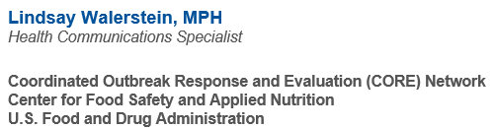
If you do not wish to participate in future survey testing, please email Lindsay.Walerstein@fda.hhs.gov

