FINAL SCREENER – CERSI JHU ENDS FLAVORS (Moran)
November 16, 2020

Sample specifications
2500 13-17 year olds: 625 non-cigarette/non-ENDS users; 625 cigarette users only; 625 ENDS users only; 625 dual cigarette/ENDS users
2500 18-24 year olds: 625 non-cigarette/non-ENDS users; 625 cigarette users only; 625 ENDS users only; 625 dual cigarette/ENDS users
Note: Former are excluded from the sample

Classifications for inclusion/exclusion criteria
INCLUDED
Non-cigarette user: Has not used cigarettes in the past 30 days and has used <100 cigarettes in lifetime
Non-e-cigarette user: Has not used e-cigarettes in the past 30 days and has never used e-cigarettes regularly/fairly regularly
Cigarette user: Has used cigarettes in past 30 days, regardless of lifetime use
E-cigarette user: Has used e-cigarettes in past 30 days, regardless of lifetime use

EXCLUDED
Former cigarette user: >100 LT cigarettes, no past 30 day use
Former e-cigarette user: Ever fairly regular e-cig use, no past 30 day use
Never heard of e-cigarettes: Responds ‘No’ to Q2.1 asking if they have ever heard of e-cigarettes

General notes
- Skip patterns are noted informally and will be programmed formally when survey is finalized
- New text added to adapted questions is indicated with underline and bracketed font
- Our internal notes are in brackets and italics
- Numeric codes will be standardized once survey questions/response options are finalized
- Response option order/randomization will be added once questions/response options are finalized
- Questions were taken or adapted from NYTS, PATH, or other literature, where applicable. Questions and response options were adapted or updated where the team deemed it was necessary. For example, the age question and responses were originally taken from NYTS, however this survey includes young adults, so response options were added to include those 19-25.
- Below each question is “ASK” which guides who each question is given to, depending on their use status.
Section 0. Screener
Paperwork Reduction Act Statement: The public reporting burden for this collection of information has been estimated to average 5 minutes per response. Send comments regarding this burden estimate or any other aspects of this collection of information, including suggestions for reducing burden to PRAStaff@fda.hhs.gov.

Source: NYTS [ADAPTED RESPONSES]
1.1 How old are you?
12 years old or younger [Not eligible]
13 years old
14 years old
15 years old
16 years old
17 years old
18 years old
19 years old
20 years old
21 years old
22 years old
23 years old
24 years old
25 years old or older [Not eligible]

Source: PATH ID: R04_YC1002_NB
1.2 Have you ever tried cigarette smoking, even one or two puffs?
1 Yes
2 No [Categorize as non-cigarette user]
-8 DON'T KNOW [Not eligible]
-7 REFUSED [Not eligible]

Source: PATH ID: R04_YC1112
1.3 When was the last time you smoked a cigarette, even one or two puffs?
1 Earlier today [Categorize as cigarette user]
2 Not today but sometime in the past 7 days [Categorize as cigarette user]
3 Not in the past 7 days but sometime in the past 30 days [Categorize as cigarette user]
4 Not in the past 30 days but sometime in the past 6 months
5 Not in the past 6 months but sometime in the past year
6 1 to 4 years ago
7 5 or more years ago
-8 DON'T KNOW [Not eligible]
-7 REFUSED [Not eligible]
ASK: Respondents who have ever smoked a cigarette: 1.2=1

Source: PATH ID: R04_YC1005
1.4 How many cigarettes have you smoked in your entire life? A pack usually has 20 cigarettes in it.
1 1 or more puffs but never a whole cigarette
2 1 cigarette
3 2 to 10 cigarettes (about ½ pack total)
4 11 to 20 cigarettes (about ½ pack to 1 pack)
5 21 to 50 cigarettes (more than 1 pack but less than 3 packs)
6 51 to 99 cigarettes (more than 2 ½ packs but less than 5 packs)
7 100 or more cigarettes (5 packs or more)
-8 DON'T KNOW [Not eligible]
-7 REFUSED [Not eligible]
ASK: Respondents who have ever smoked a cigarette: 1.2=1
Notes for quotas:
If 1.2=2, categorize as non-cigarette user
If 1.3=1, 2 or 3, categorize as cigarette user
If 1.3=4, 5, 6 or 7 & 1.4=1, 2, 3, 4, 5, or 6, categorize as non-cigarette user
If 1.3=4, 5, 6 or 7 & 1.4=7, categorize as former cigarette user and exclude

The next several questions are about electronic cigarettes or e-cigarettes. E-cigarettes are battery powered devices that usually contain a nicotine-based liquid that is vaporized and inhaled. You may also know them as e-cigs, vape-pens, e-hookahs, vapes, pod-mods, or mods. Some can be bought as one-time, disposable products, while others can be bought as reusable kits that are rechargeable. Some brand examples include JUUL, Suorin, Vuse, Blu, Logic, NJOY, Puff Bar and SMOK.

[SHOW GENERIC IMAGE OF E-PRODUCTS]

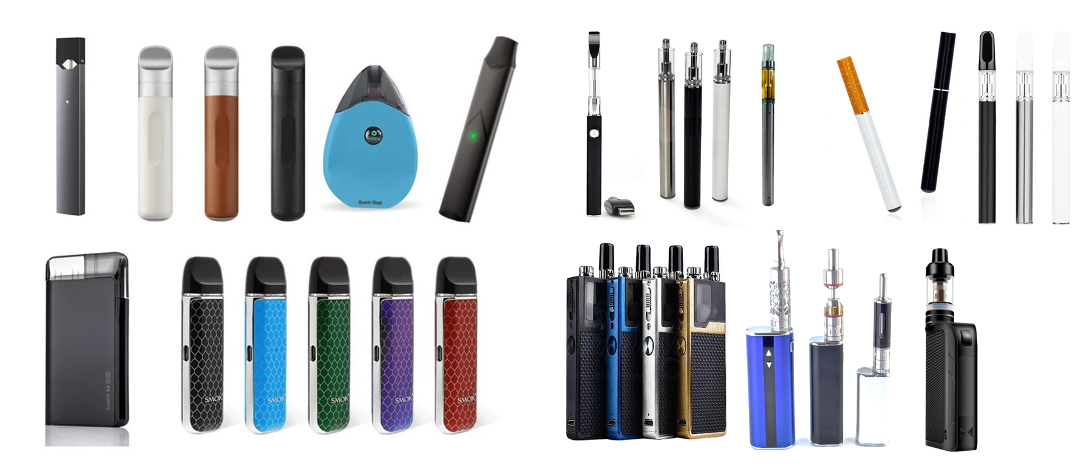
Source: PATH ID: R04_YV1001_NB
2.1 Have you ever seen or heard of an e-cigarette before this study? (e-cigarette products include e-cigs, vape pens, e-hookahs, vapes, pod-mods, or mods.)
[SHOW GENERIC IMAGE OF E-PRODUCTS]
1 Yes
2 No [Not eligible]
-8 DON'T KNOW [Not eligible]
-7 REFUSED [Not eligible]

Source: PATH ID: R04_YV1002_NB
2.2 Have you ever used an e-cigarette, even one or two times? (e-cigarette products include e-cigs, vape-pens, e-hookahs, vapes, pod-mods, or mods.)
[SHOW GENERIC IMAGE OF E-PRODUCTS]
1 Yes
2 No [Categorize as non-e-cig user]
-8 DON'T KNOW [Not eligible]
-7 REFUSED [Not eligible]
ASK: Respondents who have heard of e-products: 2.1=1.

Source: PATH ID: R04_YV1112
2.3 When was the last time you used an e-cigarette, even one or two times?
1 Earlier today [Categorize as e-cig user]
2 Not today but sometime in the past 7 days [Categorize as e-cig user]
3 Not in the past 7 days but sometime in the past 30 days [Categorize as e-cig user]
4 Not in the past 30 days but sometime in the past 6 months
5 Not in the past 6 months but sometime in the past year
6 1 to 4 years ago
7 5 or more years ago
-8 DON'T KNOW [Not eligible]
-7 REFUSED [Not eligible]
ASK: Respondents who have ever used an e-product: 2.2=1.

Source: PATH ID: R04_AV1100
2.4 Have you ever used an e-cigarette fairly regularly?
1 Yes
2 No
-8 DON'T KNOW [Not eligible]
-7 REFUSED [Not eligible]
ASK: Respondents who have ever used an e-product: 2.2=1.
Notes for quotas:
If 2.2 = 2, categorize as non-e-cigarette user
If 2.3=1, 2 or 3, categorize as e-cigarette user
If 2.3=4, 5, 6 or 7 & 2.4=2, categorize as non-e-cigarette user
If 2.3=4, 5, 6 or 7 & 2.4=1, categorize as former e-cigarette user and exclude

