FINAL SURVEY – CERSI JHU ENDS FLAVORS (Moran)
November 16, 2020

Sample specifications
2500 13-17 year olds: 625 non-cigarette/non-ENDS users; 625 cigarette users only; 625 ENDS users only; 625 dual cigarette/ENDS users
2500 18-24 year olds: 625 non-cigarette/non-ENDS users; 625 cigarette users only; 625 ENDS users only; 625 dual cigarette/ENDS users
Note: Former are excluded from the sample

Classifications for inclusion/exclusion criteria
INCLUDED
Non-cigarette user: Has not used cigarettes in the past 30 days and has used <100 cigarettes in lifetime
Non-e-cigarette user: Has not used e-cigarettes in the past 30 days and has never used e-cigarettes regularly/fairly regularly
Cigarette user: Has used cigarettes in past 30 days, regardless of lifetime use
E-cigarette user: Has used e-cigarettes in past 30 days, regardless of lifetime use

EXCLUDED
Former cigarette user: >100 LT cigarettes, no past 30 day use
Former e-cigarette user: Ever fairly regular e-cig use, no past 30 day use
Never heard of e-cigarettes: Responds ‘No’ to Q2.1 asking if they have ever heard of e-cigarettes

General notes
- Skip patterns are noted informally and will be programmed formally when survey is finalized
- New text added to adapted questions is indicated with underline and bracketed font
- Our internal notes are in brackets and italics
- Numeric codes will be standardized once survey questions/response options are finalized
- Response option order/randomization will be added once questions/response options are finalized
- Questions were taken or adapted from NYTS, PATH, or other literature, where applicable. Questions and response options were adapted or updated where the team deemed it was necessary. For example, the age question and responses were originally taken from NYTS, however this survey includes young adults, so response options were added to include those 19-25.
- Below each question is “ASK” which guides who each question is given to, depending on their use status.
Section 1. Tobacco Product Use
Paperwork Reduction Act Statement: The public reporting burden for this collection of information has been estimated to average 20 minutes per response. Send comments regarding this burden estimate or any other aspects of this collection of information, including suggestions for reducing burden to PRAStaff@fda.hhs.gov.

CIGARETTES
BOX ID: R04_YCT01
The next questions are about your experience with cigarettes.

Source: PATH ID: R04_AC1003
3.1 Do you now smoke cigarettes…
1 Every day
2 Some days
3 Not at all
-8 DON'T KNOW
-7 REFUSED
ASK: Respondents who have ever smoked a cigarette: 1.2=1.

Source: PATH ID: R04_YC1022
3.2 In the past 30 days, on how many days did you smoke cigarettes?
1 I__I__I DAYS
-8 DON'T KNOW
-7 REFUSED
ASK: Past 30 day cigarette smokers: 1.3=1, 2, or 3.

Source: PATH ID: R04_YC1103
3.3 Have you ever been curious about smoking a cigarette?
1 Yes, very curious
2 Yes, somewhat curious
3 Yes, a little curious
4 No, not at all curious
-8 DON'T KNOW
-7 REFUSED
ASK: Respondents who have never smoked a cigarette: 1.2=2.

Source: PATH ID: R04_YC1206
3.4 Do you think you will smoke a cigarette in the next year?
1 Definitely yes
2 Probably yes
3 Probably not
4 Definitely not
-8 DON'T KNOW
-7 REFUSED
ASK: Respondents who have never smoked a cigarette: 1.2=2.

Source: PATH ID: R04_YC1104
3.5 Do you think that you will try a cigarette soon?
1 Definitely yes
2 Probably yes
3 Probably not
4 Definitely not
-8 DON'T KNOW
-7 REFUSED
ASK: Respondents who have never smoked a cigarette: 1.2=2.

Source: PATH ID: R04_YC1105
3.6 If one of your best friends were to offer you a cigarette, would you smoke it?
1 Definitely yes
2 Probably yes
3 Probably not
4 Definitely not
-8 DON'T KNOW
-7 REFUSED
ASK: Respondents who have never smoked a cigarette: 1.2=2.

E-CIGARETTES

Source: PATH ID: R04_AV1003
4.1 Do you now use an e-cigarette…
1 Every day
2 Some days
3 Not at all
-8 DON'T KNOW
-7 REFUSED
ASK: Respondents who have ever used an e-product: 2.2=1.

Source: PATH ID: R04_YV1005
4.2 How many times have you used an e-cigarette in your entire life?
1 1 time, even just a few puffs
2 2 to 10 times
3 11 to 20 times
4 21 to 50 times
5 51 to 99 times
6 100 or more times
-8 DON'T KNOW
-7 REFUSED
ASK: Respondents who have ever used an e-product: 2.2=1.

Source: NYTS 2019
4.3 During the past 30 days, what brand [or brands] of e-cigarette did you usually use? (Choose all that apply.)
1 JUUL
2 NJOY
3 Vuse
4 Puff Bar
5 blu
6 Logic
7 SMOK
8 Suorin
9 Some other brand not listed here (specify): _______________________
ASK: Past 30 day e-cigarette users: 2.3=1, 2, or 3.

Source: PATH ID: R04_YV9140
4.4 Please look at this picture. Which group is most like the e-cigarette you use most often?
[SHOW IMAGE OF 4 E-PRODUCT GROUPS; DO NOT SHOW TEXT DESCRIBING WHAT IMAGE REPRESENTS]

1 Group 1 [pod]
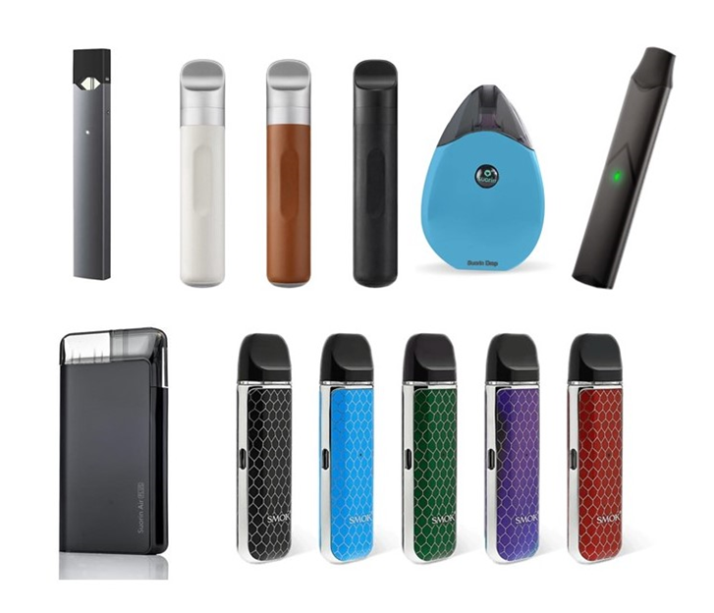

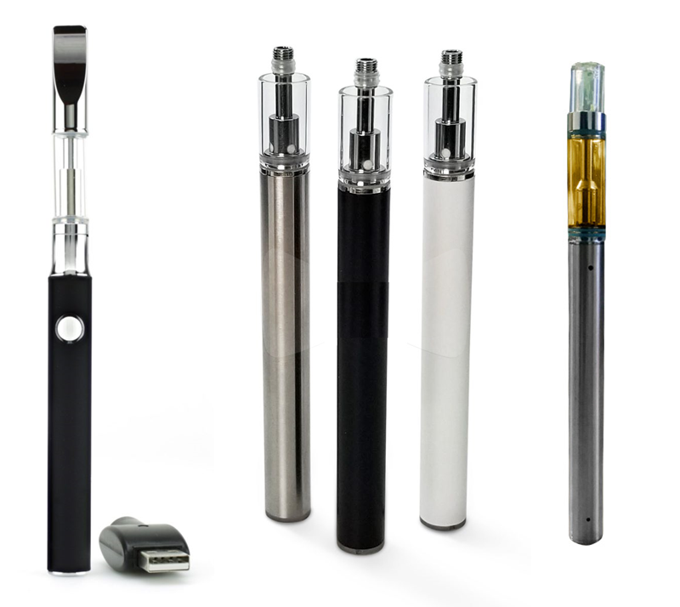
2 Group 2 [pen]

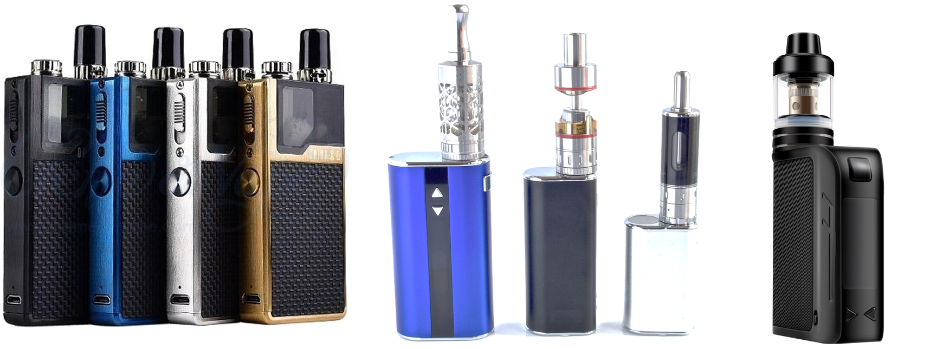
3 Group 3 [mod]

4 Group 4 [disposable]

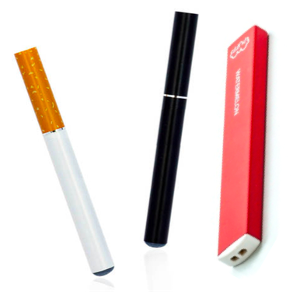

5 None of the above
-8 DON'T KNOW
-7 REFUSED
ASK: Past 30 day e-cigarette users: 2.3=1,2, or 3

Source: PATH ID: R04_YV1131
4.5 Which flavors of e-cigarettes have you used in the past 30 days? Choose all that apply.
1 Tobacco-flavored
2 Menthol
3 Mint
4 Clove or spice
5 Fruit
6 Chocolate
7 An alcoholic drink (such as wine, cognac, margarita or other cocktails)
8 A non-alcoholic drink (such as coffee, soda, energy drinks, or other beverages)
9 Candy, desserts or other sweets
10 Some other flavor (SPECIFY)
-8 DON'T KNOW
-7 REFUSED
ASK: Past 30 day e-cigarette users: 2.3=1,2, or 3

Source: PATH ID: R04_YV1103
4.6 Have you ever been curious about using an e-cigarette? (e-cigarette products include e-cigs, vape pens, e-hookahs, vapes, pod-mods, or mods)
1 Yes, very curious
2 Yes, somewhat curious
3 Yes, a little curious
4 No, not at all curious
-8 DON'T KNOW
-7 REFUSED
ASK: Respondents who have heard of but never used e-cigarette products: 2.1=1 & 2.2=2.

Source: PATH ID: R04_YV1104
4.7 Do you think that you will try an e-cigarette soon?
1 Definitely yes
2 Probably yes
3 Probably not
4 Definitely not
-8 DON’T KNOW
-7 REFUSED
ASK: Respondents who have heard of but never used e-products: 2.1=1 & 2.2=2.

Source: PATH ID: R04_YV1206
4.8 Do you think you will try an e-cigarette in the next year?
1 Definitely yes
2 Probably yes
3 Probably not
4 Definitely not
-8 DON'T KNOW
-7 REFUSED
ASK: Respondents who have heard of but never used e-cigarette products: 2.1=1 & 2.2=2.

Source: PATH ID: R04_YV1105
4.9 If one of your best friends were to offer you an e-cigarette, would you try it?
1 Definitely yes
2 Probably yes
3 Probably not
4 Definitely not
-8 DON'T KNOW
-7 REFUSED
ASK: Respondents who have heard of but never used e-products: 2.1=1 & 2.2=2.

OTHER TOBACCO PRODUCTS
Source: NYTS 2018
5.1 Have you ever tried any of these products, even just one time?
- Cigars, cigarillos or little cigars, such as Black and Milds, Swisher Sweets, Dutch Masters, White Owl, or Phillies Blunts [Product not included in NYTS measure – asked as separate question. Wording taken from separate NYTS question]
- Chewing tobacco, snuff, or dip, such as Redman, Levi Garrett, Beechnut, Skoal, Skoal Bandits, or Copenhagen [Product not included in NYTS measure – asked as separate question. Wording taken from separate NYTS question]
- Hookah or waterpipe
- Roll-your-own cigarettes
- Pipes filled with tobacco (not waterpipe)
- Snus, such as Camel, Marlboro, or General Snus
- Dissolvable tobacco products such as Ariva, Stonewall, Camel orbs, Camel sticks, Marlboro sticks, or Camel strips
- Bidis (small brown cigarettes wrapped in a leaf)
1 Yes
2 No
-8 Don’t know

Source: NYTS 2018
5.2 In the past 30 days, have you used this product on at least one day?
- Cigars, cigarillos or little cigars, such as Black and Milds, Swisher Sweets, Dutch Masters, White Owl, or Phillies Blunts [Product not included in NYTS measure – asked as separate question. Wording taken from separate NYTS question]
- Chewing tobacco, snuff, or dip, such as Redman, Levi Garrett, Beechnut, Skoal, Skoal Bandits, or Copenhagen [Product not included in NYTS measure – asked as separate question. Wording taken from separate NYTS question]
- Hookah or waterpipe
- Roll-your-own cigarettes
- Pipes filled with tobacco (not waterpipe)
- Snus, such as Camel, Marlboro, or General Snus
- Dissolvable tobacco products such as Ariva, Stonewall, Camel orbs, Camel sticks, Marlboro sticks, or Camel strips
- Bidis (small brown cigarettes wrapped in a leaf)

1 Yes
2 No
-8 Don’t know

ASK: Participants who report ever using any other tobacco products: Any of 5.1a-h=1

Section 2. Exposure to Tobacco Advertising and Brand Familiarity

Source: Moran, Brown et al., 2018 and Moran & Pearson, 2019
6.1 Before this survey, have you ever heard of Vype e-cigarettes?
1 Yes
2 No
-8 Don’t know
-7 Refused

Source: Moran, Brown et al., 2018 and Moran & Pearson, 2019
6.2 What is your opinion of Vype e-cigarettes?
1 Very negative
2 Somewhat negative
3 Neither negative nor positive
4 Somewhat positive
5 Very positive
-8 Don’t know
-7 Refused
Ask: Participants who have heard of Vype e-cigarettes: 6.1=1

Source: Moran, Brown et al., 2018 and Moran & Pearson, 2019
6.3 Before this survey, have you ever heard of Vuse e-cigarettes?
1 Yes
2 No
-8 Don’t know
-7 Refused

Source: Moran, Brown et al., 2018 and Moran & Pearson, 2019
6.4 What is your opinion of Vuse e-cigarettes?
1 Very negative
2 Somewhat negative
3 Neither negative nor positive
4 Somewhat positive
5 Very positive
-8 Don’t know
-7 Refused
Ask: Participants who have heard of Vuse e-cigarettes: 6.3=1

Source: Moran, Brown et al., 2018 and Moran & Pearson, 2019
6.5 Before this survey, have you ever heard of Juul e-cigarettes?
1 Yes
2 No
-8 Don’t know
-7 Refused

Source: Moran, Brown et al., 2018 and Moran & Pearson, 2019
6.6 What is your opinion of Juul e-cigarettes?
1 Very negative
2 Somewhat negative
3 Neither negative nor positive
4 Somewhat positive
5 Very positive
-8 Don’t know
-7 Refused
Ask: Participants who have heard of Juul e-cigarettes: 6.5=1

ATTENTION CHECK 1
A.1 A cow says moo. Choose the bubble below that says dog next to it.
1 Cow
2 Dog
3 Elephant
4 Horse
-8 DON'T KNOW
-7 REFUSED

The next eight questions ask about only e-cigarette ads. Do not think about ads for cigarettes or other tobacco products.

Source: NYTS 2018 [ QUESTION ADAPTED]
7.1 When you are using the Internet or social media such as Instagram, Snapchat, Tik Tok, Facebook, Twitter, YouTube and other types of social media or websites you use, how often do you see ads or promotions for e-cigarettes?
1 I do not use the Internet
2 Never
3 Rarely
4 Sometimes
5 Most of the time
6 Always
-8 DON'T KNOW
-7 REFUSED

Source: NYTS 2018
7.2 When you read newspapers or magazines, in print or online, how often do you see ads or promotions for e-cigarettes?
1 I do not read newspapers or magazines
2 Never
3 Rarely
4 Sometimes
5 Most of the time
6 Always
-8 DON'T KNOW
-7 REFUSED

Source: NYTS 2018
7.3 When you go to a convenience store, supermarket, or gas station, how often do you see ads or promotions for e-cigarettes?
1 I never go to a convenience store, supermarket, or gas station
2 Never
3 Rarely
4 Sometimes
5 Most of the time
6 Always
-8 DON'T KNOW
-7 REFUSED

Source: NYTS 2018 [QUESTION ADAPTED]
7.4 When you watch TV or stream TV using streaming services (such as Netflix, Hulu, Disney+, Amazon Prime), or go to the movies, how often do you see ads or promotions for e-cigarettes?
1 I do not watch or stream TV or go to the movies
2 Never
3 Rarely
4 Sometimes
5 Most of the time
6 Always
-8 DON'T KNOW
-7 REFUSED

Source: PATH ID: R04_YX0709 [QUESTION ADAPTED]
7.5 Do you have a favorite e-cigarette advertisement?
1 Yes
2 No
-8 DON'T KNOW
-7 REFUSED

Source: PATH ID: R04_YX0297
7.6 What is the brand of your favorite advertisement for an e-cigarette?
Choose only one.
If you do not see the brand listed below, select “Something else”.
1 Juul
2 NJOY
3 Vuse
4 Puff Bar
5 Blu
6 Logic
7 Smok
8 Suorin
9 Something else (SPECIFY): ______________________
-8 DON'T KNOW
-7 REFUSED
ASK: Participants who have a favorite e-product advertisement.: 7.5=1

The next four questions ask about tobacco advertisements (for example, ads for cigarettes, smokeless tobacco, cigars, cigarillos or little cigars). Do not think of e-cigarettes.
Source: NYTS 2018 [QUESTION ADAPTED]

8.1 When you are using the Internet or social media such as Instagram, Snapchat, Tik Tok, Facebook, Twitter, YouTube and other types of social media or websites you use,, how often do you see ads or promotions for cigarettes or other tobacco products?
1 I do not use the Internet
2 Never
3 Rarely
4 Sometimes
5 Most of the time
6 Always
-8 DON'T KNOW
-7 REFUSED

Source: NYTS 2018
8.2 When you read newspapers or magazines, how often do you see ads or promotions for cigarettes or other tobacco products?
1 I do not read newspapers or magazines
2 Never
3 Rarely
4 Sometimes
5 Most of the time
6 Always
-8 DON'T KNOW
-7 REFUSED

Source: NYTS 2018
8.3 When you go to a convenience store, supermarket, or gas station, how often do you see ads or promotions for cigarettes or other tobacco products?
1 I never go to a convenience store, supermarket, or gas station
2 Never
3 Rarely
4 Sometimes
5 Most of the time
6 Always
-8 DON'T KNOW
-7 REFUSED

Source: NYTS 2018
8.4 When you watch TV or stream TV using streaming services (such as Netflix, Hulu Hulu, Disney+, Amazon Prime), or go to the movies, how often do you see ads or promotions for cigarettes or other tobacco products?
1 I do not watch TV or go to the movies
2 Never
3 Rarely
4 Sometimes
5 Most of the time
6 Always
-8 DON'T KNOW
-7 REFUSED

Section 3. Outcome Variables

Source: Adapted from PATH ID R01_YX0184_01 through _20
9.1 Please indicate how much you disagree or agree with the following statement:
I like this ad.
1 Strongly disagree
2 Disagree
3 Neither disagree nor agree
4 Agree
5 Strongly agree
-8 DON’T KNOW
-7 REFUSED

Source: Loosely adapted from R04_AV1103 (stem changed, response options the same)
9.2 Please indicate how much you disagree or agree with the following statement:
This ad made me curious about the product.
1 Strongly disagree
2 Disagree
3 Neither disagree nor agree
4 Agree
5 Strongly agree
-8 DON'T KNOW
-7 REFUSED

Source: Adapted from prior study from Moran
9.3 Please indicate how much you disagree or agree with the following statement:
This ad made me interested in using the product.
1 Strongly disagree
2 Disagree
3 Neither disagree nor agree
4 Agree
5 Strongly agree
-8 DON’T KNOW
-7 REFUSED

ATTENTION CHECK 2
A.2 A car has wheels. Choose the bubble below that has a picture of a flower next to it.
1 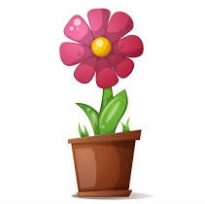

2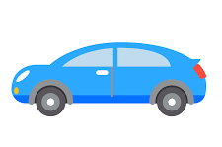

3 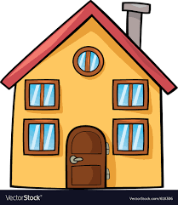
-8 DON’T KNOW
-7 REFUSED

Source: Gratale, Maloney, Sangalang & Cappella, 2017
9.4 How much would you like to use this product, even one puff, at any time in the next 6 months?
1 Would not like to use at all
2 Would not like to use
3 Would somewhat not like to use
4 Not sure if I would like to use
5 Would somewhat like to use
6 Would like to use
7 Would like to use very much
-8 Don’t know
-7 Refused

Source: Gratale, Maloney, Sangalang & Cappella, 2017
9.5 How likely are you to try this product if it were offered to you?
1 Definitely will not try
2 Will not try
3 Probably will not try
4 Not sure if I will try
5 Probably will try
6 Will try
7 Definitely will try
-8 [Don’t know]
-7 Refused

Source: Adapted from PATH ID R04_AE9050
9.6 How harmful do you think this product is to health?
1 Not at all harmful
2 Slightly harmful
3 Somewhat harmful
4 Very harmful
5 Extremely harmful
-8 DON’T KNOW
-7 REFUSED

Source: Adapted from PATH ID R04_AC1110
9.7 How harmful do you think this product is compared to other e-cigarettes?
1 A lot less harmful
2 A little less harmful
3 About the same
4 A little more harmful
5 A lot more harmful
-8 DON'T KNOW
-7 REFUSED

Source: Adapted from PATH ID R04_AE9050, used in Moran, Brown et al., 2018 and Moran & Pearson, 2019
9.8 How addictive do you think this product is?
1 Not at all addictive
2 Slightly addictive
3 Somewhat addictive
4 Very addictive
5 Extremely addictive
-8 DON'T KNOW
-7 REFUSED

Source: Adapted from PATH ID R04_AC1110, used in Moran, Brown et al., 2018 and Moran & Pearson, 2019
9.9 How addictive do you think this product is compared to other e-cigarettes?
1 A lot less addictive
2 A little less addictive
3 About the same
4 A little more addictive
5 A lot more addictive
-8 DON'T KNOW
-7 REFUSED

Source: Adapted from PATH ID R04_AE9050 and Pacek, McClernon et al., 2017
9.10 How much nicotine do you think this product has?
1 No nicotine
2 A little nicotine
3 A moderate amount of nicotine
4 A lot of nicotine
5 An extremely high amount of nicotine
-8 DON'T KNOW
-7 REFUSED

Source: Adapted from PATH ID R04_AC1110, used in Moran, Brown et al., 2018 and Moran & Pearson, 2019
9.11 How much nicotine do you think this product has compared to other e-cigarettes?
1 No nicotine
2 A little nicotine
3 A moderate amount of nicotine
4 A lot of nicotine
5 An extremely high amount of nicotine
-8 DON'T KNOW
-7 REFUSED

Source: Gratale, Maloney, Sangalang & Cappella, 2017
9.12 Please click on the slider below and move it to the point on the scale from -3 to +3 to reflect how you would rate [this product] on each of the following features. The numerical representation of your response will appear to the right of the scale as you move the slider.

[Note: These will be displayed as separate items when the survey is programmed online; presented in matrix format here for ease of review only]

Tastes very bad | Tastes bad | Tastes somewhat bad | No opinion | Tastes somewhat good | Tastes good | Tastes very good
Very inexpensive | Inexpensive | Somewhat inexpensive | No opinion | Somewhat expensive | Expensive | Very expensive
Very hard to use | Hard to use | Somewhat hard to use | No opinion | Somewhat easy to use | Easy to use | Very easy to use
Very unenjoyable to use | Unenjoyable to use | Somewhat unenjoyable to use | No opinion | Somewhat enjoyable to use | Enjoyable to use | Very enjoyable to use
Very unpleasant | Unpleasant | Somewhat unpleasant | No opinion | Somewhat pleasant | Pleasant | Very pleasant
Very hard to hide from people | Hard to hide from people | Somewhat hard to hide from people | No opinion | Somewhat easy to hide from people | Easy to hide from people | Very easy to hide from people
Very unlikely to give a strong buzz | Unlikely to give a strong buzz | Somewhat unlikely to give a strong buzz | No opinion | Somewhat likely to give a strong buzz | Likely to give a strong buzz | Very likely to give a strong buzz

Much more harmful to me than smoking cigarettes | More harmful to me than smoking cigarettes | Somewhat more harmful to me than smoking cigarettes | No opinion | Somewhat less harmful to me than smoking cigarettes | Less harmful to me than smoking cigarettes | Much less harmful to me than smoking cigarettes
Much more harmful to people around me than smoking cigarettes | More harmful to people around me than smoking cigarettes | Somewhat more harmful to people around me than smoking cigarettes | No opinion | Somewhat less harmful to people around me than smoking cigarettes | Less harmful to people around me than smoking cigarettes | Much less harmful to people around me than smoking cigarettes
My friends would be very unlikely to use it | My friends would be unlikely to use it | My friends would be somewhat unlikely to use it | No opinion | My friends would be somewhat likely to use it | My friends would be likely to use it | My friends would be very likely to use it
Would make me very unlikely to switch from cigarettes completely [presented to cigarette smokers only] | Would make me unlikely to switch from cigarettes completely [presented to cigarette smokers only] | Would make me somewhat unlikely to switch from cigarettes completely [presented to cigarette smokers only] | No opinion [presented to cigarette smokers only] | Would make me somewhat likely to switch from cigarettes completely [presented to cigarette smokers only] | Would make me likely to switch from cigarettes completely [presented to cigarette smokers only] | Would make me very likely to switch from cigarettes completely [presented to cigarette smokers only]
Very unlikely to increase my concentration | Unlikely to increase my concentration | Somewhat unlikely to increase my concentration | No opinion | Somewhat likely to increase my concentration | Likely to increase my concentration | Very likely to increase my concentration
Very unlikely to help me lose weight | Unlikely to help me lose weight | Somewhat unlikely to help me lose weight | No opinion | Somewhat likely to help me lose weight | Likely to help me lose weight | Very likely to help me lose weight

[Display ads previously shown to participant]
9.14 Please rank these products in order from the one you would MOST like to try, to the one you would LEAST like to try.
[We will talk with survey programmer about best way to format this question]

Section 4. Socio-demographics

Source: Federal Register / Vol. 62, No. 210 / Thursday, October 30, 1997 / Notices 58789
10.1 What is your race/ethnicity? Choose all that apply.
1 American Indian or Alaska Native
2 Asian
3 Black or African American
4 Hispanic or Latino
5 Native Hawaiian or Other Pacific Islander
6 White
-8 PREFER NOT TO SAY/REFUSE TO ANSWER

Source: OMB Guidance
10.2 Do you currently describe yourself as male, female, or transgender?
1 Male
2 Female
3 Transgender
4 None of these
-8 DON'T KNOW
-7 REFUSED

Source: OMB Guidance
10.3 Which of the following best represents how you think of yourself?
1 Lesbian or gay
2 Straight, that is not lesbian or gay
3 Bisexual
4 Something else
-8 I don’t know the answer
-7 REFUSED
ASK: Youth respondents aged 14 and older: 1.1>13.

Source: PATH ID: R04_YM0020
10.4 What grade or year in school did you last complete?
1 4th grade or below
2 5th
3 6th
4 7th
5 8th
6 9th
7 10th
8 11th
9 12th grade
10 Some college, vocational or technical school
11 I am home-schooled
12 My school is ungraded
-8 DON'T KNOW
-7 REFUSED
ASK: Youth: 1.1>12 & <18

Source: PATH ID: R04_AM0018
10.5 What is the highest grade or level of school you have completed?
1 Less than high school
2 Some high school, no diploma
3 GED
4 High school graduate—diploma
5 Some college but no degree
6 Associate degree—occupational/vocational
7 Associate degree—academic program
8 Bachelor’s degree (ex: BA, AB, BS)
9 Master’s degree (ex: MA, MS, MEng, MEd, MSW)
10 Professional school degree (ex: MD, DDS, DVM, JD)
11 Doctorate degree (ex: PhD, EdD)
-8 DON'T KNOW
-7 REFUSED
ASK: Young adults: 1.1>17 & <25

