Form Approved

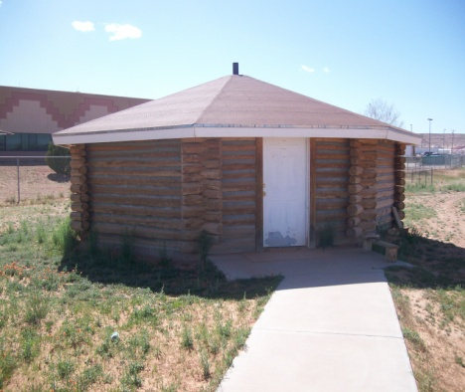OMB Form No. 0917-0036

Expiration Date:

**Office of Native Medicine (ONM) Service Survey**

**Date of Visit**:_____________ **Time**: _________________

Thank you for participating in our ONM Customer Satisfaction Survey today. You are a valued customer and what you have to say is important to us. Please take a moment to let us know how we are doing by filling out this form and giving us your honest feedback.

**Gende**r**:** ___ Male  **Ages**: ___ 5 years and younger ___ 6-17 years ___ 18-34years

___ Female ___ 35-64 years ___ 65-years and older

For each statement below circle the number based on this scale:

**1 2 3 4 5**



Strongly Disagree Neutral Agree Strongly

Disagree Agree

1. I would recommend ONM to my family and friends. **1 2 3 4 5**
2. Usually my health is good. **1 2 3 4 5**
3. I am sure I can take care of my own health. (T’áá hwo ajit’éego) **1 2 3 4 5**
4. The ONM Staff greeted me well today. **1 2 3 4 5**
5. The information given to me today about my health was helpful. **1 2 3 4 5**
6. The Native healer explained things clearly to me during my visit. **1 2 3 4 5**
7. Having Native Medicine services available through IHS is beneficial.**1 2 3 4 5**
8. Did Native Medicine Staff showed good customer services. **1 2 3 4 5**

What did we do well today? ___________________________________________________

What can ONM do better to service patients/clients? _______________________________

**---------------------------------------For Native Medicine Use Only--------------------------------------------**

***Practitioner Name: ___________________*** Revised 7.2015

According to the Paperwork Reduction Act of 1995, no persons are required to respond to a collection of information unless it displays a valid OMB control number. The  valid OMB control number for this information collection is 0917-0036.  The time required to complete this information collection is estimated to average 3 minutes per response, including the time to review instructions, search existing data resources, gather the data needed, and complete and review the information collection. If you have comments concerning the accuracy of the time estimate(s) or suggestions for improving this form, please write to: U.S. Department of Health & Human Services, OS/OCIO/PRA, 200 Independence Ave., S.W., Suite 336E, Washington D.C. 20201, Attention: PRA Reports Clearance Officer.