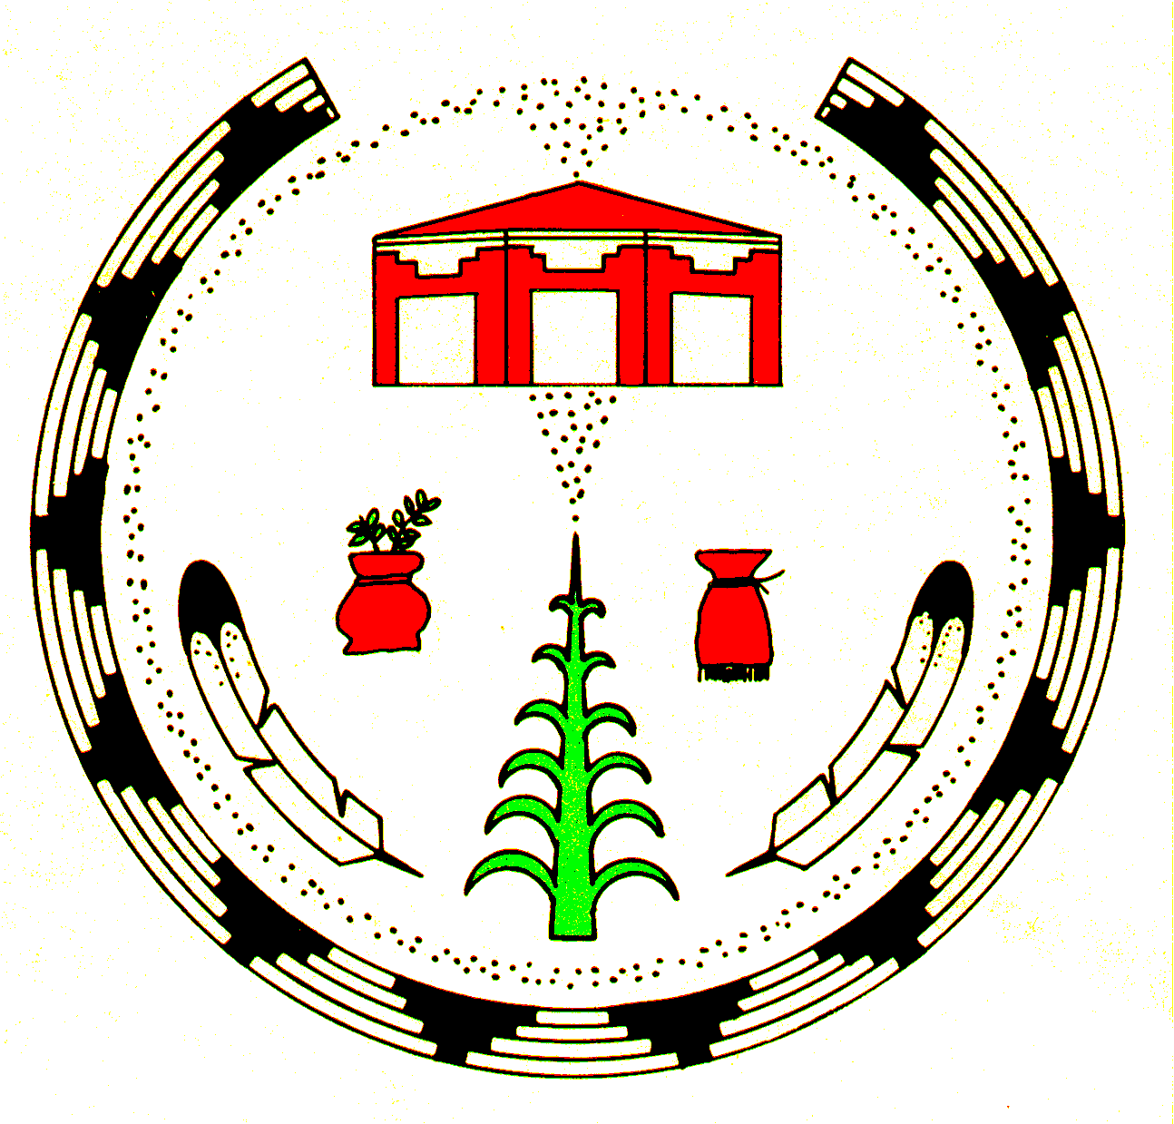**Public Health Nursing**

**Customer Service Survey**

**Care- Giver**

**Patient’s Community/Residence:**

□ Black Mesa/Kitsillie □ Low Mountain □ Cottnwood/Blk Mtn □ Valley Store □ Round Rock

□ Blue Gap/Tachee □ Pinon □ Canyon de Chelly □ Many Farms □ Lukachukai/U. Grswd

□ Burntcorn □ Smoke Signal □ Spider Rock □ Salina Springs □ Tsaile/Black Rock

□ Forest Lake □ Whippoorwill □ Del Muerto □ Rough Rock □ Wheatfields

□ Hard Rock □ Chinle □ Nazlini □ Rock Point □ Other ____________

**Patient’s Gender:** __ Male __ Female

**Patient’s Age:** __ 5 years and younger __ 18 – 34 years __ 65 years and older __ 6 – 17 years __ 35 – 64 years

**For each statement below circle the number based on this scale:**

**1 2 3 4 5**

Strongly Disagree Neutral Agree Strongly

Disagree Agree

1. I would recommend Public Health Nursing (PHN) services to my family and friends **1 2 3 4 5**
2. I am sure I can take care of my patient’s health **1 2 3 4 5**
3. I feel comfortable discussing my patient’s care issues with PHN staff **1 2 3 4 5**
4. The PHN staff helped me make a plan to improve my patient’s health **1 2 3 4 5**
5. I am able to get the care I need for my patient when I need it **1 2 3 4 5**
6. The PHN staff treated me and my patient with courtesy and respect at all times today **1 2 3 4 5**
7. The health information given to me by the PHN staff was explained clearly **1 2 3 4 5**
8. The PHN staff greeted me at the beginning of their visit **1 2 3 4 5**

What did we do well today? _________________________________________________________________

How can we do better? _____________________________________________________________________

**************************************************************************************************

PHN STAFF USE ONLY

* Group Visits □ Family Spirit □ Home Visit □ Flu Clinic □ Other _________________

PHN Staff Name: ­­­­­­­­­­­­­­_________________________________ Date of Visit: _________________________ Revised 04.20.15

According to the Paperwork Reduction Act of 1995, no persons are required to respond to a collection of information unless it displays a valid OMB control number. The   valid OMB control number for this information collection is 0917-0036.  The time required to complete this information collection is estimated to average 3 minutes per response, including the time to review instructions, search existing data resources, gather the data needed, and complete and review the information collection. If you have comments concerning the accuracy of the time estimate(s) or suggestions for improving this form, please write to: U.S. Department of Health & Human Services, OS/OCIO/PRA, 200 Independence Ave., S.W., Suite 336E, Washington D.C. 20201, Attention: PRA Reports Clearance Officer.