Form Approved
OMB No. 0920-0929
Exp. Date XX-XX-XXXX

Petition for the Addition of a New WTC-Related Health Condition for Coverage under the World Trade Center
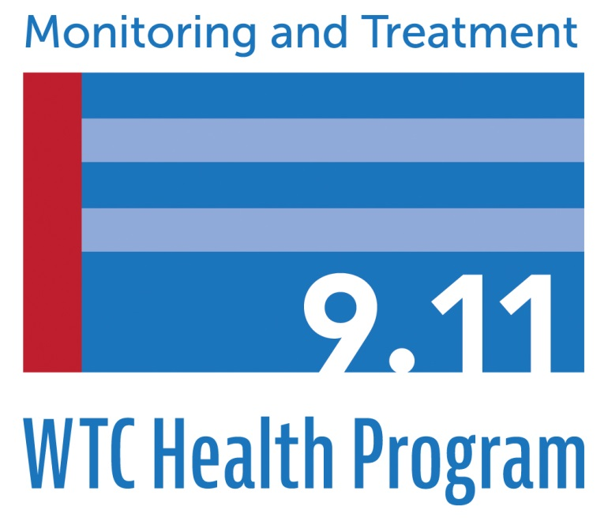
(WTC) Health Program

U.S. Department of Health and Human Services
Centers for Disease Control and Prevention
National Institute for Occupational Safety and Health
General Instructions
Any interested party may petition the WTC Program Administrator to add a condition to the List of WTC-Related Health Conditions (List) in 42 C.F.R. Part 88 (see http://www.cdc.gov/wtc/faq.html#hlthcond for the complete list).

Please use this form to petition the Administrator to add a health condition (any recognized medical condition requiring treatment or medication) to the List. Please use a separate form for each health condition.

Use of this petition form is voluntary, but any petition must include all of the information identified below, as required by 42 C.F.R. Part 88. Petitions that do not provide the required information will not be considered by the WTC Program Administrator. Additional supporting materials may be submitted and are encouraged.

Please note, however, the petition and all supporting materials submitted to the WTC Health Program are part of the public record and may be subject to public disclosure. Personal information will be redacted prior to public disclosure.

Please TYPE or PRINT all information clearly on the form.
If you need more space to provide the required information, please attach additional pages to this form. Mail or email this form to: World Trade Center Health Program
395 E. Street, S.W., Suite 9200
Washington, D.C. 20201 WTC@cdc.gov

Public reporting burden of this collection of information is estimated to average 60 minutes per response, including the time for reviewing instructions, searching existing data sources, gathering and maintaining the data needed, and completing and reviewing the collection of information. An agency may not conduct or sponsor, and a person is not required to respond to a collection of information unless it displays a currently valid OMB control number. Send comments regarding this burden estimate or any other aspect of this collection of information, including suggestions for reducing this burden to CDC/ATSDR Information Collection Review Office, 1600 Clifton Road NE, MS D-74, Atlanta, Georgia 30333; ATTN: PRA (0920-0929).

Interested Party Information
A1. Do you represent an organization (are you submitting this petition on behalf of an organization)? □ Yes (Go to A2) □ No (Go to A3)

A2. Organization Information:

Name of organization

A3. Name of Individual Petitioner or Organization Representative:

First name Last name

Position, if representative of organization

A4. Mailing Address:

Street

City State Zip code

A5. Telephone Number:

A6. Email Address:

- Proposed WTC-Related Health Condition Information

B1. Health Condition Information:

Name of health condition you wish to petition to add to the List of covered conditions

If the name of the condition is not known, please provide a description of the condition or the name of the diagnosis provided by a physician or other healthcare provider.

C. Basis for Proposing that the Condition Be Added to the List of WTC-Related Health Conditions

C1. Describe the reasons the WTC Program Administrator should consider the addition of this health condition. Explain how the health condition you are proposing relates to the exposures that may have occurred from the September 11, 2001, terrorist attacks. Your explanation must include a medical basis for the relationship/association between the 9/11 exposure and the proposed health condition. The medical basis may be demonstrated by reference to a peer-reviewed, published, epidemiologic study about the health condition among 9/11 exposed populations or to clinical case reports of health conditions in WTC responders or survivors. First-hand accounts or anecdotal evidence may not be sufficient to establish medical basis. If you need more space, please attach additional pages to this form.

D. Signature of Petitioner

Sign your name below to indicate that you are petitioning the WTC Program Administrator to consider adding a health condition to the list of WTC-related health conditions identified in 42 C.F.R. Part 88.

Signature Date

Privacy Act Statement

In accordance with the Privacy Act of 1974, as amended (5 U.S.C. § 552a), you are hereby notified of the following:

Title I of the James Zadroga 9/11 Health and Compensation Act of 2010 amended the Public Health Service Act (PHS Act) to establish the World Trade Center (WTC) Health Program. Sections 3311, 3312, and 3321 of Title XXXIII of the PHS Act require that the WTC Program Administrator develop regulations to implement portions of the WTC Health Program established within the Department of Health and Human Services (HHS). The WTC Health Program is administered by the Director of the National Institute for Occupational Safety and Health (NIOSH), within the Centers for Disease Control and Prevention (CDC). The information provided with this form and supporting documentation will be used by the WTC Program Administrator to consider the disposition of a petitioned-for health condition. Disclosure of this information is voluntary.

Records containing information in identifiable form become part of an existing NIOSH system of records under the Privacy Act, 09-20-0147, “Occupational Health Epidemiological Studies and EEOICPA Program Records and WTC Health Program Records, HHS/CDC/NIOSH.” These records are treated in a confidential manner, unless otherwise compelled by law.

Information submitted to WTC Health Program which may be considered “protected health information” pursuant to the Health Insurance Portability and Accountability Act of 1996 (HIPAA) (Pub. L. 104–191; 42 U.S.C. § 1320d) and the HIPAA Privacy, Security, Breach Notification, and Enforcement Rules (45 C.F.R. pts. 160, 162, and 164) will be maintained in accordance with all applicable laws.

NIOSH may disclose information in identifiable form only insofar as such disclosure is permitted pursuant to the HIPAA Privacy Rule; this may include disclosure to the WTC Health Program Scientific/Technical Advisory Committee (STAC), which may be asked to consider the petition and issue a recommendation to the WTC Program Administrator. Information in identifiable form will be redacted from submitted petition forms and supporting documentation that become a part of the public record (e.g. in conjunction with STAC consideration or a rulemaking).

