General Disenrollment and Decertification Letter

WTC Health Program
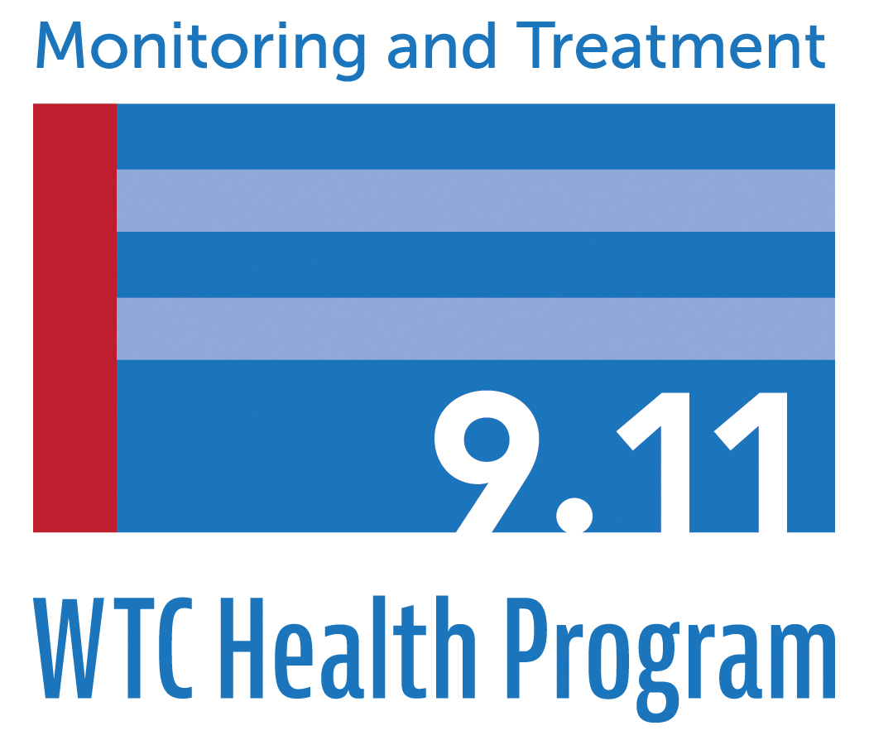
PO Box 7002
Rensselaer, NY 12144

XXXXXXXXXXXX
Address
Address

Re: 911XXXXXX
Dear XXXXXXX:

Following a review of your application and related documents for enrollment, the World Trade Center (WTC) Health Program has determined that the initial decision to enroll you as a member of the WTC Health Program was incorrect. After careful consideration of your application and relevant documents, I regret to inform you that we have determined that you are not eligible for enrollment under the requirements specified in Sections 3311 or 3321 of Title XXXIII of the Public Health Service Act (the James Zadroga 9/11 Health and Compensation Act), 42 U.S.C. §§ 300mm-21 or 300mm-31.
The determination that you are not eligible was based on the following reason(s):

[Insert Reason using templates for enrollment denial letters]

This determination means that you will be unenrolled as a member of the WTC Health Program and the condition(s) for which you have been certified, XXXX, will be decertified. Because the WTC Health Program may only provide treatment for eligible members with certified conditions, this means that the WTC Health Program will no longer pay for any medical treatment or prescriptions for this condition(s). You also are not eligible for any monitoring exams through the WTC Health Program. The [INSERT CCE] will work with you to transition you to a non-WTC Health Program provider for treatment..
Appeal Rights
If you believe the determination to unenroll you from the WTC Health Program was made in error, you or your representative may appeal the denial by sending a written letter to the Administrator, World Trade Center Health Program, at the following address: World Trade Center Health Program, 327 Columbia Turnpike, Rensselaer, NY 12144.
The letter must be sent within 60 calendar days of the date of this letter. The information you submit with your appeal should include a complete explanation of the specific reasons you feel the denial is incorrect. A copy of your original application is included with this letter. You may include with your appeal letter any relevant information in support of your appeal which was not previously provided to the Administrator of the World Trade Center Health Program.
Public reporting burden of this collection of information is estimated to average 90 minutes per response, including the time for reviewing instructions, searching existing data sources, gathering and maintaining the data needed, and completing and reviewing the collection of information. An agency may not conduct or sponsor, and a person is not required to respond to a collection of information unless it displays a currently valid OMB control number. Send comments regarding this burden estimate or any other aspect of this collection of information, including suggestions for reducing this burden to CDC/ATSDR Information Collection Review Office, 1600 Clifton Road NE, MS D-74, Atlanta, Georgia 30333; ATTN: PRA (0920-xxxx).
Please note that all appeal letters must be signed and such signature denotes that the information you have provided is truthful.
If you have any questions, please contact Kecia Leatherwood at 404-498-2529 or call the WTC Health Program toll-free at 1-888-982-4747 and ask to speak to Ms. Leatherwood.
Sincerely,
John Howard, M.D., Administrator, World Trade Center Health Program

