General Disenrollment Letter

WTC Health Program
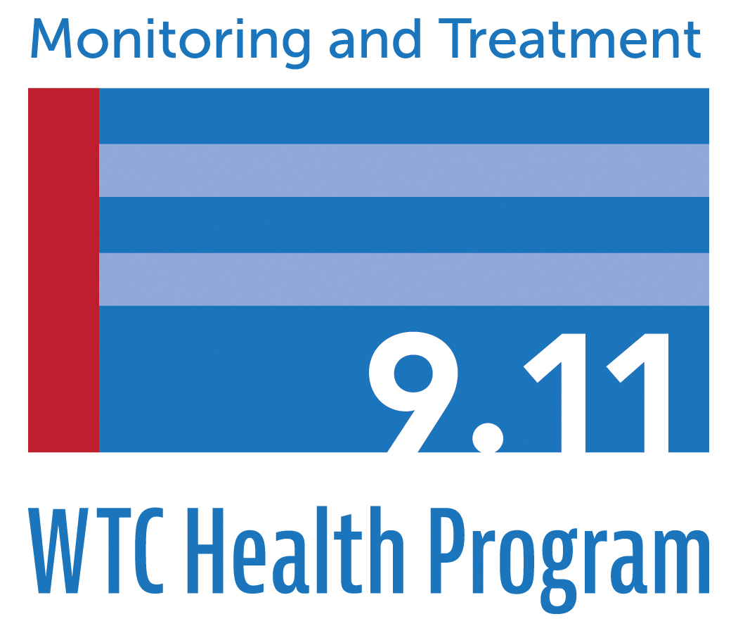
PO Box 7002
Rensselaer, NY 12144

XXXXXXXXXXXX
Address
Address

Re: 911XXXXXX
Dear XXXXXXX:

Following a review of your application and related documents for enrollment, the World Trade Center (WTC) Health Program has determined that the initial decision to enroll you as a member of the WTC Health Program was incorrect. After careful consideration of your application and relevant documents, I regret to inform you that we have determined that you are not eligible for enrollment under the requirements specified in Sections 3311 or 3321 of Title XXXIII of the Public Health Service Act (the James Zadroga 9/11 Health and Compensation Act), 42 U.S.C. §§ 300mm-21 or 300mm-31.
The determination that you are not eligible was based on the following reason(s):

[Insert Reason using templates for enrollment denial letters]

This determination means that you will be unenrolled as a member of the WTC Health Program and are not eligible for any WTC Health Program benefits, including any future screening or monitoring exams.
Appeal Rights
If you believe the determination to unenroll you from the WTC Health Program was made in error, you or your representative may appeal the denial by sending a written letter to the Administrator, World Trade Center Health Program, at the following address: World Trade Center Health Program, 327 Columbia Turnpike, Rensselaer, NY 12144.
The letter must be sent within 60 calendar days of the date of this letter. The information you submit with your appeal should include a complete explanation of the specific reasons you feel the denial is incorrect. A copy of your original application is included with this letter. You may include with your appeal letter any relevant information in support of your appeal which was not previously provided to the Administrator of the WTC Health Program.
Please note that all appeal letters must be signed and such signature denotes that the information you have provided is truthful.
If you have any questions, please contact Kecia Leatherwood at 404-498-2529 or call the WTC Health Program toll-free at 1-888-982-4747 and ask to speak to Ms. Leatherwood.
Sincerely,
John Howard, M.D., Administrator, World Trade Center Health Program

