Fellowship Management System (FMS)
FMS Activity Tracking Module
Privacy Act and Public Burden Information
Privacy Act Information
The Privacy Act applies to this information collection. Information collected will be kept private as noted in the System of Records Notice is 09-20-0112, Fellowship Program and Guest Researcher Records.

Public Burden Information
Form Approved
OMB No. 0920-0765
Exp. Date 03/31/2023

Public reporting burden of this collection of information is an estimated average of 39 minutes per response, including the time for reviewing instructions, searching existing data sources, gathering and maintaining the data needed, and completing and reviewing the collection of information. An agency may not conduct or sponsor, and a person is not required to respond to a collection of information unless it displays a currently valid OMB control number. Send comments regarding this burden estimate or any other aspect of this collection of information, including suggestions for reducing this burden to CDC/ATSDR Reports Clearance Officer; 1600 Clifton Road NE, MS D-74, Atlanta, Georgia 30333; ATTN: PRA (0920-0765).
2020

Table of Contents
Table of Contents 2
1. Introduction 5
1.1 Document Structure 6
2. Sign-In & Sign-Up Pages 7
2.1 Sign-In Page 7
2.2 Sign-Up Page (For New Users) 9
3. eFMS System Help Desk Ticket 10
4. Activity Tracking Welcome Page 12
5. Activity Tracking Profile 13
5.1 General Information 13
5.2 EEP 15
5.3 SAF 20
6. Activities & Projects 21
6.1 EEP 21
6.1.1 Project Goals 21
6.1.2 Project Plan 23
6.1.3 Project Tracking Form 25
6.2 SAF 27
6.2.1 Conference Presentation 27
6.3 ELI 29
6.3.1 Success Story 29
6.3.2 Photo Release 30
7. Surveys 31
7.1 EEP 31
7.1.1 Orientation Survey 31
7.1.2 Student Exit Survey 39
7.2 SAF 67
7.2.1 Summer Course Satisfaction Survey 67
7.2.2 Fellow Exit Survey 85
7.3 LLS 108
7.3.1 Supervisor 1-Year Survey 108
7.3.2 Supervisor Exit Survey 119
7.4 ELI 132
7.4.1 End of Year Survey 132
7.5 EIS 145
7.5.1 Supervisor Exit Survey 145
7.5.2 Supervisor Survey 158
7.5.3 Position Description Survey 166
8. Assessments & Evaluations 176
8.1 EEP 176
8.1.1 Supervisor Evaluation of Student Survey 176
8.1.2 Project Review 186
8.2 LLS 188
8.2.1 Fellow Assessment 188
8.2.2 6-Month CAL Assessment 190
8.2.3 Activity Review 213
8.3 PE 216
8.3.1 Supervisor Evaluation of PE Fellow – End of Year 1 and Year 2 216
8.3.2 Accomplishment Review 229
8.4 PHAP 231
8.4.1 Semi-Annual Activity Reporting (SAAR) 231
8.4.2 Project Review 236
8.5 ELI 245
8.5.1 Mentor Feedback Survey 245
8.6 EIS 252
8.6.1 EIS Progress Assessment 252
8.6.2 Activity Review 255
8.7 PHIFP 258
8.7.1 Project Review 258
9. Appendix 262
I. Field Value Tables 262
II. Lookup Tables 263

Introduction

The purpose of this document is to list all the data elements collected online through the Fellowship Management System (FMS). The FMS activity tracking module is a streamlined mechanism for Centers for Disease Control and Prevention (CDC) fellow, program associates and host site supervisors to submit information online and track statuses of fellowship progression (e.g., CALs, competencies). The FMS is a robust flexible framework and the FMS Activity Tracking Module is tailored successfully for various CDC fellowships:
- Epidemic Intelligence Service (EIS)
- CDC E-learning Institute (ELI)
- Epidemiology Elective Program (EEP)
- Future Leaders in Infections and Global Health Threats (FLIGHT)
- Laboratory Leadership Service (LLS)
- CDC Steven M. Teutsch Prevention Effectiveness (PE) Fellowship
- Public Health Associate Program (PHAP)
- Public Health Informatics Fellowship Program (PHIFP)
- Science Ambassador Fellowship (SAF)

1.1 Document Structure
This document is broken down by the major pages of the FMS Activity Tracking. In this document, each page of the FMS Activity Tracker has sections and some sub-sections. Instructions, login, and registration pages are included. Instructions and emails in the FMS Activity Tracker are tailored to each CDC fellowship’s requirements.
Following the screenshots in each section is a table that shows the status of the collection of data elements by each CDC fellowships. The following labels indicate the status of the collection:
- “Yes” indicates that the fellowship collects the information and that applicants are required to submit this information.
- “No” indicates that the fellowship does not collect this information.
- “-“ indicates open text field
In addition, the table shows the data values of each data element, and for ones that have a list of dropdown values, the data value category is hyperlinked to its list located in the Appendix.

Sign-In & Sign-Up Pages

Sign-In Page

Figure 2.1-a. Sign-In Page
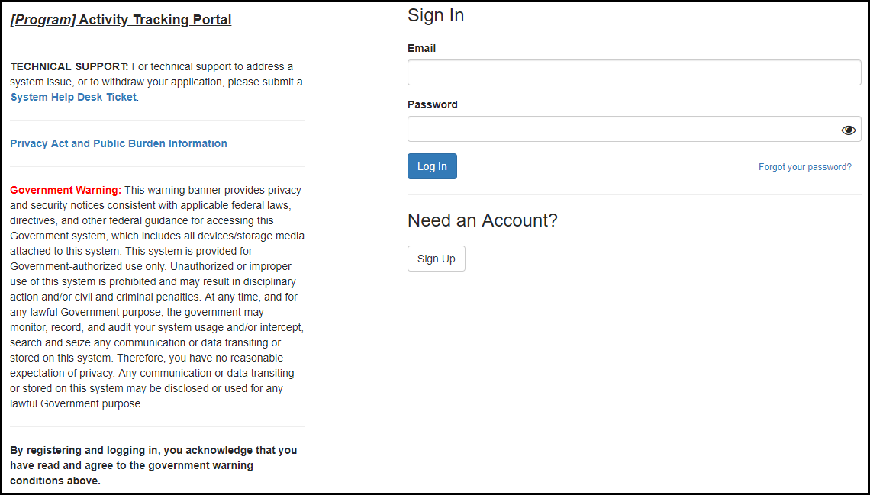

Figure 2.1-b. Privacy Act and Public Burden Information
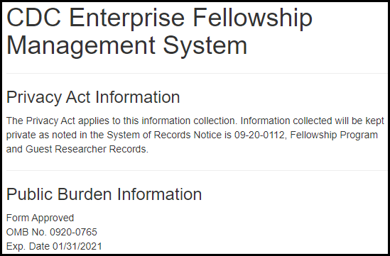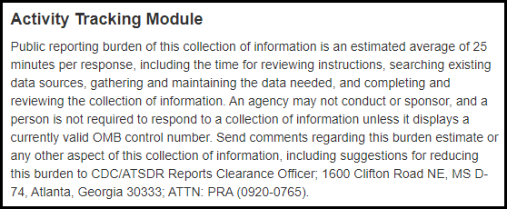
Table 2.1-a. Sign-In Fields
Field | Values | EIS | LLS | FLIGHT | EEP | SAF | PHIFP | PE | ELI | PHAP
Email | - | Yes | Yes | Yes | Yes | Yes | Yes | Yes | Yes | Yes
Password | - | Yes | Yes | Yes | Yes | Yes | Yes | Yes | Yes | Yes

Sign-Up Page (For New Users)

Figure 2.2-a. Sign-Up Fields
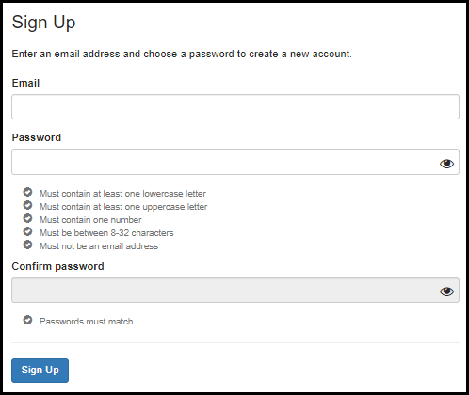
Table 2.2-a. Sign-Up Fields
Field | Values | EIS | LLS | FLIGHT | EEP | SAF | PHIFP | PE | ELI | PHAP
Email | - | Yes | Yes | Yes | Yes | Yes | Yes | Yes | Yes | Yes
Password | - | Yes | Yes | Yes | Yes | Yes | Yes | Yes | Yes | Yes
Confirm Password | - | Yes | Yes | Yes | Yes | Yes | Yes | Yes | Yes | Yes

eFMS System Help Desk Ticket

Figure 3-a. eFMS System Help Desk Ticket Fields
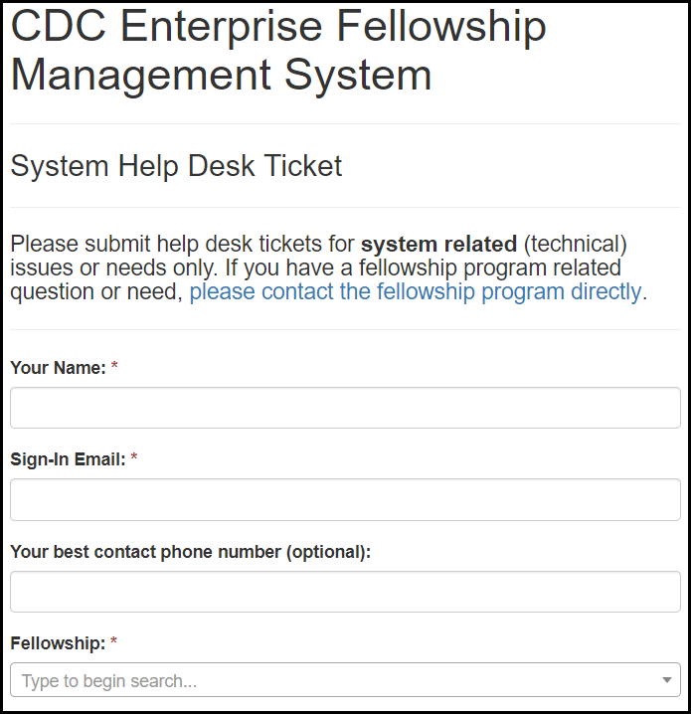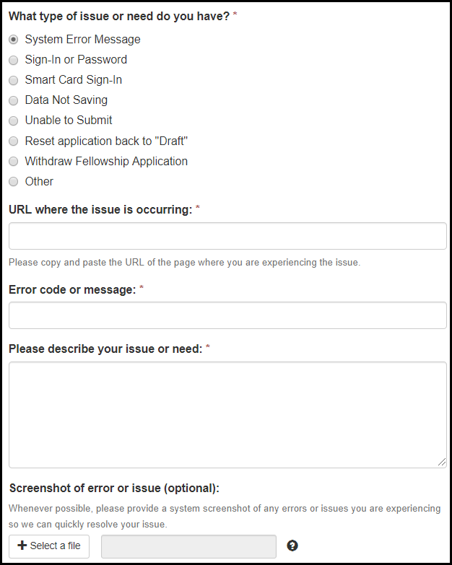

Table 3-a. eFMS System Help Desk Ticket Fields
Field | Values | EIS | LLS | FLIGHT | EEP | SAF | PHIFP | PE | ELI | PHAP
Your Name: | - | Yes | Yes | Yes | Yes | Yes | Yes | Yes | Yes | Yes
Sign-In Email: | - | Yes | Yes | Yes | Yes | Yes | Yes | Yes | Yes | Yes
Contact Phone Number: | - | Yes | Yes | Yes | Yes | Yes | Yes | Yes | Yes | Yes
Fellowship: | Fellowship Lookup Table | Yes | Yes | Yes | Yes | Yes | Yes | Yes | Yes | Yes
What type of issue or need do you have? | 1. System Error Message  2. Sign-In or Password  3. Smart Card Sign-In  4. Data Not Saving  5. Unable to Submit  6. Reset application back to "Draft"  7. Withdraw Fellowship Application  8. Other | Yes | Yes | Yes | Yes | Yes | Yes | Yes | Yes | Yes
URL where the issue is occurring: | - | Yes | Yes | Yes | Yes | Yes | Yes | Yes | Yes | Yes
Error code message: | - | Yes | Yes | Yes | Yes | Yes | Yes | Yes | Yes | Yes
Please describe your issue or need: | - | Yes | Yes | Yes | Yes | Yes | Yes | Yes | Yes | Yes
Screenshot of error or issue (optional): | - | Yes | Yes | Yes | Yes | Yes | Yes | Yes | Yes | Yes

Activity Tracking Welcome Page

Figure 4-a. Application Welcome Page
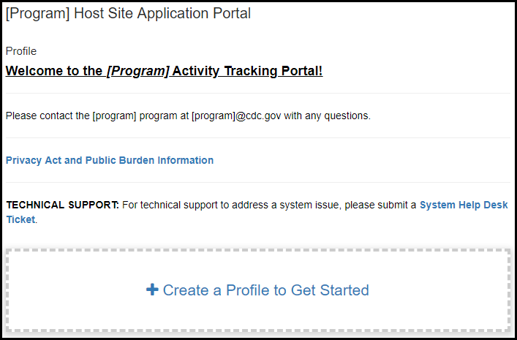

Activity Tracking Profile

General Information

Figure 5.1-a. General Information Fields
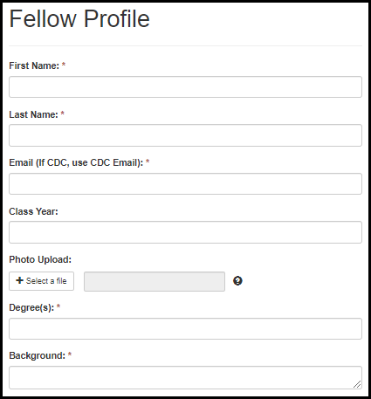

Table 5.1-a. General Information Fields
Field Name | Values | EIS | LLS | FLIGHT | EEP | SAF | PHIFP | PE | ELI | PHAP
First Name: | - | Yes | Yes | Yes | Yes | Yes | Yes | Yes | Yes | Yes
Last Name: | - | Yes | Yes | Yes | Yes | Yes | Yes | Yes | Yes | Yes
CDC Employee? | 1. Yes  2. No | No | No | No | No | No | No | No | No | Yes
Email (If CDC, use CDC Email): | - | Yes | Yes | Yes | Yes | Yes | Yes | Yes | Yes | Yes
Class Year: | - | Yes | Yes | Yes | Yes | Yes | Yes | Yes | Yes | Yes
Photo Upload: | - | Yes | Yes | Yes | Yes | Yes | Yes | Yes | Yes | Yes
Degree(s): | - | Yes | Yes | Yes | Yes | Yes | Yes | Yes | Yes | Yes
Background: | - | Yes | Yes | Yes | Yes | Yes | Yes | Yes | Yes | Yes

5.2 EEP
Figure 5.2-a. EEP Profile Fields
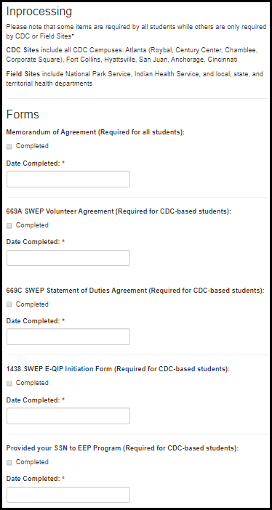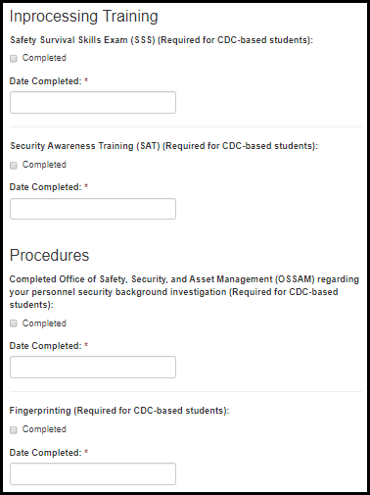

Table 5.2-a. EEP Profile Fields
Field Name | Values | EIS | LLS | FLIGHT | EEP | SAF | PHIFP | PE | ELI | PHAP
Memorandum of Agreement (Required for all students): | 1. Completed | No | No | No | Yes | No | No | No | No | No
Date Completed: | - | No | No | No | Yes | No | No | No | No | No
669A SWEP Volunteer Agreement: | 1. Completed | No | No | No | Yes | No | No | No | No | No
Date Completed: | - | No | No | No | Yes | No | No | No | No | No
669C SWEP Statement of Duties Agreement : | 1. Completed | No | No | No | Yes | No | No | No | No | No
Date Completed: | - | No | No | No | Yes | No | No | No | No | No
1438 SWEP E-QIP Initiation Form: | 1. Completed | No | No | No | Yes | No | No | No | No | No
Date Completed: | - | No | No | No | Yes | No | No | No | No | No
Provided your SSN to EEP Program: | 1. Completed | No | No | No | Yes | No | No | No | No | No
Date Completed: | - | No | No | No | Yes | No | No | No | No | No

Table 5.2-b. EEP Profile Fields
Field Name | Values | EIS | LLS | FLIGHT | EEP | SAF | PHIFP | PE | ELI | PHAP
Safety Survival Skills Exam (SSS) : | 1. Completed | No | No | No | Yes | No | No | No | No | No
Date Completed: | - | No | No | No | Yes | No | No | No | No | No
Security Awareness Training (SAT): | 1. Completed | No | No | No | Yes | No | No | No | No | No
Date Completed: | - | No | No | No | Yes | No | No | No | No | No
Completed Office of Safety, Security, and Asset Management (OSSAM) regarding your personnel security background investigation : | 1. Completed | No | No | No | Yes | No | No | No | No | No
Date Completed: | - | No | No | No | Yes | No | No | No | No | No
Fingerprinting: | 1. Completed | No | No | No | Yes | No | No | No | No | No
Date Completed: | - | No | No | No | Yes | No | No | No | No | No

Figure 5.3-b. EEP Profile Fields
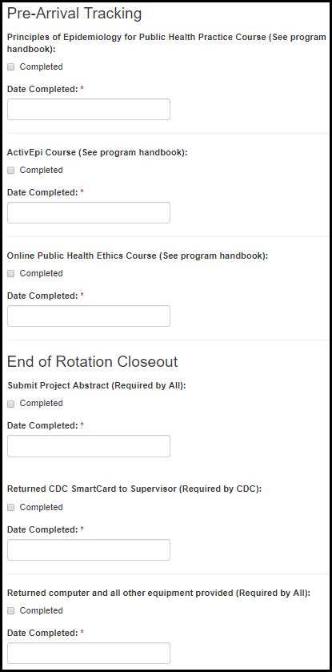

Table 5.3-c. EEP Profile Fields
Field Name | Values | EIS | LLS | FLIGHT | EEP | SAF | PHIFP | PE | ELI | PHAP
Principles of Epidemiology for Public Health Practice Course (See program handbook) (Optional for all students): | 1. Completed | No | No | No | Yes | No | No | No | No | No
Date Completed: | - | No | No | No | Yes | No | No | No | No | No
ActiEpi Course (See program handbook) (Optional for all students): | 1. Completed | No | No | No | Yes | No | No | No | No | No
Date Completed: | - | No | No | No | Yes | No | No | No | No | No
Online Public Health Ethics Course (See program handbook) (Optional for all students): | 1. Completed | No | No | No | Yes | No | No | No | No | No
Date Completed: | - | No | No | No | Yes | No | No | No | No | No
Submit Project Abstract (Required for all students): | 1. Completed | No | No | No | Yes | No | No | No | No | No
Date Completed: | - | No | No | No | Yes | No | No | No | No | No
Return CDC SmartCard to Supervisor (Required for CDC-based students): | 1. Completed | No | No | No | Yes | No | No | No | No | No
Date Completed: | - | No | No | No | Yes | No | No | No | No | No
Return computer and all other equipment provided: | 1. Completed | No | No | No | Yes | No | No | No | No | No
Date Completed: | - | No | No | No | Yes | No | No | No | No | No

5.3 SAF

Figure 5.3-a. SAF Profile Fields
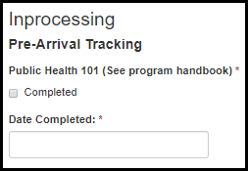

Figure 5.3-a. SAF Profile Fields
Field Name | Values | EIS | LLS | FLIGHT | EEP | SAF | PHIFP | PE | ELI | PHAP
Public Health 101 (See program handbook) | 1. Completed | No | No | No | No | Yes | No | No | No | No
Date Completed: | - | No | No | No | No | Yes | No | No | No | No

Activities & Projects

EEP

6.1.1 Project Goals
Figure 6.1.1-a. EEP Project Goal Fields
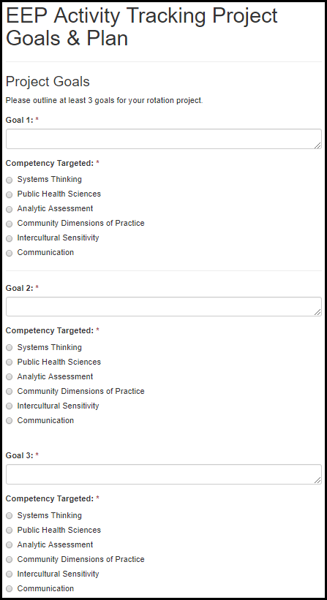

Table 6.1.1-a. EEP Project Goal Fields
Field Name | Values | EIS | LLS | FLIGHT | EEP | SAF | PHIFP | PE | ELI | PHAP
Goal 1: | - | No | No | No | Yes | No | No | No | No | No
Competency Domain Targeted: | 1. Systems Thinking  2. Public Health Sciences  3. Analytic Assessment  4. Community Dimensions of Practice  5. Intercultural Sensitivity  6. Communication | No | No | No | Yes | No | No | No | No | No
Goal 2: | - | No | No | No | Yes | No | No | No | No | No
Competency Domain Targeted: | 1. Systems Thinking  2. Public Health Sciences  3. Analytic Assessment  4. Community Dimensions of Practice  5. Intercultural Sensitivity  6. Communication | No | No | No | Yes | No | No | No | No | No
Goal 3: | - | No | No | No | Yes | No | No | No | No | No
Competency Domain Targeted: | 1. Systems Thinking  2. Public Health Sciences  3. Analytic Assessment  4. Community Dimensions of Practice  5. Intercultural Sensitivity  6. Communication | No | No | No | Yes | No | No | No | No | No

6.1.2 Project Plan

Figure 6.1.2-a. EEP Project Plan Fields
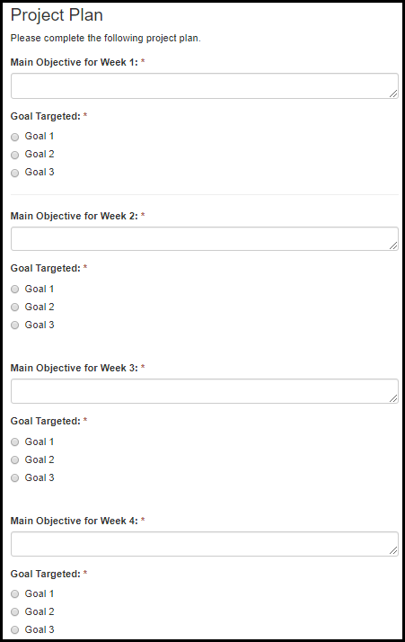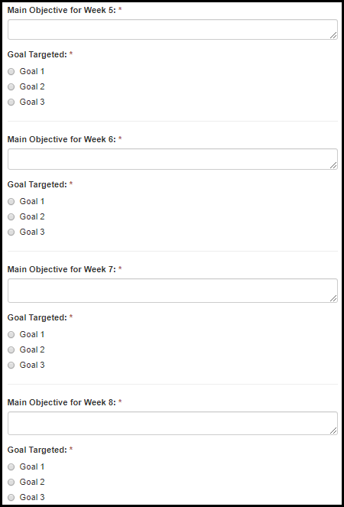

Figure 6.1.2-a. EEP Project Plan Fields
Field Name | Values | EIS | LLS | FLIGHT | EEP | SAF | PHIFP | PE | ELI | PHAP
Main Objective for Week 1: | - | No | No | No | Yes | No | No | No | No | No
Goal Targeted: | 1. Goal 1  2. Goal 2  3. Goal 3 | No | No | No | Yes | No | No | No | No | No
Main Objective for Week 2: | - | No | No | No | Yes | No | No | No | No | No
Goal Targeted: | 1. Goal 1  2. Goal 2  3. Goal 3 | No | No | No | Yes | No | No | No | No | No
Main Objective for Week 3: | - | No | No | No | Yes | No | No | No | No | No
Goal Targeted: | 1. Goal 1  2. Goal 2  3. Goal 3 | No | No | No | Yes | No | No | No | No | No
Main Objective for Week 4: | - | No | No | No | Yes | No | No | No | No | No
Goal Targeted: | 1. Goal 1  2. Goal 2  3. Goal 3 | No | No | No | Yes | No | No | No | No | No
Main Objective for Week 5: | - | No | No | No | Yes | No | No | No | No | No
Goal Targeted: | 1. Goal 1  2. Goal 2  3. Goal 3 | No | No | No | Yes | No | No | No | No | No
Main Objective for Week 6: | - | No | No | No | Yes | No | No | No | No | No
Goal Targeted: | 1. Goal 1  2. Goal 2  3. Goal 3 | No | No | No | Yes | No | No | No | No | No
Main Objective for Week 7: | - | No | No | No | Yes | No | No | No | No | No
Goal Targeted: | 1. Goal 1  2. Goal 2  3. Goal 3 | No | No | No | Yes | No | No | No | No | No
Main Objective for Week 8: | - | No | No | No | Yes | No | No | No | No | No
Goal Targeted: | 1. Goal 1  2. Goal 2  3. Goal 3 | No | No | No | Yes | No | No | No | No | No

6.1.3 Project Tracking Form

Figure 6.1.3-a. EEP Project Tracking Form Fields
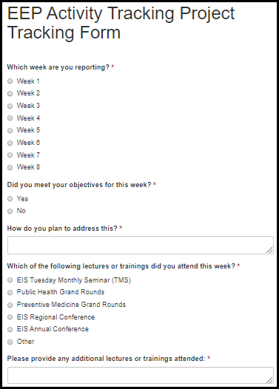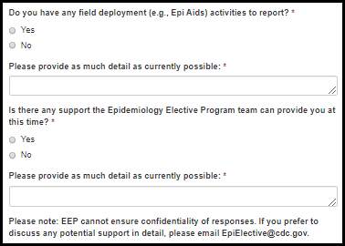

Table 6.1.3-a. EEP Project Tracking Form Fields
Field Name | Values | EIS | LLS | FLIGHT | EEP | SAF | PHIFP | PE | ELI | PHAP
Which week are you reporting? | 1. Week 1  2. Week 2  3. Week 3  4. Week 4  5. Week 5  6. Week 6  7. Week 7  8. Week 8 | No | No | No | Yes | No | No | No | No | No
Did you meet your objectives for this week? | 1. Yes  2. No | No | No | No | Yes | No | No | No | No | No
How do you plan to address this? | - | No | No | No | Yes | No | No | No | No | No
Which of the following lectures or trainings did you attend this week? | 1. EIS Tuesday Monthly Seminar (TMS)  2. Public Health Grand Rounds  3. Preventive Medicine Grand Rounds  4. EIS Regional Conference  5. EIS Annual Conference  6. Other | No | No | No | Yes | No | No | No | No | No
Please provide any additional lectures or trainings attended: | - | No | No | No | Yes | No | No | No | No | No
Do you have any field deployment (e.g., Epi Aids) or large-scale response activities to report? | 1. Yes  2. No | No | No | No | Yes | No | No | No | No | No
Please provide as much detail as currently possible: | - | No | No | No | Yes | No | No | No | No | No
Is there any support the Epidemiology Elective Program team can provide you at this time? | 1. Yes  2. No | No | No | No | Yes | No | No | No | No | No
Please provide as much detail as currently possible: |  | No | No | No | Yes | No | No | No | No | No

SAF

Conference Presentation

Figure 6.2.1-a. Conference Presentation Fields
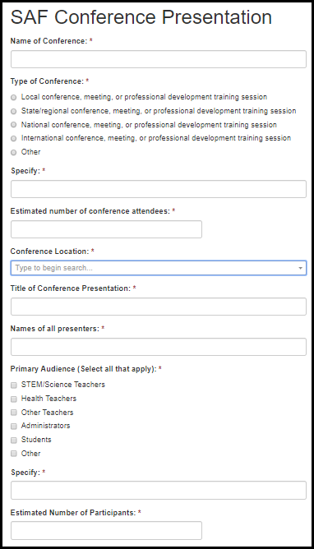

Table 6.2.1-a. Conference Presentation Fields
Field Name | Values | EIS | LLS | FLIGHT | EEP | SAF | PHIFP | PE | ELI | PHAP
Name of Conference: | - | No | No | No | No | Yes | No | No | No | No
Type of Conference: | 1. Local conference, meeting, or professional development training session  2. State/regional conference, meeting, or professional development training session  3. National conference, meeting, or professional development training session  4. International conference, meeting, or professional development training session  5. Other | No | No | No | No | Yes | No | No | No | No
Specify: | - | No | No | No | No | Yes | No | No | No | No
Estimated number of conference attendees: | - | No | No | No | No | Yes | No | No | No | No
Conference Location: | State/Territory Lookup | No | No | No | No | Yes | No | No | No | No
Title of Conference Presentation: | - | No | No | No | No | Yes | No | No | No | No
Number of Presenters: | - | No | No | No | No | Yes | No | No | No | No
Primary Audience (Select all that apply): | 1. STEM/Science Teachers  2. Health Teachers  3. Other Teachers  4. Administrators  5. Students  6. Other | No | No | No | No | Yes | No | No | No | No
Specify: | - | No | No | No | No | Yes | No | No | No | No
Estimated number of presentation attendees: | - | No | No | No | No | Yes | No | No | No | No

ELI

Success Story
Figure 6.3.1-a. Success Story Fields
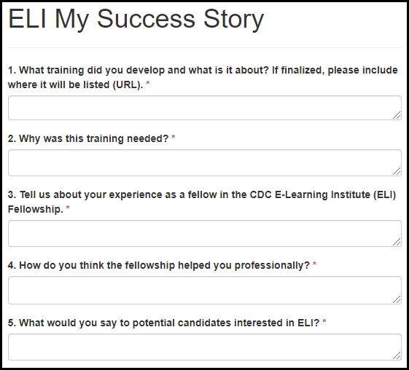
Table 6.3.1-a. Success Story Fields
Field Name | Values | EIS | LLS | FLIGHT | EEP | SAF | PHIFP | PE | ELI | PHAP
1. What training did you develop and what is it about? If finalized, please include where it will be listed (URL). | - | No | No | No | No | No | No | No | Yes | No
2. Why was this training needed? | - | No | No | No | No | No | No | No | Yes | No
3. Tell us about your experience as a fellow in the CDC E-Learning Institute (ELI) Fellowship. | - | No | No | No | No | No | No | No | Yes | No
4. How do you think the fellowship helped you professionally? | - | No | No | No | No | No | No | No | Yes | No
5. What would you say to potential candidates interested in ELI? | - | No | No | No | No | No | No | No | Yes | No

Photo Release

Figure 6.3.2-a. Photo Release Fields
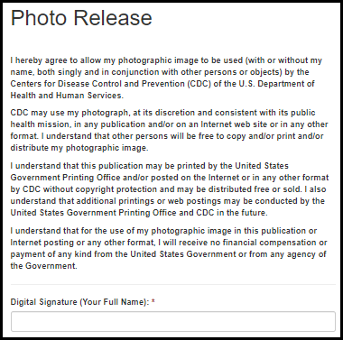
Table 6.3.2-a. Photo Release Fields
Field Name | Values | EIS | LLS | FLIGHT | EEP | SAF | PHIFP | PE | ELI | PHAP
Digital Signature: (Full Name) | - | No | No | No | No | No | No | No | Yes | No

Surveys

EEP

Orientation Survey

Introduction & Orientation Experience

Figure 7.1.1.1.a. Introduction & Orientation Experience Fields
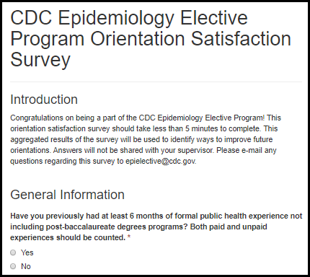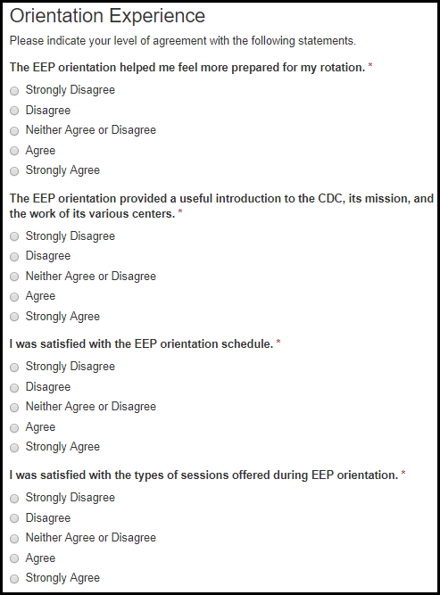

Table 7.1.1.1.a. Introduction & Orientation Experience Fields
Field Name | Values | EIS | LLS | FLIGHT | EEP | SAF | PHIFP | PE | ELI | PHAP
Have you previously had at least 6 months of formal public health experience not including post-baccalaureate degrees programs? Both paid and unpaid experiences should be counted. | 1. Yes  2. No | No | No | No | Yes | No | No | No | No | No
The EEP orientation helped me feel more prepared for my rotation. | 1. Strongly Disagree  2. Disagree  3. Neither Agree or Disagree  4. Agree  5. Strongly Agree | No | No | No | Yes | No | No | No | No | No
The EEP orientation provided a useful introduction to the CDC, its mission, and the work of its various centers. | 1. Strongly Disagree  2. Disagree  3. Neither Agree or Disagree  4. Agree  5. Strongly Agree | No | No | No | Yes | No | No | No | No | No
I was satisfied with the EEP orientation schedule. | 1. Strongly Disagree  2. Disagree  3. Neither Agree or Disagree  4. Agree  5. Strongly Agree | No | No | No | Yes | No | No | No | No | No
I was satisfied with the types of sessions offered during EEP orientation. | 1. Strongly Disagree  2. Disagree  3. Neither Agree or Disagree  4. Agree  5. Strongly Agree | No | No | No | Yes | No | No | No | No | No

Orientation Curriculum

Figure 7.1.1.2.a. Orientation Curriculum Fields
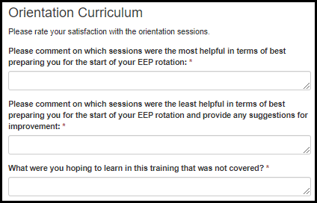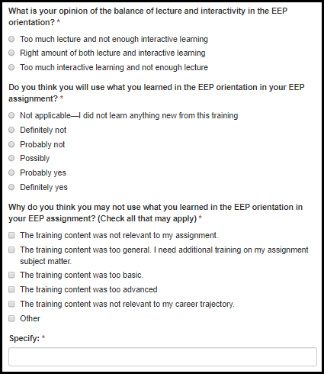
Table 7.1.1.2.a. Orientation Curriculum Fields
Field Name | Values | EIS | LLS | FLIGHT | EEP | SAF | PHIFP | PE | ELI | PHAP
Please comment on which sessions were the most helpful in terms of best preparing you for the start of your EEP rotation: | - | No | No | No | Yes | No | No | No | No | No
Please comment on which sessions were the least helpful in terms of best preparing you for the start of your EEP rotation and provide any suggestions for improvement: | - | No | No | No | Yes | No | No | No | No | No
What were you hoping to learn in this training that was not covered? | - | No | No | No | Yes | No | No | No | No | No
What is your opinion of the balance of lecture and interactivity in the EEP orientation? | 1. Too much lecture and not enough interactive learning  2. Right amount of both lecture and interactive learning  3. Too much interactive learning and not enough lecture | No | No | No | Yes | No | No | No | No | No
Do you think you will use what you learned in the EEP orientation in your EEP assignment? | 1. Not applicable—I did not learn anything new from this training  2. Definitely not  3. Probably not  4. Possibly  5. Probably yes  6. Definitely yes | No | No | No | Yes | No | No | No | No | No
Why do you think you may not use what you learned in the EEP orientation in your EEP assignment? (Check all that may apply) | 1. The training content was not relevant to my assignment.  2. The training content was too general. I need additional training on my assignment subject matter.  3. The training content was too basic.  4. The training content was too advanced  5. The training content was not relevant to my career trajectory.  6. Other | No | No | No | Yes | No | No | No | No | No
Please specify: | - | No | No | No | Yes | No | No | No | No | No

Future Considerations

Figure 7.1.1.3.a. Future Consideration Fields
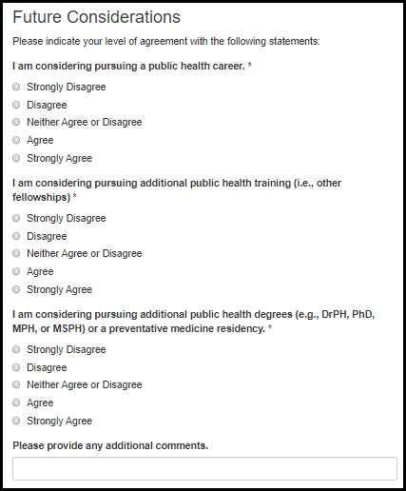

Table 7.1.1.3.a. Future Consideration Fields
Field Name | Values | EIS | LLS | FLIGHT | EEP | SAF | PHIFP | PE | ELI | PHAP
I am considering pursuing a public health career. | 1. Strongly Disagree  2. Disagree  3. Neither Agree or Disagree  4. Agree  5. Strongly Agree | No | No | No | Yes | No | No | No | No | No
I am considering pursuing additional public health training (i.e., other fellowships) | 1. Strongly Disagree  2. Disagree  3. Neither Agree or Disagree  4. Agree  5. Strongly Agree | No | No | No | Yes | No | No | No | No | No
I am considering pursuing additional public health degrees (e.g., DrPH, PhD, MPH, or MSPH) or a preventative medicine residency. | 1. Strongly Disagree  2. Disagree  3. Neither Agree or Disagree  4. Agree  5. Strongly Agree | No | No | No | Yes | No | No | No | No | No
Please provide any additional comments. | - | No | No | No | Yes | No | No | No | No | No

Getting Started

Figure 7.1.1.4.a. Getting Started Fields
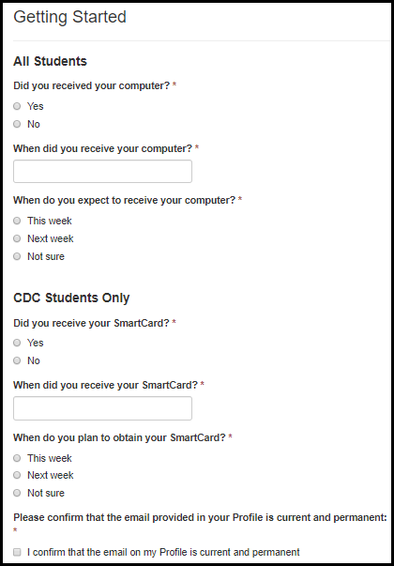

Table 7.1.1.4.a. Getting Started Fields
Field Name | Values | EIS | LLS | FLIGHT | EEP | SAF | PHIFP | PE | ELI | PHAP
Did you receive your computer? | 1. Yes  2. No | No | No | No | Yes | No | No | No | No | No
When did you receive your computer? | - | No | No | No | Yes | No | No | No | No | No
When do you expect to receive your computer? | 1. This week  2. Next week  3. Not sure | No | No | No | Yes | No | No | No | No | No
Did you receive your SmartCard? | 1. Yes  2. No | No | No | No | Yes | No | No | No | No | No
When did you receive your SmartCard? | - | No | No | No | Yes | No | No | No | No | No
When do you expect to receive your SmartCard? | 1. This week  2. Next week  3. Not sure | No | No | No | Yes | No | No | No | No | No
Please confirm that the email provided in your Profile is current and permanent: | 1. I confirm that the email on my Profile is current and permanent | No | No | No | Yes | No | No | No | No | No

Student Exit Survey

Main Project and Supervisor

Figure 7.1.2.1.a. Main Project and Supervisor Fields
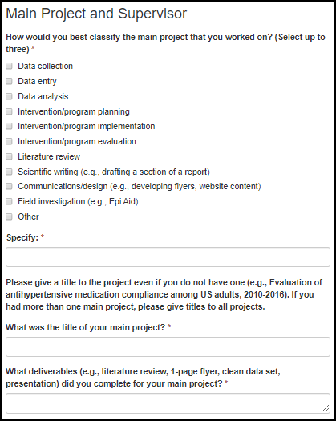

Table 7.1.2.1.a. Main Project and Supervisor Fields
Field Name | Values | EIS | LLS | FLIGHT | EEP | SAF | PHIFP | PE | ELI | PHAP
How would you best classify the main project that you worked on? (Select up to three) | 1. Data collection  2. Data entry  3. Data analysis  4. Intervention/program planning  5. Intervention/program implementation  6. Intervention/program evaluation  7. Literature review  8. Scientific writing (e.g., drafting a section of a report)  9. Communications/design (e.g., developing flyers, website content)  10. Field investigation (e.g., Epi Aid)  11. Other | No | No | No | Yes | No | No | No | No | No
Specify: | - | No | No | No | Yes | No | No | No | No | No
What was the title of your main project? | - | No | No | No | Yes | No | No | No | No | No
What deliverables (e.g., literature review, 1-page flyer, clean data set, presentation) did you complete for your main project? | - | No | No | No | Yes | No | No | No | No | No

Figure 7.1.2.1.b. Main Project and Supervisor Fields
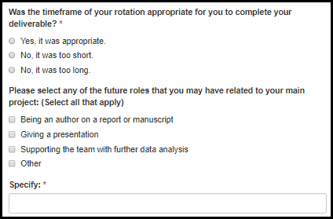
Table 7.1.2.1.b. Main Project and Supervisor Fields
Field Name | Values | EIS | LLS | FLIGHT | EEP | SAF | PHIFP | PE | ELI | PHAP
Was the timeframe of your rotation appropriate for you to complete your deliverables? | 1. Yes, it was appropriate.  2. No, it was too short.  3. No, it was too long. | No | No | No | Yes | No | No | No | No | No
Please select any of the future roles that you may have related to your main project: (Select all that apply) | 1. Being an author on a report or manuscript  2. Giving a presentation  3. Supporting the team with further data analysis  4. Other | No | No | No | Yes | No | No | No | No | No
Specify: | - | No | No | No | Yes | No | No | No | No | No

Figure 7.1.2.1.c. Main Project and Supervisor Fields
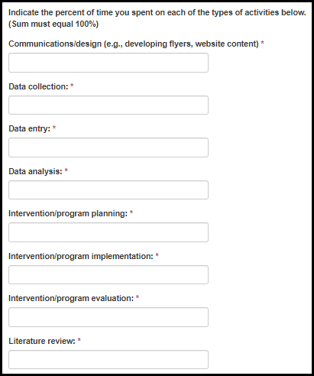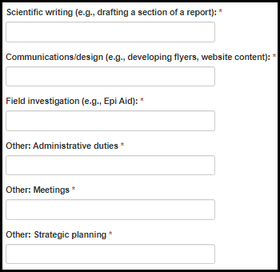
Table 7.1.2.1.c. Main Project and Supervisor Fields
Field Name | Values | EIS | LLS | FLIGHT | EEP | SAF | PHIFP | PE | ELI | PHAP
Data collection: | - | No | No | No | Yes | No | No | No | No | No
Data entry: | - | No | No | No | Yes | No | No | No | No | No
Data analysis: | - | No | No | No | Yes | No | No | No | No | No
Intervention/program planning: | - | No | No | No | Yes | No | No | No | No | No
Intervention/program implementation: | - | No | No | No | Yes | No | No | No | No | No
Intervention/program evaluation: | - | No | No | No | Yes | No | No | No | No | No
Literature review: | - | No | No | No | Yes | No | No | No | No | No
Scientific writing (e.g., drafting a section of a report): | - | No | No | No | Yes | No | No | No | No | No
Communications/design (e.g., developing flyers, website content): | - | No | No | No | Yes | No | No | No | No | No
Field investigation (e.g., Epi Aid): | - | No | No | No | Yes | No | No | No | No | No
Other: Administrative duties | - | No | No | No | Yes | No | No | No | No | No
Other: Meetings | - | No | No | No | Yes | No | No | No | No | No
Other: Strategic planning | - | No | No | No | Yes | No | No | No | No | No

Figure 7.1.2.1.e. Main Project and Supervisor Fields
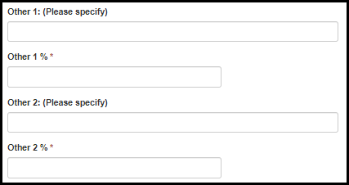
Table 7.1.2.1.e. Main Project and Supervisor Fields
Field Name | Values | EIS | LLS | FLIGHT | EEP | SAF | PHIFP | PE | ELI | PHAP
Other 1: (Please specify) | - | No | No | No | Yes | No | No | No | No | No
Other 1: % | - | No | No | No | Yes | No | No | No | No | No
Other 2: (Please specify) | - | No | No | No | Yes | No | No | No | No | No
Other 2: % | - | No | No | No | Yes | No | No | No | No | No

Figure 7.1.2.1.f. Main Project and Supervisor Fields
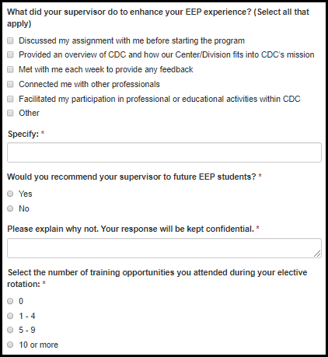

Table 7.1.2.1.f. Main Project and Supervisor Fields
Field Name | Values | EIS | LLS | FLIGHT | EEP | SAF | PHIFP | PE | ELI | PHAP
What did your supervisor do to enhance your EEP experience? (Select all that apply) | 1. Discussed my assignment with me before starting the program  2. Provided an overview of CDC and how our Center/Division fits into CDC’s mission  3. Met with me each week to provide any feedback  4. Connected me with other professionals  5. Facilitated my participation in professional or educational activities within CDC  6. Other | No | No | No | Yes | No | No | No | No | No
Specify: | - | No | No | No | Yes | No | No | No | No | No
Would you recommend your supervisor to future EEP students? | 1. Yes  2. No | No | No | No | Yes | No | No | No | No | No
Please explain why not. Your response will be kept confidential. | - | No | No | No | Yes | No | No | No | No | No
Select the number of training opportunities you attended during your elective rotation: | 1. 0  2. 1-4  3. 5-9  4. 10 or more | No | No | No | Yes | No | No | No | No | No

Figure 7.1.2.1.g. Main Project and Supervisor Fields
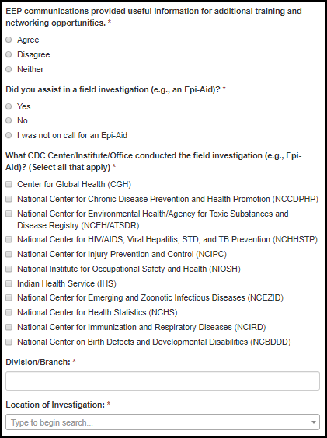

Table 7.1.2.1.g. Main Project and Supervisor Fields
Field Name | Values | EIS | LLS | FLIGHT | EEP | SAF | PHIFP | PE | ELI | PHAP
EEP communications provided useful information for additional training and networking opportunities. | 1. Agree  2. Disagree  3. Neither | No | No | No | Yes | No | No | No | No | No
Did you assist in a field investigation (e.g., an Epi-Aid)? | 1. Yes  2. No | No | No | No | Yes | No | No | No | No | No
What CDC Center/Institute/Office conducted the field investigation (e.g., Epi-Aid)? (Select all that apply) | Center/Division/Branch Lookup | No | No | No | Yes | No | No | No | No | No
Division/Branch: | - | No | No | No | Yes | No | No | No | No | No
Location of Investigation: | State Lookup | No | No | No | Yes | No | No | No | No | No

Figure 7.1.2.1.h. Main Project and Supervisor Fields
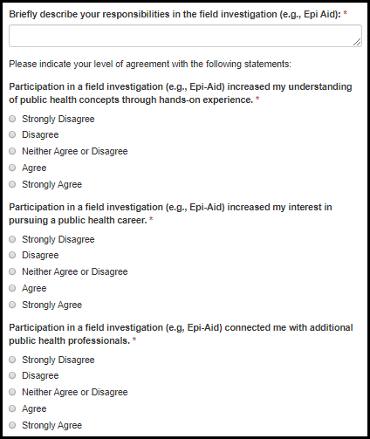

Table 7.1.2.1.h. Main Project and Supervisor Fields
Field Name | Values | EIS | LLS | FLIGHT | EEP | SAF | PHIFP | PE | ELI | PHAP
Briefly describe your responsibilities in the field investigation (e.g., Epi Aid): | - | No | No | No | Yes | No | No | No | No | No
Participation in a field investigation (e.g., Epi-Aid) increased my understanding of public health concepts through hands-on experience. | 1. Strongly Disagree  2. Disagree  3. Neither Agree or Disagree  4. Agree  5. Strongly Agree | No | No | No | Yes | No | No | No | No | No
Participation in a field investigation (e.g., Epi-Aid) increased my interest in pursuing a public health career. | 1. Strongly Disagree  2. Disagree  3. Neither Agree or Disagree  4. Agree  5. Strongly Agree | No | No | No | Yes | No | No | No | No | No
Participation in a field investigation (e.g, Epi-Aid) connected me with additional public health professionals. | 1. Strongly Disagree  2. Disagree  3. Neither Agree or Disagree  4. Agree  5. Strongly Agree | No | No | No | Yes | No | No | No | No | No

Competencies

Figure 7.1.2.2.a. Competency Fields
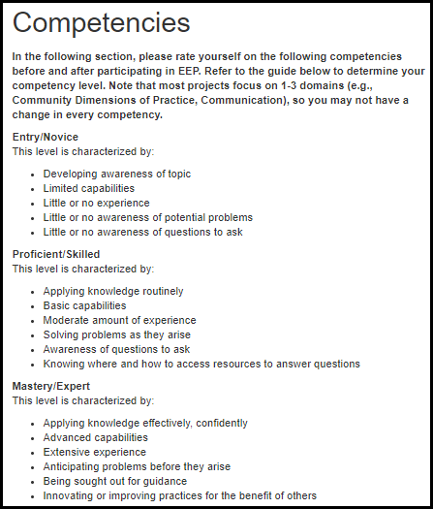

Figure 7.1.2.2.b. Competency Fields
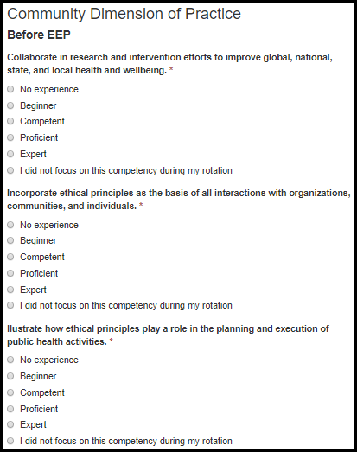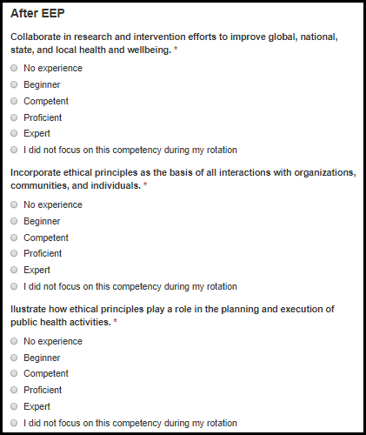

Table 7.1.2.2.a. Competency Fields
Field Name | Values | EIS | LLS | FLIGHT | EEP | SAF | PHIFP | PE | ELI | PHAP
Collaborate in research and intervention efforts to improve global, national, state, and local health and wellbeing. | 1. No experience  2. Beginner  3. Competent  4. Proficient  5. Expert  6. I did not focus on this competency during my rotation | No | No | No | Yes | No | No | No | No | No
Incorporate ethical principles as the basis of all interactions with organizations, communities, and individuals. | 1. No experience  2. Beginner  3. Competent  4. Proficient  5. Expert  6. I did not focus on this competency during my rotation | No | No | No | Yes | No | No | No | No | No
Illustrate how ethical principles play a role in the planning and execution of public health activities. | 1. No experience  2. Beginner  3. Competent  4. Proficient  5. Expert  6. I did not focus on this competency during my rotation | No | No | No | Yes | No | No | No | No | No

Figure 7.1.2.2.b. Competency Fields
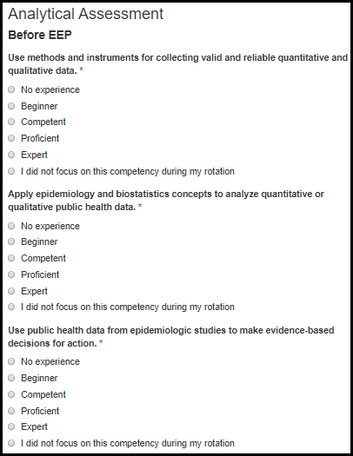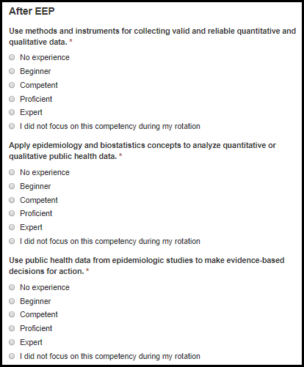

Table 7.1.2.2.b. Competency Fields
Field Name | Values | EIS | LLS | FLIGHT | EEP | SAF | PHIFP | PE | ELI | PHAP
Use methods and instruments for collecting valid and reliable quantitative and qualitative data. | 1. No experience  2. Beginner  3. Competent  4. Proficient  5. Expert  6. I did not focus on this competency during my rotation | No | No | No | Yes | No | No | No | No | No
Apply epidemiology and biostatistics concepts to analyze quantitative or qualitative public health data. | 1. No experience  2. Beginner  3. Competent  4. Proficient  5. Expert  6. I did not focus on this competency during my rotation | No | No | No | Yes | No | No | No | No | No
Use public health data from epidemiologic studies to make evidence-based decisions for action. | 1. No experience  2. Beginner  3. Competent  4. Proficient  5. Expert  6. I did not focus on this competency during my rotation | No | No | No | Yes | No | No | No | No | No

Figure 7.1.2.2.c. Competency Fields
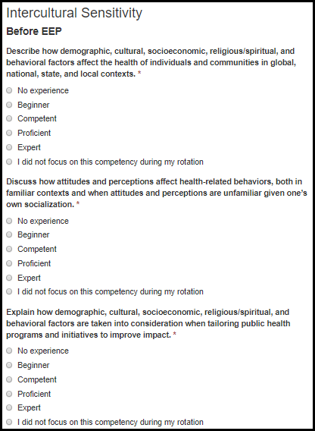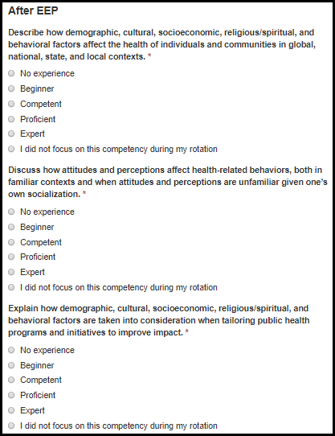

Table 7.1.2.2.c. Competency Fields
Field Name | Values | EIS | LLS | FLIGHT | EEP | SAF | PHIFP | PE | ELI | PHAP
Describe how demographic, cultural, socioeconomic, religious/spiritual, and behavioral factors affect the health of individuals and communities in global, national, state, and local contexts. | 1. No experience  2. Beginner  3. Competent  4. Proficient  5. Expert  6. I did not focus on this competency during my rotation | No | No | No | Yes | No | No | No | No | No
Discuss how attitudes and perceptions affect health-related behaviors, both in familiar contexts and when attitudes and perceptions are unfamiliar given one’s own socialization. | 1. No experience  2. Beginner  3. Competent  4. Proficient  5. Expert  6. I did not focus on this competency during my rotation | No | No | No | Yes | No | No | No | No | No
Explain how demographic, cultural, socioeconomic, religious/spiritual, and behavioral factors are taken into consideration when tailoring public health programs and initiatives to improve impact. | 1. No experience  2. Beginner  3. Competent  4. Proficient  5. Expert  6. I did not focus on this competency during my rotation | No | No | No | Yes | No | No | No | No | No

Figure 7.1.2.2.d. Competency Fields
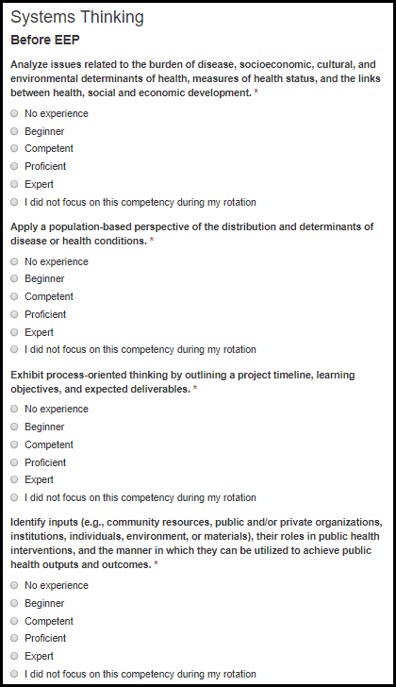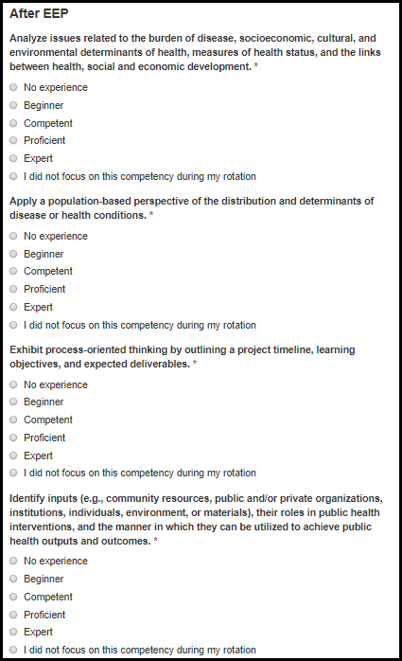

Table 7.1.2.2.d. Competency Fields
Field Name | Values | EIS | LLS | FLIGHT | EEP | SAF | PHIFP | PE | ELI | PHAP
Analyze issues related to the burden of disease, socioeconomic, cultural, and environmental determinants of health, measures of health status, and the links between health, social and economic development. | 1. No experience  2. Beginner  3. Competent  4. Proficient  5. Expert  6. I did not focus on this competency during my rotation | No | No | No | Yes | No | No | No | No | No
Apply a population-based perspective of the distribution and determinants of disease or health conditions. | 1. No experience  2. Beginner  3. Competent  4. Proficient  5. Expert  6. I did not focus on this competency during my rotation | No | No | No | Yes | No | No | No | No | No
Exhibit process-oriented thinking by outlining a project timeline, learning objectives, and expected deliverables. | 1. No experience  2. Beginner  3. Competent  4. Proficient  5. Expert  6. I did not focus on this competency during my rotation | No | No | No | Yes | No | No | No | No | No
Identify inputs (e.g., community resources, public and/or private organizations, institutions, individuals, environment, or materials), their roles in public health interventions, and the manner in which they can be utilized to achieve public health outputs and outcomes. | 1. No experience  2. Beginner  3. Competent  4. Proficient  5. Expert  6. I did not focus on this competency during my rotation | No | No | No | Yes | No | No | No | No | No

Figure 7.1.2.2.e. Competency Fields
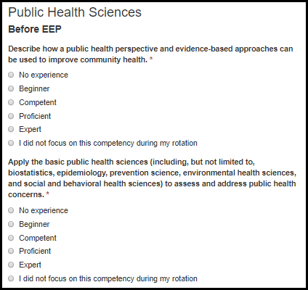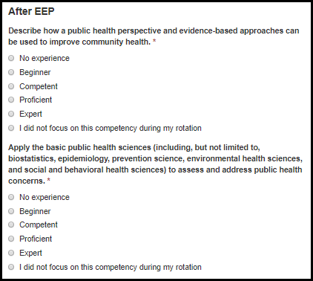

Table 7.1.2.2.e. Competency Fields
Field Name | Values | EIS | LLS | FLIGHT | EEP | SAF | PHIFP | PE | ELI | PHAP
Describe how a public health perspective and evidence-based approaches can be used to improve community health. | 1. No experience  2. Beginner  3. Competent  4. Proficient  5. Expert  6. I did not focus on this competency during my rotation | No | No | No | Yes | No | No | No | No | No
Apply the basic public health sciences (including, but not limited to, biostatistics, epidemiology, prevention science, environmental health sciences, and social and behavioral health sciences) to assess and address public health concerns. | 1. No experience  2. Beginner  3. Competent  4. Proficient  5. Expert  6. I did not focus on this competency during my rotation | No | No | No | Yes | No | No | No | No | No

Figure 7.1.2.2.f. Competency Fields
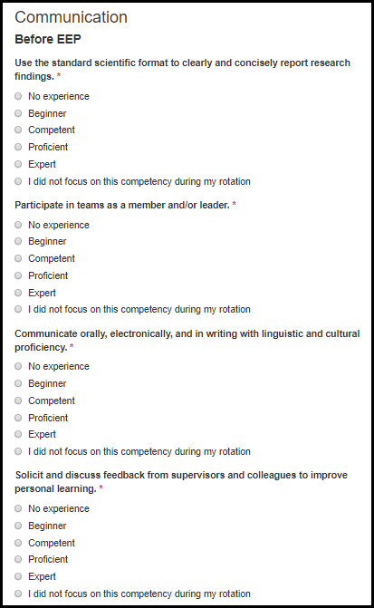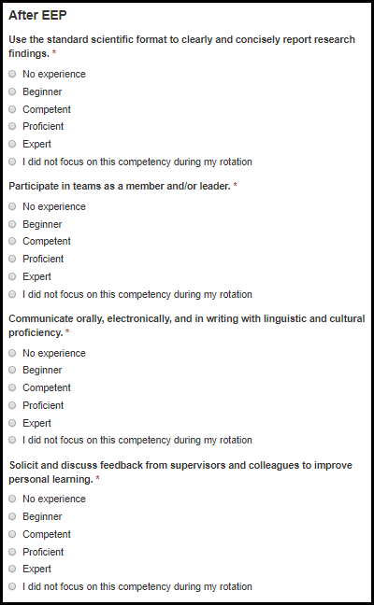

Table 7.1.2.2.f. Competency Fields
Field Name | Values | EIS | LLS | FLIGHT | EEP | SAF | PHIFP | PE | ELI | PHAP
Use the standard scientific format to clearly and concisely report research findings. | 1. No experience  2. Beginner  3. Competent  4. Proficient  5. Expert  6. I did not focus on this competency during my rotation | No | No | No | Yes | No | No | No | No | No
Participate in teams as a member and/or leader. | 1. No experience  2. Beginner  3. Competent  4. Proficient  5. Expert  6. I did not focus on this competency during my rotation | No | No | No | Yes | No | No | No | No | No
Communicate orally, electronically, and in writing with linguistic and cultural proficiency. | 1. No experience  2. Beginner  3. Competent  4. Proficient  5. Expert  6. I did not focus on this competency during my rotation | No | No | No | Yes | No | No | No | No | No
Solicit and discuss feedback from supervisors and colleagues to improve personal learning. | 1. No experience  2. Beginner  3. Competent  4. Proficient  5. Expert  6. I did not focus on this competency during my rotation | No | No | No | Yes | No | No | No | No | No

Future Considerations

Figure 7.1.2.3.a. Future Consideration Fields
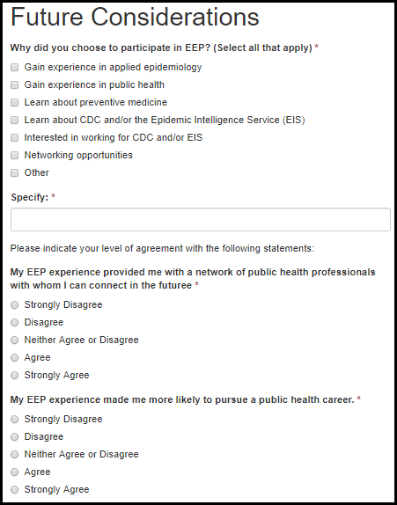

Table 7.1.2.3.a. Future Consideration Fields
Field Name | Values | EIS | LLS | FLIGHT | EEP | SAF | PHIFP | PE | ELI | PHAP
Why did you choose to participate in EEP? (Select all that apply) | 1. Gain experience in applied epidemiology  2. Gain experience in public health  3. Learn about preventive medicine  4. Learn about CDC and/or the Epidemic Intelligence Service (EIS) and other fellowships  5. Interested in working for CDC and/or EIS  6. Networking opportunities  7. Other | No | No | No | Yes | No | No | No | No | No
Please specify: | - | No | No | No | Yes | No | No | No | No | No
My EEP experience provided me with a network of public health professionals with whom I can connect in the future. | 1. Strongly Disagree  2. Disagree  3. Neither Agree or Disagree  4. Agree  5. Strongly Agree | No | No | No | Yes | No | No | No | No | No
My EEP experience made me more likely to pursue a public health career. | 1. Strongly Disagree  2. Disagree  3. Neither Agree or Disagree  4. Agree  5. Strongly Agree | No | No | No | Yes | No | No | No | No | No
My EEP experience made me more likely to incorporate public health perspectives into clinical practice. | 1. Strongly Disagree  2. Disagree  3. Neither Agree or Disagree  4. Agree  5. Strongly Agree | No | No | No | Yes | No | No | No | No | No
My EEP experience made me more likely to pursue additional public health training. | 1. Strongly Disagree  2. Disagree  3. Neither Agree or Disagree  4. Agree  5. Strongly Agree | No | No | No | Yes | No | No | No | No | No

Figure 7.1.2.3.b. Future Consideration Fields
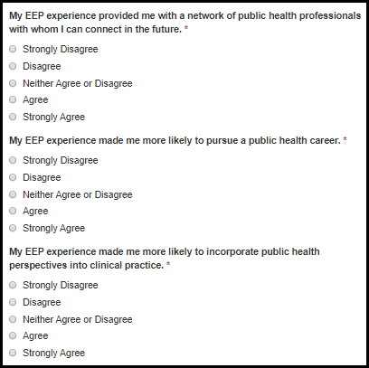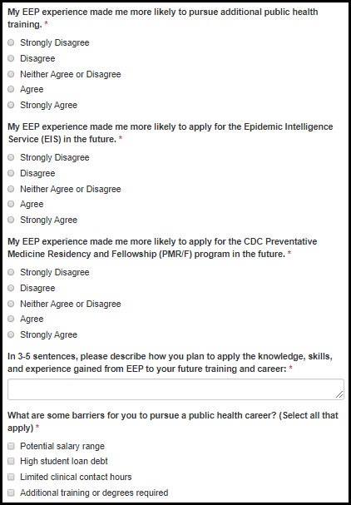

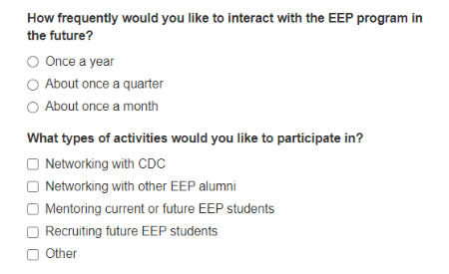
Table 7.1.2.3.b. Future Consideration Fields
Field Name | Values | EIS | LLS | FLIGHT | EEP | SAF | PHIFP | PE | ELI | PHAP
My EEP experience made me more likely to apply for the Epidemic Intelligence Service (EIS) in the future. | 1. Strongly Disagree  2. Disagree  3. Neither Agree or Disagree  4. Agree  5. Strongly Agree | No | No | No | Yes | No | No | No | No | No
My EEP experience made me more likely to apply for the CDC Preventative Medicine Residency and Fellowship (PMR/F) program in the future. | 1. Strongly Disagree  2. Disagree  3. Neither Agree or Disagree  4. Agree  5. Strongly Agree | No | No | No | Yes | No | No | No | No | No
In 3-5 sentences, please describe how you plan to apply the knowledge, skills, and experience gained from EEP to your future training and career: | - | No | No | No | Yes | No | No | No | No | No
What are some barriers for you to pursue a public health career? (Select all that apply) | 1. Potential salary range  2. High student loan debt  3. Limited clinical contact hours  4. Additional training or degrees required | No | No | No | Yes | No | No | No | No | No
Field Name | Values | EIS | LLS | FLIGHT | EEP | SAF | PHIFP | PE | ELI | PHAP
How frequently would you like to interact with the EEP program in the future? | 1. Once a year  2. About once a quarter  3. About once a month | No | No | No | Yes | No | No | No | No | No
What types of activities would you like to participate in? | 1. Networking with CDC  2. Networking with other EEP alumni  3. Mentoring current or future EEP students  4. Recruiting future EEP students  5. Other | No | No | No | Yes | No | No | No | No | No

SAF

Summer Course Satisfaction Survey

Introduction

Figure 7.2.1.1.a. Introduction Fields
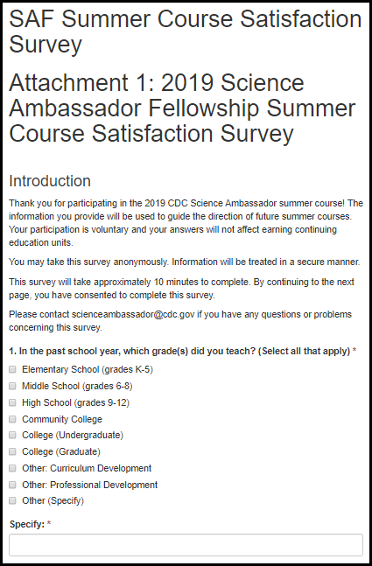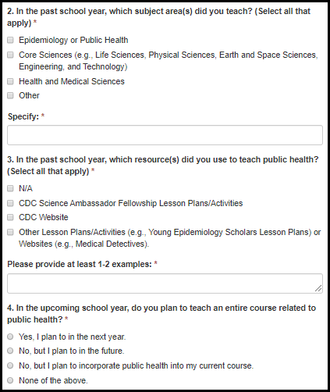

Table 7.2.1.1.a. Introduction Fields
Field Name | Values | EIS | LLS | FLIGHT | EEP | SAF | PHIFP | PE | ELI | PHAP
1. In the past school year, which grade(s) did you teach? (Select all that apply) | 1. Elementary School (grades K-5)  2. Middle School (grades 6-8)  3. High School (grades 9-12)  2. Community College  3. College (Undergraduate)  4. College (Graduate)  5. Other: Curriculum Development  6. Other: Professional Development  7. Other (Specify) | No | No | No | No | Yes | No | No | No | No
Specify: | - | No | No | No | No | Yes | No | No | No | No
2. In the past school year, which subject area(s) did you teach? (Select all that apply) | 1. Epidemiology or Public Health  2. Core Sciences (e.g., Life Sciences, Physical Sciences, Earth and Space Sciences, Engineering, and Technology)  3. Health and Medical Sciences  4. Other | No | No | No | No | Yes | No | No | No | No
Specify: | - | No | No | No | No | Yes | No | No | No | No
3. In the past school year, which resource(s) did you use to teach public health? (Select all that apply) | 1. N/A  2. CDC Science Ambassador Fellowship Lesson Plans/Activities  3. CDC Website  4. Other Lesson Plans/Activities (e.g., Young Epidemiology Scholars Lesson Plans) or Websites (e.g., Medical Detectives). Please provide at least 1-2 examples: | No | No | No | No | Yes | No | No | No | No
Examples: | - | No | No | No | No | Yes | No | No | No | No
4. In the upcoming school year, do you plan to teach an entire course related to public health? | 1. Yes, I plan to in the next year.  2. No, but I plan to in the future.  3. No, but I plan to incorporate public health into my current course.  4. None of the above. | No | No | No | No | Yes | No | No | No | No

Figure 7.2.1.1.b. Introduction Fields
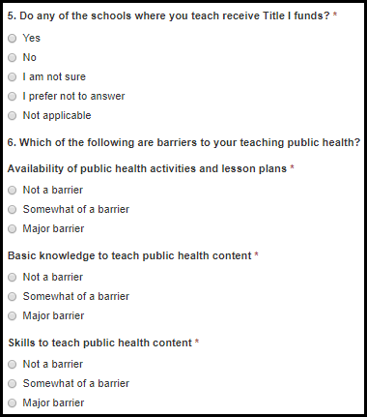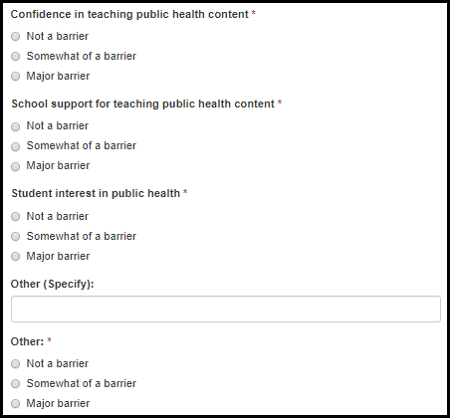

Table 7.2.1.1.b. Introduction Fields
Field Name | Values | EIS | LLS | FLIGHT | EEP | SAF | PHIFP | PE | ELI | PHAP
5. Do any of the schools where you teach receive Title I funds? | 1. Yes  2. No  3. I am not sure  4. I prefer not to answer  5. Not applicable | No | No | No | No | Yes | No | No | No | No
Availability of public health activities and lesson plans | 1. Not a barrier  2. Somewhat of a barrier  3. Major barrier | No | No | No | No | Yes | No | No | No | No
Basic knowledge to teach public health content | 1. Not a barrier  2. Somewhat of a barrier  3. Major barrier | No | No | No | No | Yes | No | No | No | No
Skills to teach public health content | 1. Not a barrier  2. Somewhat of a barrier  3. Major barrier | No | No | No | No | Yes | No | No | No | No
Confidence in teaching public health content | 1. Not a barrier  2. Somewhat of a barrier  3. Major barrier | No | No | No | No | Yes | No | No | No | No
School support for teaching public health content | 1. Not a barrier  2. Somewhat of a barrier  3. Major barrier | No | No | No | No | Yes | No | No | No | No
Student interest in public health | 1. Not a barrier  2. Somewhat of a barrier  3. Major barrier | No | No | No | No | Yes | No | No | No | No
Other (Specify) | 1. Not a barrier  2. Somewhat of a barrier  3. Major barrier | No | No | No | No | Yes | No | No | No | No
Specify: |  | No | No | No | No | Yes | No | No | No | No

Figure 7.2.1.1.c. Introduction Fields
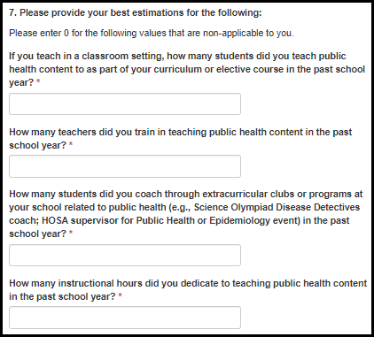

Table 7.2.1.1.c. Introduction Fields
Field Name | Values | EIS | LLS | FLIGHT | EEP | SAF | PHIFP | PE | ELI | PHAP
If you teach in a classroom setting, how many students did you teach public health content to as part of your curriculum or elective course in the past school year? | - | No | No | No | No | Yes | No | No | No | No
How many teachers did you train in teaching public health content in the past school year? | - | No | No | No | No | Yes | No | No | No | No
How many students did you coach through extracurricular clubs or programs at your school related to public health (e.g., Science Olympiad Disease Detectives coach; HOSA supervisor for Public Health or Epidemiology event) in the past school year? | - | No | No | No | No | Yes | No | No | No | No
How many instructional hours did you dedicate to teaching public health content in the past school year? | - | No | No | No | No | Yes | No | No | No | No

Figure 7.2.1.1.d. Introduction Fields
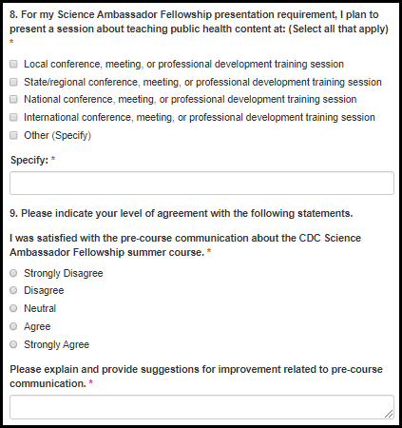

Table 7.2.1.1.d. Introduction Fields
Field Name | Values | EIS | LLS | FLIGHT | EEP | SAF | PHIFP | PE | ELI | PHAP
8. For my Science Ambassador Fellowship presentation requirement, I plan to present a session about teaching public health content at: (Select all that apply) | 1. Local conference, meeting, or professional development training session  2. State/regional conference, meeting, or professional development training session  3. National conference, meeting, or professional development training session  4. International conference, meeting, or professional development training session  5. Other (Specify) | No | No | No | No | Yes | No | No | No | No
Specify: | - | No | No | No | No | Yes | No | No | No | No
I was satisfied with the pre-course communication about the CDC Science Ambassador Fellowship summer course. | 1. Strongly Disagree  2. Disagree  3. Neutral  4. Agree  5. Strongly Agree | No | No | No | No | Yes | No | No | No | No
Please explain and provide suggestions for improvement related to pre-course communication. | - | No | No | No | No | Yes | No | No | No | No

Figure 7.2.1.1.e. Introduction Fields
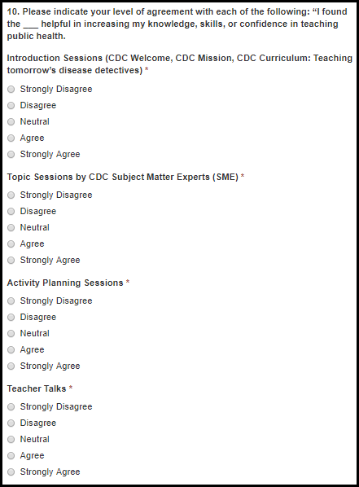

Table 7.2.1.1.e. Introduction Fields
Field Name | Values | EIS | LLS | FLIGHT | EEP | SAF | PHIFP | PE | ELI | PHAP
Introduction Sessions (CDC Welcome, CDC Mission, CDC Curriculum: Teaching tomorrow’s disease detectives) | 1. Strongly Disagree  2. Disagree  3. Neutral  4. Agree  5. Strongly Agree | No | No | No | No | Yes | No | No | No | No
Topic Sessions by CDC Subject Matter Experts (SME) | 1. Strongly Disagree  2. Disagree  3. Neutral  4. Agree  5. Strongly Agree | No | No | No | No | Yes | No | No | No | No
Activity Planning Sessions | 1. Strongly Disagree  2. Disagree  3. Neutral  4. Agree  5. Strongly Agree | No | No | No | No | Yes | No | No | No | No
Teacher Talks | 1. Strongly Disagree  2. Disagree  3. Neutral  4. Agree  5. Strongly Agree | No | No | No | No | Yes | No | No | No | No

Figure 7.2.1.1.f. Introduction Fields
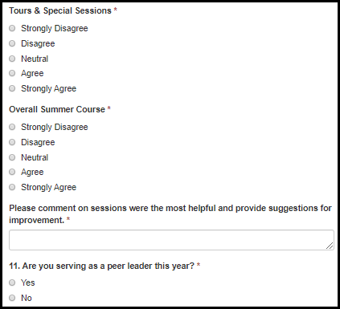

Table 7.2.1.1.f. Introduction Fields
Field Name | Values | EIS | LLS | FLIGHT | EEP | SAF | PHIFP | PE | ELI | PHAP
Tours & Special Sessions | 1. Strongly Disagree  2. Disagree  3. Neutral  4. Agree  5. Strongly Agree | No | No | No | No | Yes | No | No | No | No
Overall Summer Course | 1. Strongly Disagree  2. Disagree  3. Neutral  4. Agree  5. Strongly Agree | No | No | No | No | Yes | No | No | No | No
Please comment on sessions were the most helpful and provide suggestions for improvement. | - | No | No | No | No | Yes | No | No | No | No
11. Are you serving as a peer leader this year? | 1. Yes  2. No | No | No | No | No | Yes | No | No | No | No

Reflection on Fellowship – Fellows

Figure 7.2.1.2.a. Reflection on Fellowship - Fellow Fields
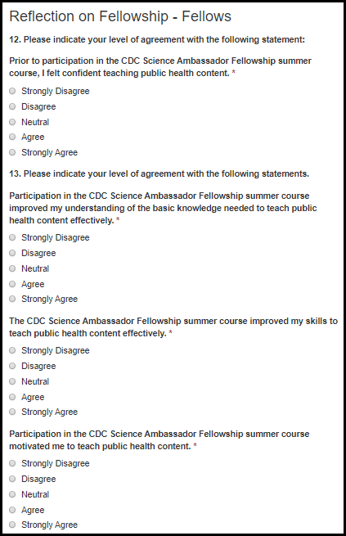

Table 7.2.1.2.a. Reflection on Fellowship - Fellow Fields
Field Name | Values | EIS | LLS | FLIGHT | EEP | SAF | PHIFP | PE | ELI | PHAP
Prior to participation in the CDC Science Ambassador Fellowship summer course, I felt confident teaching public health content. | 1. Strongly Disagree  2. Disagree  3. Neutral  4. Agree  5. Strongly Agree | No | No | No | No | Yes | No | No | No | No
Participation in the CDC Science Ambassador Fellowship summer course improved my understanding of the basic knowledge needed to teach public health content effectively. | 1. Strongly Disagree  2. Disagree  3. Neutral  4. Agree  5. Strongly Agree | No | No | No | No | Yes | No | No | No | No
The CDC Science Ambassador Fellowship summer course improved my skills to teach public health content effectively. | 1. Strongly Disagree  2. Disagree  3. Neutral  4. Agree  5. Strongly Agree | No | No | No | No | Yes | No | No | No | No
Participation in the CDC Science Ambassador Fellowship summer course motivated me to teach public health content. | 1. Strongly Disagree  2. Disagree  3. Neutral  4. Agree  5. Strongly Agree | No | No | No | No | Yes | No | No | No | No

Figure 7.2.1.2.b. Reflection on Fellowship - Fellow Fields
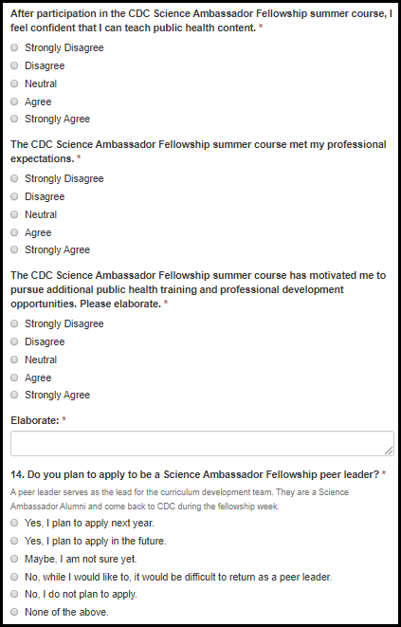

Table 7.2.1.2.b. Reflection on Fellowship - Fellow Fields
Field Name | Values | EIS | LLS | FLIGHT | EEP | SAF | PHIFP | PE | ELI | PHAP
After participation in the CDC Science Ambassador Fellowship summer course, I feel confident that I can teach public health content. | 1. Strongly Disagree  2. Disagree  3. Neutral  4. Agree  5. Strongly Agree | No | No | No | No | Yes | No | No | No | No
The CDC Science Ambassador Fellowship summer course met my professional expectations. | 1. Strongly Disagree  2. Disagree  3. Neutral  4. Agree  5. Strongly Agree | No | No | No | No | Yes | No | No | No | No
The CDC Science Ambassador Fellowship summer course has motivated me to pursue additional public health training and professional development opportunities. Please elaborate. | 1. Strongly Disagree  2. Disagree  3. Neutral  4. Agree  5. Strongly Agree | No | No | No | No | Yes | No | No | No | No
Elaborate: | - | No | No | No | No | Yes | No | No | No | No
14. Do you plan to apply to be a Science Ambassador Fellowship peer leader? | 1. Yes, I plan to apply next year.  2. Yes, I plan to apply in the future.  3. Maybe, I am not sure yet.  4. No, while I would like to, it would be difficult to return as a peer leader.  5. No, I do not plan to apply.  6. None of the above. | No | No | No | No | Yes | No | No | No | No

Reflection on Fellowship – Peer Leaders

Figure 7.2.1.3.a. Reflection on Fellowship – Peer Leader Fields
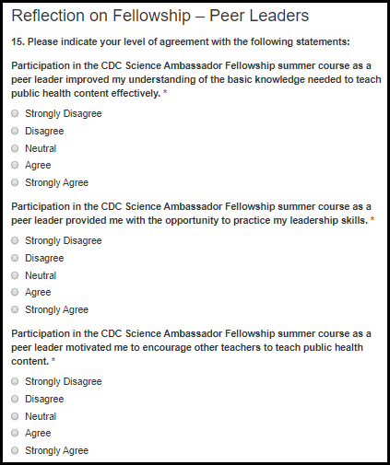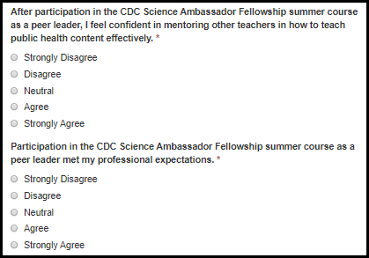

Table 7.2.1.3.a. Reflection on Fellowship – Peer Leader Fields
Field Name | Values | EIS | LLS | FLIGHT | EEP | SAF | PHIFP | PE | ELI | PHAP
Participation in the CDC Science Ambassador Fellowship summer course as a peer leader improved my understanding of the basic knowledge needed to teach public health content effectively. | 1. Strongly Disagree  2. Disagree  3. Neutral  4. Agree  5. Strongly Agree | No | No | No | No | Yes | No | No | No | No
Participation in the CDC Science Ambassador Fellowship summer course as a peer leader provided me with the opportunity to practice my leadership skills. | 1. Strongly Disagree  2. Disagree  3. Neutral  4. Agree  5. Strongly Agree | No | No | No | No | Yes | No | No | No | No
Participation in the CDC Science Ambassador Fellowship summer course as a peer leader motivated me to encourage other teachers to teach public health content. | 1. Strongly Disagree  2. Disagree  3. Neutral  4. Agree  5. Strongly Agree | No | No | No | No | Yes | No | No | No | No
After participation in the CDC Science Ambassador Fellowship summer course as a peer leader, I feel confident in mentoring other teachers in how to teach public health content effectively. | 1. Strongly Disagree  2. Disagree  3. Neutral  4. Agree  5. Strongly Agree | No | No | No | No | Yes | No | No | No | No
Participation in the CDC Science Ambassador Fellowship summer course as a peer leader met my professional expectations. | 1. Strongly Disagree  2. Disagree  3. Neutral  4. Agree  5. Strongly Agree | No | No | No | No | Yes | No | No | No | No

Fellow Exit Survey

Introduction

Figure 7.2.2.1.a. Introduction Fields
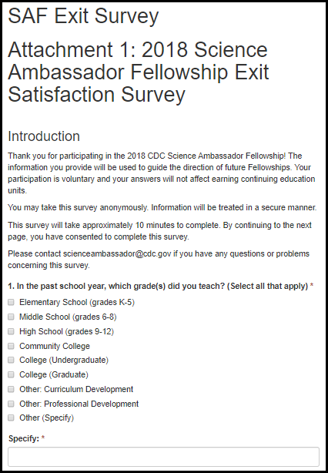

Table 7.2.2.1.a. Introduction Fields
Field Name | Values | EIS | LLS | FLIGHT | EEP | SAF | PHIFP | PE | ELI | PHAP
1. In the past school year, which grade(s) did you teach? (Select all that apply) | 1. Elementary School (grades K-5)  2. Middle School (grades 6-8)  3. High School (grades 9-12)  2. Community College  3. College (Undergraduate)  4. College (Graduate)  5. Other: Curriculum Development  6. Other: Professional Development  7. Other (Specify) | No | No | No | No | Yes | No | No | No | No
Specify: | - | No | No | No | No | Yes | No | No | No | No

Figure 7.2.2.1.b. Introduction Fields
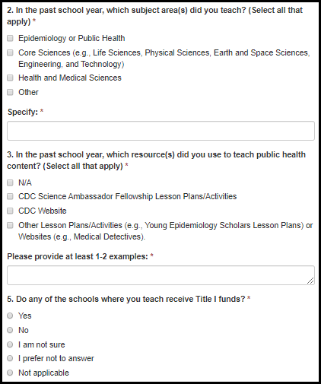

Table 7.2.2.1.b. Introduction Fields
Field Name | Values | EIS | LLS | FLIGHT | EEP | SAF | PHIFP | PE | ELI | PHAP
2. In the past school year, which subject area(s) did you teach? (Select all that apply) | 1. Epidemiology or Public Health  2. Core Sciences (e.g., Life Sciences, Physical Sciences, Earth and Space Sciences, Engineering, Technology, and Applications of Science)  3. Health and Medical Sciences  4. Other (Specify) | No | No | No | No | Yes | No | No | No | No
Specify: |  | No | No | No | No | Yes | No | No | No | No
3. In the past school year, which resource(s) did you use to teach public health content? (Select all that apply) | 1. N/A  2. CDC Science Ambassador Fellowship Lesson Plans/Activities  3. CDC Website  4. Other Lesson Plans/Activities (e.g., Young Epidemiology Scholars Lesson Plans) or Websites (e.g., Medical Detectives). Please provide at least 1-2 examples: | No | No | No | No | Yes | No | No | No | No
Examples: |  | No | No | No | No | Yes | No | No | No | No
4. In the upcoming school year, do you plan to teach an entire course related to public health? | 1. Yes, I plan to in the next year.  2. No, but I plan to in the future.  3. No, but I plan to incorporate public health into my current course.  4. None of the above. | No | No | No | No | Yes | No | No | No | No
5. Do any of the schools where you teach receive Title I funds? | 1. Yes  2. No  3. I am not sure  4. I prefer not to answer  5. Not applicable | No | No | No | No | Yes | No | No | No | No

Figure 7.2.2.1.c. Introduction Fields
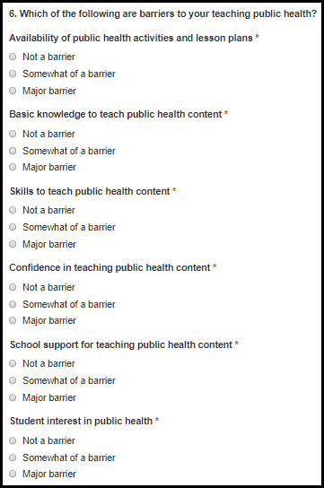

Table 7.2.2.1.c. Introduction Fields
Field Name | Values | EIS | LLS | FLIGHT | EEP | SAF | PHIFP | PE | ELI | PHAP
Availability of public health activities and lesson plans | 1. Not a barrier  2. Somewhat of a barrier  3. Major barrier | No | No | No | No | Yes | No | No | No | No
Basic knowledge to teach public health content | 1. Not a barrier  2. Somewhat of a barrier  3. Major barrier | No | No | No | No | Yes | No | No | No | No
Skills to teach public health content | 1. Not a barrier  2. Somewhat of a barrier  3. Major barrier | No | No | No | No | Yes | No | No | No | No
Confidence in teaching public health content | 1. Not a barrier  2. Somewhat of a barrier  3. Major barrier | No | No | No | No | Yes | No | No | No | No
School support for teaching public health content | 1. Not a barrier  2. Somewhat of a barrier  3. Major barrier | No | No | No | No | Yes | No | No | No | No
Student interest in public health | 1. Not a barrier  2. Somewhat of a barrier  3. Major barrier | No | No | No | No | Yes | No | No | No | No

Figure 7.2.2.1.d. Introduction Fields
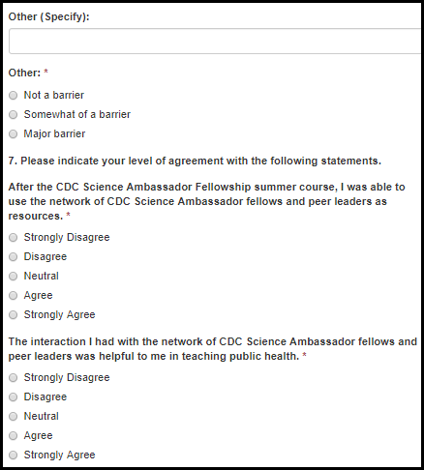

Table 7.2.2.1.d. Introduction Fields
Field Name | Values | EIS | LLS | FLIGHT | EEP | SAF | PHIFP | PE | ELI | PHAP
Other (Specify) | 1. Not a barrier  2. Somewhat of a barrier  3. Major barrier | No | No | No | No | Yes | No | No | No | No
Specify: | - | No | No | No | No | Yes | No | No | No | No
After the CDC Science Ambassador Fellowship summer course, I was able to use the network of CDC Science Ambassador fellows and peer leaders as resources. | 1. Strongly Disagree  2. Disagree  3. Neutral  4. Agree  5. Strongly Agree | No | No | No | No | Yes | No | No | No | No
The interaction I had with the network of CDC Science Ambassador fellows and peer leaders was helpful to me in teaching public health. | 1. Strongly Disagree  2. Disagree  3. Neutral  4. Agree  5. Strongly Agree | No | No | No | No | Yes | No | No | No | No

Figure 7.2.2.1.e. Introduction Fields
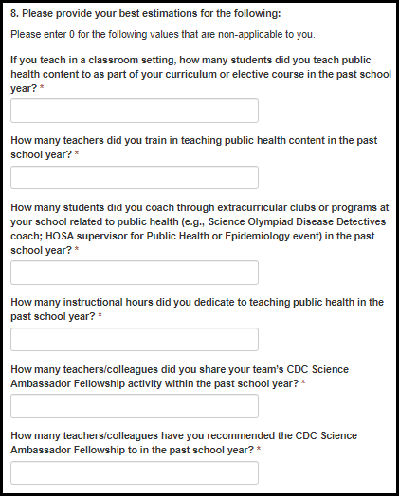

Table 7.2.2.1.e. Introduction Fields
Field Name | Values | EIS | LLS | FLIGHT | EEP | SAF | PHIFP | PE | ELI | PHAP
If you teach in a classroom setting, how many students did you teach public health content to as part of your curriculum or elective course in the past school year? | - | No | No | No | No | Yes | No | No | No | No
How many teachers did you train in teaching public health content in the past school year? | - | No | No | No | No | Yes | No | No | No | No
How many students did you coach through extracurricular clubs or programs at your school related to public health (e.g., Science Olympiad Disease Detectives coach; HOSA supervisor for Public Health or Epidemiology event) in the past school year? | - | No | No | No | No | Yes | No | No | No | No
How many instructional hours did you dedicate to teaching public health in the past school year? | - | No | No | No | No | Yes | No | No | No | No
How many teachers/colleagues did you share your team’s CDC Science Ambassador Fellowship activity within the past school year? | - | No | No | No | No | Yes | No | No | No | No
How many teachers/colleagues have you recommended the CDC Science Ambassador Fellowship to in the past school year? | - | No | No | No | No | Yes | No | No | No | No

Figure 7.2.2.1.f. Introduction Fields
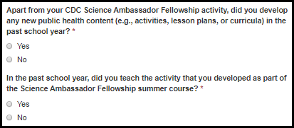

Table 7.2.2.1.f. Introduction Fields
Field Name | Values | EIS | LLS | FLIGHT | EEP | SAF | PHIFP | PE | ELI | PHAP
Apart from your CDC Science Ambassador Fellowship activity, did you develop any new public health content (e.g., activities, lesson plans, or curricula) in the past school year? | 1. Yes  2. No | No | No | No | No | Yes | No | No | No | No
In the past school year, did you teach the activity that you developed as part of the Science Ambassador Fellowship summer course? | 1. Yes  2. No | No | No | No | No | Yes | No | No | No | No

Figure 7.2.2.1.g. Introduction Fields
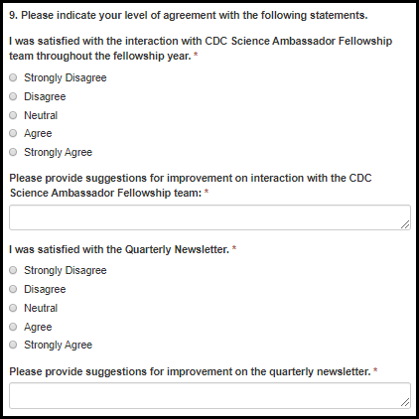

Table 7.2.2.1.g. Introduction Fields
Field Name | Values | EIS | LLS | FLIGHT | EEP | SAF | PHIFP | PE | ELI | PHAP
I was satisfied with the interaction with CDC Science Ambassador Fellowship team throughout the fellowship year. | 1. Strongly Disagree  2. Disagree  3. Neutral  4. Agree  5. Strongly Agree | No | No | No | No | Yes | No | No | No | No
Please provide suggestions for improvement on interaction with the CDC Science Ambassador Fellowship team. | - | No | No | No | No | Yes | No | No | No | No
I was satisfied with the Quarterly Newsletter. | 1. Strongly Disagree  2. Disagree  3. Neutral  4. Agree  5. Strongly Agree | No | No | No | No | Yes | No | No | No | No
Please provide suggestions for improvement on the quarterly newsletter. |  | No | No | No | No | Yes | No | No | No | No

Figure 7.2.2.1.h. Introduction Fields
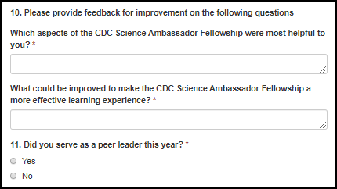

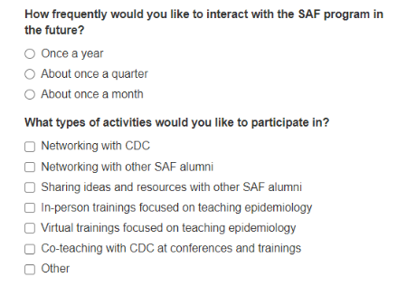
Table 7.2.2.1.h. Introduction Fields
Field Name | Values | EIS | LLS | FLIGHT | EEP | SAF | PHIFP | PE | ELI | PHAP
Which aspects of the CDC Science Ambassador Fellowship were most helpful to you? | - | No | No | No | No | Yes | No | No | No | No
What could be improved to make the CDC Science Ambassador Fellowship a more effective learning experience? | - | No | No | No | No | Yes | No | No | No | No
Did you serve as a peer leader this year? | 1. Yes  2. No | No | No | No | No | Yes | No | No | No | No
How frequently would you like to interact with the SAF program in the future? | 1. Once a year  2. About once a quarter  3. About once a month | No | No | No | No | Yes | No | No | No | No
What types of activities would you like to participate in? | 1. Networking with CDC  2. Networking with other SAF alumni  3. Sharing ideas and resources with other SAF alumni  4. In-person trainings focused on teaching epidemiology  5. Virtual trainings focused on teaching epidemiology  6. Co-teaching with CDC at conferences and trainings  7. Other | No | No | No | No | Yes | No | No | No | No

7.2.2.2 Reflections on Fellowship – Fellows

Figure 7.2.2.2.a. Reflections on Fellowship - Fellow Fields
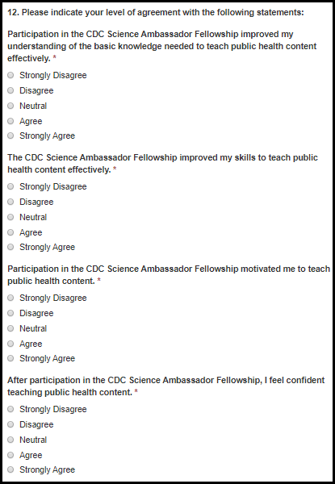

Table 7.2.2.2.a. Reflections on Fellowship - Fellow Fields
Field Name | Values | EIS | LLS | FLIGHT | EEP | SAF | PHIFP | PE | ELI | PHAP
Participation in the CDC Science Ambassador Fellowship improved my understanding of the basic knowledge needed to teach public health content effectively. | 1. Strongly Disagree  2. Disagree  3. Neutral  4. Agree  5. Strongly Agree | No | No | No | No | Yes | No | No | No | No
The CDC Science Ambassador Fellowship improved my skills to teach public health content effectively. | 1. Strongly Disagree  2. Disagree  3. Neutral  4. Agree  5. Strongly Agree | No | No | No | No | Yes | No | No | No | No
Participation in the CDC Science Ambassador Fellowship motivated me to teach public health content. | 1. Strongly Disagree  2. Disagree  3. Neutral  4. Agree  5. Strongly Agree | No | No | No | No | Yes | No | No | No | No
After participation in the CDC Science Ambassador Fellowship, I feel confident teaching public health content. | 1. Strongly Disagree  2. Disagree  3. Neutral  4. Agree  5. Strongly Agree | No | No | No | No | Yes | No | No | No | No

Figure 7.2.2.2.b. Reflections on Fellowship - Fellow Fields
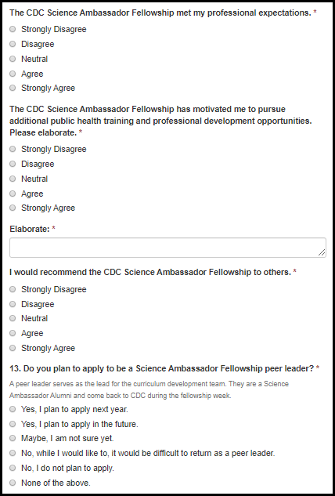

Table 7.2.2.2.b. Reflections on Fellowship - Fellow Fields
Field Name | Values | EIS | LLS | FLIGHT | EEP | SAF | PHIFP | PE | ELI | PHAP
The CDC Science Ambassador Fellowship met my professional expectations. | 1. Strongly Disagree  2. Disagree  3. Neutral  4. Agree  5. Strongly Agree | No | No | No | No | Yes | No | No | No | No
The CDC Science Ambassador Fellowship has motivated me to pursue additional public health training and professional development opportunities. Please elaborate. | 1. Strongly Disagree  2. Disagree  3. Neutral  4. Agree  5. Strongly Agree | No | No | No | No | Yes | No | No | No | No
Elaborate: | - | No | No | No | No | Yes | No | No | No | No
I would recommend the CDC Science Ambassador Fellowship to others. | 1. Strongly Disagree  2. Disagree  3. Neutral  4. Agree  5. Strongly Agree | No | No | No | No | Yes | No | No | No | No
13. Do you plan to apply to be a Science Ambassador Fellowship peer leader? | 1. Yes, I plan to apply next year.  2. Yes, I plan to apply in the future.  3. Maybe, I am not sure yet.  4. No, while I would like to, it would be difficult to return as a peer leader.  5. No, I do not plan to apply.  6. None of the above. | No | No | No | No | Yes | No | No | No | No

7.2.2.3 Reflections on Fellowship – Peer Leaders

Figure 7.2.2.3.a. Reflections on Fellowship – Peer Leader Fields
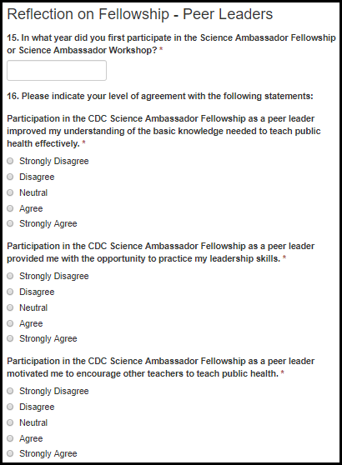

Table 7.2.2.3.a. Reflections on Fellowship – Peer Leader Fields
Field Name | Values | EIS | LLS | FLIGHT | EEP | SAF | PHIFP | PE | ELI | PHAP
14. In what year did you first participate in the Science Ambassador Fellowship or Science Ambassador Workshop? | - | No | No | No | No | Yes | No | No | No | No
Participation in the CDC Science Ambassador Fellowship as a peer leader improved my understanding of the basic knowledge needed to teach public health effectively. | 1. Strongly Disagree  2. Disagree  3. Neutral  4. Agree  5. Strongly Agree | No | No | No | No | Yes | No | No | No | No
Participation in the CDC Science Ambassador Fellowship as a peer leader provided me with the opportunity to practice my leadership skills. | 1. Strongly Disagree  2. Disagree  3. Neutral  4. Agree  5. Strongly Agree | No | No | No | No | Yes | No | No | No | No
Participation in the CDC Science Ambassador Fellowship as a peer leader motivated me to encourage other teachers to teach public health. | 1. Strongly Disagree  2. Disagree  3. Neutral  4. Agree  5. Strongly Agree | No | No | No | No | Yes | No | No | No | No

Figure 7.2.2.3.b. Reflections on Fellowship – Peer Leader Fields
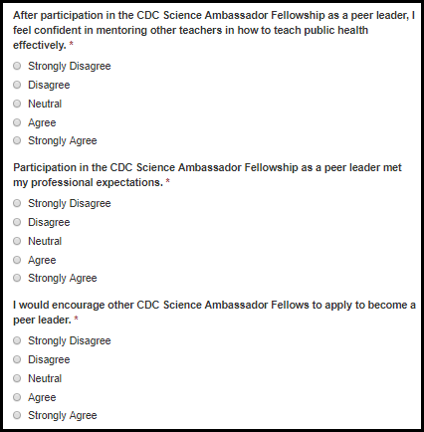

Table 7.2.2.3.b. Reflections on Fellowship – Peer Leader Fields
Field Name | Values | EIS | LLS | FLIGHT | EEP | SAF | PHIFP | PE | ELI | PHAP
After participation in the CDC Science Ambassador Fellowship as a peer leader, I feel confident in mentoring other teachers in how to teach public health effectively. | 1. Strongly Disagree  2. Disagree  3. Neutral  4. Agree  5. Strongly Agree | No | No | No | No | Yes | No | No | No | No
Participation in the CDC Science Ambassador Fellowship as a peer leader met my professional expectations. | 1. Strongly Disagree  2. Disagree  3. Neutral  4. Agree  5. Strongly Agree | No | No | No | No | Yes | No | No | No | No
I would encourage other CDC Science Ambassador Fellows to apply to become a peer leader. | 1. Strongly Disagree  2. Disagree  3. Neutral  4. Agree  5. Strongly Agree | No | No | No | No | Yes | No | No | No | No

LLS

Supervisor 1-Year Survey

Introduction

Figure 7.3.1.1.a. Introduction Fields
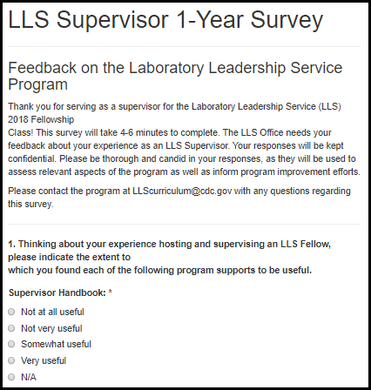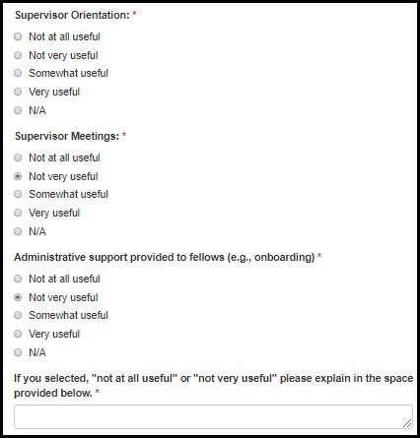

Table 7.3.1.1.a. Introduction Fields
Field Name | Values | EIS | LLS | FLIGHT | EEP | SAF | PHIFP | PE | ELI | PHAP
Supervisor Handbook | 1. Not at all useful  2. Not very useful  3. Somewhat useful  4. Very useful  5. N/A | No | Yes | No | No | No | No | No | No | No
Supervisor Orientation | 1. Not at all useful  2. Not very useful  3. Somewhat useful  4. Very useful  5. N/A | No | Yes | No | No | No | No | No | No | No
Supervisor Meetings | 1. Not at all useful  2. Not very useful  3. Somewhat useful  4. Very useful  5. N/A | No | Yes | No | No | No | No | No | No | No
Administrative support provided to fellows (e.g., onboarding) | 1. Not at all useful  2. Not very useful  3. Somewhat useful  4. Very useful  5. N/A | No | Yes | No | No | No | No | No | No | No
If you selected, "not at all useful" or "not very useful" please explain in the space provided below. |  | No | Yes | No | No | No | No | No | No | No

Figure 7.3.1.1.b. Introduction Fields
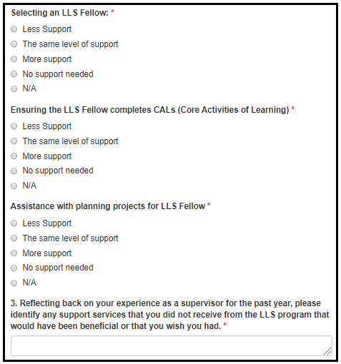

Table 7.3.1.1.b. Introduction Fields
Field Name | Values | EIS | LLS | FLIGHT | EEP | SAF | PHIFP | PE | ELI | PHAP
Selecting an LLS Fellow | 1. Less Support  2. The same level of support  3. More support  4. No support needed  5. N/A | No | Yes | No | No | No | No | No | No | No
Ensuring the LLS Fellow completes CALs (Core Activities of Learning) | 1. Less Support  2. The same level of support  3. More support  4. No support needed  5. N/A | No | Yes | No | No | No | No | No | No | No
Assistance with planning projects for LLS Fellow | 1. Less Support  2. The same level of support  3. More support  4. No support needed  5. N/A | No | Yes | No | No | No | No | No | No | No
If you selected, "less support" or "more support" please specify in the space provided below. | - | No | Yes | No | No | No | No | No | No | No
3. Reflecting back on your experience as a supervisor for the past year, please identify any support services that you did not receive from the LLS program that would have been beneficial or that you wish you had. | - | No | Yes | No | No | No | No | No | No | No

Figure 7.3.1.1.c. Introduction Fields
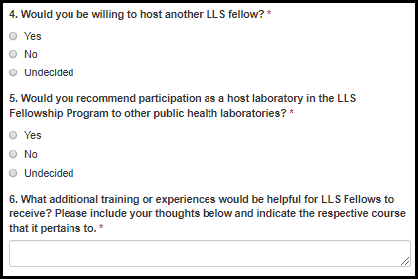
Table 7.3.1.1.c. Introduction Fields
Field Name | Values | EIS | LLS | FLIGHT | EEP | SAF | PHIFP | PE | ELI | PHAP
4. Would you be willing to host another LLS fellow? | 1. No  2. Yes  3. Undecided | No | Yes | No | No | No | No | No | No | No
If you selected, "no" or "undecided" please explain. | - | No | Yes | No | No | No | No | No | No | No
5. Would you recommend participation as a host laboratory in the LLS Fellowship Program to other public health laboratories? | 1. No  2. Yes  3. Undecided | No | Yes | No | No | No | No | No | No | No
If you selected, "no" or "undecided" please explain. | - | No | Yes | No | No | No | No | No | No | No
6. What additional training or experiences would be helpful for LLS Fellows to receive? Please include your thoughts below and indicate the respective course that it pertains to. |  | No | Yes | No | No | No | No | No | No | No

Communication

Figure 7.3.1.2.a. Communication Fields
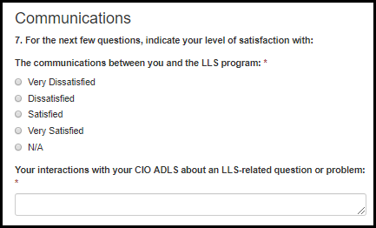
Table 7.3.1.2.a. Communication Fields
Field Name | Values | EIS | LLS | FLIGHT | EEP | SAF | PHIFP | PE | ELI | PHAP
The communications between you and the LLS program. | 1. Very Dissatisfied  2. Dissatisfied  3. Satisfied  4. Very Satisfied  5. Not Applicable | No | Yes | No | No | No | No | No | No | No
Your interactions with your CIO ADLS about an LLS-related question or problem. | - | No | Yes | No | No | No | No | No | No | No

Feedback on Hosting an LLS Fellow

Figure 7.3.1.3.a. Feedback on Hosting an LLS Fellow Fields
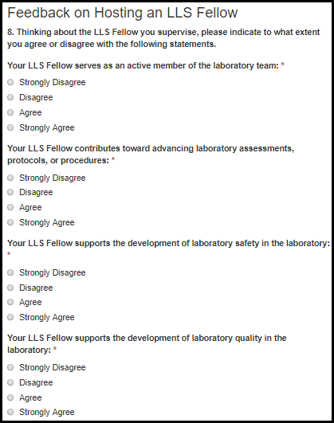

Table 7.3.1.3.a. Feedback on Hosting an LLS Fellow Fields
Field Name | Values | EIS | LLS | FLIGHT | EEP | SAF | PHIFP | PE | ELI | PHAP
Your LLS Fellow serves as an active member of the laboratory team. | 1. Strongly Disagree  2. Disagree  3. Agree  4. Strongly Agree | No | Yes | No | No | No | No | No | No | No
Your LLS Fellow contributes toward advancing laboratory assessments, protocols, or procedures. | 1. Strongly Disagree  2. Disagree  3. Agree  4. Strongly Agree | No | Yes | No | No | No | No | No | No | No
Your LLS Fellow supports the development of laboratory safety in the laboratory. | 1. Strongly Disagree  2. Disagree  3. Agree  4. Strongly Agree | No | Yes | No | No | No | No | No | No | No
Your LLS Fellow supports the development of laboratory quality in the laboratory. | 1. Strongly Disagree  2. Disagree  3. Agree  4. Strongly Agree | No | Yes | No | No | No | No | No | No | No

Figure 7.3.1.3.b. Feedback on Hosting an LLS Fellow Fields
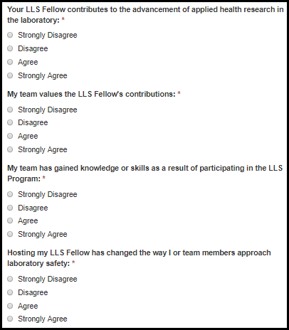

Table 7.3.1.3.b. Feedback on Hosting an LLS Fellow Fields
Field Name | Values | EIS | LLS | FLIGHT | EEP | SAF | PHIFP | PE | ELI | PHAP
Your LLS Fellow contributes to the advancement of applied health research in the laboratory. | 1. Strongly Disagree  2. Disagree  3. Agree  4. Strongly Agree | No | Yes | No | No | No | No | No | No | No
My team values the LLS Fellow's contributions. | 1. Strongly Disagree  2. Disagree  3. Agree  4. Strongly Agree | No | Yes | No | No | No | No | No | No | No
My team has gained knowledge or skills as a result of participating in the LLS Program. | 1. Strongly Disagree  2. Disagree  3. Agree  4. Strongly Agree | No | Yes | No | No | No | No | No | No | No
Hosting my LLS Fellow has changed the way I or team members approach laboratory safety. | 1. Strongly Disagree  2. Disagree  3. Agree  4. Strongly Agree | No | Yes | No | No | No | No | No | No | No

Figure 7.3.1.3.c. Feedback on Hosting an LLS Fellow Fields
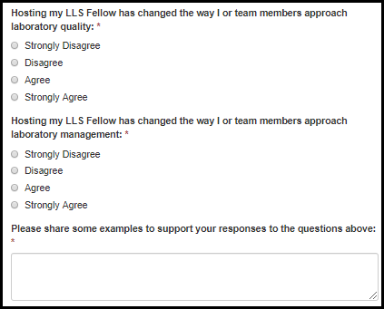
Table 7.3.1.3.c. Feedback on Hosting an LLS Fellow Fields
Field Name | Values | EIS | LLS | FLIGHT | EEP | SAF | PHIFP | PE | ELI | PHAP
Hosting my LLS Fellow has changed the way I or team members approach laboratory quality. | 1. Strongly Disagree  2. Disagree  3. Agree  4. Strongly Agree | No | Yes | No | No | No | No | No | No | No
Hosting my LLS Fellow has changed the way I or team members approach laboratory management. | 1. Strongly Disagree  2. Disagree  3. Agree  4. Strongly Agree | No | Yes | No | No | No | No | No | No | No
Please share some examples to support your responses to the questions above. | - | No | Yes | No | No | No | No | No | No | No

Supervisor Exit Survey

Introduction

Figure 7.3.2.1.a. Introduction Fields
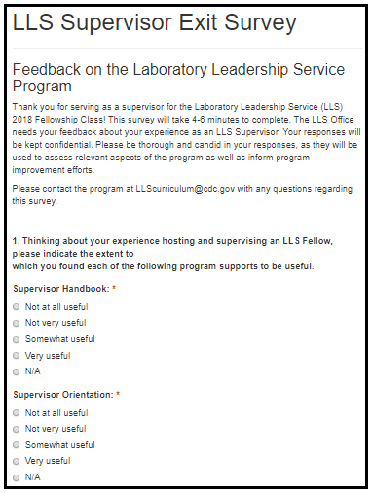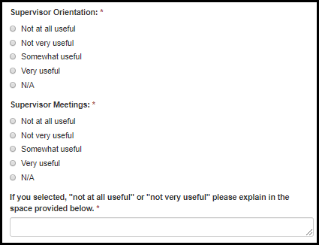

Table 7.3.2.1.a. Introduction Fields
Field Name | Values | EIS | LLS | FLIGHT | EEP | SAF | PHIFP | PE | ELI | PHAP
Supervisor Handbook | 1. Not at all useful  2. Not very useful  3. Somewhat useful  4. Very useful  5. N/A | No | Yes | No | No | No | No | No | No | No
Supervisor Orientation | 1. Not at all useful  2. Not very useful  3. Somewhat useful  4. Very useful  5. N/A | No | Yes | No | No | No | No | No | No | No
Supervisor Meetings | 1. Not at all useful  2. Not very useful  3. Somewhat useful  4. Very useful  5. N/A | No | Yes | No | No | No | No | No | No | No
If you selected, "not at all useful" or "not very useful" please explain in the space provided below. | - | No | Yes | No | No | No | No | No | No | No

Figure 7.3.2.1.b. Introduction Fields
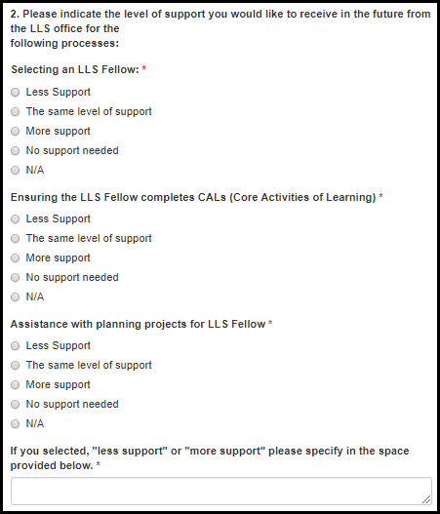

Table 7.3.2.1.b. Introduction Fields
Field Name | Values | EIS | LLS | FLIGHT | EEP | SAF | PHIFP | PE | ELI | PHAP
Selecting an LLS Fellow | 1. Less Support  2. The same level of support  3. More support  4. No support needed  5. N/A | No | Yes | No | No | No | No | No | No | No
Ensuring the LLS Fellow completes CALs (Core Activities of Learning) | 1. Less Support  2. The same level of support  3. More support  4. No support needed  5. N/A | No | Yes | No | No | No | No | No | No | No
Assistance with planning projects for LLS Fellow | 1. Less Support  2. The same level of support  3. More support  4. No support needed  5. N/A | No | Yes | No | No | No | No | No | No | No
If you selected, "less support" or "more support" please specify in the space provided below. | - | No | Yes | No | No | No | No | No | No | No

Figure 7.3.2.1.c. Introduction Fields
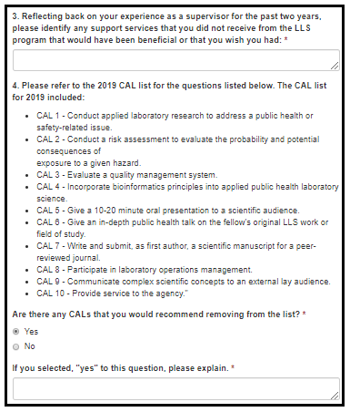

Figure 7.3.2.1.c. Introduction Fields
Field Name | Values | EIS | LLS | FLIGHT | EEP | SAF | PHIFP | PE | ELI | PHAP
3. Reflecting back on your experience as a supervisor for the past two years, please identify any support services that you did not receive from the LLS program that would have been beneficial or that you'd wished you had. | - | No | Yes | No | No | No | No | No | No | No
Are there any CALs that you would recommend removing from the list? | 1. Yes  2. No | No | Yes | No | No | No | No | No | No | No
If you selected, "yes" to either question, please explain. | - | No | Yes | No | No | No | No | No | No | No

Figure 7.3.2.1.d. Introduction Fields
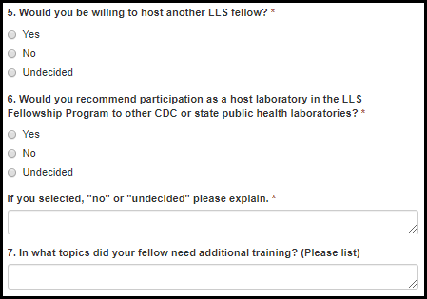
Table 7.3.2.1.d. Introduction Fields
Field Name | Values | EIS | LLS | FLIGHT | EEP | SAF | PHIFP | PE | ELI | PHAP
5. Would you be willing to host another LLS fellow? | 1. Yes  2. No  3. Undecided | No | Yes | No | No | No | No | No | No | No
If you selected, "no" or "undecided" please explain. | - | No | Yes | No | No | No | No | No | No | No
6. Would you recommend participation as a host laboratory in the LLS Fellowship Program to other CDC or state public health laboratories? | 1. Yes  2. No  3. Undecided | No | Yes | No | No | No | No | No | No | No
If you selected, "no" or "undecided" please explain. | - | No | Yes | No | No | No | No | No | No | No
7. In what topics did your fellow need additional training? (Please list) | - | No | Yes | No | No | No | No | No | No | No

Communications

Figure 7.3.2.1.a. Communications Fields
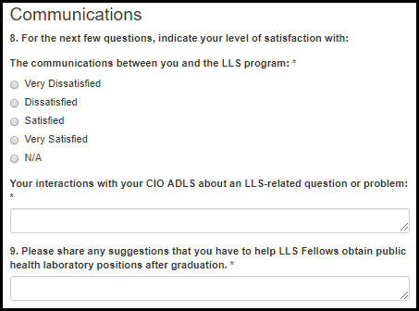
Table 7.3.2.1.a. Communications Fields
Field Name | Values | EIS | LLS | FLIGHT | EEP | SAF | PHIFP | PE | ELI | PHAP
The communication between you and the LLS program. | 1. Very Dissatisfied  2. Dissatisfied  3. Satisfied  4. Very Satisfied  5. Not Applicable | No | Yes | No | No | No | No | No | No | No
Your interactions with your CIO ADLS about an LLS-related question or problem. | 1. Very Dissatisfied  2. Dissatisfied  3. Satisfied  4. Very Satisfied  5. Not Applicable | No | Yes | No | No | No | No | No | No | No
9. Please share any suggestions that you have to help LLS Fellows obtain public health laboratory  positions after graduation. | - | No | Yes | No | No | No | No | No | No | No

Feedback on Hosting an LLS Fellow

Figure 7.3.2.3.a. Feedback on Hosting an LLS Fellow Fields
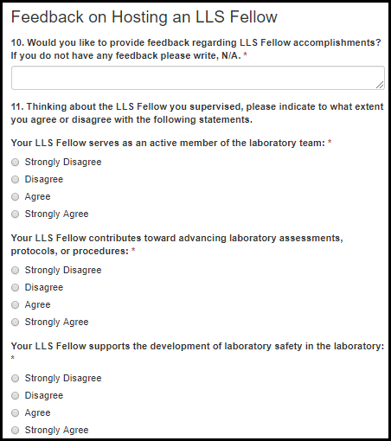

Table 7.3.2.3.a. Feedback on Hosting an LLS Fellow Fields
Field Name | Values | EIS | LLS | FLIGHT | EEP | SAF | PHIFP | PE | ELI | PHAP
10. Would you like to provide feedback regarding LLS Fellow accomplishments? If you do not have any feedback please write, N/A. | - | No | Yes | No | No | No | No | No | No | No
Your LLS Fellow serves as an active member of the laboratory team. | 1. Strongly Disagree  2. Disagree  3. Agree  4. Strongly Agree | No | Yes | No | No | No | No | No | No | No
Your LLS Fellow contributes toward advancing laboratory assessments, protocols, or procedures. | 1. Strongly Disagree  2. Disagree  3. Agree  4. Strongly Agree | No | Yes | No | No | No | No | No | No | No
Your LLS Fellow supports the development of laboratory safety in the laboratory. | 1. Strongly Disagree  2. Disagree  3. Agree  4. Strongly Agree | No | Yes | No | No | No | No | No | No | No

Figure 7.3.2.3.b. Feedback on Hosting an LLS Fellow Fields
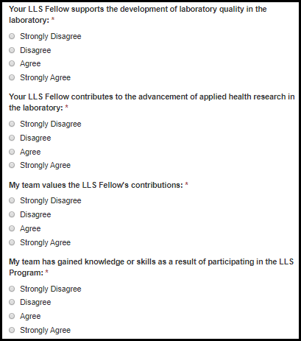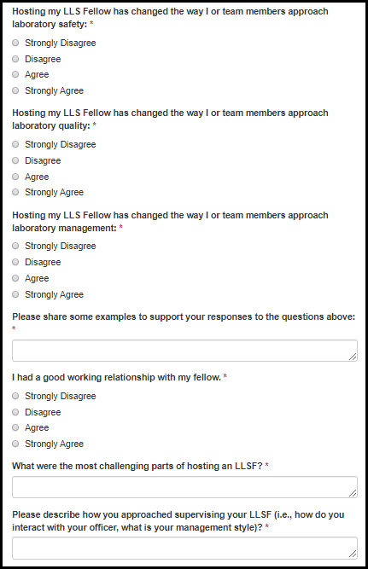

Table 7.3.2.3.b. Feedback on Hosting an LLS Fellow Fields
Field Name | Values | EIS | LLS | FLIGHT | EEP | SAF | PHIFP | PE | ELI | PHAP
Your LLS Fellow supports the development of laboratory quality in the laboratory. | 1. Strongly Disagree  2. Disagree  3. Agree  4. Strongly Agree | No | Yes | No | No | No | No | No | No | No
Your LLS Fellow contributes to the advancement of applied health research in the laboratory. | 1. Strongly Disagree  2. Disagree  3. Agree  4. Strongly Agree | No | Yes | No | No | No | No | No | No | No
My team values the LLS Fellow's contributions. | 1. Strongly Disagree  2. Disagree  3. Agree  4. Strongly Agree | No | Yes | No | No | No | No | No | No | No
My team has gained knowledge or skills as a result of participating in the LLS Program. | 1. Strongly Disagree  2. Disagree  3. Agree  4. Strongly Agree | No | Yes | No | No | No | No | No | No | No
Hosting my LLS Fellow has changed the way I or team members approach laboratory safety. | 1. Strongly Disagree  2. Disagree  3. Agree  4. Strongly Agree | No | Yes | No | No | No | No | No | No | No
Hosting my LLS Fellow has changed the way I or team members approach laboratory quality. | 1. Strongly Disagree  2. Disagree  3. Agree  4. Strongly Agree | No | Yes | No | No | No | No | No | No | No
Hosting my LLS Fellow has changed the way I or team members approach laboratory management. | 1. Strongly Disagree  2. Disagree  3. Agree  4. Strongly Agree | No | Yes | No | No | No | No | No | No | No
Please share some examples to support your responses to the question above. | - | No | Yes | No | No | No | No | No | No | No
I had a good working relationship with my fellow. | 1. Strongly Disagree  2. Disagree  3. Agree  4. Strongly Agree | No | Yes | No | No | No | No | No | No | No
What were the most challenging parts of hosting an LLSF? | - | No | Yes | No | No | No | No | No | No | No
Please describe how you approached supervising your LLSF (i.e., how do you interact with your officer, what is your management style)? | - | No | Yes | No | No | No | No | No | No | No

ELI

End of Year Survey

Introduction

Figure 7.4.1.1.a Introduction Fields
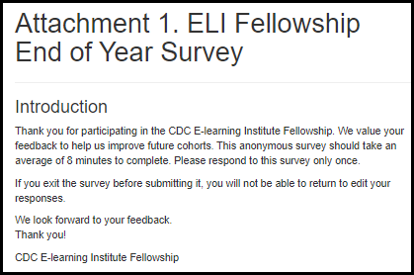

Increases in Knowledge, Skill, Self-Efficacy

Figure 7.4.1.2.a Increases in Knowledge, Skill, Self-Efficacy Fields
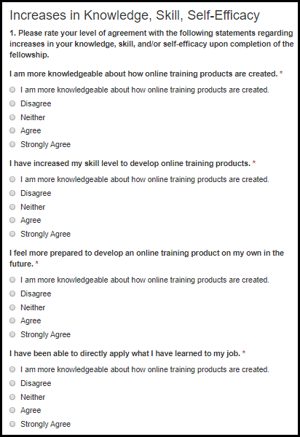

Table 7.4.1.2.a Increases in Knowledge, Skill, Self-Efficacy Fields
Field Name | Values | EIS | LLS | FLIGHT | EEP | SAF | PHIFP | PE | ELI | PHAP
I am more knowledgeable about how online training products are created. | 1. Strongly Disagree  2. Disagree  3. Neither  4. Agree  5. Strongly Agree | No | No | No | No | No | No | No | Yes | No
I have increased my skill level to develop online training products. | 1. Strongly Disagree  2. Disagree  3. Neither  4. Agree  5. Strongly Agree | No | No | No | No | No | No | No | Yes | No
I feel more prepared to develop an online training product on my own in the future. | 1. Strongly Disagree  2. Disagree  3. Neither  4. Agree  5. Strongly Agree | No | No | No | No | No | No | No | Yes | No
I have been able to directly apply what I have learned to my job. | 1. Strongly Disagree  2. Disagree  3. Neither  4. Agree  5. Strongly Agree | No | No | No | No | No | No | No | Yes | No

Instructional Design Competencies

Figure 7.4.1.3.a Instructional Design Competencies Fields
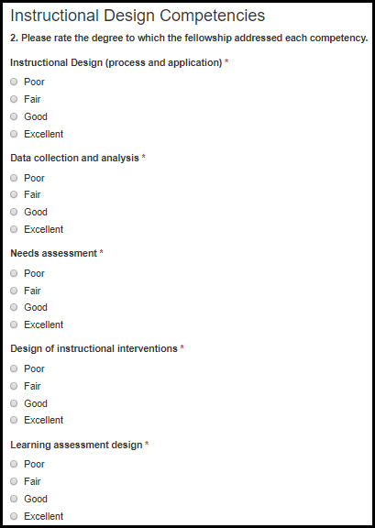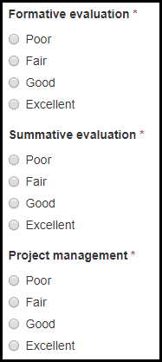

Table 7.4.1.3.a Instructional Design Competencies Fields
Field Name | Values | EIS | LLS | FLIGHT | EEP | SAF | PHIFP | PE | ELI | PHAP
Instructional Design (process and application) | 1. Poor  2. Fair  3. Good  4. Excellent | No | No | No | No | No | No | No | Yes | No
Data collection and analysis | 1. Poor  2. Fair  3. Good  4. Excellent | No | No | No | No | No | No | No | Yes | No
Needs assessment | 1. Poor  2. Fair  3. Good  4. Excellent | No | No | No | No | No | No | No | Yes | No
Design of instructional interventions | 1. Poor  2. Fair  3. Good  4. Excellent | No | No | No | No | No | No | No | Yes | No
Learning assessment design | 1. Poor  2. Fair  3. Good  4. Excellent | No | No | No | No | No | No | No | Yes | No
Formative evaluation | 1. Poor  2. Fair  3. Good  4. Excellent | No | No | No | No | No | No | No | Yes | No
Summative evaluation | 1. Poor  2. Fair  3. Good  4. Excellent | No | No | No | No | No | No | No | Yes | No
Project management | 1. Poor  2. Fair  3. Good  4. Excellent | No | No | No | No | No | No | No | Yes | No

Capacity Increases Attributed to Fellowship

Figure 7.4.1.4.a. Capacity Increases Attributed to Fellowship Fields
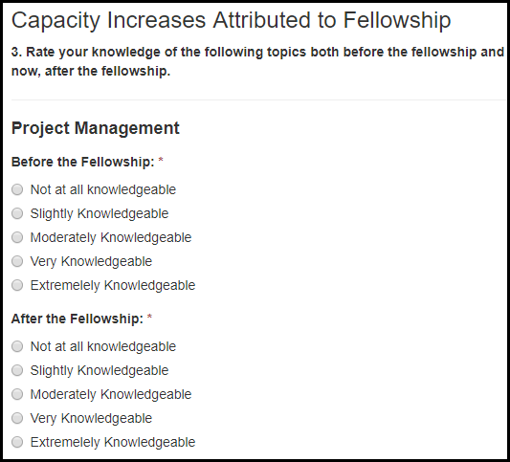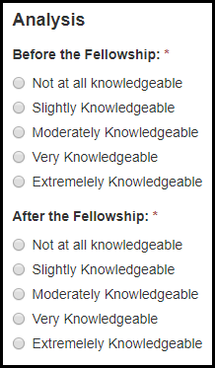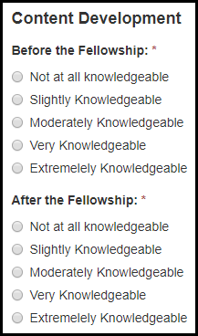

Figure 7.4.1.4.b Capacity Increases Attributed to Fellowship Fields
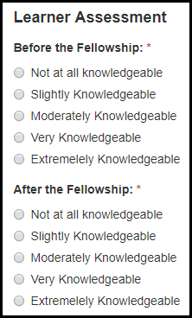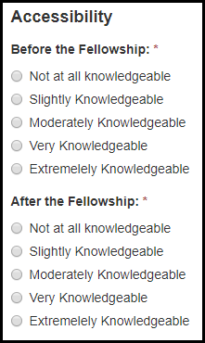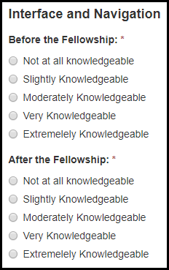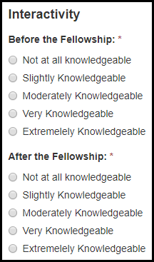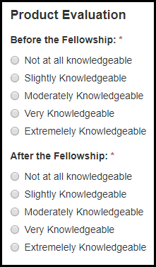

Table 7.4.1.4.a. Capacity Increases Attributed to Fellowship Fields
Field Name | Values | EIS | LLS | FLIGHT | EEP | SAF | PHIFP | PE | ELI | PHAP
Before the Fellowship: | 1. Not at all knowledgeable  2. Slightly Knowledgeable  3. Moderately Knowledgeable  4. Very Knowledgeable  5. Extremely Knowledgeable | No | No | No | No | No | No | No | Yes | No
After the Fellowship: | 1. Not at all knowledgeable  2. Slightly Knowledgeable  3. Moderately Knowledgeable  4. Very Knowledgeable  5. Extremely Knowledgeable | No | No | No | No | No | No | No | Yes | No

Post-Fellowship Implementation

Figure 7.4.1.5.a Post-Fellowship Implementation Fields
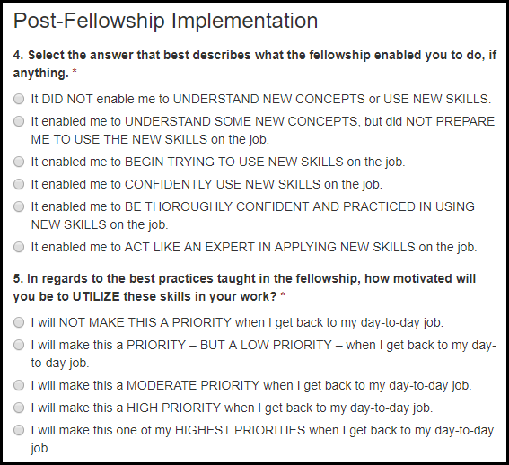

Table 7.4.1.5.a Post-Fellowship Implementation Fields
Field Name | Values | EIS | LLS | FLIGHT | EEP | SAF | PHIFP | PE | ELI | PHAP
4. Select the answer that best describes what the fellowship enabled you to do, if anything. | 1. It DID NOT enable me to UNDERSTAND NEW CONCEPTS or USE NEW SKILLS.  2. It enabled me to UNDERSTAND SOME NEW CONCEPTS, but did NOT PREPARE ME TO USE THE NEW SKILLS on the job.  3. It enabled me to BEGIN TRYING TO USE NEW SKILLS on the job.  4. It enabled me to CONFIDENTLY USE NEW SKILLS on the job.  5. It enabled me to BE THOROUGHLY CONFIDENT AND PRACTICED IN USING NEW SKILLS on the job.  6. It enabled me to ACT LIKE AN EXPERT IN APPLYING NEW SKILLS on the job. | No | No | No | No | No | No | No | Yes | No
5. In regards to the best practices taught in the fellowship, how motivated will you be to UTILIZE these skills in your work? | 1. I will NOT MAKE THIS A PRIORITY when I get back to my day-to-day job.  2. I will make this a PRIORITY – BUT A LOW PRIORITY – when I get back to my day-to-day job.  3. I will make this a MODERATE PRIORITY when I get back to my day-to-day job.  4. I will make this a HIGH PRIORITY when I get back to my day-to-day job.  5. I will make this one of my HIGHEST PRIORITIES when I get back to my day-to-day job. | No | No | No | No | No | No | No | Yes | No

Overall

Figure 7.4.1.6.a Overall Fields
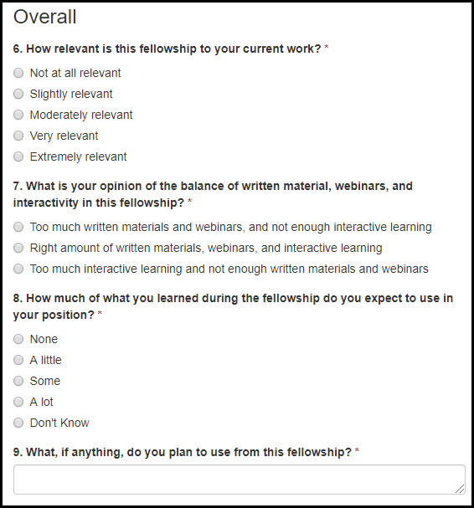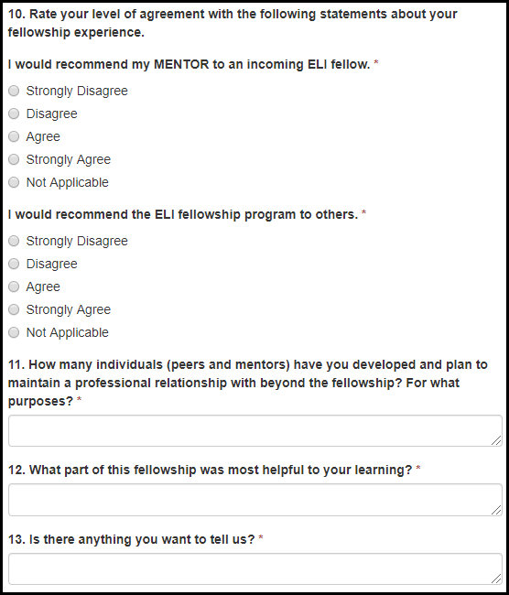

Table 7.4.1.6.a Overall Fields
Field Name | Values | EIS | LLS | FLIGHT | EEP | SAF | PHIFP | PE | ELI | PHAP
6. How relevant is this fellowship to your current work? | 1. Not at all relevant  2. Slightly relevant  3. Moderately relevant  4. Very relevant  5. Extremely relevant | No | No | No | No | No | No | No | Yes | No
7. What is your opinion of the balance of written material, webinars, and interactivity in this fellowship? | 1. Too much written materials and webinars, and not enough interactive learning  2. Right amount of written materials, webinars, and interactive learning  3. Too much interactive learning and not enough written materials and webinars | No | No | No | No | No | No | No | Yes | No
8. How much of what you learned during the fellowship do you expect to use in your position? | 1. None  2. A little  3. Some  4. A lot  5. Don't know | No | No | No | No | No | No | No | Yes | No

Table 7.4.1.6.b Overall Fields
Field Name | Values | EIS | LLS | FLIGHT | EEP | SAF | PHIFP | PE | ELI | PHAP
I would recommend my MENTOR to an incoming ELI fellow. | 1. Strongly Disagree  2. Disagree  3. Agree  4. Strongly Agree  5. Not Applicable | No | No | No | No | No | No | No | Yes | No
I would recommend the ELI fellowship program to others. | 1. Strongly Disagree  2. Disagree  3. Agree  4. Strongly Agree  5. Not Applicable | No | No | No | No | No | No | No | Yes | No
11. How many individuals (peers and mentors) have you developed and plan to maintain a professional relationship with beyond the fellowship? For what purposes? | - | No | No | No | No | No | No | No | Yes | No
12. What part of this fellowship was most helpful to your learning? | - | No | No | No | No | No | No | No | Yes | No
13. Is there anything you want to tell us? | - | No | No | No | No | No | No | No | Yes | No

EIS

Supervisor Exit Survey

Feedback on General EIS Program Support

Figure 7.5.1.1.a Feedback on General EIS Program Support Fields
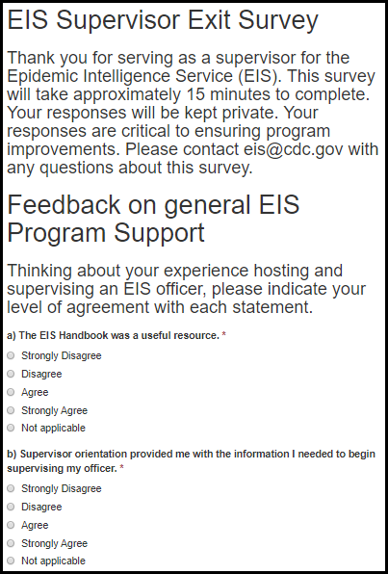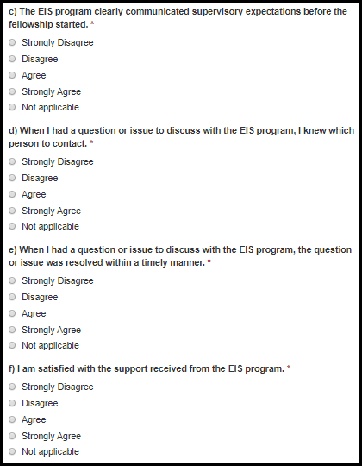

Figure 7.5.1.1.b Feedback on General EIS Program Support Fields
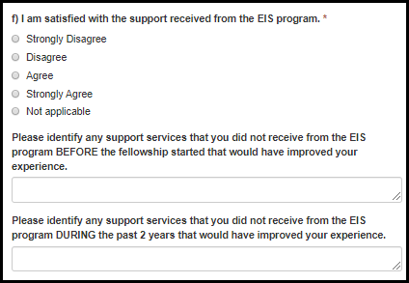

Table 7.5.1.1.a Feedback on General EIS Program Support Fields
Field Name | Values | EIS | LLS | FLIGHT | EEP | SAF | PHIFP | PE | ELI | PHAP
a) The EIS Handbook was a useful resource. | 1. Strongly Disagree  2. Disagree  3. Agree  4. Strongly Agree  5. Not Applicable | Yes | No | No | No | No | No | No | No | No
b) Supervisor orientation provided me with the information I needed to begin supervising my officer. | 1. Strongly Disagree  2. Disagree  3. Agree  4. Strongly Agree  5. Not Applicable | Yes | No | No | No | No | No | No | No | No
c) The EIS program clearly communicated supervisory expectations before the fellowship started. | 1. Strongly Disagree  2. Disagree  3. Agree  4. Strongly Agree  5. Not Applicable | Yes | No | No | No | No | No | No | No | No
d) When I had a question or issue to discuss with the EIS program, I knew which person to contact. | 1. Strongly Disagree  2. Disagree  3. Agree  4. Strongly Agree  5. Not Applicable | Yes | No | No | No | No | No | No | No | No
e) When I had a question or issue to discuss with the EIS program, the question or issue was resolved within a timely manner. | 1. Strongly Disagree  2. Disagree  3. Agree  4. Strongly Agree  5. Not Applicable | Yes | No | No | No | No | No | No | No | No

Table 7.5.1.1.b Feedback on General EIS Program Support Fields
Field Name | Values | EIS | LLS | FLIGHT | EEP | SAF | PHIFP | PE | ELI | PHAP
f) I am satisfied with the support received from the EIS program. | 1. Strongly Disagree  2. Disagree  3. Agree  4. Strongly Agree  5. Not Applicable | Yes | No | No | No | No | No | No | No | No
If you selected “strongly disagree” or “disagree,” please explain in the space provided below. | - | Yes | No | No | No | No | No | No | No | No
Please identify any support services that you did not receive from the EIS program before the fellowship started that would have improved your experience. | - | Yes | No | No | No | No | No | No | No | No
Please identify any support services that you did not receive from the EIS program during the past 2 years that would have improved your experience. | - | Yes | No | No | No | No | No | No | No | No

Feedback on Supervisor Training

Figure 7.5.1.2.a Feedback on Supervisor Training Fields
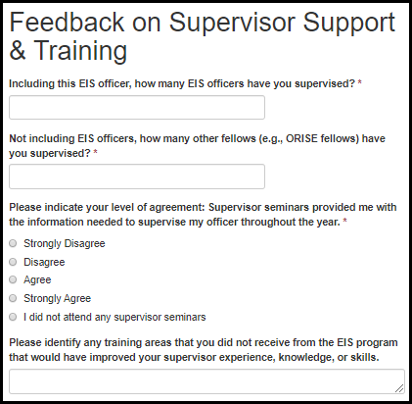

Table 7.5.1.2.a Feedback on Supervisor Training Fields
Field Name | Values | EIS | LLS | FLIGHT | EEP | SAF | PHIFP | PE | ELI | PHAP
Including this EIS officer, how many EIS officers have you supervised? | - | Yes | No | No | No | No | No | No | No | No
Not including EIS officers, how many other fellows (e.g., ORISE fellows) have you supervised? | - | Yes | No | No | No | No | No | No | No | No
Please indicate your level of agreement: Supervisor seminars provided me with the information needed to supervise my officer throughout the year. | 1. Strongly Disagree  2. Disagree  3. Agree  4. Strongly Agree  5. I did not attend any supervisor seminars. | Yes | No | No | No | No | No | No | No | No
If you selected “strongly disagree,” “disagree,” or “I did not attend any supervisor seminars,” please explain in the space provided below. | - | Yes | No | No | No | No | No | No | No | No
Please identify any training areas that you did not receive from the EIS program that would have improved your supervisor experience, knowledge, or skills. | - | Yes | No | No | No | No | No | No | No | No

Feedback on EIS Officer

Figure 7.5.1.3.a Feedback on EIS Officer Fields
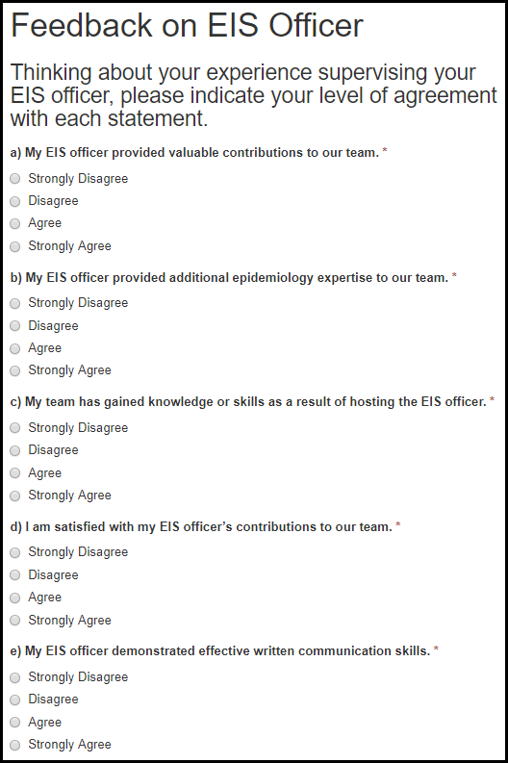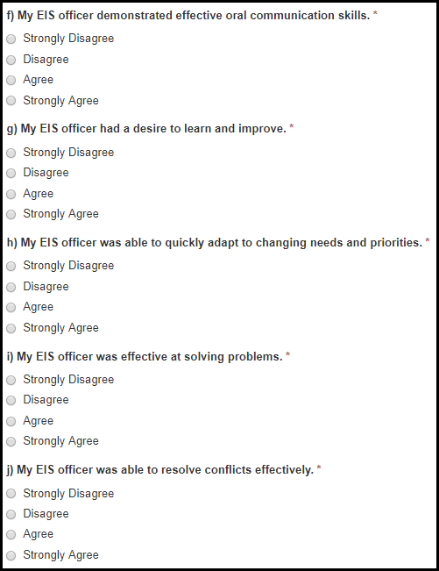

Figure 7.5.1.3.b Feedback on EIS Officer Fields
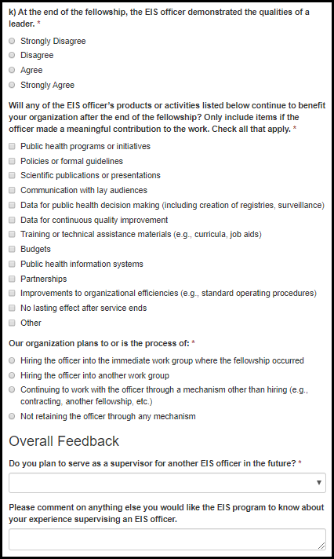

Table 7.5.1.3.a Feedback on EIS Officer Fields
Field Name | Values | EIS | LLS | FLIGHT | EEP | SAF | PHIFP | PE | ELI | PHAP
a) The EIS officer provided valuable contributions to the host site. | 1. Strongly Disagree  2. Disagree  3. Agree  4. Strongly Agree | Yes | No | No | No | No | No | No | No | No
b) The EIS officer provided additional epidemiology expertise to the host site. | 1. Strongly Disagree  2. Disagree  3. Agree  4. Strongly Agree | Yes | No | No | No | No | No | No | No | No
c) The host site has gained knowledge or skills as a result of hosting the EIS officer. | 1. Strongly Disagree  2. Disagree  3. Agree  4. Strongly Agree | Yes | No | No | No | No | No | No | No | No
d) I had a good working relationship with my officer. | 1. Strongly Disagree  2. Disagree  3. Agree  4. Strongly Agree | Yes | No | No | No | No | No | No | No | No
e) At the end of the fellowship, the EIS officer demonstrated effective written communication skills. | 1. Strongly Disagree  2. Disagree  3. Agree  4. Strongly Agree | Yes | No | No | No | No | No | No | No | No
f) At the end of the fellowship, the EIS officer demonstrated effective oral communication skills. | 1. Strongly Disagree  2. Disagree  3. Agree  4. Strongly Agree | Yes | No | No | No | No | No | No | No | No
g) At the end of the fellowship, the EIS officer had a desire to learn and improve. | 1. Strongly Disagree  2. Disagree  3. Agree  4. Strongly Agree | Yes | No | No | No | No | No | No | No | No

Figure 7.5.1.3.b Feedback on EIS Officer Fields
Field Name | Values | EIS | LLS | FLIGHT | EEP | SAF | PHIFP | PE | ELI | PHAP
h) At the end of the fellowship, the EIS officer was able to quickly adapt to changing needs and priorities. | 1. Strongly Disagree  2. Disagree  3. Agree  4. Strongly Agree | Yes | No | No | No | No | No | No | No | No
i) At the end of the fellowship, the EIS officer was effective at solving problems. | 1. Strongly Disagree  2. Disagree  3. Agree  4. Strongly Agree | Yes | No | No | No | No | No | No | No | No
j) At the end of the fellowship, the EIS officer was able to resolve conflicts effectively. | 1. Strongly Disagree  2. Disagree  3. Agree  4. Strongly Agree | Yes | No | No | No | No | No | No | No | No
k) At the end of the fellowship, the EIS officer demonstrated the qualities of a leader. | 1. Strongly Disagree  2. Disagree  3. Agree  4. Strongly Agree | Yes | No | No | No | No | No | No | No | No
If you selected “strongly disagree” or “disagree,” please explain in the space provided below. | - | Yes | No | No | No | No | No | No | No | No

Figure 7.5.1.3.c Feedback on EIS Officer Fields
Field Name | Values | EIS | LLS | FLIGHT | EEP | SAF | PHIFP | PE | ELI | PHAP
15. Will any of the EIS officer’s products or activities listed below continue to benefit your organization after the end of the fellowship? Only include items if the officer made a meaningful contribution to the work. (Check all that apply) | 1. Public health programs or initiatives  2. Policies or formal guidelines  3. Scientific publications or presentations  3. Communication with lay audiences  4. Data for public health decision making (including creation of registries, surveillance)  5. Data for continuous quality improvement  6. Training or technical assistance materials (e.g., curricula, job aids)  7. Budgets  8. Public health information systems  9. Partnerships  10. Improvements to organizational efficiencies (e.g., standard operating procedures)  11. No lasting effect after service ends  12. Other | Yes | No | No | No | No | No | No | No | No
Specify: |  | Yes | No | No | No | No | No | No | No | No
16. Our organization plans to or is the process of: | 1. Hiring the officer into the immediate work group where the fellowship occurred  2. Hiring the officer into another work group  3. Continuing to work with the officer through a mechanism other than hiring (e.g., contracting, another fellowship, etc.)  4. Not retaining the officer through any mechanism | Yes | No | No | No | No | No | No | No | No

Figure 7.5.1.3.d Feedback on EIS Officer Fields
Field Name | Values | EIS | LLS | FLIGHT | EEP | SAF | PHIFP | PE | ELI | PHAP
17. Which of these are reasons why your organization is not planning to hire the officer or continue to work with the officer through another mechanism? (Check all that apply) | 1. No position available  2. No funds available  3. Officer is not interested (e.g., accepted another position)  4. Officer does not have the knowledge and skills needed for the work  5. My organization already has the knowledge and skills the officer would bring (i.e., no value added)  6. Personal qualities of the officer (e.g., dependability, work ethic)  7. Other | Yes | No | No | No | No | No | No | No | No
Specify: | - | Yes | No | No | No | No | No | No | No | No
18. Which of these are reasons why your organization is planning to work with your officer? (Check all that apply) | 1. Officer has the knowledge and skills needed for the work  2. Officer brings additional knowledge and skills the team would not otherwise have  3. Personal qualities of the officer (e.g., dependability, work ethic)  4. Easier than recruiting for a new person for the position  5. Familiarity with your organization and its work  6. Other | Yes | No | No | No | No | No | No | No | No
Specify: | - | Yes | No | No | No | No | No | No | No | No

Overall Feedback

Figure 7.5.1.4.a Overall Feedback Fields
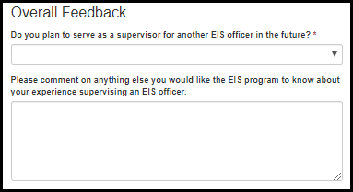
Table 7.5.1.4.a Overall Feedback Fields
Field Name | Values | EIS | LLS | FLIGHT | EEP | SAF | PHIFP | PE | ELI | PHAP
Do you plan to serve as a supervisor for another EIS officer in the future? | 1. Yes  2. No  3. Undecided | Yes | No | No | No | No | No | No | No | No
If you selected “No” or “Undecided,” please explain: | - | Yes | No | No | No | No | No | No | No | No
Please comment on anything else you would like the EIS program to know about your experience supervising an EIS officer. | - | Yes | No | No | No | No | No | No | No | No

Supervisor Survey

Introduction

Figure 7.5.2.1.a Introduction Fields
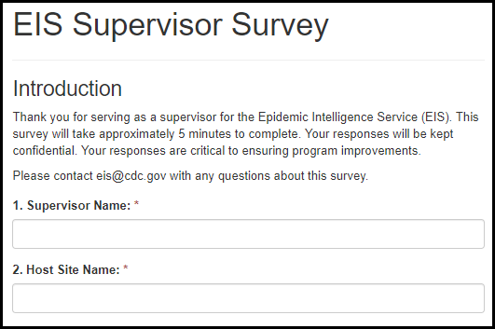
Table 7.5.2.1.a Introduction Fields
Field Name | Values | EIS | LLS | FLIGHT | EEP | SAF | PHIFP | PE | ELI | PHAP
1. Supervisor Name: | - | Yes | No | No | No | No | No | No | No | No
2. Host Site Name: | - | Yes | No | No | No | No | No | No | No | No

Feedback on EIS Program Support

Figure 7.5.2.2.a. Feedback on EIS Program Support Fields
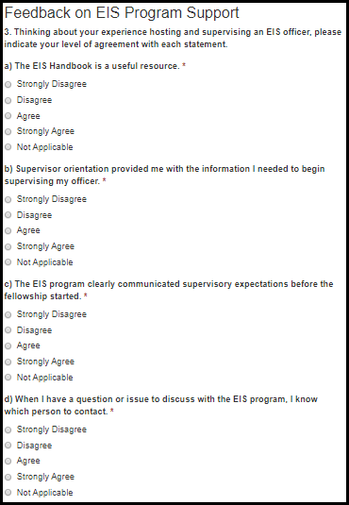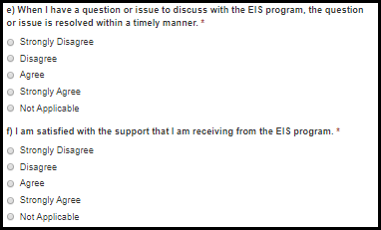

Figure 7.5.2.2.b. Feedback on EIS Program Support Fields
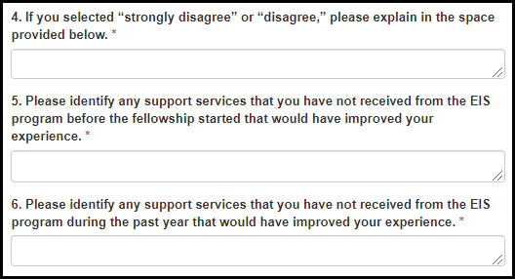

Table 7.5.2.2.a. Feedback on EIS Program Support Fields
Field Name | Values | EIS | LLS | FLIGHT | EEP | SAF | PHIFP | PE | ELI | PHAP
a) The EIS Handbook is a useful resource. | 1. Strongly Disagree  2. Disagree  3. Agree  4. Strongly Agree  5. Not Applicable | Yes | No | No | No | No | No | No | No | No
b) Supervisor orientation provided me with the information I needed to begin supervising my officer. | 1. Strongly Disagree  2. Disagree  3. Agree  4. Strongly Agree  5. Not Applicable | Yes | No | No | No | No | No | No | No | No
c) The EIS program clearly communicated supervisory expectations before the fellowship started. | 1. Strongly Disagree  2. Disagree  3. Agree  4. Strongly Agree  5. Not Applicable | Yes | No | No | No | No | No | No | No | No
d) When I have a question or issue to discuss with the EIS program, I know which person to contact. | 1. Strongly Disagree  2. Disagree  3. Agree  4. Strongly Agree  5. Not Applicable | Yes | No | No | No | No | No | No | No | No

Table 7.5.2.2.b. Feedback on EIS Program Support Fields
Field Name | Values | EIS | LLS | FLIGHT | EEP | SAF | PHIFP | PE | ELI | PHAP
e) When I have a question or issue to discuss with the EIS program, the question or issue is resolved within a timely manner. | 1. Strongly Disagree  2. Disagree  3. Agree  4. Strongly Agree  5. Not Applicable | Yes | No | No | No | No | No | No | No | No
f) I am satisfied with the support that I am receiving from the EIS program. | 1. Strongly Disagree  2. Disagree  3. Agree  4. Strongly Agree  5. Not Applicable | Yes | No | No | No | No | No | No | No | No
4. If you selected “strongly disagree” or “disagree,” please explain in the space provided below. | - | Yes | No | No | No | No | No | No | No | No
5. Please identify any support services that you have not received from the EIS program before the fellowship started that would have improved your experience. | - | Yes | No | No | No | No | No | No | No | No
6. Please identify any support services that you have not received from the EIS program during the past year that would have improved your experience. | - | Yes | No | No | No | No | No | No | No | No

Feedback on Supervisor Training

Figure 7.5.2.3.a. Feedback on Supervisor Training Fields
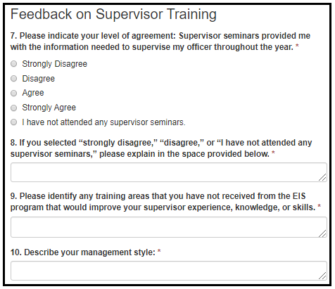

Table 7.5.2.3.a. Feedback on Supervisor Training Fields
Field Name | Values | EIS | LLS | FLIGHT | EEP | SAF | PHIFP | PE | ELI | PHAP
7. Please indicate your level of agreement: Supervisor seminars provided me with the information needed to supervise my officer throughout the year. | 1. Strongly Disagree  2. Disagree  3. Agree  4. Strongly Agree  5. I have not attended any supervisor seminars. | Yes | No | No | No | No | No | No | No | No
8. If you selected “strongly disagree,” “disagree,” or “I have not attended any supervisor seminars,” please explain in the space provided below. | - | Yes | No | No | No | No | No | No | No | No
9. Please identify any training areas that you have not received from the EIS program that would improve your supervisor experience, knowledge, or skills. | - | Yes | No | No | No | No | No | No | No | No
10. Describe your management style: | - | Yes | No | No | No | No | No | No | No | No

Overall Feedback

Figure 7.5.2.4.a. Overall Feedback Fields
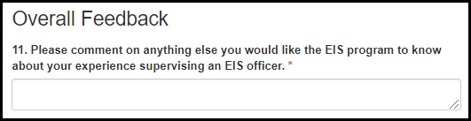
Table 7.5.2.4.a. Overall Feedback Fields
Field Name | Values | EIS | LLS | FLIGHT | EEP | SAF | PH-TIPP | PHIFP | PE | ELI | PHAP
11. Please comment on anything else you would like the EIS program to know about your experience supervising an EIS officer. | - | Yes | No | No | No | No | No | No | No | No | No

Position Description Survey

Introduction

Figure 7.5.3.1.a Introduction Fields
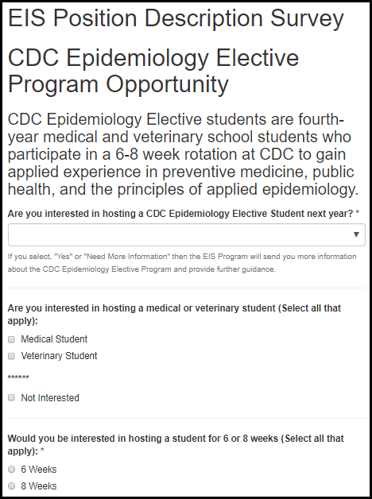

Table 7.5.3.1.a Introduction Fields
Field Name | Values | EIS | LLS | FLIGHT | EEP | SAF | PHIFP | PE | ELI | PHAP
2. Are you interested in hosting a CDC Epidemiology Elective student next year? | 1. Yes  2. No | Yes | No | No | No | No | No | No | No | No
3. Are you interested in hosting a medical or veterinary student (Select all that apply): | 1. Medical Student  2. Veterinary Student  3. Not Interested | Yes | No | No | No | No | No | No | No | No
4. Would you be interested in hosting a student for 6 or 8 weeks (Select all that apply): | 1. 6 weeks  2. 8 weeks | Yes | No | No | No | No | No | No | No | No

EIS Officer Professional Category Needs Assessment

Figure 7.5.3.2.a EIS Officer Professional Category Needs Assessment Fields
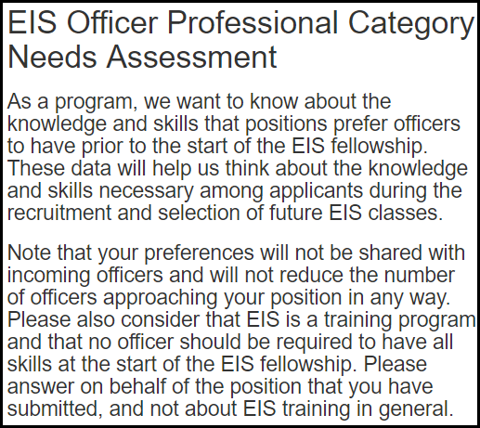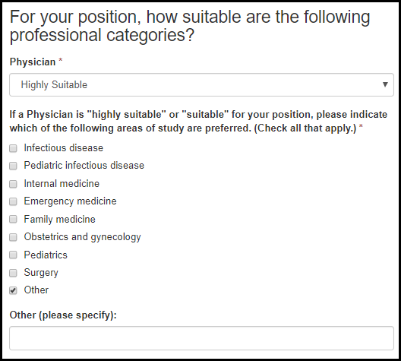

Figure 7.5.3.2.b EIS Officer Professional Category Needs Assessment Fields
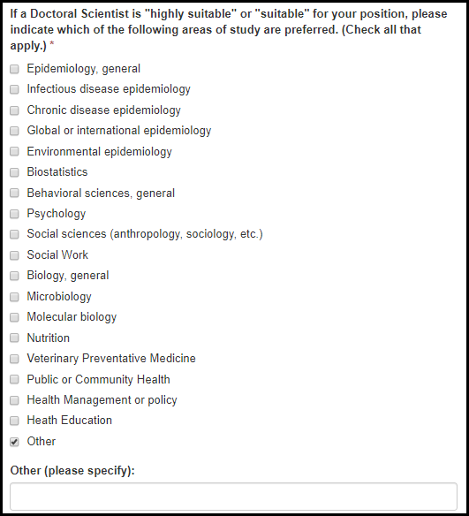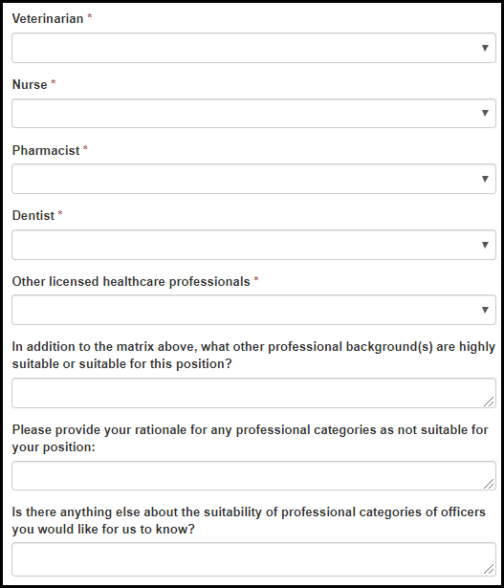

Table 7.5.3.2.a EIS Officer Professional Category Needs Assessment Fields
Field Name | Values | EIS | LLS | FLIGHT | EEP | SAF | PHIFP | PE | ELI | PHAP
Physician: | 1. Highly Suitable  2. Suitable  3. No Preference  4. Not Suitable | Yes | No | No | No | No | No | No | No | No
9. If a Physician is "highly suitable" or "suitable" for your position, please indicate which of the following areas of study are preferred. (Check all that apply) | 1. Infectious disease  2. Pediatric infectious disease  3. Internal medicine  4. Emergency medicine  5. Family medicine  6. Obstetrics and gynecology  7. Pediatrics  8. Surgery  9. Other | Yes | No | No | No | No | No | No | No | No
Please List: | - | Yes | No | No | No | No | No | No | No | No
Doctoral Scientist: | 1. Highly Suitable  2. Suitable  3. No Preference  4. Not Suitable | Yes | No | No | No | No | No | No | No | No
8. If a Doctoral Scientist is "highly suitable" or "suitable" for your position, please indicate which of the following areas of study are preferred. (Select all that apply) | 1. Epidemiology, general  2. Infectious disease epidemiology  3. Chronic disease epidemiology  4. Global or international epidemiology  5. Environmental epidemiology  6. Biostatistics  7. Behavioral sciences, general  8. Psychology  9. Social sciences (anthropology, sociology, etc.)  10. Social Work  11. Biology, general  12. Microbiology  13. Molecular biology  14. Nutrition  15. Veterinary Preventative Medicine  16. Public or Community Health  17. Health Management or policy  18. Heath Education  19. Other | Yes | No | No | No | No | No | No | No | No
Please List: | - | Yes | No | No | No | No | No | No | No | No

Figure 7.5.3.2.b EIS Officer Professional Category Needs Assessment Fields
Field Name | Values | EIS | LLS | FLIGHT | EEP | SAF | PHIFP | PE | ELI | PHAP
Veterinarian: | 1. Highly Suitable  2. Suitable  3. No Preference  4. Not Suitable | Yes | No | No | No | No | No | No | No | No
Nurse: | 1. Highly Suitable  2. Suitable  3. No Preference  4. Not Suitable | Yes | No | No | No | No | No | No | No | No
Pharmacist: | 1. Highly Suitable  2. Suitable  3. No Preference  4. Not Suitable | Yes | No | No | No | No | No | No | No | No
Dentist: | 1. Highly Suitable  2. Suitable  3. No Preference  4. Not Suitable | Yes | No | No | No | No | No | No | No | No
Other licensed healthcare professionals: | 1. Highly Suitable  2. Suitable  3. No Preference  4. Not Suitable | Yes | No | No | No | No | No | No | No | No
6. In addition to the matrix above, what other professional background(s) are highly suitable or suitable for this position? | - | Yes | No | No | No | No | No | No | No | No
7. Please provide your rationale for any professional categories as not suitable for your position: | - | Yes | No | No | No | No | No | No | No | No
10. Is there anything else about the suitability of professional categories of officers you would like for us to know? | - | Yes | No | No | No | No | No | No | No | No

EIS Officer Knowledge and Skills Needs Assessment

Figure 7.5.3.3.a EIS Officer Knowledge and Skills Needs Assessment Fields
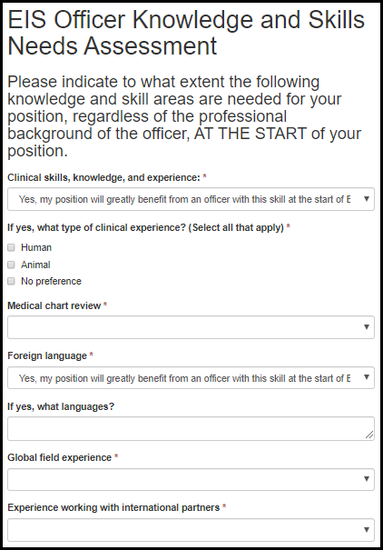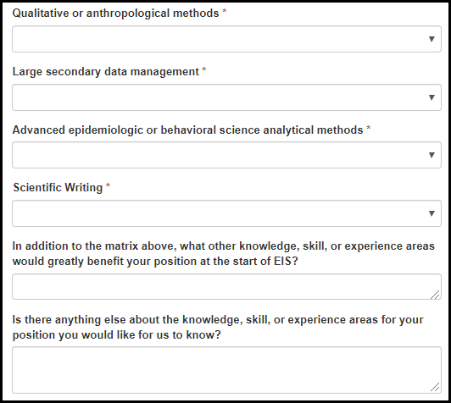

Table 7.5.3.3.a EIS Officer Knowledge and Skills Needs Assessment Fields
Field Name | Values | EIS | LLS | FLIGHT | EEP | SAF | PHIFP | PE | ELI | PHAP
Clinical skills, knowledge, and experience: | 1. Yes, my position will greatly benefit from an officer with this skill at the start of EIS  2. Yes, nice to have for my position  3. No preference  4. No, my position does not require this skill from an officer at the start of EIS | Yes | No | No | No | No | No | No | No | No
What type of clinical experience? | 1. Human  2. Animal  3. No Preference | Yes | No | No | No | No | No | No | No | No
Medical chart review | 1. Yes, my position will greatly benefit from an officer with this skill at the start of EIS  2. Yes, nice to have for my position  3. No preference  4. No, my position does not require this skill from an officer at the start of EIS | Yes | No | No | No | No | No | No | No | No
Foreign language | 1. Yes, my position will greatly benefit from an officer with this skill at the start of EIS  2. Yes, nice to have for my position  3. No preference  4. No, my position does not require this skill from an officer at the start of EIS | Yes | No | No | No | No | No | No | No | No
If yes, what languages? | - | Yes | No | No | No | No | No | No | No | No
Global field experience | 1. Yes, my position will greatly benefit from an officer with this skill at the start of EIS  2. Yes, nice to have for my position  3. No preference  4. No, my position does not require this skill from an officer at the start of EIS | Yes | No | No | No | No | No | No | No | No

Table 7.5.3.3.b EIS Officer Knowledge and Skills Needs Assessment Fields
Field Name | Values | EIS | LLS | FLIGHT | EEP | SAF | PHIFP | PE | ELI | PHAP
Experience working with international partners | 1. Yes, my position will greatly benefit from an officer with this skill at the start of EIS  2. Yes, nice to have for my position  3. No preference  4. No, my position does not require this skill from an officer at the start of EIS | Yes | No | No | No | No | No | No | No | No
Qualitative or anthropological methods | 1. Yes, my position will greatly benefit from an officer with this skill at the start of EIS  2. Yes, nice to have for my position  3. No preference  4. No, my position does not require this skill from an officer at the start of EIS | Yes | No | No | No | No | No | No | No | No
Large secondary data management | 1. Yes, my position will greatly benefit from an officer with this skill at the start of EIS  2. Yes, nice to have for my position  3. No preference  4. No, my position does not require this skill from an officer at the start of EIS | Yes | No | No | No | No | No | No | No | No
Advanced epidemiologic or behavioral science analytical methods | 1. Yes, my position will greatly benefit from an officer with this skill at the start of EIS  2. Yes, nice to have for my position  3. No preference  4. No, my position does not require this skill from an officer at the start of EIS | Yes | No | No | No | No | No | No | No | No
Scientific writing |  | Yes | No | No | No | No | No | No | No | No

Figure 7.5.3.3.c EIS Officer Knowledge and Skills Needs Assessment Fields
Field Name | Values | EIS | LLS | FLIGHT | EEP | SAF | PHIFP | PE | ELI | PHAP
12. In addition to the matrix above, what other knowledge, skill, or experience areas would greatly benefit your position at the start of EIS? | - | Yes | No | No | No | No | No | No | No | No
13. Is there anything else about the knowledge, skill, or experience areas for your position you would like for us to know? | - | Yes | No | No | No | No | No | No | No | No

Assessments & Evaluations

EEP

Supervisor Evaluation of Student Survey

General Information

Figure 8.1.1.1.a. General Information Fields
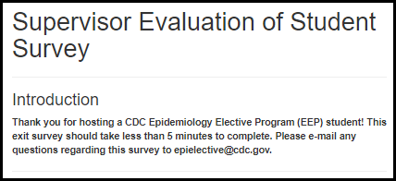

Main Project

Figure 8.1.1.2.a. Main Project Fields
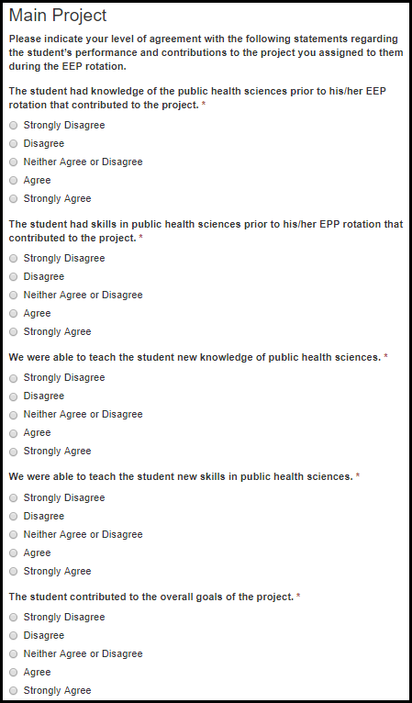

Table 8.1.1.2.a. Main Project Fields
Field Name | Values | EIS | LLS | FLIGHT | EEP | SAF | PHIFP | PE | ELI | PHAP
The student had knowledge of the public health sciences prior to his/her EEP rotation that contributed to the project. | 1. Strongly Disagree  2. Disagree  3. Neither Agree nor Disagree  4. Agree  5. Strongly Agree | No | No | No | Yes | No | No | No | No | No
The student had skills in public health sciences prior to his/her EPP rotation that contributed to the project. | 1. Strongly Disagree  2. Disagree  3. Neither Agree nor Disagree  4. Agree  5. Strongly Agree | No | No | No | Yes | No | No | No | No | No
We were able to teach the student new knowledge of public health sciences. | 1. Strongly Disagree  2. Disagree  3. Neither Agree nor Disagree  4. Agree  5. Strongly Agree | No | No | No | Yes | No | No | No | No | No
We were able to teach the student new skills in public health sciences. | 1. Strongly Disagree  2. Disagree  3. Neither Agree nor Disagree  4. Agree  5. Strongly Agree | No | No | No | Yes | No | No | No | No | No
The student contributed to the overall goals of the project. | 1. Strongly Disagree  2. Disagree  3. Neither Agree nor Disagree  4. Agree  5. Strongly Agree | No | No | No | Yes | No | No | No | No | No

Student Professional Skills

Figure 8.1.1.3.a. Student Professional Skills Fields
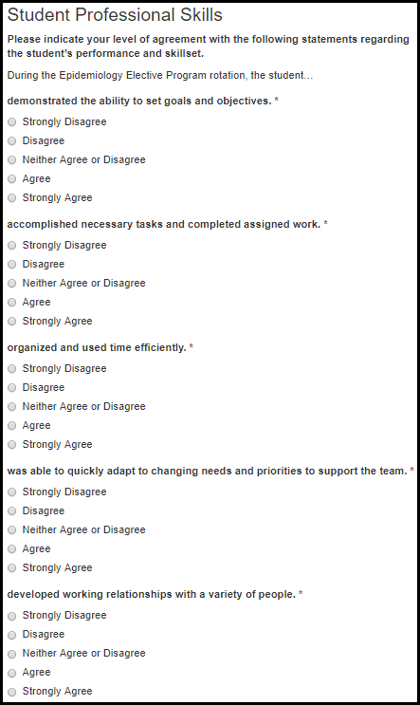

Table 8.1.1.3.a. Student Professional Skills Fields
Field Name | Values | EIS | LLS | FLIGHT | EEP | SAF | PHIFP | PE | ELI | PHAP
Demonstrated the ability to set goals and objectives. | 1. Strongly Disagree  2. Disagree  3. Neither Agree nor Disagree  4. Agree  5. Strongly Agree | No | No | No | Yes | No | No | No | No | No
Accomplished necessary tasks and completed assigned work. | 1. Strongly Disagree  2. Disagree  3. Neither Agree nor Disagree  4. Agree  5. Strongly Agree | No | No | No | Yes | No | No | No | No | No
Organized and used time efficiently. | 1. Strongly Disagree  2. Disagree  3. Neither Agree nor Disagree  4. Agree  5. Strongly Agree | No | No | No | Yes | No | No | No | No | No
Was able to quickly adapt to changing needs and priorities to support the team. | 1. Strongly Disagree  2. Disagree  3. Neither Agree nor Disagree  4. Agree  5. Strongly Agree | No | No | No | Yes | No | No | No | No | No
Developed working relationships with a variety of people. | 1. Strongly Disagree  2. Disagree  3. Neither Agree nor Disagree  4. Agree  5. Strongly Agree | No | No | No | Yes | No | No | No | No | No

Figure 8.1.1.3.b. Student Professional Skills Fields
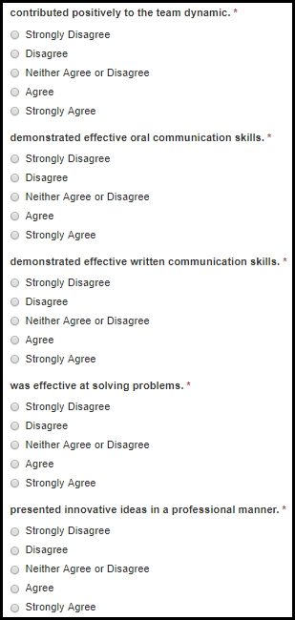

Table 8.1.1.3.b. Student Professional Skills Fields
Field Name | Values | EIS | LLS | FLIGHT | EEP | SAF | PHIFP | PE | ELI | PHAP
Contributed positively to the team dynamic. | 1. Strongly Disagree  2. Disagree  3. Neither Agree nor Disagree  4. Agree  5. Strongly Agree | No | No | No | Yes | No | No | No | No | No
Demonstrated effective oral communication skills. | 1. Strongly Disagree  2. Disagree  3. Neither Agree nor Disagree  4. Agree  5. Strongly Agree | No | No | No | Yes | No | No | No | No | No
Demonstrated effective written communication skills. | 1. Strongly Disagree  2. Disagree  3. Neither Agree nor Disagree  4. Agree  5. Strongly Agree | No | No | No | Yes | No | No | No | No | No
Was effective at solving problems. | 1. Strongly Disagree  2. Disagree  3. Neither Agree nor Disagree  4. Agree  5. Strongly Agree | No | No | No | Yes | No | No | No | No | No
Presented innovative ideas in a professional manner. | 1. Strongly Disagree  2. Disagree  3. Neither Agree nor Disagree  4. Agree  5. Strongly Agree | No | No | No | Yes | No | No | No | No | No

Figure 8.1.1.3.c. Student Professional Skills Fields
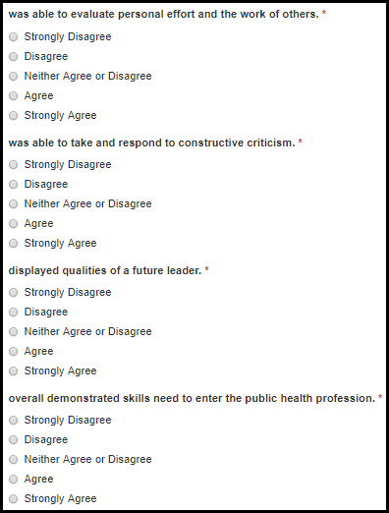

Table 8.1.1.3.c. Student Professional Skills Fields
Field Name | Values | EIS | LLS | FLIGHT | EEP | SAF | PHIFP | PE | ELI | PHAP
Was able to evaluate personal effort and the work of others. | 1. Strongly Disagree  2. Disagree  3. Neither Agree nor Disagree  4. Agree  5. Strongly Agree | No | No | No | Yes | No | No | No | No | No
Was able to take and respond to constructive criticism. | 1. Strongly Disagree  2. Disagree  3. Neither Agree nor Disagree  4. Agree  5. Strongly Agree | No | No | No | Yes | No | No | No | No | No
Displayed qualities of a future leader. | 1. Strongly Disagree  2. Disagree  3. Neither Agree nor Disagree  4. Agree  5. Strongly Agree | No | No | No | Yes | No | No | No | No | No
Overall demonstrated skills need to enter the public health profession. | 1. Strongly Disagree  2. Disagree  3. Neither Agree nor Disagree  4. Agree  5. Strongly Agree | No | No | No | Yes | No | No | No | No | No

Future Considerations

Figure 8.1.1.4.a. Future Consideration Fields
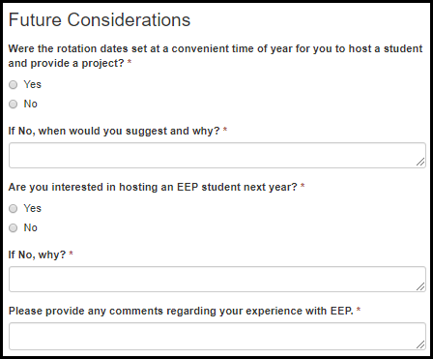
Table 8.1.1.4.a. Future Consideration Fields
Field Name | Values | EIS | LLS | FLIGHT | EEP | SAF | PHIFP | PE | ELI | PHAP
Were the rotation dates set at a convenient time of year for you to host a student and provide a project? | 1. Yes  2. No | No | No | No | Yes | No | No | No | No | No
If No, when would you suggest and why? | - | No | No | No | Yes | No | No | No | No | No
Are you interested in hosting an EEP student next year? | 1. Yes  2. No | No | No | No | Yes | No | No | No | No | No
If No, why? | - | No | No | No | Yes | No | No | No | No | No
Please provide any comments regarding your experience with EEP. | - | No | No | No | Yes | No | No | No | No | No

Project Review

Figure 8.1.2.a. Project Review Fields
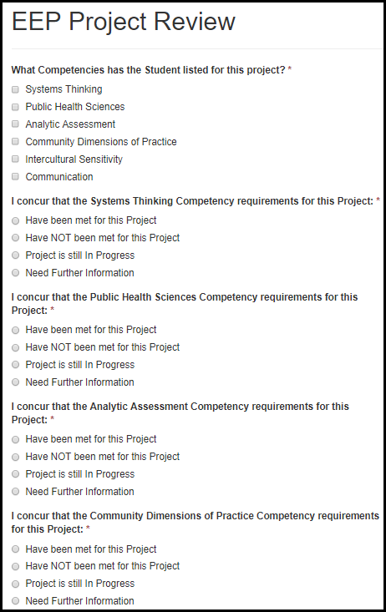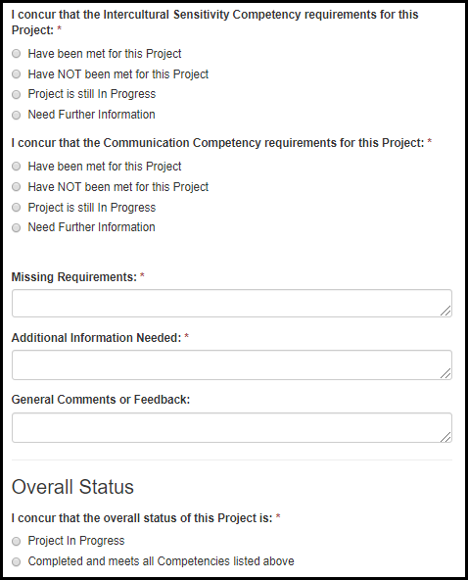

Table 8.1.2.a. Project Review Fields
Field Name | Values | EIS | LLS | EEP | SAF | PHIFP | PE | ELI | PHAP
What competencies has the student listed for this project? | 1. Systems Thinking  2. Public Health Sciences  3. Analytic Assessment  4. Community Dimensions of Practice  5. Intercultural Sensitivity  6. Communication | No | No | Yes | No | No | No | No | No
I concur that the competency requirements for this project: | 1. Have been met for this Project  2. Have NOT been met for this Project  3. Project is still In Progress  4. Need Further Information | No | No | Yes | No | No | No | No | No
Missing requirements: | - | Yes | Yes | Yes | No | Yes | Yes | Yes | Yes
Additional information needed: | - | Yes | Yes | Yes | No | Yes | Yes | Yes | Yes
General comments or feedback: | - | Yes | Yes | Yes | No | Yes | Yes | Yes | Yes
I concur that the overall status of this project is: | 1. Project in Progress  2. Completed and meets all the Competencies listed above | No | No | Yes | No | No | No | No | No

LLS

Fellow Assessment

Figure 8.2.1.a. Fellow Assessment Fields
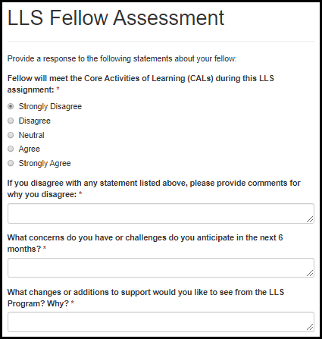

Table 8.2.1.a. Fellow Assessment Fields
Field Name | Values | EIS | LLS | FLIGHT | EEP | SAF | PHIFP | PE | ELI | PHAP
Fellow will meet the Core Activities of Learning (CALs) during this LLS assignment | 1. Strongly Disagree  2. Disagree  3. Neutral  4. Agree  5. Strongly Agree | No | Yes | No | No | No | No | No | No | No
If you disagree with any statement listed above, please provide comments for why you disagree: | - | No | Yes | No | No | No | No | No | No | No
What concerns do you have or challenges do you anticipate in the next 6 months? | - | No | Yes | No | No | No | No | No | No | No
What changes or additions to support would you like to see from the LLS Program? Why? | - | No | Yes | No | No | No | No | No | No | No

6-Month CAL Assessment

Section I.

Figure 8.2.2.1.a. CAL 1 Fields
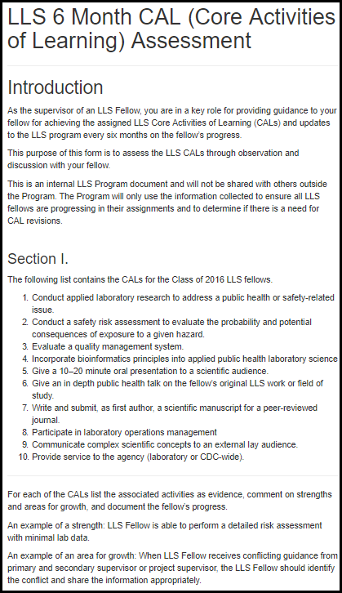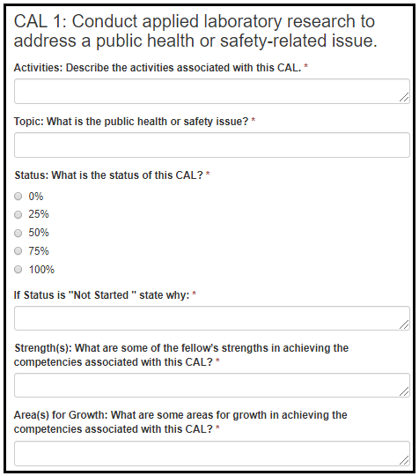

Table 8.2.2.1.a. CAL 1 Fields
Field Name | Values | EIS | LLS | FLIGHT | EEP | SAF | PHIFP | PE | ELI | PHAP
Activities: Describe the activities associated with this CAL. | - | No | Yes | No | No | No | No | No | No | No
Topic: What is the public health or safety issue? | - | No | Yes | No | No | No | No | No | No | No
Status: What is the status of this CAL? | 1. 0%  2. 25%  3. 50%  4. 75%  5. 100% | No | Yes | No | No | No | No | No | No | No
If Status is "Not Started " state why: | - | No | Yes | No | No | No | No | No | No | No
Strength(s): What are some of the fellow’s strengths in achieving the competencies associated with this CAL? | - | No | Yes | No | No | No | No | No | No | No
Area(s) for Growth: What are some areas for growth in achieving the competencies associated with this CAL? | - | No | Yes | No | No | No | No | No | No | No

Figure 8.2.2.1.b. CAL 2 Fields
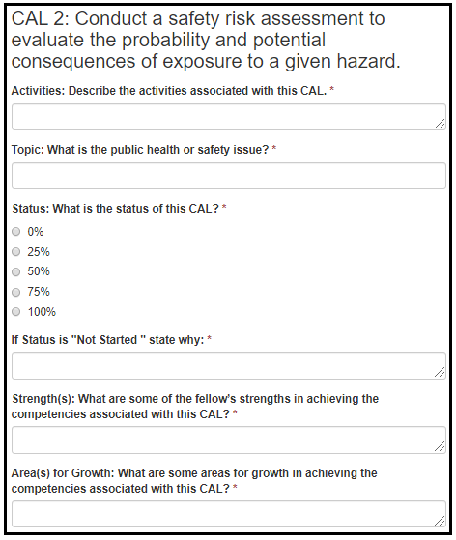

Table 8.2.2.1.b. CAL 2 Fields
Field Name | Values | EIS | LLS | FLIGHT | EEP | SAF | PHIFP | PE | ELI | PHAP
Activities: Describe the activities associated with this CAL. | - | No | Yes | No | No | No | No | No | No | No
Topic: What is the public health or safety issue? | - | No | Yes | No | No | No | No | No | No | No
Status: What is the status of this CAL? | 1. 0%  2. 25%  3. 50%  4. 75%  5. 100% | No | Yes | No | No | No | No | No | No | No
If Status is "Not Started " state why: | - | No | Yes | No | No | No | No | No | No | No
Strength(s): What are some of the fellow’s strengths in achieving the competencies associated with this CAL? | - | No | Yes | No | No | No | No | No | No | No
Area(s) for Growth: What are some areas for growth in achieving the competencies associated with this CAL? | - | No | Yes | No | No | No | No | No | No | No

Figure 8.2.2.1.c. CAL 3 Fields
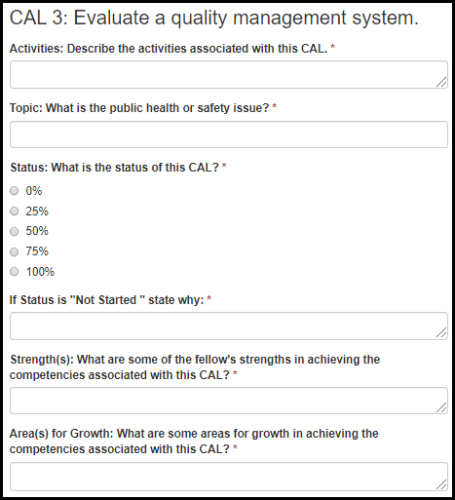

Table 8.2.2.1.c. CAL 3 Fields
Field Name | Values | EIS | LLS | FLIGHT | EEP | SAF | PHIFP | PE | ELI | PHAP
Activities: Describe the activities associated with this CAL. | - | No | Yes | No | No | No | No | No | No | No
Topic: What is the public health or safety issue? | - | No | Yes | No | No | No | No | No | No | No
Status: What is the status of this CAL? | 1. 0%  2. 25%  3. 50%  4. 75%  5. 100% | No | Yes | No | No | No | No | No | No | No
If Status is "Not Started " state why: | - | No | Yes | No | No | No | No | No | No | No
Strength(s): What are some of the fellow’s strengths in achieving the competencies associated with this CAL? | - | No | Yes | No | No | No | No | No | No | No
Area(s) for Growth: What are some areas for growth in achieving the competencies associated with this CAL? | - | No | Yes | No | No | No | No | No | No | No

Figure 8.2.2.1.d. CAL 4 Fields
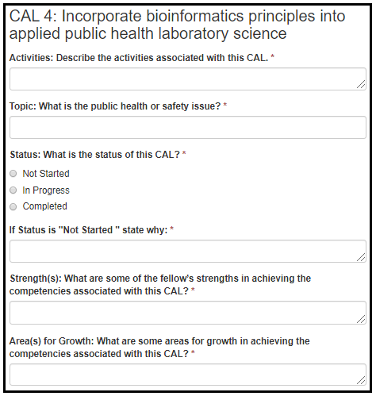

Table 8.2.2.1.d. CAL 4 Fields
Field Name | Values | EIS | LLS | FLIGHT | EEP | SAF | PHIFP | PE | ELI | PHAP
Activities: Describe the activities associated with this CAL. | - | No | Yes | No | No | No | No | No | No | No
Topic: What is the public health or safety issue? | - | No | Yes | No | No | No | No | No | No | No
Status: What is the status of this CAL? | 1. Not Started  2. In Progress  3. Completed | No | Yes | No | No | No | No | No | No | No
If Status is "Not Started " state why: | - | No | Yes | No | No | No | No | No | No | No
Strength(s): What are some of the fellow’s strengths in achieving the competencies associated with this CAL? | - | No | Yes | No | No | No | No | No | No | No
Area(s) for Growth: What are some areas for growth in achieving the competencies associated with this CAL? | - | No | Yes | No | No | No | No | No | No | No

Figure 8.2.2.1.e. CAL 5 Fields
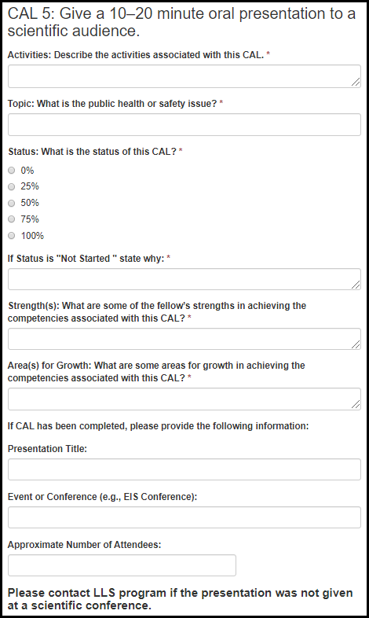

Table 8.2.2.1.e. CAL 5 Fields
Field Name | Values | EIS | LLS | FLIGHT | EEP | SAF | PHIFP | PE | ELI | PHAP
Activities: Describe the activities associated with this CAL. | - | No | Yes | No | No | No | No | No | No | No
Topic: What is the public health or safety issue? | - | No | Yes | No | No | No | No | No | No | No
Status: What is the status of this CAL? | 1. 0%  2. 25%  3. 50%  4. 75%  5. 100% | No | Yes | No | No | No | No | No | No | No
If Status is "Not Started " state why: | - | No | Yes | No | No | No | No | No | No | No
Strength(s): What are some of the fellow’s strengths in achieving the competencies associated with this CAL? | - | No | Yes | No | No | No | No | No | No | No
Area(s) for Growth: What are some areas for growth in achieving the competencies associated with this CAL? | - | No | Yes | No | No | No | No | No | No | No
Presentation Title: | - | No | Yes | No | No | No | No | No | No | No
Event or Conference (e.g., EIS Conference): | - | No | Yes | No | No | No | No | No | No | No
Approximate Number of Attendees: | - | No | Yes | No | No | No | No | No | No | No

Figure 8.2.2.1.f. CAL 6 Fields
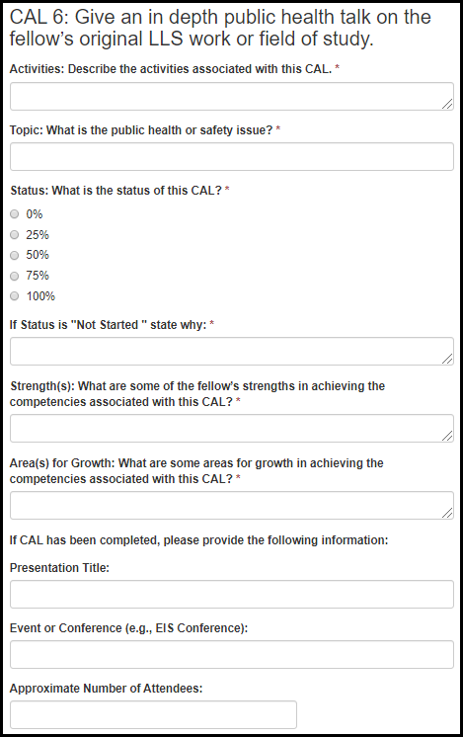

Table 8.2.2.1.f. CAL 6 Fields
Field Name | Values | EIS | LLS | FLIGHT | EEP | SAF | PHIFP | PE | ELI | PHAP
Activities: Describe the activities associated with this CAL. | - | No | Yes | No | No | No | No | No | No | No
Topic: What is the public health or safety issue? | - | No | Yes | No | No | No | No | No | No | No
Status: What is the status of this CAL? | 1. 0%  2. 25%  3. 50%  4. 75%  5. 100% | No | Yes | No | No | No | No | No | No | No
If Status is "Not Started " state why: | - | No | Yes | No | No | No | No | No | No | No
Strength(s): What are some of the fellow’s strengths in achieving the competencies associated with this CAL? | - | No | Yes | No | No | No | No | No | No | No
Area(s) for Growth: What are some areas for growth in achieving the competencies associated with this CAL? | - | No | Yes | No | No | No | No | No | No | No
Presentation Title: | - | No | Yes | No | No | No | No | No | No | No
Event or Conference (e.g., EIS conference): | - | No | Yes | No | No | No | No | No | No | No
Approximate Number of Attendees | - | No | Yes | No | No | No | No | No | No | No

Figure 8.2.2.1.g. CAL 7 Fields
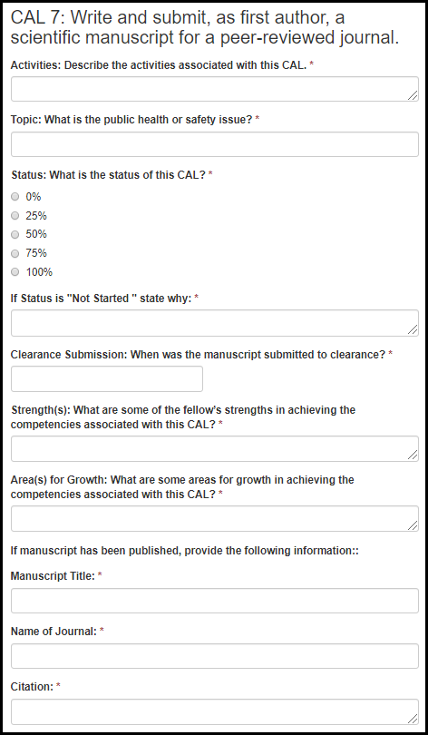

Table 8.2.2.1.g. CAL 7 Fields
Field Name | Values | EIS | LLS | FLIGHT | EEP | SAF | PHIFP | PE | ELI | PHAP
Activities: Describe the activities associated with this CAL. | - | No | Yes | No | No | No | No | No | No | No
Topic: What is the public health or safety issue? | - | No | Yes | No | No | No | No | No | No | No
Status: What is the status of this CAL? | 1. 0%  2. 25%  3. 50%  4. 75%  5. 100% | No | Yes | No | No | No | No | No | No | No
If Status is "Not Started " state why: | - | No | Yes | No | No | No | No | No | No | No
Clearance Submission: When was the manuscript submitted to clearance? | - | No | Yes | No | No | No | No | No | No | No
Strength(s): What are some of the fellow’s strengths in achieving the competencies associated with this CAL? | - | No | Yes | No | No | No | No | No | No | No
Area(s) for Growth: What are some areas for growth in achieving the competencies associated with this CAL? | - | No | Yes | No | No | No | No | No | No | No
Manuscript Title: | - | No | Yes | No | No | No | No | No | No | No
Name of Journal: | - | No | Yes | No | No | No | No | No | No | No
Citation: | - | No | Yes | No | No | No | No | No | No | No

Figure 8.2.2.1.h. CAL 8 Fields
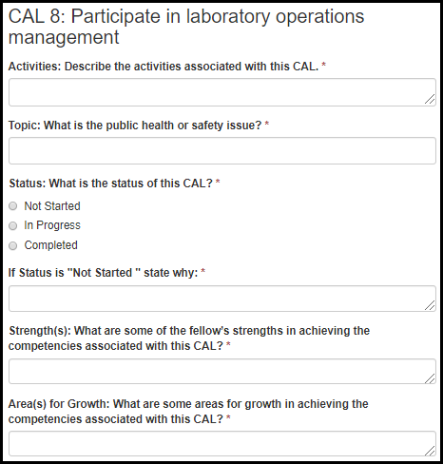

Figure 8.2.2.1.h. CAL 8 Fields
Field Name | Values | EIS | LLS | FLIGHT | EEP | SAF | PHIFP | PE | ELI | PHAP
Activities: Describe the activities associated with this CAL. | - | No | Yes | No | No | No | No | No | No | No
Topic: What is the public health or safety issue? | - | No | Yes | No | No | No | No | No | No | No
Status: What is the status of this CAL? | 1. Not Started  2. In Progress  3. Completed | No | Yes | No | No | No | No | No | No | No
If Status is "Not Started " state why: | - | No | Yes | No | No | No | No | No | No | No
Strength(s): What are some of the fellow’s strengths in achieving the competencies associated with this CAL? | - | No | Yes | No | No | No | No | No | No | No
Area(s) for Growth: What are some areas for growth in achieving the competencies associated with this CAL? | - | No | Yes | No | No | No | No | No | No | No

Figure 8.2.2.1.i. CAL 9 Fields
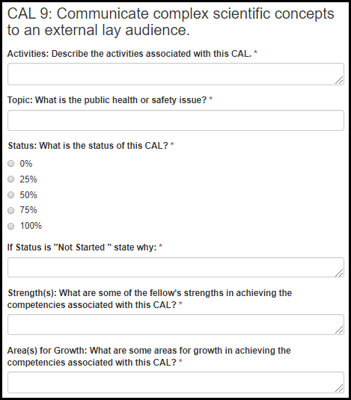

Table 8.2.2.1.i. CAL 9 Fields
Field Name | Values | EIS | LLS | FLIGHT | EEP | SAF | PHIFP | PE | ELI | PHAP
Activities: Describe the activities associated with this CAL. | - | No | Yes | No | No | No | No | No | No | No
Topic: What is the public health or safety issue? | - | No | Yes | No | No | No | No | No | No | No
Status: What is the status of this CAL? | 1. 0%  2. 25%  3. 50%  4. 75%  5. 100% | No | Yes | No | No | No | No | No | No | No
If Status is "Not Started " state why: | - | No | Yes | No | No | No | No | No | No | No
Strength(s): What are some of the fellow’s strengths in achieving the competencies associated with this CAL? | - | No | Yes | No | No | No | No | No | No | No
Area(s) for Growth: What are some areas for growth in achieving the competencies associated with this CAL? | - | No | Yes | No | No | No | No | No | No | No

Figure 8.2.2.1.j. CAL 10 Fields
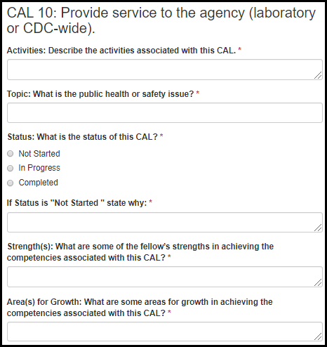

Table 8.2.2.1.j. CAL 10 Fields
Field Name | Values | EIS | LLS | FLIGHT | EEP | SAF | PHIFP | PE | ELI | PHAP
Activities: Describe the activities associated with this CAL. | - | No | Yes | No | No | No | No | No | No | No
Topic: What is the public health or safety issue? | - | No | Yes | No | No | No | No | No | No | No
Status: What is the status of this CAL? | 1. Not Started  2. In Progress  3. Completed | No | Yes | No | No | No | No | No | No | No
If Status is "Not Started " state why: | - | No | Yes | No | No | No | No | No | No | No
Strength(s): What are some of the fellow’s strengths in achieving the competencies associated with this CAL? | - | No | Yes | No | No | No | No | No | No | No
Area(s) for Growth: What are some areas for growth in achieving the competencies associated with this CAL? | - | No | Yes | No | No | No | No | No | No | No

Section II.
Figure 8.2.2.2.a. Project 1 Fields
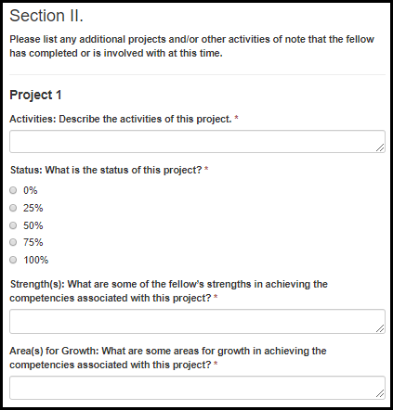
Table 8.2.2.2.a. Project 1 Fields
Field Name | Values | EIS | LLS | FLIGHT | EEP | SAF | PHIFP | PE | ELI | PHAP
Activities: Describe the activities of this project. | - | No | Yes | No | No | No | No | No | No | No
Status: What is the status of this project? | 1. 0%  2. 25%  3. 50%  4. 75%  5. 100% | No | Yes | No | No | No | No | No | No | No
Strength(s): What are some of the fellow’s strengths in achieving the competencies associated with this project? | - | No | Yes | No | No | No | No | No | No | No
Area(s) for Growth: What are some areas for growth in achieving the competencies associated with this project? | - | No | Yes | No | No | No | No | No | No | No
Figure 8.2.2.2.b. Project 2 Fields
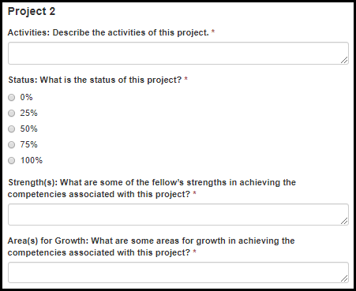
Table 8.2.2.2.b. Project 2 Fields
Field Name | Values | EIS | LLS | FLIGHT | EEP | SAF | PHIFP | PE | ELI | PHAP
Activities: Describe the activities of this project. | - | No | Yes | No | No | No | No | No | No | No
Status: What is the status of this project? | 1. 0%  2. 25%  3. 50%  4. 75%  5. 100% | No | Yes | No | No | No | No | No | No | No
Strength(s): What are some of the fellow’s strengths in achieving the competencies associated with this project? | - | No | Yes | No | No | No | No | No | No | No
Area(s) for Growth: What are some areas for growth in achieving the competencies associated with this project? | - | No | Yes | No | No | No | No | No | No | No
Figure 8.2.2.2.c. Project 3 Fields
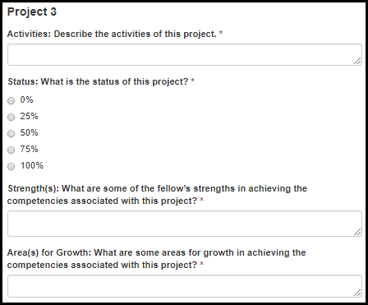
Table 8.2.2.2.c. Project 3 Fields
Field Name | Values | EIS | LLS | FLIGHT | EEP | SAF | PHIFP | PE | ELI | PHAP
Activities: Describe the activities of this project. | - | No | Yes | No | No | No | No | No | No | No
Status: What is the status of this project? | 1. 0%  2. 25%  3. 50%  4. 75%  5. 100% | No | Yes | No | No | No | No | No | No | No
Strength(s): What are some of the fellow’s strengths in achieving the competencies associated with this project? | - | No | Yes | No | No | No | No | No | No | No
Area(s) for Growth: What are some areas for growth in achieving the competencies associated with this project? | - | No | Yes | No | No | No | No | No | No | No

Activity Review

Figure 8.2.3.a. Activity Review Fields
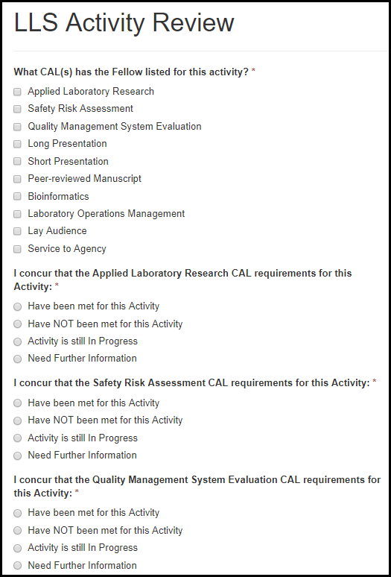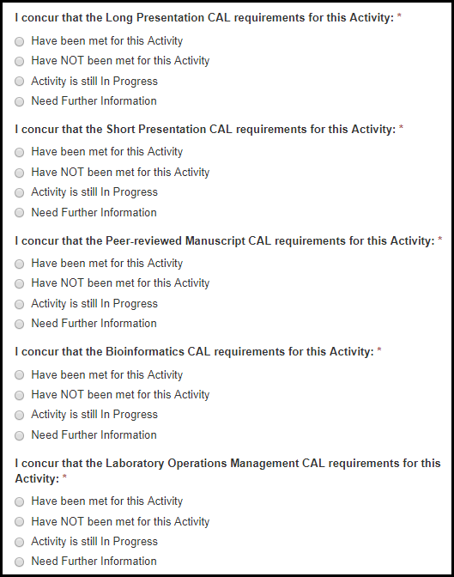

Figure 8.2.3.b. Activity Review Fields
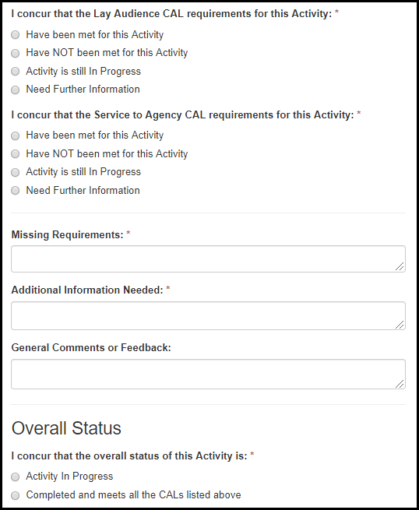

Table 8.2.3.a. Activity Review Fields
Field Name | Values | EIS | LLS | EEP | SAF | PHIFP | PE | ELI | PHAP
What CALs has the Fellow listed for this activity? | 1. Applied Laboratory Research  2. Safety Risk Assessment  3. Quality Management System Evaluation  4. Long Presentation  5. Short Presentation  6. Peer-reviewed Manuscript  7. Bioinformatics  8. Laboratory Operations Management  9. Lay Audience  10. Service to Agency | No | Yes | No | No | No | No | No | No
I concur that the CAL requirements for this Activity: | 1. Have been met for this Activity  2. Have NOT been met for this Activity  3. Activity is still In Progress  4. Need Further Information | No | Yes | No | No | No | No | No | No
Missing Requirements: | - | Yes | Yes | No | No | Yes | Yes | Yes | Yes
Additional Information Needed: | - | Yes | Yes | No | No | Yes | Yes | Yes | Yes
General Comments or Feedback: | - | Yes | Yes | No | No | Yes | Yes | Yes | Yes
I concur that the overall status of this Activity is: | 1. Activity in Progress  2. Completed and meets all the CALs listed above | No | Yes | No | No | No | No | No | No

PE

Supervisor Evaluation of PE Fellow – End of Year 1 and Year 2

Introduction

Figure 8.3.1.1.a. Introduction Fields
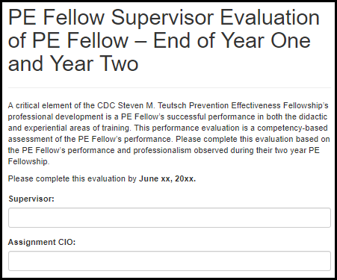
Table 8.3.1.1.a. Introduction Fields
Field Name | Values | EIS | LLS | FLIGHT | EEP | SAF | PHIFP | PE | ELI | PHAP
Supervisor: | - | No | No | No | No | No | No | Yes | No | No
Assignment CIO: | - | No | No | No | No | No | No | Yes | No | No

Development of Competencies

Figure 8.3.1.2.a. Analytic / Assessment Skills Fields
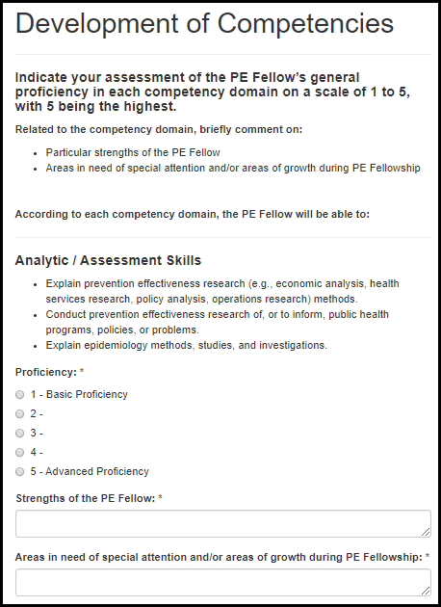

Table 8.3.1.2.a. Analytic / Assessment Skills Fields
Field Name | Values | EIS | LLS | FLIGHT | EEP | SAF | PHIFP | PE | ELI | PHAP
Proficiency: | 1. 1 - Basic Proficiency  2. 2 -  3. 3 -  4. 4 -  5. 5 - Advanced Proficiency | No | No | No | No | No | No | Yes | No | No
Strengths of the PE Fellow: | - | No | No | No | No | No | No | Yes | No | No
Areas in need of special attention and/or areas of growth during PE Fellowship: | - | No | No | No | No | No | No | Yes | No | No

Figure 8.3.1.2.b. Policy Assessment and Communication Fields
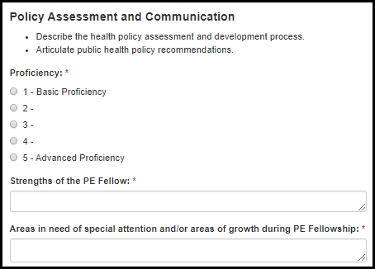
Figure 8.3.1.2.b. Policy Assessment and Communication Fields
Field Name | Values | EIS | LLS | FLIGHT | EEP | SAF | PHIFP | PE | ELI | PHAP
Proficiency: | 1. 1 - Basic Proficiency  2. 2 -  3. 3 -  4. 4 -  5. 5 - Advanced Proficiency | No | No | No | No | No | No | Yes | No | No
Strengths of the PE Fellow: | - | No | No | No | No | No | No | Yes | No | No
Areas in need of special attention and/or areas of growth during PE Fellowship: | - | No | No | No | No | No | No | Yes | No | No

Figure 8.3.1.2.c. Interpersonal and Professional Communication Fields
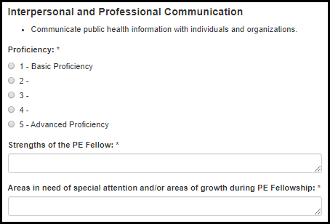
Table 8.3.1.2.c. Interpersonal and Professional Communication Fields
Field Name | Values | EIS | LLS | FLIGHT | EEP | SAF | PHIFP | PE | ELI | PHAP
Proficiency: | 1. 1 - Basic Proficiency  2. 2 -  3. 3 -  4. 4 -  5. 5 - Advanced Proficiency | No | No | No | No | No | No | Yes | No | No
Strengths of the PE Fellow: | - | No | No | No | No | No | No | Yes | No | No
Areas in need of special attention and/or areas of growth during PE Fellowship: | - | No | No | No | No | No | No | Yes | No | No

Figure 8.3.1.2.d. Foundations for Leadership Fields
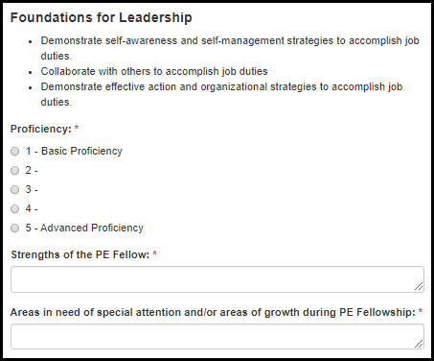
Table 8.3.1.2.d. Foundations for Leadership Fields
Field Name | Values | EIS | LLS | FLIGHT | EEP | SAF | PHIFP | PE | ELI | PHAP
Proficiency: | 1. 1 - Basic Proficiency  2. 2 -  3. 3 -  4. 4 -  5. 5 - Advanced Proficiency | No | No | No | No | No | No | Yes | No | No
Strengths of the PE Fellow: | - | No | No | No | No | No | No | Yes | No | No
Areas in need of special attention and/or areas of growth during PE Fellowship: | - | No | No | No | No | No | No | Yes | No | No

Leadership Inventory

Figure 8.3.1.3.a. Leadership Inventory Fields
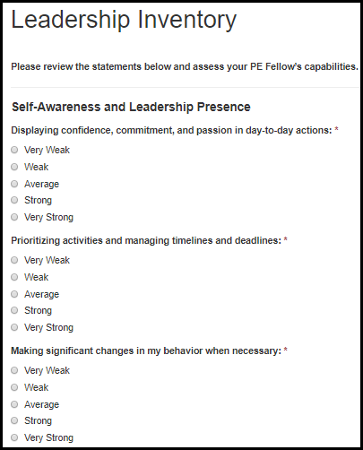

Table 8.3.1.3.a. Leadership Inventory Fields
Field Name | Values | EIS | LLS | FLIGHT | EEP | SAF | PHIFP | PE | ELI | PHAP
Displaying confidence, commitment, and passion in day-to-day actions: | 1. Very Weak  2. Weak  3. Average  4. Strong  5. Very Strong | No | No | No | No | No | No | Yes | No | No
Prioritizing activities and managing timelines and deadlines: | 1. Very Weak  2. Weak  3. Average  4. Strong  5. Very Strong | No | No | No | No | No | No | Yes | No | No
Making significant changes in my behavior when necessary: | 1. Very Weak  2. Weak  3. Average  4. Strong  5. Very Strong | No | No | No | No | No | No | Yes | No | No

Figure 8.3.1.3.b. Leadership Inventory Fields
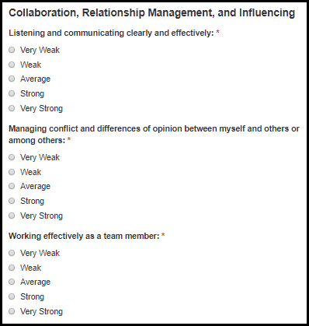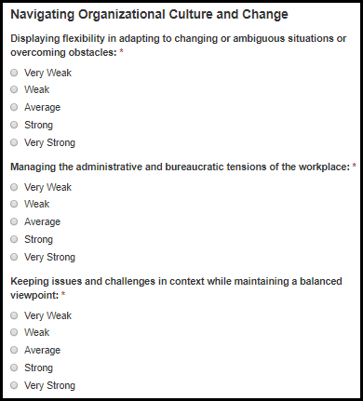
Table 8.3.1.3.b. Leadership Inventory Fields
Field Name | Values | EIS | LLS | FLIGHT | EEP | SAF | PHIFP | PE | ELI | PHAP
Listening and communicating clearly and effectively: | 1. Very Weak  2. Weak  3. Average  4. Strong  5. Very Strong | No | No | No | No | No | No | Yes | No | No
Managing conflict and differences of opinion between myself and others or among others: | 1. Very Weak  2. Weak  3. Average  4. Strong  5. Very Strong | No | No | No | No | No | No | Yes | No | No
Working effectively as a team member: | 1. Very Weak  2. Weak  3. Average  4. Strong  5. Very Strong | No | No | No | No | No | No | Yes | No | No
Displaying flexibility in adapting to changing or ambiguous situations or overcoming obstacles: | 1. Very Weak  2. Weak  3. Average  4. Strong  5. Very Strong | No | No | No | No | No | No | Yes | No | No
Managing the administrative and bureaucratic tensions of the workplace: | 1. Very Weak  2. Weak  3. Average  4. Strong  5. Very Strong | No | No | No | No | No | No | Yes | No | No
Keeping issues and challenges in context while maintaining a balanced viewpoint: | 1. Very Weak  2. Weak  3. Average  4. Strong  5. Very Strong | No | No | No | No | No | No | Yes | No | No

Progress on Performance Requirements

Figure 8.3.1.4.a. Progress on Performance Requirements Fields
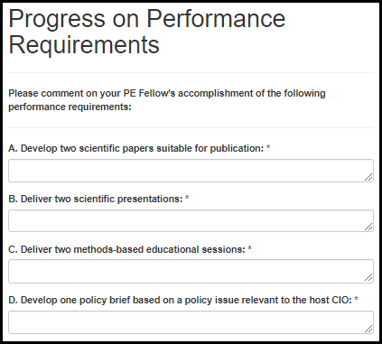
Table 8.3.1.4.a. Progress on Performance Requirements Fields
Field Name | Values | EIS | LLS | FLIGHT | EEP | SAF | PHIFP | PE | ELI | PHAP
A. Develop two scientific papers suitable for publication: | - | No | No | No | No | No | No | Yes | No | No
B. Deliver two scientific presentations: | - | No | No | No | No | No | No | Yes | No | No
C. Deliver two methods-based educational sessions: | - | No | No | No | No | No | No | Yes | No | No
D. Develop one policy brief based on a policy issue relevant to the host CIO: | - | No | No | No | No | No | No | Yes | No | No

Overall Performance

Figure 8.3.1.5.a. Overall Performance Fields
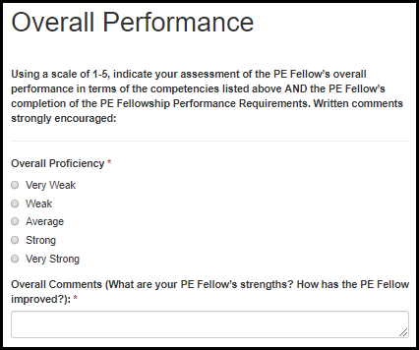
Table 8.3.1.5.a. Overall Performance Fields
Field Name | Values | EIS | LLS | FLIGHT | EEP | SAF | PHIFP | PE | ELI | PHAP
Overall Proficiency: | 1. Very Weak  2. Weak  3. Average  4. Strong  5. Very Strong | No | No | No | No | No | No | Yes | No | No
Overall Comments (What are your PE Fellow’s strengths? How has the PE Fellow improved?): | - | No | No | No | No | No | No | Yes | No | No

Statement of Value

Figure 8.3.1.6.a. Statement of Value Fields
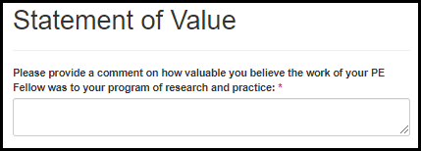
Table 8.3.1.6.a. Statement of Value Fields
Field Name | Values | EIS | LLS | FLIGHT | EEP | SAF | PHIFP | PE | ELI | PHAP
Please provide a comment on how valuable you believe the work of your PE Fellow was to your program of research and practice: | - | No | No | No | No | No | No | Yes | No | No

Accomplishment Review

Figure 8.3.2.a. Accomplishment Review Fields
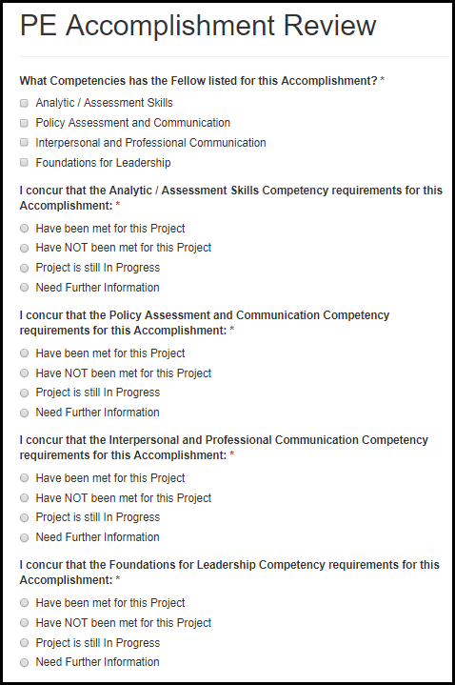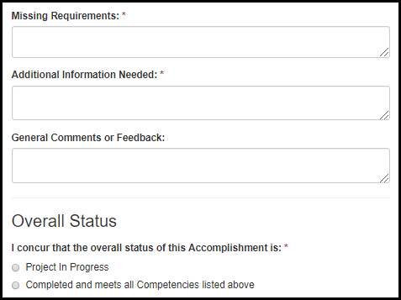

Table 8.3.2.a. Accomplishment Review Fields
Field Name | Values | EIS | LLS | EEP | SAF | PHIFP | PE | ELI | PHAP
What Competencies has the Fellow listed for this Accomplishment? | 1. Analytic / Assessment Skills  2. Policy Assessment and Communication  3. Interpersonal and Professional Communication  4. Foundations for Leadership | No | No | No | No | No | Yes | No | No
I concur that the Competency requirements for this Accomplishment: | 1. Have been met for this Accomplishment  2. Have NOT been met for this Accomplishment  3. Accomplishment is still In Progress  4. Need Further Information | No | No | No | No | No | Yes | No | No
Missing Requirements: | - | Yes | Yes | Yes | No | Yes | Yes | Yes | Yes
Additional Information Needed: | - | Yes | Yes | Yes | No | Yes | Yes | Yes | Yes
General Comments or Feedback: | - | Yes | Yes | Yes | No | Yes | Yes | Yes | Yes
I concur that the overall status of this Accomplishment is: | 1. Accomplishment in Progress  2. Completed and meets all the Competencies listed above | No | No | No | No | No | Yes | No | No

PHAP

Semi-Annual Activity Reporting (SAAR)

Section 1: Associate Activity
Figure 8.4.1.1.a. Section 1: Associate Activity Fields
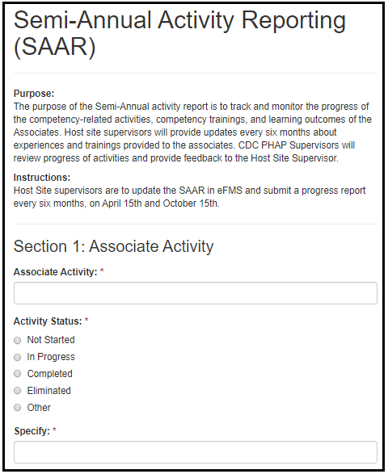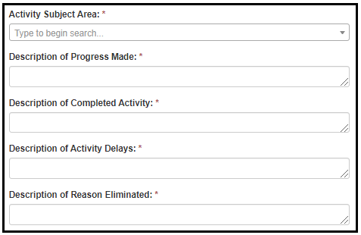

Table 8.4.1.1.a. Section 1: Associate Activity Fields
Field Name | Values | EIS | LLS | FLIGHT | EEP | SAF | PHIFP | PE | ELI | PHAP
Associate Activity: | - | No | No | No | No | No | No | No | No | Yes
Activity Status: | 1. Not Started  2. In Progress  3. Completed  4. Eliminated  5. Other | No | No | No | No | No | No | No | No | Yes
Specify: | - | No | No | No | No | No | No | No | No | Yes
Activity Subject Area: | Subject Area Lookup | No | No | No | No | No | No | No | No | Yes
Description of Progress Made: | - | No | No | No | No | No | No | No | No | Yes
Description of Completed Activity: | - | No | No | No | No | No | No | No | No | Yes
Description of Activity Delays: | - | No | No | No | No | No | No | No | No | Yes
Description of Reason Eliminated: | - | No | No | No | No | No | No | No | No | Yes

Section 2: Competency Training

Figure 8.4.1.2.a. Section 2: Competency Training Fields
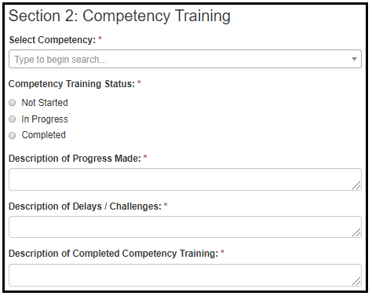
Table 8.4.1.2.a. Section 2: Competency Training Fields
Field Name | Values | EIS | LLS | FLIGHT | EEP | SAF | PHIFP | PE | ELI | PHAP
Select Competency: | - | No | No | No | No | No | No | No | No | Yes
Competency Training Status: | 1. Not Started  2. In Progress  3. Completed | No | No | No | No | No | No | No | No | Yes
Description of Progress Made: | - | No | No | No | No | No | No | No | No | Yes
Description of Delays / Challenges: | - | No | No | No | No | No | No | No | No | Yes
Description of Completed Competency Training: | - | No | No | No | No | No | No | No | No | Yes

Section 3: Learning Outcome

Figure 8.4.1.3.a. Section 3: Learning Outcome Fields
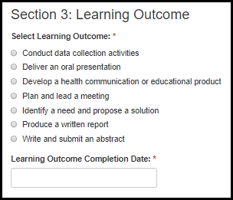
Table 8.4.1.3.a. Section 3: Learning Outcome Fields
Field Name | Values | EIS | LLS | FLIGHT | EEP | SAF | PHIFP | PE | ELI | PHAP
Select Learning Outcome: | 1. Conduct data collection activities  2. Deliver an oral presentation  3. Develop a health communication or educational product  4. Plan and lead a meeting  5. Identify a need and propose a solution  6. Produce a written report  7. Write and submit an abstract | No | No | No | No | No | No | No | No | Yes
Learning Outcome Completion Date: | - | No | No | No | No | No | No | No | No | Yes

Section 4: Priority Training Needs

Figure 8.4.1.4.a. Section 3: Learning Outcome Fields
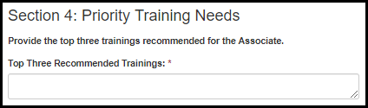
Table 8.4.1.4.a. Section 3: Learning Outcome Fields
Field Name | Values | EIS | LLS | FLIGHT | EEP | SAF | PHIFP | PE | ELI | PHAP
Top Three Recommended Trainings: | - | No | No | No | No | No | No | No | No | Yes

Project Review

Figure 8.4.2.a. Project Review Fields
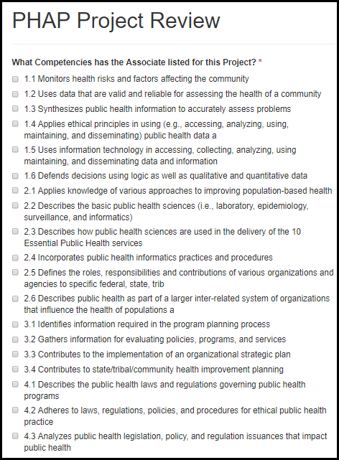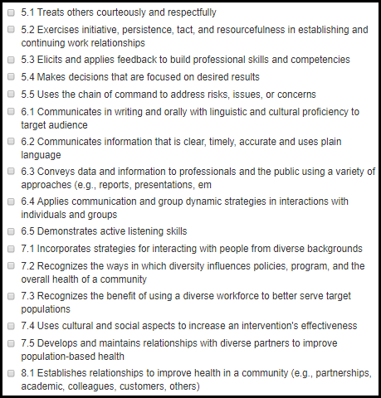

Figure 8.4.2.b. Project Review Fields
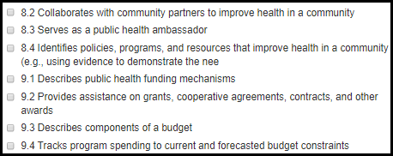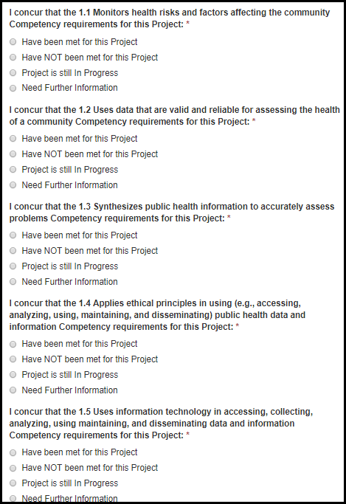

Figure 8.4.2.c. Project Review Fields
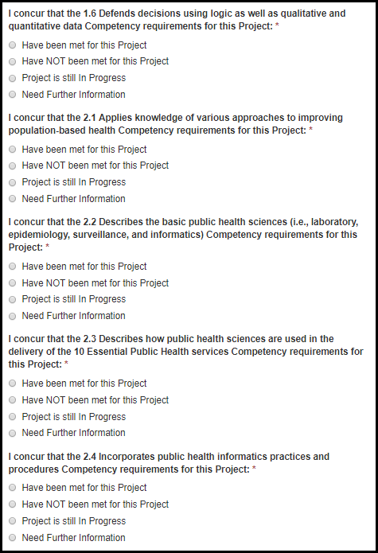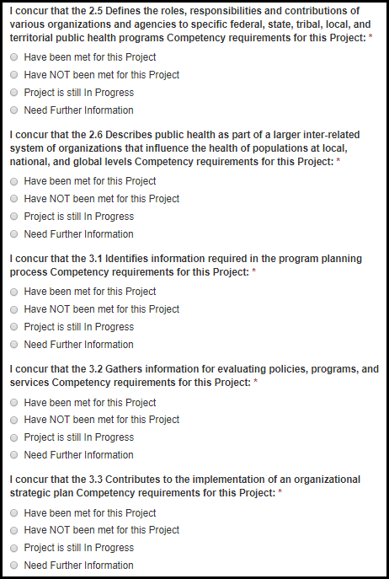

Figure 8.4.2.d. Project Review Fields
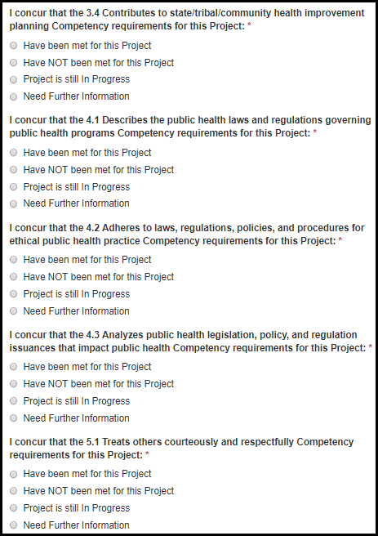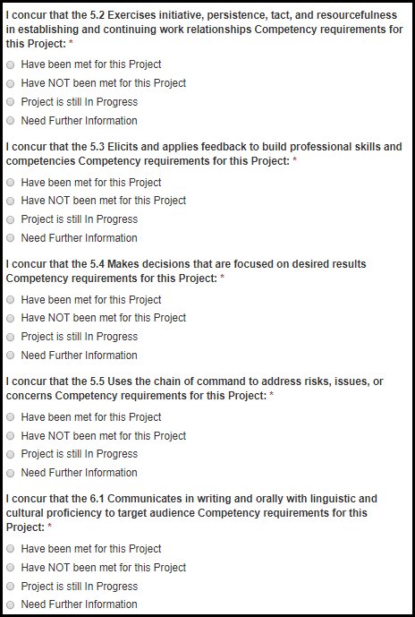

Figure 8.4.2.d. Project Review Fields
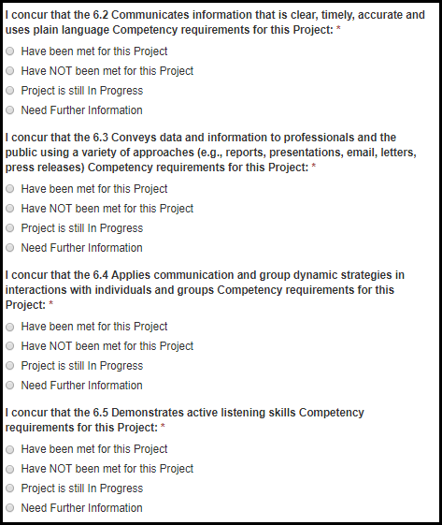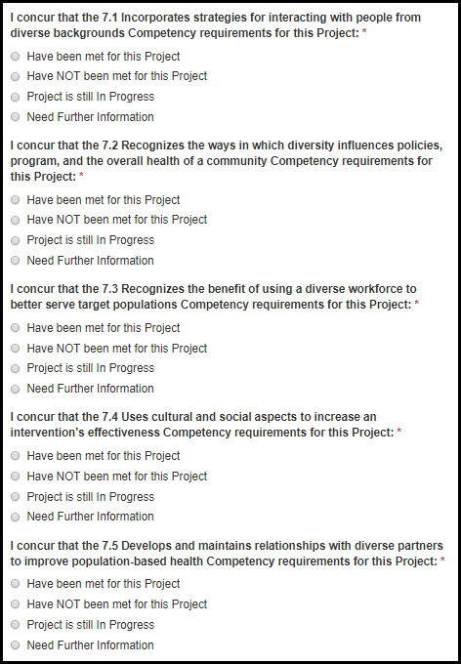

Figure 8.4.2.e. Project Review Fields
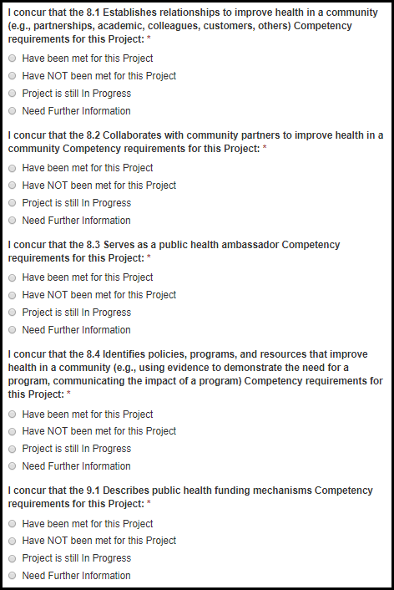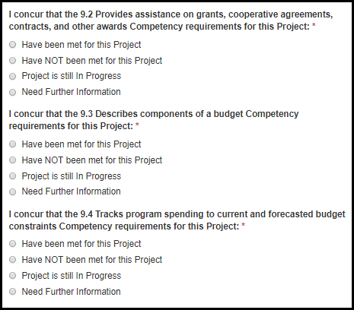

Figure 8.4.2.f. Project Review Fields
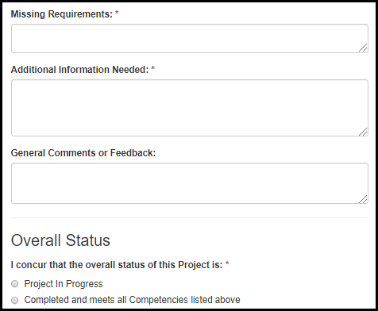

Table 8.4.2.a. Project Review Fields
Field Name | Values | EIS | LLS | EEP | SAF | PHIFP | PE | ELI | PHAP
What Competencies has the Associate listed for this Project? | 1. 1.1 Monitors health risks and factors affecting the community  2. 1.2 Uses data that are valid and reliable for assessing the health of a community  3. 1.3 Synthesizes public health information to accurately assess problems  4. 1.4 Applies ethical principles in using (e.g., accessing, analyzing, using, maintaining, and disseminating) public health data and information  5. 1.5 Uses information technology in accessing, collecting, analyzing, using maintaining, and disseminating data and information  6. 1.6 Defends decisions using logic as well as qualitative and quantitative data  7. 2.1 Applies knowledge of various approaches to improving population-based health  8. 2.2 Describes the basic public health sciences (i.e., laboratory, epidemiology, surveillance, and informatics)  9. 2.3 Describes how public health sciences are used in the delivery of the 10 Essential Public Health services  10. 2.4 Incorporates public health informatics practices and procedures  11. 2.5 Defines the roles, responsibilities and contributions of various organizations and agencies to specific federal, state, tribal, local, and territorial public health programs  12. 2.6 Describes public health as part of a larger inter-related system of organizations that influence the health of populations at local, national, and global levels  13. 3.1 Identifies information required in the program planning process  14. 3.2 Gathers information for evaluating policies, programs, and services  15. 3.3 Contributes to the implementation of an organizational strategic plan  16. 3.4 Contributes to state/tribal/community health improvement planning  17. 4.1 Describes the public health laws and regulations governing public health programs  18. 4.2 Adheres to laws, regulations, policies, and procedures for ethical public health practice  19. 4.3 Analyzes public health legislation, policy, and regulation issuances that impact public health  20. 5.1 Treats others courteously and respectfully  21. 5.2 Exercises initiative, persistence, tact, and resourcefulness in establishing and continuing work relationships  22. 5.3 Elicits and applies feedback to build professional skills and competencies  23. 5.4 Makes decisions that are focused on desired results  24. 5.5 Uses the chain of command to address risks, issues, or concerns  25. 6.1 Communicates in writing and orally with linguistic and cultural proficiency to target audience  26. 6.2 Communicates information that is clear, timely, accurate and uses plain language  27. 6.3 Conveys data and information to professionals and the public using a variety of approaches (e.g., reports, presentations, email, letters, press releases)  28. 6.4 Applies communication and group dynamic strategies in interactions with individuals and groups  29. 6.5 Demonstrates active listening skills  30. 7.1 Incorporates strategies for interacting with people from diverse backgrounds  31. 7.2 Recognizes the ways in which diversity influences policies, program, and the overall health of a community  32. 7.3 Recognizes the benefit of using a diverse workforce to better serve target populations  33. 7.4 Uses cultural and social aspects to increase an intervention's effectiveness  34. 7.5 Develops and maintains relationships with diverse partners to improve population-based health  35. 8.1 Establishes relationships to improve health in a community (e.g., partnerships, academic, colleagues, customers, others)  36. 8.2 Collaborates with community partners to improve health in a community  37. 8.3 Serves as a public health ambassador  38. 8.4 Identifies policies, programs, and resources that improve health in a community (e.g., using evidence to demonstrate the need for a program, communicating the impact of a program)  39. 9.1 Describes public health funding mechanisms  40. 9.2 Provides assistance on grants, cooperative agreements, contracts, and other awards  41. 9.3 Describes components of a budget  42. 9.4 Tracks program spending to current and forecasted budget constraints | No | No | No | No | No | No | No | Yes
Table 8.4.2.b. Project Review Fields
Field Name | Values | EIS | LLS | EEP | SAF | PHIFP | PE | ELI | PHAP
I concur that the Competency requirements for this Project: | 1. Have been met for this Project  2. Have NOT been met for this Project  3. Project is still In Progress  4. Need Further Information | No | No | No | No | No | No | No | Yes
Missing Requirements: | - | Yes | Yes | Yes | No | Yes | Yes | Yes | Yes
Additional Information Needed: | - | Yes | Yes | Yes | No | Yes | Yes | Yes | Yes
General Comments or Feedback: | - | Yes | Yes | Yes | No | Yes | Yes | Yes | Yes
I concur that the overall status of this Project is: | 1. Project in Progress  2. Completed and meets all the Competencies listed above | No | No | No | No | No | No | No | Yes

ELI

Mentor Feedback Survey

Introduction

Figure 8.5.1.1.a. Introduction Fields
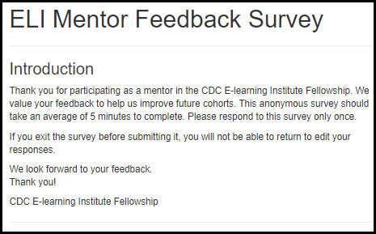

Instructional Design Competencies and Program Design

Figure 8.5.1.2.a. Instructional Design Competencies and Program Design Fields
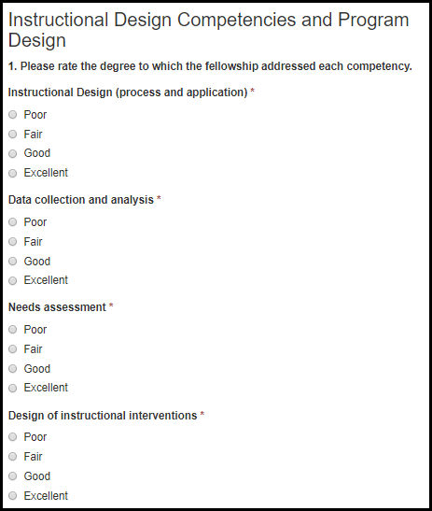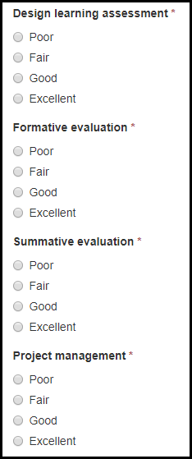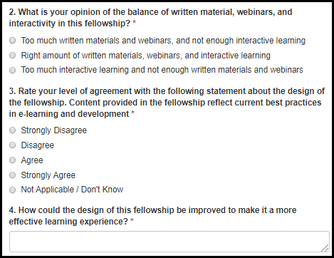

Table 8.5.1.2.a. Instructional Design Competencies and Program Design Fields
Field Name | Values | EIS | LLS | FLIGHT | EEP | SAF | PHIFP | PE | ELI | PHAP
Instructional Design (process and application) | 1. Poor  2. Fair  3. Good  4. Excellent | No | No | No | No | No | No | No | Yes | No
Data collection and analysis | 1. Poor  2. Fair  3. Good  4. Excellent | No | No | No | No | No | No | No | Yes | No
Needs assessment | 1. Poor  2. Fair  3. Good  4. Excellent | No | No | No | No | No | No | No | Yes | No
Design of instructional interventions | 1. Poor  2. Fair  3. Good  4. Excellent | No | No | No | No | No | No | No | Yes | No
Design learning assessment | 1. Poor  2. Fair  3. Good  4. Excellent | No | No | No | No | No | No | No | Yes | No
Formative evaluation | 1. Poor  2. Fair  3. Good  4. Excellent | No | No | No | No | No | No | No | Yes | No
Summative evaluation | 1. Poor  2. Fair  3. Good  4. Excellent | No | No | No | No | No | No | No | Yes | No
Project management | 1. Poor  2. Fair  3. Good  4. Excellent | No | No | No | No | No | No | No | Yes | No

Table 8.5.1.2.b. Instructional Design Competencies and Program Design Fields
Field Name | Values | EIS | LLS | FLIGHT | EEP | SAF | PHIFP | PE | ELI | PHAP
2. What is your opinion of the balance of written material, webinars, and interactivity in this fellowship? | 1. Too much written materials and webinars, and not enough interactive learning  2. Right amount of written materials, webinars, and interactive learning  3. Too much interactive learning and not enough written materials and webinars | No | No | No | No | No | No | No | Yes | No
3. Rate your level of agreement with the following statement about the design of the fellowship.  Content provided in the fellowship reflect current best practices in e-learning and development. | 1. Strongly Disagree  2. Disagree  3. Agree  4. Strongly Agree  5. Not Applicable / Don't know | No | No | No | No | No | No | No | Yes | No
4. How could the design of this fellowship be improved to make it a more effective learning experience? | - | No | No | No | No | No | No | No | Yes | No

Your Mentoring Experience

Figure 8.5.1.3.a. Your Mentoring Experience Fields
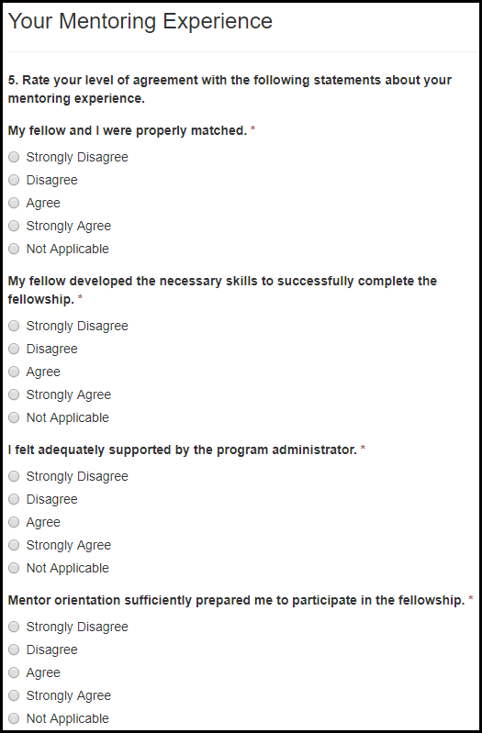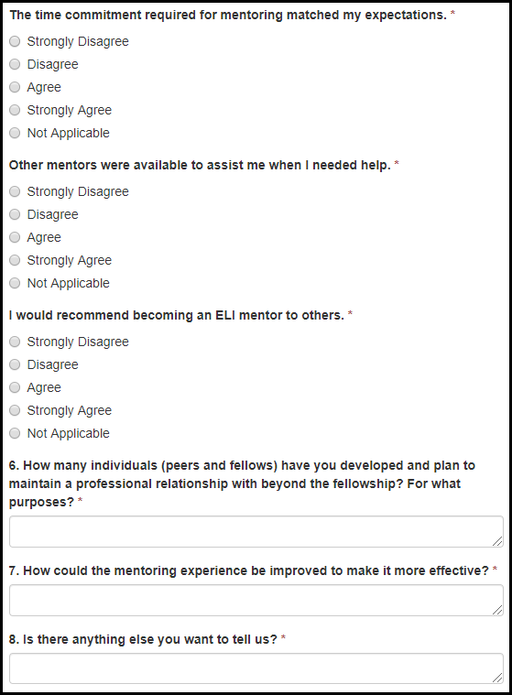

Table 8.5.1.3.a. Your Mentoring Experience Fields
Field Name | Values | EIS | LLS | FLIGHT | EEP | SAF | PHIFP | PE | ELI | PHAP
My fellow and I were properly matched. | 1. Strongly Disagree  2. Disagree  3. Agree  4. Strongly Agree  5. Not Applicable | No | No | No | No | No | No | No | Yes | No
My fellow developed the necessary skills to successfully complete the fellowship. | 1. Strongly Disagree  2. Disagree  3. Agree  4. Strongly Agree  5. Not Applicable | No | No | No | No | No | No | No | Yes | No
I felt adequately supported by the program administrator. | 1. Strongly Disagree  2. Disagree  3. Agree  4. Strongly Agree  5. Not Applicable | No | No | No | No | No | No | No | Yes | No
Mentor orientation sufficiently prepared me to participate in the fellowship. | 1. Strongly Disagree  2. Disagree  3. Agree  4. Strongly Agree  5. Not Applicable | No | No | No | No | No | No | No | Yes | No
The time commitment required for mentoring matched my expectations. | 1. Strongly Disagree  2. Disagree  3. Agree  4. Strongly Agree  5. Not Applicable | No | No | No | No | No | No | No | Yes | No

Table 8.5.1.3.b. Your Mentoring Experience Fields
Field Name | Values | EIS | LLS | FLIGHT | EEP | SAF | PHIFP | PE | ELI | PHAP
Other mentors were available to assist me when I needed help. | 1. Strongly Disagree  2. Disagree  3. Agree  4. Strongly Agree  5. Not Applicable | No | No | No | No | No | No | No | Yes | No
I would recommend becoming an ELI mentor to others. | 1. Strongly Disagree  2. Disagree  3. Agree  4. Strongly Agree  5. Not Applicable | No | No | No | No | No | No | No | Yes | No
6. How many individuals (peers and fellows) have you developed and plan to maintain a professional relationship with beyond the fellowship? For what purposes? | - | No | No | No | No | No | No | No | Yes | No
7. How could the mentoring experience be improved to make it more effective? | - | No | No | No | No | No | No | No | Yes | No
8. Is there anything else you want to tell us? | - | No | No | No | No | No | No | No | Yes | No

EIS

EIS Progress Assessment

Figure 8.6.1.a. EIS Progress Assessment Fields
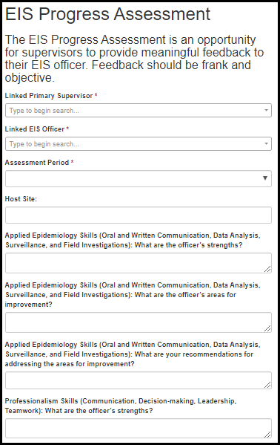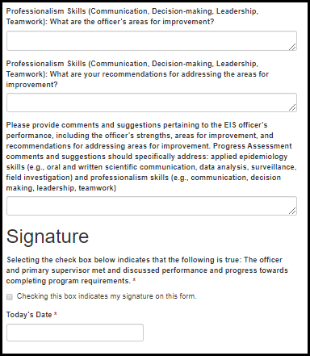
Table 8.6.1.a. EIS Progress Assessment Fields
Field Name | Values | EIS | LLS | FLIGHT | EEP | SAF | PHIFP | PE | ELI | PHAP
Primary Supervisor Name: | Supervisor Lookup | Yes | No | No | No | No | No | No | No | No
EIS Officer Name: | Officer Lookup | Yes | No | No | No | No | No | No | No | No
Assessment Period: | 1. 6 Month  2. 12 Month  3. 18 Month  4. 24 Month | Yes | No | No | No | No | No | No | No | No
Host Site: | - | Yes | No | No | No | No | No | No | No | No
Applied Epidemiology Skills (Oral and Written Communication, Data Analysis, Surveillance, and Field Investigations): What are the officer’s strengths? | - | Yes | No | No | No | No | No | No | No | No
Applied Epidemiology Skills (Oral and Written Communication, Data Analysis, Surveillance, and Field Investigations): What are the officer’s areas for improvement? | - | Yes | No | No | No | No | No | No | No | No
Applied Epidemiology Skills (Oral and Written Communication, Data Analysis, Surveillance, and Field Investigations): What are your recommendations for addressing the areas for improvement? | - | Yes | No | No | No | No | No | No | No | No
Professionalism Skills (Communication, Decision-making, Leadership, Teamwork): What are the officer’s strengths? | - | Yes | No | No | No | No | No | No | No | No
Professionalism Skills (Communication, Decision-making, Leadership, Teamwork): What are the officer’s areas for improvement? | - | Yes | No | No | No | No | No | No | No | No
Professionalism Skills (Communication, Decision-making, Leadership, Teamwork): What are your recommendations for addressing the areas for improvement? | - | Yes | No | No | No | No | No | No | No | No
Comments and Suggestions: | - | Yes | No | No | No | No | No | No | No | No
Signature: | 1. Checking this box indicates my signature on this form. | Yes | No | No | No | No | No | No | No | No
Today's Date: |  | Yes | No | No | No | No | No | No | No | No

8.6.2 Activity Review

Figure 8.6.2.a. Activity Review Fields
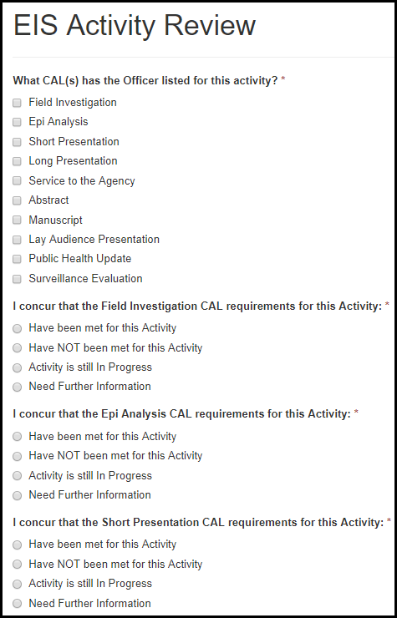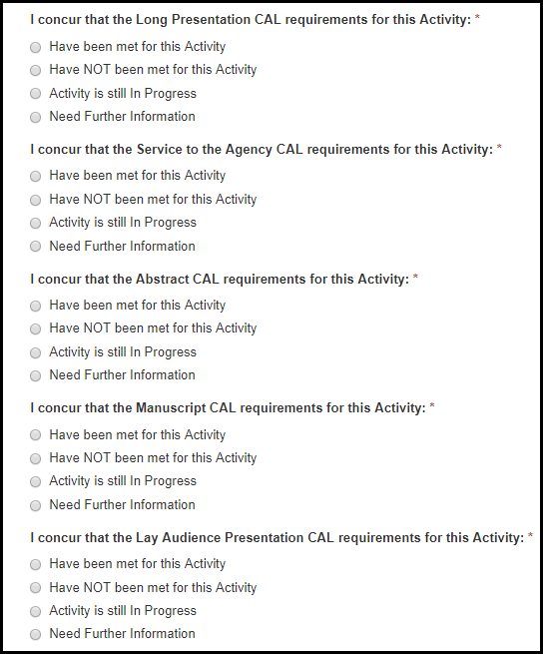

Figure 8.6.2.b. Activity Review Fields
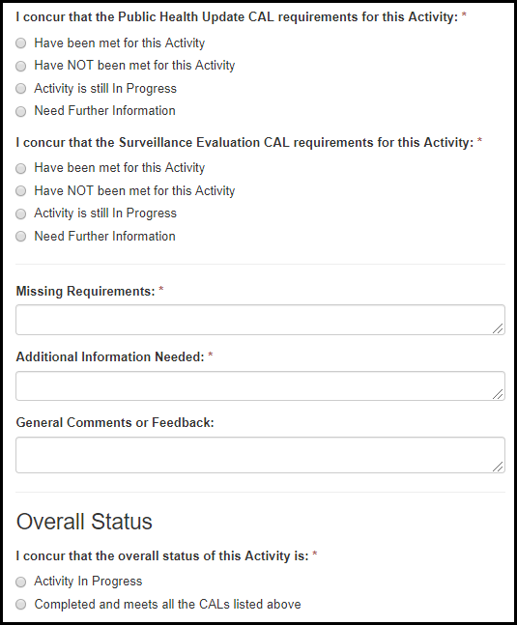

Table 8.6.2.a. Activity Review Fields
Field Name | Values | EIS | LLS | EEP | SAF | PHIFP | PE | ELI
What CALs has the Officer listed for this activity? | 1. Field Investigation  2. Epi Analysis  3. Short Presentation  4. Long Presentation  5. Service to the Agency  6. Abstract  7. Manuscript  8. Lay Audience Presentation  9. Public Health Update  10. Surveillance Evaluation | Yes | No | No | No | No | No | No
I concur that the CAL requirements for this Activity: | 1. Have been met for this Activity  2. Have NOT been met for this Activity  3. Activity is still In Progress  4. Need Further Information | Yes | No | No | No | No | No | No
Missing Requirements: | - | Yes | Yes | No | No | Yes | Yes | Yes
Additional Information Needed: | - | Yes | Yes | No | No | Yes | Yes | Yes
General Comments or Feedback: | - | Yes | Yes | No | No | Yes | Yes | Yes
I concur that the overall status of this Activity is: | 1. Activity in Progress  2. Completed and meets all the CALs listed above | Yes | No | No | No | No | No | No

PHIFP

Project Review

Figure 8.7.1.a. Project Review Fields
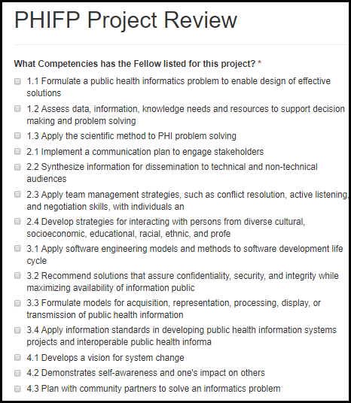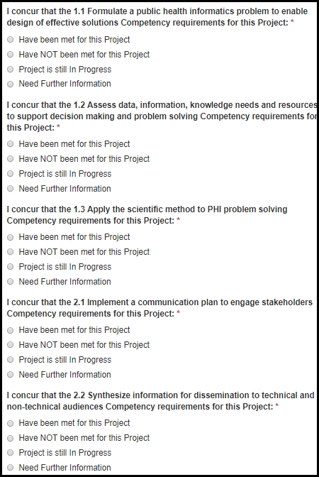

Figure 8.7.1.b. Project Review Fields
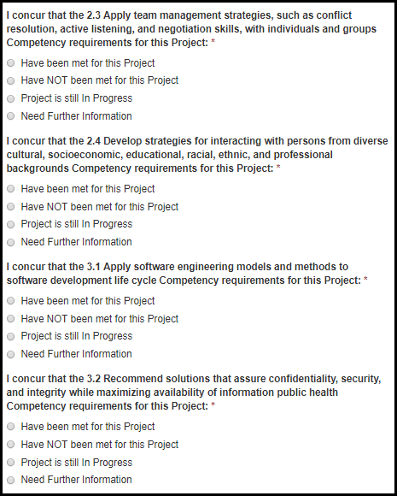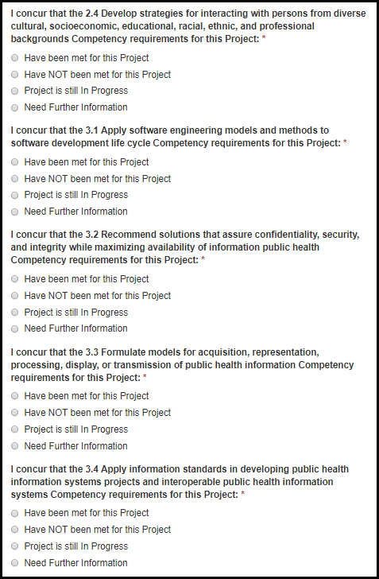

Figure 8.7.1.c. Project Review Fields
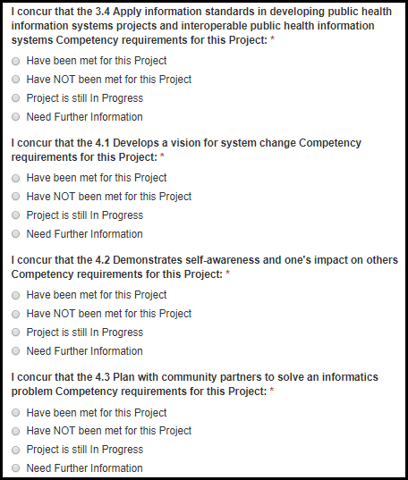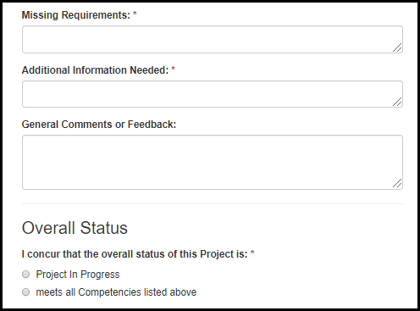
Table 8.7.1.a. Project Review Fields
Field Name | Values | EIS | LLS | EEP | SAF | PHIFP | PE | ELI | PHAP
What Competencies has the Fellow listed for this project? | 1. 1.1 Formulate a public health informatics problem to enable design of effective solutions  2. 1.2 Assess data, information, knowledge needs and resources to support decision making and problem solving  3. 1.3 Apply the scientific method to PHI problem solving  4. 2.1 Implement a communication plan to engage stakeholders  5. 2.2 Synthesize information for dissemination to technical and non-technical audiences  6. 2.3 Apply team management strategies, such as conflict resolution, active listening, and negotiation skills, with individuals and groups  7. 2.4 Develop strategies for interacting with persons from diverse cultural, socioeconomic, educational, racial, ethnic, and professional backgrounds  8. 3.1 Apply software engineering models and methods to software development life cycle  9. 3.2 Recommend solutions that assure confidentiality, security, and integrity while maximizing availability of information public health  10. 3.3 Formulate models for acquisition, representation, processing, display, or transmission of public health information  11. 3.4 Apply information standards in developing public health information systems projects and interoperable public health information systems  12. 4.1 Develops a vision for system change  13. 4.2 Demonstrates self-awareness and one's impact on others  14. 4.3 Plan with community partners to solve an informatics problem | No | No | No | No | Yes | No | No | No
I concur that the Competency requirements for this Project: | 1. Have been met for this Project  2. Have NOT been met for this Project  3. Activity is still In Progress  4. Need Further Information | No | No | No | No | Yes | No | No | No
Missing Requirements: | - | Yes | Yes | Yes | Yes | Yes | Yes | Yes | Yes
Additional Information Needed: | - | Yes | Yes | Yes | Yes | Yes | Yes | Yes | Yes
General Comments or Feedback: | - | Yes | Yes | Yes | Yes | Yes | Yes | Yes | Yes
I concur that the overall status of this Project is: | 1. Project in Progress  2. Completed and meets all the Competencies listed above | No | No | No | No | Yes | No | No | No

Appendix

I. Field Value Tables

Appendix of Field Value Tables
Field Name | Application Locations | Values  1 | Values  2 | Values  3 | Values  4
Approved Country List | 6.2 Citizenship Status | United States  Anguilla  Antigua  Australia  Bahamas  Barbados  Barbuda  Belize  Bermuda  British Virgin Islands  Canada  Dominica  Grand Cayman Islands | Grenada  Guyana  Irish Republic  Jamaica  Montserrat  New Zealand  Saint Kitts and Nevis  St. Lucia  St. Vincent & the Grenadine  Tabago  Trinidad  Turks and Caicos Islands  United Kingdom

II. Lookup Tables

Appendix of Lookup Tables
Lookup Table Name | Application Locations | Values  1 | Values  2 | Values  3 | Values  4 | Values  5
Fellowship Lookup | 3. eFMS System Help Desk Ticket | CDC E-learning Institute Fellowship Program (ELI)  CDC Steven M. Teutsch Prevention Effectiveness (PE) Fellowship  Epidemic Intelligence Service (EIS)  Epidemiology Elective Program (EEP)  Future Leaders in Infections and Global Health Threats (FLIGHT)  Laboratory Leadership Service (LLS)  Population Health Training in Place Program (PH-TIPP)  Population Health Workforce Initiative (PHWI)  Preventive Medicine Residency and Fellowship (PMR/F)  Public Health Associate Program (PHAP)  Public Health Informatics Fellowship Program (PHIFP)  Science Ambassador Fellowship (SAF)
State/Territory Lookup | 6.2.1 Conference Presentation  6.4.3 Success Story  7.1.2 Student Exit Survey | Alabama  Alaska  Arizona  Arkansas  California  Colorado  Connecticut  Delaware  Washington, DC  Florida  Georgia  Hawaii  Idaho  Illinois  Indiana  Iowa  Kansas  Kentucky  Louisiana  Maine  Maryland  Massachusetts  Michigan  Minnesota  Mississippi  Missouri  Montana  Nebraska | Nevada  New Hampshire  New Jersey  New Mexico  New York  North Carolina  North Dakota  Ohio  Oklahoma  Oregon  Pennsylvania  Rhode Island  South Carolina  South Dakota  Tennessee  Texas  Utah  Vermont  Virginia  Washington  West Virginia  Wisconsin  Wyoming  Puerto Rico  Pacific Islands  U.S. Virgin Islands  Guam  Northern Mariana Islands
Center/Division/Branch Lookup | 7.1.2 Student Exit Survey | NIOSH / Office of the Director / Administrative Svcs Branch (Cincinnati)  NIOSH / Office of the Director / Administrative Svcs Branch (Morgantown)  NIOSH / Office of the Director / Administrative Svcs Branch (Spokane)  NIOSH / Office of the Director / Administrative Svrcs Branch (Pittsburgh)  NCHS / Office of Analysis & Epidemiology / Aging & Chronic Disease Statistics Branch  NIOSH / Health Effects Laboratory Division / Allergy & Clinical Immunology Branch  NCHS / Division of Health Care Statistics / Ambulatory and Hospital Care Statistics Branch  NIOSH / Division of Safety Research / Analysis & Field Branch  NCHS / Division of Health & Nutrition Examination Surveys / Analysis Branch  NCHS / Office of Analysis & Epidemiology / Analytic Studies Branch  NCEZID / Division of Scientific Resources / Animal Resources Branch  NCCDPHP / Division for Heart Disease and Stroke Prevention / Applied Research and Evaluation Branch  NCCDPHP / Division of Population Health / Applied Research and Translation Branch  CPR / Division of State and Local Readiness / Applied Science and Evaluation Branch  NCCDPHP / Division of Reproductive Health / Applied Sciences Branch  NCEZID / Division of Vector-Borne Diseases / Arboviral Diseases Branch  NCEZID / Division of Preparedness and Emerging Infections / Arctic Investigations Program  NCCDPHP / Division of Population Health / Arthritis, Epilepsy and Well-Being Branch  NCIRD / Immunization Services Division / Assessment Branch  NCEH / Division of Environmental Health Science and Practice / Asthma and Community Health Branch  NCEZID / Division of Vector-Borne Diseases / Bacterial Diseases Branch  NCEZID / Division of High Consequence Pathogens & Pathology / Bacterial Special Pathogens Branch  NCHHSTP / Division of HIV/AIDS Prevention Surveillance & Epidemiology / Behavioral And Clinical S...  NIOSH / Division of Applied Research & Technology / Biomonitoring & Health Assessment Branch  NIOSH / Health Effects Laboratory Division / Biostatistics & Epidemiology Branch  NCEZID / Division of Foodborne, Waterborne and Environmental Diseases / Biostatistics and Informa...  NCEZID / Division of Scientific Resources / Biotechnology Core Facility Branch  NCBDDD / Division of Congenital and Developmental Disorders / Birth Defects Branch  NCHS / Office of Management & Operations / Building Operations & Services Staff  NCHS / Office of Management & Operations / Business Logistics Staff  NCCDPHP / Division of Cancer Prevention and Control / Cancer Surveillance Branch  NCHHSTP / Division of HIV/AIDS Prevention-Intervention & Support / Capacity Building Branch  CPR / Division of State and Local Readiness / Capacity Building Branch  ATSDR / Division of Community Health Investigations / Central Branch  NIOSH / Division of Applied Research & Technology / Chemical Exposure & Monitoring  NCBDDD / Division of Human Development and Disability / Child Development and Disability Branch  NCEZID / Division of High Consequence Pathogens & Pathology / Chronic Viral Diseases Branch  NCHS / Classification & Public Health Data Standards Staff / Classification & Public Health Data ...  NCEZID / Division of Healthcare Quality Promotion / Clinical & Environmental Microbiology Branch  NCEH / Division of Laboratory Science / Clinical chemistry branch  NCHHSTP / Division of Tuberculosis Elimination / Clinical Research Branch  NCHS / Division of Research & Methodology / Collaborating Center for Questionnaire Design & Evalu...  NCHS / Division of Research & Methodology / Collaborating Center for Statistical Research & Surve...  NCIRD / Immunization Services Division / Communication and Education Branch  NCHHSTP / Division of Tuberculosis Elimination / Communications, Education, and Behavioral Studie...  CSELS / Division of Public Health Information and Dissemination / Community Guide Branch  NCCDPHP / Division of Cancer Prevention and Control / Comprehensive Cancer Control Branch  ATSDR / Division of Toxicology and Human Health Sciences / Computational Toxicology and Methods D...  NIOSH / Education & Information Division / Document Development Branch  NIOSH / National Personal Protective Technology Laboratory / Conformity Verification & Standards ...  NCCDPHP / Division of Population Health / Coordinated State Support Branch  NIOSH / Pittsburgh Mining Research Division / Dust, Ventilation & Toxic Substances Branch  CGH / Division of Global Health Protection / Country Strategy and Implementation Branch  ATSDR / Division of Community Health Investigations / Eastern Branch  NCHS / Division of Vital Statistics / Data Acquisition, Classification & Evaluation Branch  CGH / Division of Global HIV and TB / Economics and Health Services Research Branch | NCHS / Division of Health Interview Statistics / Data Analysis & Quality Assurance Branch  CSELS / Division of Scientific Education and Professional Development / Education and Training Se...  NCHHSTP / Division of Tuberculosis Elimination / Data Management and Statistics Branch  NIOSH / Pittsburgh Mining Research Division / Electrical & Mechanical Systems Safety Branch  NCHS / Division of Health Interview Statistics / Data Production & Systems Branch  CPR / Division of Emergency Operations / Emergency and Risk Communications Branch  NCEZID / Division of Vector-Borne Diseases / Dengue Branch  NCEH / Division of Environmental Health Science and Practice / Emergency Management, Radiation, a...  NCBDDD / Division of Congenital and Developmental Disorders / Developmental Disabilities Branch  NCEZID / Division of Preparedness and Emerging Infections / Emergency Preparedness and Response B...  NCBDDD / Division of Human Development and Disability / Disability and Health Branch  CGH / Division of Global Health Protection / Emergency Response and Recovery Branch  NIOSH / Division of Compensation Analysis & Support / Division of Compensation Analysis & Support  NCEH / Division of Laboratory Science / Emergency response branch  NCCDPHP / Division of Oral Health / Division of Oral Health  ATSDR / Division of Toxicology and Human Health Sciences / Emergency Response Program  NIOSH / Health Effects Laboratory Division / Engineering & Control Branch  NIOSH / Division of Applied Research & Technology / Engineering & Physical Hazards Branch  NCEZID / Division of Foodborne, Waterborne and Environmental Diseases / Enteric Diseases Epidemio...  NCEZID / Division of Foodborne, Waterborne and Environmental Diseases / Enteric Diseases Laborato...  CGH / Division of Parasitic Diseases and Malaria / Entomology Branch  ATSDR / Division of Toxicology and Human Health Sciences / Environmental Epidemiology Branch  NCCDPHP / Division of Population Health / Epidemiology and Surveillance Branch  NCEH / Division of Emergency and Environmental Health Services / Environmental Health Services Br...  ATSDR / Division of Toxicology and Human Health Sciences / Environmental Health Surveillance Branch  NCHHSTP / Division of Viral Hepatitis / Epidemiology and Surveillance Branch  ATSDR / Division of Toxicology and Human Health Sciences / Environmental Medicine Branch  NCHHSTP / Division of HIV/AIDS Prevention Surveillance & Epidemiology / Epidemiology Branch  NCEH / Division of Emergency and Environmental Health Services / Environmental Public Health Read...  NCCDPHP / Office on Smoking and Health / Epidemiology Branch  ATSDR / Division of Toxicology and Human Health Sciences / Environmental Toxicology Branch  NCEZID / Division of Healthcare Quality Promotion / Epidemiology Research and Innovations Branch  NCCDPHP / Division of Cancer Prevention and Control / Epidemiology and Applied Research Branch  CSELS / Division of Scientific Education and Professional Development / Epidemiology Workforce Br...  NCIRD / Influenza Division / Epidemiology and Prevention Branch  CGH / Division of Global Health Protection / Epidemiology, Informatics, Surveillance and Lab Branch  NCCDPHP / Division of Diabetes Translation / Epidemiology and Statistics Branch  NIOSH / National Personal Protective Technology Laboratory / Evaluation & Testing Branch  NCHHSTP / Division of Sexually Transmitted Disease Prevention / Epidemiology and Statistics Branch  NIOSH / Health Effects Laboratory Division / Exposure Assessment Branch  NCCDPHP / Division for Heart Disease and Stroke Prevention / Epidemiology and Surveillance Branch  NCHHSTP / Division of Sexually Transmitted Disease Prevention / Field Services Branch  NCBDDD / Division of Blood Disorders / Epidemiology and Surveillance Branch  CPR / Division of State and Local Readiness / Field Services Branch  CGH / Division of Global HIV and TB / Epidemiology and Surveillance Branch  NCHHSTP / Division of Tuberculosis Elimination / Field Services Branch  NIOSH / Respiratory Health Division / Field Studies Branch  NCCDPHP / Division of Reproductive Health / Field Support Branch | NIOSH / Pittsburgh Mining Research Division / Fires and Explosions Branch  NCEZID / Division of Foodborne, Waterborne and Environmental Diseases / Food Safety Office  NCEZID / Division of Global Migration and Quarantine / Geographic Medicine and Health Promotion B...  NCHS / Office of Analysis & Epidemiology / Health Promotion Statistics Branch  ATSDR / Division of Toxicology and Human Health Sciences / Geospatial Research, Analysis, and Ser...  CGH / Division of Global Health Protection / Global Non-communicable Disease Branch  NCCDPHP / Office on Smoking and Health / Global Tobacco Control Branch  NCHHSTP / Division of Sexually Transmitted Disease Prevention / Health Services Research and Eval...  CGH / Division of Global HIV and TB / Global Tuberculosis Branch  NCIPC / Division of Unintentional Injury Prevention / Health Systems and Trauma Systems Branch  NIOSH / Pittsburgh Mining Research Division / Ground Control Branch  NCEH / Division of Emergency and Environmental Health Services / Healthy Community Design Initiative  NIOSH / Division of Surveillance, Hazard Evaluations & Field Studies / Hazard Evaluations & Techn...  NCEH / Division of Emergency and Environmental Health Services / Healthy Homes and Lead Poisoning...  NIOSH / Health Effects Laboratory Division / Health Communication Research Branch  NCBDDD / Division of Blood Disorders / Hemostasis Laboratory Branch  NCCDPHP / Office of the Director / Health Communication Science Office  NCHHSTP / Office of the Director / Health Communication Science Office  CGH / Division of Global HIV and TB / HIV Care and Treatment Branch  NCBDDD / Office of the Director / Health Communication Science Office  NCHHSTP / Division of HIV/AIDS Prevention Surveillance & Epidemiology / HIV Incidence and Case Su...  NIOSH / Pittsburgh Mining Research Division / Health Communication, Surveillance, Research Suppor...  CGH / Division of Global HIV and TB / HIV Prevention Branch  NCCDPHP / Office on Smoking and Health / Health Communications Branch  NCIPC / Division of Unintentional Injury Prevention / Home, Recreation, and Transportation Branch  CGH / Division of Global HIV and TB / Health Informatics, Data Management, and Statistics Branch  NIOSH / Pittsburgh Mining Research Division / Human Factors Branch  NCEZID / Division of Global Migration and Quarantine / Immigrant, Refugee, and Migrant Health Branch  NCIRD / Immunization Services Division / Immunization Information System Support Branch  NCEZID / Division of Healthcare Quality Promotion / Immunization Safety Office  CGH / Global Immunization Division / Immunization System Branch  NCIRD / Influenza Division / Immunology and Pathogenesis Branch  NIOSH / Division of Surveillance, Hazard Evaluations & Field Studies / Industrywide Studies Branch  NCHS / Office of Analysis & Epidemiology / Infant, Child, & Women?s Health Statistics Branch  NCEZID / Division of High Consequence Pathogens & Pathology / Infectious Diseases Pathology Branch  NCIRD / Office of the Director / Influenza Coordination Unit  CGH / Division of Global HIV and TB / International Laboratory Branch  NCHS / Division of Health & Nutrition Examination Surveys / Informatics Branch  CSELS / Division of Public Health Information and Dissemination / Informatics Innovation Unit  NCHHSTP / Division of HIV/AIDS Prevention Surveillance & Epidemiology / Laboratory Branch  NCHHSTP / Office of the Director / Informatics Office  NCHHSTP / Division of Tuberculosis Elimination / Laboratory Branch  NCHS / Office of Information Services / Information Design & Publishing Staff  NCHHSTP / Division of Viral Hepatitis / Laboratory Branch  NCHS / Office of Information Services / Information Dissemination Staff  NIOSH / Education & Information Division / Information Resources and Dissemination Branch  CSELS / Division of Laboratory Systems / Laboratory Practice Standards Branch  NCEZID / Division of Preparedness and Emerging Infections / Laboratory Preparedness and Response ...  CSELS / Division of Health Informatics and Surveillance Systems / Information Systems Branch  NCHHSTP / Division of Sexually Transmitted Disease Prevention / Laboratory Reference and Research...  NCHS / Division of Vital Statistics / Information Technology Branch  NCHS / Office of Information Technology / Information Technology Solutions & Services Staff  CSELS / Division of Laboratory Systems / Laboratory | Research and Evaluation Branch  NCEH / Division of Laboratory Science / Inorganic and radiation analytical toxicology branch  CSELS / Division of Laboratory Systems / Laboratory Training and Services Branch  NCEH / Division of Environmental Health Science and Practice / Lead Poisoning Prevention and Envi...  CSELS / Division of Public Health Information and Dissemination / Library Science Branch  CPR / Division of Strategic National Stockpile / Logistics Branch  CPR / Division of Emergency Operations / Logistics Support Branch  NCHS / Division of Health Care Statistics / Long-Term Care Statistics Branch  CGH / Division of Parasitic Diseases and Malaria / Malaria Branch  CGH / Division of Global HIV and TB / Management and Operations Branch  NIOSH / Office of the Director / Management Systems Branch  CGH / Division of Global HIV and TB / Maternal and Child Health Branch  NCCDPHP / Division of Reproductive Health / Maternal and Infant Health Branch  NCIRD / Division of Bacterial Branch / Meningitis and Vaccine Preventable Diseases Branch  CGH / Division of Global HIV and TB / Monitoring, Evaluation, and Data Analysis Branch  NIOSH / Office of the Director / Office of Extramural Coordination & Special Projects  NCHS / Division of Vital Statistics / Mortality Statistics Branch  NCEZID / Division of Foodborne, Waterborne and Environmental Diseases / Mycotic Diseases Branch  NCEH / Office of the Director / Office of Financial, Administrative, and Information Services  NCEH / Division of Laboratory Science / Newborn screening and molecular biology branch  NCIRD / Office of the Director / Office of Health Communication Science  NCCDPHP / Division of Nutrition, Physical Activity, & Obesity / Nutrition Branch  NCHHSTP / Office of the Director / Office of Health Equity  NCEH / Division of Laboratory Science / Nutritional biomarkers branch  NCIRD / Office of the Director / Office of Informatics  NCCDPHP / Division of Nutrition, Physical Activity, & Obesity / Obesity Prevention and Control Br...  NCIRD / Office of the Director / Office of Laboratory Science  NIOSH / Office of the Director / Office of Administrative & Management Svcs  NCIRD / Office of the Director / Office of Management and Operations  NCEH / Office of the Director / Office of Communication  NCHHSTP / Office of the Director / Office of Management and Program Support  NCIPC / Office of the Director / Office of Communication  NCHS / Office of Planning Budget and Legislation / Office of Planning Budget and Legislation  NCIRD / Office of the Director / Office of Policy  NCIPC / Office of the Director / Office of Policy and Partnerships  NCEH / Office of the Director / Office of Policy, Planning, and Evaluation  NCIPC / Office of the Director / Office of Program Management and Operations  NCHHSTP / Office of the Director / Office of Program Planning & Policy Coordination  CSELS / Division of Public Health Information and Dissemination / Office of Public Health Genomics  NCCDPHP / Office of the Director / Office of Public Health Practice  NCIRD / Office of the Director / Office of Science and Integrated Programs  NCHHSTP / Office of the Director / Office of the Associate Director for Laboratory Science  NCHHSTP / Office of the Director / Office of the Associate Director for Science  NCIPC / Office of the Director / Office of the Associate Director for Science  NCHS / Office of the Director / Office of the Director  NCHS / Division of Health & Nutrition Examination Surveys / Office of the Director  NCHS / Division of Health Care Statistics / Office of the Director  CPR / Office of the Director / Office of the Director  NCHS / Division of Health Interview Statistics / Office of the Director  NCEZID / Division of Healthcare Quality Promotion / Office of the Director/International Infectio...  NCCDPHP / Division of Reproductive Health / Office of the Director  NCCDPHP / Division of Cancer Prevention and Control / Office of the Director/Office of Internatio...  NCHS / Division of Vital Statistics / Office of the Director  NCEZID / Office of the Director / One Health Office  NCHS / Office of Analysis & Epidemiology / Office of the Director  CPR / Division of Emergency Operations / Operations Branch  CGH / Office of the Director / Office of the Director  NCHS / Division of Health & Nutrition Examination Surveys / Operations Branch  CSELS / Office of the Director / Office of the Director | CPR / Division of Select Agents and Toxins / Operations Branch  NCEZID / Office of the Director / Office of the Director  NCEH / Division of Laboratory Science / Organic analytical toxicology branch  NCHS / Office of the Director / Office of the Director  NIOSH / Division of Applied Research & Technology / Organizational Science & Human Factors Branch  NCEZID / Division of Foodborne, Waterborne and Environmental Diseases / Outbreak Response and Pre...  CGH / Division of Global Health Protection / Overseas Business Operations Branch  CGH / Division of Global HIV and TB / Overseas Strategy and Management Branch  CGH / Division of Parasitic Diseases and Malaria / Parasitic Diseases Branch  CSELS / Division of Health Informatics and Surveillance Systems / Partnerships and Evaluation Branch  NIOSH / Health Effects Laboratory Division / Pathology & Physiological Research Branch  NCCDPHP / Division of Nutrition, Physical Activity, & Obesity / Physical Activity and Health Branch  CPR / Division of Strategic National Stockpile / Planning and Analysis Branch  NCHS / Division of Health & Nutrition Examination Surveys / Planning Branch  CPR / Division of Emergency Operations / Plans, Training, Exercise and Evaluation Branch  NCIPC / Division of Violence Prevention / Prevention Practice and Translation Branch  NCBDDD / Office of the Director / Policy, Planning, and Evaluation Team  NCHHSTP / Division of HIV/AIDS Prevention-Intervention & Support / Prevention Program Branch  NCIRD / Division of Viral Diseases / Polio and Picornavirus Laboratory Branch  NCBDDD / Division of Congenital and Developmental Disorders / Prevention Research and Translation...  CGH / Global Immunization Division / Polio Eradication  NCCDPHP / Division of Population Health / Population Health Surveillance Branch  NCHHSTP / Division of HIV/AIDS Prevention-Intervention & Support / Prevention Research Branch  CSELS / Division of Scientific Education and Professional Development / Population Health Workfor...  NCEZID / Division of High Consequence Pathogens & Pathology / Prion & Public Health Office  NCEZID / Division of High Consequence Pathogens & Pathology / Poxvirus and Rabies Branch  NCHHSTP / Office of the Director / Program and Performance Improvement Office  NCIPC / Division of Analysis, Research, and Practice Integration / Practice Integration and Evalu...  CGH / Division of Global HIV and TB / Program Budget and Extramural Management Branch  NCEZID / Division of Healthcare Quality Promotion / Prevention & Response Branch  NCCDPHP / Division of Nutrition, Physical Activity, & Obesity / Program Development and Evaluatio...  NCHHSTP / Division of Viral Hepatitis / Prevention Branch  NCCDPHP / Division for Heart Disease and Stroke Prevention / Program Development and Services Branch  NCHHSTP / Division of HIV/AIDS Prevention-Intervention & Support / Prevention Communications Branch  NCHHSTP / Division of Adolescent and School Health / Program Development and Services Branch  NCHHSTP / Division of HIV/AIDS Prevention-Intervention & Support / Program Evaluation Branch  NCCDPHP / Division of Diabetes Translation / Program Implementation Branch  CPR / Division of Select Agents and Toxins / Program Management and Operations Branch  NCIRD / Immunization Services Division / Program Operations Branch  NCCDPHP / Division of Cancer Prevention and Control / Program Services Branch  CPR / Division of Select Agents and Toxins / Program Services Branch  CPR / Division of State and Local Readiness / Program Services Branch  NCCDPHP / Office of the Director / Program Services Branch  NCCDPHP / Office on Smoking and Health / Program Services Branch  NCHHSTP / Division of Sexually Transmitted Disease Prevention / Programs Development and Quality ...  NIOSH / Division of Safety Research / Protective Technology Branch  NCIRD / Division of Viral Diseases / Respiratory Viruses Branch  NCHHSTP / Division of HIV/AIDS Prevention Surveillance & Epidemiology / Quantitative Sciences and...  NCEZID / Division of Global Migration and Quarantine / Quarantine and Border Health Services Branch  CPR / Division of Strategic National Stockpile / Response Branch  NCHS / Division of Vital Statistics / Reproductive Statistics Branch  NCEZID / Division of Vector-Borne Diseases / Rickettsial Zoonoses Branch  NCIPC / Division of Violence Prevention / Research and Evaluation Branch  NIOSH / Education & Information Division / Risk Evaluation Branch  NCHHSTP / Division of Adolescent and School Health / Research Application and Evaluation Branch  NCCDPHP / Division of Population Health / School Health Branch  NIOSH / National Personal Protective Technology Laboratory / Research Branch  NCHS / Division of Research & Methodology / Research Data Center  NCHHSTP / Division of Adolescent and School Health / School-Based Surveillance Branch  NCBDDD / Office of the Director / Resource Management Office  NCBDDD / Office of the Director / Science and Public Health Team  NCIRD / Division of Bacterial Branch / Respiratory Diseases Branch  CGH / Division of Global HIV and TB / Science Integrity Branch  ATSDR / Division of Community Health Investigations / Science Support Branch  NCEZID / Division of Preparedness and Emerging Infections / Scientific and Program Services Branch  NCEZID / Division of Scientific Resources / Scientific Products and Support Branch  CSELS / Division of Public Health Information and Dissemination / Scientific Publications Branch  NCHHSTP / Division of Sexually Transmitted Disease Prevention / Social and Behavioral Research an...  CGH / Division of Global HIV and TB / Special Initiatives Branch  NCHS / Office of Analysis & Epidemiology / Special Projects Branch  NCIPC / Division of Violence Prevention / Special Surveys & Prevention Initiatives Branch (proposed)  NCEZID / Division of Scientific Resources / Specimen Management Branch  NIOSH / Spokane Mining Research Division / Spokane Mining Research Division  NIOSH / Division of Surveillance, Hazard Evaluations & Field Studies / Statistical Support Most E...  NCIPC / Division of Analysis, Research, and Practice Integration / Statistics, Programming, and E...  CGH / Global Immunization Division / Strategic Information and Workforce Development Branch  NCHS / Division of Health Interview Statistics / Survey Planning & Special Surveys Branch  CGH / Division of Global HIV and TB / Strategy, Policy, and Communication Branch  CSELS / Division of Health Informatics and Surveillance Systems / Surveillance and Data Branch  NCHS / Division of Health Care Statistics / Technical Services Branch  NCHHSTP / Division of Sexually Transmitted Disease Prevention / Surveillance and Data Management ...  NCEH / Division of Laboratory Science / Tobacco and volatiles branch  NIOSH / Health Effects Laboratory Division / Toxicology & Molecular Biology Branch  NIOSH / Division of Safety Research / Surveillance and Field Investigations Branch  NIOSH / Education & Information Division / Training Research & Evaluation Branch  NCEZID / Division of Healthcare Quality Promotion / Surveillance Branch  NCCDPHP / Division of Diabetes Translation / Translation, Health Education and Evaluation Branch  NIOSH / Division of Surveillance, Hazard Evaluations & Field Studies / Surveillance Branch  NCEZID / Division of Global Migration and Quarantine / U.S. - Mexico Unit  NCIPC / Division of Violence Prevention / Surveillance Branch  NCIRD / Immunization Services Division / Vaccine Supply and Assurance Branch  NIOSH / Respiratory Health Division / Surveillance Branch  NCIRD / Division of Viral Diseases / Viral Gastroenteritis Branch  NCHHSTP / Division of Tuberculosis Elimination / Surveillance, Epidemiology, & Outbreak Investiga...  NCEZID / Division of High Consequence Pathogens & Pathology / Viral Special Pathogens Branch  NCIRD / Division of Viral Diseases / Viral Vaccine Preventable Diseases Branch  NCIRD / Influenza Division / Virology, Surveillance and Diagnosis Branch  NCEH / Division of Environmental Health Science and Practice / Water, Food, and Environmental Hea...  NCEZID / Division of Foodborne, Waterborne and Environmental Diseases / Waterborne Diseases Preve...  ATSDR / Division of Community Health Investigations / Western Branch  NIOSH / Western States Division / Western States Division  NCCDPHP / Division of Reproductive Health / Women?s Health and Fertility Branch  NCHS / Office of Management & Operations / Workforce & Career Development Staff  CGH / Division of Global Health Protection / Workforce and Institute Development Branch  NIOSH / Pittsburgh Mining Research Division / Workplace Health Branch  NIOSH / World Trade Center Health Program / World Trade Center Health Program  NCBDDD / Division of Congenital and Developmental Disorders / Zika Transition Unit  CGH / Global Immunization Division / Accelerated Disease Control and Vaccine Preventable Diseases...  NCCDPHP / Office on Smoking and Health / Office of the Director
Subject Area Lookup | 8.4.1 Semi-Annual Activity Reporting (SAAR) | Adolescent & School Health (non-STI)  Community Health Improvement Planning (CHIP)/Community Health Assessments (CHA)  Chronic Disease  Emergency/Disaster Preparedness and Response  Environmental Health  Genomics  Health Equity/Access to Care  Health Department Improvement/Accreditation  Immunizations/Vaccine Preventable Disease Investigation  Sexually Transmitted Disease Prevention  Tuberculosis Prevention  HIV Prevention  Viral Hepatitis Prevention  Adolescent/school-based Sexually Transmitted Disease prevention  Other Infectious Disease  Injury Prevention  Maternal & Infant Health  Public Health Policy & Law  Public Health Surveillance  Oral Health

