Attachment C – Screen Shots for Modifications to FMS Application Module
OMB CONTROL NUMBER 0920-0765
FELLOWSHIP MANAGEMENT SYSTEM
NON-SUBSTANTIVE CHANGE REQUEST

PROPOSED MODIFICATIONS FOR FMS APPLICATION MODULE
DATE SUBMITTED: June, 2021

Revised public burden statement
Privacy Act and Public Burden Information
Privacy Act Information
The Privacy Act applies to this information collection. Information collected will be kept private as noted in the System of Records Notice is 09-20-0112, Fellowship Program and Guest Researcher Records.
Public Burden Information
Form Approved
OMB No. 0920-0765
Exp. Date 03/31/2023
Public reporting burden of this collection of information is an estimated average of 71 minutes per response, with an additional 15 minutes for the reference letter writers (total 86 min), and including the time for reviewing instructions, searching existing data sources, gathering and maintaining the data needed, and completing and reviewing the collection of information. An agency may not conduct or sponsor, and a person is not required to respond to a collection of information unless it displays a currently valid OMB control number. Send comments regarding this burden estimate or any other aspect of this collection of information, including suggestions for reducing this burden to CDC/ATSDR Reports Clearance Officer; 1600 Clifton Road NE, MS D-74, Atlanta, Georgia 30333; ATTN: PRA (0920-0765).

6.4.1 Eligibility

PMR/F
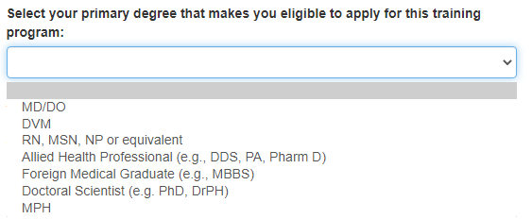
PMR/F
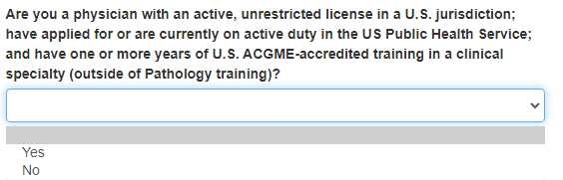
PMR/F
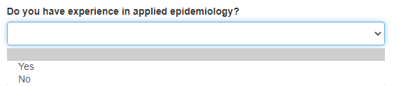
PMR/F
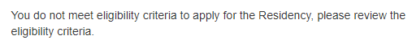

PMR/F
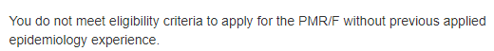
PMR/F
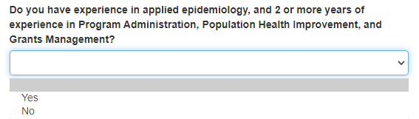
PMR/F
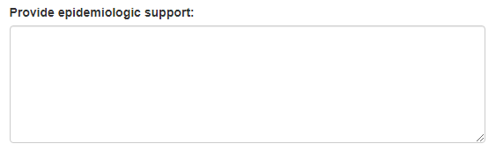
PMR/F
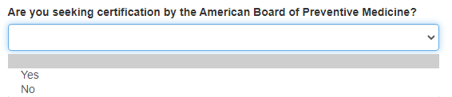
PMR/F
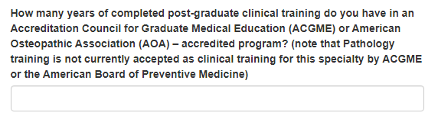
PMR/F
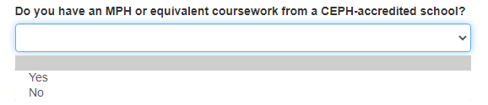
PMR/F
PMR/F
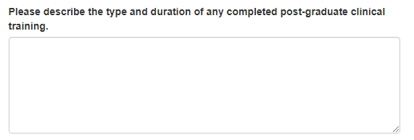
PMR/F
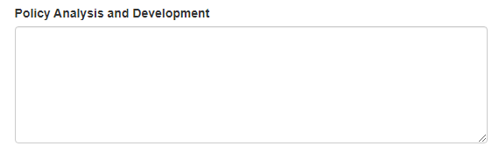
PMR/F
PMR/F
PMR/F
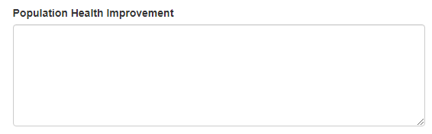
PMR/F
PMR/F
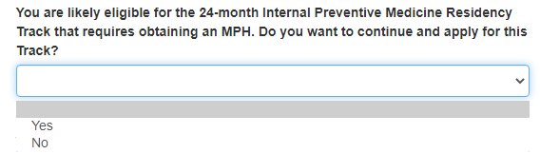
PMR/F
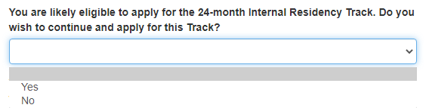
PMR/F
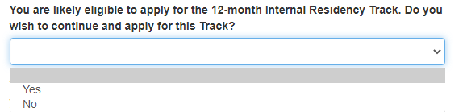
PMR/F
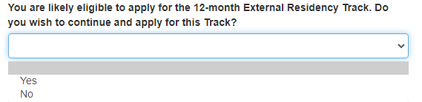
PMR/F
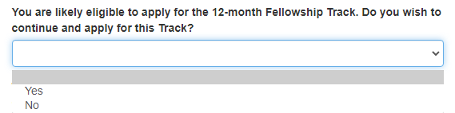

6.5.1 ELIGIBILITY

PHIFP
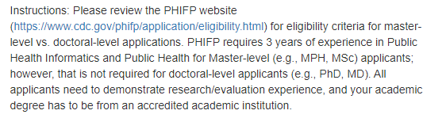
PHIFP
PHIFP
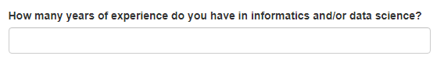
PHIFP

PHIFP

6.2 CITIZENSHIP STATUS

PHIFP
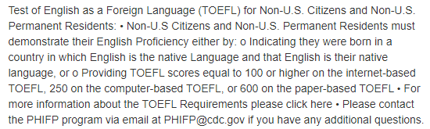
PEF
PEF
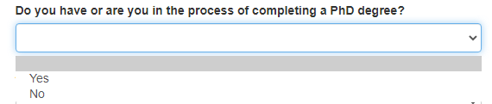

6.9 FLIGHT

FLIGHT

6.10 PH-TIPP

PH-TIPP

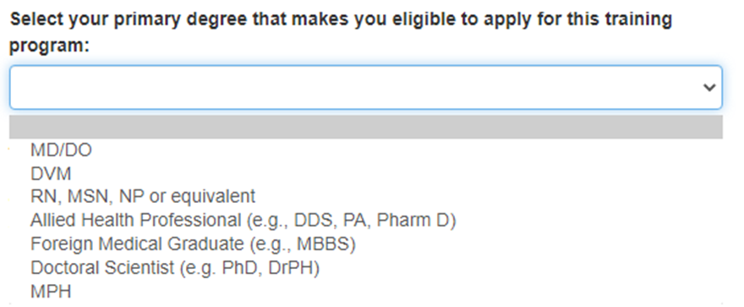
PH-TIPP
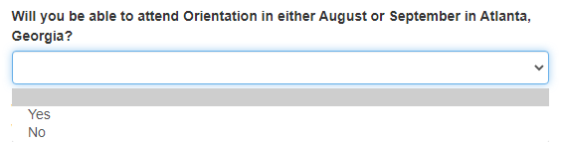
PH-TIPP
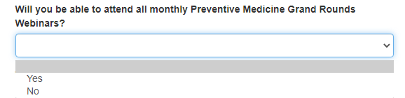
PH-TIPP
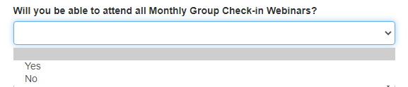
PH-TIPP
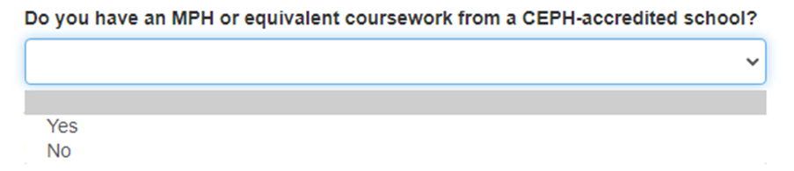
PH-TIPP

7.1 ADDING EDUCATION OR LICENSES

PHIFP
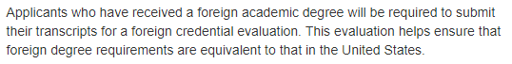

7.7 DEGREE

PEF

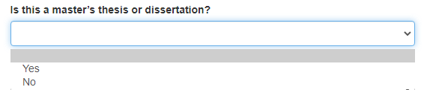

9.3 CLINICAL TRAINING

PMR/F

9.4 U.S. BOARD CERTIFICATIONS AND SPECIALTY

PMR/F

11.1 ALL FELLOWSHIPS EXCEPT FLIGHT

PEF
PEF

13.1 SELF ASSESSMENT OF SKILLS
PHIFP
