Attachment C – Screen Shots for Modifications to FMS Host Site Module
OMB control number 0920-0765
Fellowship management system
In support of a Nov 2021 non-substantive change request

PHAP eFMS Host Site Module Revisions
6.14.2 Subject Area Proposed Assignment
This screenshot displays the section to which the new question will be added
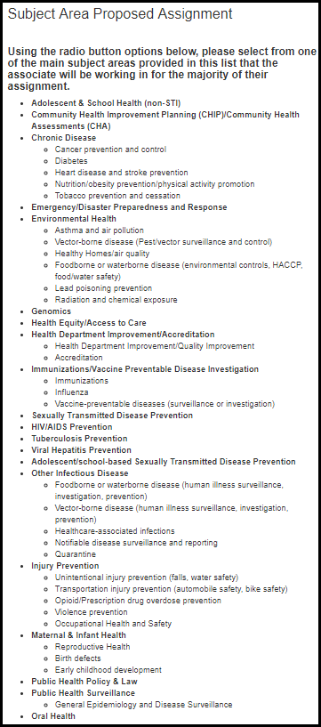

This screenshot below are the added questions, as they will appear in the module following the above questions.
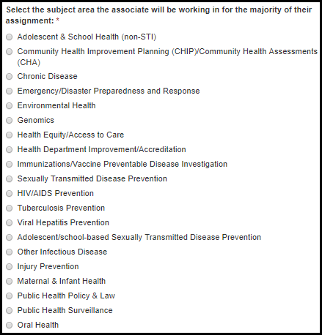

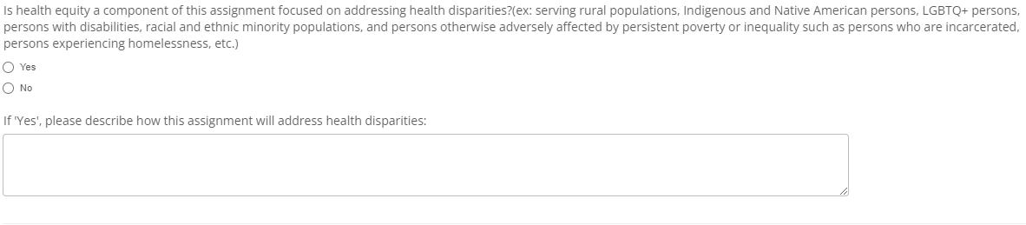

6.14.4 Other Public Health Agency Details

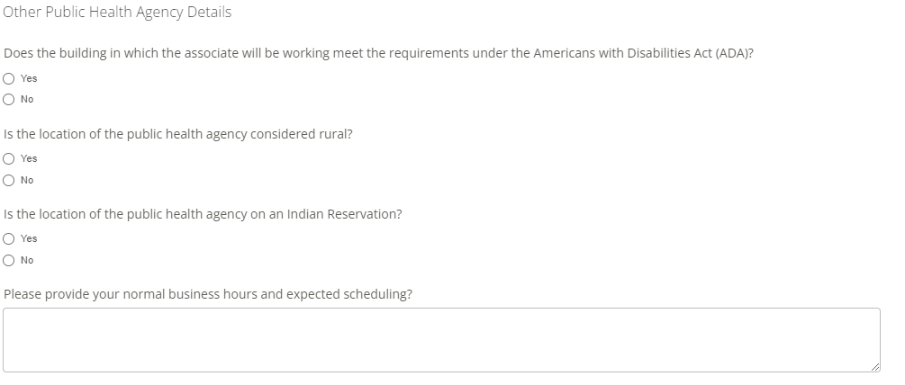
This new question is proposed for addition to the module

