OMB Control Number 0920-0765 Fellowship Management System Change Request
Attachment 2 – Host Site Module Screenshots
Program | Page/  Section | Requested Change | Screenshot
SAF | 2.1-a | Change type: question deletion  Remove for SAF | N/A – this will be hidden for the SAF Host Site Application.
SAF | 2.1-a | Change type: question deletion  Remove for SAF | N/A – this will be hidden for the SAF Host Site Application.
EEP | 6.3-1 | Change type: question addition  Add new question for EEP in this section to read:  Which type of work settings are you open to for your EEP student? (select all that apply):  - Remote/Full Telework  - Hybrid/Partial Telework  - In-person | 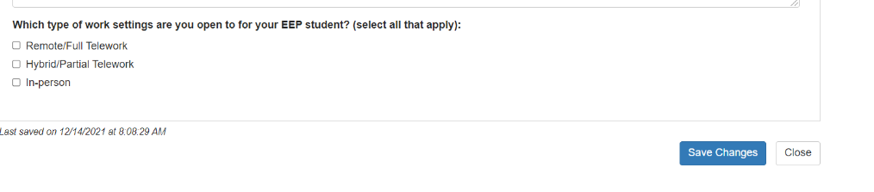
EEP | 6.9.1-a | Change type: Response option revision  How would you best describe the subject area covered in this position? Select all that apply.  Note: added options are 13, 18, 27, 29, 33  Change options to:  1. Obesity, nutrition, and physical activity  2. Cancer prevention and control  3. Diabetes  4. Heart disease and stroke prevention  5. Tobacco prevention and cessation  6. Other chronic disease  7. Emergency preparedness and response  8. Asthma and air pollution  9. Environmental health  10. Immunizations/vaccine preventable disease  11. Influenza  12. HIV/AIDS, or Tuberculosis  13. STD prevention  14. Viral hepatitis  15. Foodborne diseases  16. Waterborne diseases  17. Vectorborne diseases  18. Fungal Diseases  19. One Health and zoonotic disease  20. Arctic Investigations (Alaska)  21. Healthcare-associated infections  22. Quarantine and border health services  23. Unintentional injury  24. Opioid/prescription drug overdose prevention  25. Occupational health and safety  26. Violence Prevention  27. Reproductive Health  28. Maternal and infant health  29. Blood Disorders  30. Health statistics  31. State, local, and territorial health  32. Global health  33. COVID-19  34. Other (specify) | 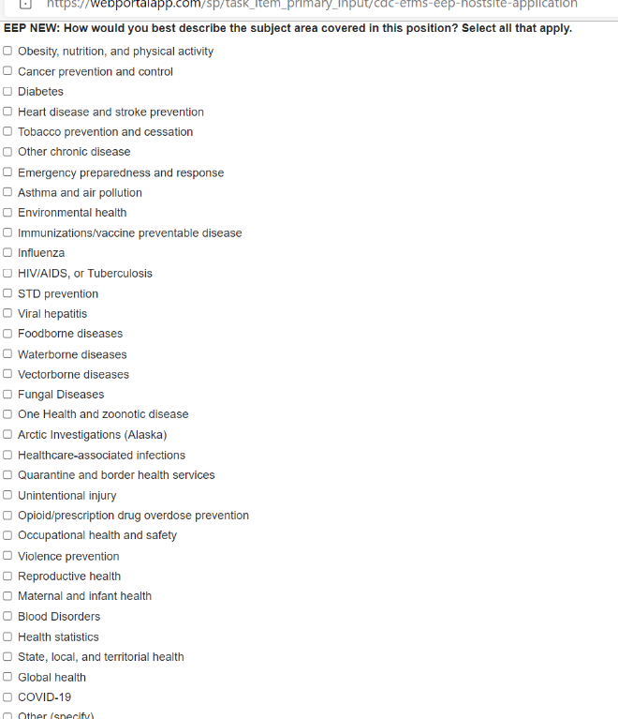  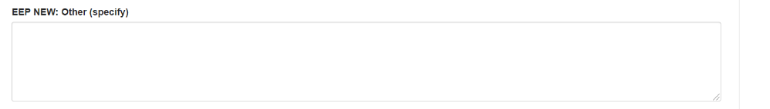
EEP | 6.9.1-b | Change type: Question addition  For EEP, after the Specify [project type] field, please add the following question to this section (6.9.1-b):  Do you prefer a language skill? [select one]  - Yes  - No  If select Yes, please select language [drop-down]:  - French  - Spanish  - Other: [open-ended]  What level of proficiency do you prefer?  - At least Good  - At least Excellent | 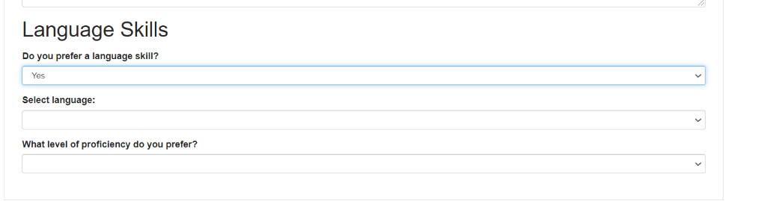
EEP | 6.9.1-b | Change type: Question addition  For EEP, please add the following question to this section 6.9.1-b:  Does the host site prefer a student who has statistical software experience? [select one]  - Yes  - No  If yes, please select the statistical software package(s) [select all that apply]:  Statistical Software Skills  - SAS  - STATA  - Epi-Info  - R  - Excel  Other: [open-ended] [If select other, open-ended] | 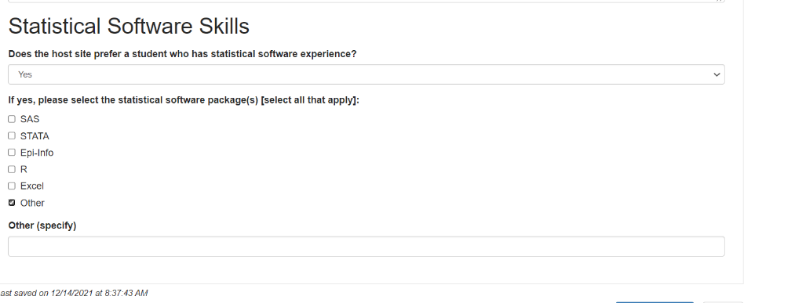
EEP | 5.3-a  and  5.3 Public Health Agency Details | Change type: response option revision  Add: NIOSH/Pittsburgh, PA (CDC Campus Lookup) | 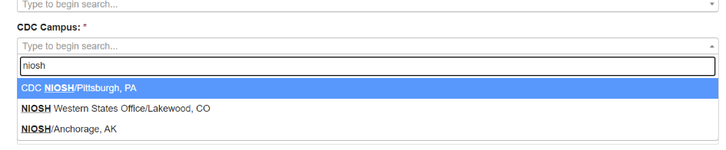
EEP | 7.2-a | Change type: Question deletion  Remove for EEP. | N/A – this will be hidden for the EEP Host Site Application.
SAF | 11.2 | Change type: Question deletion  Remove for SAF. | N/A – this will be hidden for the SAF Host Site Application.
All | - Field Value Tables | Change type: Response option revision  Add American Samoa | 