OMB Control Number 0920-0765 Fellowship Management System Change Request
Attachment 3 – Activity Tracking Module Screenshots
Program | Page/  Section | Requested Change | Screenshot
EEP | 5.2-a | Change type: Question/Response option revision  Handbook Acknowledgement (Required for all students):  - Completed
EEP | 5.2-a | Change type: Question/Response option revision  669A SWEP Volunteer Agreement (Required for all students):  - Completed
EEP | 5.2-a | Change type: Question/Response option revision  669C SWEP Statement of Duties Agreement (Required for all students):  - Completed
EEP | 5.2-a | Change type: Question/Response option revision  Change to:  1438 SWEP E-QIP Initiation Form (Required for all students):  - Completed
EEP | 5.2-a | Change type: Question/Response option revision  Change to:  Provided your SSN to EEP Program (Required for all students):  - Completed
EEP | 5.2-a | Change type: Question/Response option revision  Change to:  Safety Survival Skills Exam (SSS):  - Completed  - Not applicable
EEP | 5.2-a | Change type: Question/Response option revision  Change to  Security Awareness Training (SAT):  - Completed  - Not applicable
EEP | 5.2-a | Change type: Response option revision  Change to:  Personnel security background investigation completed by Office of Safety, Security, and Asset Management (OSSAM):  - Completed  - Not applicable
EEP | 5.2-a | Change type: Response option revision  Change to:  Fingerprinting:  - Completed  - Not applicable
EEP | 5.3-c | Change type: Response option revision  Change to:  Principles of Epidemiology for Public Health Practice Course (See program handbook) (Optional for all students):  - Completed  - Not applicable | 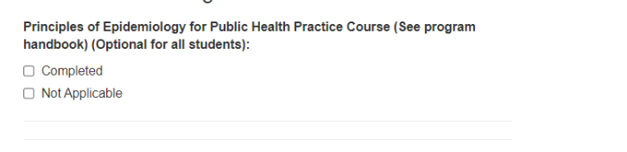
EEP | 5.3-c | Change type: Question deletion  REMOVE ActivEpi Course (See program handbook) (Optional for all students):  Completed | N/A – Field will be removed for EEP Activity Tracking.
EEP | 5.3-c | Change type: Question deletion  REMOVE Online Public Health Ethics Course (See program handbook) (Optional for all students):  Completed | N/A – Field will be removed for EEP Activity Tracking.
EEP | 5.3-c | Change type: Response option revision  Return CDC SmartCard to Supervisor (Required for CDC-based students):  - Completed  - Not applicable
EEP | 5.3-c | Change type: Response option revision  Return computer and all other equipment provided:  - Completed  - Not applicable
EEP | 7.1.1.1.a | Change type: Question addition  Add new question:  How would you describe your connection with other EEP students following the orientation? [MULTIPLE CHOICE] (very connected, somewhat connected, a little connected, not at all connected) | 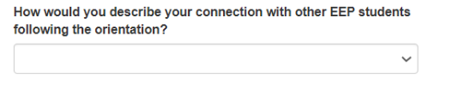
EEP | 7.1.1.4.a | Change type: Question addition  Questions currently listed on screenshot should apply to All Students. Please combine current All Students and CDC Students Only sections into a single All Students section. | Screenshots remain the same as what is current in eFMS 2.0 OMB package.
EEP | 7.1.1.4.a | Change type: Response option revision  Change to:  Did you receive your computer?  - Yes  - No  - Not applicable
EEP | 7.1.1.4.a | Change type: Response option revision  Change to:  When do you expect to receive your computer?  - This week  - Next week  - Not sure  - Not applicable
EEP | 7.1.1.4.a | Change type: Response option revision  Change to:  Did you receive your SmartCard?  - Yes  - No  - Not applicable
EEP | 7.1.1.4.a | Change type: Response option revision  Change to:  When do you expect to receive your SmartCard?  - This week  - Next week  - Not sure  - Not applicable
EEP | 7.1.1.4.a | Change type: Instructional text revision  Below “Please confirm that the email provided in your Profile is current and permanent,” add a new section for “Orientation Travel”. This section should only be completed by students not based in Atlanta for EEP.
EEP | 7.1.1.4.a | Change type: Question addition  In Orientation Travel section, add:  What went well during the travel planning process? [OPEN ENDED]
EEP | 7.1.1.4.a | Change type: Question addition  In Orientation Travel section, add:  Please describe what could be improved for future EEP students traveling to and staying in Atlanta during orientation. [OPEN ENDED]
EEP | 7.1.1.4.a | Change type: Question addition  In Orientation Travel section, add:  What challenges, if any, did you experience traveling to Atlanta for orientation? [OPEN ENDED]
EEP | 7.1.1.4.a | Change type: Question addition  In Orientation Travel section, add:  What do you recommend to improve the travel and lodging process for EEP students traveling for orientation in the future? [OPEN ENDED]
EEP | 7.1.2.1.f | Change type: Response option revision  Change to:  What did your supervisor do to enhance your EEP experience? (Select all that apply)  - Discussed my assignment with me before starting the program  - Provided an overview of CDC and how our Center/Division fits into CDC’s mission  - Provided an overview of organization and how our work fits into a public health mission  - Met with me each week to provide any feedback  - Connected me with other professionals  - Facilitated my participation in professional or educational activities within CDC  - Other | 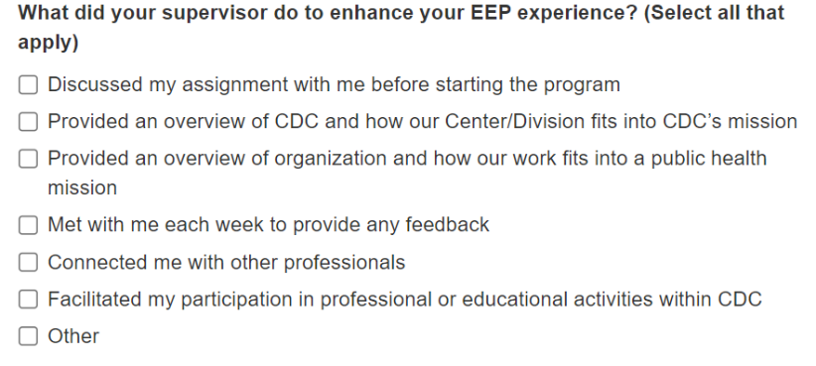
EEP | 7.1.2.1.f | Change type: Question addition  Add:  I received adequate support from my host site supervisor to complete my projects. (strongly agree, agree, neither agree nor disagree, disagree, strongly disagree) | 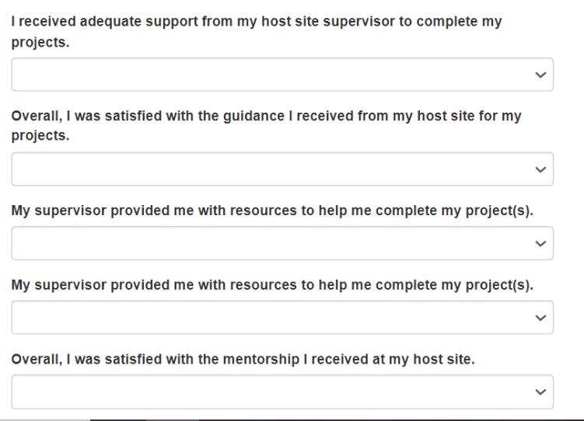
EEP | 7.1.2.1.f | Change type: Question addition  Add:  Overall, I was satisfied with the guidance I received from my host site for my projects. (strongly agree, agree, neither agree nor disagree, disagree, strongly disagree)
EEP | 45/7.1.2.1.f | Change type: Question addition  Add:  My supervisor provided me with resources to help me complete my project(s). (strongly agree, agree, neither agree nor disagree, disagree, strongly disagree)
EEP | 7.1.2.1.f | Change type: Question addition  Add:  My supervisor provided me with timely feedback on my work. (strongly agree, agree, neither agree nor disagree, disagree, strongly disagree)
EEP | 7.1.2.1.f | Change type: Question addition  Add:  Overall, I was satisfied with the mentorship I received at my host site. (strongly agree, agree, neither agree nor disagree, disagree, strongly disagree)
EEP | 7.1.2.1.g | Change type: Question revision  Change to:  Did you assist in a public health response activity (e.g., an Epi-Aid, EOC deployment, field investigation, other large-scale response, or similar)?
EEP | 7.1.2.1.g | Change type: Question addition  Add new question for EEP:  Which type(s) of public health response activities did you participate in? Select all that apply:  - Epi-Aid  - CDC Emergency Operations Center (EOC) deployment  - State, tribal, local, or territorial field investigation within your host site jurisdiction  - Other field investigation/field deployment  - Other: [DESCRIBE]
EEP | 7.1.2.1.g | Change type: Question revision  Change question to:  Which CDC Center/Institute/Office(s) did you support during your public health response activity (e.g., an Epi-Aid, EOC deployment, field investigation, other large-scale response, or similar)? (Select all that apply) | 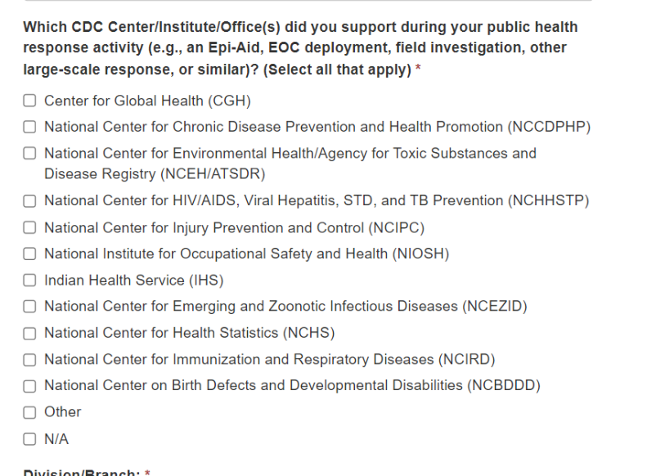
EEP | 7.1.2.1.g | Change type: Response option revision  Change values to allow EEP student to select from the Center/Division/Branch Lookup OR choose one of the following options:  - Other  - N/A
EEP | 7.1.2.1.h | Change type: Question revision  Change to:  Briefly describe your responsibilities in the public health response activity (e.g., an Epi-Aid, EOC deployment, field investigation, other large-scale response, or similar):
EEP | 7.1.2.1.h | Change type: Question revision  Change to:  Participation in a public health response activity (e.g., an Epi-Aid, EOC deployment, field investigation, other large-scale response, or similar) increased my understanding of public health concepts through hands-on experience.
EEP | 7.1.2.1.h | Change type: Question revision  Change to:  Participation in a public health response activity (e.g., an Epi-Aid, EOC deployment, field investigation, other large-scale response, or similar) increased my interest in pursuing a public health career.
EEP | 7.1.2.1.h | Change type: Question revision  Change to:  Participation in a public health response activity (e.g., an Epi-Aid, EOC deployment, field investigation, other large-scale response, or similar) connected me with additional public health professionals.
EEP | 7.1.2.3.a | Change type: Question addition  Add [for all students]:  Overall, I am satisfied with my host site experience. (Strongly disagree, disagree, neither agree nor disagree, agree, strongly agree)
EEP | 7.1.2.3.a | Change type: Question addition  Add [for all students]:  What were the most valuable parts of your host site experience? [OPEN-ENDED]
EEP | 7.1.2.3.a | Change type: Question addition  Add [for all students]:  What were the most challenging parts of your host site experience? [OPEN-ENDED]
SAF | 7.2.1.1.a | Change type: Question revision  Change to:  - In the past school year, which resource(s) did you use to teach public health? (Select all that apply)  - N/A  - CDC Science Ambassador Fellowship Lesson Plans/Activities  - CDC NERD Academy  - CDC Website  - Other Lesson Plans/Activities Other Lesson Plans/Activities (e.g., Young Epidemiology Scholars Lesson Plans) or Websites (e.g., Medical Detectives). Please provide at least 1-2 examples: | 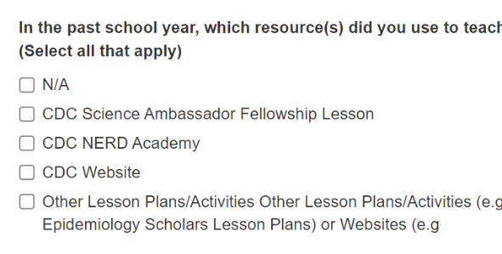
SAF | 7.2.1.1.a | Change type: Question revision  Change to:  4. In the upcoming school year, do you plan to teach an entire course related to public health?  1. Yes, I plan to in the next year.  2. No, but I plan to in the future.  3. No, but I plan to incorporate public health into my current course.  4. No, and I do not plan to incorporate public health into my current course.  5. N/A | 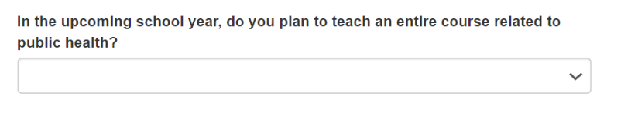
SAF | 8.1.2.a | Change type: Question deletion  Remove section 8.1.2.a from SAF Activity Tracking module | N/A – Fields/section will be removed for SAF Activity Tracking.
SAF | 8.2.3.a | Change type: Question deletion  Remove section 8.2.3.a from SAF Activity Tracking module | N/A – Fields/section will be removed for SAF Activity Tracking.
SAF | 8.3.2.a | Change type: Question deletion  Remove section 8.3.2.a from SAF Activity Tracking module | N/A – Fields/section will be removed for SAF Activity Tracking.
SAF | 8.4.2.b | Change type: Question deletion  Remove section 8.4.2.b from SAF Activity Tracking module | N/A – Fields/section will be removed for SAF Activity Tracking.
SAF | 8.6.2.b | Change type: Question deletion  Remove section 8.6.2.b from SAF Activity Tracking module | N/A – Fields/section will be removed for SAF Activity Tracking.
EIS | 8.6.2.a Activity Review Fields | Change type: Question revision  On a scale of 1-5 where 1=very poor and 5=excellent, please rate the overall quality of this activity or its associated deliverables/products.  - 1=very poor  - 2=poor  - 3=fair  - 4=good  - 5=excellent | 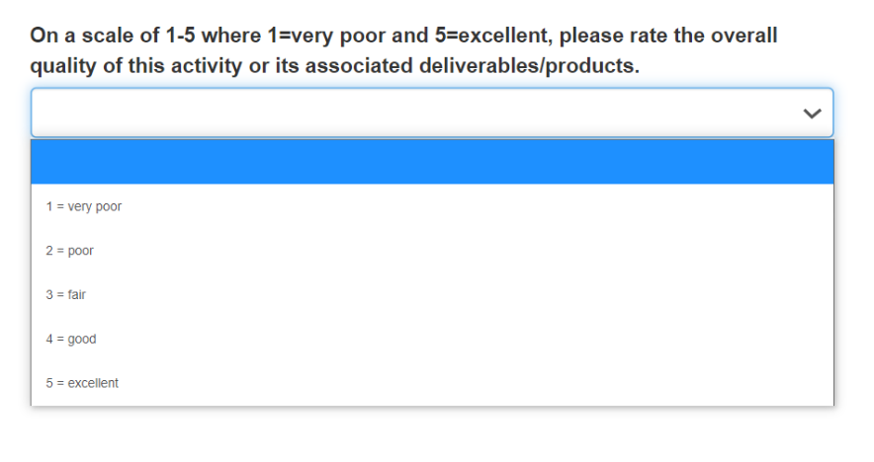
All | - Field Table Values | Change type: Response option revision  Add American Samoa | 