Attachment 3e

Mobile Exam Center (MEC) Interview and Examination
Data Collection Forms
2021-2022
Form Approved
OMB No. 0920-0950
Exp. Date XX/XX/20XX

Notice – CDC estimates the average public reporting burden for this collection of information as 2.5 hours per response, including the time for reviewing instructions, searching existing data/information sources, gathering and maintaining the data/information needed, and completing and reviewing the collection of information. An agency may not conduct or sponsor, and a person is not required to respond to a collection of information unless it displays a currently valid OMB control number. Send comments regarding this burden estimate or any other aspect of this collection of information, including suggestions for reducing this burden to CDC/ATSDR Information Collection Review Office, 1600 Clifton Road, MS D-74, Atlanta, GA 30333; ATTN: PRA (0920-0950).

Assurance of Confidentiality – We take your privacy very seriously. All information that relates to or describes identifiable characteristics of individuals, a practice, or an establishment will be used only for statistical purposes. NCHS staff, contractors, and agents will not disclose or release responses in identifiable form without the consent of the individual or establishment in accordance with section 308(d) of the Public Health Service Act (42U.S.C. 242m) and the Confidential Information Protection and Statistical Efficiency Act (Title III of the Foundations for Evidence-Based Policymaking Act of 2018 (Pub. L. No. 115-435, 132 Stat. 5529 § 302)). In accordance with CIPSEA, every NCHS employee, contractor, and agent has taken an oath and is subject to a jail term of up to five years, a fine of up to $250,000, or both if he or she willfully discloses ANY identifiable information about you.

National health and Nutrition Examination Survey (NHANES)
Mobile Examination Center (MEC) Interview & Exam

TABLE OF CONTENTS

MEC INTERVIEW – ACASI 3
SEXUAL ORIENTATION – SXQ-O 3
DEPRESSION SCREEN – DPQ 4
REPRODUCTIVE HEALTH – RHQ 7
CURRENT HEALTH STATUS – HSQ 13
PHYSICAL ACTIVITY AND PHYSICAL FITNESS – PAQ 14
TOBACCO – SMQ 15
ALCOHOL USE – ALQ 23
KIDNEY CONDITIONS - KIQ 29
DRUG USE – DUQ 31
SEXUAL BEHAVIOR – SXQ (FEMALE) 33
SEXUAL BEHAVIOR – SXQ (MALE) 37
MEC DATA COLLECTION FORMS 41
MEC ENTRY SCREENING 42
ANTHROPOMETRY - BODY MEASURES 44
STANDING BALANCE 45
DUAL ENERGY X-RAY ABSORPTIOMETRY (DXA) 47
BLOOD PRESSURE MEASUREMENT 49
LIVER ELASTOGRAPHY 50
VENIPUNCTURE 51

MEC Interview – ACASI

SEXUAL ORIENTATION – SXQ-O
Target Group: SPs 18-59 Yeas

BOX 1

CHECK ITEM SXQ.300:
- IF SP = FEMALE AND SP = 18 – 59 YEARS, CONTINUE WITH SXQ.295.
- ELSE IF SP = MALE AND SP = 18 – 59 YEARS, CONTINUE WITH SXQ.296.
- OTHERWISE, GO TO END OF SECTION.

SXQ.295 Do you think of yourself as lesbian or gay; straight, that is, not lesbian or gay; bisexual; something else; or you don’t know the answer?

INSTRUCTIONS TO SP:
Please select one of the following choices.

Lesbian or gay 1 (END OF SECTION)
Straight, that is, not lesbian or gay 2 (END OF SECTION)
Bisexual 3 (END OF SECTION)
Something else 4 (END OF SECTION)
I don’t know the answer 9 (END OF SECTION)
REFUSED 77 (END OF SECTION)
DON’T KNOW 99 (END OF SECTION)

SXQ.296 Do you think of yourself as gay; straight, that is, not gay; bisexual; something else; or you don’t know the answer?

INSTRUCTIONS TO SP:
Please select one of the following choices.

Gay 1
Straight, that is, not gay 2
Bisexual 3
Something else 4
I don’t know the answer 9
REFUSED 77
DON’T KNOW 99

DEPRESSION SCREEN – DPQ
Target Group: SPs 12+

DPQ.010_ The {first/next} questions are about how your feelings over the last 2 weeks.

CAPI INSTRUCTION:
IF SPs AGE = 12-17 AND 60+, DISPLAY = first
IF SPs AGE = 18 – 59, DISPLAY = next

DPQ.010 Over the last 2 weeks, how often have you been bothered by any of the following problems:

little interest or pleasure in doing things?

INSTRUCTIONS TO SP:
Please select one of the following choices.

Not at all 0
Several days 1
More than half the days 2
Nearly every day 3
REFUSED 7
DON’T KNOW 9

DPQ.020 Over the last 2 weeks, how often have you been bothered by:

feeling down, depressed, or hopeless?

INSTRUCTIONS TO SP:
Please select one of the following choices.

Not at all 0
Several days 1
More than half the days 2
Nearly every day 3
REFUSED 7
DON’T KNOW 9

DPQ.030 Over the last 2 weeks, how often have you been bothered by:

trouble falling or staying asleep, or sleeping too much?

INSTRUCTIONS TO SP:
Please select one of the following choices.

Not at all 0
Several days 1
More than half the days 2
Nearly every day 3
REFUSED 7
DON’T KNOW 9

DPQ.040 Over the last 2 weeks, how often have you been bothered by:

feeling tired or having little energy?

INSTRUCTIONS TO SP:
Please select one of the following choices.

Not at all 0
Several days 1
More than half the days 2
Nearly every day 3
REFUSED 7
DON’T KNOW 9

DPQ.050 Over the last 2 weeks, how often have you been bothered by:

poor appetite or overeating?

INSTRUCTIONS TO SP:
Please select one of the following choices.

Not at all 0
Several days 1
More than half the days 2
Nearly every day 3
REFUSED 7
DON’T KNOW 9

DPQ.060 Over the last 2 weeks, how often have you been bothered by:

feeling bad about yourself – or that you are a failure or have let yourself or your family down?

INSTRUCTIONS TO SP:
Please select one of the following choices.

Not at all 0
Several days 1
More than half the days 2
Nearly every day 3
REFUSED 7
DON’T KNOW 9

DPQ.070 Over the last 2 weeks, how often have you been bothered by:

trouble concentrating on things, such as reading the newspaper or watching TV?

INSTRUCTIONS TO SP:
Please select one of the following choices.

Not at all 0
Several days 1
More than half the days 2
Nearly every day 3
REFUSED 7
DON’T KNOW 9

DPQ.080 Over the last 2 weeks, how often have you been bothered by:

moving or speaking so slowly that other people could have noticed? Or the opposite – being so fidgety or restless that you have been moving around a lot more than usual?

INSTRUCTIONS TO SP:
Please select one of the following choices.

Not at all 0
Several days 1
More than half the days 2
Nearly every day 3
REFUSED 7
DON’T KNOW 9

DPQ.090 Over the last 2 weeks, how often have you been bothered by the following problem:

Thoughts that you would be better off dead or of hurting yourself in some way?

INSTRUCTIONS TO SP:
Please select one of the following choices.

Not at all 0
Several days 1
More than half the days 2
Nearly every day 3
REFUSED 7
DON’T KNOW 9

BOX 2

CHECK ITEM DPQ.095:
- IF RESPONSE TO ANY OF QUESTIONS DPQ.010 – DPQ.090 = 1, 2, OR 3, GO TO DPQ.100.
- OTHERWISE, GO TO NEXT SECTION.

DPQ.100 How difficult have these problems made it for you to do your work, take care of things at home, or get along with people?

INSTRUCTIONS TO SP:
Please select one of the following choices.

Not at all difficult 0
Somewhat difficult 1
Very difficult 2
Extremely difficult 3
REFUSED 7
DON’T KNOW 9

REPRODUCTIVE HEALTH – RHQ
Target Group: Female SPs Ages 12+

RHQ.010_ The next series of questions are about your reproductive history. Help is available for many of the questions.

RHQ.010 How old were you when you had your first menstrual period?

INSTRUCTIONS TO SP:
Please enter an age or enter zero if you have not started your period.

CAPI INSTRUCTION:
SOFT EDIT VALUES: AGE ≤8 YEARS.
ERROR MESSAGE: “You reported 8 years or younger as the age of your first menstrual period. If that is correct, please press the “Next” button to continue. If that is not correct, press the “Back” button, press “Clear,” and enter another age.”
SOFT EDIT VALUES: AGE ≥ 25 YEARS.
ERROR MESSAGE: “You reported 25 years or older as the age of your first menstrual period. If that is correct, please press the “Next” button to continue. If that is not correct, press the “Back” button, press “Clear,” and enter another age.”

HARD EDIT VALUES: AGE OF 1ST PERIOD CANNOT BE GREATER THAN CURRENT AGE.
ERROR MESSAGE: “Your response is greater than your recorded age. Please press the “Back” button, press “Clear,” and try again.”
SOFT EDIT: DISPLAY EDIT WHEN AGE OF SP IS GREATER THAN OR EQUAL TO 20 AND RHQ.010 IS CODED ‘0’.
ERROR MESSAGE: “You reported never starting your menstrual period. If that is correct, please press the “Next” button to continue. If that is not correct, press the “Back” button, press “Clear,” and enter another age.”

|___|___|
ENTER AGE IN YEARS

REFUSED 777
DON’T KNOW 999

BOX 1

CHECK ITEM RHQ.015:
- IF PERIODS HAVEN’T STARTED (CODED ‘0’), GO TO END OF SECTION.
- OTHERWISE, GO TO RHQ.031.

RHQ.031 Have you had at least one menstrual period in the past 12 months?

INSTRUCTIONS TO SP:
Please select . . .

HELP TEXT: If you have had at least one very light period in the past 12 months because you use hormonal birth control, such as pills, injectables or IUDs, select “Yes.”
If you have not had a period in the past 12 months, but you had bleeding due to medical conditions, hormone therapy, or surgeries, select “No”

SOFT EDIT: DISPLAY EDIT WHEN AGE OF SP IS GREATER THAN OR EQUAL TO 60 AND RHQ.031 IS CODED YES.
ERROR MESSAGE: “If you have not had a period in the past 12 months, but you had bleeding due to medical conditions, hormone therapy, or surgeries, please press the “Back” button and select “No.” Otherwise, press the “Next” button to continue.”

Yes 1
No 2 (RHQ.043)
REFUSED 7 (RHQ.060)
DON’T KNOW 9 (RHQ.060)

BOX 1A

CHECK ITEM RHQ.033:
- IF SP < 20 YEARS OLD AND RHQ.031 = 1, GO TO BOX 5.
- IF SP 20+ YEARS OLD AND RHQ.031 = 1, GO TO RHQ.282.
- OTHERWISE, CONTINUE.

RHQ.043 What is the reason that you have not had a period in the past 12 months?

INSTRUCTIONS TO SP:
Please select one of the following choices.

HELP TEXT: Select “some other reason” if you have not had a period in the past 12 months, for reasons including, but not limited to: hormonal birth control use; cancer; a thyroid condition; chemotherapy; excessive exercise; anorexia; low body weight.

SOFT EDIT: DISPLAY EDIT WHEN AGE OF SP IS YOUNGER THAN 45 AND RHQ.043 IS CODED 7 (MENOPAUSE/CHANGE OF LIFE).
ERROR MESSAGE: “You reported that the reason you have not had a period in the past 12 months is because of menopause, meaning your periods have completely stopped. If that is correct, please press the “Next” button to continue. If that is not correct, press the “Back” button, press “Clear,” and select a different reason.”

Pregnancy 1 (BOX 5)
Breast feeding 2
Hysterectomy 3
Menopause or the change of life 7
Some other reason 9
REFUSED 77
DON’T KNOW 99

RHQ.282 Have you had a hysterectomy, including a partial hysterectomy, that is, surgery to remove your uterus or womb?

INSTRUCTIONS TO SP:
Please select . . .

CAPI INSTRUCTION:
IF RHQ.043 = 3, fill = 1

Yes 1
No 2
REFUSED 7
DON’T KNOW 9

RHQ.305 Have you had both of your ovaries removed {either when you had your uterus removed or at any other time}?

HELP TEXT: It is possible to have both ovaries removed, only one ovary removed, or only part of an ovary removed. Ovaries may be removed during a hysterectomy. Select “Yes” only if a surgeon completely removed both ovaries.

INSTRUCTIONS TO SP:
Please select . . .

CAPI INSTRUCTION: IF RHQ.282 = 1 DISPLAY {either when you had your uterus removed or at any other time}”

Yes 1
No 2 (BOX 1B)
REFUSED 7 (RHQ.060)
DON’T KNOW 9 (RHQ.060)

RHQ.332 How old were you when you had your ovaries removed or last ovary removed if removed at different times?

INSTRUCTIONS TO SP:
Please enter an age.

CAPI INSTRUCTION:
HARD EDIT: RHQ.332 MUST BE EQUAL TO OR LESS THAN AGE OF SP.
ERROR MESSAGE: “Your response is greater than your recorded age. Please press the “Back” button, press “Clear,” and try again.”

|___|___|___|
ENTER AGE IN YEARS

REFUSED 7777
DON’T KNOW 9999

BOX 1B

CHECK ITEM RHQ.334:
- IF RHQ.031 = 1 AND RHQ.282 = 2 AND RHQ.305 = 2, GO TO BOX 5.
- OTHERWISE, CONTINUE.

RHQ.060 About how old were you when you had your last menstrual period?

INSTRUCTIONS TO SP:
Please enter an age.

SOFT EDIT: DISPLAY EDIT WHEN RHQ.060 IS GREATER THAN 59.
ERROR MESSAGE: “You reported your last menstrual period after age 59. If that is correct, please press the “Next” button to continue. If that is not correct, press the “Back” button, press “Clear,” and try again.”

SOFT EDIT: RHQ.060 MUST BE LESS THAN OR EQUAL TO RHQ.332.
ERROR MESSAGE: “You reported the age of your last menstrual period after the age that both of your ovaries were removed. If that is correct, please press the “Next” button to continue. If that is not correct, press the “Back” button, press “Clear,” and try again.”

HARD EDIT: RHQ.060 MUST BE EQUAL TO OR LESS THAN AGE OF SP.
ERROR MESSAGE: “Your response is greater than your recorded age. Please press the “Back” button, press “Clear,” and try again.”

|___|___|
ENTER AGE IN YEARS

REFUSED 777
DON’T KNOW 999

BOX 5

CHECK ITEM RHQ.086:
- IF SP IS 12-17 YEARS OLD, GO TO RHQ.131.
- IF SP IS 18-59 YEARS OLD, CONTINUE.
- OTHERWISE, END OF SECTION.

RHQ.078 Have you ever been treated for an infection in your fallopian tubes, uterus or ovaries, also called a pelvic infection, pelvic inflammatory disease, or PID?

INSTRUCTIONS TO SP:
Please select . . .

Yes 1
No 2
REFUSED 7
DON’T KNOW 9

RHQ.131_ The next questions are about your pregnancy history.

RHQ.131 Have you ever been pregnant? Please include current pregnancy, live births, miscarriages, stillbirths, tubal pregnancies and abortions.

INSTRUCTIONS TO SP:
Please select . . .

HELP TEXT:
Miscarriage is the loss of a baby before the 20th week of pregnancy.
Stillbirth is the loss of a baby at or after 20 weeks of pregnancy.
Tubal Pregnancy is a pregnancy that occurs in the fallopian tube.
Abortion is the termination of a pregnancy using induced methods.

Yes 1
No 2 (END OF SECTION)
REFUSED 7 (END OF SECTION)
DON’T KNOW 9 (END OF SECTION)

BOX 6

CHECK ITEM RHQ.136:
- IF THE SP HAS EXPERIENCED MENOPAUSE (RHQ.043 = 7), GO TO RHQ.167.
- IF THE SP HAD HYSTERECTOMY (RHQ.043 = 3 OR RHQ.282 = 1), GO TO RHQ.167.
- OTHERWISE, CONTINUE.

RHQ.143 Are you pregnant now?

INSTRUCTIONS TO SP:
Please select . . .

Yes 1
No 2
REFUSED 7
DON’T KNOW 9

RHQ.167 How many vaginal or Cesarean deliveries have you had? Please count all stillbirths as well as live births.

If you delivered twins or had any other multiple birth, count it as one delivery.

INSTRUCTIONS TO SP:
Please enter the total number of deliveries.

|___|___|
ENTER NUMBER

REFUSED 777
DON’T KNOW 999

BOX 7B

CHECK ITEM RHQ.170A:
- IF THE NUMBER OF DELIVERIES IN RHQ.167 EQUALS ZERO, GO TO END OF SECTION.
- OTHERWISE, CONTINUE.

RHQ.200 Are you now breast feeding a child?

INSTRUCTIONS TO SP:
Please select . . .

Yes 1
No 2
REFUSED 7
DON’T KNOW 9

CURRENT HEALTH STATUS – HSQ
Target Group: SPs 16+

HSQ.590_ The first question is about the test for HIV, the virus that causes AIDS.

HSQ.590 Except for tests you may have had as part of blood donations, have you ever been tested for HIV?

INSTRUCTIONS TO SP:
Please select . . .

Yes 1
No 2
REFUSED 7
DON'T KNOW 9

PHYSICAL ACTIVITY AND PHYSICAL FITNESS – PAQ
Target Group: SPs 12-15 Years

PAQ.706_ The first questions are about your activities.

PAQ.706 During the past 7 days, on how many days were you physically active for a total of at least 60 minutes per day? Add up all the time you spent in any kind of physical activity that increased your heart rate and made you breathe hard some of the time.

INSTRUCTIONS TO SP:
Please select one of the following choices.

0 days 0
1 day 1
2 days 2
3 days 3
4 days 4
5 days 5
6 days 6
7 days 7
REFUSED 77
DON’T KNOW 99

PAQ.711 On a typical day during the school year, about how many hours do you usually spend playing with a smartphone or computer, watching TV or movies, or playing video games?

INSTRUCTIONS TO SP:
Please enter a number.

|___|___|
ENTER NUMBER OF HOURS

REFUSED 77
DON'T KNOW 99

SOFT EDIT: 18 – 24 HOURS.
ERROR MESSAGE: “You said on a typical day during the school year, you usually spend 18 hours or more playing with a smartphone or computer, watching TV or movies, or playing video games. If that is correct, please press the “Next” button to continue. If that is not correct, press the “Back” button, press “Clear,” and try again.”

HARD EDIT: 25 HOURS OR MORE.
ERROR MESSAGE: “Please enter a number between 0 and 24. Please press the “Back” button, press “Clear,” and try again.”

TOBACCO – SMQ
Target Group: SPs 12+

BOX 1

CHECK ITEM SMQ.605:
- IF SP AGED 18+, GO TO SMQ.681_.
- OTHERWISE, CONTINUE.

SMQ.621__ The following questions are about cigarette smoking and other tobacco use. Do not include cigars or marijuana.

SMQ.621 About how many cigarettes have you smoked in your entire life?

INSTRUCTIONS TO SP:
Please select . . .

I have never smoked, not even a puff 1 (SMQ.681_)
1 or more puffs but never a whole cigarette 2 (SMQ.681_)
1 cigarette 3
2 to 5 cigarettes 4
6 to 15 cigarettes 5
16 to 25 cigarettes 6
26 to 99 cigarettes 7
100 or more cigarettes 8
REFUSED 77 (SMQ.681_)
DON’T KNOW 99 (SMQ.681_)

SMQ.632 How old were you when you smoked a whole cigarette for the first time?
SMQ.632a
INSTRUCTIONS TO SP:
Please enter an age.

CAPI INSTRUCTION:
COMBINATION CONTROL: NUMBER PAD: ENTER AGE
ACCEPTABLE VALUES: 6-18 YEARS, REFUSED, DON’T KNOW.
IF R ENTERS 1-5, STORE 6 YEARS.

HARD EDIT: IF SMQ.632 > RIAAGEYR THEN ERROR.
ERROR MESSAGE: “Your response is older than your recorded age. Please press the “Back” button, press “Clear,” and try again.”

HARD EDIT: IF SMQ.632 = 0 THEN ERROR.
ERROR MESSAGE: “Your response must be greater than zero. Please press the “Back” button, press “Clear,” and try again.”

|___|___|
ENTER AGE

AGE 1-18
REFUSED 77
DON’T KNOW 99

SMQ.641 On how many of the past 30 days did you smoke cigarettes?

INSTRUCTIONS TO SP:
Please enter a number or enter zero for none.

CAPI INSTRUCTION:
ACCEPTABLE VALUES: 0-30, REFUSED, DON’T KNOW
HARD EDIT: IF SMQ.641 > 30 THEN ERROR.
ERROR MESSAGE: “Your response cannot exceed 30 days. Please press the “Back” button, press “Clear,” and try again.”

|___|___|
ENTER NUMBER OF DAYS

REFUSED 77
DON’T KNOW 99

BOX 1A

CHECK ITEM SMQ.645:
- (IF ‘NONE’ (CODE ‘00’), ‘REFUSED’ (CODE ‘77’), OR ‘DON’T KNOW’ (CODE ‘99’) IN SMQ.641) AND SMQ.621 NOT EQUAL TO 8, GO TO SMQ.681_.
- (IF ‘NONE’ (CODE ‘00’), ‘REFUSED’ (CODE ‘77’), OR ‘DON’T KNOW’ (CODE ‘99’) IN SMQ.641) AND SMQ.621 = 8, CONTINUE.
- OTHERWISE, GO TO SMQ.650.

SMQ.050 How long has it been since you quit smoking cigarettes?
Q/U
INSTRUCTIONS TO SP:
Please enter the number of days, weeks, months, or years, then select the unit of time.

|___|___|___|
ENTER NUMBER (OF DAYS, WEEKS, MONTHS OR YEARS)

REFUSED 77777
DON’T KNOW 99999

ENTER UNIT

Days 1
Weeks 2
Months 3
Years 4
REFUSED 7
DON’T KNOW 9

BOX 1A1

CHECK ITEM SMQ.051:
- IF SMQ.050 LESS THAN 30 DAYS GO TO SMQ.650.
- OTHERWISE, GO TO SMQ.681_.

SMQ.650 On average, when you smoked during the past 30 days, how many cigarettes did you smoke a day?
SMQ.650a
INSTRUCTIONS TO SP:
Please enter a number.

CAPI INSTRUCTION:
IF R SAYS 95 OR MORE CIGARETTES PER DAY, STORE 95 IN SMQ650a.
HARD EDIT: IF SMQ.650 = 0 THEN ERROR.
ERROR MESSAGE: “Your response must be greater than 0. Please press the “Back” button, press “Clear,” and try again.”

|___|___|___|
ENTER NUMBER OF CIGARETTES

REFUSED 7777
DON’T KNOW 9999

SMQ.681_ The following questions ask about use of tobacco products in the past 5 days.

SMQ.682 During the past 5 days, including today, did you smoke {cigarettes,} pipes, regular cigars, cigarillos, or little filtered cigars, water pipes, or hookahs with tobacco?

INSTRUCTIONS TO SP:
Please select . . .

CAPI INSTRUCTIONS:
IF SMQ.621 = 1 OR 2 OR SMQ.641 = 00 THEN DO NOT DISPLAY {“cigarettes, “}
RECORDING NOTE: 2 WAVE FILES NEEDED ONE WITH AND ONE WITHOUT THE WORD CIGARETTES.

Yes 1
No 2 (SMQ.846)
REFUSED 7 (SMQ.846)
DON’T KNOW 9 (SMQ.846)

BOX 1C

CHECK ITEM SMQ.850:
- IF SMQ.621 = 1 OR 2 OR SMQ.641 = 00, GO TO SMQ.692B.
- OTHERWISE, CONTINUE WITH SMQ.692A.

SMQ.692A Which of these products did you smoke? (CHECK ALL THAT APPLY)

INSTRUCTIONS TO SP:
Please select all that you used.

Cigarettes 1 (BOX 2)
Pipes 2 (BOX 2)
Regular cigars, cigarillos, or little filtered
cigars 3 (BOX 2)
Water pipes or Hookahs with tobacco 4 (BOX 2)
REFUSED 77 (SMQ.846)
DON’T KNOW 99 (SMQ.846)

SMQ.692B Which of these products did you smoke? (CHECK ALL THAT APPLY)

INSTRUCTIONS TO SP:
Please select all that you used.

Pipes 1
Regular cigars, cigarillos, or little filtered
cigars 2
Water pipes or Hookahs with tobacco 3
REFUSED 77 (SMQ.846)
DON’T KNOW 99 (SMQ.846)

BOX 2

CHECK ITEM SMQ.701:
- IF ‘CIGARETTES’ (CODE 1) IN SMQ.692A, GO TO SMQ.710.
- IF ‘PIPES’ (CODE 2) IN SMQ.692A OR (CODE 1) IN SMQ.692B, GO TO SMQ.740.
- IF ‘CIGARS’ (CODE 3) IN SMQ.692A OR (CODE 2) IN SMQ.692B, GO TO SMQ.771.
- IF ‘WATER PIPE OR HOOKAH’ (CODE 4) IN SMQ.692A OR (CODE 3) IN SMQ.692B, GO TO SMQ.845.

SMQ.710 During the past 5 days, including today, on how many days did you smoke cigarettes?

INSTRUCTIONS TO SP:
Please enter a number.

CAPI INSTRUCTIONS:
HARD EDIT: IF SMQ.710 < 1 OR SMQ.710 > 5 THEN ERROR.
ERROR MESSAGE: “Please enter a number between 1 and 5. Please press the “Back” button, press “Clear,” and try again.”

|___|
ENTER NUMBER OF DAYS

REFUSED 7
DON’T KNOW 9

SMQ.720 During the past 5 days, including today, on the days you smoked, how many cigarettes did you smoke
SMQ.720a each day?

INSTRUCTIONS TO SP:
Please enter a number.

CAPI INSTRUCTION:
IF R SAYS 95 OR MORE CIGARETTES PER DAY, STORE 95 IN SMQ720a.
HARD EDIT: IF SMQ.720 = 0 THEN ERROR.
ERROR MESSAGE: “Your response must be greater than 0. Please press the “Back” button, press “Clear,” and try again.”

|___|___|___|
ENTER NUMBER OF CIGARETTES

REFUSED 7777
DON’T KNOW 9999

SMQ.725 When did you smoke your last cigarette? Was it . . .

Today 1
Yesterday 2
3 to 5 days ago 3
REFUSED 7
DON’T KNOW 9

BOX 3

CHECK ITEM SMQ.731:
- IF ‘PIPES’ (CODE 2) IN SMQ.692A OR (CODE 1) IN SMQ.692B, GO TO SMQ.740.
- IF ‘CIGARS’ (CODE 3) IN SMQ.692A OR (CODE 2) IN SMQ.692B, GO TO SMQ.771.
- IF ‘WATER PIPE OR HOOKAH (CODE 4) IN SMQ.692A OR (CODE 3) IN SMQ.692B, GO TO SMQ.845.
- OTHERWISE, GO TO SMQ.846.

SMQ.740 During the past 5 days, including today, on how many days did you smoke a pipe?

INSTRUCTIONS TO SP:
Please enter a number.

CAPI INSTRUCTIONS:
HARD EDIT: IF SMQ.740 < 1 OR SMQ.740 > 5 THEN ERROR.
ERROR MESSAGE: “Please enter a number between 1 and 5. Please press the “Back” button, press “Clear,” and try again.”

|___|
ENTER NUMBER OF DAYS

REFUSED 7
DON’T KNOW 9

BOX 4

CHECK ITEM SMQ.761:
- IF ‘CIGARS’ (CODE 3) IN SMQ.692A OR (CODE 2) IN SMQ.692B, GO TO SMQ.771.
- IF ‘WATER PIPES OR HOOKAH’ (CODE 4) IN SMQ.692A OR (CODE 3) IN SMQ.692B, GO TO SMQ.SMQ.845.
- OTHERWISE, GO TO SMQ.846.

SMQ.771 During the past 5 days, including today, on how many days did you smoke regular cigars, cigarillos, or little filtered cigars?

INSTRUCTIONS TO SP:
Please enter a number.

CAPI INSTRUCTIONS:
HARD EDIT: IF SMQ.771 < 1 OR SMQ.771 > 5 THEN ERROR.
ERROR MESSAGE: “Please enter a number between 1 and 5. Please press the “Back” button, press “Clear,” and try again.”

|___|
ENTER NUMBER OF DAYS

REFUSED 7
DON’T KNOW 9

BOX 5

CHECK ITEM SMQ.791:
- IF ‘WATERPIPE’ (CODE 4) IN SMQ.692A OR (CODE 3) IN SMQ.692B, GO TO SMQ.845.
- OTHERWISE, GO TO SMQ.846.

SMQ.845 During the past 5 days, including today, on how many days did you smoke tobacco in a water pipe or hookah?

INSTRUCTIONS TO SP:
Please enter a number.

CAPI INSTRUCTIONS:
HARD EDIT: IF SMQ.845 < 1 OR SMQ.845 > 5 THEN ERROR.
ERROR MESSAGE: “Please enter a number between 1 and 5. Please press the “Back” button, press “Clear,” and try again.”

|___|
ENTER NUMBER OF DAYS

REFUSED 7
DON’T KNOW 9

SMQ.846 During the past 5 days, including today, did you use e-cigarettes? You may also know them as JUULTM, vape-pens, vapes, hookah-pens, e-hookahs, or vaporizers. These are battery-powered, usually contain liquid nicotine, and produce vapor instead of smoke?

INSTRUCTIONS TO SP:
Please select . . .

Yes 1
No 2 (SMQ.851)
REFUSED 7 (SMQ.851)
DON’T KNOW 9 (SMQ.851)

SMQ.849 During the past 5 days, including today, on how many days did you use e-cigarettes?

INSTRUCTIONS TO SP:
Please enter a number.

CAPI INSTRUCTIONS:
HARD EDIT: IF SMQ.849 < 1 OR SMQ.849 > 5 THEN ERROR.
ERROR MESSAGE: “Please enter a number between 1 and 5. Please press the “Back” button, press “Clear,” and try again.”

|___|
ENTER NUMBER OF DAYS

REFUSED 7
DON’T KNOW 9

SMQ.851_ Smokeless tobacco products are placed in the mouth or nose and can include chewing tobacco, snuff, dip, snus, or dissolvable tobacco.

SMQ.851 During the past 5 days, including today, did you use any smokeless tobacco?

INSTRUCTIONS TO SP:
Please do not include nicotine replacement therapy products like patches, gum, lozenge or spray which are considered products to help you stop smoking.

Please select . . .

Yes 1
No 2 (END OF SECTION)
REFUSED 7 (END OF SECTION)
DON’T KNOW 9 (END OF SECTION)

SMQ.853 Which of these products did you use?

INSTRUCTIONS TO SP:
Please select all that you used.

(CHECK ALL THAT APPLY)
Chewing tobacco 1
Snuff 2
Snus 3
Dissolvables 4
Dip 5
REFUSED 77
DON’T KNOW 99

BOX 6

CHECK ITEM SMQ.610:
- IF SP AGED 12 - 17, GO TO END OF SECTION.
- OTHERWISE, CONTINUE.

SMQ.863 During the past 5 days, including today, did you use any nicotine replacement therapy products such as nicotine patches, gum, lozenges, inhalers, or nasal sprays?

INSTRUCTIONS TO SP:
Please select . . .
Yes 1
No 2
REFUSED 7
DON’T KNOW 9

ALCOHOL USE – ALQ
Target Group: SPs 12+

BOX 1A

CHECK ITEM ALQ.005:
- IF SP AGED 18+, GO TO ALQ.111_.
- OTHERWISE, CONTINUE.

ALQ.010_ The following questions ask about alcohol use. This includes beer, wine, wine coolers, and liquor such as rum, gin, vodka, or whiskey. This does not include drinking a few sips of wine for religious purposes.

ALQ.022 During your life, on how many days have you had at least one drink of alcohol?

INSTRUCTIONS TO SP:
Please select one of the following choices.

0 days 1 (END OF SECTION)
1 or 2 days 2
3 to 9 days 3
10 to 19 days 4
20 to 39 days 5
40 to 99 days 6
100 or more days 7
REFUSED 77
DON'T KNOW 99

ALQ.010 How old were you when you had your first drink of alcohol, other than a few sips?

INSTRUCTIONS TO SP:
Please select one of the following choices.

HARD EDIT: IF (RIAAGEYR < 17 AND ALQ.010 = 7) OR (RIAAGEYR < 15 AND ALQ.010 IN (6, 7)) OR (RIAAGEYR < 13 AND ALQ.010 IN (5, 6, 7)) THEN ERROR.
Error message: “Your response is older than your recorded age. Please press the “Back” button, press “Clear,” and try again.”

8 years old or younger 2
9 or 10 years old 3
11 or 12 years old 4
13 or 14 years old 5
15 or 16 years old 6
17 years old or older 7
REFUSED 77
DON'T KNOW 99

ALQ.031 During the past 30 days, on how many days did you have at least one drink of alcohol?

INSTRUCTIONS TO SP:
Please select one of the following choices.

HARD EDIT: IF (ALQ.022 = 2 AND ALQ.031 IN (3,4,5,6,7)) OR (ALQ.022 = 3 AND ALQ.031 IN (5,6,7)) OR (ALQ.022 = 4 AND ALQ.031 IN (6,7)) THEN ERROR.
Error message: “Your response is not consistent with your lifetime use. Please press the “Back” button, press “Clear,” and try again.”

0 days 1 (END OF SECTION)
1 or 2 days 2
3 to 5 days 3
6 to 9 days 4
10 to 19 days 5
20 to 29 days 6
All 30 days 7
REFUSED 77
DON'T KNOW 99

ALQ.042 During the past 30 days, on how many days did you have {DISPLAY NUMBER} or more drinks of alcohol in a row, that is, within a couple of hours?

INSTRUCTIONS TO SP:
Please select one of the following choices.

CAPI INSTRUCTION:
IF SP = MALE, DISPLAY = 5
IF SP = FEMALE, DISPLAY = 4

HARD EDIT: IF (ALQ.031 = 2 AND ALQ.042 IN (4,5,6,7)) OR (ALQ.031 = 3 AND ALQ.042 IN (5,6,7)) OR (ALQ.031 = 4 AND ALQ.042 IN (6,7)) OR (ALQ.031 = 5 AND ALQ.042 = 7) THEN ERROR.
Error message: “Your response is not consistent with your use in the past 30 days. Please press the “Back” button, press “Clear,” and try again.”

0 days 1 (END OF SECTION)
1 day 2 (END OF SECTION)
2 days 3 (END OF SECTION)
3 to 5 days 4 (END OF SECTION)
6 to 9 days 5 (END OF SECTION)
10 to 19 days 6 (END OF SECTION)
20 or more days 7 (END OF SECTION)
REFUSED 77 (END OF SECTION)
DON'T KNOW 99 (END OF SECTION)

ALQ.111_ The next questions are about drinking alcoholic beverages. Included are liquor (such as whiskey or gin), beer, wine, wine coolers, and any other type of alcoholic beverage.

ALQ.111 In your entire life, have you had at least 1 drink of any kind of alcohol, not counting small tastes or sips? By a drink, I mean a 12 oz. beer, a 5 oz. glass of wine, or one and a half ounces of liquor.

INSTRUCTIONS TO SP:
Please select . . .

CAPI INSTRUCTION: SHOW IMAGES OF 12 OZ BEER, 5 OZ WINE, AND 1.5 OZ LIQUOR.

Yes 1
No 2 (END OF SECTION)
REFUSED 7
DON'T KNOW 9

ALQ.121 During the past 12 months, about how often did you drink any type of alcoholic beverage?

In other words, how many days per week, per month, or per year did you drink?

INSTRUCTIONS TO SP:
Please select one of the following choices.

HELP SCREEN: If you only drank part of the year, report what your drinking pattern was for most of the year. If you drank half of the year but did not drink during the other half of the year, report your current drinking pattern. Choose the closest response when a perfect option is not available.

Every day 1
Nearly every day 2
3 to 4 times a week 3
2 times a week 4
Once a week 5
2 to 3 times a month 6
Once a month 7
7 to 11 times in the last year 8
3 to 6 times in the last year 9
1 to 2 times in the last year 10
Never in the last year 0
REFUSED 77
DON’T KNOW 99

BOX 1

CHECK ITEM ALQ.125:
- IF SP DIDN'T DRINK (CODED '0') IN ALQ.121, GO TO ALQ.151.
- OTHERWISE, CONTINUE WITH ALQ.130.

ALQ.130 During the past 12 months, on those days that you drank alcoholic beverages, on average, how many drinks did you have? By a drink, I mean a 12 oz. beer, a 5 oz. glass of wine, or one and a half ounces of liquor.

INSTRUCTIONS TO SP:
Please enter a number.

CAPI INSTRUCTIONS:
SHOW IMAGES OF 12 OZ BEER, 5 OZ WINE, AND 1.5 OZ LIQUOR.

IF R ENTERS LESS THAN 1 DRINK, STORE '1'.
IF R ENTERS 95 DRINKS OR MORE, STORE '95'.

SOFT EDIT: IF RESPONSE >=20, THEN DISPLAY “You said on the days that you drink you have on average 20 or more drinks. If that is correct, please press the “Next” button to continue. If that is not correct, press the “Back” button, press “Clear,” and try again.”

|___|___|___|
ENTER # OF DRINKS

REFUSED 777
DON'T KNOW 999

ALQ.142 During the past 12 months, about how often did you have {DISPLAY NUMBER} or more drinks of any alcoholic beverage?

In other words, how many days per week, per month, or per year did you have {DISPLAY NUMBER} or more drinks in a single day?

INSTRUCTIONS TO SP:
Please select one of the following choices.

CAPI INSTRUCTION:
IF SP = MALE, DISPLAY = 5
IF SP = FEMALE, DISPLAY = 4

HARD EDIT: ALQ.142 CANNOT HAVE A LOWER CODED VALUE THAN ALQ.121, UNLESS ALQ.142 IS CODED ‘0’.
ERROR MESSAGE: “Your response is not consistent with your previous response about how often you drank during the past 12 months. Please press the “Back” button, press “Clear,” and try again.”

Every day 1
Nearly every day 2
3 to 4 times a week 3
2 times a week 4
Once a week 5
2 to 3 times a month 6
Once a month 7
7 to 11 times in the last year 8
3 to 6 times in the last year 9
1 to 2 times in the last year 10
Never in the last year 0 (ALQ.151)
REFUSED 77
DON’T KNOW 99

ALQ.270 During the past 12 months, about how often did you have {DISPLAY NUMBER} or more drinks in a period of two hours or less?

INSTRUCTIONS TO SP:
Please select one of the following choices.

CAPI INSTRUCTION:
IF SP = MALE, DISPLAY = 5
IF SP = FEMALE, DISPLAY = 4

HARD EDIT: ALQ.270 CANNOT HAVE A LOWER CODED VALUE THAN ALQ.121, UNLESS ALQ.270 IS CODED ‘0’.
ERROR MESSAGE: “Your response is not consistent with your previous response about how often you drank during the past 12 months. Please press the “Back” button, press “Clear,” and try again.”

Every day 1
Nearly every day 2
3 to 4 times a week 3
2 times a week 4
Once a week 5
2 to 3 times a month 6
Once a month 7
7 to 11 times in the last year 8
3 to 6 times in the last year 9
1 to 2 times in the last year 10
Never in the last year 0
REFUSED 77
DON’T KNOW 99

ALQ.280 During the past 12 months, about how often did you have 8 or more drinks in a single day?

INSTRUCTIONS TO SP:
Please select one of the following choices.

HARD EDIT: ALQ.280 CANNOT HAVE A LOWER CODED VALUE THAN ALQ.121, UNLESS ALQ.280 IS CODED ‘0’.
ERROR MESSAGE: “Your response is not consistent with your previous response about how often you drank during the past 12 months. Please press the “Back” button, press “Clear,” and try again.”

Every day 1
Nearly every day 2
3 to 4 times a week 3
2 times a week 4
Once a week 5
2 to 3 times a month 6
Once a month 7
7 to 11 times in the last year 8
3 to 6 times in the last year 9
1 to 2 times in the last year 10
Never in the last year 0 (ALQ.151)
REFUSED 77
DON’T KNOW 99

ALQ.151 Was there ever a time or times in your life when you drank {DISPLAY NUMBER} or more drinks of any kind of alcoholic beverage almost every day?

INSTRUCTIONS TO SP:
Please select . . .

CAPI INSTRUCTION:
IF SP = MALE, DISPLAY = 5
IF SP = FEMALE, DISPLAY = 4

Yes 1
No 2
REFUSED 7
DON'T KNOW 9

BOX 2

CHECK ITEM ALQ.152:
- IF ALQ.121 = 0, OR ALQ.142 = 0, GO TO END OF SECTION.
- OTHERWISE, CONTINUE TO ALQ.170.

ALQ.170 Considering all types of alcoholic beverages, during the past 30 days, how many times did you have {DISPLAY NUMBER} or more drinks on an occasion?

INSTRUCTIONS TO SP:
Please enter a number or enter zero for none.

HELP SCREEN: An occasion is a period of several hours on the same day.

CAPI INSTRUCTION:
IF SP = MALE, DISPLAY = 5
IF SP = FEMALE, DISPLAY = 4

SOFT EDIT: IF RESPONSE IS > 60 TIMES, THEN DISPLAY “You said that in the past 30 days, you had {DISPLAY NUMBER} or more drinks of any kind of alcohol on an occasion, more than 60 times. If that is correct, please press the “Next” button to continue. If that is not correct, press the “Back” button, press “Clear,” and try again.

|___|___|
ENTER QUANTITY

REFUSED 777
DON'T KNOW 999

KIDNEY CONDITIONS - KIQ
Target Group: SPs 20+

KIQ.005_ The next few questions ask about urine leakage.

KIQ.005 Many people have leakage of urine. How often do you have urinary leakage?
INSTRUCTIONS TO SP:
Please select one of the following choices.

HELP SCREEN: Other terms for urinary leakage are not being able to hold your urine until you can reach a toilet, not being able to control your bladder, loss of urine control.

never 1 (KIQ.042)
less than once a month 2
a few times a month 3
a few times a week 4
every day and/or night 5
REFUSED 7 (KIQ.042)
DON’T KNOW 9 (KIQ.042)

KIQ.010 How much urine do you lose each time?

INSTRUCTIONS TO SP:
Please select one of the following choices.

drops 1
small splashes 2
more 3
REFUSED 7
DON’T KNOW 9

KIQ.042 During the past 12 months, have you leaked or lost control of even a small amount of urine with an activity like coughing, lifting or exercise?

INSTRUCTIONS TO SP:
Please select . . .

Yes 1
No 2
REFUSED 7
DON’T KNOW 9

KIQ.044 During the past 12 months, have you leaked or lost control of even a small amount of urine with an urge or pressure to urinate and you couldn’t get to the toilet fast enough?

INSTRUCTIONS TO SP:
Please select . . .

Yes 1
No 2
REFUSED 7
DON’T KNOW 9

BOX 1

CHECK ITEM KIQ.048A:
- IF 'YES' (CODED '1') IN KIQ.042 OR KIQ.044, CONTINUE WITH KIQ.052.
- OTHERWISE, GO TO KIQ.481.

KIQ.052 During the past 12 months, how much did your leakage of urine affect your day-to-day activities?

INSTRUCTIONS TO SP:
Please select one of the following choices.

not at all 1
only a little 2
somewhat 3
very much 4
greatly 5
REFUSED 7
DON'T KNOW 9

KIQ.481 In the past 30 days, during a typical night, how many times did you wake up and urinate?

INSTRUCTIONS TO SP:
Please select one of the following choices.

0 0
1 1
2 2
3 3
4 4
5 or more 5
REFUSED 77
DON'T KNOW 99

DRUG USE – DUQ
Target Group: SPs 12 - 59 Yeas

DUQ.200_ The following questions ask about use of drugs. Please remember that your answers to these questions will be kept confidential.

DUQ.230 During the past 30 days, on how many days did you use marijuana or cannabis, also called pot or weed?

INSTRUCTIONS TO SP:
Please enter a number or enter zero if you have never used marijuana or cannabis.

HARD EDIT VALUES: 0-30.
IF DUQ.230 > 30, DISPLAY ERROR MESSAGE: “Your response cannot exceed 30 days. Please press the “Back” button, press “Clear,” and try again.”

|___|___|
ENTER A NUMBER

REFUSED 77
DON'T KNOW 99

DUQ.250 Have you ever, even once, used cocaine including all the different forms of cocaine such as powder, ‘crack’, ‘free base’, and coca paste?

INSTRUCTIONS TO SP:
Please select . . .

Yes 1
No 2
REFUSED 7
DON'T KNOW 9

DUQ.290 Have you ever, even once, used heroin?

INSTRUCTIONS TO SP:
Please select . . .

Yes 1
No 2
REFUSED 7
DON'T KNOW 9

DUQ.330 Have you ever, even once, used methamphetamine, also known as crank, crystal, ice or speed?

INSTRUCTIONS TO SP:
Please select . . .

Yes 1
No 2
REFUSED 7
DON'T KNOW 9

DUQ.370 Have you ever, even once, used a needle to inject a drug not prescribed by a doctor?

INSTRUCTIONS TO SP:
Please select . . .

Yes 1
No 2
REFUSED 7
DON'T KNOW 9

SEXUAL BEHAVIOR – SXQ (Female)
Target Group: Female SPs 14-69 Years

SXQ.615_ The next set of questions is about your sexual history. By sex, we mean vaginal, oral, or anal sex. Please remember that your answers will be kept confidential.

BOX 1B

CHECK ITEM SXQ.773:
- IF SP AGE GREATER THAN 17, GO TO SXQ.700.
- OTHERWISE, CONTINUE.

SXQ.615 Have you ever had any kind of sex?
(Target 14-17)
INSTRUCTIONS TO SP:
Please select . . .

Yes 1
No 2 (END OF SECTION)
REFUSED 7 (END OF SECTION)
DON’T KNOW 9 (END OF SECTION)

SXQ.700 Have you ever had vaginal sex, also called sexual intercourse, with a man? This means a man’s penis in your vagina?
(Target 14-69)
INSTRUCTIONS TO SP:
Please select . . .

Yes 1
No 2
REFUSED 7
DON’T KNOW 9

SXQ.703 Have you ever performed oral sex on a man? This means putting your mouth on a man’s penis or genitals.
(Target 14-69)
INSTRUCTIONS TO SP:
Please select . . .

Yes 1
No 2
REFUSED 7
DON’T KNOW 9

SXQ.706 Have you ever had anal sex? This means contact between a man’s penis and your anus or butt.
(Target 14-69)
INSTRUCTIONS TO SP:
Please select . . .

Yes 1
No 2
REFUSED 7
DON’T KNOW 9

SXQ.709 Have you ever had any kind of sex with a woman? By sex, we mean sexual contact with another woman’s vagina or genitals.
(Target 14-69)
INSTRUCTIONS TO SP:
Please select . . .

Yes 1
No 2
REFUSED 7
DON’T KNOW 9

BOX 1

CHECK ITEM SXQ.702:
- IF SP 60-69 YEARS, GO TO END OF SECTION.
- IF SXQ.700 = 2 AND SXQ.703 = 2 AND SXQ.706 = 2 AND SXQ.709 = 2, GO TO END OF SECTION.
- IF SXQ.709 = 1 AND (SXQ.700, SXQ.703, AND SXQ.706 = 2), GO TO SXQ.736.
- OTHERWISE, CONTINUE.

SXQ.712 In your lifetime, with how many men have you had any kind of sex?
(Target 14-59)
INSTRUCTIONS TO SP:
Please enter a number.

|___|___|___|___|
ENTER NUMBER

REFUSED 77777
DON’T KNOW 99999

HARD EDIT: SXQ.712 MUST BE GREATER THAN 0.
Error message: “Your response is not consistent with your previous responses about male sex partners. Please press the “Back” button, press “Clear,” and try again.”

SXQ.718 In the past 12 months, with how many men have you had any kind of sex?
(Target 14-59)
INSTRUCTIONS TO SP:
Please enter a number or enter zero for none.

|___|___|___|___|
ENTER NUMBER

REFUSED 77777
DON’T KNOW 99999

HARD EDIT: SXQ.718 MUST BE EQUAL TO OR LESS THAN SXQ.712.
Error message: “Your response is greater than your lifetime number of male partners. Please press the “Back” button, press “Clear,” and try again.”

BOX 6

CHECK ITEM SXQ.733:
- IF SXQ.709 = 1, GO TO SXQ.736.
- OTHERWISE, GO TO BOX 7B.

SXQ.736 In your lifetime, with how many women have you had sex? By sex, we mean sexual contact with another woman’s vagina or genitals.
(Target 14-59)
INSTRUCTIONS TO SP:
Please enter a number.

|___|___|___|___|
ENTER NUMBER

REFUSED 77777
DON’T KNOW 99999

HARD EDIT: SXQ.736 MUST BE GREATER THAN ZERO.
Error message: “Your response is not consistent with your previous responses about sex with a female partner. Please press the “Back” button, press “Clear,” and try again.”

SXQ.739 In the past 12 months, with how many women have you had sex? By sex, we mean sexual contact with another woman’s vagina or genitals.
(Target 14-59)
INSTRUCTIONS TO SP:
Please enter a number or enter zero for none.

|___|___|___|___|
ENTER NUMBER

REFUSED 77777
DON’T KNOW 99999

HARD EDIT: SXQ.739 MUST BE EQUAL TO OR LESS THAN SXQ.736.
Error message: “Your response is greater than your lifetime number of female partners. Please press the “Back” button, press “Clear”, and try again.”

BOX 7B

CHECK ITEM SXQ.771:
- IF SXQ.718 OR SXQ.739 GREATER THAN ‘0000’, GO TO SXQ.648.
- OTHERWISE, GO TO SXQ.260.

SXQ.648 In the past 12 months, did you have any kind of sex with a person that you never had sex with before?
(Target 14-59)
INSTRUCTIONS TO SP:
Please select . . .

Yes 1
No 2
REFUSED 7
DON’T KNOW 9

SXQ.260 Has a doctor or other health care professional ever told you that you had genital herpes?
(Target 14-59)
INSTRUCTIONS TO SP:
Please select . . .

Yes 1
No 2
REFUSED 7
DON’T KNOW 9

SXQ.265 Has a doctor or other health care professional ever told you that you had genital warts?
(Target 14-59)
INSTRUCTIONS TO SP:
Please select . . .

Yes 1
No 2
REFUSED 7
DON’T KNOW 9

SEXUAL BEHAVIOR – SXQ (Male)
Target Group: Male SPs 14-69 Years

SXQ.615_ The next set of questions is about your sexual history. By sex, we mean vaginal, oral, or anal sex.
Please remember that your answers will be kept confidential.

BOX 1B

CHECK ITEM SXQ.873:
- IF SP AGE GREATER THAN 17, GO TO SXQ.800.
- OTHERWISE, CONTINUE.

SXQ.615 Have you ever had any kind of sex?
(Target 14-17)
INSTRUCTIONS TO SP:
Please select . . .

Yes 1
No 2 (END OF SECTION)
REFUSED 7 (END OF SECTION)
DON’T KNOW 9 (END OF SECTION

SXQ.800  (Target 14-69) | Have you ever had vaginal sex, also called sexual intercourse, with a woman? This means your penis in a woman’s vagina.

INSTRUCTIONS TO SP:
Please select . . .

Yes 1
No 2
REFUSED 7
DON’T KNOW 9

SXQ.803  (Target 14-69) | Have you ever performed oral sex on a woman? This means putting your mouth on a woman’s vagina or genitals.

INSTRUCTIONS TO SP:
Please select . . .

Yes 1
No 2
REFUSED 7
DON’T KNOW 9

SXQ.806  (Target 14-69) | Have you ever had anal sex with a woman? Anal sex means contact between your penis and a woman’s anus or butt.

INSTRUCTIONS TO SP:
Please select . . .

Yes 1
No 2
REFUSED 7
DON’T KNOW 9

SXQ.809 Have you ever had any kind of sex with a man, including oral or anal?
(Target 14-69)
INSTRUCTIONS TO SP:
Please select . . .

Yes 1
No 2
REFUSED 7
DON’T KNOW 9

BOX 1

CHECK ITEM SXQ.802:
- IF SP 60-69 YEARS, GO TO END OF SECTION.
- IF SXQ.800 = 2 AND SXQ.806 = 2 AND SXQ.803 = 2 AND SXQ.809 = 2, GO TO END OF SECTION.
- IF SXQ.809 = 1 AND (SXQ.800, SXQ.803, AND SXQ.806 = 2), GO TO SXQ.410.
- OTHERWISE, CONTINUE.

SXQ.812 In your lifetime, with how many women have you had any kind of sex?
(Target 14-59)
INSTRUCTIONS TO SP:
Please enter a number.

|___|___|___|___|
ENTER NUMBER

REFUSED 77777
DON’T KNOW 99999

HARD EDIT: SXQ.812 MUST BE GREATER THAN ZERO.
Error message: “Your response is not consistent with your previous responses about female sex partners. Please press the “Back” button, press “Clear,” and try again.”

SXQ.818 In the past 12 months, with how many women have you had any kind of sex?
(Target 14-59)
INSTRUCTIONS TO SP:
Please enter a number or enter zero for none.

|___|___|___|___|
ENTER NUMBER

REFUSED 77777
DON’T KNOW 99999

HARD EDIT: SXQ.818 MUST BE EQUAL TO OR LESS THAN SXQ.812.
Error message: “Your response is greater than your lifetime number of female partners. Please press the “Back” button, press “Clear,” and try again.”

BOX 5

CHECK ITEM SXQ.833:
- IF SXQ.809 = 1, GO TO SXQ.410.
- OTHERWISE, GO TO BOX 9B.

SXQ.410 In your lifetime, with how many men have you had anal or oral sex?
(Target 14-59)
INSTRUCTIONS TO SP:
Please enter a number or enter zero for none.

|___|___|___|___|

ENTER NUMBER

REFUSED 77777
DON’T KNOW 99999

HARD EDIT: SXQ.410 MUST BE GREATER THAN ZERO.
Error message: “Your response is not consistent with your previous responses about male sex partners. Please press the “Back” button, press “Clear,” and try again.”

SXQ.550 In the past 12 months, with how many men have you had anal or oral sex?
(Target 14-59)
INSTRUCTIONS TO SP:
Please enter a number or enter zero for none.

|___|___|___|___|

ENTER NUMBER

REFUSED 77777
DON’T KNOW 99999

HARD EDIT: SXQ.550 MUST BE EQUAL TO OR LESS THAN SXQ.410.
Error message: “Your response is greater than your lifetime number of male partners. Please press the “Back” button, press “Clear,” and try again.”

BOX 9B

CHECK ITEM SXQ.871:
- IF SXQ.818 OR SXQ.550 GREATER THAN ‘0000’, GO TO SXQ.648.
- OTHERWISE, GO TO SXQ.260.

SXQ.648  (Target 14-59) | In the past 12 months, did you have any kind of sex with a person that you never had sex with before?
INSTRUCTIONS TO SP:
Please select . . .

Yes 1
No 2
REFUSED 7
DON’T KNOW 9

SXQ.260 Has a doctor or other health care professional ever told you that you had genital herpes?
(Target 14-59)
INSTRUCTIONS TO SP:
Please select . . .

Yes 1
No 2
REFUSED 7
DON’T KNOW 9

SXQ.265 Has a doctor or other health care professional ever told you that you had genital warts?
(Target 14-59)
INSTRUCTIONS TO SP:
Please select . . .

Yes 1
No 2
REFUSED 7
DON’T KNOW 9

MEC DATA COLLECTION FORMS

- MEC Entry Screening
- Anthropometry - Body Measures
- Standing Balance
- Dual Energy X-Ray Absorptiometry (DXA)
- Blood Pressure Measurement
- Liver Steatosis and Fibrosis Ultrasound Elastography
- Urine Collection*
- Venipuncture

*No data collection form for urine collection

MEC ENTRY SCREENING

MEC ENTRY SCREENING – MEQ
Target Group: SPs Birth +

MEQ.010 ENTER SP’S TEMPERATURE.

|___|___|___|.|___|
ENTER TEMPERATURE IN DEGREES FAHRENHEIT

BOX 1

CHECK ITEM MEQ.015:

IF THE TEMPERATURE ENTERED IS 100.4 DEGREES OR HIGHER, GO TO MEQ_END1.
IF THE TEMPERATURE ENTERED IS LESS THAN 100.4 DEGREES, CONTINUE.

MEQ.020 {Have you/Has SP} experienced any of the following symptoms in the past 48 hours that is not related to any of your existing chronic conditions or allergies?

CODE ALL THAT APPLY

Fever or chills 1
Cough 2
Shortness of breath or difficulty breathing 3
Fatigue 4
Muscle or body aches that are not caused by physical activities 5
Headache 6
New loss of taste or smell 7
Sore throat 8
Congestion or runny nose 9
Nausea or vomiting …10

NO SYMPTOMS REPORTED 0
REFUSED 77
DON’T KNOW 99

BOX 2

CHECK ITEM MEQ.025:

IF MEC.020a = 0, CONTINUE.
OTHERWISE, GO TO MEQ_END1.

MEQ.030 Within the past 14 days, {Have you/Has SP} been in close physical contact (that is 6 feet or closer for at least 15 minutes) with a person who is known to have laboratory-confirmed COVID-19, a person who is awaiting COVID-19 test results, or with anyone who has any symptoms consistent with COVID-19?

YES 1 (MEQ_END1)
NO 2
REFUSED 7 (MEQ_END1)
DON’T KNOW 9 (MEQ_END1)

MEQ.040 {Are you/Is SP} currently isolating or quarantining because {you were/SP was} diagnosed with COVID-19, {you/SP} may have been exposed to a person with COVID-19, or are {you/SP} worried that {you/he/she} may be sick with COVID-19?

YES 1 (MEQ_END1)
NO 2
REFUSED 7 (MEQ_END1)
DON’T KNOW 9 (MEQ_END1)

MEQ.050 {Are you/Is SP} currently waiting on the results of a COVID-19 test because you have experienced COVID-like symptoms or exposed to someone with COVID-19 or may have COVID-19?

YES 1 (MEQ_END1)
NO 2 (MEQ_END2)
REFUSED 7 (MEQ_END1)
DON’T KNOW 9 (MEQ_END1)

MEQ_END1 MEC ENTRY SCREENING FAILED

Thank you. Because {REASON FOR FAIL SCREENING}, at this time you will not be able to continue with the NHANES mobile examination center today. This is to ensure that everyone entering stays as safe as possible. We will have someone follow up with you and see if it’s possible to schedule a visit for a later date.

CAPI INSTRUCTION:
IF MEQ.010 = 100.4, DISPLAY “your temperature is 100.4 degree”.
IF MEQ.010 = 100.4, DISPLAY “your temperature is higher than 100.4 degree”.
IF MEQ.020 = 1, 7, OR 9, DISPLAY “you may be experiencing COVID-19-like symptoms”.
IF MEQ.030 = 1, 7, OR 9, DISPLAY “you may have had contact to individuals with COVID-19”.
IF MEQ.040 = 1, 7, OR 9, DISPLAY “you are currently isolating or quarantining”.
IF MEQ.050 = 1, 7, OR 9, DISPLAY “you are currently waiting on the results of a COVID-19 test”.

MEQ_END2 MEC ENTRY SCREENING APPROVED

Thank you for helping us protect you and others during this time. Please now follow me to enter our mobile examination center.

ANTHROPOMETRY - BODY MEASURES
(All ages)

AMPUTATION QUESTIONS:
Information is recorded during the body measurement examination for all ages. Questions may be asked if the information is not obvious to the examiner. The responses are used to interpret body measurement results, particularly the body weight data.
Are there any amputations? Recorder codes YES/NO
IF YES to the amputation question, continue with information on the site(s) of the amputation(s)

Target Age Groups: Anthropometry Measurements and Questions

Birth+ | 2mo+ | 2yr+ | 8yr+ | 12yr+
Weight | Weight | Weight | Weight | Weight
Recumbent length | Recumbent length | Recumbent length  (through 47 mos.)
Head circumference | Head circumference (through 6 mos.)
 |  | Standing height | Standing height | Standing height
 | Upper arm length | Upper arm length | Upper arm length | Upper arm length
 | Mid-upper arm circumference | Mid-upper arm circumference | Mid-upper arm circumference | Mid-upper arm circumference
 |  | Waist circumference | Waist circumference | Waist circumference
 |  |  |  | Hip circumference
 |  |  | Upper leg length | Upper leg length
Would you like to know your height and weight? | Would you like to know your height and weight? | Would you like to know your height and weight? | Would you like to know your height and weight? | Would you like to know your height and weight?

STANDING BALANCE
20-69 Years

SCRIPTS: MRT FOR STANDING BALANCE
Health technician: Wand the participant’s bracelet for this exam and say:
Now we are going to check the things that keep you balanced when standing. First, I need to ask you some questions, then I’ll explain the test.
(See Page 48: Fall Safety Exclusion and Protocol Questions for MRT; Neck Safety Exclusion Questions for MRT). If responding “YES” to any of Neck Safety Exclusion Question they will be excluded from part 5 of MRT.

Health technician: If participant reports a neck problem during the safety exclusion questions, s/he is excluded from the 5th part of the MRT. The computer skips him/her out of the 5th part of the MRT.

Health technician: If participant is NOT excluded, say:
First I’m going to show you what I want you to try, so please stay seated and watch. You’re going to stand like this with your arms crossed and your feet together.

for up to 30 seconds.
(DEMONSTRATE CORRECT STANCE).
You may do this several times in different ways, for example, with your eyes open or your eyes closed.

I will be standing right here in case you lose your balance. I am going to put this safety belt around your waist (SHOW THE BELT) to help me steady you if you get off balance.

The whole test will take several minutes. Do you have any questions?

Health technician: Do not let participant stand in test position while you explain the condition- let them relax. Verify that the computer is ready to start Condition 1. When ready to start, say:

Stand on the stickers facing me. Once we start the test, do not talk. Cross your arms. Put your feet together. Look at the mark on the wall.

Health technician: As soon as the participant is ready for Condition 1 test, start the timer, and say to the participant:
Begin.

Health technician: At the end of the 15 seconds or if the participant is unable to maintain their balance, make sure that the participant is steady, and say:
Stop. You can relax.

If the participant was unable to maintain the stance for 15 seconds, say:
Can we try that again?

If the participant was able to maintain the stance for at least 15 seconds for one of the two trials, move on to Condition 2. Say to the participant:
This time we’ll do the same thing, but with your eyes closed.

Health technician: Make sure that the participant is positioned correctly (as done in the first test). Verify that the computer is ready to start Condition 2. Then tell the participant:
Ready? Cross your arms. Put your feet together.
When you close your eyes, we’ll start.

At the end of the 15 seconds or if the participant is unable to maintain their balance, make sure the participant is steadied and say:
Open your eyes and relax.

If the participant was unable to maintain the stance for 15 seconds, say:
Can we try that again?

If the participant was able to maintain the stance for at least 15 seconds for one of the two trials, move on to Condition 3.
Health technician: Show the participant the foam pad and say:
This time you’ll be doing the same thing but standing on this foam and looking at the mark on the wall.
Ready? Step up on the foam. Cross your arms. Put your feet together. Look at the mark.
Begin.

After 30 seconds or if participant is unable to maintain their balance, verify participant is steady and say: Step down.

If the participant was unable to maintain the stance for 30 seconds, say:
Can we try that again?

Switch to the other foam pad for this trial to allow the first pad to decompress fully.
If the participant was able to maintain the stance for at least 20 seconds for one of the two trials, move on to Condition 4.
Health Technician: Verify that computer is ready to start Condition 4. Tell participant:
Next, you’ll do the same thing, but with your eyes closed.
Ready? Step up on the foam. Cross your arms. Put your feet together.
When you close your eyes, we’ll start.

At the end of the 30 seconds or if the participant is unable to maintain their balance, make sure the participant is steady and say:
Open your eyes and step down.

If the participant was unable to maintain the stance for 30 seconds, say:
Can we try that again?

If the participant was able to maintain the stance for at least 20 seconds for one of the two trials, move on to Condition 5
Health technician: Say to the participant:
For the last test, you’ll do the same thing, but this time you’ll be moving your head from side-to-side to the this beat. [TURN ON METRONOME] Watch me. [DEMONSTRATE].

Ready? Step up on the foam. Cross your arms. Put your feet together.
Close your eyes When you start turning your head, we’ll start.

At the end of the 30 seconds or if the participant is unable to maintain their balance, make sure the participant is steady and say: Stop. Open your eyes and step down.

If the participant was unable to maintain the stance for 30 seconds, say:
Can we try that again?
At the end of the second trial or if the participant is unable to maintain their balance, make sure that the participant is steadied, and say:
We’re all done with the balance test. After I remove the belt, please have a seat while I finish recording these results.

Thank you for your hard work!

MEC Questions for Safety Exclusion

Pregnancy exclusion question for entire MRT evaluation:
Women with positive pregnancy tests will not be sent for the MRT.
Regardless, all women will still be asked if they think that they are currently pregnant. This information is generally prefilled from earlier components (namely phlebotomy or DEXA), but if this information is not available, then it will be asked before the MRT
- Are you currently pregnant? (women 20-59)

Neck Safety Exclusion Questions Condition 5 of MRT:
The health technician will ask these questions to the participant in the MEC once. If eligible for the MRT it will be asked before this exam.
2) Do you have neck pain now? YES NO
3) Have you ever had surgery on your neck? YES NO
4) Have you ever had a neck problem that lasted more than six weeks?YESNO
5) Can you comfortably move your head 30 degrees to the left and right?YESNO
If responding “Yes” to question 1 or 2 or 3 or “No” to questions 4, then exclude from part 5 of MRT.

Fall Safety Exclusion and Protocol Questions for MRT:
The health technician will ask these questions to the participant the MEC before the MRT as safety exclusion questions. NHANES used these in 2019-2020 for the same purpose.

6) Can you stand on your own? yes no
Help screen: "On your own" means without assistance from another person; without use of a device, such as a cane, walker, or leg brace; and without relying on support from a wall, furniture, etc.
Those who cannot stand unassisted are excluded from the MRT.

7) Do you have any amputations of your legs or feet, other than toes? yes no
Those responding “Yes” to this question are excluded from the MRT.

8) Are you currently wearing a leg brace? yes no
Help screen: This question does not include any orthotic device below the waist, such as extra-depth or orthopedic shoes or orthotic inserts in shoes.
Those responding “Yes” to this question are excluded from the MRT.

9) Do you have an injury or surgery to your foot, leg, or hip that would hinder you from doing a balance Test while standing? yes no
Those with a leg brace are excluded from the MRT.

10) How much do you weigh without shoes or clothes?* _____ lbs
If refuse or don’t know, then ask: “Do you weigh less than 300 pounds?” YES NO
Those >315 lbs.(or state weighting more than 300 lbs.) are excluded from the MRT (due to limitations of the foam pad density that they will use when standing.)

11) Have you had a problem during the last 24 hours with dizziness, lightheadedness, feeling as if you are going to pass out or faint? yes no

12) Have you fallen during the past 12 months due to a problem with dizziness or Balance? (By falls or falling, we mean unexpectedly dropping to the floor or ground from a standing, walking or bending position.) yes no
Those saying “Yes” to the last 2 questions combined are excluded from the MRT

13) Are you OK to begin this balance test?” YES NO
Those saying “Yes” will have the test administered.

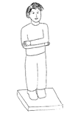
Protocol
Participants will stand with their feet together and their arms crossed at their waist, holding their elbows (see Figure 1). The technician will attach a safety belt around the participant’s waist. Participants will hold that stance for as long as they can under five separate conditions to a maximum of 15 seconds for condition 1 - 2 and 30 seconds for conditions 3 - 5):

Condition 1: Firm surface (no pad), eyes open

Figure 1: Stance for modified Romberg test
Condition 2: Firm surface (no pad), eyes closed
Condition 3: Compliant surface (foam pad), eyes open
Condition 4: Compliant surface (foam pad), eyes closed
Condition 5: Compliant surface (foam pad), eyes closed,
head moving side to side at 3 Hz

DUAL ENERGY X-RAY ABSORPTIOMETRY (DXA)
8-59 years

Body Composition

Excluded from scan if body weight is over 450 pounds or if yes to one of the following items;
  - Are you currently pregnant?
  - Have you had a medical test with contrast material such as dyes or barium in the last 7 days?

Whole Body Tissue Information:

- Total mass (gm)
- Bone mineral content (BMC) (gm)
- Bone area (cm²)
- Bone mineral density (BMD) (gm/cm²)
- Fat mass (gm)
- Lean mass excluding BMC (gm)
- Lean mass including BMC (gm)
- Percent body fat (%)

Values for each of the variables listed above will be given for the following regions:
Head
Left Arm
Right Arm
Trunk
Left Leg
Right Leg
Subtotal
Total

Whole Body Bone Information:

Area cm²
Bone Mineral Content grams
Bone Mineral Density grams/cm²

Values for each of the variables listed above will be given for the following regions:
Head
Left Arm
Right Arm
Left Ribs
Right Ribs
Thoracic Spine
Lumbar Spine
Pelvis
Left Leg
Right Leg

BLOOD PRESSURE MEASUREMENT
8+ Years

Have you had any of the following in the past 30 minutes? (food, coffee, alcohol, cigarettes) Check all that apply.

Arm selected Right/left/Could not obtain
Cuff size selected Infant/Child/Adult/Large Arm/Thigh
Heart Rate/Pulse Beats per minute
Pulse type
Radial/Brachial
Maximum Inflation Level mm Hg
Systolic Blood Pressure (Readings 1,2,3) mm Hg
Diastolic Blood Pressure (Readings 1,2,3) mm Hg
Average Blood Pressure mm Hg (mean of last 2 measurements will be used)

LIVER ELASTOGRAPHY
12+ years
Participants are excluded if they (1) are unable to lie down on the exam table, (2) are currently pregnant, (3) have an implanted electronic medical device, or (4) are wearing a bandage or have lesions on the right side of their abdomen by the ribs.

SP ID______________ Tech ID_______________

HEPATIC (liver) STEATOSIS TEST RESULTS
Test complete Yes No
Test result for median controlled attenuation parameter (CAP™) ____ decibel per meter, (dB/m)

REASONS TEST INCOMPLETE OR NOT DONE
Physical limitation
SP refusal
SP ill/emergency
Out of time
Equipment failure
Communication problem

HEPATIC (liver) FIBROSIS TEST RESULTS
Test complete Yes No
Test result for median Young’s Modulus (E) __________ kilopascals

REASONS TEST INCOMPLETE OR NOT DONE
Physical limitation
SP refusal
SP ill/emergency
Out of time
Equipment failure
Communication problem

VENIPUNCTURE
1+ years

Pesticide Use

Introduction
I am going to ask you a couple of questions about the use of pesticides and weed killers in your home, yard, and garden.

PESTICIDE USE – PUQ
6+ Years

PUQ.100 In the past 7 days, were any chemical products used in {your/his/her} home to control fleas, roaches, ants, termites, or other insects?

CAPI INSTRUCTION:
IF SP 8-17 YEARS, DISPLAY THE FOLLOWING INTERVIEWER INSTRUCTION: "THIS ITEM IS COLLECTED VIA PROXY FOR SPS 8-17."

YES 1
NO 2
REFUSED 7
DON'T KNOW 9

PUQ.110 In the past 7 days, were any chemical products used in {your/his/her} lawn or garden to kill weeds?

CODE ‘NO’ IF THE RESPONDENT SAYS S/HE DOES NOT HAVE A LAWN OR GARDEN.

CAPI INSTRUCTION:
IF SP 8-17 YEARS, DISPLAY THE FOLLOWING INTERVIEWER INSTRUCTION: "THIS ITEM IS COLLECTED VIA PROXY FOR SPS 8-17."

YES 1
NO 2
REFUSED 7
DON'T KNOW 9

Venipuncture

PRE VENIPUNCTURE QUESTIONS
1+ Years

I am now going to ask you a few questions about your health to determine if you are eligible to have your blood drawn. I will also ask a series of questions to determine the last time you had anything to eat or drink.

SP ID______________ Tech ID_______________

Pre venipuncture questions (Q1 asked if female participant ages 12-59 and younger if participant has reported starting menstruating. Q2 – Q9 are asked of all participants or parent/guardian ages 1+)

Q1. Are you currently pregnant?

Pregnancy Status

Positive
Negative
Don’t know

Q2. Do you have hemophilia?

Yes (Venipuncture will not be conducted)
No
Refused
Don’t know

Q3. Have you received cancer chemotherapy in the past four weeks?

Yes(Venipuncture will not be conducted)
No
Refused
Don’t know

Q4. When was the last time you ate or drank anything other than plain water? Do not include diet soda or black coffee with artificial sweetener like Sweet’N Low, Nutrasweet, Equal, or Splenda

HH:MM (AM PM ) MMDDYY

Have you had any of the following since [HH:MM (AM PM) MMDDYY {from Q4}] for Q5-Q9

Q5. Coffee or tea with cream or sugar? [Include milk or non-dairy creamers]

YES HH:MM (AM PM ) MMDDYY
NO

Q6. Alcohol, such as beer, wine or liquor?

YES HH:MM (AM PM ) MMDDYY
NO

Q7. Gum, breath mints, lozenges, or cough drops or other cough or cold remedies?

YES HH:MM (AM PM ) MMDDYY
NO

Q8. Antacids. Laxatives or anti-diarrheals?

YES HH:MM (AM PM ) MMDDYY
NO

Q9. Dietary supplements such as vitamins and minerals? [Include multivitamins and single nutrient supplements]
YES HH:MM (AM PM ) MMDDYY
NO

RESULTS STATUS OF VENIPUNCTURE

Test complete
Test partially complete
Test not done

REASONS TEST INCOMPLETE OR NOT DONE

Safety exclusion
SP refusal
No time

Physical limitation

SP ill/emergency

Equipment failure
Communication problem
Interrupted
Error (technician, software, supply)
Other, specify
No suitable vein
Vein collapsed
SP not feeling well
Fainting episode
No tubes drawn
Language barrier

Participants Deemed Ineligible to Have Their Blood Collected:
“Based on your answers to the safety questions, you are not eligible to participate in the blood collection.”

Participants Eligible to Have Their Blood Collected:
“I am now going to prepare the supplies needed to draw your blood sample.”

<Perform Venipuncture for All Eligible Study Participants>
Phlebotomy Talking Points

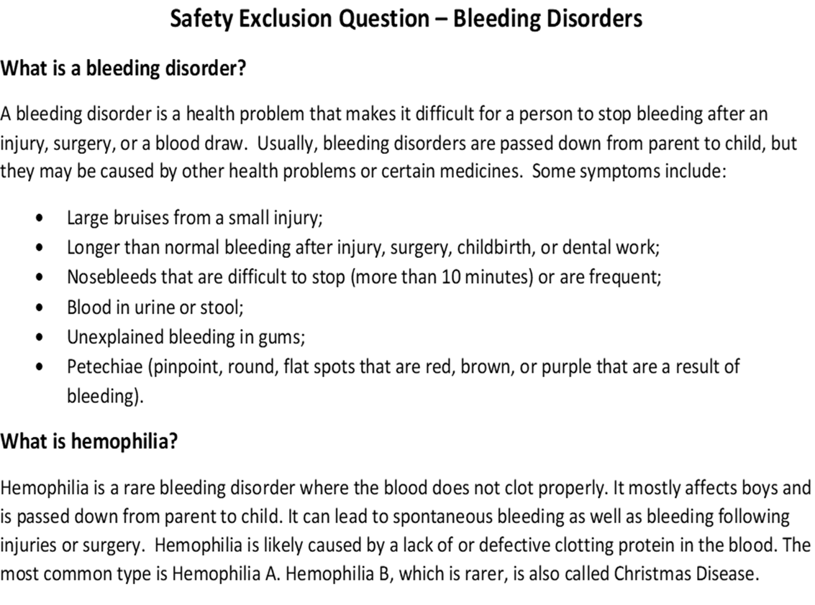

Phlebotomy talking points for participants ages 1-2 years old

- Complete Blood Count (CBC): We will check your child's hemoglobin level which may tell if your child has a low blood count.

- Iron: Is an important nutrient that is vital for growth and development. We will do tests that will tell us if your child may have low iron.

- Folate: Is an important nutrient for your child’s brain development.

- Lead: Element found in the environment that may lower iron levels and cause anemia or low blood count, and may also affect brain development at high levels.

- Mercury: Exposure to this environmental element is often from eating fish or seafood and high levels may affect (your) child’s brain and nervous system.

- Hepatitis B_{S}Ab: A positive test result indicates your child is protected against hepatitis B virus

- CMV (Cytomegalovirus) antibodies: A positive result means your child has had a CMV infection.

Phlebotomy talking points participants ages 3-5 years old

- Complete Blood Count (CBC): We will check your child's hemoglobin level which may tell if your child has a low blood count.

- Iron: Is an important nutrient that is vital for growth and development. We will do tests that will tell us if your child may have low iron.

- Folate: Is an important nutrient for your child’s brain development.

- Lead: Element found in the environment that may lower iron levels and cause anemia or low blood count, and may also affect brain development at high levels.

- Mercury: Exposure to this environmental element is often from eating fish or seafood and high levels may affect your child’s brain and nervous system.

- Hepatitis B_{S}Ab: A positive test result indicates your child is protected against hepatitis B virus.

- CMV (Cytomegalovirus) antibodies: A positive result means your child has had a CMV infection.

- Thyroid panel: This panel measures the function of your child’s thyroid gland, which plays a major role in the metabolism, growth and development of the human body. It also helps to regulate many bodily functions.

- Cotinine: Will determine if your child has been exposed to secondhand smoke or tobacco products.

Phlebotomy talking points participants ages 6-11 years old

- Complete Blood Count (CBC): We will check your child's hemoglobin level which may tell if your child has a low blood count.

- Folate: Is an important nutrient for your infant child’s brain development.

- C-Reactive Protein (CRP): High levels of CRP may be a sign of inflammation.

- Lead: Element found in the environment that may lower iron levels and cause anemia or low blood count, and may also affect brain development at high levels.

- Mercury: Exposure to this environmental element is often from eating fish or seafood and high levels may affect your child’s brain and nervous system.

- Hepatitis profile: The hepatitis profile is a series of blood tests used to detect current or past infection of hepatitis A, hepatitis B, or hepatitis C.

- Thyroid panel: This panel measures the function of your child’s thyroid gland, which plays a major role in the metabolism, growth and development of the human body. It also helps to regulate many bodily functions.

- Lipid profile: Measures the amount of “good” and “bad” cholesterol and triglycerides, a type of fat, in your blood.

- Cotinine: Will determine if your child has been exposed to secondhand smoke or tobacco products.

- Steroid hormones: important hormones responsible for reproductive health and development, such as testosterone and estrogen.

Phlebotomy talking points participants ages 12-19 years old

- Complete Blood Count (CBC): We will check your child's hemoglobin level which may tell if your child has a low blood count.

- Iron: Is an important nutrient that is vital for growth and development. We will do tests called ferritin and transferrin receptor that will tell us if your infant may have low iron.

- Folate: Is an important nutrient for your infant child’s brain development.

- C-Reactive Protein (CRP): High levels of CRP may be a sign of inflammation.

- Lead: Element found in the environment that may lower iron levels and cause anemia or low blood count, and may also affect brain development at high levels.

- Mercury: Exposure to this environmental element is often from eating fish or seafood and high levels may affect your child’s brain and nervous system.

- Diabetes Testing: This measures your fasting glucose and hemoglobin A1c which is a three month average of your glucose.

- Biochemistry Panel: Measures liver, heart, kidney functions, as well as lipid metabolism and nutritional health.

- Hepatitis profile: The hepatitis profile is a series of blood tests used to detect current or past infection of hepatitis A, hepatitis B, or hepatitis C.

- Thyroid panel: This panel measures the function of your child’s thyroid gland, which plays a major role in the metabolism, growth and development of the human body. It also helps to regulate many bodily functions.

- Lipid profile: Measure the amount of “good” and “bad” cholesterol and triglycerides, a type of fat, in your blood.

- Cotinine: Will determine if your child has been exposed to secondhand smoke or tobacco products.

- Steroid hormones: important hormones responsible for reproductive health and development, such as testosterone and estrogen.

- Infectious Disease: Herpes Virus testing starting at 14 years, HIV starting at 18 years

Phlebotomy Distraction Cards

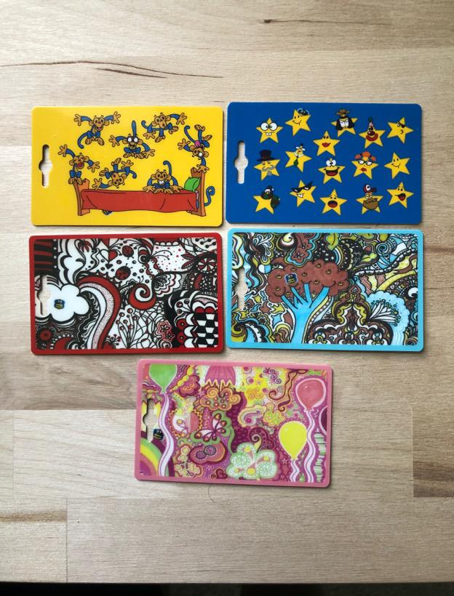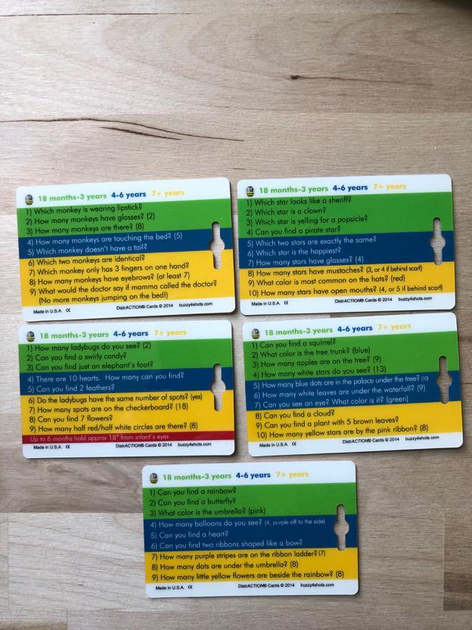
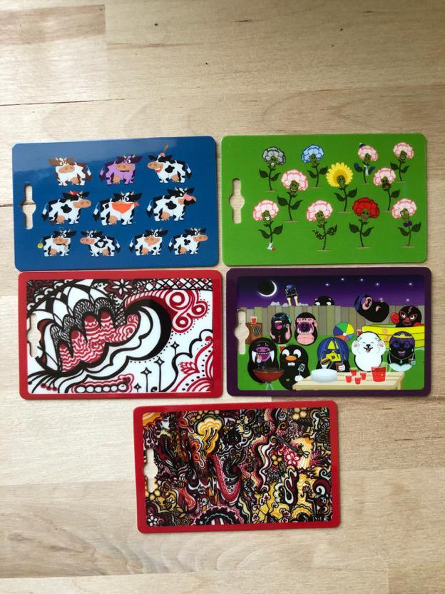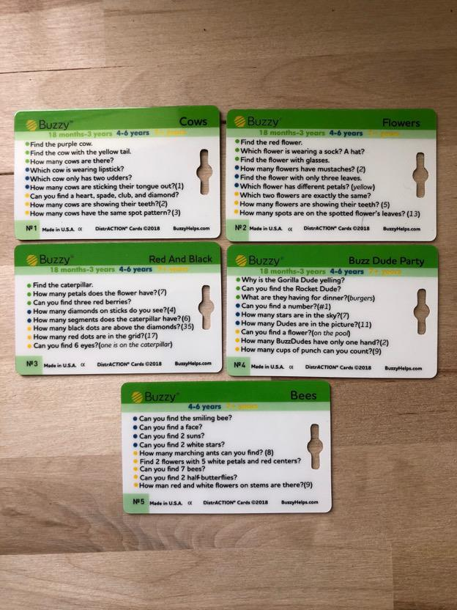
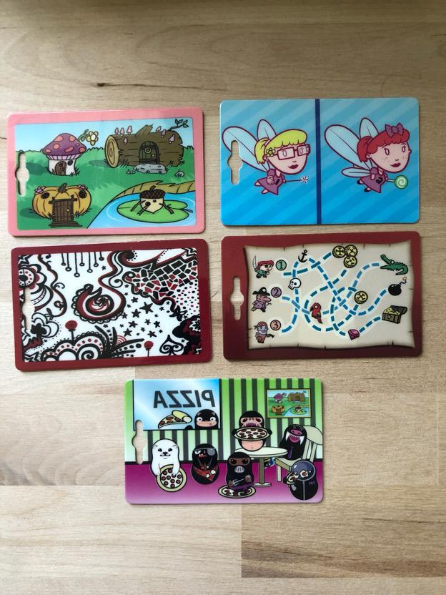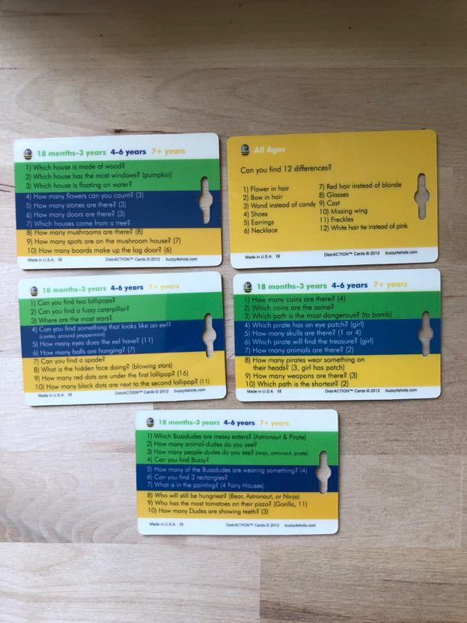

Phlebotomy Photo story
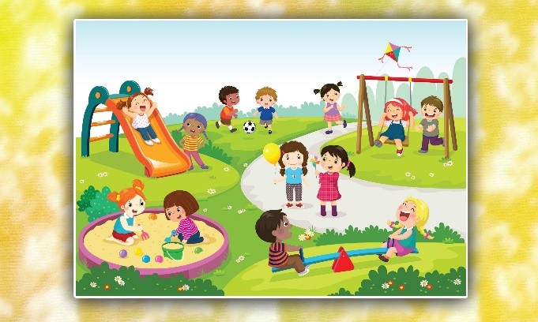
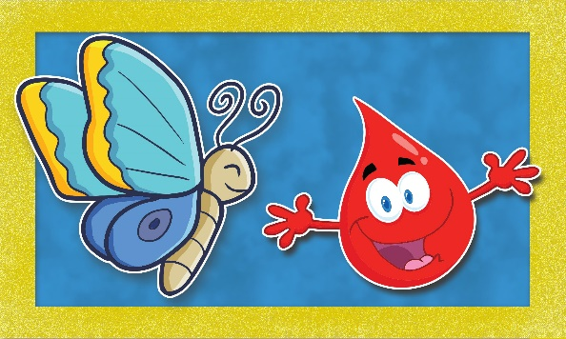
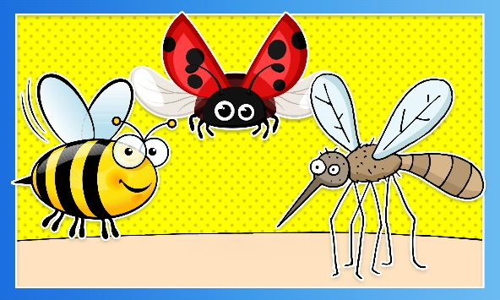
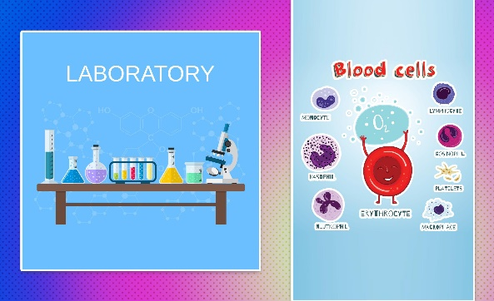
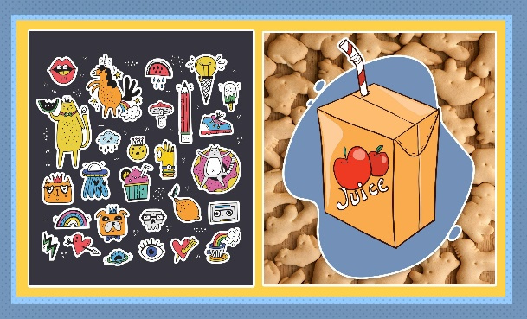
Volatile Organic Compound (VOC)

The VOC section is applicable for only those SPs that are subsampled into VOC. To determine if a particular SP is subsampled into VOC, check the mec_sp_subsample. If the SP in question has a record for subsample 1, they are subsampled for VOC and so should get the VOC section.

Introduction:
“Finally, I have a few questions about potential environmental exposures you have had in the last 48 hours while engaged in routine activities, both in your home and at other locations.”

VOLATILE TOXICANT – VTQ
12+ Years

VTQ.210_ First, I would like to ask you a few questions about {your/SP's} home.

VTQ.220 Is the source of water for {your/her/his} home from a private well?

YES 1
NO 2
REFUSED 7
DON'T KNOW 9

VTQ.231a {Do you/Does she/Does he} currently use moth balls, moth crystals or toilet bowl deodorizers inside {your/her/his} home?

HELP SCREEN SHOULD READ: Some toilet bowl deodorizers clip onto the toilet rim, others, such as deodorant blocks and gels, are placed inside the tank or hang inside the wall of the tank. Brand names include Bully, 2000 Flushes, Vanish, X-14, Ty-D-Bol, Toilet Duck, Clorox, Lime-A-Way, and Sno Bol.

YES 1
NO 2
REFUSED 7
DON'T KNOW 9

VTQ.233a In the last three days, did {you/she/he} inhale smoke from any source for 10 or more minutes?

HELP SCREEN: Inhaled smoke includes smoke from campfires, fireplaces, marijuana, and tobacco products such as cigarettes, cigars and pipes.

YES 1
NO 2 (VTQ.241_)
REFUSED 7 (VTQ.241_)
DON'T KNOW 9 (VTQ.241_)

VTQ.233b When did {you/she/he} last spend 10 or more minutes inhaling smoke?

TODAY 1
YESTERDAY 2
MORE THAN 2 DAYS 3
REFUSED 7
DON'T KNOW 9

VTQ.241_ Now I am going to ask you a few questions about {your/SP’s} activities over the last 48 hours. This means today or yesterday.

VTQ.244a In the last 48 hours, did {you/she/he} pump gas into a car or other motor vehicle {yourself/herself/ himself}?

YES 1
NO 2 (VTQ.251a)
REFUSED 7 (VTQ.251a)
DON'T KNOW 9 (VTQ.251a)

VTQ.244b How long ago, in hours, did {you/she/he} pump gas into a car or other motor vehicle {yourself/herself/
G/Q/D/T himself}?

CAPI INSTRUCTION:
IF “1” IS ENTERED FOR GATE, ALLOW INTERVIEWER TO ENTER NUMBER OF HOURS WITH A HARD EDIT RANGE OF 1 – 48.

IF “2” IS ENTERED FOR GATE, ALLOW INTERVIEWER TO ENTER “DATE EVENT OCCURRED” WITH A CALENDAR WHERE DATE CAN BE SELECTED AND “TIME EVENT OCCURRED”. CALCULATE “HOURS SINCE EVENT OCCURRED” BASED ON THE CURRENT DATE AND TIME AND DISPLAY RESULT ON SCREEN. THE RESULT OF THE CALCULATION USING THE CALENDAR AND TIME GOES INTO Q. HARD EDIT RANGE IS 1 – 48.
THE APPLICATION WILL PERFORM THE FOLLOWING CONSISTENCY CHECKS AND ROUNDING RULE:
“DATE EVENT OCCURRED” AND “TIME EVENT OCCURRED” COMBINED MUST BE BEFORE CURRENT DATE AND TIME COMBINED.
WHEN “TIME SINCE EVENT OCCURRED” FALLS EXACTLY ON THE ONE-HALF, ROUND TO THE NEAREST EVEN WHOLE NUMBER.

|___|___|
HOURS

ENTER DATE AND TIME 2
REFUSED 77
DON'T KNOW 99

|___|___|
HOURS

ENTER DATE AND TIME 2
REFUSED 77
DON'T KNOW 99

VTQ.261a In the last 48 hours, did {you/she/he} use dry cleaning solvents, visit a dry cleaning shop or wear clothes that had been dry-cleaned within the last week?

HELP SCREEN: Examples of dry cleaning solvents include Guardsman Dry Cleaning Fluid, Amway prewash, LPS F-104 Dry Solvent, Dryel At-Home Dry Cleaning starter kit, Woolite Dry Clean at Home, and Bounce 15 minute Dry Cleaner.

YES 1
NO 2 (VTQ.271a)
REFUSED 7 (VTQ.271a)
DON'T KNOW 9 (VTQ.271a)

VTQ.261b How long ago, in hours, has it been since {you/she/he} used dry cleaning solvents, visited a dry
G/Q/D/T cleaning shop or wore clothes that had been dry-cleaned within the last week?

CAPI INSTRUCTION:
IF “1” IS ENTERED FOR GATE, ALLOW INTERVIEWER TO ENTER NUMBER OF HOURS WITH A HARD EDIT RANGE OF 1 – 48.

IF “2” IS ENTERED FOR GATE, ALLOW INTERVIEWER TO ENTER “DATE EVENT OCCURRED” WITH A CALENDAR WHERE DATE CAN BE SELECTED AND “TIME EVENT OCCURRED”. CALCULATE “HOURS SINCE EVENT OCCURRED” BASED ON THE CURRENT DATE AND TIME AND DISPLAY RESULT ON SCREEN. THE RESULT OF THE CALCULATION USING THE CALENDAR AND TIME GOES INTO Q. HARD EDIT RANGE IS 1 – 48.
THE APPLICATION WILL PERFORM THE FOLLOWING CONSISTENCY CHECKS AND ROUNDING RULE:
“DATE EVENT OCCURRED” AND “TIME EVENT OCCURRED” COMBINED MUST BE BEFORE CURRENT DATE AND TIME COMBINED.
WHEN “TIME SINCE EVENT OCCURRED” FALLS EXACTLY ON THE ONE-HALF, ROUND TO THE NEAREST EVEN WHOLE NUMBER.

|___|___|
HOURS

ENTER DATE AND TIME 2
REFUSED 77
DON'T KNOW 99

VTQ.271a In the last 48 hours, did {you/she/he} take a hot shower or bath for five minutes or longer?

YES 1
NO 2 (VTQ.281a)
REFUSED 7 (VTQ.281a)
DON'T KNOW 9 (VTQ.281a)

VTQ.271b How long ago, in hours, has it been since {your/SP’s} last shower or hot bath?
G/Q/D/T
CAPI INSTRUCTION:
IF “1” IS ENTERED FOR GATE, ALLOW INTERVIEWER TO ENTER NUMBER OF HOURS WITH A HARD EDIT RANGE OF 1 – 48.

IF “2” IS ENTERED FOR GATE, ALLOW INTERVIEWER TO ENTER “DATE EVENT OCCURRED” WITH A CALENDAR WHERE DATE CAN BE SELECTED AND “TIME EVENT OCCURRED”. CALCULATE “HOURS SINCE EVENT OCCURRED” BASED ON THE CURRENT DATE AND TIME AND DISPLAY RESULT ON SCREEN. THE RESULT OF THE CALCULATION USING THE CALENDAR AND TIME GOES INTO Q. HARD EDIT RANGE IS 1 – 48.
THE APPLICATION WILL PERFORM THE FOLLOWING CONSISTENCY CHECKS AND ROUNDING RULE:
“DATE EVENT OCCURRED” AND “TIME EVENT OCCURRED” COMBINED MUST BE BEFORE CURRENT DATE AND TIME COMBINED.
WHEN “TIME SINCE EVENT OCCURRED” FALLS EXACTLY ON THE ONE-HALF, ROUND TO THE NEAREST EVEN WHOLE NUMBER.

|___|___|
HOURS

ENTER DATE AND TIME 2
REFUSED 77
DON'T KNOW 99

VTQ.281a In the last 48 hours, did {you/she/he} breathe fumes from freshly painted indoor surfaces, paints, paint thinner, or varnish?

YES 1
NO 2
REFUSED 7
DON'T KNOW 9

VTQ.281b How long ago, in hours, has it been since {you/she/he} breathed fumes from freshly painted indoor
G/Q/D/T surfaces, paints, paint thinner, or varnish?

CAPI INSTRUCTION:
IF “1” IS ENTERED FOR GATE, ALLOW INTERVIEWER TO ENTER NUMBER OF HOURS WITH A HARD EDIT RANGE OF 1 – 48.

IF “2” IS ENTERED FOR GATE, ALLOW INTERVIEWER TO ENTER “DATE EVENT OCCURRED” WITH A CALENDAR WHERE DATE CAN BE SELECTED AND “TIME EVENT OCCURRED”. CALCULATE “HOURS SINCE EVENT OCCURRED” BASED ON THE CURRENT DATE AND TIME AND DISPLAY RESULT ON SCREEN. THE RESULT OF THE CALCULATION USING THE CALENDAR AND TIME GOES INTO Q. HARD EDIT RANGE IS 1 – 48.
THE APPLICATION WILL PERFORM THE FOLLOWING CONSISTENCY CHECKS AND ROUNDING RULE:
“DATE EVENT OCCURRED” AND “TIME EVENT OCCURRED” COMBINED MUST BE BEFORE CURRENT DATE AND TIME COMBINED.
WHEN “TIME SINCE EVENT OCCURRED” FALLS EXACTLY ON THE ONE-HALF, ROUND TO THE NEAREST EVEN WHOLE NUMBER.

|___|___|
HOURS

ENTER DATE AND TIME 2
REFUSED 77
DON'T KNOW 99

