|  |
| --- |
| **NCI/Office of Communications and Public Liaison** |
| **APPENDIX 3** |
| **SOCIAL MEDIA SERVICE** |

|  |
| --- |
|  |

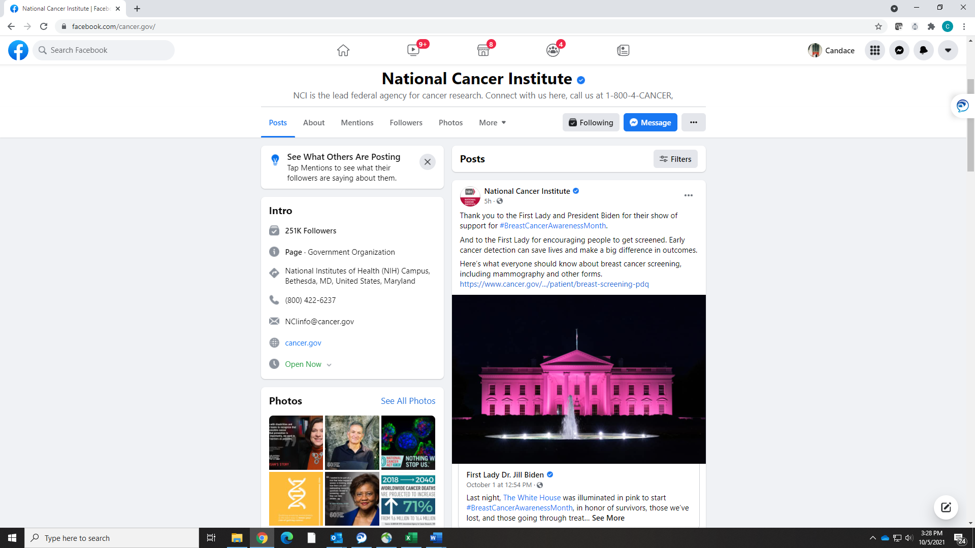

Facebook

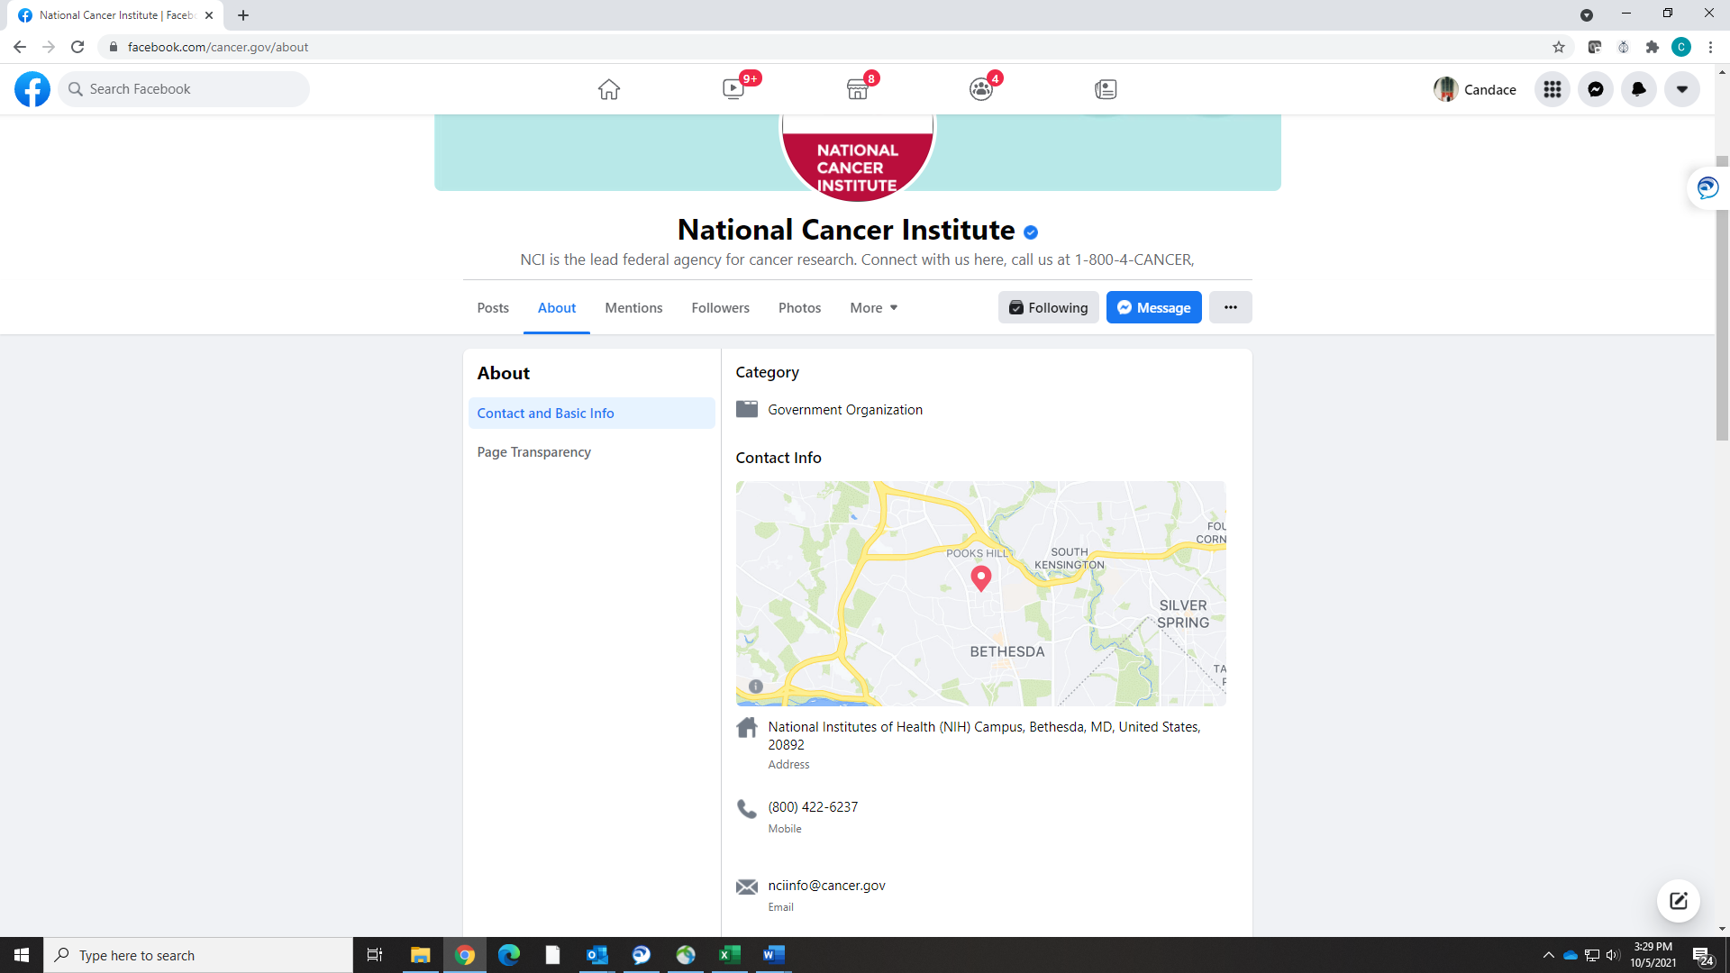

Facebook

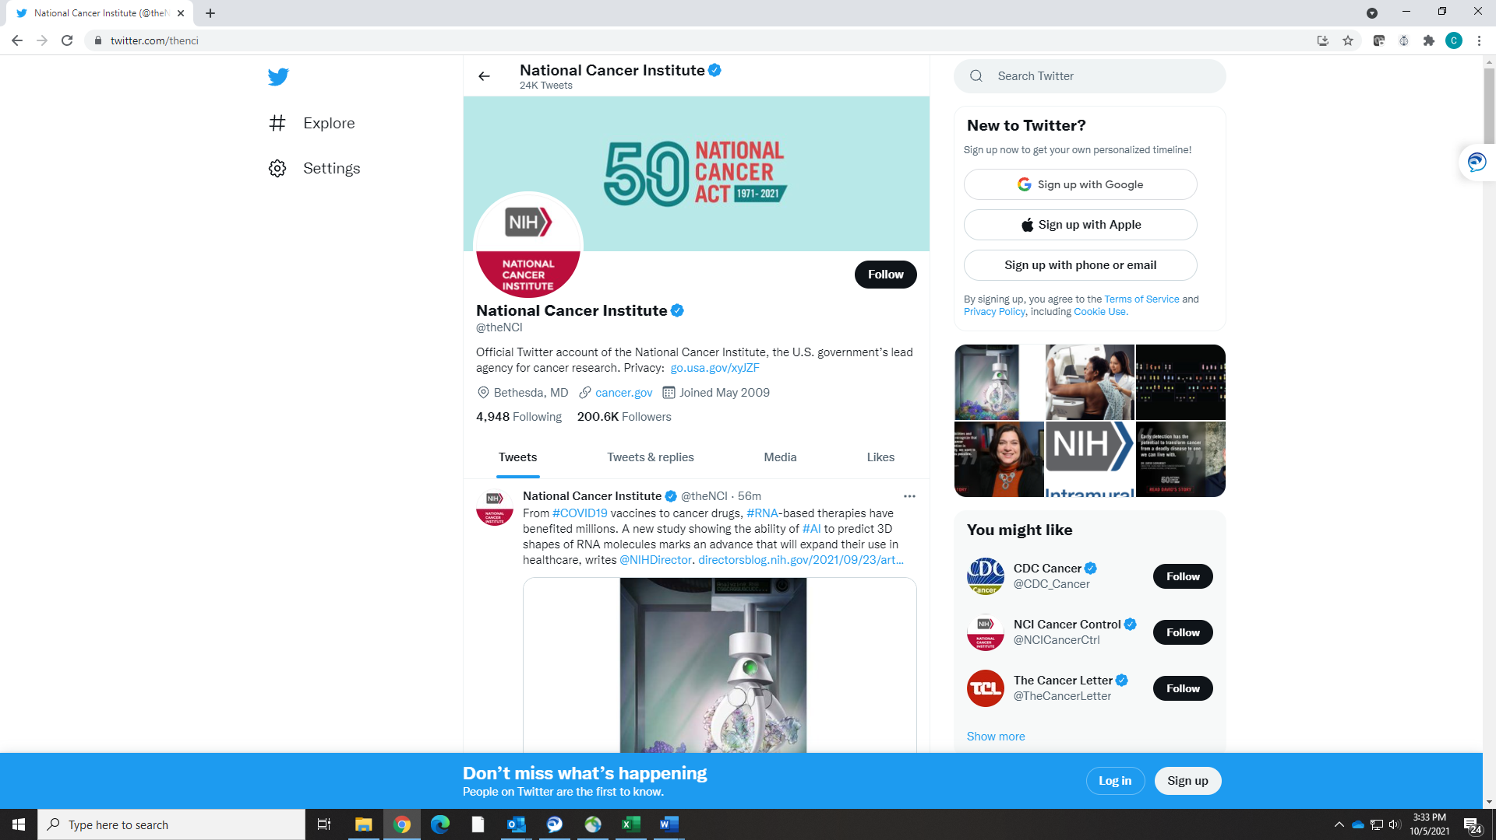

Twitter

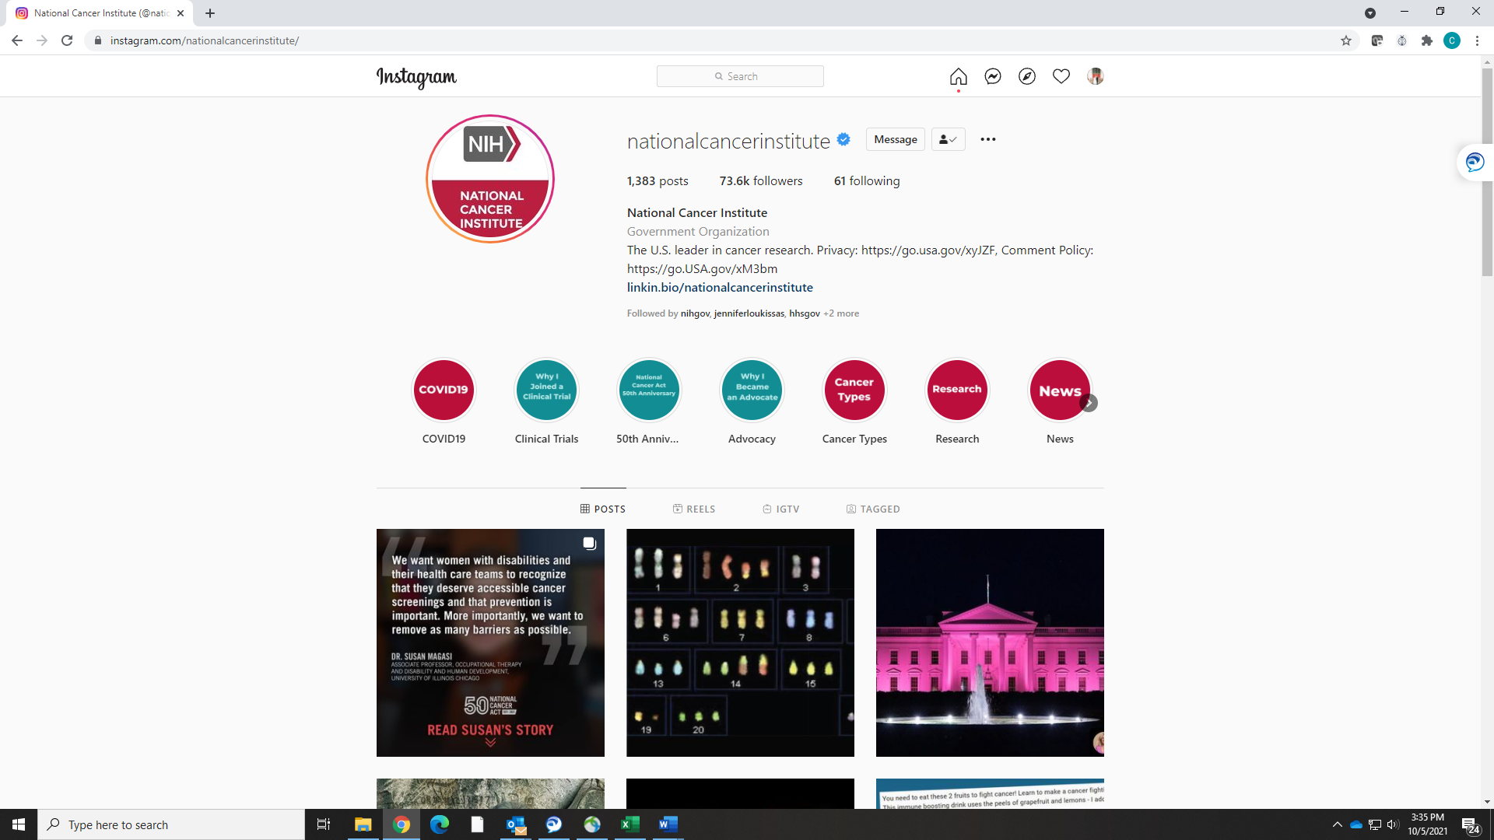

Instagram

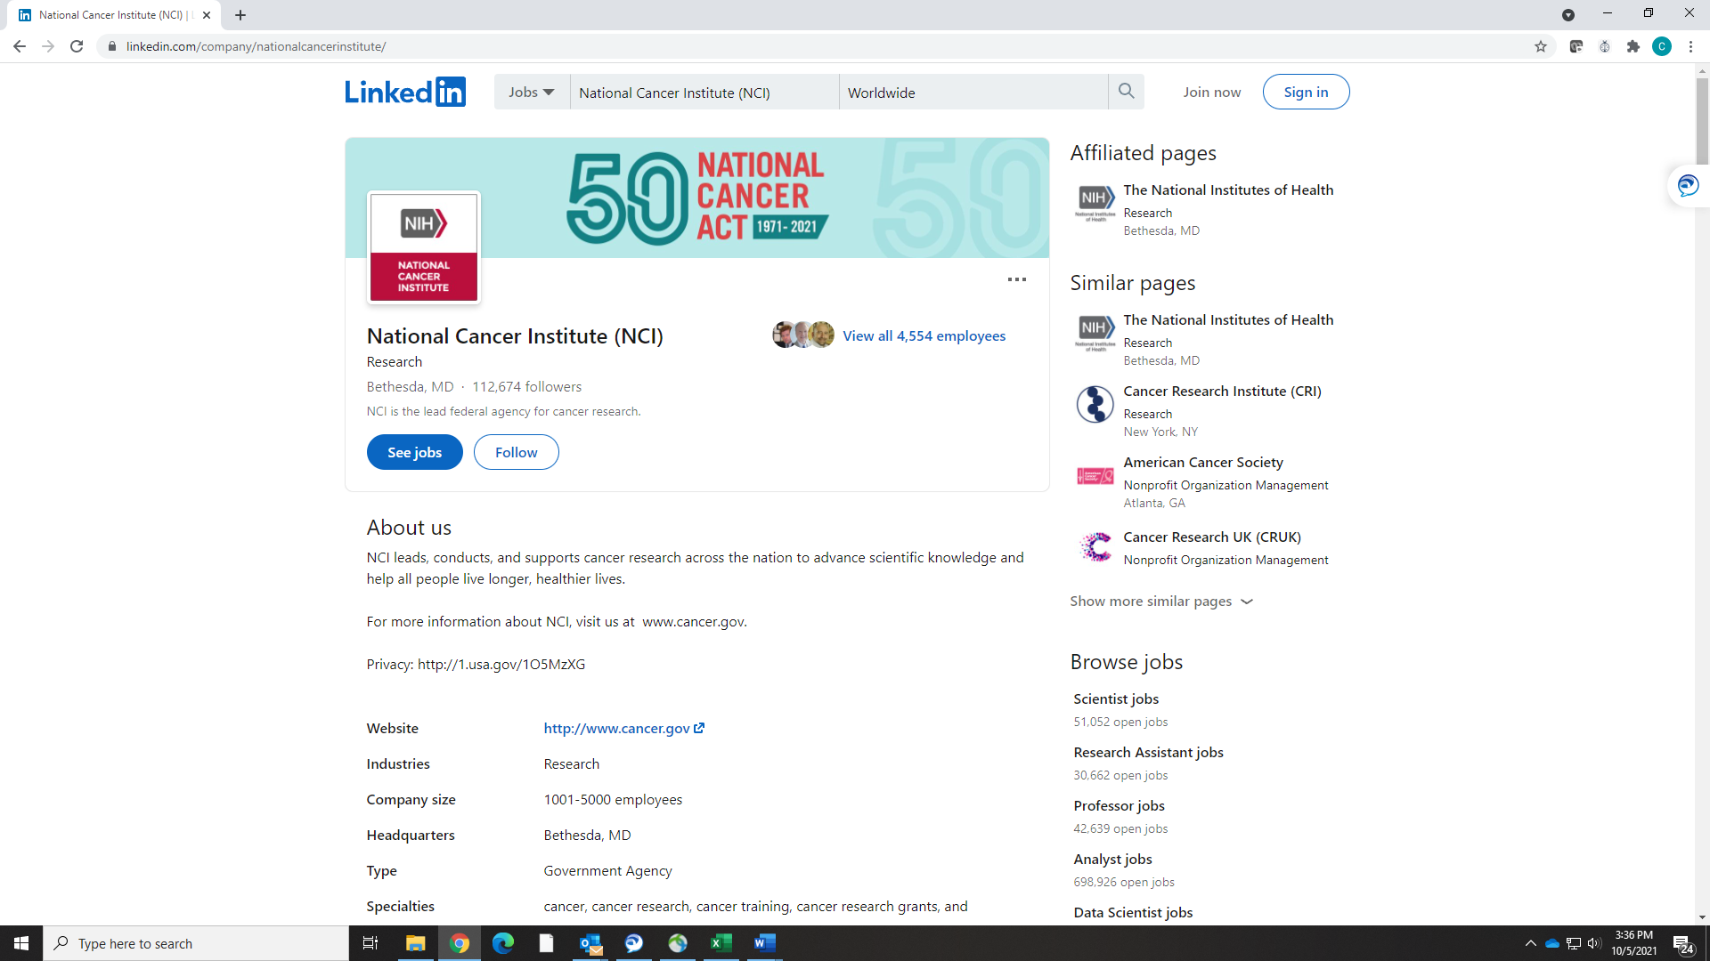

Linked In

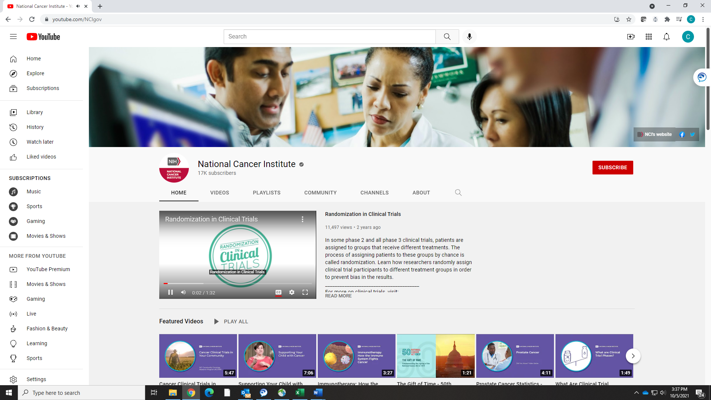

YouTube