NCI/Office of Communications and Public Liaison
APPENDIX 10
ELECTRONIC CONTACT RECORD FORM(ECRF) with SCREEN SHOTS

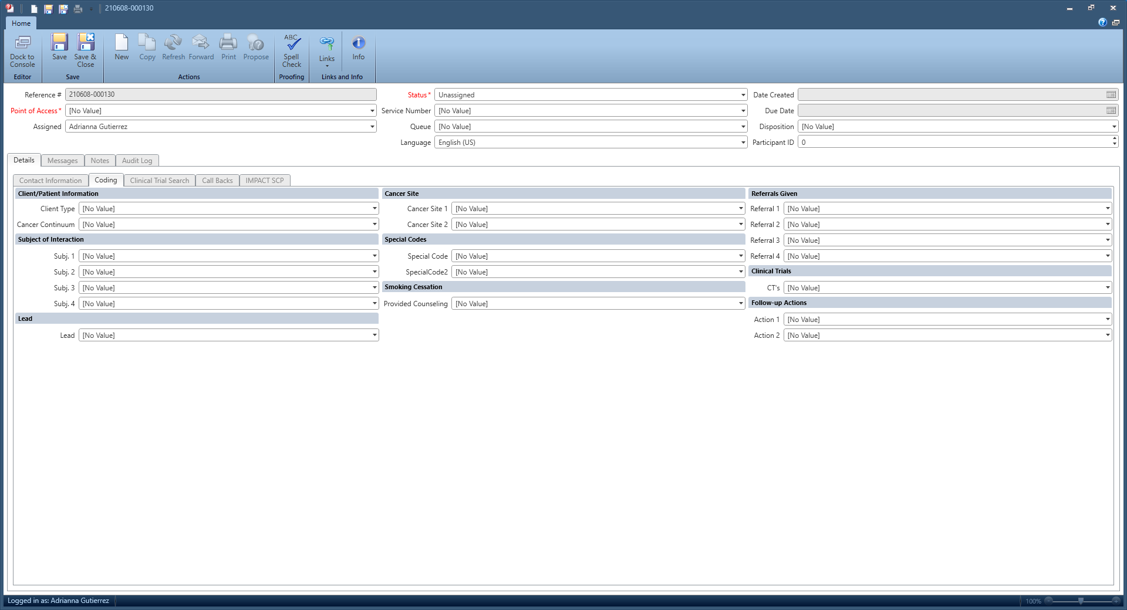

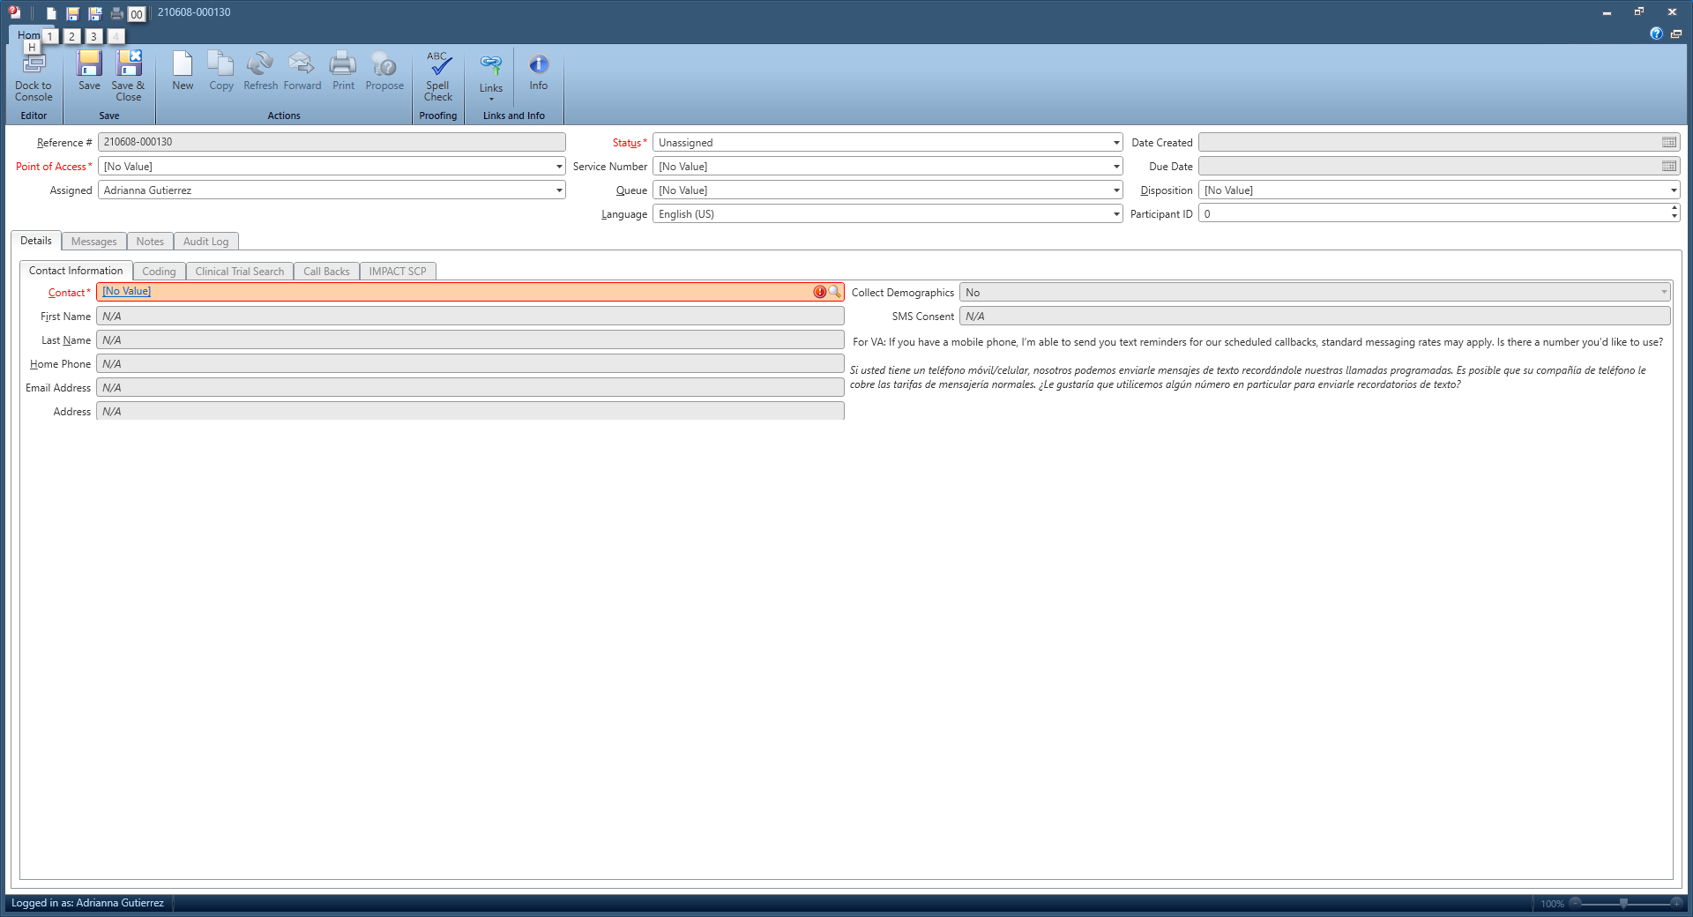
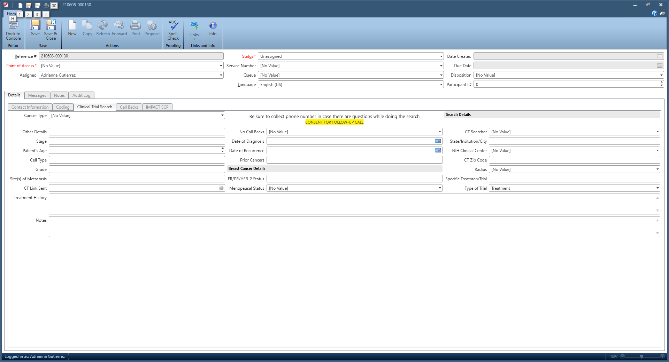

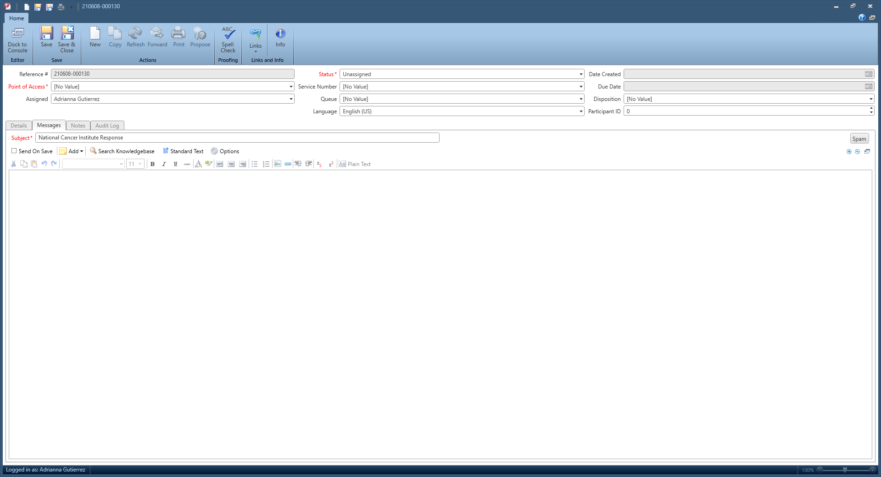

TYPE OF USER
Cancer Patient | Patients along any point of the cancer continuum, recurrence or a new primary who were previously treated, started but not completed treatment. Includes cancer survivors and those with treated myeloproliferative and myelodysplastic disorders, and treated DCIS. Post-treatment maintenance, etc.
Spouse, relative, friend of diagnosed cancer patient | Includes relatives/friends of deceased cancer patients
General Public | Members of the public including: symptomatic people and their friends/relatives, inquiries about pets, precancerous or noncancerous conditions. (Includes all non-health professionals e.g. educators, clergy, librarian, lawyers, CPAs, insurance agents)
Organization * | Contacts from organizations, healthcare facilities, advocacy groups
Health professional * | MDs,RNs,PAs,PTs,NPs, social workers, nutritionists, and other allied health professionals, public health professionals, cancer registrar
Scientist/Researcher * | Includes researchers and scientists in training
Media * | Newspaper, television, radio, web – media
Cigarette smoker – help to Quit

Other tobacco user – help to Quit

Relative/friend of tobacco user

Students * | Except researchers and scientist in training
Government/Congressional * | Congressional Aides; Federal Employee, etc.
Other/Not able to ascertain

*Do not ask demographics
Cancer Continuum
N/A | Non-Cancer interactions, Cancer Continuum unknown, Patient is deceased, general questions not about a specific individual
General Public/Undiagnosed | symptoms questions, finding a health center
Screening | Questions about screening or finding a screening program
Diagnostic | People who have a symptom or have been referred for diagnostic testing, but have not yet received an official diagnosis
Staging | People who have been diagnosed but have not yet begun treatment because they are being staged
Treatment | Patients who are in treatment, this could be any stage of treatment
Post-Treatment | Any questions about life after treatment; follow-up care, recurrence rates, late effects, etc..
End-of-Life | Would include hospice/palliative or other end of life conversations

SUBJECT OF INTERACTION
Understanding Cancer/General Cancer (G) | Heading
G-COVID-19 | Use when main topic of conversation is COVID-19. Also use Special Code COVID-19
G-General Cancer Questions | Topics related to cancer in general that are not specific to a type of treatment
G-Symptoms | Topics related to symptoms of cancer in general, specific types of cancer, metastasis, or symptoms for recurrence
G-Cancer Statistics/Epidemiological Stats | Statistical data (e.g. incidence rates) not related to specific cancer patient/prognosis
G-Prognosis | Questions about prognosis for cancer at any stage including survival statistics
G-Research Donations | Questions about making donations to research (tissue, body, blood, etc)
G-General Donations | Donations to NCI, other organizations, and inquiries about solicitations (e.g. take me off your mailing list)
G-Suicidal Client

G-Other Inquiries | Any other questions that are not defined in list
Causes and Prevention (CP) | Heading
CP-Risk Factors | Questions about any type of risk factor for any type of cancer (e.g. HPV, Environmental, hormone use and cancer, EMF, etc.)
CP-Genetics | Questions about heredity/genetics as a risk factor or for cancer treatment
CP-Prevention | Any questions about how to prevent cancer (e.g. Diet and Nutrition – including preventing recurrence, exercise, etc)
Tests | Questions about any tests that are done to screen, diagnose, stage, monitor, follow-up for cancer, including risks and benefits of tests
Treatment (TX) | Heading
TX-General Treatment | Questions about treatment in general that are not specific to a type of treatment including healthy eating during treatment
TX-Surgery

TX-Radiation Therapy

TX-Chemotherapy

TX-Immunotherapy | Includes CAR T-cell, TIL, Vaccines (such as Sipuleucel-T), checkpoint inhibitors, BCG
TX-Targeted Therapy | Includes Monoclonal Antibodies, Angiogenesis inhibitors, examples: Sutent, Gleevec, Avastin
TX-Hormone Therapy

TX-Stem Cell Transplant

TX-Complementary and Alternative Medicine  CAM-Medical Marijuana  CAM-Biological Based Products  CAM-Manual Therapies  CAM-Whole Systems  CAM-Mind Body/Spirituality/Energy Med.  CAM-High Dose Vitamin C | Any questions related to any type of CAM used as any type of treatment (Biological based products, Body, spirituality, energy medicine, Manual therapies, Whole systems, marijuana, nutrition as supplement)  Herbs, supplement/vitamins, food, special diets  Acupuncture, massage, chiropractic, reflexology  Homeopathy, naturopathy, Ayurveda  Hypnosis, Tai Chi, Reiki, therapeutic touch, yoga, meditation, visualization, relaxation, prayer
Side Effects | Includes any type of side effects from treatment. (Side effects from cancer itself-code symptoms)
Clinical Trials (CT) | Heading
CT-General Information Only | General information about clinical trials are discussed, CTs as a treatment option, cost, enrollment and eligibility information, etc.
CT-General Information & Search | Including searches that result in no matches. Does NOT include CCR trials. Also code CCR Clinical Trials for searches that include the Clinical Center. Code as 1st SOI when a search is needed
CT-CCR Clinical Trials | Educated about or searched for CCR trials (NIH Clinical Center)
CT-Results & Outcomes | Discussed results of trial (This does NOT refer to sharing clinical trial search result). Includes client wanting to know about results of a trial he/she participated in or heard about.
Coping | Use when listening to client talk about coping, providing emotional coping strategies, or giving significant emotional support (for depression, anxiety, distress or any other psychosocial issues)
Managing Cancer Care (MC) | Heading
MC-Finding Health Care Services | Use when helping client find any type of health care services (GP, Screening, Treatment, Genetics, etc) Includes finding support, transportation, lodging services
MC-Managing Costs and Medical Information | Use when providing information about costs and structure of health care system as well as financial assistance
MC-Palliative/Hospice Care

Publication Requests |  | Also code Cancer Type
Smoking Cessation (SM) | Heading
SM-Cigarettes

SM-Cigars, Cigarillos, or Little Cigars

SM-Pipes | (not water or hookah)
SM-Chewing Tobacco

SM-Other Tobacco

SM-Marijuana (recreational use) | *For medical marijuana, see CAM section
SM-Cessation Counseling/Information

SM-E-cigs

SM-NRT (nicotine replacement therapy)

NCI | Heading
NCI-About NCI | Questions about NCI
NCI-Key Initiatives | Cancer Moonshot, Genomic Data Commons, NCTN, RAS, Bioinformatics
NCI Budget | Funding priorities, Budget, Getting funding, asking about/applying for grants
NCI-Problems with a CT search | User specifically states difficulty finding a CT or using the CT search form.
NCI Permissions Requests | Includes logo requests, artwork, text and licensing permissions/requests
NCI – Other | Includes product endorsement from NCI, employment verification, contacting NCI and NIH staff members, help with fund- raising or other events such as health fairs, scientific materials for researchers including cell lines, mice, etc.
NCI Resources | Questions about content, PDQ and cancer.gov comments and questions.
 | Includes Breast, Colorectal and Melanoma RATs
NCI-Risk Tools | Includes Breast, Colorectal and Melanoma RATs  (QuitSTART replaced Quitpal)
NCI-QuitSTART and other apps | (QuitSTART replaced Quitpal)
SEER | Heading
SEER Cancer Statistics
 | CSR Current and Archived, Stats tools: Fast Stats, State Cancer Profiles, SEER*Explorer, Cancer Query System, Cancer Stat Facts
 | i.e. SEER*Stat databases; SEER*Stat; Dictionary of SEER*Stat Variables; SEER-Medicare linked Database
SEER Datasets and Software

SEER Manuals | Coding and Staging Manual - Current and Archived and SEER Heme and Lymph Neop. Database Man.
SEER Registries/Training etc. | i.e. List of Registries; Cancer Registrars Training; SEER Quality Improvement documents
SEER - other
FB –Advertising (products/services)

FB – Fundraising

FB – Other Languages

FB – CAM Cures

PRIMARY CANCER SITE/TYPE
AIDS-related cancers | AIDS-related lymphomas, Kaposi’s sarcoma, and others
ALL | Acute Lymphocytic Leukemia
AML | Acute Myeloid Leukemia
Anal

Biliary Tract | Gallbladder and bile ducts outside the liver. Does NOT include intrahepatic cholangiocarcinoma (code as Liver).
Bladder

Brain

Breast | Includes breast exam questions
Carcinoma of unknown primary | Physician has specified that the primary site cannot be determined and diagnosis is CUP. Includes metastatic squamous neck cancer with occult primary. NOTE: If there is no specific site discussed, code Not Applicable
Cervical | Includes cervical dysplasia
CLL | Chronic Lymphocytic Leukemia
CML | Chronic Myelogenous Leukemia
Colorectal

Endometrial/Uterine

Esophageal

Eye | Includes intraocular melanoma and retinoblastoma.
Gastrointestinal carcinoid tumor/GIST

Head and Neck | Includes lip and oral cavity, laryngeal, pharyngeal, paranasal sinus, nasal cavity, and salivary gland.
Hodgkin Lymphoma

Liver | Includes intrahepatic cholangiocarcinoma
Lung and Bronchus

Melanoma | Includes all non-ocular melanoma regardless of site.
Myeloma/Plasma cell neoplasm

Non-Hodgkin Lymphoma | Includes CNS lymphomas and mycosis fungoides
Ovarian | Includes ovarian epithelial, germ cell, stromal
Pancreas

Prostate

Renal (kidney) & renal pelvis

Skin cancer (nonmelanoma) | Includes Merkel cell
Small Intestine

Soft tissue | Includes sarcomas/leiomyosarcomas, and heart, and uterine sarcoma
Stomach/Gastric

Thyroid

Other – Central Nervous System | Includes neuroblastoma
Other – Digestive

Other – Endocrine system | Includes pituitary, islet cell, pheochromocytoma, adrenocortical, parathyroid, and peripheral neuroepithelioma
Other – Hematologic system | Includes myeloproliferative disorders and myelodysplastic syndromes
Other – Leukemia | Includes leukemias whose type is unknown or not specified, or any other than AML, ALL, CML, CLL
Other – Lymphoma | Includes lymphomas whose type is unknown or not specified. Otherwise, code as HL or NHL.
Other – Musculoskeletal and connective tissue | Includes bone and joints
Other – Reproductive, female | Includes labia, vulva, vagina, peritoneal carcinoma, and gestational trophoblastic tumors.
Other – Reproductive, male | Includes testicular, penile, and extragonadal germ cell tumors.
Other – Respiratory | Includes malignant Mesothelioma and thymoma
Other – Urinary organs | Includes Wilms tumor (also code Childhood cancers)
Other Cancers | Use for a specific site that does not fit in any of the categories; includes all non-intestinal carcinoid tumors and paraganglioma. NOTE: if Dr’s diagnosis is CUP, see Carcinoma of Unknown Primary code
Childhood Cancers | NOTE: When choosing this code, be sure to also choose an additional code for cancer type.
Not applicable/no site mentioned | Includes benign & non-cancer calls, general questions, site-unspecified calls, clients that are unsure about cancer site/type and questions related to pet/animal cancer. Use Solo.

SPECIAL CODES
COVID-19  NCCAPS (NCI COVID study) | Use whenever COVID-19 is part of the interaction, regardless of who initiates the conversation about COVID-19. Also includes when info about COVID-19 addressed only in f/u email.
CTCA Call (callers ref’d to us by CTCA)

VA Smoking Chat

TMIST

All of Us Research Program

Dr. Rosenberg

Affordable Care Act (ACA)

In the News (anything people saw on TV e.g. Angelina Jolie, etc.)

Vice President’s Cancer Initiative

First in Human

CT Feedback (PIQ only)

Cancer Research Initiative Mailbox

Genomics Podcast
VA Lung Screening

Pediatric Petitions/Funding

FDA Referral (quit smoking)

Exceptional Responders

MATCH

Ped MATCH

Emperor of All Maladies

VM Callback

FB Live Event

Hurricane

DART

Every Try Counts

Cell Phone Risk

E2112

PIQ Custom Phone Response

PIQ Referred by DOC

PIO Referred by Center for Global Health

PIQ Incarcerated Client

ACTIONS: [up to 5]
None

Sent information by mail | Mail, letters, faxes, pubs, other printed material, PDQ stmts, CT searches, materials to walk-ins, or holding material for pick-up. Use when sending via NCI Pubs Locator.
Emailed caller information

Social Media Post

Warm transferred to Organization/Federal agency

Scheduled proactive callback

Other | Any other actions taken as follow-up (e.g. contacting POS for user)
SMOKING CESSATION
Yes

No

Scheduled Intake

REFERRALS GIVEN
Dr/Nurse/Pharmacist/SW/HP | Includes referral to Social Worker, nurse, pharmacist or other HP
NCI-Designated Cancer Center

National or Community Org/Other Gov Program | Use when referrals are made to community services, organizations, state and local gov’t programs, and federal gov’t programs other than NCI. Includes smokefree.gov.
Other Healthcare Facility | Includes hospitals, clinics, and screening facilities. Use when sending CoC hospitals or other facilities. Do NOT use when referring to BCCEDP programs, genetic services, NCI-designated cancer centers, or NCCCP hospitals.
NCI Contact Center | Inquiries referred to 1-800-4-CANCER
Smoking Quitline | Inquiries referred to 1-877-44U-QUIT
Public Inquiries

POS | Publication Ordering Service
NCI DOC/Program | NCI Divisions Offices & Centers (DOCs) e.g. refs to DCEG, CTEP, DCCPS, TCGA, SEER, etc. Includes providing contact information for Dr. Sharpless or NCI researcher.
NCI CCR/Clinical Center

CDC-BCCEDP | Use when a referral is given to Breast/Cervical Cancer Early Detection Program EXCEPT when referring to Missouri.
Genetics Services

International Referral

CPEN Bulk Printing

Other

None

CLINICAL TRIALS
N/A | Clinical trials were not discussed
Client Initiated | The topic of clinical trials was presented by the client
IS Initiated | The topic of clinical trials was presented by the Information Specialist
HOW FOUND OUT
REFERRAL
Relative/Friend | Incl. co-worker
Health Professional

MEDIA
TV
Radio
Huerta Radio Series
Magazine
Newspaper
NCI
NCI Publications | Incl. PDQ hard copy or fax
POS

ORGANIZATIONS
Organization/community group | Incl. hospitals, health agencies, CTCA
ACS
CIS parent institution | FHCRC
CDC
NCI-Designated Cancer Center
Other 800 service
State Health department

DIRECTORIES/OTHER
Phone book/directory assistance
Other printed source | Incl. book, package insert, newsletter, prof journal, non-NCI pubs
Other | Source not listed elsewhere, incl. NCI, NIH
“I just know it”
Internet
LiveHelp
Cancer.gov
Direct mail
NCI Facebook
Other Facebook
NCI Twitter
Other Twitter
NCI YouTube
Other Youtube
App | Incl. apps for IPhone, iPad, iTouch, Android, Blackberry, etc. NOTE: if specific app is listed, choose that code instead
Refusal
Did not ask

