NCI/Office of Communications and Public Liaison
APPENDIX 1AB
AUTOMATED CUSTOMER SERVICE AND demographic QUESTIONS

Customer Service Questions

The Public Burden statement for the phone demographics is on the workspace:
https://livehelp.cancer.gov/ci/documents/detail/5/1/12/d20f5cee1379622717570b0dd5ba13012e07435c

The VA Demographics share the public burden statement, which is on the workspace above, here is the actual VA survey:
https://livehelp.cancer.gov/ci/documents/detail/5/6/12/3d59acc925ccbfd3f780e854ed1be3795a3be5a7

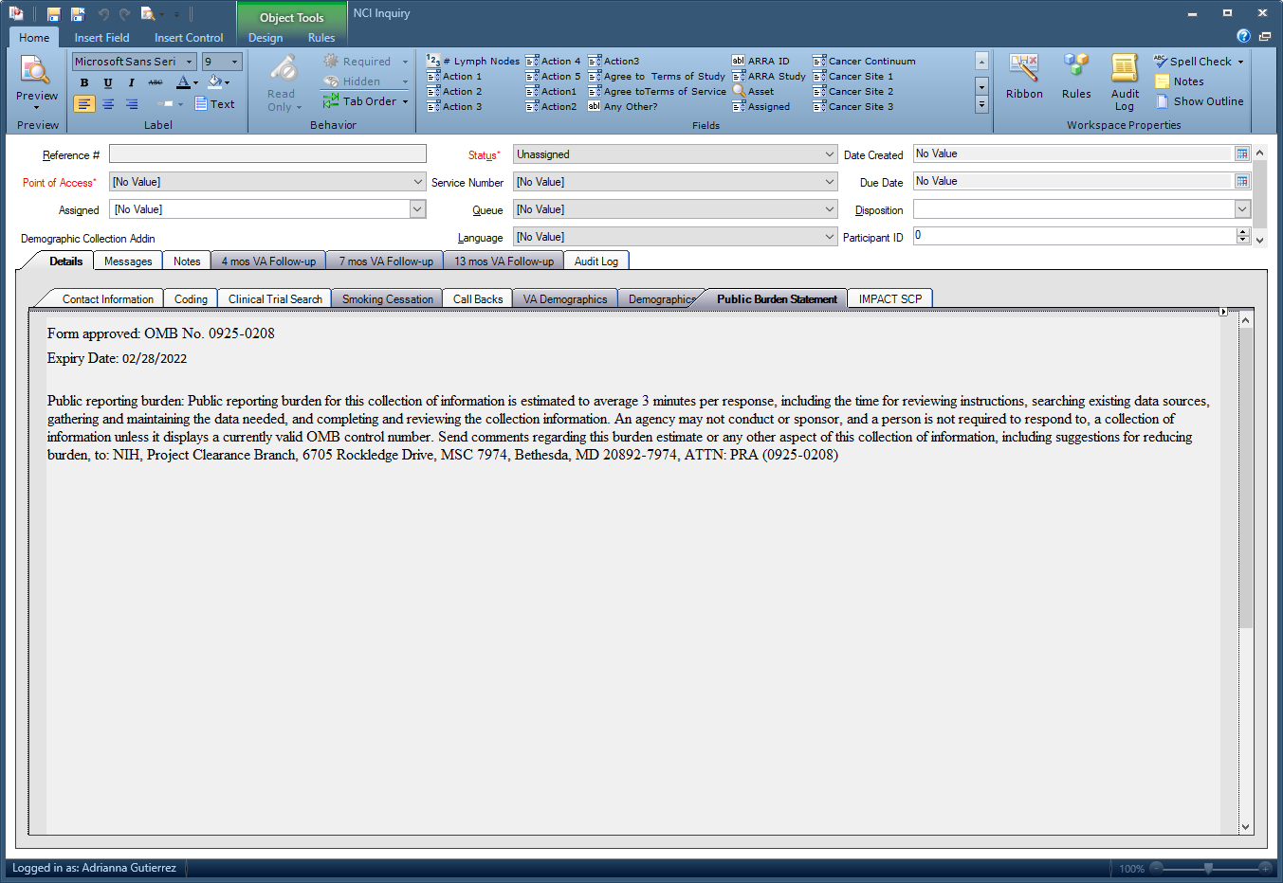

Questions:
- Have you used service before?
- How did you find our Service?
- Zip Code?

Demographic Survey Questions

Please select a response from the following responses:

What is your age?

- 1- 18-34
- 2- 35-49
- 3- 50-64
- 4- 65-74
- 5- 75+

What is your Gender?

- 1- Male
- 2- Female
- 3- Don’t know
- 4- I do not wish to respond

Which of These Categories Best Describes You?

- 1- Hispanic or Latino
- 2- Not Hispanic or Latino
- 3- Don’t know
- 4- I do not wish to respond

Which of These Categories Best Describes You?

- 1- American Indian or Alaska Native
- 2- Asian
- 3- Black or African American
- 4- Native Hawaiian or Other Pacific Islander
- 5- White

What Is the Highest Level of Education You Have Completed?

- 1- Some high school or less
- 2- High school graduate
- 3- College graduate
- 4- Post-graduate
- 5- I do not wish to respond

Is There a Place You Usually Go to When You are Sick or Need Advice About Your Health?

- 1- Yes
- 2 -No
- 3- Don't Know
- 4- I do not wish to respond

What Kind of Place Do You Go Most Often?

- 1- A doctor’s office
- 2- A clinic or health center
- 3- The emergency room or urgent care
- 4- Some other place, or
- 5- Don’t know

What Was Your Total Household Income from All Sources Before Taxes Last Year?

- 1- Less than $25,000
- 2- $25,000 - $49,000
- 3- $50,000 - $74,000
- 4- more than $75,000
- 5- I do not wish to respond

Including Yourself, How Many People Living in Your Household are Supported by This Total Household Income?

- 1- 1
- 2- 2
- 3- 3
- 4- 4 or more
- 5- I do not wish to respond

