Healthy BCD – Fall 2020 PI Meeting
  - Registration Form Screenshots – 10/7/2020
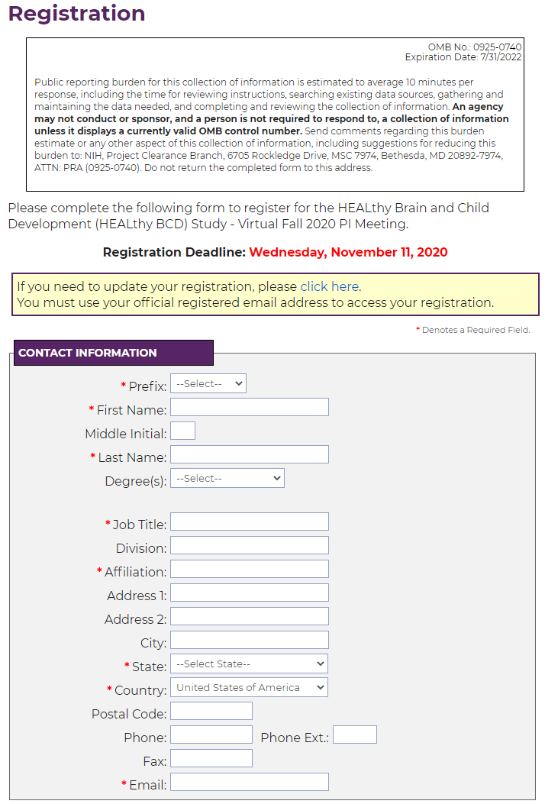
Figure 1. Registration Page - Part 1 of 2
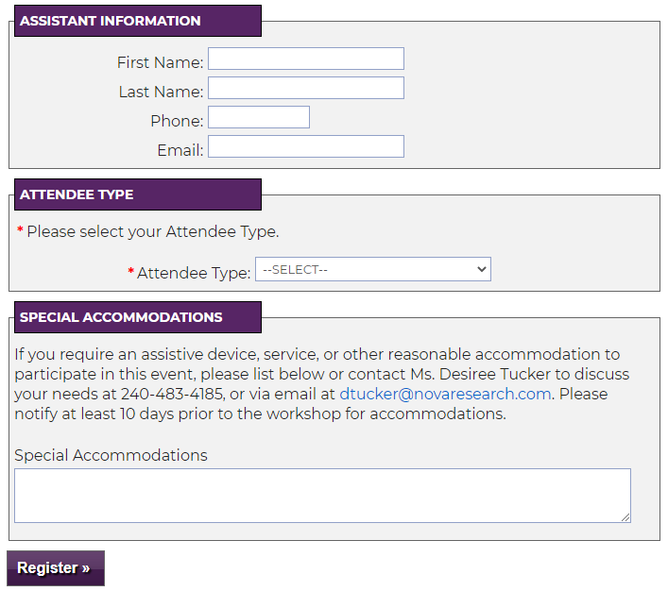
Figure 2. Registration Page - Part 2 of 2

