2021 Professional Development Workshop and Mentored Mock Review – Screenshots - Call for Abstracts/Posters Page

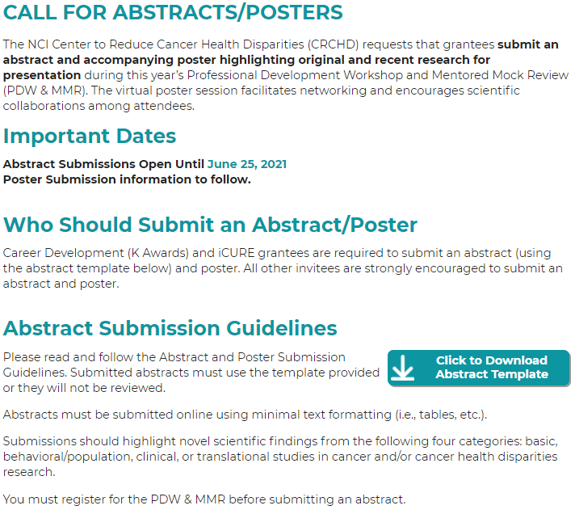
Call for Abstracts/Posters Page, Part 1
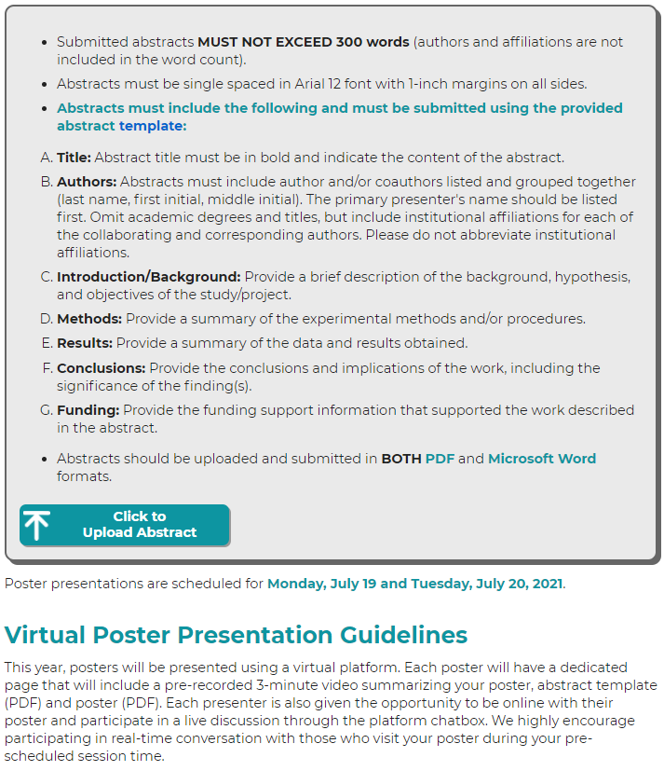
Call for Abstracts/Posters Page, Part 2
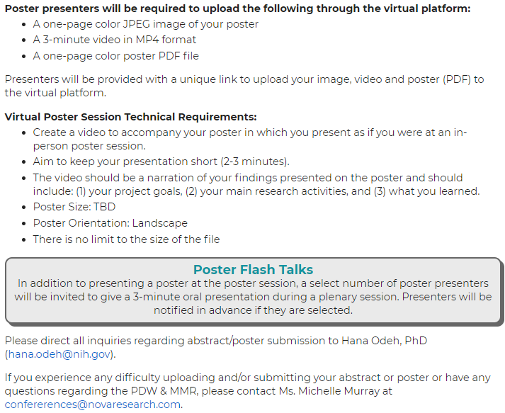
Call for Abstracts/Posters Page, Part 3

Abstract Upload Form

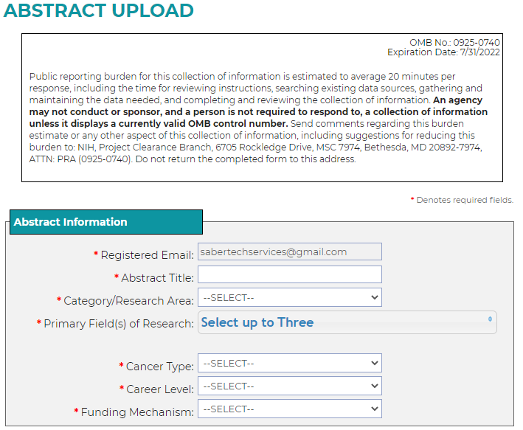
Abstract Upload Form, Part 1

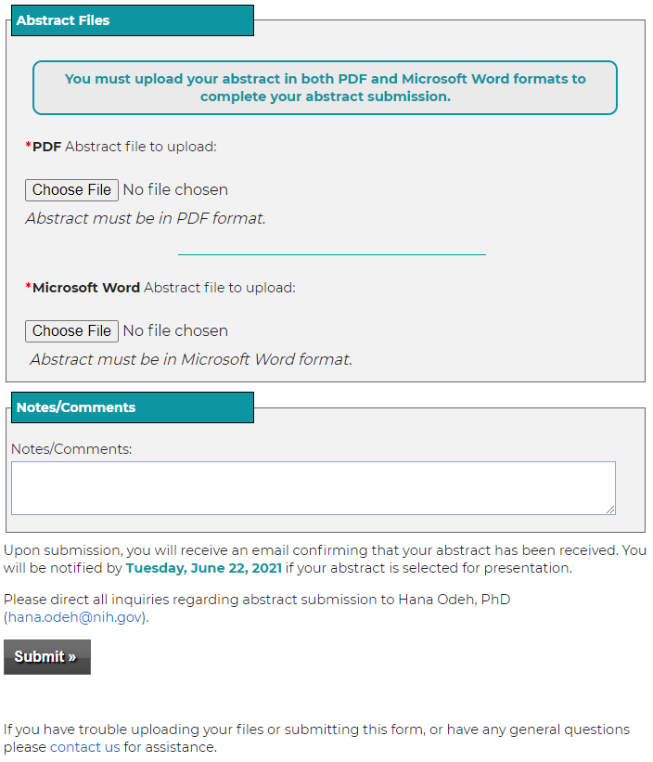
Abstract Upload Form, Part 2

