2021 Professional Development Workshop and Mentored Mock Review – Screenshots - Registration Form

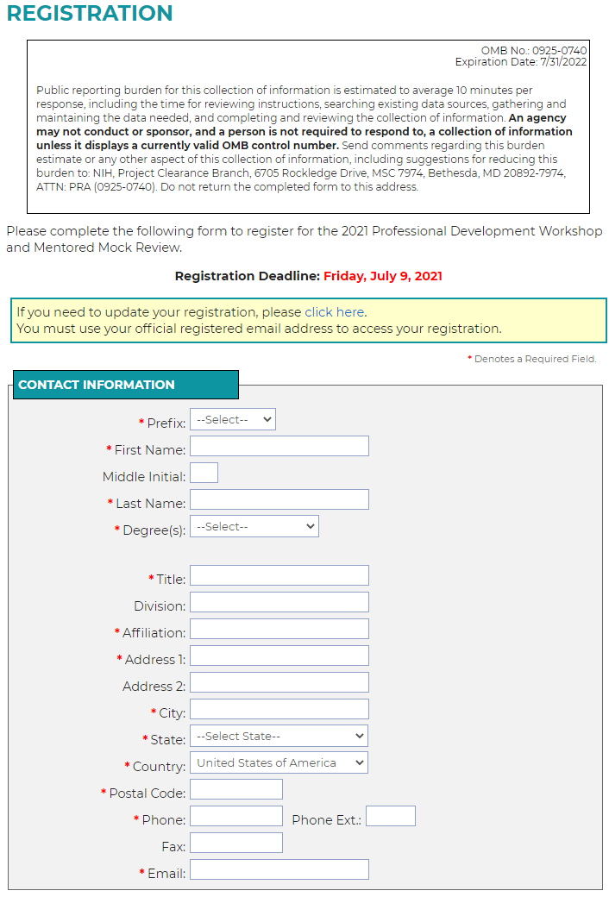
Registration Form, Part 1
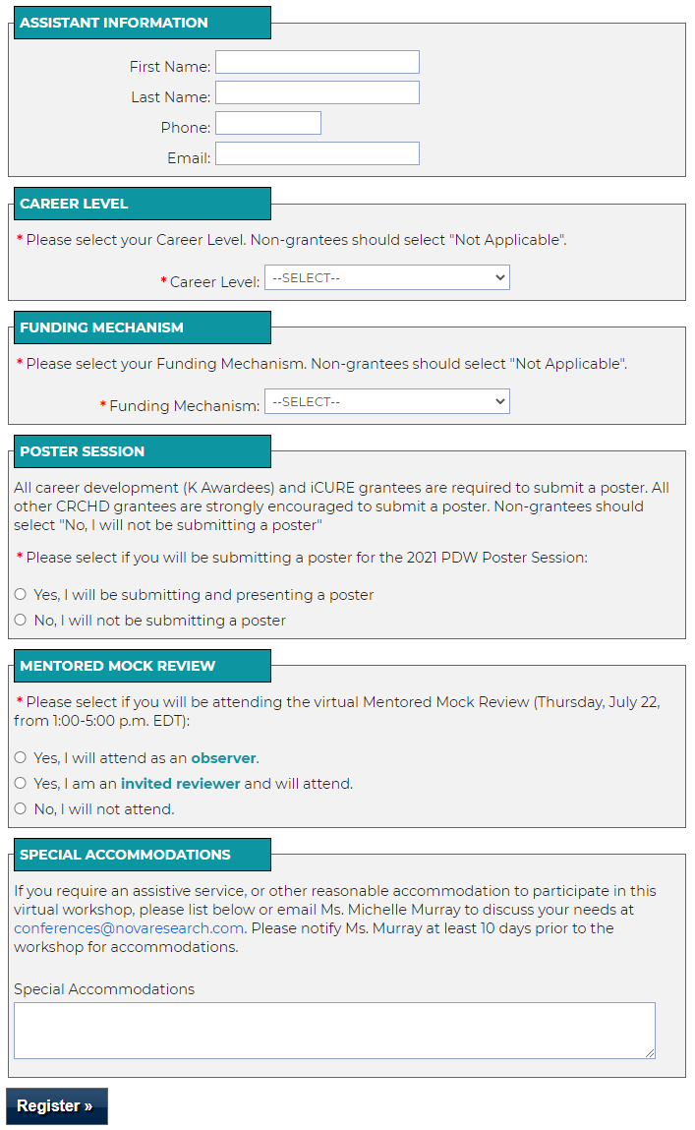
Registration Form, Part 2

