2021 Professional Development Workshop and Mentored Mock Review – Screenshots – Email Invite

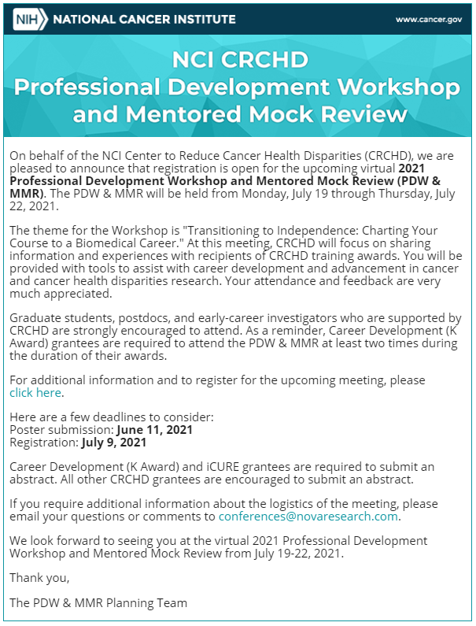

Registration Invitation Email