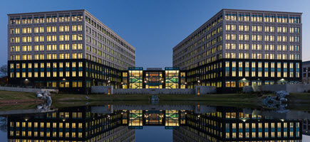

**Cancer Screening Trial Workshop**

**Division of Cancer Prevention,**

**National Cancer Institute**

