iCURE Welcome Ceremony 2021
  - Registration Form Screenshots – September 15, 2021

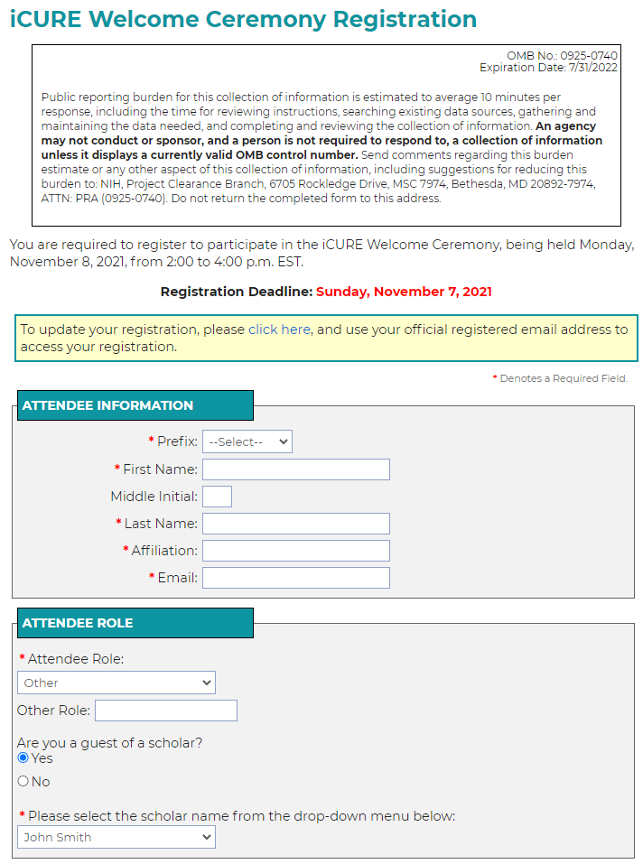
Figure 1. Registration Form - Part 1 of 2
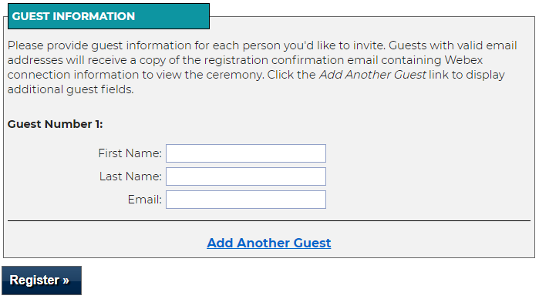
Figure 2. Registration Form - Part 2 of 2

