iCURE Welcome Ceremony 2021
  - Scholar Questionnaire Screenshots – September 15, 2021
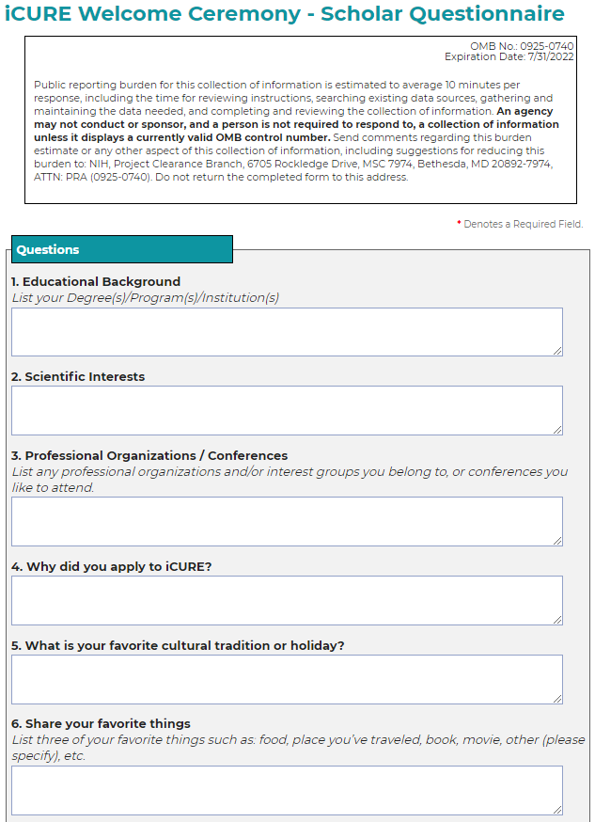
Figure 1. Scholar Questionnaire - Part 1 of 2

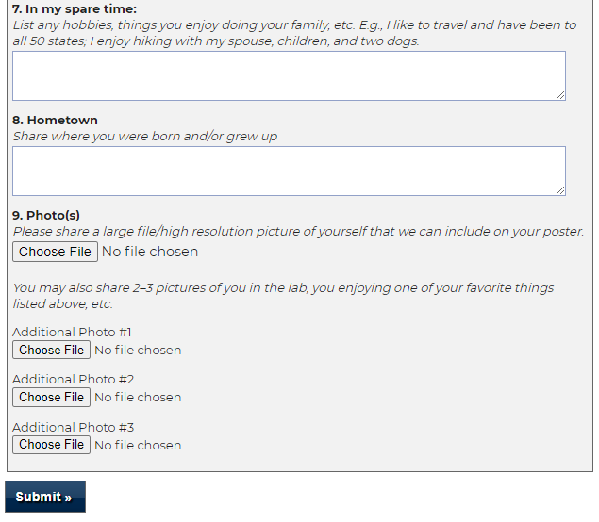
Figure 2. Scholar Questionnaire - Part 2 of 2

