iCURE Welcome Ceremony 2021

Invitation Email Screenshot – September 15, 2021

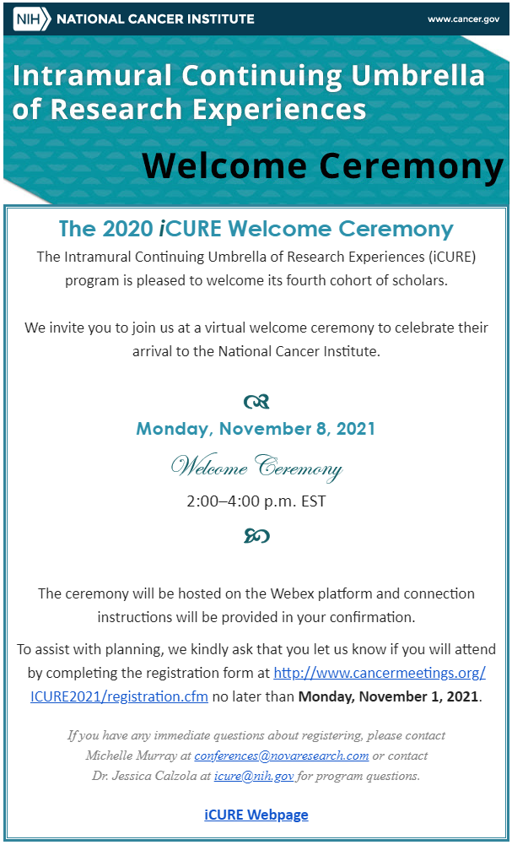

Figure . Invitation Email