HBCD 2021 – Registration Form Screenshots

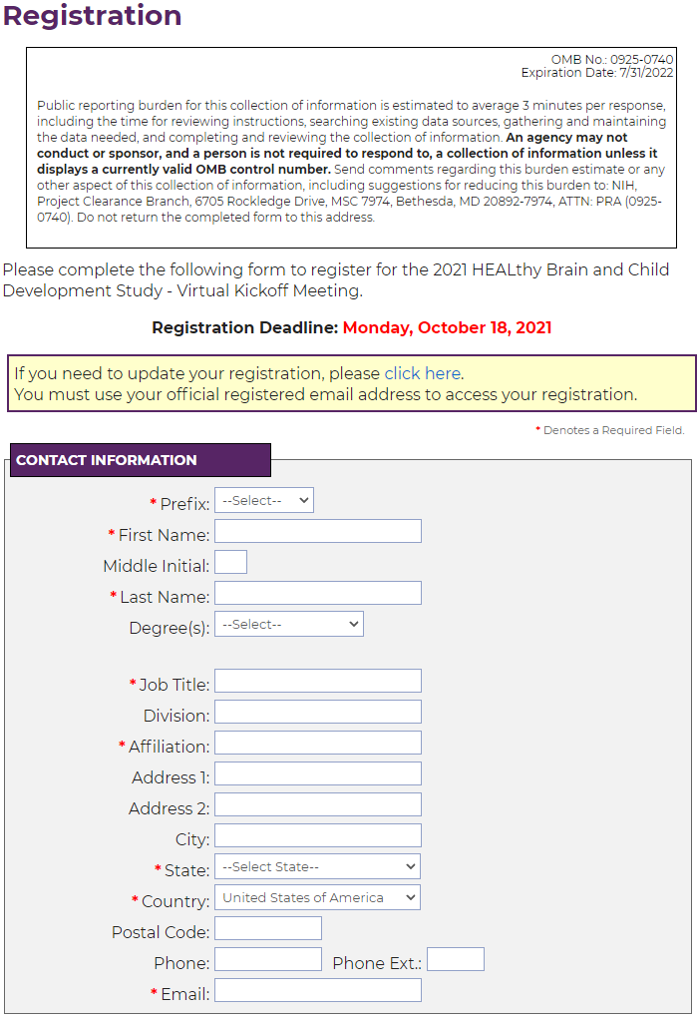
Figure 1. Registration Form - Part 1 of 2
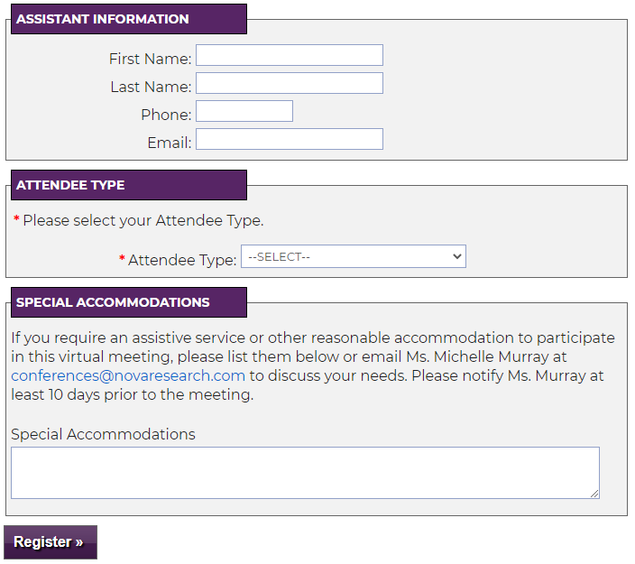
Figure 2. Registration Form - Part 2 of 2

