HBCD 2021 – Invitation Email Screenshot

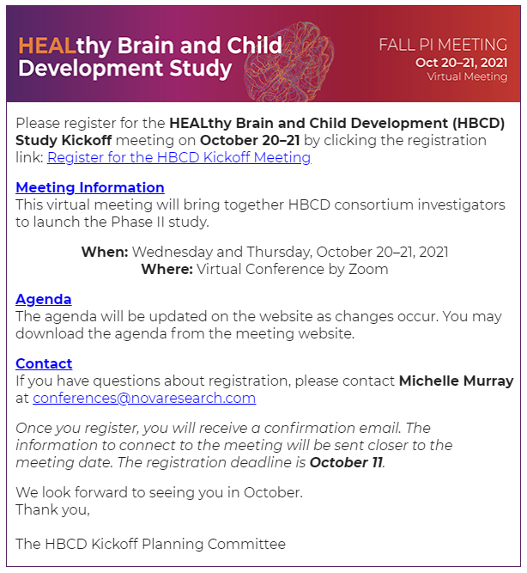

Figure . Invitation Email