2021 NCORP Annual Meeting – Screenshots

Registration Invitation Email
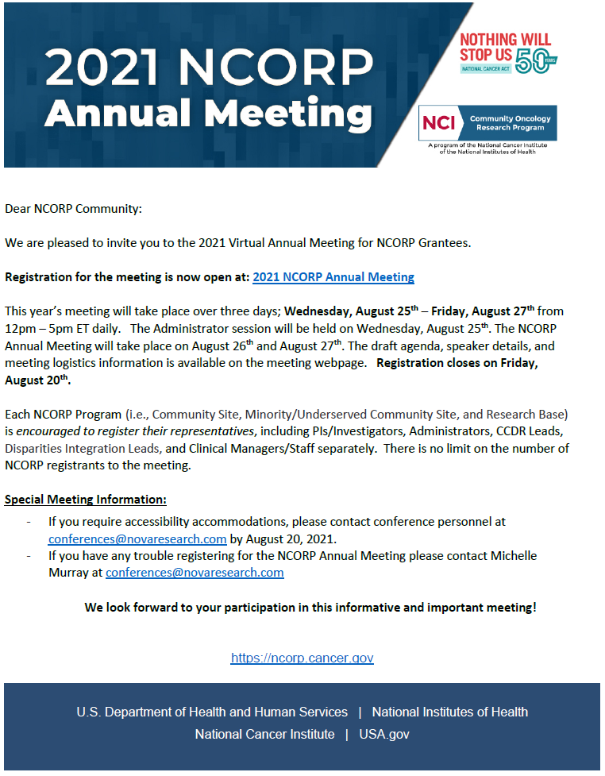
Figure 1. Registration Invitation Email

