# Plan Benefit Package (PBP) Software

Comment:

**Section B Item #2** - A new service category screens will be added for Hospital at Home Services may be added as a supplemental benefit.

PBP SCREEN/CATEGORY: B13j, Hospital at Home Services

**Question**:

1. Will CMS be providing a ***Description of Benefit*** for this category? There is limited information currently available as to how this is defined so want to ensure we use this category correctly.

**Response: CMS will look into evaluating the feasibility of adding this feature for future requirement for CY2024.**

Comment:

**Section B Item #5** - Separate notes fields are added for each subcategory (enhanced benefits) under 16a and 16b. The general 16a and general 16b notes fields will be removed.

PBP SCREEN/CATEGORY: 16a Preventive Dental and 16b Comprehensive Dental

**Question**:

1. The print screens provided makes it seem like a new note field is only being added to describe the “Other, Describe” periodicity throughout the dental sections. Is this separate from the item described in the List of Changes or in addition to it? (see the sample below - Appendix_C_PBP2023_Screenshots_SectionB.pdf page 219)

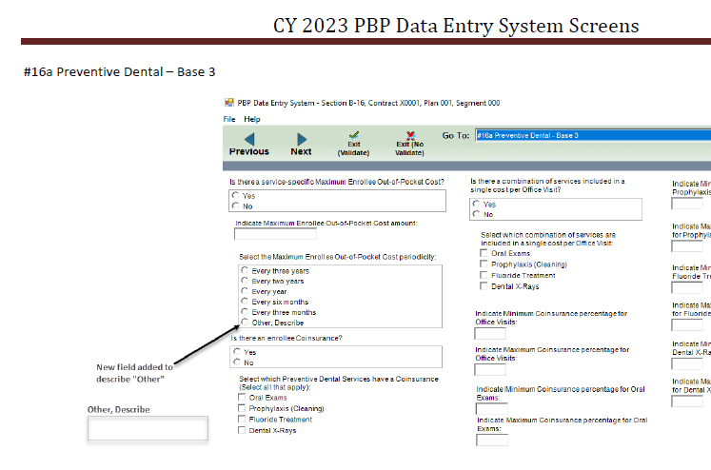

1. While the addition of separate note field for each subcategories is helpful, the removal of a general note box may require comments that apply to all dental to be repeated within those new multiple fields. Is it possible to keep a general note field for 16A and 16B for notes that apply to all services? Additionally, will 16B Medicare-covered comprehensive dental be considered a subcategory? It is not mentioned.

**Response: Yes, the separate notes fields added for each subcategory (enhanced benefits) under 16a and 16b are in addition to the note field added to describe “Other, Describe” periodicity throughout the dental sections. Those new note fields can be seen on pages 221 and 227 of the updated 30-day PRA package. The general note field for 16A and 16B has been removed for CY2023. CMS hopes that this will make it easier to match the notes to the specific benefits subcategory without too much repetition. Yes, a separate notes field has been added for the subcategory “Medicare-covered Benefits” under 16b Comprehensive Dental.**

Comment:

**Section D** –Item addition not noted on 2023 List of Changes memo

**Question**: Intermediate MOOP was last mentioned in the CMS 2020 announcement dated April 1st, 2019, but was never pushed through. Please advise if this is not an accurate change occurring to the 2023 PBP Database. This change noted on page 14 of Appendix_C_PBP2023_Screenshots_SectionD.pdf is not listed in the memo as an update.

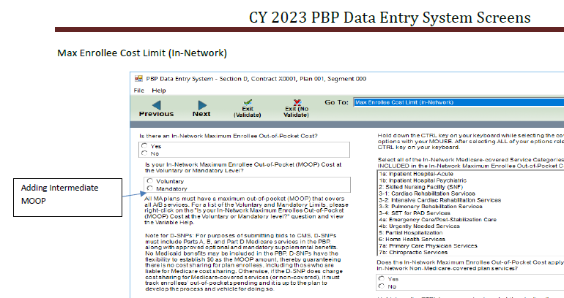

**Response: The list of changes is accurate, we are not adding Intermediate MOOP to the selection box. The indication we were doing so was erroneously included in the screenshots from a previous discussion of whether or not it would be included. We’ve updated the screenshots for the 30-day package accordingly.**

Comment:

**Mass Exit (Validate) of PBP Data Entry**

The current PBP data validation process is a time-intensive process that requires users to click through every screen of the software to validate data on a single plan. Currently, during PBP data entry, there is a function at the data entry-level screen to "Exit (Validate)" the data. To improve efficiency and help organizations with quality checks prior to bid submission, we recommend that CMS develop the functionality within the PBP software to "Exit (Validate)" all screens simultaneously for a single plan.

**Response: We are taking this into consideration for future PBP.**

Comment:

**Export PBP Data Reports Directly to PDF**

To export PBP data reports to PDF currently requires health plans to complete a multi-step process in which plans must export the PBP data reports to Excel, then from Excel to PDF. Viewing the report in PDF is clearer and more user-friendly than viewing it in Excel format. To reduce the number of steps necessary to export PBP data reports to PDF, we recommend CMS add the capability to export PBP Data Reports directly to PDF format.

**Response: We are taking this into consideration for future PBP reports**

Comment:

**Align Section C - OON and Section C - POS to Section B Service Category Setup**

The OON Grouping setup of the PBP software creates situations where there are more OON benefit variations than groupings, which can cause data to be unclear when a user must enter multiple cost shares for multiple benefits in the same grouping. Currently, Section C - OON and Section C - POS restrict users to 15 groups of like cost sharing. This causes issues when plans have more than 15 variations in OON cost sharing for filed benefits. We recommend that Section C - OON and Section C - POS be redesigned to align to the setup in Section B for Service Categories. Having alignment between Section B and Section C would eliminate the need to group benefits into common cost sharing. It would also result in more clear cost sharing descriptions in the Medicare Plan Finder and would reduce burden on plans when developing their own member materials.

**Response: We are taking this into consideration for future PBP.**