This is the pages for operator data entry:

for "Rig Departure off of a Well" (part 2 of BSEE-0144):

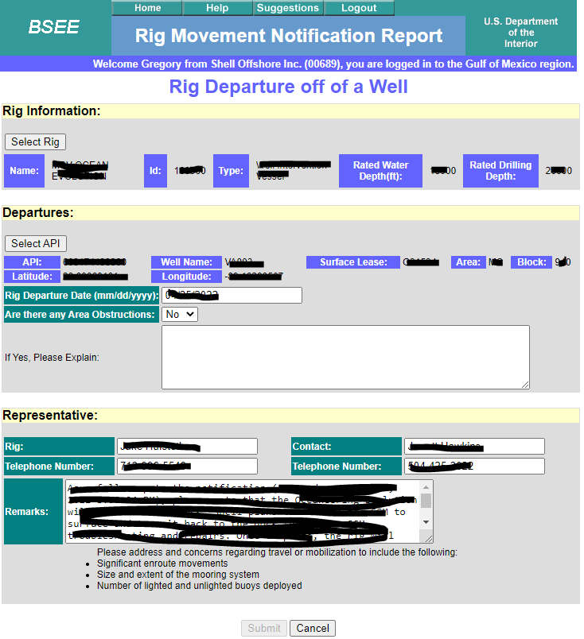

for "Rig Departing off of and Arriving onto a Well (NonSkid)" (part 2 and 3 of BSEE-0144):

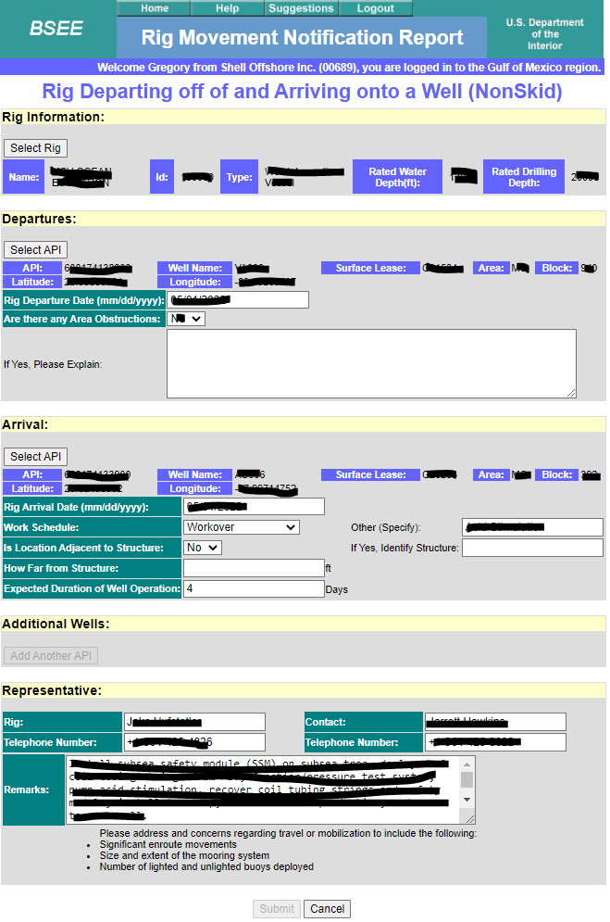

for "Rig Arrival onto a Well" (part 3 of BSEE-0144):

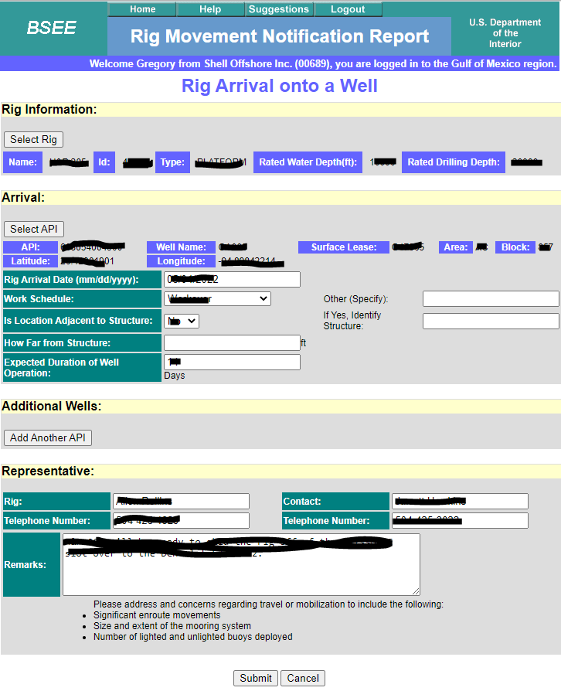

For "Rig is being stacked or moved out of the OCS" (part 4 of BSEE-0144):

