Background/Intro

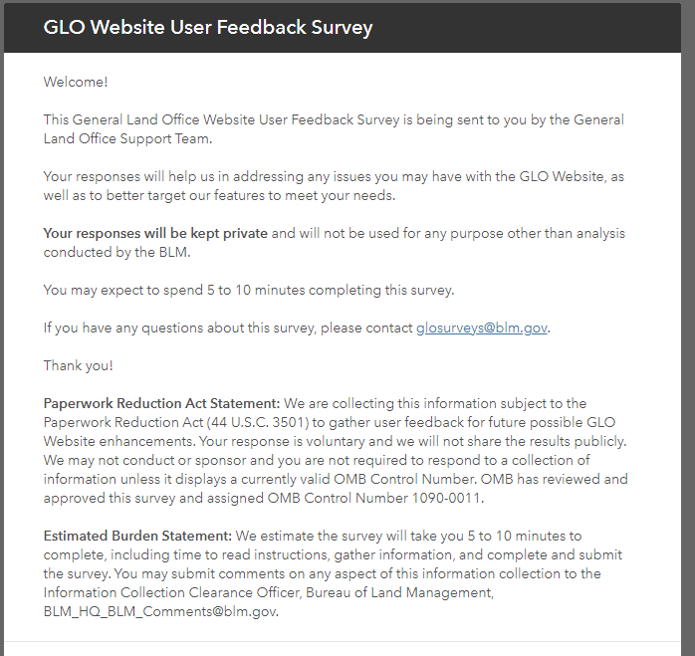

Question 1:

Question 2:

Question 3:

Question 3A: (only shows if you select YES for question 3)

Questions 4 & 5:

Questions 6 & 7:

Question 8 & 9:

Questions 10 & 11:

Question 12 & 13:

Question 14:

Question 15:

Questions 16 & 17:

Question 18:

