Online Claims Submission Portal — For Submission of
TTB F 5620.8, Claim – Alcohol, Tobacco, and Firearms Taxes
After downloading and completing a fillable-printable TTB F 5620.8 form from the TTB website (https://www.ttb.gov/forms), respondents may electronically upload and submit the completed form and any required supporting documents to TTB via the Online Claims Submission portal on the TTB website at https://my.ttb.gov/nrc-claims-submission/claim-form.

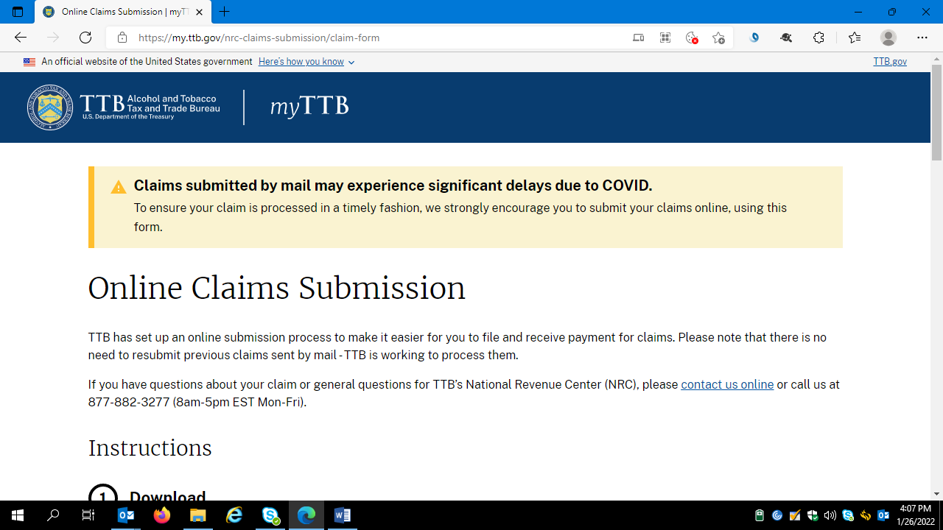
Introduction and Instructions – continued.

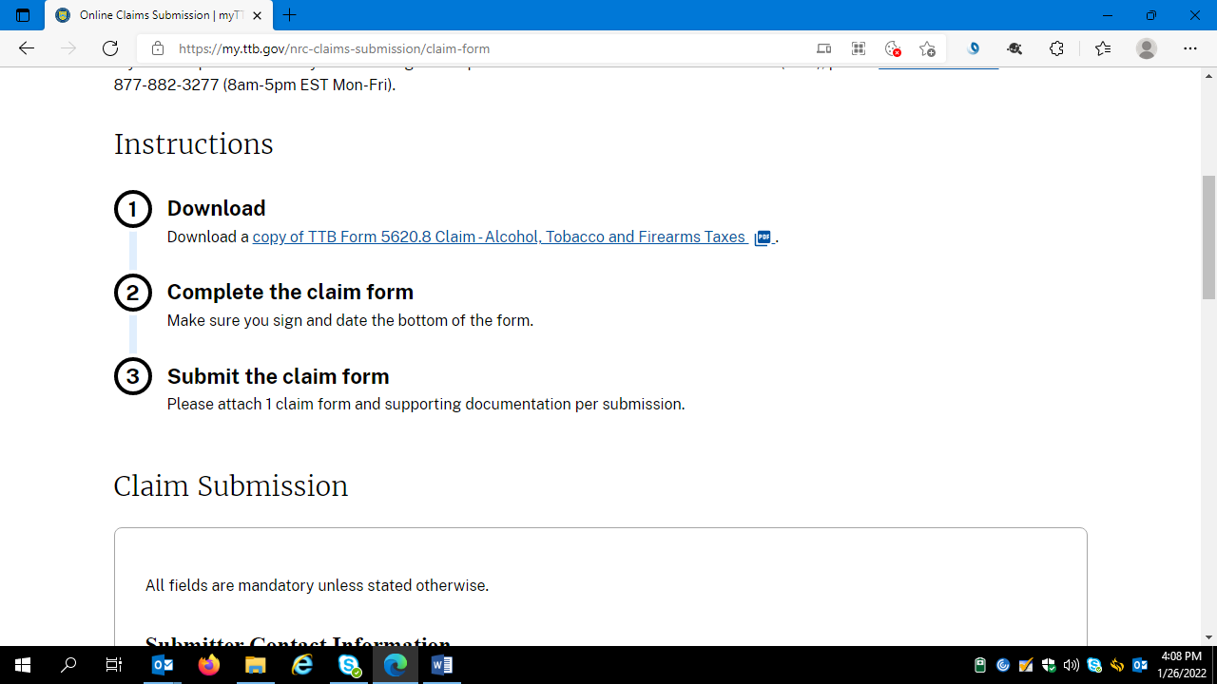

Respondents complete the Submitter Contact Information data fields:

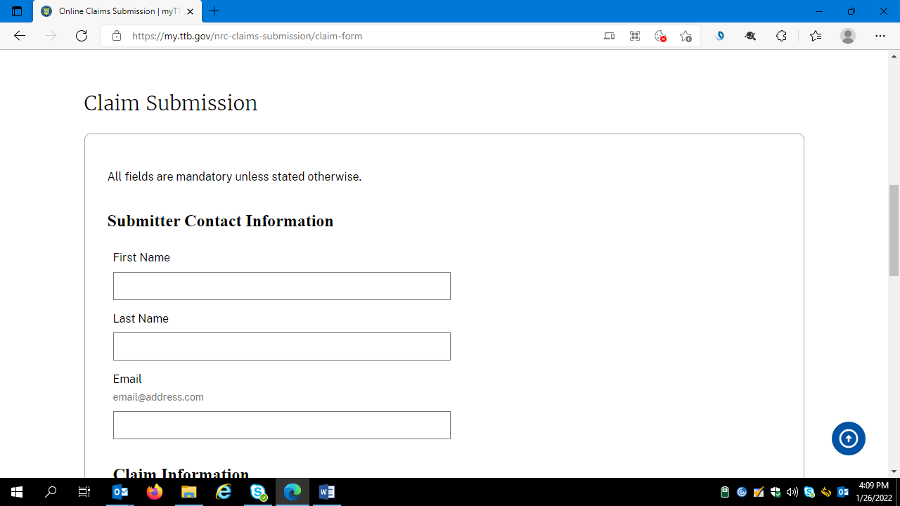

Respondents complete the Claim Information data fields and attach a copy of one completed and signed TTB F 5620.8, along with any required supporting documents:

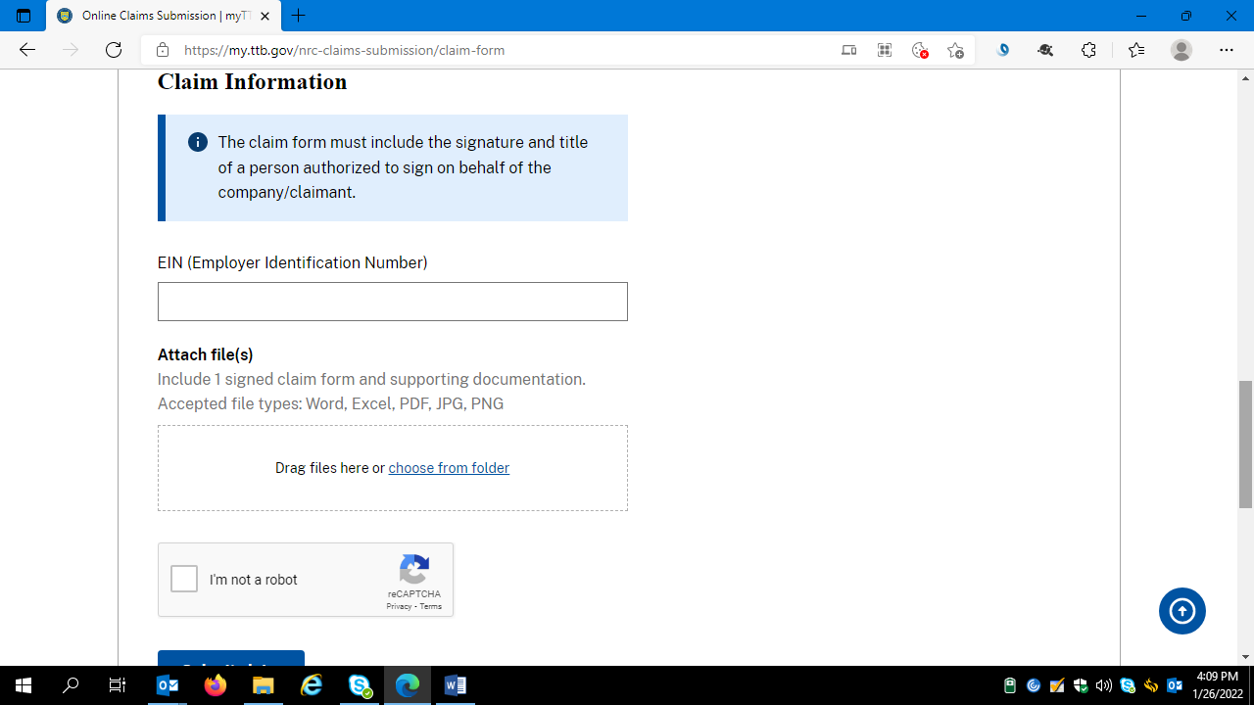

Respondents verify that they are not a robot, and click the Submit Claim button:

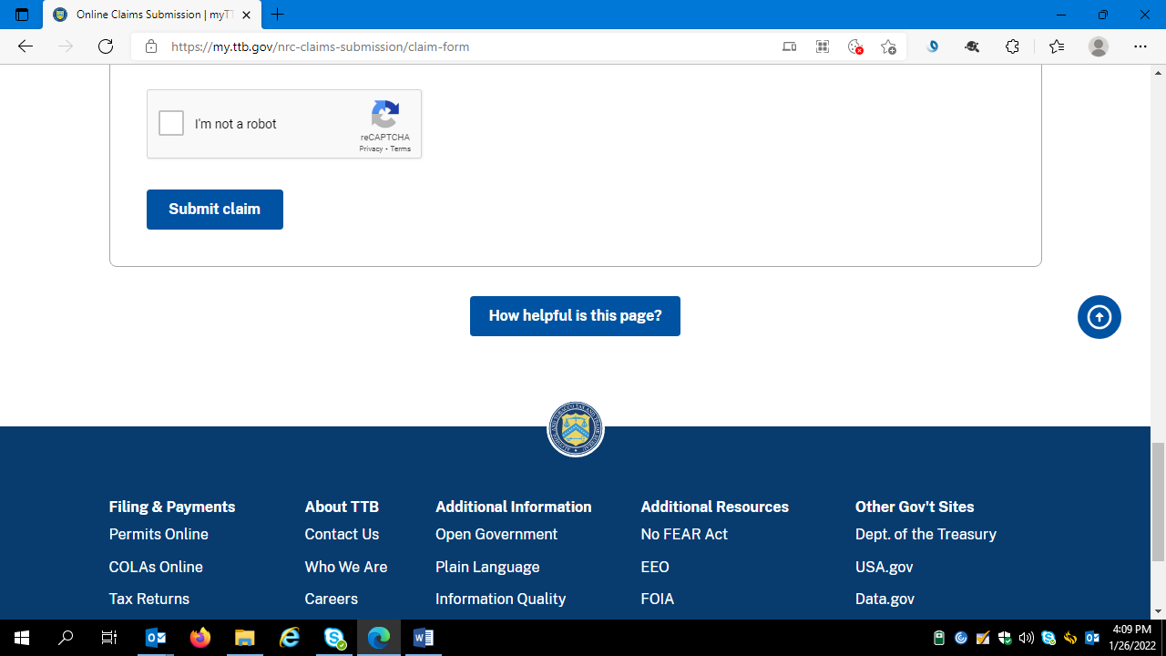

-- END --

