Welcome
Security Notification:
You are about to access a Department of Homeland Security computer system. This computer system and data therein are property of the U.S. Government and provided for official U.S. Government information and use. There is no expectation of privacy when you use this computer system. The use of a password or any other security measure does not establish an expectation of privacy. By using this system, you consent to the terms set forth in this notice. You may not process classified national security information on this computer system. Access to this system is restricted to authorized users only. Unauthorized access, use, or modification of this system or of data contained herein, or in transit to/from this system, may constitute a violation of section 1030 of title 18 of the U.S. Code and other criminal laws. Anyone who accesses a Federal computer system without authorization or exceeds access authority, or obtains, alters, damages, destroys, or discloses information, or prevents authorized use of information on the computer system, may be subject to penalties, fines or imprisonment. This computer system and any related equipment is subject to monitoring for administrative oversight, law enforcement, criminal investigative purposes, inquiries into alleged wrongdoing or misuse, and to ensure proper performance of applicable security features and procedures. DHS may conduct monitoring activities without further notice.
The Electronic Advance Passenger Information System, or eAPIS, allows you to enter or upload passenger and crew manifests online. Reports are also available through eAPIS for Customs and Border Protection approved individuals.

 | Enrolled Users |  |  |  |  |  |  | New eAPIS Users
 |  | Top of Form  To begin using this service, please enter your sender ID and password and select Log In.  Sender ID:  Password:  Bottom of Form |  | Need help logging in?  Select the link above to access enrollment, login, and account activation help information.  Reset your password  Forgot or need to reset your password? Select the link above to create a new password and re-activate your account.  Privacy Statement  Select the link above to review the eAPIS Privacy Statement. |  |  |  | If you are a new user,  you will need to Enroll.

Paperwork Reduction Act Statement: An agency may not conduct or sponsor an information collection and a person is not required to respond to this information unless it displays a current valid OMB control number and an expiration date. The control number for this collection is 1651-0088. The estimated average time to complete this application is 10 minutes per commercial aircraft and 15 minutes per private aircraft. If you have any comments regarding the burden estimate you can write to U.S. Customs and Border Protection, Regulations and Rulings, 90 K Street, NE, 10th Floor, Washington D.C. 20229. Exp. October 31, 2023

Terms and Conditions Page

Manifest Options

Notice of Arrival

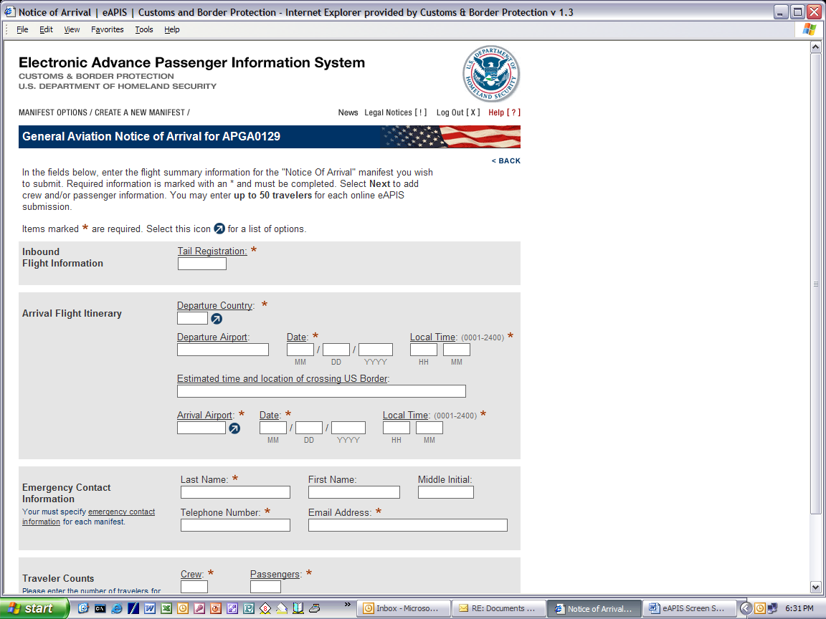

Notice of Departure

Aircraft Information

Crew Information

Passenger Information

List of Travelers

Notice of Saved Manifest

Cancellation of a Current Activity

Cancellation Confirmed

Crew Maintenance

Initial Shared Access Code

Share Crew List

Upload Manifest

Warning for an Already Existing Active Session

No Errors or Warnings Page

Final Review Page

Confirmation Page

You Have Chosen to Log Out Of eAPIS

Log Out Confirmed

Select eAPIS Account Type

Enroll Commercial Airline Page

Enrollment Confirmation

Enroll Private Pilot Page

Complete Private Pilot Enrollment Page

Legal Notes Page

News Page

Help Page

