PAPERWORK BURDEN DISCLOSURE NOTICE
Public reporting burden for this data collection is estimated to average 10 minutes per response. The burden estimate includes the time for reviewing instructions, searching existing data sources, gathering and maintaining the data needed, and completing and submitting this form. This collection of information is required to obtain or retain benefits. You are not required to respond to this collection of information unless a valid OMB control number is displayed on this form. Send comments regarding the accuracy of the burden estimate and any suggestions for reducing the burden to: Information Collections Management, Department of Homeland Security, Federal Emergency Management Agency, 500 C Street, SW, Washington, DC 20472-3100, Paperwork Reduction Project (1660-0002) NOTE: Do not send your completed form to this address.

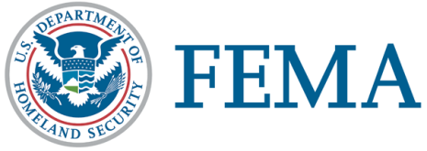
FEMA Director Name Governor’s Name
FEMA Title Governor’s Title
FEMA Directorate Reference State of (State Name)

National Processing Service Center 00/00/0000
P.O. Box 10055
Hyattsville, MD 20782 – 7055

FEMA Application Number.000000000 Disaster Number: 0000

Applicant Name
Applicant Street Address
Applicant City, State, Zip

Dear Applicant Name:

Our records indicate you may have a need for the type(s) of assistance listed below. However, we need additional information to process your application. Please provide the following information within 21 days of the date of this letter:

Moving & Storage expenses:

- Furnish date(s) of moving and storage, provide telephone number and address of storage facility used and furnish a copy of receipts or lease of storage unit.

- If essential personal property was damaged or lost in the storage unit, furnish photographs (if available), an itemized list of losses and a written statement of why essential personal property was stored at the time of the disaster.

3. Documentation of why the moving and storage expenses were required.

Mail your documents to: Fax your documents to:
FEMA – Applicant Services 1-800-827-8112
National Processing Service Center OR Attention: FEMA – Applicant Services
P.O. Box 10055
Hyattsville, MD 20782-8055

Include your FEMA Application Number and Disaster Number on all pages of your documents. Both numbers are printed at the top of the first page of this letter. Keep all originals for your records.

If we do not receive the information within 21 days, we will deny your request for this assistance and you will not be eligible.

If you have any questions, please call FEMA’s Helpline at 1-800-621-FEMA (3362). For people who are deaf, hard of hearing or with speech disabilities, the TTY is 1-800-462-7585.

Sincerely,

Individual Assistance Branch Director RFI

