**EPA ICR No.** **2205.22**

**SUPPORTING STATEMENT**

**Part A**

**Section 1. Identification of the Information Collection**

**1(a) Title of the Information Collection:**

Focus Groups as Used by EPA for Economics Projects (Renewal)

EPA ICR Number 2205.22, OMB Control Number 2090-0028

**1(b) Short Characterization/Abstract:**

The Environmental Protection Agency (EPA) is seeking approval for a generic information collection request (ICR) for the conduct of focus groups and one-on-one interviews related to economics projects primarily for survey development. Focus groups are groups of individuals brought together for moderated discussions on a specific topic or issue. These groups are typically formed to gain insight and understanding of attitudes and perceptions held by the public surrounding an issue. One-on-one interviews, as the term implies, are individual interviews in which a respondent is generally asked to review materials and provide feedback on their content and design as well as the thought processes that the materials invoke.

Focus groups and one-on-one interviews (hereafter referred to collectively as “focus groups”) used as a qualitative research tool have three major purposes:

* To better understand respondents’ attitudes, perceptions and emotions in response to specific topics and concepts;
* To obtain respondent information useful for better defining variables and measures in later quantitative studies; and
* To further explore findings obtained from quantitative studies.

Through these focus groups, the Agency will be able to gain a more in-depth understanding of the public’s attitudes, beliefs, motivations and feelings regarding specific issues and will provide invaluable information regarding the quality of draft survey instruments. Focus group discussions are necessary and important steps in the design of a quality survey.

**Section 2. Need For and Use of the Collection**

**2(a) Need/Authority for the Collection**

Over the next three years, the Agency anticipates embarking on a number of survey development efforts associated with a variety of economics projects including those related to motor vehicle electrification, non-fatal health risks, and improvements to water quality to name a few. Focus groups are an important part of any survey development process, allowing researchers to directly gauge what specific issues are important to the public and providing a means for explicitly testing draft survey materials.

If this information is not collected, a vital link in developing methods to better understand the economic benefits and costs associated with Agency actions will be lost. This loss will cause further delays in the development of improved estimates of benefits and costs.

This data collection is conducted for research purposes; there are no legal requirements. The materials prepared for these discussions will fully conform to federal regulations – specifically the Privacy Act of 1974 (5 U.S.C. 552a), the Hawkins-Stafford Amendments of 1988 (P.L 100-297), and the Computer Security Act of 1987.

**2(b) Practical Utility/Users of the Data**

The information collected in the focus groups will help inform economics projects as well as economics-related surveys under development. To the extent that the surveys are ultimately successfully administered, they will serve to expand the Agency’s understanding of benefits and costs of a variety of actions and could provide the means to quantitatively assess the effects of others. Participation in the focus groups will be voluntary and the identity of the participants will be kept confidential.

Focus groups generally do not yield meaningful quantitative findings and do not yield data about public opinion that can be generalized. As such, they cannot be used directly to estimate benefits and costs associated with a specific environmental action. However, program offices engaged in survey research use focus groups as an important tool to inform thinking on issues and refine ideas, especially in the survey development process. The conduct of quantitative research would need to be completed before new estimates of benefits or costs could be developed.

**Section 3. Non-duplication, Consultations, and Other Collection Criteria**

**3(a) Non-duplication**

It is not expected that any of the information to be submitted to the EPA during these focus group studies is duplicative or is already in the possession of the Federal Government. The proposed focus groups will address the needs of the Agency and significantly improve our ability to test and redefine ideas that will allow EPA to conduct further quantitative research on various environmental economics issues.

**3(b) Public Notice Required Prior to ICR Submission to OMB**

On September 29, 2021 (86 FR 53961), EPA sought comments on this ICR pursuant to 5 CFR 1320.8(d) (see Appendix 1). EPA received no substantive comments related to the notice.

Any additional comments on this ICR should be submitted to EPA and OMB within 30 days of this notice.

**3(c) Consultations**

EPA will use in-house staff and/or outside contractors (including possible contacts with the academic community) to develop focus group plans for specific areas of interest. According to OMB guidelines for generic clearances for focus groups, EPA has established an independent review process to assure the development and implementation of high-quality focus groups by EPA. EPA will provide OMB a copy of the survey instrument for inclusion in the public docket. This generic ICR does not obviate the need for OMB review and approval of each focus group project.

This ICR covers the conduct of focus groups related to environmental economics projects. As such, follow up with respondents regarding the accuracy of estimated burden hours is not possible as focus groups by their very nature are structured as one-time collections. Focus groups are often conducted at facilities designed for this purpose, therefore deviations from estimated burden hours are generally small.

The need for generic ICRs to facilitate the survey administration process was discussed at a workshop hosted at Resources for the Future on October 2, 2006 entitled: Sample Representativeness: Implications for Administering and Testing Stated Preference Surveys. Generic ICRs for the conduct of focus groups were specifically identified as a means of reducing review times for focus groups and enhancing Agency’s ability to navigate the survey approval process. See <http://www.rff.org/rff/Events/upload/32432_1.pdf> for a summary of the workshop.

**3(d) Effects of Less Frequent Collection**

Each focus group will be a one-time collection exercise for the enrolled participants.

**3(e) General Guidelines**

This collection does not violate any of OMB’s general guidelines for information collections.

Information will be collected according to the guidelines in 5 CFR 1320. Respondents will be asked to participate in one focus group and their participation will be voluntary. There will be no need for participants to maintain records or submit documents or proprietary trade secrets. There will be complete protection of any demographic information collection from participant—full names, phone numbers and addresses will not be associated with responses.

EPA has developed EPA Information Quality Guidelines (2002) to ensure the utility, objectivity and integrity of information that is disseminated by the Agency. It is EPA’s intention that collection of information under this ICR will result in information that will be collected, maintained, and used in ways consistent with both the EPA Information Quality Guidelines (2002) and the OMB Information Quality Guidelines (2002). EPA intends to conduct a pre-dissemination review when the Agency prepares to disseminate information collected under this ICR.

**3(f) Confidentiality**

Each focus group will fully conform to federal regulations – specifically the Privacy Act of 1974 (5 U.S.C. 552a), the Hawkins-Stafford Amendments of 1988 (P.L 100-297), and the Computer Security Act of 1987.

**3(g) Sensitive Questions**

No questions will be asked that are of a personal or sensitive nature.

**Section 4. The Respondents and the Information Requested**

**4(a) Respondents/SIC Codes**

The target population for the focus group discussions will vary by project but will generally include members of the public. The target population will be clearly defined in advance for each focus group and participants will be randomly recruited whenever feasible.

**4(b) Information Requested**

1. Data items, including record keeping requirements
2. Respondent Activities

Respondents will be asked to participate in a moderated discussion on a specific topic or issue, during which they will be asked their thoughts, perceptions, and beliefs regarding the issue. The collection will be a one-time event and there will be no need for participants to maintain records or submit documents or proprietary trade secrets. There will be complete protection of any demographic information collection from participants -- names, phone numbers and addresses will not be associated with responses.

**Section 5. The Information Collected – Agency Activities, Collection Methodology, and Information Management**

**5(a) Agency Activities**

Agency activities associated with this information collection will include:

-- Drafting focus groups scripts and accompanying materials

-- Observing and, in some cases, moderating the focus group discussions

-- Summarizing focus group results and making changes to draft materials as appropriate

In addition, the Agency has established a cross-office panel to review focus group projects proposed under this ICR. Membership on the panel is on a rotational basis and consists of one economist from the Office of Policy’s National Center for Environmental Economics and three economists from elsewhere in the Agency. Each of the four panel members must have experience with surveys. To avoid potential conflicts of interest and to promote impartiality, each project will be reviewed by three of the panel members. Only projects that have as their primary goal the estimation of benefits, the estimation of costs, or the elicitation of preferences for health outcomes, safety and/or environmental goods will be considered. Additional details about the panel review process can be found in Appendix 2.

**5(b) Collection Methodology and Management**

Focus group studies are directed group discussions that do not produce quantitative data, but which enable skilled observers to infer the underlying views and assumptions of the group that are expressed in the discussion. To facilitate interpretation, discussions are generally recorded and videotaped so that both a visual record and written transcript of the discussion are available for review. Participants are informed in advance that the sessions will be recorded. Transcripts and video tapes will be maintained in the individual project files.

**5(c) Small Entity Flexibility**

Small businesses, small organizations, and small governmental jurisdictions will not be required to participate in focus groups or interviews as part of this information collection.

**5(d) Collection Schedule**

Focus groups will be scheduled according to the needs of individual projects. No firm schedule for this collection has been established otherwise.

**Section 6. Estimating the Burden and Cost of Collection**

**6(a) Estimating Respondent Burden**

**6(b) Estimating Respondent Costs**

Estimates of respondent burden were derived from projected focus group usage over the next three years. Each program office was asked for the number and size of the focus groups that they anticipate conducting for economics projects over the next three years. At this stage, a total of eleven study areas are projected for the next three years on subjects including water quality valuation, non-fatal health risk valuation, recreational benefits, vehicle electrification, effects of causality, coastal adaptation, prevention of algal blooms, and ecosystem services. In addition to these study areas, we also recognize that the timing of research-related focus group projects is lumpy in nature and predictions of when these projects will occur are imprecise. The total estimated hourly burden imposed by this collection of information over the next three years for focus groups is approximately 2,178 hours or approximately 726 hours annually. The total burden per year is valued at approximately $19,493. The participants for the planned focus groups are individuals from the general public participating during non-work hours. As such, there are no capital costs or operating and maintenance costs associated with this collection. There is a total of about 363 respondents per year. This is derived by taking the approximate number of studies multiplied by the average number of focus groups per study and again multiplied by the average number of participants per group. The total number of respondents for the 3-year collection would be about 1,089.

TABLE 1a. – **Average Annual Respondent Burden and Costs**1

|  |  |  |  |  |  |
| --- | --- | --- | --- | --- | --- |
| Approximate Number of Studies | Average Number of Focus Groups per Study | Average Number of Participants per Group | Average Hours of Duration for Each Group (includes screening) | Total Estimated “Respondent” Hours  Over next 3 years | Total Estimated  Burden per Year ($)2 |
| 11 | 11 | 9 | 2.0 | 2,178 | $19,493 |

1 There are no respondent capital costs or operating and maintenance costs associated with this collection of information.

2 Average hourly rate for wages and salaries ($26.85) from “Table 1. Employer costs for Employee Compensation by ownership: Civilian workers, June 2021”. U.S. Department of Labor, Bureau of Labor Statistics. (http://www.bls.gov/news.release/ecec.t01.htm)

**6(c) Estimating Agency Burden and Costs**

The Agency incurs costs to develop the focus group materials, organize and conduct focus group discussions, and observe focus group discussions. These expenses will vary by specific project. The table below provides a hypothetical assessment of what the costs might be per year based on several assumptions regarding the level of effort required. EPA person-costs are estimated using an hourly rate for a GS-14 (step 1) based in Washington, DC in 2021 (See GS Pay Tables at: http://www.opm.gov/policy-data-oversight/pay-leave/salaries-wages/salary-tables/pdf/2021/DCB_h.pdf). These hourly rates are multiplied by a factor of 1.6 to reflect federal labor costs (e.g., employee benefits). Time spent on each step may vary as well as the GS-level of the employees involved. Contractor costs will also depend on the location of focus groups, degree of involvement in materials preparation and whether written transcripts of each focus group are required. The estimates presented below assume that the Agency prepares all materials and that approximately 3 individuals observe each focus group.

**Estimated Average Annual Agency Burden and Costs**

|  |  |  |  |  |  |
| --- | --- | --- | --- | --- | --- |
| Task | Costs (and Person-hours) Per Focus Group Hour | | | Total Hours and Cost | |
| EPA  ($58.71 per  Hour * 1.6) | Estimated Contractor Costs1 | O&M Cost | Number of focus group hours/year. | Total Cost/Year |
| Prepare Materials for Focus Group Discussion | $1,879  (20 hrs) | -- | -- | 75 | $140,925 |
| Organize and conduct focus group discussion  (contractor) | -- | $5,000 | -- | 75 | $375,000 |
| Observe focus group discussion | $282  (3 hrs) | -- | -- | 75 | $21,150 |
| Total | $2,161 | $5,000 | -- | 75 | $539,236 |

Notes: 1includes recruiting respondents, meeting space, respondent reimbursement for approximately 9 participants, and recording of discussion.

**6(d) Estimating the Respondent Universe and Total Burden and Costs**

**6(e) Bottom Line Burden Hours and Cost Tables**

We expect respondent focus group hours to total 2,178 over the next 3 years or about 726 each year. These hours will be spread over approximately 121 focus groups over the course of the 3-year time frame (~41 per year).

1. Respondent Tally

|  |  |  |  |  |  |
| --- | --- | --- | --- | --- | --- |
| Action | Approximate Number of Focus Groups per year | Estimated Respondent Hours per Year | Total labor Cost per Year | Total Annual Capital Costs | Total Annual O&M costs |
| Focus Group Discussion | 41 | 726 | $21,150 | $0 | $0 |

1. Agency Tally

|  |  |  |  |  |  |
| --- | --- | --- | --- | --- | --- |
|  | Approximate Number of Focus Groups per year | Estimated Focus Group Hours per year | Contracting Services | Total Labor Cost per Year | Total Annual Cost |
| Focus Group Discussion | 41 | 75 | $375,000 | $164,236 | $539,236 |

**6(f) Reasons for Change in Burden**

The request for 2,178 total burden hours represents a decrease of 414 (=2,592-2,178) hours in the total estimated burden currently identified in the OMB Inventory of Approved ICR Burdens. Burden estimates derived for this (and the previous) renewal are based on projected use estimates for this generic ICR provided by the various program offices at EPA. These projections are based on anticipated, new and continuing projects over the coming three years. A decrease in burden over the previous ICR conveys simply that EPA anticipates less need for the conduct of focus groups under this ICR than in the past.

**6(g) Burden Statement**

The annual public reporting and recordkeeping burden for this collection of information is estimated to average 2.0 hours per response.

Burden means the total time, effort, or financial resources expended by persons to generate, maintain, retain, or disclose or provide information to or for a Federal agency. This includes the time needed to review instructions; develop, acquire, install, and utilize technology and systems for the purposes of collecting, validating, and verifying information, processing and maintaining information, and disclosing and providing information; adjust the existing ways to comply with any previously applicable instructions and requirements; train personnel to be able to respond to a collection of information; search data sources; complete and review the collection of information; and transmit or otherwise disclose the information. An Agency may not conduct of sponsor, and a person is not required to respond to, a collection of information unless it displays a currently valid OMB control number. The OMB control number for EPA’s regulations are listed in 40 CFR Part 9 and 48 CFR Chapter 15.

To comment on the Agency's need for this information, the accuracy of the provided burden estimates, and any suggested methods for minimizing respondent burden, including the use of automated collection techniques, EPA has established a public docket for this ICR under Docket ID Number EPA-HQ-OA-2008-0701, which is available for online viewing at [www.regulations.gov](http://www.regulations.gov), or in person viewing at the OEI Docket in the EPA Docket Center (EPA/DC), EPA West, Room 3334, 1301 Constitution Avenue, NW, Washington, D.C. The EPA Docket Center Public Reading Room is open from 8:30 a.m. to 4:30 p.m., Monday through Friday, excluding legal holidays. The telephone number for the Reading Room is (202) 566-1744, and the telephone number for the OEI docket is (202) 566-1752. An electronic version of the public docket is available at www.regulations.gov. This site can be used to submit or view public comments, access the index listing of the contents of the public docket, and to access those documents in the public docket that are available electronically. When in the system, select “search,” then key in the Docket ID Number identified above. Also, you can send comments to the Office of Information and Regulatory Affairs, Office of Management and Budget, 725 17th Street, NW, Washington, D.C. 20503, Attention: Desk Officer for EPA. Please include the EPA Docket ID Number EPA-HQ-OA-2008-0701 and OMB Control Number 2090-0028 in any correspondence.

**Part B.**

There are no tabulated results for this information collection.

Information gathered from focus groups is qualitative in nature. They allow for a more in-depth understanding of respondents’ attitudes, beliefs, motivations, and feelings than do quantitative studies. It serves the narrowly defined need for direct and informal opinion on a specific topic.

**Appendix 1**

**Federal Register Notice**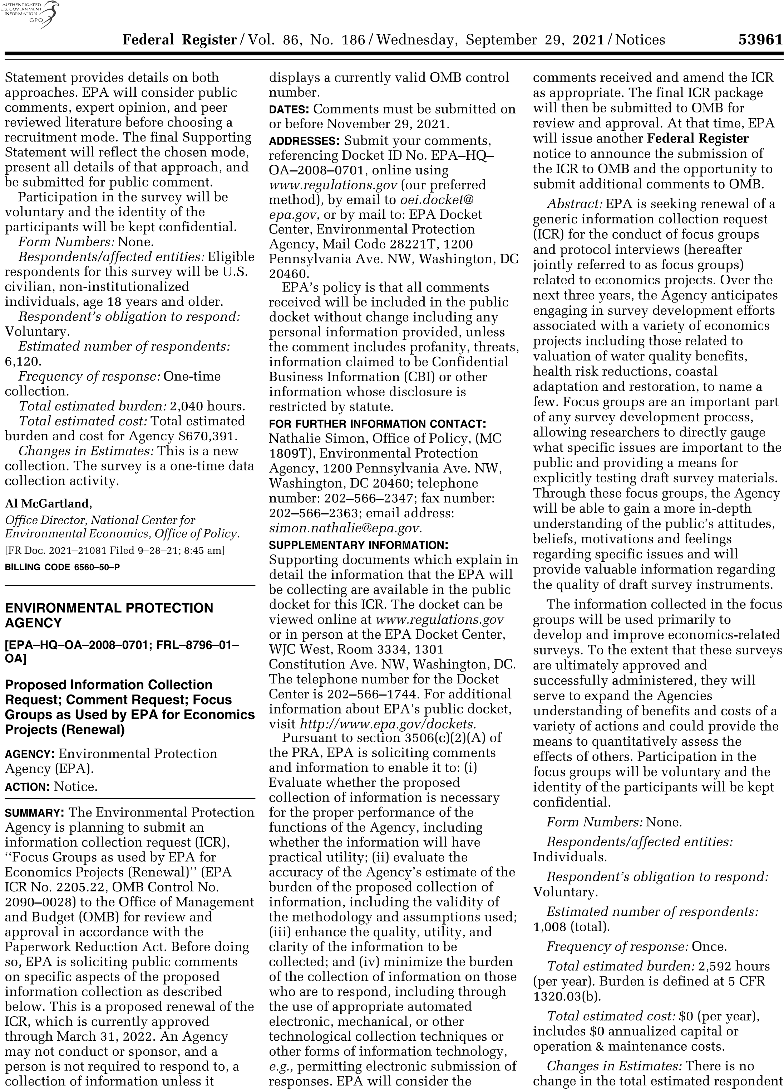

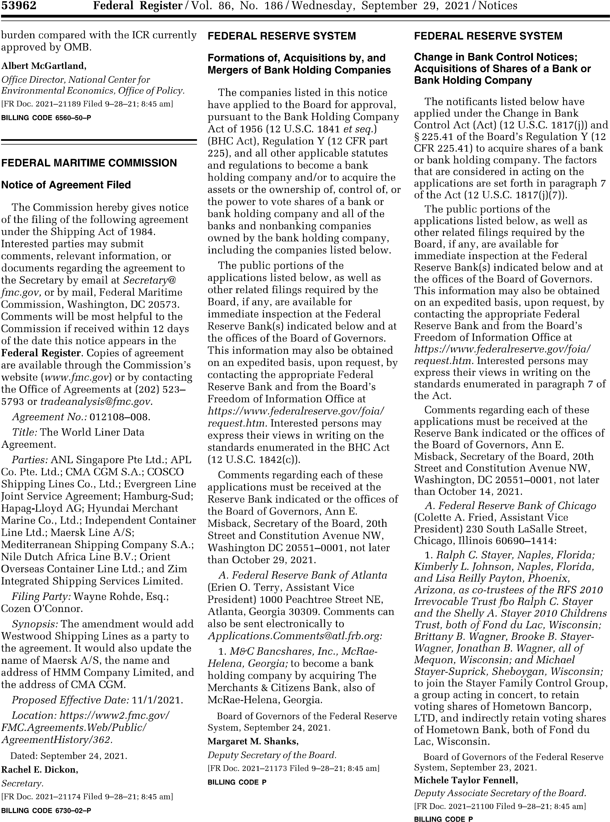

**Appendix 2**

**Proposed Process for Review of Focus Group Submissions**

**Under Generic ICR “Focus Groups as Used by EPA for Economics Projects”**

1. **A cross-office, standing panel** **has been created,** consisting of three economists with survey experience, to review requests from individuals or teams wishing to conduct focus groups under the generic ICR. One member of the panel will be from NCEE. Nominations for the other two seats will be solicited from the Program offices through the Econ Forum and will be decided by the Econ Forum Steering Committee. Membership on the panel will be on a rotational basis with each member appointed to a 1-year term. Members will be permitted to serve up to five, consecutive terms, but must then step down for a 12-month period before serving in this capacity again. In order to prevent wholesale turn-over of the panel at one time, the following maximum term limits may be applied to members of the panel (if needed):

**NCEE – no more than 3 consecutive terms**

**Program Office #1 – no more than 4 consecutive terms**

**Program Office #2 – no more than 5 consecutive terms.**

1. **Only relevant projects** **will be considered.** Relevant projects are defined as those with an economics component. That is, they must have as their primary goal the estimation of benefits, the estimation of costs, or the elicitation of preferences for health outcomes, safety and/or environmental goods.
2. **Projects submitted for consideration must have their parent projects entered into the Science Inventory Database**. The Science Inventory Database is a publicly searchable database designed to track and report peer review and other science activities across the Agency. Peer review work products are divided into three categories: highly influential scientific assessments, influential scientific information and other products. Creating an entry in the database will allow more public scrutiny of the proposed research and will allow the project to be reflected in the Agency’s Annual report to OMB summarizing peer review activities.

Entries should clearly indicate whether or not the parent survey under development will yield data that is expected to be "highly influential." According to EPA’s Science Policy Council Peer Review Handbook, influential scientific or technical work products are those expected to have “a major impact, [involve] precedential, novel, and/or controversial issues, or the Agency has a legal and/or statutory obligation to conduct a peer review.” Highly influential scientific assessments are those that “could have a potential impact of more than $500 million in any year,” or that are considered “novel, controversial, or precedent-setting or has significant interagency interest.” Our reading of these definitions would place all surveys in the “influential scientific assessments” category. The classification of a specific survey as “highly influential” will need to be determined on a case by case basis. Most surveys developed specifically for direct input into an economic analysis for a rule or regulation will be considered “highly influential.” However, other survey activities could also be considered “highly influential” depending on the subject matter.



1. **Supporting statements, clearly indicating peer review plans, must accompany each request**. Individuals or teams wishing to submit a project for consideration under this generic ICR must submit a draft supporting statement for review by the standing panel. Since focus group results are not expected to yield data that can be analyzed statistically, only Part A of the supporting statement will be expected.

In addition to the other standard requirements of the supporting statement, the document should clearly describe the need for and purpose of the parent project as well as the projected peer-review plan to assess the quality of any potential survey instruments. For highly influential parent projects, an external peer review panel process, as recommended by the EPA Peer Review Handbook, will be expected. This panel review could take one of two forms: periodic consultations with experts in the field throughout the survey development process or a panel review of the survey development process in advance of submitting an ICR to OMB should the project advance to that stage.

1. **Time-lines for project completion should accompany the supporting statement,** highlighting hard deadlines where they exist. In assessing the project, the review panel will consider whether in their view there is sufficient and reasonable time to complete the focus groups given these timing constraints. As separate ICR approval will be required for administration of any survey once developed, the submitted timeline should reflect the date by which the project team expects to file the ICR for any anticipated survey administration.