Title 49: Transportation
Browse Previous | Browse Next

PART 391—QUALIFICATIONS OF DRIVERS AND LONGER COMBINATION VEHICLE (LCV) DRIVER INSTRUCTORS

Section Contents
Subpart A—General
§ 391.1 Scope of the rules in this part; additional qualifications; duties of carrier-drivers.
§ 391.2 General exceptions.
Subpart B—Qualification and Disqualification of Drivers
§ 391.11 General qualifications of drivers.
§ 391.13 Responsibilities of drivers.
§ 391.15 Disqualification of drivers.
Subpart C—Background and Character
§ 391.21 Application for employment.
§ 391.23 Investigation and inquiries.
§ 391.25 Annual inquiry and review of driving record.
§ 391.27 Record of violations.
Subpart D—Tests
§ 391.31 Road test.
§ 391.33 Equivalent of road test.
Subpart E—Physical Qualifications and Examinations
§ 391.41 Physical qualifications for drivers.
§ 391.43 Medical examination; certificate of physical examination.
§ 391.45 Persons who must be medically examined and certified.
§ 391.47 Resolution of conflicts of medical evaluation.
§ 391.49 Alternative physical qualification standards for the loss or impairment of limbs.
Subpart F—Files and Records
§ 391.51 General requirements for driver qualification files.
§ 391.53 Driver investigation history file.
§ 391.55 LCV Driver-Instructor qualification files.
Subpart G—Limited Exemptions
§ 391.61 Drivers who were regularly employed before January 1, 1971.
§ 391.62 Limited exemptions for intra-city zone drivers.
§ 391.63 Multiple-employer drivers.
§ 391.64 Grandfathering for certain drivers participating in vision and diabetes waiver study programs.
§ 391.65 Drivers furnished by other motor carriers.
§ 391.67 Farm vehicle drivers of articulated commercial motor vehicles.
§ 391.68 Private motor carrier of passengers (nonbusiness).
§ 391.69 Private motor carrier of passengers (business).
§ 391.71 [Reserved]

Authority: 49 U.S.C. 322, 504, 508, 31133, 31136, and 31502; sec. 4007(b) of Pub. L. 102–240, 105 Stat. 2152; sec. 114 of Pub. L. 103–311, 108 Stat. 1673, 1677; sec. 215 of Pub. L. 106–159, 113 Stat. 1767; and 49 CFR 1.73.
Source: 35 FR 6460, Apr. 22, 1970, unless otherwise noted.
Editorial Note: Nomenclature changes to part 391 appear at 66 FR 49873, Oct. 1, 2001.

Subpart A—General
top

§ 391.1 Scope of the rules in this part; additional qualifications; duties of carrier-drivers.
top
(a) The rules in this part establish minimum qualifications for persons who drive commercial motor vehicles as, for, or on behalf of motor carriers. The rules in this part also establish minimum duties of motor carriers with respect to the qualifications of their drivers.
(b) A motor carrier who employs himself/herself as a driver must comply with both the rules in this part that apply to motor carriers and the rules in this part that apply to drivers.
[35 FR 6460, Apr. 22, 1970, as amended at 53 FR 18057, May 19, 1988; 60 FR 38744, July 28, 1995]

§ 391.2 General exceptions.
top
(a) Farm custom operation. The rules in this part do not apply to a driver who drives a commercial motor vehicle controlled and operated by a person engaged in custom-harvesting operations, if the commercial motor vehicle is used to—
(1) Transport farm machinery, supplies, or both, to or from a farm for custom-harvesting operations on a farm; or
(2) Transport custom-harvested crops to storage or market.
(b) Apiarian industries. The rules in this part do not apply to a driver who is operating a commercial motor vehicle controlled and operated by a beekeeper engaged in the seasonal transportation of bees.
(c) Certain farm vehicle drivers. The rules in this part do not apply to a farm vehicle driver except a farm vehicle driver who drives an articulated (combination) commercial motor vehicle, as defined in §390.5. (For limited exemptions for farm vehicle drivers of articulated commercial motor vehicles, see §391.67.)
[36 FR 24219, Dec. 22, 1971, as amended at 37 FR 26112, Dec. 8, 1972; 54 FR 12202, Mar. 24, 1989; 60 FR 38745, July 28, 1995; 61 FR 13346, Mar. 26, 1996; 61 FR 17253, Apr. 19, 1996]

Subpart B—Qualification and Disqualification of Drivers
top

§ 391.11 General qualifications of drivers.
top
(a) A person shall not drive a commercial motor vehicle unless he/she is qualified to drive a commercial motor vehicle. Except as provided in §391.63, a motor carrier shall not require or permit a person to drive a commercial motor vehicle unless that person is qualified to drive a commercial motor vehicle.
(b) Except as provided in subpart G of this part, a person is qualified to drive a motor vehicle if he/she—
(1) Is at least 21 years old;
(2) Can read and speak the English language sufficiently to converse with the general public, to understand highway traffic signs and signals in the English language, to respond to official inquiries, and to make entries on reports and records;
(3) Can, by reason of experience, training, or both, safely operate the type of commercial motor vehicle he/she drives;
(4) Is physically qualified to drive a commercial motor vehicle in accordance with subpart E—Physical Qualifications and Examinations of this part;
(5) Has a currently valid commercial motor vehicle operator's license issued only by one State or jurisdiction;
(6) Has prepared and furnished the motor carrier that employs him/her with the list of violations or the certificate as required by §391.27;
(7) Is not disqualified to drive a commercial motor vehicle under the rules in §391.15; and
(8) Has successfully completed a driver's road test and has been issued a certificate of driver's road test in accordance with §391.31, or has presented an operator's license or a certificate of road test which the motor carrier that employs him/her has accepted as equivalent to a road test in accordance with §391.33.
[35 FR 6460, Apr. 22, 1970, as amended at 35 FR 17420, Nov. 13, 1970; 35 FR 19181, Dec. 18, 1970; 36 FR 222, Jan. 7, 1971, 36 FR 24220, Dec. 22, 1971; 45 FR 46424, July 10, 1980; 52 FR 20589, June 1, 1987; 59 FR 60323, Nov. 23, 1994; 60 FR 38744, 38745, July 28, 1995; 63 FR 33276, June 18, 1998]

§ 391.13 Responsibilities of drivers.
top
In order to comply with the requirements of §392.9(a) and §393.9 of this subchapter, a motor carrier shall not require or permit a person to drive a commercial motor vehicle unless the person—
(a) Can, by reason of experience, training, or both, determine whether the cargo he/she transports (including baggage in a passenger-carrying commercial motor vehicle) has been properly located, distributed, and secured in or on the commercial motor vehicle he/she drives;
(b) Is familiar with methods and procedures for securing cargo in or on the commercial motor vehicle he/she drives.
[63 FR 33277, June 18, 1998]

§ 391.15 Disqualification of drivers.
top
(a) General. A driver who is disqualified shall not drive a commercial motor vehicle. A motor carrier shall not require or permit a driver who is disqualified to drive a commercial motor vehicle.
(b) Disqualification for loss of driving privileges. (1) A driver is disqualified for the duration of the driver's loss of his/her privilege to operate a commercial motor vehicle on public highways, either temporarily or permanently, by reason of the revocation, suspension, withdrawal, or denial of an operator's license, permit, or privilege, until that operator's license, permit, or privilege is restored by the authority that revoked, suspended, withdrew, or denied it.
(2) A driver who receives a notice that his/her license, permit, or privilege to operate a commercial motor vehicle has been revoked, suspended, or withdrawn shall notify the motor carrier that employs him/her of the contents of the notice before the end of the business day following the day the driver received it.
(c) Disqualification for criminal and other offenses —(1) General rule. A driver who is convicted of (or forfeits bond or collateral upon a charge of) a disqualifying offense specified in paragraph (c)(2) of this section is disqualified for the period of time specified in paragraph (c)(3) of this section, if—
(i) The offense was committed during on-duty time as defined in §395.2(a) of this subchapter or as otherwise specified; and
(ii) The driver is employed by a motor carrier or is engaged in activities that are in furtherance of a commercial enterprise in interstate, intrastate, or foreign commerce;
(2) Disqualifying offenses. The following offenses are disqualifying offenses:
(i) Driving a commercial motor vehicle while under the influence of alcohol. This shall include:
(A) Driving a commercial motor vehicle while the person's alcohol concentration is 0.04 percent or more;
(B) Driving under the influence of alcohol, as prescribed by State law; or
(C) Refusal to undergo such testing as is required by any State or jurisdiction in the enforcement of §391.15(c)(2)(i) (A) or (B), or §392.5(a)(2).
(ii) Driving a commercial motor vehicle under the influence of a 21 CFR 1308.11 Schedule I identified controlled substance, an amphetamine, a narcotic drug, a formulation of an amphetamine, or a derivative of a narcotic drug;
(iii) Transportation, possession, or unlawful use of a 21 CFR 1308.11 Schedule I identified controlled substance, amphetamines, narcotic drugs, formulations of an amphetamine, or derivatives of narcotic drugs while the driver is on duty, as the term on-duty time is defined in §395.2 of this subchapter;
(iv) Leaving the scene of an accident while operating a commercial motor vehicle; or
(v) A felony involving the use of a commercial motor vehicle.
(3) Duration of disqualification —(i) First offenders. A driver is disqualified for 1 year after the date of conviction or forfeiture of bond or collateral if, during the 3 years preceding that date, the driver was not convicted of, or did not forfeit bond or collateral upon a charge of an offense that would disqualify the driver under the rules of this section. Exemption. The period of disqualification is 6 months if the conviction or forfeiture of bond or collateral soley concerned the transportation or possession of substances named in paragraph (c)(2)(iii) of this section.
(ii) Subsequent offenders. A driver is disqualified for 3 years after the date of his/her conviction or forfeiture of bond or collateral if, during the 3 years preceding that date, he/she was convicted of, or forfeited bond or collateral upon a charge of, an offense that would disqualify him/her under the rules in this section.
(d) Disqualification for violation of out-of-service orders —(1) General rule. A driver who is convicted of violating an out-of-service order is disqualified for the period of time specified in paragraph (d)(2) of this section.
(2) Duration of disqualification for violation of out-of-service orders —(i) First violation. A driver is disqualified for not less than 90 days nor more than one year if the driver is convicted of a first violation of an out-of-service order.
(ii) Second violation. A driver is disqualified for not less than one year nor more than five years if, during any 10-year period, the driver is convicted of two violations of out-of-service orders in separate incidents.
(iii) Third or subsequent violation. A driver is disqualified for not less than three years nor more than five years if, during any 10-year period, the driver is convicted of three or more violations of out-of-service orders in separate incidents.
(iv) Special rule for hazardous materials and passenger offenses. A driver is disqualified for a period of not less than 180 days nor more than two years if the driver is convicted of a first violation of an out-of-service order while transporting hazardous materials required to be placarded under the Hazardous Materials Transportation Act (49 U.S.C. 5101 et seq. ), or while operating commercial motor vehicles designed to transport more than 15 passengers, including the driver. A driver is disqualified for a period of not less than three years nor more than five years if, during any 10-year period, the driver is convicted of any subsequent violations of out-of-service orders, in separate incidents, while transporting hazardous materials required to be placarded under the Hazardous Materials Transportation Act, or while operating commercial motor vehicles designed to transport more than 15 passengers, including the driver.
[37 FR 24902, Nov. 23, 1972, as amended at 49 FR 44215, Nov. 5, 1984; 51 FR 8200, Mar. 10, 1986; 53 FR 18057, May 19, 1988; 53 FR 39051, Oct. 4, 1988; 54 FR 40788, Oct. 3, 1989; 59 FR 26028, May 18, 1994; 60 FR 38744, 38745, July 28, 1995; 62 FR 37152, July 11, 1997; 63 FR 33277, June 18, 1998]

Subpart C—Background and Character
top

§ 391.21 Application for employment.
top
(a) Except as provided in subpart G of this part, a person shall not drive a commercial motor vehicle unless he/she has completed and furnished the motor carrier that employs him/her with an application for employment that meets the requirements of paragraph (b) of this section.
(b) The application for employment shall be made on a form furnished by the motor carrier. Each application form must be completed by the applicant, must be signed by him/her, and must contain the following information:
(1) The name and address of the employing motor carrier;
(2) The applicant's name, address, date of birth, and social security number;
(3) The addresses at which the applicant has resided during the 3 years preceding the date on which the application is submitted;
(4) The date on which the application is submitted;
(5) The issuing State, number, and expiration date of each unexpired commercial motor vehicle operator's license or permit that has been issued to the applicant;
(6) The nature and extent of the applicant's experience in the operation of motor vehicles, including the type of equipment (such as buses, trucks, truck tractors, semitrailers, full trailers, and pole trailers) which he/she has operated;
(7) A list of all motor vehicle accidents in which the applicant was involved during the 3 years preceding the date the application is submitted, specifying the date and nature of each accident and any fatalities or personal injuries it caused;
(8) A list of all violations of motor vehicle laws or ordinances (other than violations involving only parking) of which the applicant was convicted or forfeited bond or collateral during the 3 years preceding the date the application is submitted;
(9) A statement setting forth in detail the facts and circumstances of any denial, revocation, or suspension of any license, permit, or privilege to operate a motor vehicle that has been issued to the applicant, or a statement that no such denial, revocation, or suspension has occurred;
(10)(i) A list of the names and addresses of the applicant's employers during the 3 years preceding the date the application is submitted,
(ii) The dates he or she was employed by that employer,
(iii) The reason for leaving the employ of that employer,
(iv) After October 29, 2004, whether the (A) Applicant was subject to the FMCSRs while employed by that previous employer,
(B) Job was designated as a safety sensitive function in any DOT regulated mode subject to alcohol and controlled substances testing requirements as required by 49 CFR part 40;
(11) For those drivers applying to operate a commercial motor vehicle as defined by Part 383 of this subchapter, a list of the names and addresses of the applicant's employers during the 7-year period preceding the 3 years contained in paragraph (b)(10) of this section for which the applicant was an operator of a commercial motor vehicle, together with the dates of employment and the reasons for leaving such employment; and
(12) The following certification and signature line, which must appear at the end of the application form and be signed by the applicant:
This certifies that this application was completed by me, and that all entries on it and information in it are true and complete to the best of my knowledge.
(Date) (Applicant's signature)
(c) A motor carrier may require an applicant to provide information in addition to the information required by paragraph (b) of this section on the application form.
(d) Before an application is submitted, the motor carrier must inform the applicant that the information he/she provides in accordance with paragraph (b)(10) of this section may be used, and the applicant's previous employers will be contacted, for the purpose of investigating the applicant's safety performance history information as required by paragraphs (d) and (e) of §391.23. The prospective employer must also notify the driver in writing of his/her due process rights as specified in §391.23(i) regarding information received as a result of these investigations.
[35 FR 6460, Apr. 22, 1970, as amended at 35 FR 17420, Nov. 13, 1970; 52 FR 20589, June 1, 1987; 60 FR 38744, July 28, 1995; 69 FR 16719, Mar. 30, 2004]

§ 391.23 Investigation and inquiries.
top
(a) Except as provided in subpart G of this part, each motor carrier shall make the following investigations and inquiries with respect to each driver it employs, other than a person who has been a regularly employed driver of the motor carrier for a continuous period which began before January 1, 1971:
(1) An inquiry to each State where the driver held or holds a motor vehicle operator's license or permit during the preceding 3 years to obtain that driver's motor vehicle record.
(2) An investigation of the driver's safety performance history with Department of Transportation regulated employers during the preceding three years.
(b) A copy of the motor vehicle record(s) obtained in response to the inquiry or inquiries to each State required by paragraph (a)(1) of this section must be placed in the driver qualification file within 30 days of the date the driver's employment begins and be retained in compliance with §391.51. If no motor vehicle record is received from the State or States required to submit this response, the motor carrier must document a good faith effort to obtain such information, and certify that no record exists for that driver in that State or States. The inquiry to the State driver licensing agency or agencies must be made in the form and manner each agency prescribes.
(c)(1) Replies to the investigations of the driver's safety performance history required by paragraph (a)(2) of this section, or documentation of good faith efforts to obtain the investigation data, must be placed in the driver investigation history file, after October 29, 2004, within 30 days of the date the driver's employment begins. Any period of time required to exercise the driver's due process rights to review the information received, request a previous employer to correct or include a rebuttal, is separate and apart from this 30-day requirement to document investigation of the driver safety performance history data.
(2) The investigation may consist of personal interviews, telephone interviews, letters, or any other method for investigating that the carrier deems appropriate. Each motor carrier must make a written record with respect to each previous employer contacted, or good faith efforts to do so. The record must include the previous employer's name and address, the date the previous employer was contacted, or the attempts made, and the information received about the driver from the previous employer. Failures to contact a previous employer, or of them to provide the required safety performance history information, must be documented. The record must be maintained pursuant to §391.53.
(3) Prospective employers should report failures of previous employers to respond to an investigation to the FMCSA following procedures specified at §386.12 of this chapter and keep a copy of such reports in the Driver Investigation file as part of documenting a good faith effort to obtain the required information.
(4) Exception. For drivers with no previous employment experience working for a DOT regulated employer during the preceding three years, documentation that no investigation was possible must be placed in the driver history investigation file, after October 29, 2004, within the required 30 days of the date the driver's employment begins.
(d) The prospective motor carrier must investigate, at a minimum, the information listed in this paragraph from all previous employers of the applicant that employed the driver to operate a CMV within the previous three years. The investigation request must contain specific contact information on where the previous motor carrier employers should send the information requested.
(1) General driver identification and employment verification information.
(2) The data elements as specified in §390.15(b)(1) of this chapter for accidents involving the driver that occurred in the three-year period preceding the date of the employment application.
(i) Any accidents as defined by §390.5 of this chapter.
(ii) Any accidents the previous employer may wish to provide that are retained pursuant to §390.15(b)(2), or pursuant to the employer's internal policies for retaining more detailed minor accident information.
(e) In addition to the investigations required by paragraph (d) of this section, the prospective motor carrier employers must investigate the information listed below in this paragraph from all previous DOT regulated employers that employed the driver within the previous three years from the date of the employment application, in a safety-sensitive function that required alcohol and controlled substance testing specified by 49 CFR part 40.
(1) Whether, within the previous three years, the driver had violated the alcohol and controlled substances prohibitions under subpart B of part 382 of this chapter, or 49 CFR part 40.
(2) Whether the driver failed to undertake or complete a rehabilitation program prescribed by a substance abuse professional (SAP) pursuant to §382.605 of this chapter, or 49 CFR part 40, subpart O. If the previous employer does not know this information ( e.g., an employer that terminated an employee who tested positive on a drug test), the prospective motor carrier must obtain documentation of the driver's successful completion of the SAP's referral directly from the driver.
(3) For a driver who had successfully completed a SAP's rehabilitation referral, and remained in the employ of the referring employer, information on whether the driver had the following testing violations subsequent to completion of a §382.605 or 49 CFR part 40, subpart O referral:
(i) Alcohol tests with a result of 0.04 or higher alcohol concentration;
(ii) Verified positive drug tests;
(iii) Refusals to be tested (including verified adulterated or substituted drug test results).
(f) A prospective motor carrier employer must provide to the previous employer the driver's written consent meeting the requirements of §40.321(b) for the release of the information in paragraph (e) of this section. If the driver refuses to provide this written consent, the prospective motor carrier employer must not permit the driver to operate a commercial motor vehicle for that motor carrier.
(g) After October 29, 2004, previous employers must:
(1) Respond to each request for the DOT defined information in paragraphs (d) and (e) of this section within 30 days after the request is received. If there is no safety performance history information to report for that driver, previous motor carrier employers are nonetheless required to send a response confirming the non-existence of any such data, including the driver identification information and dates of employment.
(2) Take all precautions reasonably necessary to ensure the accuracy of the records.
(3) Provide specific contact information in case a driver chooses to contact the previous employer regarding correction or rebuttal of the data.
(4) Keep a record of each request and the response for one year, including the date, the party to whom it was released, and a summary identifying what was provided.
(5) Exception. Until May 1, 2006, carriers need only provide information for accidents that occurred after April 29, 2003.
(h) The release of information under this section may take any form that reasonably ensures confidentiality, including letter, facsimile, or e-mail. The previous employer and its agents and insurers must take all precautions reasonably necessary to protect the driver safety performance history records from disclosure to any person not directly involved in forwarding the records, except the previous employer's insurer, except that the previous employer may not provide any alcohol or controlled substances information to the previous employer's insurer.
(i)(1) The prospective employer must expressly notify drivers with Department of Transportation regulated employment during the preceding three years—via the application form or other written document prior to any hiring decision—that he or she has the following rights regarding the investigative information that will be provided to the prospective employer pursuant to paragraphs (d) and (e) of this section:
(i) The right to review information provided by previous employers;
(ii) The right to have errors in the information corrected by the previous employer and for that previous employer to re-send the corrected information to the prospective employer;
(iii) The right to have a rebuttal statement attached to the alleged erroneous information, if the previous employer and the driver cannot agree on the accuracy of the information.
(2) Drivers who have previous Department of Transportation regulated employment history in the preceding three years, and wish to review previous employer-provided investigative information must submit a written request to the prospective employer, which may be done at any time, including when applying, or as late as 30 days after being employed or being notified of denial of employment. The prospective employer must provide this information to the applicant within five (5) business days of receiving the written request. If the prospective employer has not yet received the requested information from the previous employer(s), then the five-business days deadline will begin when the prospective employer receives the requested safety performance history information. If the driver has not arranged to pick up or receive the requested records within thirty (30) days of the prospective employer making them available, the prospective motor carrier may consider the driver to have waived his/her request to review the records.
(j)(1) Drivers wishing to request correction of erroneous information in records received pursuant to paragraph (i) of this section must send the request for the correction to the previous employer that provided the records to the prospective employer.
(2) After October 29, 2004, the previous employer must either correct and forward the information to the prospective motor carrier employer, or notify the driver within 15 days of receiving a driver's request to correct the data that it does not agree to correct the data. If the previous employer corrects and forwards the data as requested, that employer must also retain the corrected information as part of the driver's safety performance history record and provide it to subsequent prospective employers when requests for this information are received. If the previous employer corrects the data and forwards it to the prospective motor carrier employer, there is no need to notify the driver.
(3) Drivers wishing to rebut information in records received pursuant to paragraph (i) of this section must send the rebuttal to the previous employer with instructions to include the rebuttal in that driver's safety performance history.
(4) After October 29, 2004, within five business days of receiving a rebuttal from a driver, the previous employer must:
(i) Forward a copy of the rebuttal to the prospective motor carrier employer;
(ii) Append the rebuttal to the driver's information in the carrier's appropriate file, to be included as part of the response for any subsequent investigating prospective employers for the duration of the three-year data retention requirement.
(5) The driver may submit a rebuttal initially without a request for correction, or subsequent to a request for correction.
(6) The driver may report failures of previous employers to correct information or include the driver's rebuttal as part of the safety performance information, to the FMCSA following procedures specified at §386.12.
(k)(1) The prospective motor carrier employer must use the information described in paragraphs (d) and (e) of this section only as part of deciding whether to hire the driver.
(2) The prospective motor carrier employer, its agents and insurers must take all precautions reasonably necessary to protect the records from disclosure to any person not directly involved in deciding whether to hire the driver. The prospective motor carrier employer may not provide any alcohol or controlled substances information to the prospective motor carrier employer's insurer.
(l)(1) No action or proceeding for defamation, invasion of privacy, or interference with a contract that is based on the furnishing or use of information in accordance with this section may be brought against—
(i) A motor carrier investigating the information, described in paragraphs (d) and (e) of this section, of an individual under consideration for employment as a commercial motor vehicle driver,
(ii) A person who has provided such information; or
(iii) The agents or insurers of a person described in paragraph (l)(1)(i) or (ii) of this section, except insurers are not granted a limitation on liability for any alcohol and controlled substance information.
(2) The protections in paragraph (l)(1) of this section do not apply to persons who knowingly furnish false information, or who are not in compliance with the procedures specified for these investigations.
(m)(1) The motor carrier must obtain an original or copy of the medical examiner's certificate issued in accordance with §391.43, and any medical variance on which the certification is based, and place the records in the driver qualification file, before allowing the driver to operate a CMV.
(2) Exception. For drivers required to have a commercial driver's license under part 383 of this chapter:
(i) Beginning January 30, 2012, using the CDLIS motor vehicle record obtained from the current licensing State, the motor carrier must verify and document in the driver qualification file the following information before allowing the driver to operate a CMV:
(A) The type of operation the driver self-certified that he or she will perform in accordance with §§383.71(a)(1)(ii) and 383.71(g) of this chapter, or
(B) Exception. If the driver has provided the motor carrier with a date-stamped receipt from the State driver licensing agency for the medical examiner's certificate given to the driver in accordance with §383.73(a)(5) of this chapter, the motor carrier may use that receipt as proof of the driver's medical certification for up to 15 days after the date stamped on the receipt.
(ii) Until January 30, 2014, if a driver operating in non-excepted, interstate commerce has no medical certification status information on the CDLIS MVR obtained from the current State driver licensing agency, the employing motor carrier may accept a medical examiner's certificate issued to that driver prior to January 30, 2012, and place a copy of it in the driver qualification file before allowing the driver to operate a CMV in interstate commerce.
(Approved by the Office of Management and Budget under control number 2126–0004)
[35 FR 6460, Apr. 22, 1970, as amended at 35 FR 17420, Nov. 13, 1970; 69 FR 16720, Mar. 30, 2004; 72 FR 55703, Oct. 1, 2007; 73 FR 73126, Dec. 1, 2008]

§ 391.25 Annual inquiry and review of driving record.
top
(a) Except as provided in subpart G of this part, each motor carrier shall, at least once every 12 months, make an inquiry to obtain the motor vehicle record of each driver it employs, covering at least the preceding 12 months, to the appropriate agency of every State in which the driver held a commercial motor vehicle operator's license or permit during the time period.
(b) Except as provided in subpart G of this part, each motor carrier shall, at least once every 12 months, review the motor vehicle record of each driver it employs to determine whether that driver meets minimum requirements for safe driving or is disqualified to drive a commercial motor vehicle pursuant to §391.15.
(1) The motor carrier must consider any evidence that the driver has violated any applicable Federal Motor Carrier Safety Regulations in this subchapter or Hazardous Materials Regulations (49 CFR chapter I, subchapter C).
(2) The motor carrier must consider the driver's accident record and any evidence that the driver has violated laws governing the operation of motor vehicles, and must give great weight to violations, such as speeding, reckless driving, and operating while under the influence of alcohol or drugs, that indicate that the driver has exhibited a disregard for the safety of the public.
(c) Recordkeeping. (1) A copy of the motor vehicle record required by paragraph (a) of this section shall be maintained in the driver's qualification file.
(2) A note, including the name of the person who performed the review of the driving record required by paragraph (b) of this section and the date of such review, shall be maintained in the driver's qualification file.
[63 FR 33277, June 18, 1998, as amended at 73 FR 73127, Dec. 1, 2008]

§ 391.27 Record of violations.
top
(a) Except as provided in subpart G of this part, each motor carrier shall, at least once every 12 months, require each driver it employs to prepare and furnish it with a list of all violations of motor vehicle traffic laws and ordinances (other than violations involving only parking) of which the driver has been convicted or on account of which he/she has forfeited bond or collateral during the preceding 12 months.
(b) Each driver shall furnish the list required in accordance with paragraph (a) of this section. If the driver has not been convicted of, or forfeited bond or collateral on account of, any violation which must be listed, he/she shall so certify.
(c) The form of the driver's list or certification shall be prescribed by the motor carrier. The following form may be used to comply with this section:
Driver's Certification
I certify that the following is a true and complete list of traffic violations (other than parking violations) for which I have been convicted or forfeited bond or collateral during the past 12 months.
Date of conviction Offense
Location Type of motor vehicle operated
If no violations are listed above, I certify that I have not been convicted or forfeited bond or collateral on account of any violation required to be listed during the past 12 months.
(Date of certification) (Driver's signature)
(Motor carrier's name)
(Motor carrier's address)
(Reviewed by: Signature) (Title) ____________________________________
(d) The motor carrier shall retain the list or certificate required by this section, or a copy of it, in its files as part of the driver's qualification file.
(e) Drivers who have provided information required by §383.31 of this subchapter need not repeat that information in the annual list of violations required by this section.
[35 FR 6460, Apr. 22, 1970, as amended at 35 FR 17420, Nov. 13, 1970; 52 FR 20589, June 1, 1987; 60 FR 38745, July 28, 1995]

Subpart D—Tests
top

§ 391.31 Road test.
top
(a) Except as provided in subpart G, a person shall not drive a commercial motor vehicle unless he/she has first successfully completed a road test and has been issued a certificate of driver's road test in accordance with this section.
(b) The road test shall be given by the motor carrier or a person designated by it. However, a driver who is a motor carrier must be given the test by a person other than himself/herself. The test shall be given by a person who is competent to evaluate and determine whether the person who takes the test has demonstrated that he/she is capable of operating the commercial motor vehicle, and associated equipment, that the motor carrier intends to assign him/her.
(c) The road test must be of sufficient duration to enable the person who gives it to evaluate the skill of the person who takes it at handling the commercial motor vehicle, and associated equipment, that the motor carriers intends to assign to him/her. As a minimum, the person who takes the test must be tested, while operating the type of commercial motor vehicle the motor carrier intends to assign him/her, on his/her skill at performing each of the following operations:
(1) The pretrip inspection required by §392.7 of this subchapter;
(2) Coupling and uncoupling of combination units, if the equipment he/she may drive includes combination units;
(3) Placing the commercial motor vehicle in operation;
(4) Use of the commercial motor vehicle's controls and emergency equipment;
(5) Operating the commercial motor vehicle in traffic and while passing other motor vehicles;
(6) Turning the commercial motor vehicle;
(7) Braking, and slowing the commercial motor vehicle by means other than braking; and
(8) Backing and parking the commercial motor vehicle.
(d) The motor carrier shall provide a road test form on which the person who gives the test shall rate the performance of the person who takes it at each operation or activity which is a part of the test. After he/she completes the form, the person who gave the test shall sign it.
(e) If the road test is successfully completed, the person who gave it shall complete a certificate of driver's road test in substantially the form prescribed in paragraph (f) of this section.
(f) The form for the certificate of driver's road test is substantially as follows:
Certification of Road Test
Driver's name____________________
Social Security No____________________
Operator's or Chauffeur's License No____________________
State____________________
Type of power unit ______ Type of trailer(s)____________________
If passenger carrier, type of bus __________________________
This is to certify that the above-named driver was given a road test under my supervision on ______, 20__, consisting of approximately ___ miles of driving.
It is my considered opinion that this driver possesses sufficient driving skill to operate safely the type of commercial motor vehicle listed above.
(Signature of examiner)(Title) ____________________________________ (Organization and address of examiner)
(g) A copy of the certificate required by paragraph (e) of this section shall be given to the person who was examined. The motor carrier shall retain in the driver qualification file of the person who was examined—
(1) The original of the signed road test form required by paragraph (d) of this section; and
(2) The original, or a copy of, the certificate required by paragraph (e) of this section.
[35 FR 6460, Apr. 22, 1970, as amended at 36 FR 223, Jan. 7, 1971; 59 FR 8752, Feb. 23, 1994; 60 FR 38744, July 28, 1995]

§ 391.33 Equivalent of road test.
top
(a) In place of, and as equivalent to, the road test required by §391.31, a person who seeks to drive a commercial motor vehicle may present, and a motor carrier may accept—
(1) A valid Commercial Driver's License as defined in §383.5 of this subchapter, but not including double/triple trailer or tank vehicle endorsements, which has been issued to him/her to operate specific categories of commercial motor vehicles and which, under the laws of that State, licenses him/her after successful completion of a road test in a commercial motor vehicle of the type the motor carrier intends to assign to him/her; or
(2) A copy of a valid certificate of driver's road test issued to him/her pursuant to §391.31 within the preceding 3 years.
(b) If a driver presents, and a motor carrier accepts, a license or certificate as equivalent to the road test, the motor carrier shall retain a legible copy of the license or certificate in its files as part of the driver's qualification file.
(c) A motor carrier may require any person who presents a license or certificate as equivalent to the road test to take a road test or any other test of his/her driving skill as a condition to his/her employment as a driver.
[35 FR 6460, Apr. 22, 1970, as amended at 60 FR 38744, July 28, 1995; 63 FR 33277, June 18, 1998]

Subpart E—Physical Qualifications and Examinations
top

§ 391.41 Physical qualifications for drivers.
top
(a)(1)(i) A person subject to this part must not operate a commercial motor vehicle unless he or she is medically certified as physically qualified to do so, and, except as provided in paragraph (a)(2) of this section, when on-duty has on his or her person the original, or a copy, of a current medical examiner's certificate that he or she is physically qualified to drive a commercial motor vehicle. NOTE: Effective December 29, 1991, the FMCSA Administrator determined that the new Licencia Federal de Conductor issued by the United Mexican States is recognized as proof of medical fitness to drive a CMV. The United States and Canada entered into a Reciprocity Agreement, effective March 30, 1999, recognizing that a Canadian commercial driver's license is proof of medical fitness to drive a CMV. Therefore, Canadian and Mexican CMV drivers are not required to have in their possession a medical examiner's certificate if the driver has been issued, and possesses, a valid commercial driver license issued by the United Mexican States, or a Canadian Province or Territory and whose license and medical status, including any waiver or exemption, can be electronically verified. Drivers from any of the countries who have received a medical authorization that deviates from the mutually accepted compatible medical standards of the resident country are not qualified to drive a CMV in the other countries. For example, Canadian drivers who do not meet the medical fitness provisions of the Canadian National Safety Code for Motor Carriers, but are issued a waiver by one of the Canadian Provinces or Territories, are not qualified to drive a CMV in the United States. In addition, U.S. drivers who received a medical variance from FMCSA are not qualified to drive a CMV in Canada.
(ii) A person who qualifies for the medical examiner's certificate by virtue of having obtained a medical variance from FMCSA, in the form of an exemption letter or a skill performance evaluation certificate, must have on his or her person a copy of the variance documentation when on-duty.
(2) CDL exception. (i) Beginning January 30, 2012, a driver required to have a commercial driver's license under part 383 of this chapter, and who submitted a current medical examiner's certificate to the State in accordance with §383.71(h) of this chapter documenting that he or she meets the physical qualification requirements of this part, no longer needs to carry on his or her person the medical examiner's certificate specified at §391.43(h), or a copy. If there is no medical certification information on that driver's CDLIS motor vehicle record defined at 49 CFR 384.105, a current medical examiner's certificate issued prior to January 30, 2012, will be accepted until January 30, 2014. After January 30, 2014, a driver may use the date-stamped receipt (given to the driver by the State driver licensing agency) for up to 15 days after the date stamped on that receipt as proof of medical certification.
(ii) A CDL driver required by §383.71(h) to obtain a medical examiner's certificate who obtained such by virtue of having obtained a medical variance from FMCSA must continue to have in his or her possession the original or copy of that medical variance documentation at all times when on-duty.
(3) A person is physically qualified to drive a commercial motor vehicle if:
(i) That person meets the physical qualification standards in paragraph (b) of this section and has complied with the medical examination requirements in §391.43; or
(ii) That person obtained from FMCSA a medical variance from the physical qualification standards in paragraph (b) of this section and has complied with the medical examination requirement in §391.43.
(b) A person is physically qualified to drive a commercial motor vehicle if that person—
(1) Has no loss of a foot, a leg, a hand, or an arm, or has been granted a skill performance evaluation certificate pursuant to §391.49;
(2) Has no impairment of:
(i) A hand or finger which interferes with prehension or power grasping; or
(ii) An arm, foot, or leg which interferes with the ability to perform normal tasks associated with operating a commercial motor vehicle; or any other significant limb defect or limitation which interferes with the ability to perform normal tasks associated with operating a commercial motor vehicle; or has been granted a skill performance evaluation certificate pursuant to §391.49.
(3) Has no established medical history or clinical diagnosis of diabetes mellitus currently requiring insulin for control;
(4) Has no current clinical diagnosis of myocardial infarction, angina pectoris, coronary insufficiency, thrombosis, or any other cardiovascular disease of a variety known to be accompanied by syncope, dyspnea, collapse, or congestive cardiac failure.
(5) Has no established medical history or clinical diagnosis of a respiratory dysfunction likely to interfere with his/her ability to control and drive a commercial motor vehicle safely;
(6) Has no current clinical diagnosis of high blood pressure likely to interfere with his/her ability to operate a commercial motor vehicle safely;
(7) Has no established medical history or clinical diagnosis of rheumatic, arthritic, orthopedic, muscular, neuromuscular, or vascular disease which interferes with his/her ability to control and operate a commercial motor vehicle safely;
(8) Has no established medical history or clinical diagnosis of epilepsy or any other condition which is likely to cause loss of consciousness or any loss of ability to control a commercial motor vehicle;
(9) Has no mental, nervous, organic, or functional disease or psychiatric disorder likely to interfere with his/her ability to drive a commercial motor vehicle safely;
(10) Has distant visual acuity of at least 20/40 (Snellen) in each eye without corrective lenses or visual acuity separately corrected to 20/40 (Snellen) or better with corrective lenses, distant binocular acuity of at least 20/40 (Snellen) in both eyes with or without corrective lenses, field of vision of at least 70° in the horizontal Meridian in each eye, and the ability to recognize the colors of traffic signals and devices showing standard red, green, and amber;
(11) First perceives a forced whispered voice in the better ear at not less than 5 feet with or without the use of a hearing aid or, if tested by use of an audiometric device, does not have an average hearing loss in the better ear greater than 40 decibels at 500 Hz, 1,000 Hz, and 2,000 Hz with or without a hearing aid when the audiometric device is calibrated to American National Standard (formerly ASA Standard) Z24.5—1951.
(12)(i) Does not use a controlled substance identified in 21 CFR 1308.11 Schedule I, an amphetamine, a narcotic, or any other habit-forming drug.
(ii) Exception. A driver may use such a substance or drug, if the substance or drug is prescribed by a licensed medical practitioner who:
(A) Is familiar with the driver's medical history and assigned duties; and
(B) Has advised the driver that the prescribed substance or drug will not adversely affect the driver's ability to safely operate a commercial motor vehicle; and
(13) Has no current clinical diagnosis of alcoholism.
[35 FR 6460, Apr. 22, 1970, as amended at 35 FR 17420, Nov. 13, 1970; 36 FR 223, Jan. 7, 1971; 36 FR 12857, July 8, 1971; 43 FR 56900, Dec. 5, 1978; 55 FR 3554, Feb. 1, 1990; 60 FR 38744, July 28, 1995; 62 FR 37152, July 11, 1997; 65 FR 59369, Oct. 5, 2000; 67 FR 61824, Oct. 2, 2002; 73 FR 73127, Dec. 1, 2008]

§ 391.43 Medical examination; certificate of physical examination.
top
(a) Except as provided by paragraph (b) of this section, the medical examination shall be performed by a licensed medical examiner as defined in §390.5 of this subchapter.
(b) A licensed optometrist may perform so much of the medical examination as pertains to visual acuity, field of vision, and the ability to recognize colors as specified in paragraph (10) of §391.41(b).
(c) Medical examiners shall:
(1) Be knowledgeable of the specific physical and mental demands associated with operating a commercial motor vehicle and the requirements of this subpart, including the medical advisory criteria prepared by the FMCSA as guidelines to aid the medical examiner in making the qualification determination; and
(2) Be proficient in the use of and use the medical protocols necessary to adequately perform the medical examination required by this section.
(d) Any driver authorized to operate a commercial motor vehicle within an exempt intracity zone pursuant to §391.62 of this part shall furnish the examining medical examiner with a copy of the medical findings that led to the issuance of the first certificate of medical examination which allowed the driver to operate a commercial motor vehicle wholly within an exempt intracity zone.
(e) Any driver operating under a limited exemption authorized by §391.64 shall furnish the medical examiner with a copy of the annual medical findings of the endocrinologist, ophthalmologist or optometrist, as required under that section. If the medical examiner finds the driver qualified under the limited exemption in §391.64, such fact shall be noted on the Medical Examiner's Certificate.
(f) The medical examination shall be performed, and its results shall be recorded, substantially in accordance with the following instructions and examination form. Existing forms may be used until current printed supplies are depleted or until September 30, 2004, whichever occurs first.
Instructions for Performing and Recording Physical Examinations
The medical examiner must be familiar with 49 CFR 391.41, Physical qualifications for drivers, and should review these instructions before performing the physical examination. Answer each question “yes” or “no” and record numerical readings where indicated on the physical examination form.
The medical examiner must be aware of the rigorous physical, mental, and emotional demands placed on the driver of a commercial motor vehicle. In the interest of public safety, the medical examiner is required to certify that the driver does not have any physical, mental, or organic condition that might affect the driver's ability to operate a commercial motor vehicle safely.
General information. The purpose of this history and physical examination is to detect the presence of physical, mental, or organic conditions of such a character and extent as to affect the driver's ability to operate a commercial motor vehicle safely. The examination should be conducted carefully and should at least include all of the information requested in the following form. History of certain conditions may be cause for rejection. Indicate the need for further testing and/or require evaluation by a specialist. Conditions may be recorded which do not, because of their character or degree, indicate that certification of physical fitness should be denied. However, these conditions should be discussed with the driver and he/she should be advised to take the necessary steps to insure correction, particularly of those conditions which, if neglected, might affect the driver's ability to drive safely.
General appearance and development. Note marked overweight. Note any postural defect, perceptible limp, tremor, or other conditions that might be caused by alcoholism, thyroid intoxication or other illnesses.
Head-eyes. When other than the Snellen chart is used, the results of such test must be expressed in values comparable to the standard Snellen test. If the driver wears corrective lenses for driving, these should be worn while driver's visual acuity is being tested. If contact lenses are worn, there should be sufficient evidence of good tolerance of and adaptation to their use. Indicate the driver's need to wear corrective lenses to meet the vision standard on the Medical Examiner's Certificate by checking the box, “Qualified only when wearing corrective lenses.” In recording distance vision use 20 feet as normal. Report all vision as a fraction with 20 as the numerator and the smallest type read at 20 feet as the denominator. Monocular drivers are not qualified to operate commercial motor vehicles in interstate commerce.
Ears. Note evidence of any ear disease, symptoms of aural vertigo, or Meniere's Syndrome. When recording hearing, record distance from patient at which a forced whispered voice can first be heard. For the whispered voice test, the individual should be stationed at least 5 feet from the examiner with the ear being tested turned toward the examiner. The other ear is covered. Using the breath which remains after a normal expiration, the examiner whispers words or random numbers such as 66, 18, 23, etc. The examiner should not use only sibilants (s-sounding test materials). The opposite ear should be tested in the same manner. If the individual fails the whispered voice test, the audiometric test should be administered. For the audiometric test, record decibel loss at 500 Hz, 1,000 Hz, and 2,000 Hz. Average the decibel loss at 500 Hz, 1,000 Hz and 2,000 Hz and record as described on the form. If the individual fails the audiometric test and the whispered voice test has not been administered, the whispered voice test should be performed to determine if the standard applicable to that test can be met.
Throat. Note any irremediable deformities likely to interfere with breathing or swallowing.
Heart. Note murmurs and arrhythmias, and any history of an enlarged heart, congestive heart failure, or cardiovascular disease that is accompanied by syncope, dyspnea, or collapse. Indicate onset date, diagnosis, medication, and any current limitation. An electrocardiogram is required when findings so indicate.
Blood pressure (BP). If a driver has hypertension and/or is being medicated for hypertension, he or she should be recertified more frequently. An individual diagnosed with Stage 1 hypertension (BP is 140/90–159/99) may be certified for one year. At recertification, an individual with a BP equal to or less than 140/90 may be certified for one year; however, if his or her BP is greater than 140/90 but less than 160/100, a one-time certificate for 3 months can be issued. An individual diagnosed with Stage 2 (BP is 160/100–179/109) should be treated and a one-time certificate for 3-month certification can be issued. Once the driver has reduced his or her BP to equal to or less than 140/90, he or she may be recertified annually thereafter. An individual diagnosed with Stage 3 hypertension (BP equal to or greater than 180/110) should not be certified until his or her BP is reduced to 140/90 or less, and may be recertified every 6 months.
Lungs. Note abnormal chest wall expansion, respiratory rate, breath sounds including wheezes or alveolar rales, impaired respiratory function, dyspnea, or cyanosis. Abnormal finds on physical exam may require further testing such as pulmonary tests and/or x-ray of chest.
Abdomen and Viscera. Note enlarged liver, enlarged spleen, abnormal masses, bruits, hernia, and significant abdominal wall muscle weakness and tenderness. If the diagnosis suggests that the condition might interfere with the control and safe operation of a commercial motor vehicle, further testing and evaluation is required.
Genital-urinary and rectal examination. A urinalysis is required. Protein, blood or sugar in the urine may be an indication for further testing to rule out any underlying medical problems. Note hernias. A condition causing discomfort should be evaluated to determine the extent to which the condition might interfere with the control and safe operation of a commercial motor vehicle.
Neurological. Note impaired equilibrium, coordination, or speech pattern; paresthesia; asymmetric deep tendon reflexes; sensory or positional abnormalities; abnormal patellar and Babinski's reflexes; ataxia. Abnormal neurological responses may be an indication for further testing to rule out an underlying medical condition. Any neurological condition should be evaluated for the nature and severity of the condition, the degree of limitation present, the likelihood of progressive limitation, and the potential for sudden incapacitation. In instances where the medical examiner has determined that more frequent monitoring of a condition is appropriate, a certificate for a shorter period should be issued.
Spine, musculoskeletal. Previous surgery, deformities, limitation of motion, and tenderness should be noted. Findings may indicate additional testing and evaluation should be conducted.
Extremities. Carefully examine upper and lower extremities and note any loss or impairment of leg, foot, toe, arm, hand, or finger. Note any deformities, atrophy, paralysis, partial paralysis, clubbing, edema, or hypotonia. If a hand or finger deformity exists, determine whether prehension and power grasp are sufficient to enable the driver to maintain steering wheel grip and to control other vehicle equipment during routine and emergency driving operations. If a foot or leg deformity exists, determine whether sufficient mobility and strength exist to enable the driver to operate pedals properly. In the case of any loss or impairment to an extremity which may interfere with the driver's ability to operate a commercial motor vehicle safely, the medical examiner should state on the medical certificate “medically unqualified unless accompanied by a Skill Performance Evaluation Certificate.” The driver must then apply to the Field Service Center of the FMCSA, for the State in which the driver has legal residence, for a Skill Performance Evaluation Certificate under §391.49.
Laboratory and Other Testing. Other test(s) may be indicated based upon the medical history or findings of the physical examination.
Diabetes. If insulin is necessary to control a diabetic driver's condition, the driver is not qualified to operate a commercial motor vehicle in interstate commerce. If mild diabetes is present and it is controlled by use of an oral hypoglycemic drug and/or diet and exercise, it should not be considered disqualifying. However, the driver must remain under adequate medical supervision.
Upon completion of the examination, the medical examiner must date and sign the form, provide his/her full name, office address and telephone number. The completed medical examination form shall be retained on file at the office of the medical examiner.
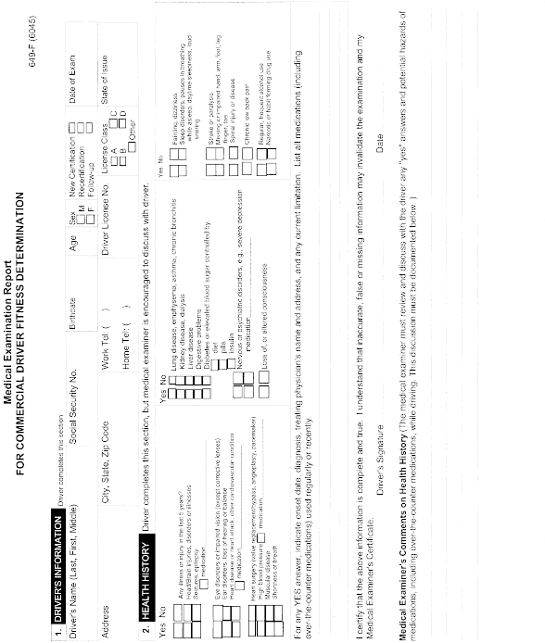
View or download PDF
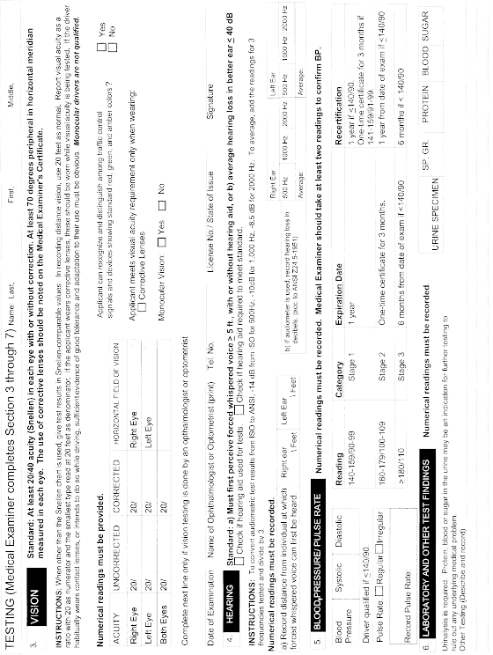
View or download PDF
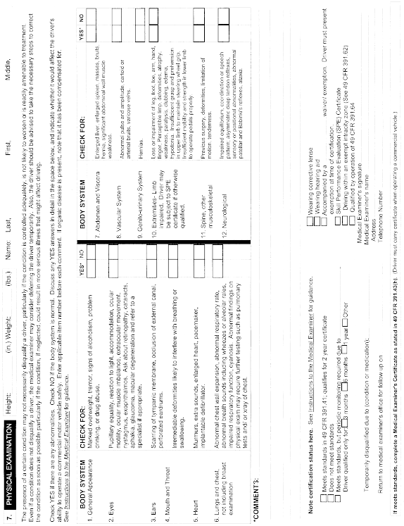
View or download PDF
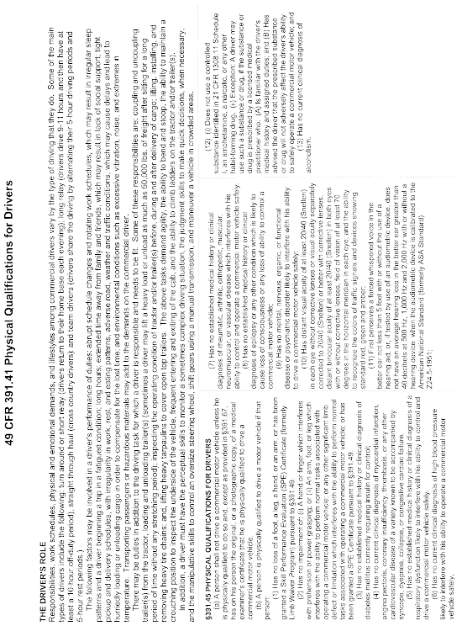
View or download PDF
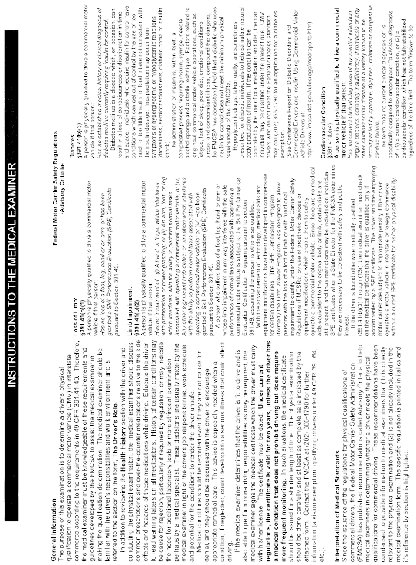
View or download PDF
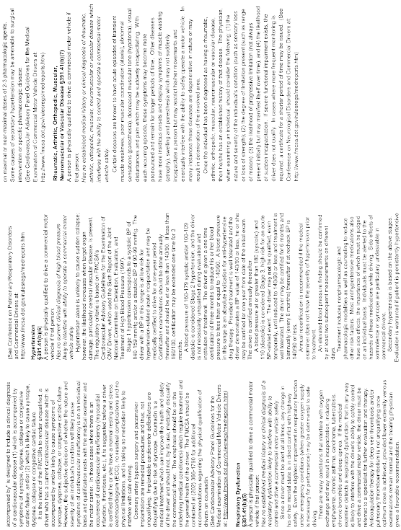
View or download PDF
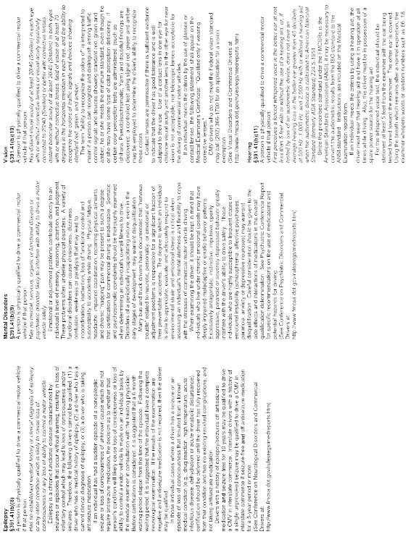
View or download PDF

View or download PDF
(g)(1) If the medical examiner finds that the person examined is physically qualified to operate a commercial motor vehicle in accordance with §391.41(b), the medical examiner should complete a certificate in the form prescribed in paragraph (h) of this section and furnish the original to the person who was examined. The examiner may provide a copy to a prospective or current employing motor carrier who requests it.
(2) For all drivers examined, the medical examiner should retain a copy of the Medical Examination Report at least 3 years from the date of the examination. If the driver was certified as physically qualified, then the medical examiner should also retain the medical certificate as well for at least 3-years from the date the certificate was issued.
(h) The medical examiner's certificate shall be substantially in accordance with the following form. Existing forms may be used until current printed supplies are depleted or until November 6, 2001, whichever occurs first.
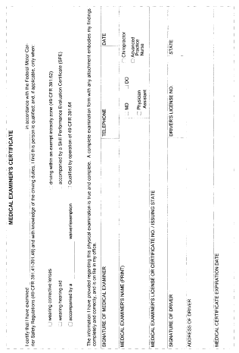
View or download PDF
[35 FR 6460, Apr. 22, 1970]
Editorial Note: ForFederal Registercitations affecting §391.43, see the List of CFR Sections Affected, which appears in the Finding Aids section of the printed volume and on GPO Access.

§ 391.45 Persons who must be medically examined and certified.
top
Except as provided in §391.67, the following persons must be medically examined and certified in accordance with §391.43 as physically qualified to operate a commercial motor vehicle:
(a) Any person who has not been medically examined and certified as physically qualified to operate a commercial motor vehicle;
(b)(1) Any driver who has not been medically examined and certified as qualified to operate a commercial motor vehicle during the preceding 24 months; or
(2) Any driver authorized to operate a commercial motor vehicle only with an exempt intracity zone pursuant to §391.62, or only by operation of the exemption in §391.64, if such driver has not been medically examined and certified as qualified to drive in such zone during the preceding 12 months; and
(c) Any driver whose ability to perform his/her normal duties has been impaired by a physical or mental injury or disease.
[35 FR 6460, Apr. 22, 1970, as amended at 36 FR 223, Jan. 7, 1971; 54 FR 12202, Mar. 24, 1989; 61 FR 13347, Mar. 26, 1996]

§ 391.47 Resolution of conflicts of medical evaluation.
top
(a) Applications. Applications for determination of a driver's medical qualifications under standards in this part will only be accepted if they conform to the requirements of this section.
(b) Content. Applications will be accepted for consideration only if the following conditions are met.
(1) The application must contain the name and address of the driver, motor carrier, and all physicians involved in the proceeding.
(2) The applicant must submit proof that there is a disagreement between the physician for the driver and the physician for the motor carrier concerning the driver's qualifications.
(3) The applicant must submit a copy of an opinion and report including results of all tests of an impartial medical specialist in the field in which the medical conflict arose. The specialist should be one agreed to by the motor carrier and the driver.
(i) In cases where the driver refuses to agree on a specialist and the applicant is the motor carrier, the applicant must submit a statement of his/her agreement to submit the matter to an impartial medical specialist in the field, proof that he/she has requested the driver to submit to the medical specialist, and the response, if any, of the driver to his/her request.
(ii) In cases where the motor carrier refuses to agree on a medical specialist, the driver must submit an opinion and test results of an impartial medical specialist, proof that he/she has requested the motor carrier to agree to submit the matter to the medical specialist and the response, if any, of the motor carrier to his/her request.
(4) The applicant must include a statement explaining in detail why the decision of the medical specialist identified in paragraph (b)(3) of this section, is unacceptable.
(5) The applicant must submit proof that the medical specialist mentioned in paragraph (b)(3) of this section was provided, prior to his/her determination, the medical history of the driver and an agreed-upon statement of the work the driver performs.
(6) The applicant must submit the medical history and statement of work provided to the medical specialist under paragraph (b)(5) of this section.
(7) The applicant must submit all medical records and statements of the physicians who have given opinions on the driver's qualifications.
(8) The applicant must submit a description and a copy of all written and documentary evidence upon which the party making application relies in the form set out in 49 CFR 386.37.
(9) The application must be accompanied by a statement of the driver that he/she intends to drive in interstate commerce not subject to the commercial zone exemption or a statement of the carrier that he/she has used or intends to use the driver for such work.
(10) The applicant must submit three copies of the application and all records.
(c) Information. The Director, Office of Bus and Truck Standards and Operations (MC-PSDPSD) may request further information from the applicant if he/she determines that a decision cannot be made on the evidence submitted. If the applicant fails to submit the information requested, the Director may refuse to issue a determination.
(d)(1) Action. Upon receiving a satisfactory application the Director, Office of Bus and Truck Standards and Operations (MC-PSDPSD) shall notify the parties (the driver, motor carrier, or any other interested party) that the application has been accepted and that a determination will be made. A copy of all evidence received shall be attached to the notice.
(2) Reply. Any party may submit a reply to the notification within 15 days after service. Such reply must be accompanied by all evidence the party wants the Director, Office of Bus and Truck Standards and Operations (MC-PSDPSD) to consider in making his/her determination. Evidence submitted should include all medical records and test results upon which the party relies.
(3) Parties. A party for the purposes of this section includes the motor carrier and the driver, or anyone else submitting an application.
(e) Petitions to review, burden of proof. The driver or motor carrier may petition to review the Director's determination. Such petition must be submitted in accordance with §386.13(a) of this chapter. The burden of proof in such a proceeding is on the petitioner.
(f) Status of driver. Once an application is submitted to the Director, Office of Bus and Truck Standards and Operations (MC-PSDPSD), the driver shall be deemed disqualified until such time as the Director, Office of Bus and Truck Standards and Operations (MC-PSDPSD) makes a determination, or until the Director, Office of Bus and Truck Standards and Operations (MC-PSDPSD) orders otherwise.
(49 U.S.C. 304, 322; 18 U.S.C. 831–835; Pub. L. 93–633, 88 Stat. 8156 (49 U.S.C. 1801, et seq .); 49 CFR 1.48, 301.60)
[42 FR 18081, Apr. 5, 1977, as amended at 42 FR 53966, Oct. 4, 1977; 60 FR 38746, July 28, 1995]

§ 391.49 Alternative physical qualification standards for the loss or impairment of limbs.
top
(a) A person who is not physically qualified to drive under §391.41(b)(1) or (b)(2) and who is otherwise qualified to drive a commercial motor vehicle, may drive a commercial motor vehicle, if the Division Administrator, FMCSA, has granted a Skill Performance Evaluation (SPE) Certificate to that person.
(b) SPE certificate. —(1) Application. A letter of application for an SPE certificate may be submitted jointly by the person (driver applicant) who seeks an SPE certificate and by the motor carrier that will employ the driver applicant, if the application is accepted.
(2) Application address. The application must be addressed to the applicable field service center, FMCSA, for the State in which the co-applicant motor carrier's principal place of business is located. The address of each, and the States serviced, are listed in §390.27 of this chapter.
(3) Exception. A letter of application for an SPE certificate may be submitted unilaterally by a driver applicant. The application must be addressed to the field service center, FMCSA, for the State in which the driver has legal residence. The driver applicant must comply with all the requirements of paragraph (c) of this section except those in (c)(1)(i) and (iii). The driver applicant shall respond to the requirements of paragraphs (c)(2)(i) to (v) of this section, if the information is known.
(c) A letter of application for an SPE certificate shall contain:
(1) Identification of the applicant(s):
(i) Name and complete address of the motor carrier coapplicant;
(ii) Name and complete address of the driver applicant;
(iii) The U.S. DOT Motor Carrier Identification Number, if known; and
(iv) A description of the driver applicant's limb impairment for which SPE certificate is requested.
(2) Description of the type of operation the driver will be employed to perform:
(i) State(s) in which the driver will operate for the motor carrier coapplicant (if more than 10 States, designate general geographic area only);
(ii) Average period of time the driver will be driving and/or on duty, per day;
(iii) Type of commodities or cargo to be transported;
(iv) Type of driver operation ( i.e., sleeper team, relay, owner operator, etc.); and
(v) Number of years experience operating the type of commercial motor vehicle(s) requested in the letter of application and total years of experience operating all types of commercial motor vehicles.
(3) Description of the commercial motor vehicle(s) the driver applicant intends to drive:
(i) Truck, truck tractor, or bus make, model, and year (if known);
(ii) Drive train;
(A) Transmission type (automatic or manual—if manual, designate number of forward speeds);
(B) Auxiliary transmission (if any) and number of forward speeds; and
(C) Rear axle (designate single speed, 2 speed, or 3 speed).
(iii) Type of brake system;
(iv) Steering, manual or power assisted;
(v) Description of type of trailer(s) ( i.e., van, flatbed, cargo tank, drop frame, lowboy, or pole);
(vi) Number of semitrailers or full trailers to be towed at one time;
(vii) For commercial motor vehicles designed to transport passengers, indicate the seating capacity of commercial motor vehicle; and
(viii) Description of any modification(s) made to the commercial motor vehicle for the driver applicant; attach photograph(s) where applicable.
(4) Otherwise qualified:
(i) The coapplicant motor carrier must certify that the driver applicant is otherwise qualified under the regulations of this part;
(ii) In the case of a unilateral application, the driver applicant must certify that he/she is otherwise qualified under the regulations of this part.
(5) Signature of applicant(s):
(i) Driver applicant's signature and date signed;
(ii) Motor carrier official's signature (if application has a coapplicant), title, and date signed. Depending upon the motor carrier's organizational structure (corporation, partnership, or proprietorship), the signer of the application shall be an officer, partner, or the proprietor.
(d) The letter of application for an SPE certificate shall be accompanied by:
(1) A copy of the results of the medical examination performed pursuant to §391.43;
(2) A copy of the medical certificate completed pursuant to §391.43(h);
(3) A medical evaluation summary completed by either a board qualified or board certified physiatrist (doctor of physical medicine) or orthopedic surgeon. The coapplicant motor carrier or the driver applicant shall provide the physiatrist or orthopedic surgeon with a description of the job-related tasks the driver applicant will be required to perform;
(i) The medical evaluation summary for a driver applicant disqualified under §391.41(b)(1) shall include:
(A) An assessment of the functional capabilities of the driver as they relate to the ability of the driver to perform normal tasks associated with operating a commercial motor vehicle; and
(B) A statement by the examiner that the applicant is capable of demonstrating precision prehension ( e.g., manipulating knobs and switches) and power grasp prehension ( e.g., holding and maneuvering the steering wheel) with each upper limb separately. This requirement does not apply to an individual who was granted a waiver, absent a prosthetic device, prior to the publication of this amendment.
(ii) The medical evaluation summary for a driver applicant disqualified under §391.41(b)(2) shall include:
(A) An explanation as to how and why the impairment interferes with the ability of the applicant to perform normal tasks associated with operating a commercial motor vehicle;
(B) An assessment and medical opinion of whether the condition will likely remain medically stable over the lifetime of the driver applicant; and
(C) A statement by the examiner that the applicant is capable of demonstrating precision prehension ( e.g., manipulating knobs and switches) and power grasp prehension ( e.g., holding and maneuvering the steering wheel) with each upper limb separately. This requirement does not apply to an individual who was granted an SPE certificate, absent an orthotic device, prior to the publication of this amendment.
(4) A description of the driver applicant's prosthetic or orthotic device worn, if any;
(5) Road test:
(i) A copy of the driver applicant's road test administered by the motor carrier coapplicant and the certificate issued pursuant to §391.31(b) through (g); or
(ii) A unilateral applicant shall be responsible for having a road test administered by a motor carrier or a person who is competent to administer the test and evaluate its results.
(6) Application for employment:
(i) A copy of the driver applicant's application for employment completed pursuant to §391.21; or
(ii) A unilateral applicant shall be responsible for submitting a copy of the last commercial driving position's employment application he/she held. If not previously employed as a commercial driver, so state.
(7) A copy of the driver applicant's SPE certificate of certain physical defects issued by the individual State(s), where applicable; and
(8) A copy of the driver applicant's State Motor Vehicle Driving Record for the past 3 years from each State in which a motor vehicle driver's license or permit has been obtained.
(e) Agreement. A motor carrier that employs a driver with an SPE certificate agrees to:
(1) File promptly (within 30 days of the involved incident) with the Medical Program Specialist, FMCSA service center, such documents and information as may be required about driving activities, accidents, arrests, license suspensions, revocations, or withdrawals, and convictions which involve the driver applicant. This applies whether the driver's SPE certificate is a unilateral one or has a coapplicant motor carrier;
(i) A motor carrier who is a coapplicant must file the required documents with the Medical Program Specialist, FMCSA for the State in which the carrier's principal place of business is located; or
(ii) A motor carrier who employs a driver who has been issued a unilateral SPE certificate must file the required documents with the Medical Program Specialist, FMCSA service center, for the State in which the driver has legal residence.
(2) Evaluate the driver with a road test using the trailer the motor carrier intends the driver to transport or, in lieu of, accept a certificate of a trailer road test from another motor carrier if the trailer type(s) is similar, or accept the trailer road test done during the Skill Performance Evaluation if it is a similar trailer type(s) to that of the prospective motor carrier. Job tasks, as stated in paragraph (e)(3) of this section, are not evaluated in the Skill Performance Evaluation;
(3) Evaluate the driver for those nondriving safety related job tasks associated with whatever type of trailer(s) will be used and any other nondriving safety related or job related tasks unique to the operations of the employing motor carrier; and
(4) Use the driver to operate the type of commercial motor vehicle defined in the SPE certificate only when the driver is in compliance with the conditions and limitations of the SPE certificate.
(f) The driver shall supply each employing motor carrier with a copy of the SPE certificate.
(g) The State Director, FMCSA, may require the driver applicant to demonstrate his or her ability to safely operate the commercial motor vehicle(s) the driver intends to drive to an agent of the State Director, FMCSA. The SPE certificate form will identify the power unit (bus, truck, truck tractor) for which the SPE certificate has been granted. The SPE certificate forms will also identify the trailer type used in the Skill Performance Evaluation; however, the SPE certificate is not limited to that specific trailer type. A driver may use the SPE certificate with other trailer types if a successful trailer road test is completed in accordance with paragraph (e)(2) of this section. Job tasks, as stated in paragraph (e)(3) of this section, are not evaluated during the Skill Performance Evaluation.
(h) The State Director, FMCSA, may deny the application for SPE certificate or may grant it totally or in part and issue the SPE certificate subject to such terms, conditions, and limitations as deemed consistent with the public interest. The SPE certificate is valid for a period not to exceed 2 years from date of issue, and may be renewed 30 days prior to the expiration date.
(i) The SPE certificate renewal application shall be submitted to the Medical Program Specialist, FMCSA service center, for the State in which the driver has legal residence, if the SPE certificate was issued unilaterally. If the SPE certificate has a coapplicant, then the renewal application is submitted to the Medical Program Specialist, FMCSA field service center, for the State in which the coapplicant motor carrier's principal place of business is located. The SPE certificate renewal application shall contain the following:
(1) Name and complete address of motor carrier currently employing the applicant;
(2) Name and complete address of the driver;
(3) Effective date of the current SPE certificate;
(4) Expiration date of the current SPE certificate;
(5) Total miles driven under the current SPE certificate;
(6) Number of accidents incurred while driving under the current SPE certificate, including date of the accident(s), number of fatalities, number of injuries, and the estimated dollar amount of property damage;
(7) A current medical examination report;
(8) A medical evaluation summary pursuant to paragraph (d)(3) of this section, if an unstable medical condition exists. All handicapped conditions classified under §391.41(b)(1) are considered unstable. Refer to paragraph (d)(3)(ii) of this section for the condition under §391.41(b)(2) which may be considered medically stable.
(9) A copy of driver's current State motor vehicle driving record for the period of time the current SPE certificate has been in effect;
(10) Notification of any change in the type of tractor the driver will operate;
(11) Driver's signature and date signed; and
(12) Motor carrier coapplicant's signature and date signed.
(j)(1) Upon granting an SPE certificate, the State Director, FMCSA, will notify the driver applicant and co-applicant motor carrier (if applicable) by letter. The terms, conditions, and limitations of the SPE certificate will be set forth. A motor carrier shall maintain a copy of the SPE certificate in its driver qualification file. A copy of the SPE certificate shall be retained in the motor carrier's file for a period of 3 years after the driver's employment is terminated. The driver applicant shall have the SPE certificate (or a legible copy) in his/her possession whenever on duty.
(2) Upon successful completion of the skill performance evaluation, the State Director, FMCSA, for the State where the driver applicant has legal residence, must notify the driver by letter and enclose an SPE certificate substantially in the following form:
Skill Performance Evaluation Certificate
Name of Issuing Agency:____________________
Agency Address:____________________
Telephone Number: ( )____________________
Issued Under 49 CFR 391.49, subchapter B of the Federal Motor Carrier Safety Regulations
Driver's Name:____________________
Effective Date:____________________
SSN:____________________
DOB:____________________
Expiration Date:____________________
Address:____________________
____________________
____________________
Driver Disability:____________________
Check One:_New_Renewal
Driver's License:_________________________
(State) (Number)
In accordance with 49 CFR 391.49, subchapter B of the Federal Motor Carrier Safety Regulations (FMCSRs), the driver application for a skill performance evaluation (SPE) certificate is hereby granted authorizing the above-named driver to operate in interstate or foreign commerce under the provisions set forth below. This certificate is granted for the period shown above, not to exceed 2 years, subject to periodic review as may be found necessary. This certificate may be renewed upon submission of a renewal application. Continuation of this certificate is dependent upon strict adherence by the above-named driver to the provisions set forth below and compliance with the FMCSRs. Any failure to comply with provisions herein may be cause for cancellation.
CONDITIONS: As a condition of this certificate, reports of all accidents, arrests, suspensions, revocations, withdrawals of driver licenses or permits, and convictions involving the above-named driver shall be reported in writing to the Issuing Agency by the EMPLOYING MOTOR CARRIER within 30 days after occurrence.
LIMITATIONS:
1. Vehicle Type (power unit):*____________________
2. Vehicle modification(s):____________________
____________________
3. Prosthetic or Orthotic device(s) (Required to be Worn While Driving):____________________
____________________
4. Additional Provision(s):____________________
____________________
NOTICE: To all MOTOR CARRIERS employing a driver with an SPE certificate. This certificate is granted for the operation of the power unit only. It is the responsibility of the employing motor carrier to evaluate the driver with a road test using the trailer type(s) the motor carrier intends the driver to transport, or in lieu of, accept the trailer road test done during the SPE if it is a similar trailer type(s) to that of the prospective motor carrier. Also, it is the responsibility of the employing motor carrier to evaluate the driver for those non-driving safety-related job tasks associated with the type of trailer(s) utilized, as well as, any other non-driving safety-related or job-related tasks unique to the operations of the employing motor carrier.
The SPE of the above named driver was given by a Skill Performance Evaluation Program Specialist. It was successfully completed utilizing the above named power unit and ________ (trailer, if applicable)
The tractor or truck had a ________ transmission.
Please read the NOTICE paragraph above.
Name:____________________
Signature:____________________
Title:____________________
Date:____________________
(k) The State Director, FMCSA, may revoke an SPE certificate after the person to whom it was issued is given notice of the proposed revocation and has been allowed a reasonable opportunity to appeal.
(l) Falsifying information in the letter of application, the renewal application, or falsifying information required by this section by either the applicant or motor carrier is prohibited.
[65 FR 25287, May 1, 2000, as amended at 65 FR 59380, Oct. 5, 2000; 67 FR 61824, Oct. 2, 2002]

Subpart F—Files and Records
top

§ 391.51 General requirements for driver qualification files.
top
(a) Each motor carrier shall maintain a driver qualification file for each driver it employs. A driver's qualification file may be combined with his/her personnel file.
(b) The qualification file for a driver must include:
(1) The driver's application for employment completed in accordance with §391.21;
(2) A copy of the motor vehicle record received from each State record pursuant to §391.23(a)(1);
(3) The certificate of driver's road test issued to the driver pursuant to §391.31(e), or a copy of the license or certificate which the motor carrier accepted as equivalent to the driver's road test pursuant to §391.33;
(4) The motor vehicle record received from each State driver licensing agency to the annual driver record inquiry required by §391.25(a);
(5) A note relating to the annual review of the driver's driving record as required by §391.25(c)(2);
(6) A list or certificate relating to violations of motor vehicle laws and ordinances required by §391.27;
(7)(i) The medical examiner's certificate as required by §391.43(g) or a legible copy of the certificate.
(ii) Exception. For CDL drivers beginning January 30, 2012, if the CDLIS motor vehicle record contains medical certification status information, the motor carrier employer must meet this requirement by obtaining the CDLIS motor vehicle record defined at §384.105 of this chapter. That record must be obtained from the current licensing State and placed in the driver qualification file. After January 30, 2014, a non-excepted, interstate CDL driver without medical certification status information on the CDLIS motor vehicle record is designated “not-certified” to operate a CMV in interstate commerce. For up to 15 days from the date stamped on the receipt of the medical examiner's certificate, provided to the driver by the State driver licensing agency, a motor carrier may use that receipt as proof of the driver's medical certification.
(iii) If that driver obtained the medical certification based on having obtained a medical variance from FMCSA, the motor carrier must also include a copy of the medical variance documentation in the driver qualification file in accordance with §391.51(b)(8); and
(8) A Skill Performance Evaluation Certificate obtained from a Field Administrator, Division Administrator, or State Director issued in accordance with §391.49; or the Medical Exemption document, issued by a Federal medical program in accordance with part 381 of this chapter.
(c) Except as provided in paragraph (d) of this section, each driver's qualification file shall be retained for as long as a driver is employed by that motor carrier and for three years thereafter.
(d) The following records may be removed from a driver's qualification file three years after the date of execution:
(1) The motor vehicle record received from each State driver licensing agency to the annual driver record inquiry required by §391.25(a);
(2) The note relating to the annual review of the driver's driving record as required by §391.25(c)(2);
(3) The list or certificate relating to violations of motor vehicle laws and ordinances required by §391.27;
(4) The medical examiner's certificate required by §391.43(g), a legible copy of the certificate, or for CDL drivers any CDLIS MVR obtained as required by §391.51(b)(7)(ii); and
(5) Any medical variance issued by FMCSA, including a Skill Performance Evaluation Certificate issued in accordance with §391.49; or the Medical Exemption letter issued by a Federal medical program in accordance with part 381 of this chapter.
(Approved by the Office of Management and Budget under control number 2126–004)
[63 FR 33277, June 18, 1998, as amended at 69 FR 16721, Mar. 30, 2004; 73 FR 73127, Dec. 1, 2008]

§ 391.53 Driver investigation history file.
top
(a) After October 29, 2004, each motor carrier must maintain records relating to the investigation into the safety performance history of a new or prospective driver pursuant to paragraphs (d) and (e) of §391.23. This file must be maintained in a secure location with controlled access.
(1) The motor carrier must ensure that access to this data is limited to those who are involved in the hiring decision or who control access to the data. In addition, the motor carrier's insurer may have access to the data, except the alcohol and controlled substances data.
(2) This data must only be used for the hiring decision.
(b) The file must include:
(1) A copy of the driver's written authorization for the motor carrier to seek information about a driver's alcohol and controlled substances history as required under §391.23(d).
(2) A copy of the response(s) received for investigations required by paragraphs (d) and (e) of §391.23 from each previous employer, or documentation of good faith efforts to contact them. The record must include the previous employer's name and address, the date the previous employer was contacted, and the information received about the driver from the previous employer. Failures to contact a previous employer, or of them to provide the required safety performance history information, must be documented.
(c) The safety performance histories received from previous employers for a driver who is hired must be retained for as long as the driver is employed by that motor carrier and for three years thereafter.
(d) A motor carrier must make all records and information in this file available to an authorized representative or special agent of the Federal Motor Carrier Safety Administration, an authorized State or local enforcement agency representative, or an authorized third party, upon request or as part of any inquiry within the time period specified by the requesting representative.
(Approved by the Office of Management and Budget under control number 2126–004)
[69 FR 16721, Mar. 30, 2004]

§ 391.55 LCV Driver-Instructor qualification files.
top
(a) Each motor carrier must maintain a qualification file for each LCV driver-instructor it employs or uses. The LCV driver-instructor qualification file may be combined with his/her personnel file.
(b) The LCV driver-instructor qualification file must include the information in paragraphs (b)(1) and (b)(2) of this section for a skills instructor or the information in paragraph (b)(1) of this section for a classroom instructor, as follows:
(1) Evidence that the instructor has met the requirements of 49 CFR 380.301 or 380.303;
(2) A photographic copy of the individual's currently valid CDL with the appropriate endorsements.
[69 FR 16738, Mar. 30, 2004; 69 FR 28846, May 19, 2004]

Subpart G—Limited Exemptions
top

§ 391.61 Drivers who were regularly employed before January 1, 1971.
top
The provisions of §391.21 (relating to applications for employment), §391.23 (relating to investigations and inquiries), and §391.33 (relating to road tests) do not apply to a driver who has been a single-employer driver (as defined in §390.5 of this subchapter) of a motor carrier for a continuous period which began before January 1, 1971, as long as he/she continues to be a single-employer driver of that motor carrier.
[63 FR 33278, June 18, 1998]

§ 391.62 Limited exemptions for intra-city zone drivers.
top
The provisions of §§391.11(b)(1) and 391.41(b)(1) through (b)(11) do not apply to a person who:
(a) Was otherwise qualified to operate and operated a commercial motor vehicle in a municipality or exempt intracity zone thereof throughout the one-year period ending November 18, 1988;
(b) Meets all the other requirements of this section;
(c) Operates wholly within the exempt intracity zone (as defined in 49 CFR 390.5);
(d) Does not operate a vehicle used in the transportation of hazardous materials in a quantity requiring placarding under regulations issued by the Secretary under 49 U.S.C. chapter 51.; and
(e) Has a medical or physical condition which:
(1) Would have prevented such person from operating a commercial motor vehicle under the Federal Motor Carrier Safety Regulations contained in this subchapter;
(2) Existed on July 1, 1988, or at the time of the first required physical examination after that date; and
(3) The examining physician has determined this condition has not substantially worsened since July 1, 1988, or at the time of the first required physical examination after that date.
[61 FR 13346, Mar. 26, 1996; 61 FR 17253, Apr. 19, 1996]

§ 391.63 Multiple-employer drivers.
top
(a) If a motor carrier employs a person as a multiple-employer driver (as defined in §390.5 of this subchapter), the motor carrier shall comply with all requirements of this part, except that the motor carrier need not—
(1) Require the person to furnish an application for employment in accordance with §391.21;
(2) Make the investigations and inquiries specified in §391.23 with respect to that person;
(3) Perform the annual driving record inquiry required by §391.25(a);
(4) Perform the annual review of the person's driving record required by §391.25(b); or
(5) Require the person to furnish a record of violations or a certificate in accordance with §391.27.
(b) Before a motor carrier permits a multiple-employer driver to drive a commercial motor vehicle, the motor carrier must obtain his/her name, his/her social security number, and the identification number, type and issuing State of his/her commercial motor vehicle operator's license. The motor carrier must maintain this information for three years after employment of the multiple-employer driver ceases.
(Approved by the Office of Management and Budget under control number 2125–0081)
[63 FR 33278, June 18, 1998]

§ 391.64 Grandfathering for certain drivers participating in vision and diabetes waiver study programs.
top
(a) The provisions of §391.41(b)(3) do not apply to a driver who was a participant in good standing on March 31, 1996, in a waiver study program concerning the operation of commercial motor vehicles by insulin-controlled diabetic drivers; provided:
(1) The driver is physically examined every year, including an examination by a board-certified/eligible endocrinologist attesting to the fact that the driver is:
(i) Otherwise qualified under §391.41;
(ii) Free of insulin reactions (an individual is free of insulin reactions if that individual does not have severe hypoglycemia or hypoglycemia unawareness, and has less than one documented, symptomatic hypoglycemic reaction per month);
(iii) Able to and has demonstrated willingness to properly monitor and manage his/her diabetes; and
(iv) Not likely to suffer any diminution in driving ability due to his/her diabetic condition.
(2) The driver agrees to and complies with the following conditions:
(i) A source of rapidly absorbable glucose shalll be carried at all times while driving;
(ii) Blood glucose levels shall be self-monitored one hour prior to driving and at least once every four hours while driving or on duty prior to driving using a portable glucose monitoring device equipped with a computerized memory;
(iii) Submit blood glucose logs to the endocrinologist or medical examiner at the annual examination or when otherwise directed by an authorized agent of the FMCSA;
(iv) Provide a copy of the endocrinologist's report to the medical examiner at the time of the annual medical examination; and
(v) Provide a copy of the annual medical certification to the employer for retention in the driver's qualification file and retain a copy of the certification on his/her person while driving for presentation to a duly authorized Federal, State or local enforcement official.
(b) The provisions of §391.41(b)(10) do not apply to a driver who was a participant in good standing on March 31, 1996, in a waiver study program concerning the operation of commercial motor vehicles by drivers with visual impairment in one eye; provided:
(1) The driver is physically examined every year, including an examination by an ophthalmologist or optometrist attesting to the fact that the driver:
(i) Is otherwise qualified under §391.41; and
(ii) Continues to measure at least 20/40 (Snellen) in the better eye.
(2) The driver provides a copy of the ophthalmologist or optometrist report to the medical examiner at the time of the annual medical examination.
(3) The driver provides a copy of the annual medical certification to the employer for retention in the driver's qualification file and retains a copy of the certification on his/her person while driving for presentation to a duly authorized federal, state or local enforcement official.
[61 FR 13346, Mar. 26, 1996]

§ 391.65 Drivers furnished by other motor carriers.
top
(a) A motor carrier may employ a driver who is not a regularly employed driver of that motor carrier without complying with the generally applicable driver qualification file requirements in this part, if—
(1) The driver is regularly employed by another motor carrier; and
(2) The motor carrier which regularly employs the driver certifies that the driver is fully qualified to drive a commercial motor vehicle in a written statement which—
(i) Is signed and dated by an officer or authorized employee of the regularly employing carrier;
(ii) Contains the driver's name and signature;
(iii) Certifies that the driver has been regularly employed as defined in §390.5;
(iv) Certifies that the driver is fully qualified to drive a commercial motor vehicle under the rules in part 391 of the Federal Motor Carrier Safety Regulations;
(v) States the expiration date of the driver's medical examiner's certificate;
(vi) Specifies an expiration date for the certificate, which shall be not longer than 2 years or, if earlier, the expiration date of the driver's current medical examiner's certificate; and
(vii) After April 1, 1977, is substantially in accordance with the following form:
(Name of driver) (SS No.)(Signature of driver)
I certify that the above named driver, as defined in §390.5 is regularly driving a commercial motor vehicle operated by the below named carrier and is fully qualified under part 391, Federal Motor Carrier Safety Regulations. His/her current medical examiner's certificate expires on ____ (Date)
This certificate expires:
(Date not later than expiration date of medical certificate)
Issued on ____ (date)
Issued by __________(Name of carrier)(Address)(Signature) ________________________________ (Title) ____________________________________
(b) A motor carrier that obtains a certificate in accordance with paragraph (a)(2) of this section shall:
(1) Contact the motor carrier which certified the driver's qualifications under this section to verify the validity of the certificate. This contact may be made in person, by telephone, or by letter.
(2) Retain a copy of that certificate in its files for three years.
(c) A motor carrier which certifies a driver's qualifications under this section shall be responsible for the accuracy of the certificate. The certificate is no longer valid if the driver leaves the employment of the motor carrier which issued the certificate or is no longer qualified under the rules in this part.
[41 FR 36656, Aug. 31, 1976, as amended at 53 FR 18057, May 19, 1988; 60 FR 38745, July 28, 1995; 63 FR 33278, June 18, 1998; 67 FR 61824, Oct. 2, 2002]

§ 391.67 Farm vehicle drivers of articulated commercial motor vehicles.
top
The following rules in this part do not apply to a farm vehicle driver (as defined in §390.5 of this subchapter) who is 18 years of age or older and who drives an articulated commercial motor vehicle:
(a) Section 391.11(b)(1), (b)(6) and (b)(8) (relating to general qualifications of drivers);
(b) Subpart C (relating to disclosure of, investigation into, and inquiries about the background, character, and driving record of drivers);
(c) Subpart D (relating to road tests); and
(d) Subpart F (relating to maintenance of files and records).
[63 FR 33278, June 18, 1998]

§ 391.68 Private motor carrier of passengers (nonbusiness).
top
The following rules in this part do not apply to a private motor carrier of passengers (nonbusiness) and its drivers:
(a) Section 391.11(b)(1), (b)(6) and (b)(8) (relating to general qualifications of drivers);
(b) Subpart C (relating to disclosure of, investigation into, and inquiries about the background, character, and driving record of, drivers);
(c) So much of §§391.41 and 391.45 as require a driver to be medically examined and to have a medical examiner's certificate on his/her person; and
(d) Subpart F (relating to maintenance of files and records).
[63 FR 33278, June 18, 1998]

§ 391.69 Private motor carrier of passengers (business).
top
The provisions of §391.21 (relating to applications for employment), §391.23 (relating to investigations and inquiries), and §391.31 (relating to road tests) do not apply to a driver who was a single-employer driver (as defined in §390.5 of this subchapter) of a private motor carrier of passengers (business) as of July 1, 1994, so long as the driver continues to be a single-employer driver of that motor carrier.
[63 FR 33278, June 18, 1998]

§ 391.71 [Reserved]
top

