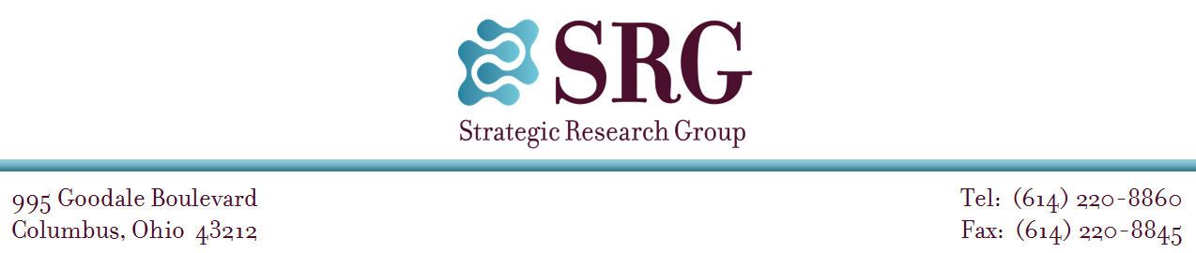

[DATE HERE]

[FIRST_NAME] [LAST_NAME] [SUFFIX]

[STREET_ADDRESS]

[CITY] [STATE] [ZIP_CODE]

Dear [FIRST_NAME] [LAST_NAME] [SUFFIX]:

The Maritime Administration (MARAD), U.S. Department of Transportation (DOT), has contracted with Strategic Research Group (SRG), an independent research firm, to administer the Mariner Survey 2022 to appropriately credentialed merchant mariners. This survey is vital to ensure MARAD has a true representation of how many qualified mariners would be willing to serve in times of National Need (war, armed conflict, or national emergency).

Before survey launch, SRG is working with MARAD to test the Mariner Survey 2022 questionnaire with a small number of mariners. This testing will help ensure that high-quality data are collected during the full survey effort. We are inviting you to contribute to this testing effort by taking the survey and participating in a telephone interview shortly thereafter. You can complete the survey either online or on a printed copy sent by mail. The survey will take approximately 20 minutes to complete.

The 30-minute telephone interview that will follow your completion of the survey will ask your opinions about the content and design of the survey. Your responses to the survey and the interview will be kept confidential and will not be provided to MARAD in any way that could identify you personally.

To thank you for your time and assistance with testing the Mariner Survey 2022 questionnaire, you will receive a $50 check after completing the survey and interview.

If you are interested in participating, please call SRG at 1-800-341-3660 **within the next seven days** to reserve your spot**.** During your call, an SRG researcher will explain the process, schedule your survey and interview, and answer any questions you may have.

If you have general questions about the survey effort or would like to verify MARAD’s support for this survey, please contact Nuns Jain, Program Excellence & Quality Assurance Advisor, Maritime Administration, U.S. DOT, at 757-322-5801 or Nuns.Jain@dot.gov.

Thank you in advance for your help with testing this very important survey.

Sincerely,

Dr. Kristen Heimdal

Project Director



U.S. Department                                                                       1200 New Jersey Avenue, S.E.

Of Transportation                      Administrator                         Washington, DC 20590

**Maritime**

**Administration**

[DATE]

[FIRST NAME] [LAST NAME] [SUFFIX]

[ADDRESS LINE 1]

[ADDRESS LINE2]

[CITY] [STATE] [ZIP]

Dear [FIRST NAME] [LAST NAME]:

You are invited to participate in the Mariner Survey 2022, which is being conducted by Strategic Research Group (SRG) on behalf of the Maritime Administration (MARAD), U.S. Department of Transportation (DOT).

Participation in this survey is voluntary. However, your input is vital to ensure MARAD has a true representation of how many qualified mariners would be willing to serve in times of National Need (war, armed conflict, or national emergency).

The survey includes questions about your current mariner status, experience sailing in different positions and on different vessels, and willingness to serve in times of National Need. MARAD is asking mariners to complete this survey regardless of whether they are willing to serve in times of National Need. Completing the survey will not obligate you to serve in times of National Need.

As you complete this survey, be assured that your answers are completely confidential. Your responses will not be provided to anyone at MARAD in any way that would identify you personally and all results will be reported as group statistics. The survey should take approximately 20 minutes to complete.

You may access the survey from any web browser by going to: **marinersurvey.websrg.com**

and entering this passcode: [**PASSCODE**]

You can exit and re-enter the survey as needed until you have completed the survey; also, any responses you have entered will be protected if you experience any internet disruptions. However, once you have clicked “finish” after the last question, you will not be able to re-enter the survey.

If you are having problems accessing the survey or have other questions about the survey, please contact SRG at marinersurvey@websrg.com or 800-341-3660.

Thank you in advance for your help with this very important survey.

Sincerely,

[NAME OF MARAD ADMINISTRATOR]