Reminder: We expect that all forms will be embedded into our Operating Fund Web Portal and will be collecting data digitally.
HUD–XXXXX (y): Shortfall Mini Budget
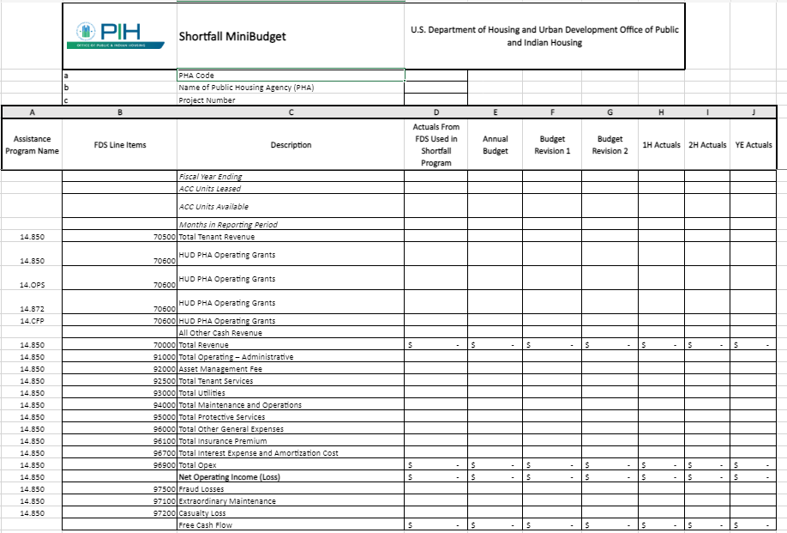
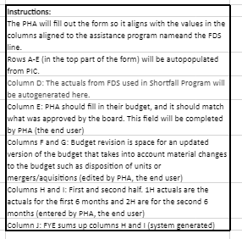
Paperwork Reduction Act burden statement:
Public reporting burden for this collection of information is estimated to average .5 hours per response, including the time for reviewing instructions, searching existing data sources, gathering and maintaining the data needed, and completing and reviewing the collection of information. HUD may not collect this information, and you are not required to complete this form, unless it displays a currently valid OMB control number.
This Shortfall Mini Budget will be used by PHAs to update and report their budget and actuals throughout the year while being part of the Shortfall Program. This will allow HUD to monitor Shortfall Funding Program participants and to evaluate the PHA’s financial and operational performance. This collection of information is mandatory to ensure that HUD is meeting its responsibility to ensure that funds are being used by PHAs to meet the Program’s objective of stabilizing PHAs financially pursuant to 24 CFR 990.280 and 24 CFR 990.285. No assurances of confidentiality are provided for this information collection.

