HUD–XXXXX(z): Action Item Template
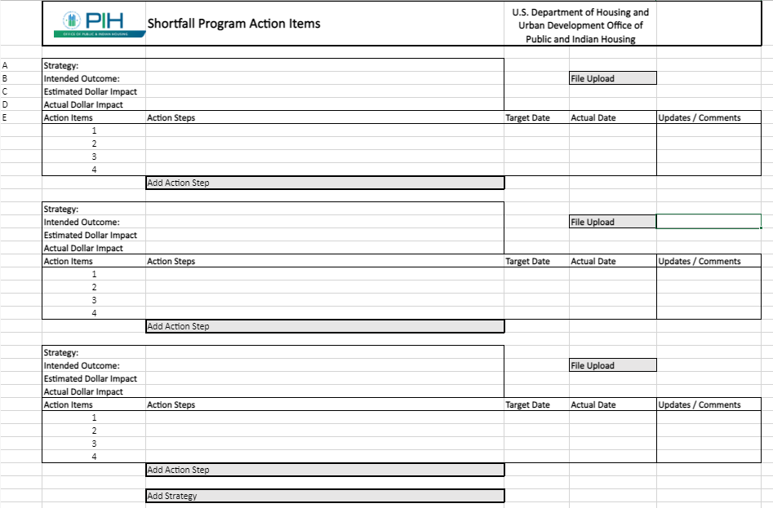
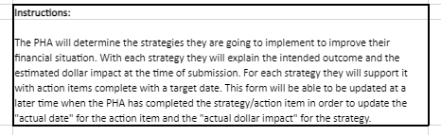

Paperwork Reduction Act burden statement:
Public reporting burden for this collection of information is estimated to average 1 hour per response, including the time for reviewing instructions, searching existing data sources, gathering and maintaining the data needed, and completing and reviewing the collection of information. HUD may not collect this information, and you are not required to complete this form, unless it displays a currently valid OMB control number.
This Action Item Template will be used by PHAs to explain the strategies and actions they are going to take to improve their Months of Operating Reserve (MOR). This will increase PHAs accountability towards making financial improvements and will allow HUD to monitor Shortfall Funding Program participants. This collection of information is mandatory to ensure that HUD is meeting its responsibility to ensure that funds are being used by PHAs to meet the Program’s objective of stabilizing PHAs financially pursuant to 24 CFR 990.280 and 24 CFR 990.285. No assurances of confidentiality are provided for this information collection.

