SUPPORTING STATEMENT
Advertising, Sales, Enrollment Materials, and Candidate Handbooks
OMB #2900-0682
NO VA FORM

A. Justification

1. Explain the circumstances that make the collection of information necessary. Identify legal or administrative requirements that necessitate the collection of information.

38 U.S.C. 3696 requires that any VA approved educational institution maintain a complete record of all advertising, sales, or enrollment materials used by or on behalf of the educational institution during the preceding 12 months. Under 38 U.S.C. 3689, the requirements of section 3696 are applicable to organizations and entities offering licensing or certification tests. For organizations and entities offering licensing or certification tests, candidate handbooks are the equivalent of enrollment materials.

Authority: 38 cfr 21.4252(h)

2. Indicate how, by whom, and for what purposes the information is to be used; indicate actual use the agency has made of the information received from current collection.

The statute prohibits approval of the enrollment of a Veteran in a course if the educational institution uses advertising, sales, or enrollment practices that are erroneous, deceptive, or misleading either by actual statement, omission, or intimation. The advertising, sales and enrollment materials are reviewed to determine if the institution is in compliance with guidelines for approval.

3. Describe whether, and to what extent, the collection of information involves the use of automated, electronic, mechanical, or other technological collection techniques or other forms of information technology, e.g. permitting electronic submission of responses, and the basis for the decision for adopting this means of collection. Also describe any consideration of using information technology to reduce burden.

The materials will be examined when State approving agency (SAA) employees or Department of Veterans Affairs (VA) employees perform a compliance survey.

4. Describe efforts to identify duplication. Show specifically why any similar information already available cannot be used or modified for use for the purposes described in Item 2 above.

Program reviews were conducted to identify potential areas of duplication; however, none were found to exist. There is no known Department or agency which maintains the necessary information, nor is it available from other sources within our Department

5. If the collection of information impacts small businesses or other small entities, describe any methods used to minimize burden.

Some of the educational institutions to which this information collection will apply are small entities. Since these institutions keep copies of the materials and handbooks in the normal course of business, there is no means to minimize the burden.

6. Describe the consequences to Federal program or policy activities if the collection is not conducted or is conducted less frequently as well as any technical or legal obstacles to reducing burden.

VA is forbidden by statute from approving an enrollment at an educational institution that uses erroneous, deceptive or misleading advertising, sales, or enrollment materials. Failure to require educational institutions to keep these materials for a year, or failure to visit educational institutions to view these materials may result in erroneous approvals of enrollments and erroneous payments to those enrolled.

7. Explain any special circumstances that would cause an information collection to be conducted more often than quarterly or require respondents to prepare written responses to a collection of information in fewer than 30 days after receipt of it; submit more than an original and two copies of any document; retain records, other than health, medical, government contract, grant-in-aid, or tax records for more than three years; in connection with a statistical survey that is not designed to produce valid and reliable results that can be generalized to the universe of study and require the use of a statistical data classification that has not been reviewed and approved by OMB.

There is no special circumstance requiring collection in a manner inconsistent with 5 CFR 1320.6 guidelines.

8. If applicable, provide a copy and identify the date and page number of publication in the Federal Register of the sponsor’s notice, required by 5 CFR 1320.8(d), soliciting comments on the information collection prior to submission to OMB. Summarize public comments received in response to that notice and describe actions taken by the sponsor in responses to these comments. Specifically address comments received on cost and hour burden.
The Department notice was published in the Federal Register on December 16, 2021, Volume 86, No. 239, page 71548. Two comments were received.

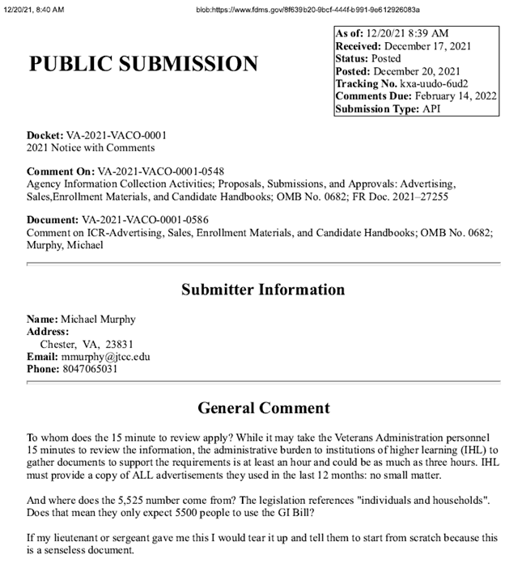

VA RESPONSE: Thanks for the information. We have accepted your recommendation and will implement an adjustment in burden hour time from 15 to 60 minutes, accordingly. Regarding the 5,525, this number is an estimated annual average number of educational institutions and entities approved for VA education training, to which a compliance survey was performed over the course of a 5-year period.

Thanks, Education Service

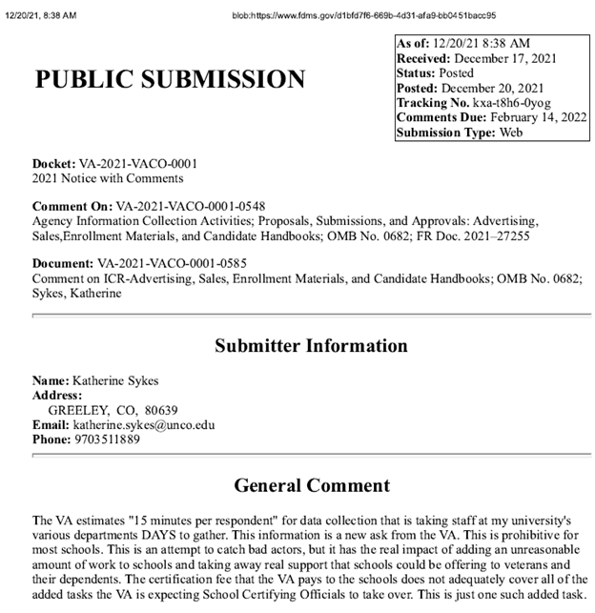

VA RESPONSE: Thanks for the information, we have accepted your recommendation and will implement an adjustment in burden hour time from 15 to 60 minutes, accordingly.

Thanks, Education Service

9. Explain any decision to provide any payment or gift to respondents, other than remuneration of contractors or grantees.

No payments or gifts to respondents have been made under this collection of information.

10. Describe any assurance of privacy, to the extent permitted by law, provided to respondents and the basis for the assurance in statute, regulation, or agency policy.

The documents reviewed for this information collection is retained permanently in the claimant's education folder. Our assurance of confidentiality is covered by 38 U.S.C. 5701 and our System of Records, Compensation, Pension, Education and Veteran Readiness and Employment Records - VA (58VA21/22/28), which are contained in the Privacy Act Issuances, 2012 Compilation.

11. Provide additional justification for any questions of a sensitive nature (Information that, with a reasonable degree of medical certainty, is likely to have a serious adverse effect on an individual's mental or physical health if revealed to him or her), such as sexual behavior and attitudes, religious beliefs, and other matters that are commonly considered private; include specific uses to be made of the information, the explanation to be given to persons from whom the information is requested, and any steps to be taken to obtain their consent.

None of the questions on this form are considered to be of a sensitive nature.

12. Estimate of the hour burden of the collection of information. Please show mathematical calculations:

The estimated average number of educational institutions and/or entities for this collection covering periods 2016, 2017, 2018, 2019 and 2020 were approximately 5,525 respondents. The amount of time required to complete each submission is 60 minutes.

Estimate of Information Collection Burden

- Number of Respondents: 5,525

- Frequency of Responses: Annually

- Annual Burden Hours: 5,525 (5,525 X 60 min / 60 = 5,525)

- Estimated Completion Time: 60 minutes

The respondent population for the collection of this information consists of educational institutions and entities that maintain a complete record of all advertising, sales, or enrollment materials. VBA cannot make further assumptions about the population of respondents because of the variability of factors such as educational background and wage potential of respondents. Therefore, VBA used general wage data for “All Occupations” to estimate the respondents’ costs associated with completing the information collection.

The Bureau of Labor Statistics (BLS) gathers information on full-time wage and salary workers. According to the latest available BLS data, the mean weekly earnings of full-time wage and salary workers are $1,120.40. Assuming a forty (40) hour work week, the mean hourly wage is $28.01 based on the BLS wage code – “00-0000 All Occupations.” ($28.01 X 40 hours). This information was taken from the following website: https://www.bls.gov/oes/current/oes_nat.htm, May 2021).
Legally, respondents may not pay a person or business for assistance in completing the information collection. Therefore, there are no expected overhead costs for completing the information collection. VBA estimates the total cost to all respondents to be $154,755.25 (5,525 burden hours X $28.01 per hour).

13. Provide an estimate of the total annual cost burden to respondents or
record-keepers resulting from the collection of information. (Do not include the cost of any hour burden shown in Items 12 and 14).

There are no questions of a sensitive nature.

14. Provide estimates of annual cost to the Federal Government. Also, provide a description of the method used to estimate cost, which should include quantification of hours, operation expenses (such as equipment, overhead, printing, and support staff), and any other expense that would not have been incurred without this collection of information. Agencies also may aggregate cost estimates from Items 12, 13, and 14 in a single table.

Estimated Costs to the Federal Government:

Grade | Step | Burden Time | Hourly Rate | Cost Per Response |  | Total Responses | Total
10 | 05 | 60 minutes | $31.95 | $31.95 | 5,525 |  | $176,523.75
-- | -- | -- | -- | -- | -- |  | --
-- | -- | -- | -- | -- | -- |  | --
Overhead at 100% Salary |  |  |  |  |  |  | $176,523.75
Overhead costs are 100% of salary and are the same as the wage listed above; and the amount is included in the total.
Processing / Analyzing Costs (3,062 hours X $29.76) |  |  |  |  |  |  | $176,523.75
Printing and Production Cost |  |  |  |  |  |  | $0
Total Cost to Government |  |  |  |  |  |  | $176,523.75

Note: The hourly wage information above is based on the hourly 2021 General Schedule (Base) Pay for GS-Grade VA employees.
https://vaww.infoshare.va.gov/sites/educationservice/pro/Lists/Procedures%20Task%20Creation/Attachments/43/2021%20GS%20Rates.pdf. This rate does not include any locality adjustment as being applied.

The processing time estimates above are based on the actual amount of time employees of the grade level spend to process to completion a claim received on this form.

15. Explain the reason for any burden hour changes since the last submission.

There is an increase in the annual reporting burden, due to an VA reassessment in the time burden measurement to which institutions and entities approved for VA education training must prepare materials required for compliance surveys to be completed. The resulting calculations derived from this reassessment covers the average annual number of compliances performed for period(s) 2016, 2017, 2018, 2019 and 2020.

16. For collections of information whose results will be published, outline plans for tabulation and publication. Address any complex analytical techniques that will be used. Provide the time schedule for the entire project, including beginning and ending dates of the collection of information, completion of report, publication dates, and other actions.

The information collection is not for publication or tabulation use.
17. If seeking approval to not display the expiration date for OMB approval of the information collection, explain the reasons that display would be inappropriate.

We are not seeking approval to omit the expiration date for OMB approval.

18. Explain each exception to the certification statement identified in
Item 19, "Certification for Paperwork Reduction Act Submissions," of
OMB83-1.

This submission does not contain any exceptions to the certification statement.

B. Collection of Information Employing Statistical Methods.

This collection of information does not employ statistical methods. If statistical methods are employed, Supporting Statement Part B must be completed.

